Attention
Deficit
Hyperactivity
Disorder
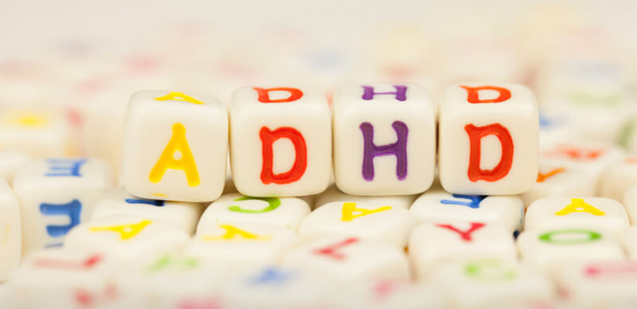
Helpful resources
Leaflet for parents

- NHS Choices -ADHD
- Royal College of Psychiatrist- ADHD in children and young people
- The Mental Health Foundation
- Young Minds – Parents information service 0808 802 5544
- ADHD foundation

Do girls display the same symptoms as boys?
Girls are less likely to demonstrate hyperactivity which leads them to be less easily identified. They are more often diagnosed with Inattentive Type of ADHD(Shatkin, 2005)

How common is ADHD?
ADHD affects 3-5 % of children and it is more common in boys than girls 4:1 ratio.
(American Psychiatric Association, 2013)

At what age children get diagnosed?
Symptoms are often recognised by the age of 2. Most of diagnosis however are made at the school age. This is when the symptoms are mostly noticeable. (American Psychiatric Association, 2013)

What causes ADHD?
- neurobiology (some parts of brain are less developed
- genetics (this disorder is more likely to run in family)
(American Psychiatric Association, 2013)
What is ADHD?
‘ADHD is a persistent pattern of inattention, hyperactivity and impulsivity that is more extreme than typically observed in individuals at a similar stage age’ (American Psychiatric Association, 2013).

Can it be caused by any outside factors?
Social and environmental factors can influence the severity of the symptoms however they cannot cause ADHD. (Munden & Arcelus,2000)

What are the common problems?
- Sleep disturbance
- Mood swings
- Aggression and temper tantrums
- Literacy and other learning problems

(Munden & Arcelus,2000)
There are three types of ADHD
(American Psychiatric Association, 2013).
.................................................

Severity of ADHD diagnosis:
- Mild. Only few symptoms are present. Minor affect on child’s social and school life

- Moderate. Impairment is more significant

- Severe. Many symptoms required for diagnosis are present which are marked as several. Symptom can cause impairment is school/ social life.

Combined Type
Combine type will demonstrate a mix of symptoms from inattentive and hyperactive type.
- Unable to wait they turn to speak and Interrupts others.
- Seams to be talking constantly
- Rarely participates in hobbies
- Unable to play quietly.
- Will run or climb at unsuitable times. Unable to sit still.
Inattentive Type
Hyperactivity Type

- Avoiding tasks that require a focus: schoolwork, projects, or reading
- Easily distracted by noises or other people talking
- Forgetfulness while doing everyday activities (forgetting certain stages of a task)
- Difficulties in following instructions

Family Impact

- Family life may not cause the ADHD however it can affect the intensity of its symptoms. ADHD is not an easy disorder to live with therefore it can cause a negative reaction within the family.
- It can also have a tremendous impact on parents and siblings’ interactions.
- Family dysfunction may be a risk factor that interacts with child predisposition to ADHD symptoms.
(Johnston & Mash 2001)

- Families of children with the Combined type of ADHD, had more problems than families of Inattentive and Hyperactive Impulsive subtype children. (Muñoz-Silva, Lago-Urbano & Sanchez-Garcia, 2017).
- Mash and Johnston (1990) reviewed the literature on parenting stress. They have demonstrated that ADHD characteristics led to parenting and family stress.
- These parents also have a negative view on themselves as a parent (Wicks-Nelson & Israel, 2000).
- Parents of children with ADHD report less marital satisfaction and more conflicts in the relationship (Mash & Johnston, 1990)

- Szatmari, Offord, and Boyle (1989)
however have reported that, parents of children with ADHD did not have more severe marital problems than the parents with healthy children.

- Furthermore, this families did not demonstrate higher divorce or separation rates
(Mash & Johnston, 1990)

Parents of children with ADHD can be more:
- directive and negative
- less social
- controlling
- negatively influence
- more negative attitudes and feelings toward their children
This may increase children with ADHD a negative outlook to life. Which can then develop into another childhood disorder like depression.
(Muñoz-Silva, Lago-Urbano & Sanchez-Garcia, 2017).


- Learning disability is a disorder often associated with ADHD. (DeShazo-Barry, Lyman & Klinger, 2002).
- As many as 30% of children with ADHD do not achieve the expected academic level
- Children with ADHD often display problem-solving and other cognitive processes which are linked to the poor academic performance
- Children with ADHD are also negatively impacted by their disruptive behaviors, which are affecting their ability to learn and master new academic material
- Children with ADHD can learn but they are underachieving as they are unable to present the knowledge on papers and tests
(Class, Milton, Ward & Sarsour, 2012).

- Over 50% of children and adolescents diagnosed with ADHD will have serious problems with peer relationships (Wehmeier, Schacht & Barkley, 2010).

- Children and adolescents with ADHD often display a impulsive, intrusive, commanding, and hostile behaviour. They can also be very self-centred orientated (Wehmeier, Schacht & Barkley, 2010).

- Children with predominantly inattentive forms of ADHD are more likely to exhibit more subtle problems (e.g., school failure) than children displaying hyperactivity. (DeShazo-Barry, Lyman & Klinger, 2002)

- Social problems are most serious in the adolescents with ADHD and comorbid ODD or CD. They are also more likely to be bullied and to become bullies themselves.
- children with ADHD are more impulsive which can contribute to quarrelling with close friends and may result in low self-esteem
- As a result of this 70 % of children won’t have a close friend.
- Children with ADHD often suffer from anxiety and depression. This may often cause them to miss school or social events. (Wehmeier, Schacht & Barkley, 2010).
- Gender can also indicate certain academic areas that require more attention. For example, girls may require more behavioural structure in Reading classes or classes for which reading is essential for success (e.g., science, social studies) (DeShazo-Barry, Lyman & Klinger, 2002)


Education and Social Impact
Provide more specific instructions:
- Switch off all electric appliances
- Break the information in to small parts
- Avoid asking question when giving instructions
- Ask the child to repeat what’s been said
(Munden & Arcelus,2000)

Provide a positive feedback and approval. This can be done verbally using phrases like:
- What a nice thing to do
- Great job
- I like when you…
You can also demonstrate that via a hug or a smile.

(Munden & Arcelus,2000)

Things that can help
- Tutoring, and training in study skills can help children with the schoolwork.
- Behavioural strategies will help them cope with the school environment.
- Behavioural interventions such as time-out from positive reinforcement, can also e effective
(DeShazo-Barry, Lyman & Klinger, 2002)

Reference
American Psychiatric Association. (2013). Diagnostic and statistical manual of mental disorders (5th ed.). Washington, DC: Author.

Class, P., Milton D., Ward, S., & Sarsour, K. (2012). Social and emotional difficulties in children with ADHD and the impact on school attendance and healthcare utilization. Child and Adolescent Psychiatry and Mental Health, 6,33. doi:org/10.1186/1753-2000-6-33

DeShazo-Barry,T., Lyman, R. D., & Klinger, L. G. (2002). Academic Underachievement and Attention-Deficit/Hyperactivity Disorder: The Negative Impact of Symptom Severity on School Performance. Journal of School Psycholog, 40(3),259-283. doi.org/10.1016/S0022-4405(02)00100-0

Johnston, C., & Mash, E. J. (2001). Families of Children with Attention-Deficit/Hyperactivity Disorder: Review and Recommendations for Future Research, Clinical Child and Family Psychology Review, 4, 183-207. doi: 10.1023/a:1017592030434

Mash, E. J., & Johnston, C. (1990). Determinants of parenting stress: Illustrations from families of hyperactive children and families of physically abused children. Journal of Clinical Child Psychology, 19(4), 313–328. doi.org/10.1207/s15374424jccp1904_3

Munden, A., & Arcelus. J. (2000). The AD/HD Handbook. A Guide for Parents and Professionals on Attention Deficit/Hyperactivity Disorder. London, England: Athenaeum Press.

Muñoz-Silva, A., Lago-Urbano, R., & Sanchez-Garcia, M. (2017). Family Impact and Parenting Styles in Families of Children with ADHD. Journal of Child Family Study, 26, 2810–2823. doi: 10.1007/s10826-017-0798-1
Szatmari, P., Offord, D. R., & Boyle, M. H. (1989). Ontario Child Health Study: Prevalence of Attention Deficit Disorder with Hyperactivity. The journal of child psychology and psychiatry, 30(2), 189-335. doi:org/10.1111/j.1469-7610. 1989.tb00236.x

Wehmeier, P. M., Schacht, & A., Barkley, R. A. (2010). Social and Emotional Impairment in Children and Adolescents with ADHD and the Impact on Quality of Life, Journal of Adolescent Health, 46, 209–217. doi: 10.1016/j.jadohealth.2009.09.009

Wicks-Nelson, R., & Israel, A. C. (2000). Behaviour Disorders of Childhood (4th ed.), London: Prentice-Hall International.

