
Software solutions for business
Module Code: ACCA 2026

April 28, 2026
Lecturer: Kwame Assa-Agyei
Student name: Jay L Boodhun
Student no: 2531572



Introduction 2
Task 1. e-Commerce Website builders or software solutions 3
1.1 Shopify 3
The Benefits of using Shopify 3
1.2 Google Sites 4
Task 2. Mind-map of contemporary software applications 4
Case 1: Saint Peters University 4
Case Study 2: Universiti teknologi MARA 5
Create a mind map of contemporary software applications 7
Task 3. Office Applications 8
Four office software solutions for business operations 8
MS Word 8
MS PowerPoint 10
MS Excel 11
MS Access 13
a. Practical demonstration of Two Office Features 15
Mail Merge 16
If Statement 19
Task 4. Using Communication and Collaboration applications 20
MS Outlook 20
MS Teams 21
a. One feature of a freely available Communication (1) and one feature of a Collaboration (1) application 21
MS Outlook 22
MS Teams 24
CONCLUSION 26
​Bibliography 27

Introduction

Software is the key to technological advancement in all areas of daily life whether if it's within a business setting, an entrepreneur or as an individual. To examine this is in detail, this assignment views the most prolific software tools used for individual and corporate use. This comprises of 4 tasks mainly, an e-commerce website builders, office packages, also mind mapping. Although mind mapping is seen as non-software-based technique. It will be explained in relevant task.

Task 1- investigates the use of shopify, which is used for entrepreneurs and how they use this platform to promote their business. In comparison Google sites is used as an integrating tool for projects on social media. The emphasises the use of E-commerce platforms in gaining any competitive edge for start-up businesses.

Task 2- Promotes the use of mind mapping as a technique for developing critical thinking. This technique is used to visualise issues instead of a written form, but in this case is used as a brainstorming exercise. It is useful for aiding an entrepreneurial mindset. This task is unique as it does not mention software, instead it is about the individual and how they apply this skill. It is the individual who decides what software they can use to exhibit their knowledge.

Task 3- The most common office software packages namely Microsoft Word for professional word processing. The other is Microsoft PowerPoint, a presentation that is used for personal and professional use. Screenshots are used to give a breakdown of the set-up process.

Task 4- Here we are looking at 2 types of Office suite tools, one is used as a popular communication tool and how this is set up. The second is a collaboration tool that is widely used in office life to conduct conference calls. Just like task 3 the use of screenshots gives a breakdown of how to use both tools.

Task 1. e-Commerce Website builders or software solutions

1.1 Shopify


According to 2 databases Pitchbook (which measures the return on investment as a venture capitalist tool for private investors), and BuiltWith (measuring the progress of start-ups on the shopify website.
Shopify is an e-commerce platform with low-code tools (known as a universal character encoding language) whereby there is no need or limited writing of codes. This is fundamental as it allows the user to use this platform by becoming an online retailer by selling goods. By doing this, it allows the user to develop themselves as an entrepreneur, The use of low-coding means that Shopify excels for two reasons. Firstly, it has proven to be a long running ecommerce platform for online retailers. E-commerce companies report that Shopify has a vast share of low-code platforms which has proved how popular it is. Secondly because of the benefits offered

The Benefits of using Shopify

Using BuiltWith which records ecommerce data, and internet usage analytics was used to measure payment tools like Shopify Pay, as well as all relevant website technologies such as widgets. Widgets are a graphical software embedded onto the platform which allow easy access to a specific function. In this case a payment function (e.g., Shopify Pay, Shopify Hosted, Shopify Discounts, Shopify Gift Cards) enabling entrepreneurs to easily create and operate an e-commerce company. ​[1]​

1.2 Google Sites

Research Methodology was conducted by examining the experiences of 185, 1st year undergraduate millennial students. This age group coencides with the development of personal computers and the internet. The emphasis was based upon to the effectiveness of the teaching and learning approach on how businesses can use web 2.0 technologies. Students would use google sites learning tools sharing digital information such as Web links showing personal interests, calendars, photos.
More importantly students would develop their project by posting their videos on how businesses can use web 2.0 technologies using this multi-media technology. The Google Sites learning tool has the facility for students to access virtual classrooms and posting their assignments. All this in an easy-to-maintain site without having any web coding technical knowledge. Students have utilised this web builder function by linking their group projects on Facebook, linking their videos- sharing their knowledge. The wide usage of all these functionalities proves the versatility of this web builder.
Upon completion of group assignments while utilising this web builder, the students were asked to complete an on-line survey assessing the effectiveness of the teaching and learning approach. Students had access to a web-based questionnaire whereby they would give their feedback on this learning tool. The outcome showed that the majority found it of great value.
This only presumes that the minority could have more scope for self-improvement. As the web 2.0 technology is an online business tool, students have a recourse to improve their technical skills in preparation for the job market with a business environment. [2]

Task 2. Mind-map of contemporary software applications

To discover the benefits of mind mapping case studies must be presented. In this scenario we have 2 studies:

Case 1: Saint Peters University

The university carried out a classroom project. In this study mind mapping demonstrates an effective methodology in assessing student learning within a business environment. Students learn within a classroom activity either individually or within a group to present a business problem, and by using mind mapping develop a solution by drawing pictures and then relating them to an outcome. This highlights their level of reasoning by viewing a complex question while providing supportive evidence that ends with their own conclusion.

This method enhances decision making skills that is effective in business life. Due to this, it is now commonly used within any classroom-based business course. Students have utilised mind mapping by going further, by developing an argument map sharing their work to stimulate discussion about the business problem/argument. Then as a result, an appropriate course of action can be used to direct business decisions. [3]
The advantage of mind mapping is that it is a visual thinking tool, and so people can see a problem or question in front of them whether if it’s on a whiteboard or a presentation slide. Viewing the problem in front of them stimulates a think tank discussion group. This leads to developing new ideas and thus improved creative thinking skills.

Case Study 2: Universiti teknologi MARA.

This study was based on qualitative study using document analysis on the application of mind mapping in innovation and entrepreneurship courses. The outcome of mind mapping showed improving students' creative thinking. Each mind map represents the knowledge of the students thinking ability on their given topic. Not surprisingly students who have more knowledge would produce more branches showing the students thinking pattern or explanation to a particular question. This in turn explains the creativity of the students' thinking ability without any restriction imposed thus developing a laissez-faire approach to problem solving.
The study promotes mind mapping as a fundamental tool for future research with the aim of optimizing innovation, within entrepreneurship courses in higher education. The off shoot of this would help the student to cultivate innovation within the field of entrepreneurship. [4]
In conclusion, having viewed both case studies the mind mapping technique works no matter what continent the student(s) resides. It is a good alternative to just taking notes, and asking the student to answer questions by using research material to investigate a solution to a problem. Mind mapping induces a process of brainstorming while visualising the problem in front of them. In doing so, the student uses their own critical thinking process, and through a process of elimination comes to their own conclusion. This is further improved if this is used by a group inducing greater interaction with all participants learning at the same time.

Create a mind map of contemporary software applications
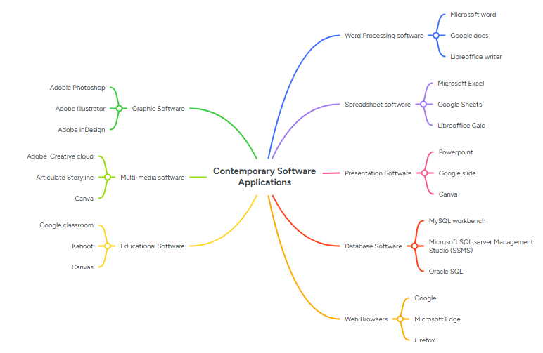
The diagram above featured around this topic was used as a demonstration of the Mind Map technique of software packages that are used in everyday life. This brainstorming session tests our awareness of what packages we think are there at our disposal.
NB. There is no “right” or “wrong” answer, it is a test on our knowledge on the subject matter.

Task 3. Office Applications

Four office software solutions for business operations

MS Word

Features
The functions that are provided are altering of the text font sizes with the options of using Bold lettering (making the recipient aware as to what area of attention that they need to pay attention to!), italic and underline any text on the A4 sheet via the work processor. Once choosing the text font, the user has the option of using line spacing, centring whether to the right or left as well as using indents (choosing how the margins are spaced out).
The Heading/tabs provided give options like cut, copy, paste and a spell checker facility. The usefulness of these functions gives wide scope for amending the letter/ document when needed.
MS Word not only provides the use of the layout of document but can also provide a table of contents by offering a grid format as a presentation.
Benefits
In addition to the features that these tools provide the user can finalise the document ready to be printed, sent or used as a presentation. Not forgetting that the document can be filed away into the computer’s operating system. This cuts down on filing cabinet spaces/ heavy storage.
The ability to amend the document when needed is an essential tool especially for producing CV’s, bullet points on reports etc.
In terms of teaching materials, lecturers have the option of checking grammar and amending presentation content. MS word facilitates graphic designs like SmartArt and PowerPoint presentations. This visual display makes learning visually stimulating to for the student in mind. Addition benefits include the MS word tools to incorporate hyperlinks in course content to open up further areas of reference when needed.
One key fundament change by using MS Word is the technological shift from typewriters for microcomputers with writing software. Using processors means that the user can have access to their files online via their computer. The use of laptops makes working out of hours more accessible and still producing more content to be used on MS word.
Limitation
There are two areas where microprocessors disadvantage the user. Firstly, using pencil and paper gives the individual the ability to plan what they want to write, developing their ideas and engaging their thought processes.
Secondly, the use of word processors means that writers planned less before beginning to write. There is a heavy reliance on the software to do the thinking for you. Despite taking these 2 areas into consideration, it is important to realise that software tools provide functions that the individual could use to construct text according to that person’s recommendation. [5]
It is also worth noting that notetaking in personal meetings allows the individual to ask questions if to amend notes to add additional comments for future reference. This is not always possible when using micro processing as note taking is faster than typing speed.


MS PowerPoint
Case study 3:- Teknologi Pendidikan, Universitas Pendidikan Indonesia

Features
As a software it provides effective presentation as a visual tool. These tools include text imagery, colour, sound and animation. This provides students visual stimulant for learning.


Benefit
It offers its advantages in terms of its professional layout. Academically, teaching staff need this tool as it delivers content of the lesson to be delivered and for class participation.
This software is an attractive multimedia presentation package that is easy to create and use. It is widely used by lecturers making use of images with background themes and colours. The well-designed features create a well-presented display which motivates students to better understand the subject matter.

Due to the power point presentations students have an important role to play in shaping their understanding and increasing awareness of what they are reading, writing, and facing. It is considered a highly valued media tool which strengthens their learning process.

There are various reasons why it is appealing to students. Firstly, it makes them feel good when lecturers teach as the designs and colours affect students' ability to follow the learning process. Due to this it makes it is easier for them to understand the course project that is before them. The learning process is more focused and straight forward.

A far as Lecturers are concerned when using the PowerPoint tool, students pay close attention and it could be argued that any distraction is cut to a minimum.

PowerPoint is a multimedia tool currently that students pay close attention to. This because as an interactive software the learning process is not spoon-fed it is a personal learning journey.

Therefore, it can be stated that interactive PowerPoint media is a learning tool that can not only be used to distribute material to students, but students may use it to interact with each other on group projects. [6]

Although the study may not have mentioned it, it can be perceived that students can use the PowerPoint media technology to create their own presentations. It can even be assumed that students may, and most likely are able to produce better presentations than their lecturers. This is not necessarily because they are better that their teachers, but this tool can be used as an experimental presentation package. This is a clear sign of creative thinking and offers the opportunity to utilize the software tool not necessary for learning but enjoyment, and when enjoyment is reached the student uses this media tool more frequently. In terms of limitations, there doesn’t seem to be anything within the case study to express this, instead it focuses on the student’s enjoyment of its use.

MS Excel


Research was aimed on the effectiveness of the MS Excel application on students' understanding of statistics courses. This was done by using quantitative data on a small sample of 22 out of 25 students who were studying engineering.

Features
The software has an inbuilt calculator giving students the functionality of performing complex formulas, and so ideal for statistical work. These include commands such as SUM, AVERAGE, and IF statement. These individual commands all perform their unique tasks. These commands are useful when analysing data and generating reports.
When writing reports this software allows the use of PivotTables or PivotChart, plus the added benefit of using filters, and sorting data to give the viewer a greater understanding of statistics.

Benefits
The students were asked questions to gage their feedback. For simplicity some questions have been grouped together as the percentage responses were similar 27% and 36.4% respectively. The reason for this it that these same percentages are highly likely to be same recuring students are who frequently answered the questions

Table 1: Corresponding Student response
Question | Often | Sometimes | Very helpful | Quite helpful/ easy | Not easy/ helpful | Un-answered
How often do students use complex formula's? | 27.3 | 36.4 |  |  |  | 36.3
Feel that MS excel helps create graphs? |  |  |  | 36.4 | 27.3 | 36.3
MS Excel helps is completing assignment? |  |  | 27.3 | 36.4 |  | 36.3

In addition to this 63.6% of students were highly motivated as they found Excel a learning process. 63.7% felt positive about completing their assignments. The study also mentions 27.3% used excel daily, 31.8% used it several time a week, and a further 31.8% used it monthly amounting to 89.9% response. [7]

Using this study in terms of its limitation, we can use Table 1 which has 36.3% unanswered response. The research does not give a reason why this is outstanding. Although 22 out of 25 students answered the questionnaire this outstanding 3 non-participating students does not correlate properly to unanswered total. In this case it is the research that is limited as it does not cater for the reason why students did not participate to gather their feedback. There are 2 areas we need to gather firstly the study was of participate group of 22 out 25 students. To get a more credible questionnaire it would better to gather a feedback response from 100 students instead of 25. In this case if 25 students represent one year, why not have questionnaire feedback spanning 4 academic years. The second area of concern is that the unanswered response was not defined. We do not know if students dropped out of their study or whether if there was an alternative application to excel that was used?

MS Access


Using a study from 2 authors from the University of Co-operative & Management and University of Yangon. The research gathered the input of 40 teachers, and how they used the application. This was to demonstrate the Relationship Database Management System (RDMS) with its link to a Structured Query Language (SQL). This is relevant as the system had to relate to Microsoft Office.

Features
Its key features are for entering/modifying/ extracting data in a database. This is usual done by tabled results. These results come stored in a column and row formation.
- Able to update tasks without the use of coding.
2) Filtering of specific data, which can anything that is entered in the database at first instance.
3 Report writing, which can include analysing, summarize specific information when need.
4)Standardised Form used for data entry.

Benefits:

At the university, teachers used it for the following benefits.

- The easy to use of storing data. This is regardless of professional or personal data. Its use of tables to visualise and update is easy to manage in different stages. It showed how simply they could delete or organising records.
- Any information stored is on a Database, showing how easy to retrieve data and so saving time. The software allows cross-referencing by merely linking one table to another without difficulty. This was demonstrated using hyperlinks.
- It can handle a huge amount of data on record without getting overloaded.
- The software can handle Multiple users on this package at once.
- Generating reports on the data imputed is very easy to use and to re-organised depending on what type of information is needed. Has the option to print the relevant record when needed.
- There are different forms layouts that can be used when generating enquiries as well as producing different layouts.
- It can be used to integrate other software packages like MS Excel and MS Word, since they are compatible.

In the study it showed how teachers utilised this package to produce a database showing different stages e.g. Storing files with attachments. It was a documented step guide on how they went about implementing the application. This step guide demonstrated how user friendly the application is, having access to any data, and giving a clear indication of their thinking process. Teachers were pleased with the professional display when documents were printed. [8]

Limitations.

In terms of limitations there did not appear to be anything that comes up on the report. This study does not mention as to whether MS office 2019 perform any stress testing prior to this test case performed by the teaching staff.

  - Practical demonstration of Two Office Features

Mail Merge
In MS word a table is created for a recruitment agent, who is has 6 candidates who have successfully reached the final round of the interview stage. Paying attention to the “Positron”, ”Company”, ”Appointment”, ”and “Venue.”

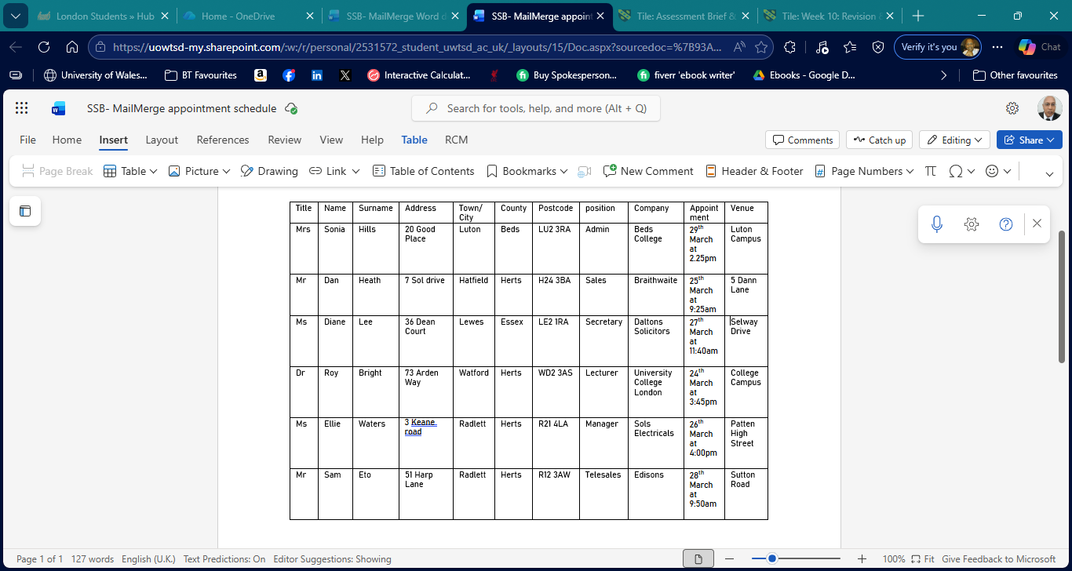

Using the MAILINGS tab, we select Letters.
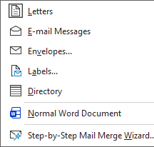

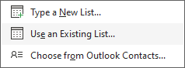

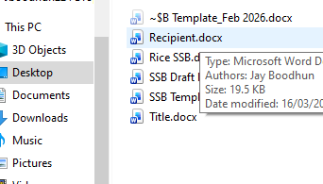

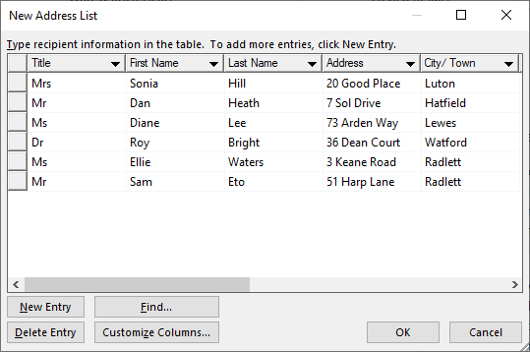

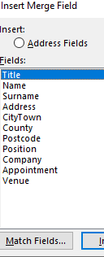

Generate Letter
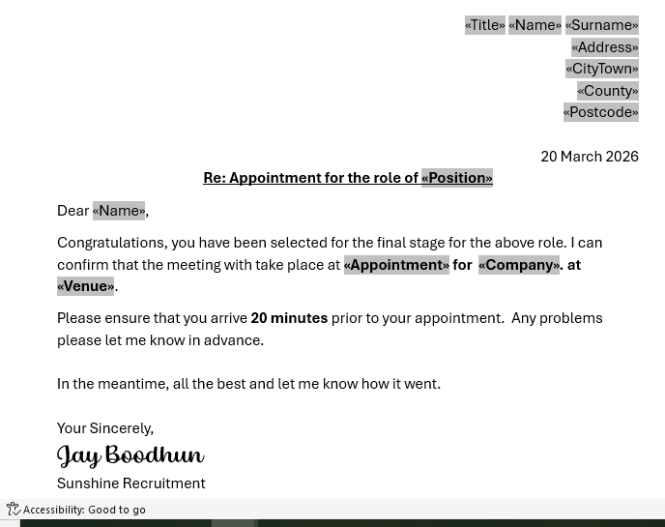

GENERATE Letters to candidates
- Go to Finish & Merge (dropdown- “Edit individual letters”)
It will show your listing of letters for each candidate
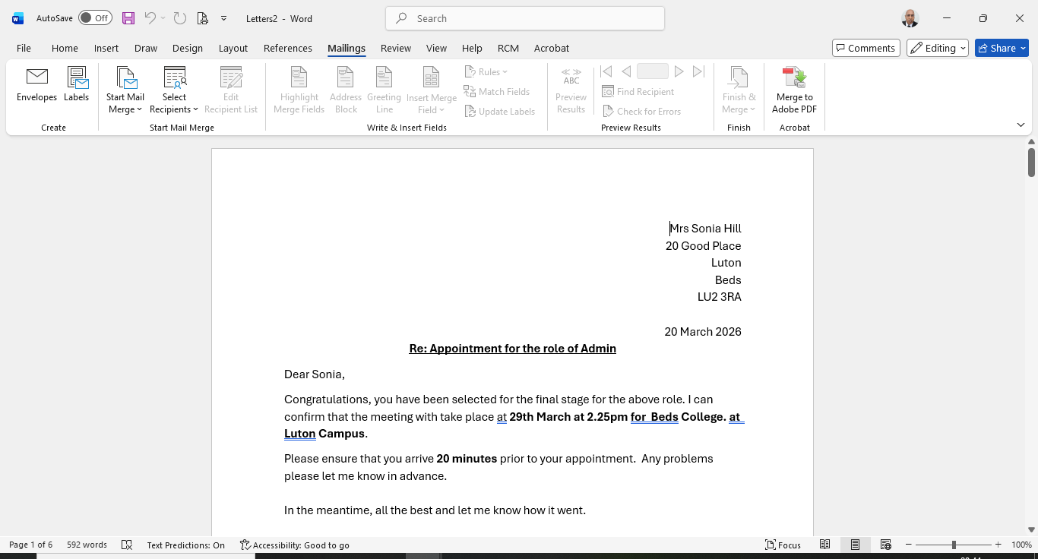
Provide evidence that you have generated the listing of all candidates. See below for 6 letters to be generated.

If Statement
Using 10 candidates to demonstrate their pass marks using the “IF” statement.
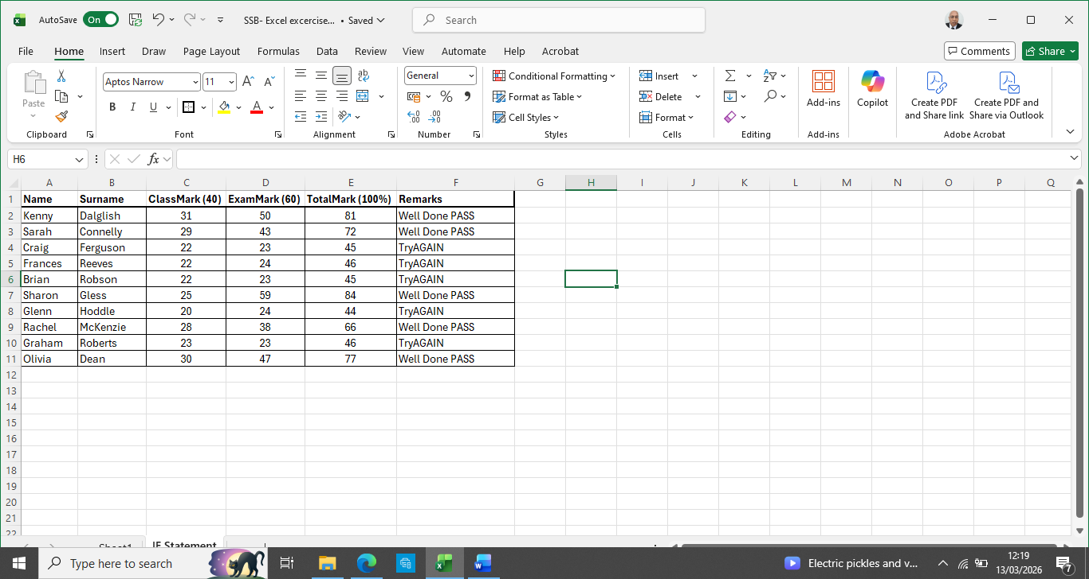

Showing the formulas:-
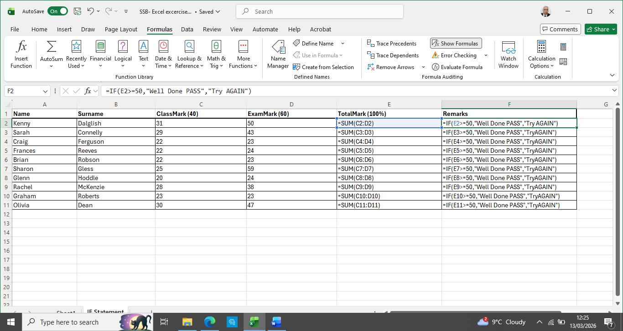

Task 4. Using Communication and Collaboration applications

MS Outlook
Features: -

As a communication tool it is highly productive, as it shares messages electronically as well as file sharing. The advantage is that you can inform multiple respondents all at once without the need to print sheets and posting it to team members. Which is not only time consuming but avoids any mishap of accidentally not including individuals leading to exclusion, thus exposing a communication deficiency. Outlook can overcome this by including all relevant members within its department. This internally helps its business operate well within its communication structure. This not only demonstrates the streamlining of messaging, making it highly effective but puts the onus on the sender to clarify electronically if the initial message was unclear by doing a follow up message quick and simple.

Managers can use Outlook to oversee progress of projects carried out via effective communication showing greater visibility. ​​ [9]​​

Team members can give feedback online producing reports or any difficulties faced when Managers are not available to interact face to face.

The benefit of using features like autoresponder messages. This informs other departments who liaise with staff members from other departments of progress. (e.g. if an individual is on holiday leave and therefore advising them to contact another member in their absence). Both Big and Small Medium Enterprises benefit from Outlooks automated response which helps the business flourish significantly.

MS Teams

Features: -

It works on the Microsoft 365 network and is a visual professional tool for chat-based interaction. Collaboration tool. This platform operates as an online file sharing tool whilst conducting real time visual meetings. Its key advantage is that it operates well as a hybrid working facility and can be used office based for clients/ colleagues who are based in different locations. The user can liaise with not just one client but multiple clients regardless of what time zone abroad, highlighting that the meeting is not restricted by physical boundaries.
The tool offers great access to PowerPoint presentations giving more visual presence in terms of advertising the companies services, recommendations, reports etc., Being an online collaboration tool there is scope for the client to ask questions for fact finding of the Companies products etc.., On a professional basis it helps the announcer to develop an online presence developing a trust element. Which is enhanced by sharing presentations that are linked to each other’s company ideals. A case study conducted stated that $270 million was saved over 3 years due to online presence. As opposed to setting up meeting rooms, this may have included hiring assembly halls, but most importantly meetings and decision making was a quick process.
Other advantages are that it works well on outlook setting up appointments giving the meeting’s agenda. The announcer could also install break outs rooms for allow group discussion to discuss its agenda in a more detail if need. At the end of the meeting, members can interact with questions and answers to gather more information to add clarity.

- One feature of a freely available Communication (1) and one feature of a Collaboration (1) application

MS Outlook
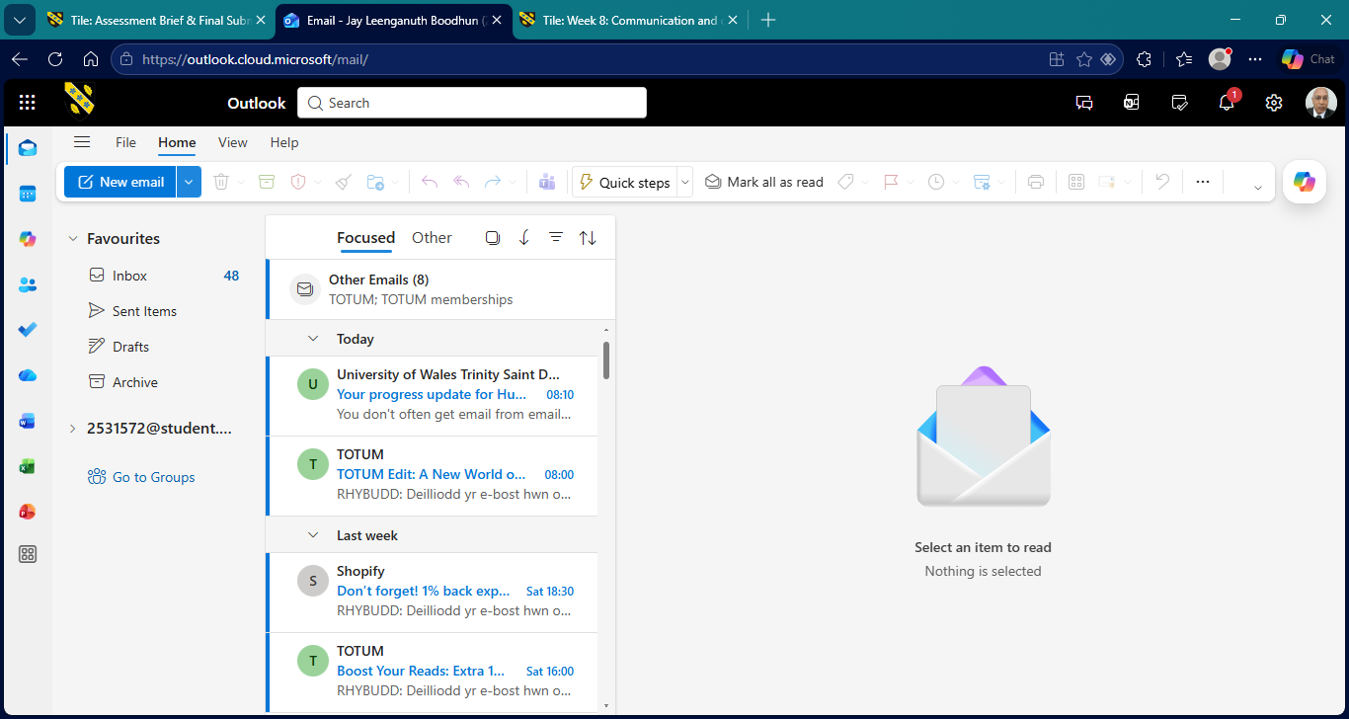
Opening an Email.
In this case outlook allows the user to create a new email simply by moving the cursor to the blue BLOCK (named “New email”).

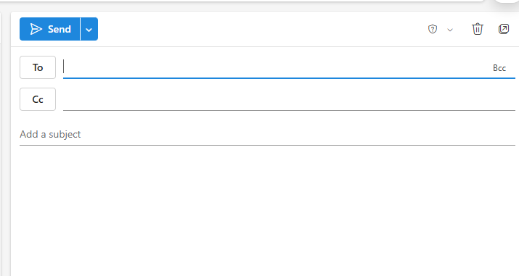
Here an email box is downloaded. The To prompt is for the intended responder and ready to input their email. The Cc: prompt is a carbon copy of the message which appears for a third-party member. This could be a manager or work colleague who must be informed of any aspect that needs attention.
The Add Subject box prompts the sender to mention the subject matter of its message. After the sender has finished writing the contents of the message, the sender will use the cursor to click the BLUE send tab.
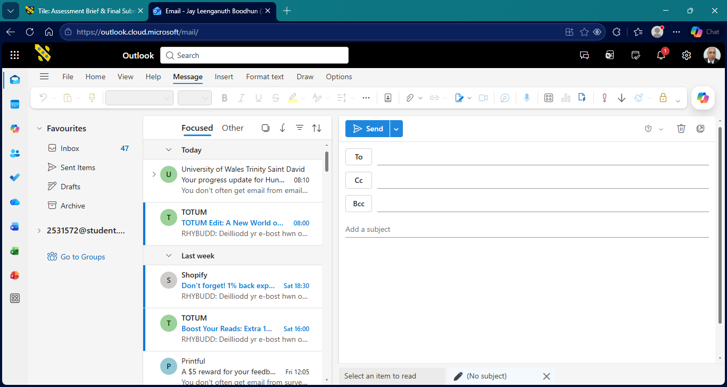
The Bcc tab known as a Blank Copy. This is to inform a 3rd party that an instruction has been given to the responder without the responder’s knowledge. The 3rd party member can gage 2 areas of interest. Firstly, if the sender’s message was fair, and secondly if the responder’s response is acceptable in dealing with the task as requested. This is a useful tool to oversee any disputes that inhibit collaboration. This is highly used for Human Resource matters.

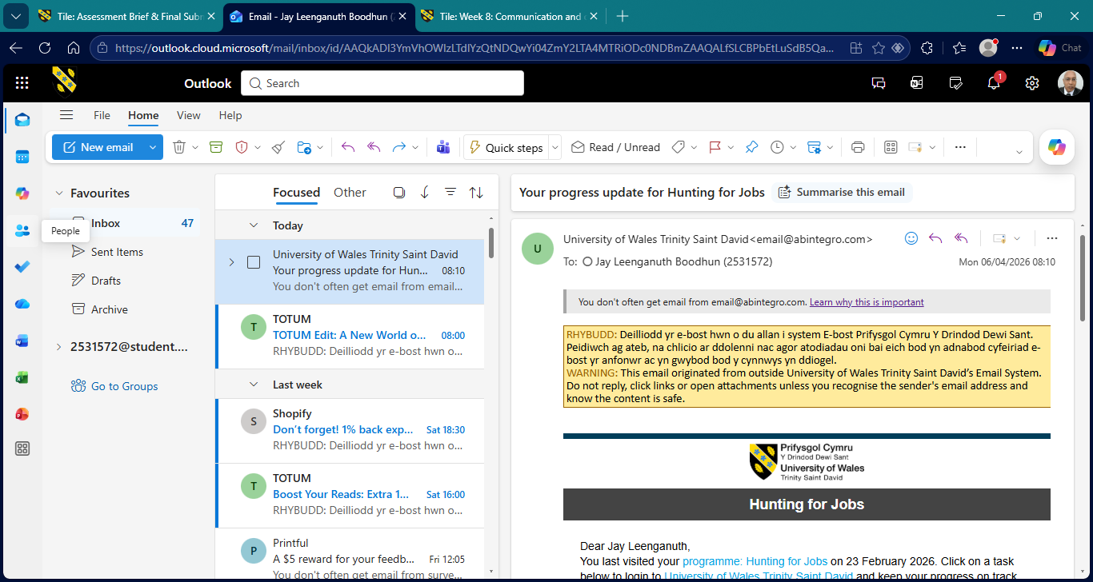
Intergrate with Microsoft Teams. Using the side panel on the left. Which is a check list of options to use Microsoft applications. The name given is “People.”

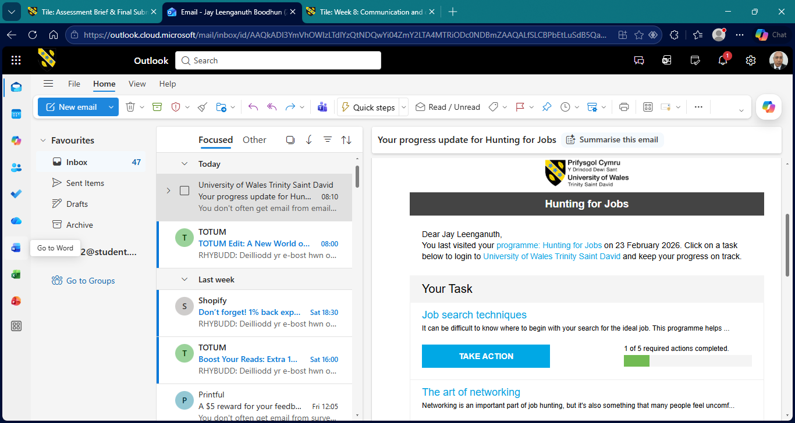
Using the cursor in the below screenshot, we can see the tab for MS word.

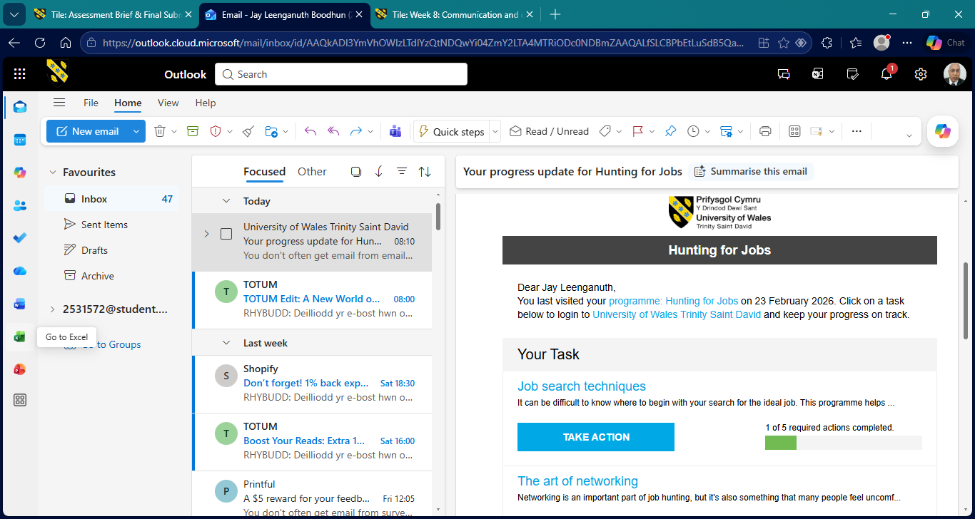
The Excel icon shows the link for this spreadsheet. This is useful as attaching spreadsheets to highlight day to day progress being achieved is useful.

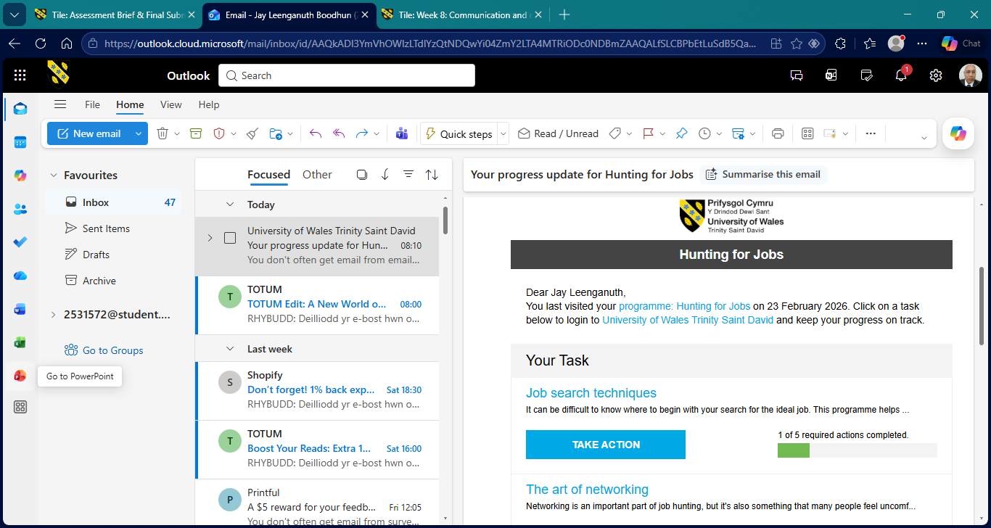
Finally, we can see that PowerPoint is also a package that is used within Microsoft Outlook.

MS Teams

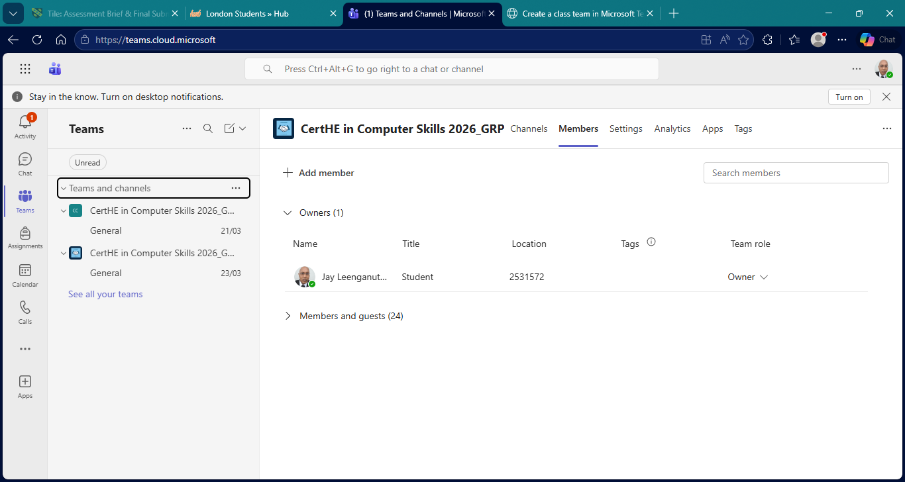
In MS Teams the drop-down box gives the option to name a group for it members. This could be a social/ business/ network Group/ Channel.

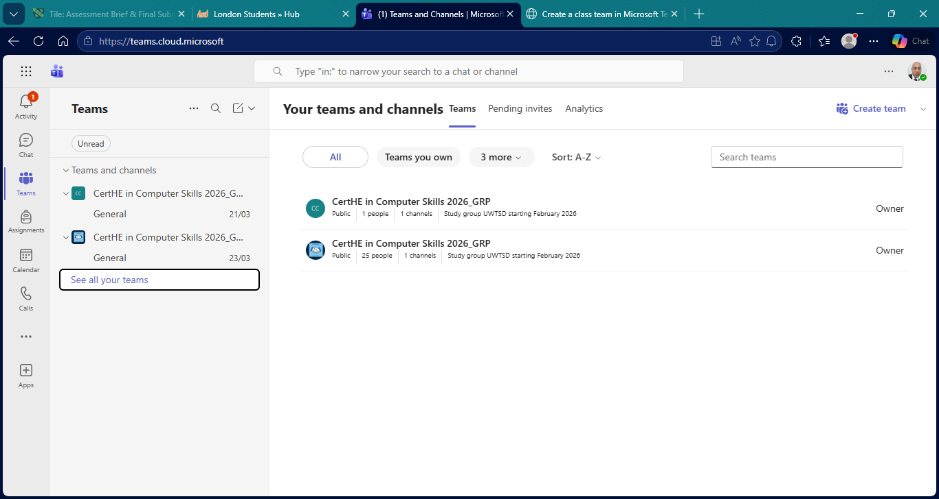
On the top right to create a Team, click on that tab to set up a new group/ channel.

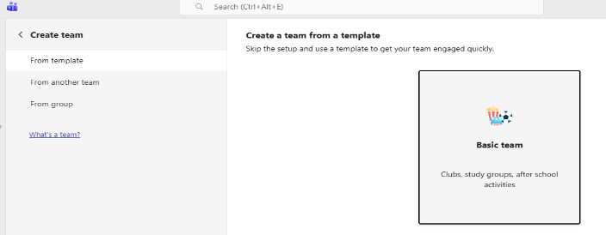
The next page gives the option to build a team if needed.

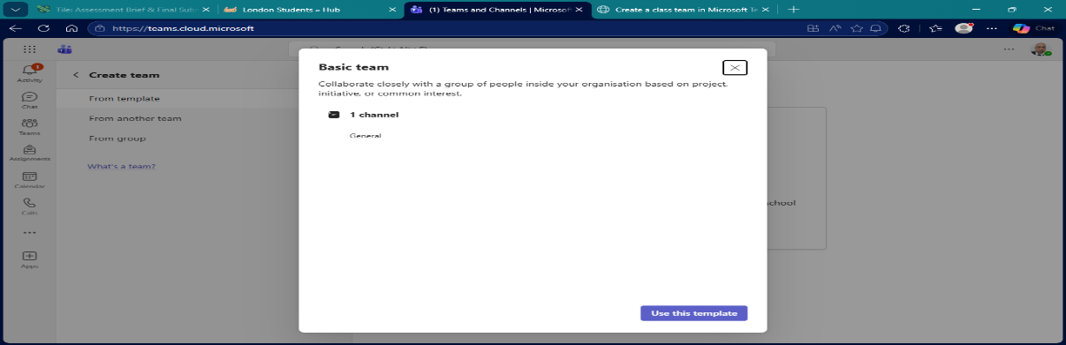
The next page dropdown and ready to click on the BLUE tab. This is under the Create Team field.

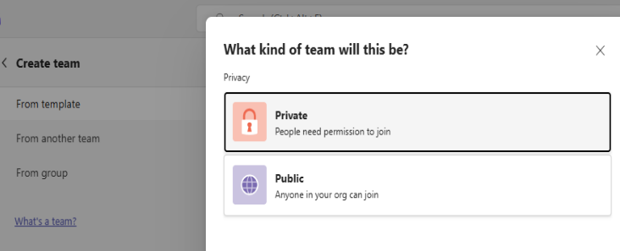
The further page gives the creator to set up a private group whereby new participants need permission to join.

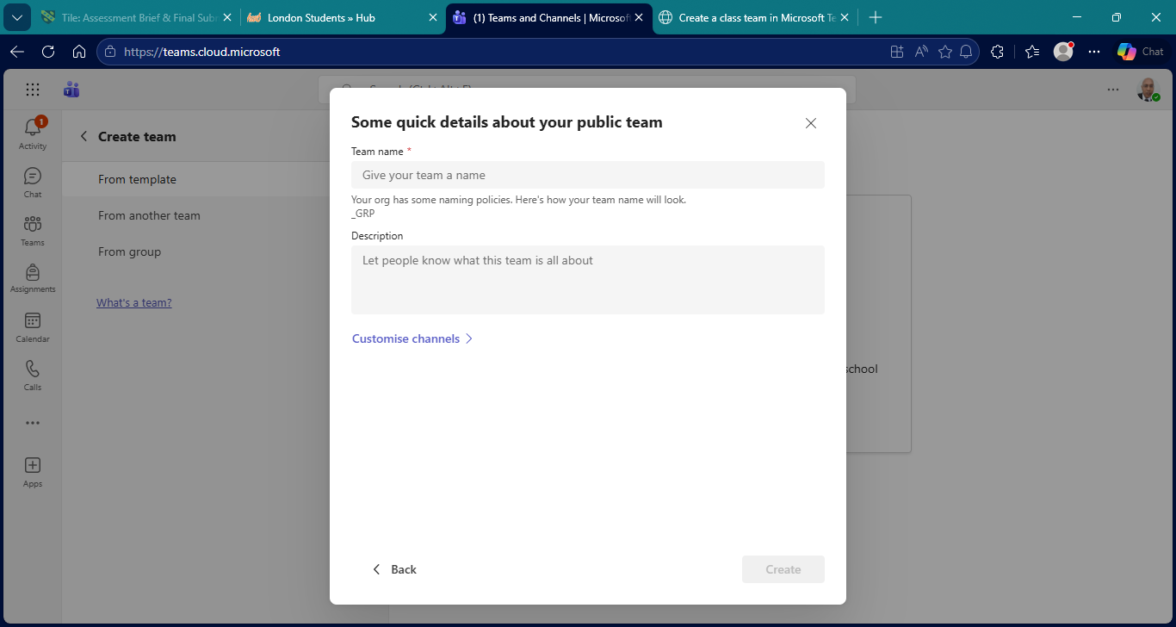
The final page gives any new participant to join the group providing that it is of interest to them depending on the aim of the channel.

CONCLUSION
Using the research material within this assignment, we can conclude that there are two types of candidates that are highlighted.

The first candidate is the Entrepreneur. The first 2 university case studies located in the USA and Malaysia focus their research on the Mind Mapping technique. This technique highlights critical thinking. The incentive here is the individual must think for themself and decide how they want their business to operate. To aid this the types of software that are presented are shopify and possibly google sites. Shopify with its e-commerce functionality offers an online presence by selling their goods and services within the marketplace without any coding experience. The other option being Google sites which offers a digital marketing opportunity liaising with other platforms to give another online presence. The advantage here is that they are not constrained by an employer having terms and conditions on how to adhere to company policies.

The second candidate is the Employee. Using the studies from 3 universities; Indonesia and two based in Burma. In this case Microsoft Office suite is open to them in the workplace. These included Outlook, Access, Excel, Word, PowerPoint, Mail Merge, and Teams. Excel was of interest as the study showed that although it was useful, you must use it continuously to enjoy this application. If there is no need to develop charts, tables using formulae then its usage is not maximised. It’s a more specialised application if needed.

Where Shopify and Google Sites offer individual business development, Microsoft Office suite gives a generic office package for employee usage to fulfil company duties. We could say that Outlook, Access and Excel were primarily use for internal use within internal company use. In general PowerPoint and Teams are a collaboration networking tool, which would most likely be used by Directors and senior Management to liaise clients.

Both types of candidates have one common ground which is software is heavily used for their needs. For any business to thrive it needs the latest software solution package or a workforce that is up to date knowledge how to use it

Software not only gives Companies/ Entrepreneurs the technological ability to keep up to date the fast-paced demands of business life, but it has opened the opportunity for a hybrid work balance, and so are free to work longer hours and complete projects within deadlines.

​​

​Bibliography
​​​​​￼
​[1] | ​Gary Dushnitsky,Bryan K. Stroube, “Low-code entrepreneurship: Shopify and the alternative path to growth,” Journal of Business Venturing Insights, November 2021.
​[2] | ​Roodt, Sumarie: Carina de Villiers, “USING GOOGLE SITES AS AN INNOVATIVE LEARNING TOOL AT UNDERGRADUATE LEVEL IN HIGHER EDUCATION,” AIS Electronic Library (AISel), 5 December 2012.
​[3] | ​Gargouri, Chanaz; Naatus, Mary Kate, “An Experiment in Mind-Mapping and Argument-Mapping: Tools for Assessing Outcomes in the Business Curriculum,” e-Journal of Business Education and Scholarship of Teaching v11 n2 p39-78, 2017.
​[4] | ​“Jin, Ruixuan: Narayanan, Geethanjali: Majid, Sheikha: Lin, Chenhui,” Exploring the application of mind map to enhance students' creative thinking, 30 September 2024.
​[5] | ​“Otto Kruse: Christian Rapp,” Word Processing Software: The Rise of MS Word, 15 September 2023.
​[6] | ​Anggun Apriliani Zahra Rosyiddin, Amir Fiqih, Hafsah Nugraha,Angga Hadiapurwa,Diemas Arya Komara, The Effect of Interactive PowerPoint Media Design on Student Learning Interests, 1 April 2023.
​[7] | ​Sinta Simaremare: Rosma Siregar, “Effectivity of the Microsoft Excel Application on Student Understanding in Statistics Courses,” Indonesian journal of Education and Social Humanities, 19 June 2024.
​[8] | ​Thang Lam Dim: Wint Pa Pa Kyaw, “IMPLEMENTATION OF A DATABASE USING MICROSOFT ACCESS,” 2019. [Online]. Available: meral.edu. [Accessed 10 March 2026].
​[9] | ​“Adoption and performance outcome of digitalization in Small & Medium sized Enterprises,” Springer Nature Link, 12 June 2023.
​[10] | ​“MS Teams for Virtual Collaborations,” in 4th International Conference on Education Technology & Online Learning, North Macedonia, 2024.
​​​​￼
​￼​​
​​￼
​​

​​

