Sinead James (1910154)
Module Tutor: Anthony Burns
Assignment two
Reflecting on the risks presented in the World Economic annual risk report and how they may prevent the achievement of the sustainable development goals
ECONOMICS OF SUSTAINABILITY
BMSP6007

Contents:
- Introduction………………………………………………………………………………….……………2
  - Purpose of this report…………………………………….………………………….....……..2
  - Who is the World Economic Forum?.....................................................................2
- Main findings……………………………………………………………………………………….…….2
  - What is the risk outlook for the next 10 years?.............................................2
  - The seventeen sustainable development goals………………………………………..…3
  - Impacts on global efforts on sustainable development………………………………..4
- Recommendations………………….………………………………………………………………….7
  - Recommendation 1…………………………………………………….………………………..7
  - Recommendation 2…………………………………………………… ………………………..8
  - Recommendation 3…………………………………………… ……………………………….8
4.0 Conclusion……………………………………………………………………….…………………………9
5.0 Reference list……………………………………………………..……………………………………10
6.0 Appendices…………………………………………………………………….………………………..12

1.0 Introduction:
1.1 Purpose of the paper:
The intention for this paper is to analyse the risk report created by the world economic forum (2022) annually and discover the forecasted outlook for the next ten years. This paper will also evidence how the suspected outlook might affect global efforts on sustainable development by reflecting on the seventeen sustainable development goals created by the United Nations (2015). Upon dissecting the information found within the annual risk report, recommendations for possible ways forward will also be present, these recommendations will hope to get the global economy back on track to achieving the sustainable development goals within the desired time horizon.
1.2 Who are the WEF?
The WEF was founded in 1971 by German engineer Klaus Schwab (1938), the purpose of the World Economic Forum is to discuss and present major issues that impact the global economy. The organisation is not run by governments, but rather by businesspeople and political leaders, and topics that are discussed include, but are not limited to, political, environmental, social and economic issues (Kagan, 2021). Each year the WEF release a global risk report that delves into high-ranking threats and arising issues that prepares governments on what is to come and allows time to innovate ameliorative and preventative intents.

2.0 Main findings:
2.1 What is the risk outlook for next 10 years?
According to the 2022 report published by the World economic forum, there are numerous risks predicted for the next ten years all with worrying consequences worldwide. It comes as no surprise that all the risks forecasted for the next ten years are man-made and have stemmed from lack of collaboration and equality amongst countries. Even the risks that are associated with extreme weather or an increase in poverty are predicted to occur due to one simple explanation: the choice of power over collaboration for prevention. Individual countries have had the opportunities to empower and embrace society and our environments, yet the power of such countries has been focused more on benefiting themselves than having a wider outlook and using their positions to benefit everyone worldwide. With the lack of collaboration for what actually matters, which is our world as a whole, countries have instead focused their priorities inward to ensure their own status remains high. It is predicted that problems such as climate action failure, extreme weather, loss of biodiversity, social cohesion erosion, livelihood crisis, infectious disease, human environmental damage, natural resource crisis, debt crisis and geo-economical confrontations will occur (WEF, 2022). The below figure 1.3 extracted from the annual risk report, ranks these risks from highest to lowest:
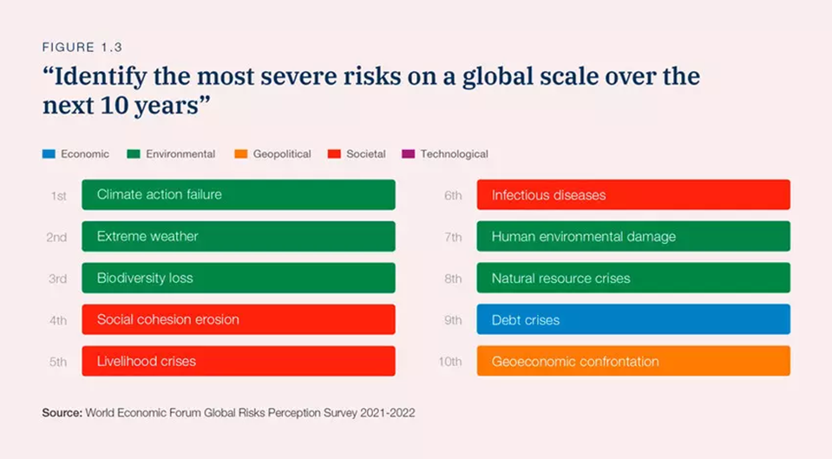

2.2 The seventeen sustainable development goals:
In 2015, the United Nations adopted objectives that consisted of seventeen goals in the hope to transition our world by 2030. The main objective for the sustainable development goals is for all countries to collaborate to achieve the aim of promoting prosperity whilst simultaneously protecting our planet (United Nations, 2015). Factors such as poverty, zero hunger, health and wellbeing, education, gender equality, clean water and sanitation, clean energy, economic growth, innovation, reduced inequality, sustainability, consumer and producer responsibilities, climate action, clean oceans, clean environments, peace and partnerships are of the utmost importance regarding the goals.
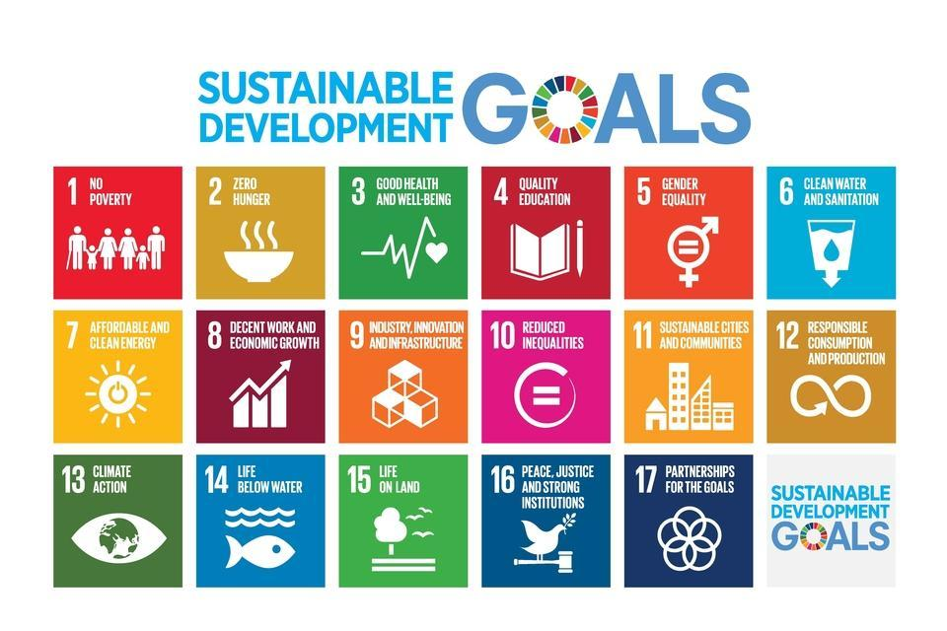

2.3 Impacts on global efforts on sustainable development:
Upon reflection of the seventeen sustainable development goals, the risk outlook for the next ten years presented within the world economic forum’s annual risk report, evidence damage to achieving the sustainable development goals within the set time horizon. Two of the ten risks that stand out more regarding causing the most damage to achieving the sustainable development goals are the climate action failure and the livelihood crisis.
Climate action failure is ranked one of the highest risks alongside extreme weather and loss of biodiversity within the annual risk report, with a divide between countries and a lack of collaboration within governments and world leaders, factors such as climate change are being pushed to one side as world leaders focus more on power and war. The tensions between countries, especially since the pandemic and war between Russia and Ukraine, are making it difficult to coordinate appropriate strategies to tackle climate action, as both countries involved in the war hold key materials to progress with the world’s renewable energy system and the pandemic has caused backward progress on tackling climate change (WEF, 2022). The COVID-19 pandemic aided a 7% decrease in annual greenhouse gas emissions compared to 2019 (Le Quere et al, 2020), as travel restrictions were put in place and factories ceased to operate, this aided the global economy to drop greenhouse gas emissions to 51% below pre-1990’s emission levels which to put plainly, was the halfway mark to meeting the United Nation’s goal of net zero emissions by 2050 (Haverford, 2021).
However, with the lockdowns putting society and the economy in an unsustainable situation, it was inevitable that these statistics would not last, with greenhouse gas emissions now at record highs and standing higher than they have been for three million years (Neuman, 2021). This global problem needs to be reconciled through collaboration of all countries, safe time horizons will not be met unless all countries work together simultaneously and view climate action as a priority. The continuation of ignorance toward climate action will ensure that number thirteen of the seventeen sustainable development goals regarding climate action will not be achieved, this will have a negative effect on some of the other goals including affordable and clean energy, sustainable cities and communities, responsible consumption and production, life below water and life on land.
The lack of action toward climate change will also negatively affect other risks mentioned in the report such as loss of biodiversity and extreme weather. However, extreme weather is an inevitability of lack of action toward climate change and with growing concerns of divide between countries and tension between world leaders, extreme weather will unfortunately be just one of the many problems that arise from climate action failure. Alongside extreme weather risks, climate action failure will cause loss of biodiversity concurrently, even though biodiversity loss was mentioned as a separate risk within the report, it comes hand in hand with lack of climate action. Biodiversity supports all life on earth, it is the food we eat, the medicines we need and the oxygen we breath, without it the earth and all life forms that reside on the planet will deteriorate (The Royal Society, 2022). There are existing regulations in place to decrease the amount of greenhouse gas emissions such as the Paris agreement (2015), which aims to reduce global warming to 1.5 degrees, however, with the occurrence of the COVID-19 pandemic, these targets are expected to be missed (WEF, 2022).
The conference of the parties is an annual event that brings together worldwide governments to discuss how to manage climate change (NHM, 2022), COP26 is the latest agreement stating that India has promised to reach a net zero emissions by 2070 and to be using renewable energy by 2050, 46 of the countries involved in the conference also pledged to use clean power by 2040, 104 countries stated they would reduce methane emissions by 30% by 2030 and 141 of the countries that took part in COP26 promised to end deforestation by 2030 (UNCCCUK, 2021). For the sustainable development goals to be achieved, countries that pledged during the COP26 conference need to do their utmost best to deliver their promise. The Kuznets curve (1950), as viewed within the appendices section of the report, demonstrates the relationship between inequalities of income per capita and economic development over time, it hypothetically demonstrates how inequality in an economy increases alongside development of the economy. It can be assumed that because of such theory, industries are allowed to continuously produce pollution to develop, such theory should be disregarded and replaced with new theories that adopt a ‘net zero emission’ approach to developing industries and have no negative effects on economic equality.

“The consequences of our failure to get to grips with the climate emergency are everywhere”
Antonio Guterres, secretary general for the United Nations (2021)

Reflecting on the livelihood crisis risk, with individual countries taking different approaches to factors such as the Covid-19 pandemic rather than taking a collaborative approach, this has caused increasing concern regarding mental health, social cohesion and livelihoods. Livelihood crisis will occur when society cannot secure the necessities of life due to factors such as social division and poverty. The livelihood crisis has a negative impact on the achievement of some of the sustainable development goals including no poverty, zero hunger, health and wellbeing, decent work and economic growth and reduced inequalities. According to the Office for Health Improvement and Disparities (2022), between June 2020 and December 2021 in England alone, there was a drastic increase in the low-life satisfaction score compared to the 2019 baseline as seen in the image below:

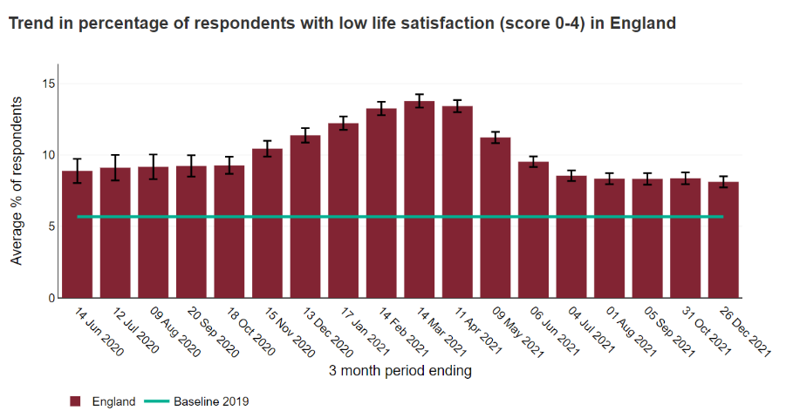
Not only is there a worrying concern for the wellbeing of society, but there are also concerns over poverty as society has transitioned into a divide of those who can afford to look after themselves and those who cannot, this greatly affects the number one sustainable development goal of achieving no poverty and has a knock-on effect on other goals such as zero hunger, gender equality, quality education and clean water and sanitation. Another factor to consider regarding the effects the COVID-19 pandemic has had on poverty, is the fact it has undone approximately 3 to 4 years’ worth of efforts previously undergone to improve extreme poverty levels, this has resulted in poor countries plunging back into extreme poverty increasing the global poverty rate from 7.8% to 9.1%, as a result 97 million individuals worldwide are living on less due to the pandemic (WEF, 2022).
During the pandemic in England, the rising wait for healthcare for those who cannot afford to go private is causing panic amongst those on a lower income and those of ethnic minority and consequently, essential treatment is being missed causing an estimate of a ten-year deduction on life expectancy between those who can afford their own healthcare and those who cannot (Propper, 2022). Statistics show that 20% of the world’s population reside in underdeveloped countries, and regarding the COVID-19 pandemic, only 6% of these numbers are vaccinated (WEF, 2015), this results in slower recovery times and an increase in deaths. This is greatly affecting the achievement of the sustainable development goals and is a main reason as to why infectious disease is a risk factor within the report.
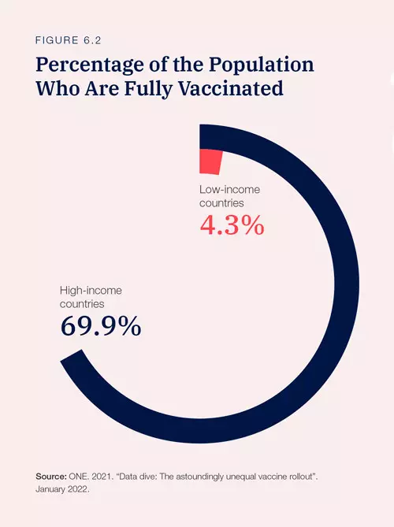

3.0 Recommendations:
Regarding climate action, COVID-19 has caused a Catch 22 situation as 2020 saw a decline in greenhouse gas emissions, and an increase by 2021 at the end of the lockdowns that has caused record highs. If the reduction of emissions that were evidenced in early 2020 remained at the same level, then we would have boosted our global efforts on reaching targets by 50%. This was never going to be the case as lockdowns are not sustainable for many reasons including economic growth, health and wellbeing. Countries that continue to rely on carbon industries will lose competitive advantage if they do not adapt to technological changes, however, if they do adapt, they will lose employment rates as millions of people work in carbon industry and will cause mass unemployment and participate toward the livelihood and debt crisis, it will cause geoeconomical tensions and economical volatility. The world needs to come together now more than ever rather than ignore collaboration, there is plain evidence that states the world will be divided over the next 10 years (Guillen, 2020), so now is the time to work together on the one asset that we all have in common, our planet.
3.1 Recommendation 1:
As the world goes mad over greed and power, the responsible countries who understand the importance of sustainable development should continue with a linear flow model to ‘hold the fort’ whilst the countries who focus inward continue to discuss matters of least importance. In the hope that countries do eventually find a common ground and put differences aside, a circular flow model could then be adopted to boost climate action. Circular flow models are used to example the relationship between circular economy principles and reverse logistics including product remanufacturing that would further improve natural resources and reusing residuals (Kneese et al, 1970). This model could be used until collaboration has further improved and a P2 pollution prevention approach is undertaken by all countries, a P2 approach focuses more on the long term and is aimed at reducing and eliminating toxic residuals, a life assessment cycle is used in a P2 approach to look at a product and how much resources are being used to analyse the environmental impacts to then select the best way forward for that product; a p2 approach uses factors such as source segregation and natural resource substitution (EPA, 2022).
3.2 Recommendation 2:
Each country may have their own resources that we do not have to share with others, but we all share the same world, and the health of the planet should be everyone’s top priority. Instead of inequality regarding development of economies, the true meaning of sharing economy should be to share one’s resources with another to balance out equality and boost the economy, every country has their own assets that another may not, to balance out the procedure we should willingly share these assets with the health of the planet in mind, not greed or power.
3.3 Recommendation 3:
The COVID-19 pandemic has caused risks to the economy but these risks were more of a short-term problem, countries have focused too much on rebuilding and repairing the short-term problems such as economic growth that they have put the long-term issue of climate change at the back of their minds, even though it is climate change which is ranked the highest risk within the annual risk report and it is this risk that will inflict the most damage on a global scale (Marchant, 2021). A recommendation to possibly create a new union of individuals for specific roles such as climate change and take away the responsibility from the government and world leaders, which will allow them to focus on the least important things such as their war. Without the intervention from politicians, the new union of individuals can instead focus on innovations to aid the source of the problems such as the global effects of loss of biodiversity and climate change.

4.0 Conclusion:
To conclude this report, it can be stated that no matter what legislation is put into place for countries to adhere to regarding amending the climate and poverty levels, the risks seem to far advanced for a full recovery to be expected. Regardless on what the politicians, world leaders and media portray as important, climate change can be overshadowed by nothing, it is of great concern to everyone across the globe that climate action is no longer a failure but a process. There will always be situations that deter society from the correct path of change, these situations include pandemics and wars, however, it is our responsibility as human beings to ensure we find the path back to responsible behaviours as swiftly as possible and not get encouraged or tempted by greed or power.

5.0 Reference list:
EPA, (2022). Pollution prevention: P2, Retrieved from: Learn About Pollution Prevention | Pollution Prevention (P2) | US EPA [Sourced on: 05/05/22]
Guillen, M. (2020). 2030: How today’s trends will collide and reshape the future of everything, Retrieved from: 2030 - Mauro Guillén (mauroguillen.com) [Sourced on: 05/05/22]
Guterres, A. (2021). Antonio Guterres secures second term as UN secretary-general, calls for new era of ‘solidarity and equality’, Retrieved from: António Guterres secures second term as UN Secretary-General, calls for new era of ‘solidarity and equality’ | | UN News [Sourced on: 03/05/22]
Haverford, (2021). Climate change in a pandemic, Retrieved from: Climate Change In a Pandemic | Haverford College [Sourced on:05/05/22]
Kagan, J. (2021). World Economic Forum (WEF): What is the WEF? Retrieved from: World Economic Forum (WEF) Definition (investopedia.com) [Sourced on: 28/04/22]
Kneese, Ayres, D’Arge, (1970). Economics and the environment: Perspective, Retrieved from: Economics and the Environment | A Materials Balance Approach | Allen (taylorfrancis.com) [Sourced on: 05/05/22]
Kuznets, S. (1950). Inequality and development: The Kuznets curve, Retrieved from: The Kuznets Curve - Development | Learn economics (learn-economics.co.uk) [Sourced on: 05/05/22]
Le Quere, C. et al. (2020). Temporary reduction in daily global CO2 emissions during the COVID-19 forced confinement, Retrieved from: Temporary reduction in daily global CO2 emissions during the COVID-19 forced confinement | Nature Climate Change [Sourced on: 03/05/22]
Marchant, N. (2021). This is how climate change could impact the global economy, Retrieved from: This is How Climate Change Could Impact The Global Economy | World Economic Forum (weforum.org) [Sourced on: 05/05/22]
Neuman, S. (2021). Greenhouse gas levels reached record highs in 2020, even with pandemic lockdowns, Retrieved from: Greenhouse gas levels hit a new high in 2020 : NPR [Sourced on:03/05/22]
NHM, (2021). COP26 explained: what it is and why it’s important for tackling climate change, Retrieved from: COP26 explained: what it is and why it's important for tackling climate change | Natural History Museum (nhm.ac.uk) [Sourced on: 03/05/22]
Propper, C. (2022). The pandemic divide: How COVID-19 has increased health inequalities, Retrieved from: The pandemic divide: how COVID-19 has increased health inequalities | Imperial College Business School [Sourced on: 03/05/22]
Schwab, K. (1938). Klaus Schwab, Retrieved from: Klaus Schwab - Wikipedia [Sourced on: 28/04/22]
The Royal Society, (2022). Why is biodiversity important? Retrieved from: Why is biodiversity important? | Royal Society [Sourced on: 03/05/22]
UNCC, (2015). The Paris agreement, Retrieved from: The Paris Agreement | UNFCCC [Sourced on: 03/05/22]
UNCCCUK, (2021). Delivering the Glasgow climate pact, Retrieved from: HOME - UN Climate Change Conference (COP26) at the SEC – Glasgow 2021 (ukcop26.org) [Sourced on: 03/05/22]
United Nations, (2015). Seventeen sustainable development goals, Retrieved from: Measuring progress towards the Sustainable Development Goals - SDG Tracker (sdg-tracker.org) [Sourced on: 03/05/22]
WEF, (2022). Annual risk report-2022, Retrieved from: Global Risks Report 2022 | World Economic Forum (weforum.org) [Sourced on: 28/04/22]
WEF, (2022). How has COVID-19 impacted world poverty? Retrieved from: Why is COVID-19 impacting poorer countries the most? | World Economic Forum (weforum.org) [Sourced on: 03/05/22]
WEF, (2022). This is how the conflict between Ukraine and Russia could impact climate change, Retrieved from: Here's why the Ukraine crisis is bad news for the climate | World Economic Forum (weforum.org) [Sourced on: 05/05/22]

6.0 Appendices:

The Kuznets curve:



