Student Name: Rhys Stroud

Student ID Number: 2114318

Programme: BEng Advanced Manufacturing Operations.

Module Code: ACMA 6007

Assignment Title: Evaluating the Effectiveness of Chosen Maintenance Strategies for Dedicated Equipment.

Submission Deadline: 07/04/2025

Contents.

1.0 – Introduction…p3.
2.0 - Critical review of current maintenance practices…p3-5.
2.1 - Thermal Insulation and Heat Retention…p3.
2.2 - Protection against Thermal and Mechanical Stress…p4.
2.3 - Cost Efficiency and Longevity…p5.
3.0 - Current approach to repairs and constraints…p5-9.
3.1 - Preparation Phase…p5-6.
3.1.1 - Shutdown of the furnace…p7.
3.2 - Set Up Phase…p7.
3.2.1 Shutter installation…p7.
3.3 Casting Phase…p8.
3.4 Curing/Drying Phase…p8
3.5 Furnace reheat…p9.
4.0 What affect does the current maintenance strategy have on the business?...p9.
5.0 – A Different Approach to Refractory Repairs…p9-11.
5.1 - A proposed usage of sprayable repairs would drastically reduce outage time, below is an example of a potential outage timeframe…p10-11
6.0 Conclusion - A Comparison on The Potential Savings…p11.
7.0 – References…p12.

1.0 - Introduction.

This report seeks to evaluate the effectiveness of the maintenance strategies implemented for the refractories of a hot mill reheat furnace sidewall panels within Tata Steel Port Talbot (=TSPT) Hot mill (=HRP). It will analyse the key factors that influence refractory performance, asses the types of maintenance strategies that are currently employed and provide an overview of the impact they have on the furnace efficiency and reliability. The findings of this study are expected to offer an insight into the optimal maintenance practices for maintaining refractory integrity, with a focus on enhancing the overall longevity of the equipment and reducing the associated maintenance costs in a highly demanding environment. Through the evaluation, the report aims to contribute valuable recommendations for improving maintenance protocols and ensuring the long-term sustainability of the reheat furnace operations.
The performance and longevity of the refractories within a hot mill reheat furnace are critical to the overall efficiency and productivity of any given steel manufacturing process. Refractory materials which line the furnace to protect it from the extreme conditions within, e.g., temperature and corrosion. Given the high level of operational demands and the severe levels of thermal condition within the reheat furnace, proper and effective maintenance strategies are a vital tool in prolonging the lifespan of the refractories, ensuring safety, and optimising the overall furnace performance.
In the context of reheat furnaces, maintenance strategies for refractories must be carefully selected and tailored to address the unique challenges that are posed by the furnace environment, including thermal cycling, mechanical stress, and chemical degradation. These strategies aim to prevent failure and to overall improve the service life of the refractories, but also to minimise the operational interruptions and maintenance costs. Consequently, a thorough evaluation of the effectiveness of the chosen maintenance strategies is essential for ensuring that the furnace operates to its full potential with minimal downtime occurring.

2.0 - Critical review of current maintenance practices.

A hot mill reheat is a critical component on the steel manufacturing process, primarily used to heat steel slabs, to the appropriate temperature for hot rolling. The heat internally within is raised to ~1250c, the heating process reduces the materials strength, increases the ductility, and allows it to be shaped or rolled into the desired product without encountering any sort of cracking or fracturing. At TSPT HRP reheat furnace a ‘walking beam’ furnace is adopted, a walking beam furnace is a type of continuous furnace that uses a series of beams to move a slab through a furnace. The beams are spaced apart, allowing the steel to move forward through the furnace in a series of steps, allowing the furnace to move over 200t of slab per hour (Mahendra, 2023). The walking beam mechanism allow the slabs to freely pass through the heating zones while preventing direct contact between the furnace floor and the steel itself, reducing wear and friction, and also promoting uniformal heating, the oscillating movement facilitates the slabs ability to evenly heat, which reduces the temperature gradients and minimises the potential risks of thermal stresses or defects in the final product. Figure 1.0 is an image of the walking beam system within a reheat furnace (Tenova, 2024).
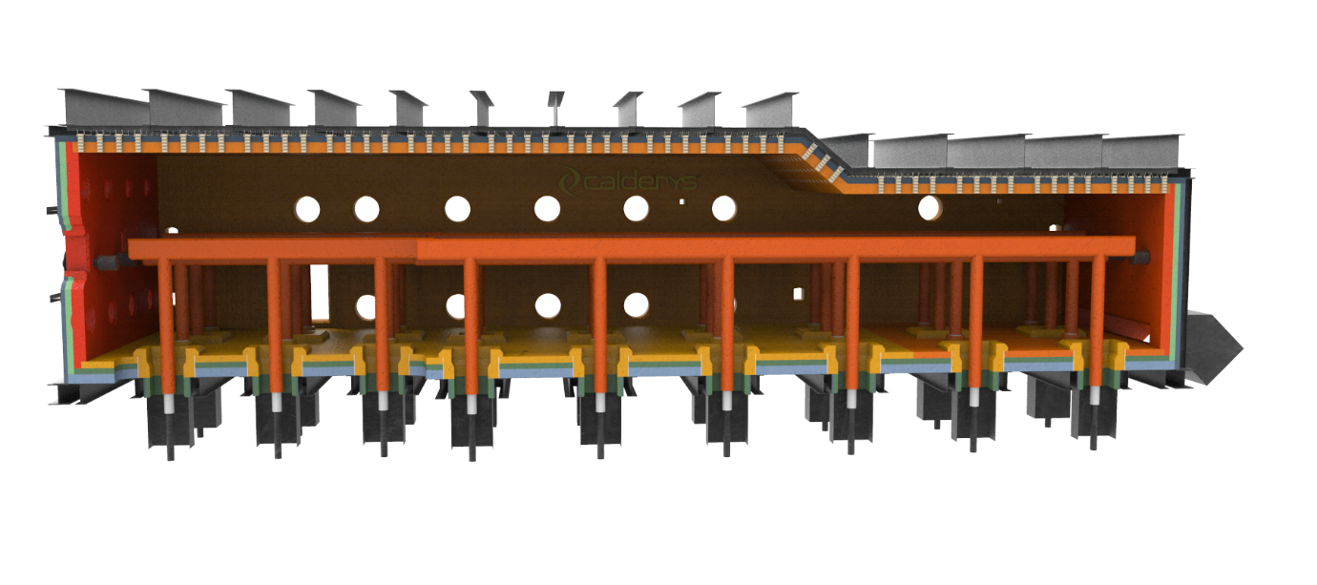
Figure 1.0 – Walking beam reheat furnace (Calderys, 2019).
To facilitate the movement, and process of slabs treatment the environment within the furnace is exposed to extreme levels of heat, so to protect the vessel itself the furnace is lined with refractories. The purpose of the given refractories within varies from insulating factors to ensuring the overall integrity of the structure, listed in the following are the main principles and characteristics required from those refractories –

2.1 - Thermal Insulation and Heat Retention.

One of the primary functions of a hot mill reheat furnace is to provide an effective thermal insulating barrier. Refractories by nature are created to withstand the extremely high temperatures which are essential for the high operating temperatures seen within the furnace itself. With the current climate the overall efficiency in the chosen materials ability to retain as much heat as possible is a key factor in minimising the energy consumption required to operate the system.

2.2 - Protection against Thermal and Mechanical Stress.

Refractories are also used to protect the integrity and overall structure of the furnace from the thermal and mechanical stresses that occur during the operations. The reheat furnace undergoes significant fluctuations in heat, which in term create thermal gradients. The refractories position within is to absorb these and distribute the stresses, to prevent the formation of cracks and other forms of damage that has the ability to compromise the overall integrity of the furnace.

2.3 - Cost Efficiency and Longevity.

Refractories are designed not only for the performance, but also their longevity, which is a crucial factor in the reduction of maintenance costs and downtime. High-quality refractories can significantly extend the life of a furnace, minimising the need for frequent repairs or replacements occurring. With the current climate within TSPT UK these are key, essential factors at play, and any way to promote the efficiency/effectiveness of a chosen repair strategy is highly sought after.

3.0 - Current approach to repairs and constraints.

TSPT HRP adopt a corrective maintenance strategy when completing repairs to the reheat furnace. The corrective maintenance that’s adopted cover the maintenance tasks that are undertaken to identify, isolate and repair a fault within in order to restore the equipment back to its operational intended functionality (TWI, 2023). Current approach to the repair/maintenance of the hot mill reheat furnace side walls is through casting refractory materials in situ. Casting the sidewall panels provide a protective lining, a critical part for ensuring the furnace operates at peak performance. The sidewalls of a reheat furnace are required to be lined with several layers of refractories. Toward the shell insulating refractories of the needed qualities and in required thicknesses (See figure 2.0 for an example of this) are to be used to ensure the furnace shell and temperature does not higher than the ambient temperature of the area (Endra, 2013). The casting process involves several critical stages, each of which must be carefully controlled to ensure that the quality and performance of the product is to the correct standard.
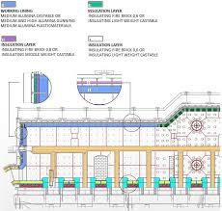
Figure 2.0 – Illustration of refractory lining within a reheat furnace (Tatic, 2020).
Reheating furnaces are traditionally lined with dense castable materials, as such, these dense refractory materials do not fare well with being exposed to intense and continuous flame impingement and thermal cycling (Endra, 2013). Routine processes like a sudden ramp up in internal temperature, ramp down in temperature and the opening/closing of the furnaces doors to charge/remove material can cause severe thermal shock and in turn damage the refractory lining. Once damaged, these dense refractory materials can and will quickly lose their core strength and encounter spalling and other degradation factors. (Endra, 2013) The hard-repair, or recasting of the material is a cumbersome, time consuming, labour intensive, and expensive job. The reheat furnace would be required to be taken out of service for an extended period of time, realistically a number of days for the refractory to cool, the repairs to be made and the specified dry-out schedule to complete. This is then followed by a time-consuming slow ramp up of the operating temperature. This requires a lot of energy, energy that is absorbed by the internal refractories.
The current approach to conducting such repairs at TSPT is set out as the following breakdown –

3.1 - Preparation Phase

Initial assessments: Using the thermography system that’s in place the deteriorating areas are monitored using thermocouples figure 3.0 is an example of the thermocouples positions within the furnace itself, in essence it’s all about identifying the problem.
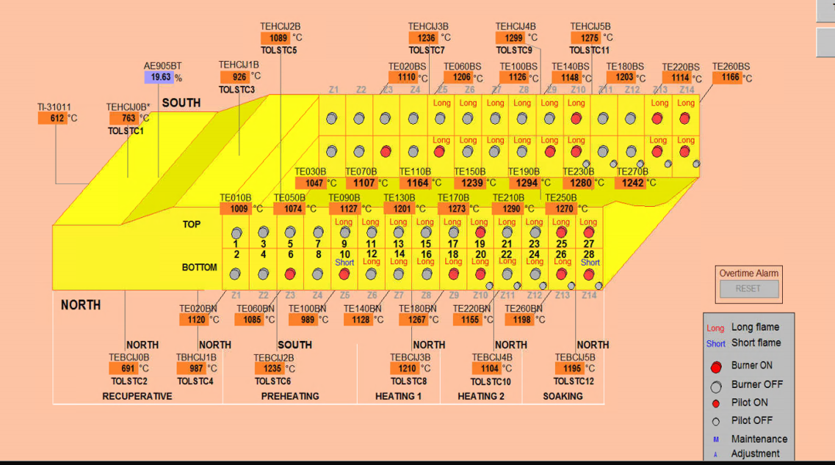
Figure 3.0 – Thermocouple position within the reheat furnace.

3.1.1 - Shutdown of the furnace

Furnace cooling, the furnace requires the temperatures to drop to a manageable, workable environment, while also ensuring that the surrounding refractories do not encounter and suffer from thermal shock. The time estimate is 12-48 hours of cooling, depending on the internal temperature.

3.2 - Set Up Phase.

3.2.1 Shutter installation

Temporary forms (shuttering) are installed within the furnace to create the desired shape and contour of the furnace sidewall panel. Currently this approach is taken through the use of wooden shuttering, created to right dimensions. The alignment of this is crucial to ensure proportionate wear is observed throughout the internal refractories, while also maintaining a correct seal is achieved to prevent any unwanted leakage occurring. Figure 4.0 is an image of the shuttering that’s used to cast the sidewalls currently. This process can take up to 8 hours when the setup of the shuttering, reinforcement placement, and aligning the formwork is completed.
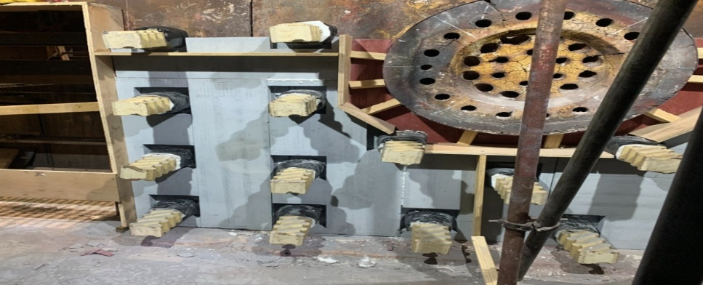
Figure 4.0 – Shuttering used to recast sidewall panel.

3.3 Casting Phase

The material is mixed using a heavy-duty mixer. When mixed to the required consistency the material is then poured into the void within the shuttering, filling the sidewall recasting the panel back to the desired outlay. In order to promote adequate consolidation and eliminate any trapped air, the material undergoes a vibration. The vibration is a critical step in this process, its use is to achieve an even distribution of the material within the formwork. Once the casting is complete, the panels surface finish is to be smoothed to achieve a consistent finish, ensuring that there are no voids in which the process conditions can further worsen and deteriorate. Depending on the complexity, size and material required the casting process can take from 6-12 hours.

3.4 Curing/Drying Phase

Once the refractory material has been cast it requires an initial curing phase to guarantee proper hardening before the dry out can commence. Once the curing is in a position in which the drying can commence the reheat furnace can begin to startup, the system is to be regulated, and temperature is to be raised slowly over an extended period to ensure the repair is adequately dried. Temperatures start off around 100-200c, these gradually rise to over 600c to eliminate the moisture from refractory material while avoiding thermal shock. The drying of the newly cast refractory material is the longest phase, depending on the amount of material cast this process can take anywhere from 48–96 hours.

3.5 Furnace reheat.

After the sidewall panel is dry, the furnace needs to be reheated gradually to its operational temperature. This gradual reheating process usually takes between 12 and 24 hours to avoid thermal shock.
In total the current approach to maintenance, in a worst-case scenario can take up to 188 hours.

4.0 What affect does the current maintenance strategy have on the business?

Currently TSPT reheat furnace averages 54 slabs of steel per day, the average cost per coil is $930/t, average weight of a singular coil being ~20t.
$$Average price per coil-\$930 ×20 \left(Ave. weight\right)=\$18,600$$
$$Total hours÷24 \left(24hr working\right)-188÷24=7.83days$$
$$Total Ave. outage (Days)×Ave. coils per day- 7.83×54=422 coils$$
$$Number of coils×Ave. cost per coil- 422×18600=\$7,862,452$$
On an average refractory outage, maintaining the current repair strategy the TSPT has the potential lose up to $7.8m in unprocessed coils. Without factoring in the refractory material, labour, and energy required.

5.0 – A Different Approach to Refractory Repairs

The principles would remain the same, thermography, monitoring and furnace process conditions. However, the approach to the repair would differ, using a more lean, cost-effective solution. The improved basis of refractory monolithic (Spray) material, has enabled the system to be widely used throughout iron and steel industries throughout the world. The benefits of using a sprayable material are/would be extremely beneficial to the business as a whole where possible.
Sprayable refractory material enables a significantly faster process compared to casting. It involves using a spray gun (See figure 5.0 for an example of this setup) to apply a layer of material onto whatever existing surface remains without needing to apply any sort of moulds/shuttering beforehand. Also, sprayable refractory material contains less active water within, meaning the material has the ability to cure a lot faster allowing for the furnace to restart operations a lot faster.
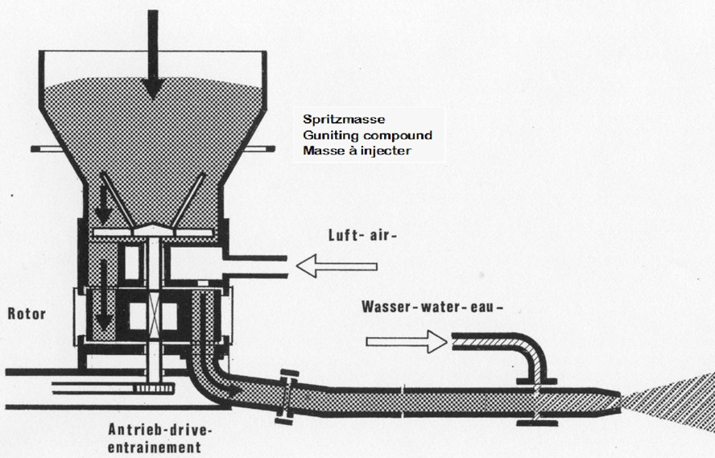
Figure 5.0 – Spray gun in operation.
However, the only downside at present is the unknown lifespan of the material in situ. Currently the castable material sidewalls have the potential to serve up to 5 years of service before being required to be recast.

5.1 - A proposed usage of sprayable repairs would drastically reduce outage time, below is an example of a potential outage timeframe –

Furnace cooling, this remains all the same, the furnace requires the temperatures to drop to a manageable, workable environment, again while also ensuring that the surrounding refractories do not encounter and suffer from thermal shock. The time estimate is 12-48 hours of cooling.
Refractory spray application, the spray process itself depending on the size and complexity of the area might take installers up to 5 hours to complete.
Curing, again, depending on the size/complexity this can take a period of up to 12 hours.
After the sidewall panel is dry, the furnace needs to be reheated gradually to its operational temperature. Because the internal temperatures wouldn’t have dropped as drastically as the current maintenance outages the furnace would only require between 12-16 hours of reheat period.
Using the figures above the furnace, implementing the above strategy to complete repairs an outage would take ~81 hours. This is a drastic reduction on the current approach and has the potential to save the business a considerable fortune. Again, using the previously used data to compare –
$$Average price per coil-\$930 ×20 \left(Ave. weight\right)=\$18,600$$
$$Total hours÷24 \left(24hr working\right)-81÷24=3.3days$$
$$Total Ave. outage (Days)×Ave. coils per day- 3.3×54=178coils$$
$$Number of coils×Ave. cost per coil- 178×18600=\$3,310,800$$
Completing a repair like still has the potential to cause massive disruption to the business, however implementing the repair strategy does drastically reduce the expected losses.
6.0 Conclusion - A Comparison on The Potential Savings.
Using the data available to the TSPT HRP team there is an average of 6 repairs per year. With the monetary values previously determined it is a fair assumption that the business has the potential to be affected in the region of $47mPA using the current approach. With the ability to implement a different strategy, as previously stated, a ‘sprayable’ material this is considerably reduced to $19mPA.

These figures are just the potential profits associated with the reduction in downtime, below tables are the current material vs proposed when completing the associated repairs –
Table 1 - Current Cost for 1 X panels
26GRD Insulation | Quote | Calderys | 1 | £ 11,550.00
AF470 | Quote | Calderys | 1 | £ 33,000.00
Fixings | Quote | Calderys | 1 | £ 16,684.00
Anchors | Quote | Calderys | 1 | £ 9,950.00
insulation Board | Quote | Calderys | 1 | £ 9,427.75
Labour | Quote | Mono | 1 | £ 41,301.77
Install materials | Quote | Mono | 1 | £ 3,210.00
 |  |  | Total | £125,123.52

Table 2 - Cost for 1X new sprayable materials
X70 | Quote | Calderys | 1 | £ 33,900.00
Fixings | Quote | Calderys | 1 | £ 16,684.00
Sidewall materials | Quote | Calderys | 1 | £ 22,532.00
Anchors | Quote | Calderys | 1 | £ 9,950.00
insulation Board | Quote | Calderys | 1 | £ 22,532.00
Install materials | Quote | Mono | 1 | £ 2,948.00
Labour | Quote | Mono | 1 | 22.015.77
 |  |  | Total | £ 108,546.00

In the material alone there is a saving of £102k/PA over 6 repairs by opting to use the sprayable material.
Using the data available to TSPT HRP there is a potential to reduce the impact that refractory repairs have on the business in the monetary region of ~$28mPA. With the current climate of the business anyway in which to save money is of the forefront, and as such a key necessity to the long-term sustainability of the business.

7.0 - References

TWI (2023). What is Corrective Maintenance? (Definition, Pros, Cons and Examples). [online] www.twi-global.com. Available at: https://www.twi-global.com/technical-knowledge/faqs/what-is-corrective-maintenance.
Mahendra, P. (2023). Reheating Furnaces | Types of Reheating Furnaces - Encon. [online] Encon Thermal Engineers. Available at: https://encon.co.in/reheating-furnaces/.
Tenova (2024). Walking Beam Furnace for Slabs | Tenova. [online] tenova.com. Available at: https://tenova.com/technologies/walking-beam-furnace-slabs.
Endra, S. (2013). Reheating Furnaces and their Types – IspatGuru. [online] IspatGuru. Available at: https://www.ispatguru.com/reheating-furnaces-in-steel-plants/.
Li, L. (2024). Choosing the right refractory materials is crucial for the efficient and safe operation of various furnace types. Refractories play a vital role in maintaining thermal insulation, withstanding high temperatures, and resisting chemical and mechanical stresses. [online] Linkedin.com. Available at: https://www.linkedin.com/pulse/how-select-refractory-materials-specific-furnace-types-lydia-li-p6kwc.
Calderys (2019). Walking Beam Furnace. [online] Calderys. Available at: https://calderys.com/iron-steel/reheat-furnace/walking-beam-furnace [Accessed 6 Apr. 2025].
Tatic, M. (2020). Advances in Thermal Processes and Energy Transformation Refractory Materials for a Reheating Furnaces and their Development in Present Time. [online] Available at: http://ww2.atpetjournal.com/papers/Vol3Nb4/ATPET-Tatic.pdf [Accessed 6 Apr. 2025].
Velco (2022). Rotor gunning machines - Velco.de. [online] Velco.de. Available at: https://www.velco.de/en/rotorgunningmachine/ [Accessed 6 Apr. 2025].

