CSR
A debate for and against voluntary CSR

Module
Globally Responsible Business.

BMSP6001

Executive Summary

Even though CSR reporting is not currently compulsory in many countries, including the U.K., businesses are growing aware of societal pressure to report on aspects other than profits. China, France, India, Indonesia, Mauritius, and South Africa are among the nations that have enacted CSR mandatory legislation, and the EU Corporate Sustainability Reporting Directive (CSRD) is scheduled to take effect on January 1st, 2024, the following two chapters will draw upon the benefits and limitations for both voluntary and mandatory CSR (Mersham & Skinner, 2016, pp. 110-129; McWilliams et al., 2019; Brunelli & Di Carlo, 2020; Delalieux & Moquet, 2020, pp. 125-143; Inekwe et al., 2021, pp. 226-242; Zhao, 2021, pp. 897-919; Panwar et al., 2022; Primec & Belak, 2022; Ramdhony et al., 2022, pp. 816-832).

The B Corp and conscious capitalism are two movements helping businesses gain the fundamental tools they need to establish ethical and sustainable business practice (Strong & Mackey, 2009; Marquis, 2020, p.9). Gatti et al., (2019, pp. 961-972) note how businesses adopting voluntary and strategic CSR initiatives, as opposed to coercive or non-strategic ones, create the most long-lasting value for both the organisation and wider societal stakeholders.

Contents
Title 1
Executive Summary 1
Contents 2
Introduction 3
Business purpose 4
Business ethics 5
Important environmental and societal factors 6
CSR 6
Position for Voluntary Reporting 7
People 8
Ethics 9
Employee satisfaction 9
Education 10
Planet 11
Ecological 12
Supply chain & Procurement 13
Prosperity 14
Philanthropy 15
Economic 15
Position against voluntary Reporting 15
People 16
Ethics 17
Consumers 18
Planet 19
Enviromental 20
Prosperity 20
Health 21
Discussion 21
Conclusion 22
References 23

Introduction

This paper will create debate about John Mackey’s notion that corporate social responsibility should be voluntary. An understanding of business, ethics and CSR will be presented, as well as arguments for and against, drawing upon key theorists, paradigms and contemporary business practices to form perspectives on both sides of the discussion and drawing a conclusion from the findings.

Business purpose

“The Social Responsibility of Business Is to Increase Its Profits,”

Friedman’s (1962; 1970; 2007, pp. 173-178) theoretical standpoint is that a business's goal should be to maximise returns for its shareholders, because only people can have social responsibilities, meaning that businesses only have obligations to their shareholders and not to society at large.

Freeman et al., (2007, pp. 303-314; 2017, pp. 7-15), and Freeman (2018, pp. 9-16) challenge these traditional conceptions that are founded on the notion that business is driven by competitive mindsets, leaving little room for ethical judgement and prioritising value capture over value creation at the expense of stakeholders, thus dehumanising people. Cunningham et al., (2014), Rey et al., (2019) and Wallace (2020, pp. 53-57) note businesses, whilst profit driven; should create value for others and serve a higher purpose. This higher purpose is its ‘vision’ which is more than just profit, driven by conscious leadership, creating conscious cultures, and considering all stakeholders (Mackey & Sisodia, 2014; Hudson, 2020). Sheth (2020, pp. 261-264) supports this view discussing the importance of business to nurture all its stakeholders.

Business ethics

Business ethics are morals, values, and standards holding businesses accountable (Ferrell et al., 2019, pp. 491-501; Ferrell & Fraedrich, 2021, pp. 4-6). Kim et al., (2019); Wasieleski & Weber (2019, p. 89) note businesses have ethical accountability and should act more responsibly on a societal level. DeTienne et al., (2021, pp. 492-448) view unethical business behaviour as knowing what is morally correct without action to mitigate.

Important environmental and societal factors

The 2007–2009 global economic crisis exposed unethical business practices, social problems, and ecological degradation, highlighting the necessity for businesses to address these issues using deontological and technical approaches (Darwish & Abdeldayem, 2019, pp. 489-504; Ofurum & Gabriel, 2019, pp. 7-18; Butt et al., 2022). Sustainable strategies should add long-term value and consider all stakeholders, including shareholders and the environment (Henisz et al., 2019; Alsayegh et al., 2020, p. 3910). This theoretical concept is frequently referred to as "the stakeholder paradigm," (Schaltegger et al., 2019, pp. 191-212; Freudenreich et al., 2020, pp. 3-18; Freeman et al., 2021, pp.1757-1770.

CSR

The concept of corporate social responsibility (CSR) is a business model enabling organisations to be socially responsible to shareholders and stakeholders, considering their impact on economic, social, and environmental domains. Other theories on CSR include; "the Carroll Theory," imposing a four-part pyramid of CSR elements ranked in importance, and "the triple bottom line theory," commonly known as the three "P's," (Fig 1.) people, planet, and prosperity (Brin & Nehme, 2019; Wagner-Tsukamoto, 2019, pp. 469-491; Farooq et al., 2021, pp. 969-979; Shim et al., 2021, pp. 4421-4435; Cheng, 2022).

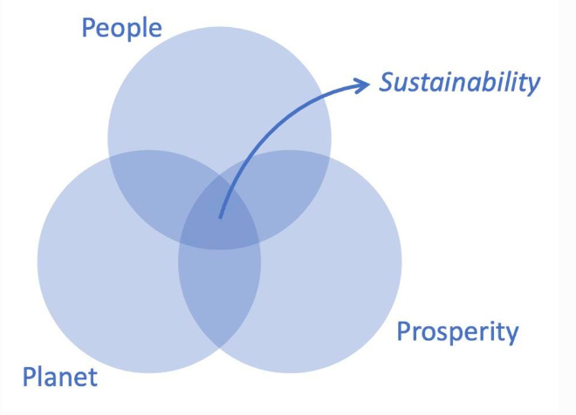
Fig 1. A diagram which displays the modern take of the 3p’s (Kraaijenbrink, 2019)

Position for Voluntary Reporting

‘Business social responsibility should not be coerced; it is a voluntary decision that the entrepreneurial leadership of every company must make on its own.’

John Mackey, Whole Foods Market CEO

According to Mackey & Sisodia (2014) long-term competitiveness requires adoption of a stakeholder attitude that will serve a greater purpose. These principles cannot be imposed but can instead be encouraged by internal corporate values that drive innovation and generate value. Freudenreich et al., (2020, pp. 3-18) support this notion, noting that sustainable business is created through value exchange between organisations and stakeholders.

People

Ethics
Schwab (2021) postulates sustainable business puts people and the planet first, with competitive advantage growing out of united beliefs and practices within organisations. One example is the recent decision by the Football Association of Wales (FAW), to address the gender pay gap, driven by conscious leadership and culture. Taylor (2023) acknowledged that the FAW decision was significant and inspirational to future generations, noting how equality is essential for sustained growth, concluding FAW truly embraces the Well-being of Future Generations Act (Jones, 2019, pp. 7-23).

Value produced by following normative business ethics must originate internally to be credible and encourage integrity amongst employees, earning the confidence of important stakeholders, such as investors, employees and consumers (Weissbrodt & Kruger, 2017, pp. 199-220; Wettstein et al., 2019, pp. 54-65; De Bakker et al., 2019, pp. 243-383) Lips-Wiersma (2019) states how opportunities are produced through fulfilling employment within ethically inclusive and constructive cultures, encouraging accountability, and enhancing teamwork capabilities.

Employee satisfaction

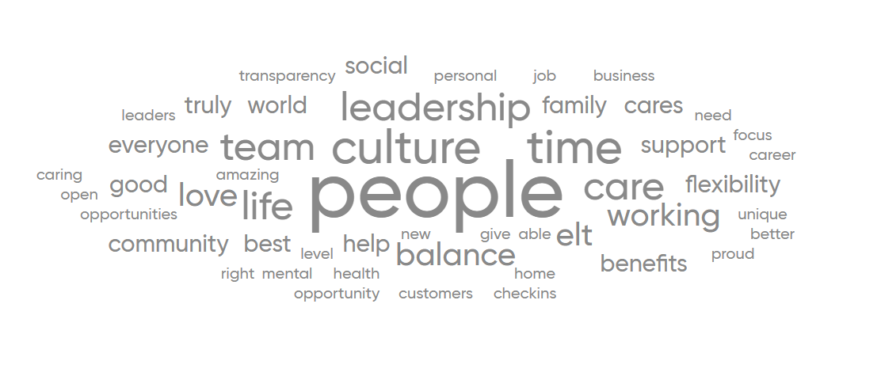Fig 2. Image which displays employees' views of working at CISCO (Great place to work, 2023)

CISCO, ‘the best place to work in 2022’, applies voluntary CSR through core values to ‘provide an inclusive future for all through the power of technology’, enhancing workplace culture. Fig 2, shows the opinions of CISCO employees who, according to recent surveys, feel valued, have a strong sense of community, and are given opportunities for training and development (Kear, 2019). Value created through voluntary CSR practices enhances diversity, social relationships, work-life balance, employee well-being, and employment stability, thus improving employee engagement and retention (Lee, 2021, pp. 348-367; Macassa et al., 2021, pp. 866-883).

Education
Kim & Kim (2019, pp. 17-27) review of CISCO’s voluntary CSR found their community-led education not only benefited global communities, but also increased profits and lowered overheads. The Eden Project, a social enterprise and charity led with conscious leadership, aims to enhance the connection between people and nature, redistributing profits to fund their charities sustainability education initiatives (Upton, 2020, pp. 1-24; Affolderback, 2022, pp. 43-60).

Planet

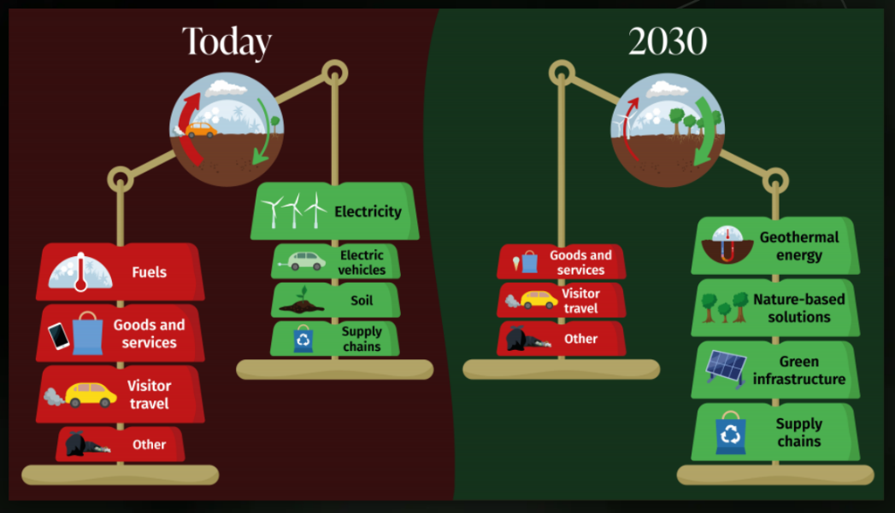
Fig 3 Graphical display of The Eden Project’s journey beyond net zero (Eden Project, 2023)

Ecological
For The Eden Project, CSR is more than simply a checkbox, the organisation is pushing the boundaries seeking to go beyond net zero by 2030, (Fig 3), investing in sustainable geothermal energy promoting grid decarbonisation and supporting the transition to clean energy (Abesser et al., 2020; Van Vuuren, 2020, pp. 50-65). Another company attempting to balance its use of resources is Starbucks, which does so by storing more carbon than it emits, cutting waste, and producing more freshwater than it uses in the process of producing green coffee (Budidharmanto, 2021, pp. 273-279). Atzori et al, (2018, pp. 1-21) and Tsai et al., (2020) note how repeat business and higher profitability result from companies' voluntary adoption of ethical green practices.

Voluntary CSR extends into the human resources domain, with many organisations encouraging recycling, cycle to work schemes and providing green transportation, such as Google and CISCO (Farooq et al., 2021; Sabokro et al., 2021; Jerónimo et al., 2020, pp. 413-421; Thompson, 2022; Calhoun, 2022). Additionally, Hong et al., (2020, pp. 302-322) observed a fall in green innovation after mandatory CSR implementation. The authors note that larger organisations can innovate with CSR due to higher equity and ability to spread costs, whereas small and medium-sized enterprises may not.

Supply chain & Procurement
Businesses are realising sustainable long-term benefits of adopting voluntary CSR, adapting strategies to include sourcing local produce, shortening supply chains, reducing carbon footprints, and providing local employment opportunities (Mangla et al., 2020, p. 162). The Eden Project uses locally produced foods and goods made from recycled or recyclable materials, implementing green procurement actively encourages organisations within the supply chain to advance their sustainability practices (Dey & Saha, 2018, pp. 388-402; Liu et al., 2020; Sönnichsen & Clement, 2020). Other businesses, such as Ikea, are committed to long-term positive change, investing heavily in innovation throughout their social, economic, and environmental activities imbedding CSR from top down, enhancing their attractiveness to consumers and competitors (Bányai & Kaczmar, 2021; Catalan, 2022; Goya, 2022).

Prosperity

Philanthropy
García-Jurado et al., (2021) reveals how organisations are donating a percentage of profits to worthy causes and education, generating societal change, however, raise concerns that mandatory CSR may have consequences to innovation and creativity. Mukherjee et al., (2018, pp. 254-265) conclude that the mandatory legislation has led to large corporations donating less revenue to charitable groups overall, while SME’s who had previously supported charitable causes ceased once they were no longer required to do so. Lips-Wiersma (2019) and Saz-Gil et al., (2020) note how voluntary integration of CSR throughout an organisation promotes the welfare of all stakeholders and drives innovation in sustainability practice, integrating businesses with the environment they operate in.

Economic
Mandatory CSR in India increased company expenditure, regulatory pressure to invest in CSR impacted business diversity resulting in a fall of competitive advantage (Nair & Bhattacharyya, 2019, pp. 106-116). Chen et al., (2018, pp. 169-190) also observed businesses experiencing decreased profits and increased operating costs due to mandatory CSR. Jiang et al., (2022) reveal how mandatory CSR imposed within Chinese companies reduced the amount of donations and increased corporate tax avoidance, highlighting possible multi-level implications of enforced CSR.

Position against voluntary Reporting

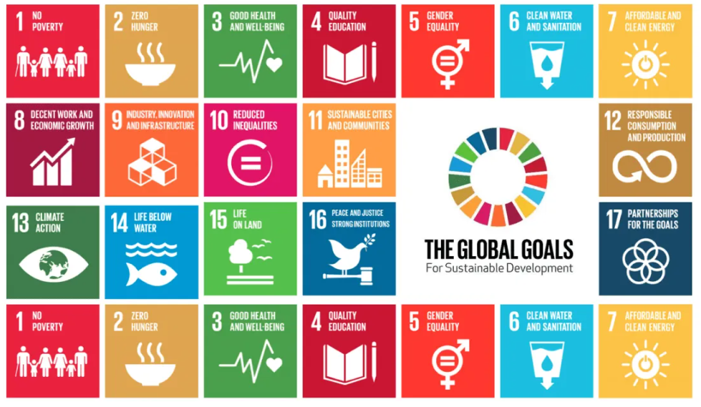
Fig 4. Sustainable Development Goals (United Nations, 2023)

The Paris Climate Agreement (PCA) and the 17 Sustainable Development Goals (SDGs) marked a turning point for the business world (Agreement, 2015; Satgar & Satgar, 2018; Sachs & Sachs, 2021, pp. 22-27). Unfortunately, some companies still operate profit focussed businesses, resulting in harm to people, our planet and prosperity.

People

Ethics
On the 23rd April 2013, two years before PCA & SDGs, the Rana Plaza building, a clothing factory driven by profit and unethical decision-making, collapsed, killing 1,134 people and leaving hundreds injured (Fig 5). Experts concluded the collapse was entirely preventable, the murder trial commenced some five years later (Koenig & Poncet, 2022).

Fig 5. A photograph of the aftermath of Rana Plaza building collapse (Ferdous & Hossain, 2020)

Despite the aftermath of Rana Plaza in 2013 other preventable accidents continue to occur. In 2015 a Pakistani factory collapsed killing 45 people (Boateng & Wright, 2019, pp. 48-61), 39 people perished in a fire at a cigarette packing factory due to poor safety measures in 2016 (Zami & Banerji, 2022). In Chittagong, a tank explosion released toxic and corrosive ammonia, which travelled several kilometres affecting 250 people (Shill et al., 2021). At a rubber factory in Sri Lanka, a worker fell into a tank of ammonia and died along with four other people who attempted to save him (Meegahapola & Prabodanie, 2018, pp. 74-84). In addition to the inadequate workplace safety, particularly in developing countries, cases of child exploitation and modern slavery are still being reported. Many workers are not granted paid time off or access to healthcare, are paid less than the legal minimum wage, and are required to work long hours in dangerous conditions (Boadu et al, 2020).

Consumers
Even though many countries have adopted marketing standards legislation, some businesses continue to engage in deceptive or unethical practices. Nestlé's marketing practises have come under much scrutiny due to unethical advertising claiming that infant formula would result in stronger, healthier babies than breast milk (Singh & Alazmi, 2019, pp. 80-85; Takahashi, 2021). Advertising within developing nations and overpricing in addition to limited supply of safe drinking water, caused malnutrition and disease. Despite decades-long legal battles, Nestle continues to advertise in underdeveloped countries with high rates of acute malnutrition (Jones et al., 2022, pp. 416-430; Newman, 2022).

With the rise in consumer awareness, greenwashing to deceive public into purchasing ‘ethical’ products has become a profitable behaviour by some organisations (Santos et al., 2023). These corporate hypocrisy between ethical sustainable views, could be addressed with a purpose driven CSR (Ioannou et al., (2022, pp. 1-15; Kurpierz & Smith ,2020, pp. 1075-1093). Bakerjian (2022, pp. 98-108) concludes by stating how CSR may guard against public deception. Gatti et al., (2019, pp. 1-15) suggest that a combination of voluntary and mandated elements could be used to combat greenwashing more effectively.

Planet

Enviromental
The absence of industry practices and government control led to the worst environmental disaster in history when a British Petroleum (BP) oil well exploded, killing 11 people and injuring dozens more, and causing catastrophic environmental impacts still present in the environment over a decade later (Harrison, 2020, pp. 333-350). BP has recently reported record profit, even though the energy crisis is still having an impact on many nations, BP prioritise shareholder value over stakeholder value (Milman, 2023).

There are numerous other businesses causing alarming environmental concerns; plastic produced by major drinks companies (Laville & Taylor, 2017; Mukheed et al., 2020, pp. 251-258), the ethics behind fast-fashion advertisement of ethical materials to attract ethical consumers but still have questionable practices in the countries their clothes are produced (Niinimäki et al., 2020, pp. 189-200; Bailey et al., 2022), industries causing water pollution and draining vital water resources (Hoque et al., 2018; Shill et al., 2021), fertilizer production (An et al., 2021; Das et al., 2022). There is urgent need to reduce environmental poor practises and urge companies to consider a circular economy (Tevapitak & Helmsing, 2019, pp. 840-848; Meginnis et al., 2022).

Prosperity

Health
Voluntary CSR allows companies to establish minimal standards for social performance. The tobacco, gambling, alcohol, unhealthy food and beverage, and other socially destructive industries (such as oil, gas and chemical) can pass hidden costs onto society and customers whilst appearing to achieve corporate goals, mandated CSR could seek to enforce transparency and minimum standards, protecting the consumer from inherited costs (Geiger & Cuzzocrea; 2017, pp. 254-272). A prime example of consumer deception is the historic advertising campaigns run by tobacco companies, after lengthy battles to prove the risks associated with smoking these products were restricted in advertising 1990 and finally in placement in shops 2015 (Flor et al., 2021, pp. 239-243). On a similar note, the growth of vape technology and its attractiveness to ex-smokers and even non-smokers are concerning as it has become stylish without any serious long-term indication of its safety (Maloney & Cappella, 2016, pp. 129-138; Tokle, 2020; Hall et al., 2021, pp.985-993; Kostygina et al., 2022, pp. 655-658).

Chowdhury et al., (2021) state, a sustainable future and better economic, social, and environmental conditions can be created through organisations pursuing responsible leadership by adopting more than just CSR and turning to Global Reporting Initiative (GRI), which reports on the health impacts of stakeholders. Sinkovics et al., (2016, pp. 617-649) found that multinational companies' existing CSR initiatives show a lack of knowledge of poverty and a failure to effectively support workers in developing nations. Nair et al., (2021) proposes a combined approach of mandatory CSR and government control could improve sustainability in line with the SDG’s. Mandatory CSR and government controls are needed, especially to protect the growth of developing countries (Khan et al., 2020; Sardana et al., 2020, p.258; Zou et al., 2021).

Discussion

Adopting a stakeholder mindset that will serve a wider purpose and provide value exchange for stakeholders is necessary for long-term corporate competitiveness. These values should originate from internal business values that encourage innovation and value creation. Sadly, even the best businesses that adhere to these values are powerless to completely eradicate harmful effects on our environment and society alone. Because of this, CSR should be made mandatory and advocate for a collaborative strategy between governments and business. However, businesses should be encouraged and rewarded to promote sustainable innovation, but they should also be able to evolve spontaneously and independently in reaction to external stimuli.

Without a concerted effort and pressure from all stakeholders, we won't be able to reduce emissions by 45% to meet the PCA aim of keeping global warming to no more than 1.5°C. Meanwhile, egotistical businesses with a singular focus on their bottom-line will continue to have catastrophic effects on our environment, endanger people's lives and exacerbate poverty. It has been eight years since PCA and SDGs were established, we cannot afford to wait another eight years for businesses to act responsibly.

Conclusion

The paper has presented arguments for and against voluntary CSR to create an understanding of its use in a broader sense, which encompasses three dimensions of people, planet, and prosperity. The paper drew upon key theorists, paradigms and contemporary business practices to form views on both sides of the debate. Despite many businesses imposing CSR and sustainability within their companies, which drive innovation and create value, we have a duty to protect our world, our people and create a prosperous inclusive world for all. We cannot ignore companies which operate within shareholder supremacy solely for profits at the expense of stakeholders and who in addition to causing harm to people, planet and prosperity threaten the credibility of business. For the PCA and SDGs to be achieved, there is an urgent need for a mandatory business-driven CSR that is jointly led by the government, we simply cannot risk more harm to occur.

References

Abesser, C., Busby, J. P., Pharaoh, T. C., Bloodworth, A. J., & Ward, R. S. (2020). Unlocking the potential of geothermal energy in the UK.

Affolderbach, J. (2022). Translating green economy concepts into practice: ideas pitches as learning tools for sustainability education. Journal of Geography in Higher Education, 46(1), 43-60.

Agreement, P. (2015, December). Paris agreement. In Report of the Conference of the Parties to the United Nations Framework Convention on Climate Change (21st Session, 2015: Paris). Retrived December (Vol. 4, p. 2017). HeinOnline.

Alsayegh, Abdul Rahman, R., & Homayoun, S. (2020). Corporate Economic, Environmental, and Social Sustainability Performance Transformation through ESG Disclosure. Sustainability (Basel, Switzerland), 12(9), 3910–. https://doi.org/10.3390/su12093910.

An, X., Wu, Z., Shi, W., Qi, H., Zhang, L., Xu, X., & Yu, B. (2021). Biochar for simultaneously enhancing the slow-release performance of fertilizers and minimizing the pollution of pesticides. Journal of Hazardous Materials, 407, 124865.

Atzori, R., Shapoval, V., & Murphy, K. S. (2018). Measuring Generation Y consumers’ perceptions of green practices at Starbucks: An IPA analysis. Journal of foodservice business research, 21(1), 1-21.

Bailey, K., Basu, A., & Sharma, S. (2022). The Environmental Impacts of Fast Fashion on Water Quality: A Systematic Review. Water, 14(7), 1073.

Bakerjian, L. (2022). The aesthetic nature of corporate social responsibility and greenwashing. Oradea Journal of Business and Economics, 7(1), 98-108.

Bányai, & Kaczmar, I. (2021). Green supply chain : competitiveness and sustainability (Bányai & I. Kaczmar, Eds.). IntechOpen.

Boadu, E. F., Wang, C. C., & Sunindijo, R. Y. (2020). Characteristics of the construction industry in developing countries and its implications for health and safety: an exploratory study in Ghana. International journal of environmental research and public health, 17(11), 4110.

Boateng, G. F., & Wright, R. (2019). A conceptual inquiry into building collapse in cities in developing countries. In Proceedings of the 43rd Australasian University Building Educators Association Conference (AUBEA 2019) (pp. 48-61). Central Queensland University.

Brin, P. V., & Nehme, M. N. (2019). Corporate social responsibility: analysis of theories and models.

Brunelli, & Di Carlo, E. (2020). Accountability, ethics and sustainability of organizations : new theories, strategies and tools for survival and growth (Brunelli & E. Di Carlo, Eds.; 1st ed. 2020.). Springer International Publishing. https://doi.org/10.1007/978-3-030-31193-3.

Budidharmanto, L. P. (2021). The effect of green product and green promotion on increased consumer loyalty at starbucks coffee. Journal of Business on Hospitality and Tourism, 7(3), 273-279.

Butt, I., Ul-Haq, S., Shareef, M. A., Chowdhury, A. H., & Ahmed, J. U. (2022). Ethical reputation and retail bank selection: a sequential exploratory mixed-methods study in an emerging economy. International Journal of Bank Marketing.

Calhoun, N. L. (2022). Corporate Social Responsibility in the Information Technology Industry.

Catalan, M. L. P. (2022). IKEA’s Supply Chain: Growth on Sustainability.

Chauhan, D. (2022). Paradigm shift from shareholders to stakeholders primacy model. Available at SSRN 4146726.

Chen, Y. C., Hung, M., & Wang, Y. (2018). The effect of mandatory CSR disclosure on firm profitability and social externalities: Evidence from China. Journal of accounting and economics, 65(1), 169-190.

Cheng, E. W. (2022). Revisiting the Concept of Values Taught in Education through Carroll’s Corporate Social Responsibility. Sustainability, 14(18), 11280.

Chowdhury, E. H., Backlund Rambaree, B., & Macassa, G. (2021). CSR reporting of stakeholders’ health: Proposal for a new perspective. Sustainability, 13(3), 1133.

Clarke, T. (2020). The contest on corporate purpose: Why Lynn Stout was right and milton friedman was wrong. Accounting, Economics, and Law: A Convivium, 10(3).

Cunningham, Arlow, N., & Noble, S. (2014). Berkshire beyond Buffett : the enduring value of values. Columbia Business School Publishing. https://doi.org/10.7312/cunn17004.

Darwish, S., & Abdeldayem, M. M. (2019). Risk management and business ethics: Relations and impacts in the GCC. International Journal of Civil Engineering and Technology, 10(10), 489-504.

Das, S. K., & Ghosh, G. K. (2022). Hydrogel-biochar composite for agricultural applications and controlled release fertilizer: a step towards pollution free environment. Energy, 242, 122977.

De Bakker, F. G., Rasche, A., & Ponte, S. (2019). Multi-stakeholder initiatives on sustainability: A cross-disciplinary review and research agenda for business ethics. Business Ethics Quarterly, 29(3), 343-383.

Delalieux, & Moquet, A.-C. (2020). French law on CSR due diligence paradox: The institutionalization of soft law mechanisms through the law. Society and Business Review, 15(2), 125–143. https://doi.org/10.1108/SBR-03-2019-0033.

DeTienne, K. B., Ellertson, C. F., Ingerson, M. C., & Dudley, W. R. (2021). Moral development in business ethics: An examination and critique. Journal of Business Ethics, 170, 429-448.

Dey, & Saha, S. (2018). Influence of procurement decisions in two-period green supply chain. Journal of Cleaner Production, 190, 388–402. https://doi.org/10.1016/j.jclepro.2018.04.114.

Eden Project (2023) The journey to net zero and beyond. Date accessed February 11, 2023, from https://www.edenproject.com/mission/about-our-mission/our-mission-sustainability/beyond-net-zero-edens-journey#:~:text=Eden%20aims%20to%20go%20from,to%20beyond%20zero%20by%202030.

Farooq, K., Yusliza, M. Y., Wahyuningtyas, R., Haque, A. U., Muhammad, Z., & Saputra, J. (2021). Exploring challenges and solutions in performing employee ecological behaviour for a sustainable workplace. Sustainability, 13(17), 9665.

Farooq, Q., Fu, P., Liu, X., & Hao, Y. (2021). Basics of macro to microlevel corporate social responsibility and advancement in triple bottom line theory. Corporate Social Responsibility and Environmental Management, 28(3), 969-979.

Ferdous, I., & Hossain, N. (2020). Picturing Accountability: What We Learned from the Photography of the Rana Plaza Disaster.

Ferrell, O. C., Harrison, D. E., Ferrell, L., & Hair, J. F. (2019). Business ethics, corporate social responsibility, and brand attitudes: An exploratory study. Journal of Business Research, 95, 491-501.

Ferrell, O. C., & Fraedrich, J. (2021). Business ethics: Ethical decision making and cases. Cengage learning.

Flor, L. S., Reitsma, M. B., Gupta, V., Ng, M., & Gakidou, E. (2021). The effects of tobacco control policies on global smoking prevalence. Nature medicine, 27(2), 239-243.

Freeman, R. E., Martin, K., & Parmar, B. (2007). Stakeholder capitalism. Journal of business ethics, 74, 303-314.

Freeman, R. E., & Dmytriyev, S. (2017). Corporate social responsibility and stakeholder theory: Learning from each other. Symphonya. Emerging Issues in Management, (1), 7-15.

Freeman, R. E. (2018). The “business sucks” story. Humanistic Management Journal, 3, 9-16.

Freeman, R. E., Dmytriyev, S. D., & Phillips, R. A. (2021). Stakeholder theory and the resource-based view of the firm. Journal of Management, 47(7), 1757-1770.

Freudenreich, Lüdeke-Freund, F., & Schaltegger, S. (2020). A Stakeholder Theory Perspective on Business Models: Value Creation for Sustainability. Journal of Business Ethics, 166(1), 3–18. https://doi.org/10.1007/s10551-019-04112-z.

Friedman, M. (1962). Capitalism and Freedom Chicago: University of Chicago.

Friedman, M. (1970). The Social Responsibility of Business is to Increase its Profits.

Friedman, M. (2007). The social responsibility of business is to increase its profits (pp. 173-178). springer berlin heidelberg.

García-Jurado, A., Pérez-Barea, J. J., & Nova, R. J. (2021). A new approach to social entrepreneurship: A systematic review and meta-analysis. Sustainability, 13(5), 2754.

Gatti, L., Seele, P., & Rademacher, L. (2019). Grey zone in–greenwash out. A review of greenwashing research and implications for the voluntary-mandatory transition of CSR. International Journal of Corporate Social Responsibility, 4(1), 1-15.

Gatti, L., Vishwanath, B., Seele, P., & Cottier, B. (2019). Are we moving beyond voluntary CSR? Exploring theoretical and managerial implications of mandatory CSR resulting from the new Indian companies act. Journal of Business Ethics, 160, 961-972.

Geiger, B. B., & Cuzzocrea, V. (2017). Corporate social responsibility and conflicts of interest in the alcohol and gambling industries: a post‐political discourse?. The British Journal of Sociology, 68(2), 254-272.

Goya Esteve, M. (2022). Integrating sustainability across Nike's supply chain (Master's thesis, Universitat Politècnica de Catalunya).

Great Place to Work® (2023). Company Overview Cisco. Date accessed February 11, 2023, retrieved from https://www.greatplacetowork.com/certified-company/1000064.

Groeger, L., Bruce, K., & Rolfe, I. (2019). Adapt fast or die slowly: Complex adaptive business models at Cisco Systems. Industrial Marketing Management, 77, 102-115.

Hall, W., Gartner, C., & Bonevski, B. (2021). Lessons from the public health responses to the US outbreak of vaping‐related lung injury. Addiction, 116(5), 985-993.

Harrison, J. A. (2020). “Down Here We Rely on Fishing and Oil”: Work Identity and Fishers’ Responses to the BP Oil Spill Disaster. Sociological Perspectives, 63(2), 333-350.

Henisz, W., Koller, T., & Nuttall, R. (2019). Five ways that ESG creates value.

Hong, M., Drakeford, B., & Zhang, K. (2020). The impact of mandatory CSR disclosure on green innovation: evidence from China. Green Finance, 2(3), 302-322.

Hoque, A., Mohiuddin, M., & Su, Z. (2018). Effects of industrial operations on socio-environmental and public health degradation: evidence from a least developing country (LDC). Sustainability, 10(11), 3948.

Hudson. (2020). LEADERS EAT LAST. Professional Safety, 65(8), 12–12.

Inekwe, Hashim, F., & Yahya, S. B. (2021). CSR in developing countries – the importance of good governance and economic growth: evidence from Africa. Social Responsibility Journal, 17(2), 226–242. https://doi.org/10.1108/SRJ-10-2019-0336.

Ioannou, I., Kassinis, G., & Papagiannakis, G. (2022). The impact of perceived greenwashing on customer satisfaction and the contingent role of capability reputation. Journal of Business Ethics, 1-15.

Jerónimo, H. M., Henriques, P. L., de Lacerda, T. C., da Silva, F. P., & Vieira, P. R. (2020). Going green and sustainable: The influence of green HR practices on the organizational rationale for sustainability. Journal of Business Research, 112, 413-421.

Jiang, W., Zhang, C., & Si, C. (2022). The real effect of mandatory CSR disclosure: Evidence of corporate tax avoidance. Technological Forecasting and Social Change, 179, 121646.

Jones, R. (2019). Governing the future and the search for spatial justice: Wales' Well-being of Future Generations Act. Fennia: International Journal of Geography, 197(1), 7-23.

Jones, A., Bhaumik, S., Morelli, G., Zhao, J., Hendry, M., Grummer-Strawn, L., & Chad, N. (2022). Digital marketing of breast-milk substitutes: a systematic scoping review. Current Nutrition Reports, 11(3), 416-430.

Kear, K., Smith, A., Donelan, H., Mikroyannidis, A., Jones, A., Rosewell, J., ... & Third, A. (2019). An Open Networking Lab for practical open education.

Khan, H. Z., Bose, S., & Johns, R. (2020). Regulatory influences on CSR practices within banks in an emerging economy: do banks merely comply?. Critical Perspectives on Accounting, 71, 102096.

Kim , S. J., & Kim , S. C. (2019). Review of corporate social responsibility effects studies. The Journal of Industrial Distribution & Business, 10(7), 17-27.

Kim, T. W., Xu, J., & Routledge, B. (2019). Are data subjects consumers, workers or investors?.

Koenig, P., & Poncet, S. (2022). The effects of the Rana Plaza collapse on the sourcing choices of French importers. Journal of International Economics, 137, 103576.

Kostygina, G., Szczypka, G., Czaplicki, L., Borowiecki, M., Ahn, R., Schillo, B., & Emery, S. L. (2022). Promoting corporate image or preventing underage use? Analysis of the advertising strategy and expenditures of the JUUL parent education for youth vaping prevention campaign. Tobacco control, 31(5), 655-658.

Kraaijenbrink, J. (2019). 3P Triple Bottomline: People, Planet, Prosperity. Forbes. Date accessed February 13, 2023, from https://www.forbes.com/sites/jeroenkraaijenbrink/2019/12/10/what-the-3ps-of-the-triple-bottom-line-really-mean/?sh=25879dfb5143.

Kurpierz, J. R., & Smith, K. (2020). The greenwashing triangle: adapting tools from fraud to improve CSR reporting. Sustainability Accounting, Management and Policy Journal, 11(6), 1075-1093.

Laville, S., & Taylor, M. (2017). A million bottles a minute: world’s plastic binge ‘as dangerous as climate change’. The Guardian, 28(6), 2017.

Lee, Y. (2021). Linking internal CSR with the positive communicative behaviors of employees: the role of social exchange relationships and employee engagement. Social Responsibility Journal, 18(2), 348-367.

Lips-Wiersma, M. (2019). Does Corporate Social Responsibility Enhance Meaningful Work?. The Oxford Handbook of Meaningful Work, 417.

Liu, J., Liu, Y., & Yang, L. (2020). Uncovering the influence mechanism between top management support and green procurement: The effect of green training. Journal of Cleaner Production, 251, 119674.

Macassa, G., McGrath, C., Tomaselli, G., & Buttigieg, S. C. (2021). Corporate social responsibility and internal stakeholders’ health and well-being in Europe: a systematic descriptive review. Health Promotion International, 36(3), 866-883.

Mackey, J., & Sisodia, R. (2014). Conscious capitalism, with a new preface by the authors: Liberating the heroic spirit of business. Harvard Business Review Press.

Maloney, E. K., & Cappella, J. N. (2016). Does vaping in e-cigarette advertisements affect tobacco smoking urge, intentions, and perceptions in daily, intermittent, and former smokers?. Health communication, 31(1), 129-138.

Mangla, S. K., Kusi-Sarpong, S., Luthra, S., Bai, C., Jakhar, S. K., & Khan, S. A. (2020). Operational excellence for improving sustainable supply chain performance. Resources, Conservation and Recycling, 162, 105025.

Marquis, C. (2020). Better business: How the B Corp movement is remaking capitalism. Yale University Press.

McWilliams, Rupp, D. E., Siegel, D. S., Stahl, Gaìâ¨. K., & Waldman, D. A. (2019). The Oxford handbook of corporate social responsibility: psychological and organizational perspectives (McWilliams, D. E. Rupp, D. S. Siegel, Gaìâ¨. K. Stahl, & D. A. (David A. Waldman, Eds.). Oxford University Press.

Meegahapola, & Prabodanie, R. A. R. (2018). Impact of environmental conditions on workers’ productivity and health. International Journal of Workplace Health Management, 11(2), 74–84. https://doi.org/10.1108/IJWHM-10-2017-0082.

Meginnis, K., Domanski, A., & Toledo-Gallegos, V. M. (2022). Is it up to business, governments, or individuals to tackle the marine plastic problem? A hybrid mixed logit approach. Marine Pollution Bulletin, 174, 113169.

Mersham, & Skinner, C. (2016). South Africa’s bold and unique experiment in CSR practice. Society and Business Review, 11(2), 110–129. https://doi.org/10.1108/SBR-04-2016-0027.

Milman, O. (2023). Monster profits’ for energy giants reveal a self-destructive fossil fuel resurgence. Date accessed, February 14, 2023, from https://www.theguardian.com/environment/2023/feb/09/profits-energy-fossil-fuel-resurgence-climate-crisis-shell-exxon-bp-chevron-totalenergies.

Mukheed, M., & Alisha, K. (2020). Plastic pollution in Pakistan: environmental and health Implications. J. Pollut. Effects Contr, 4, 251-258.

Mukherjee, A., Bird, R., & Duppati, G. (2018). Mandatory corporate social responsibility: The Indian experience. Journal of Contemporary Accounting & Economics, 14(3), 254-265.

Musiał, H. G., & Lubszczyk, M. M. (2022). The Issue of Corporate Social Responsibility in the Light of Milton Friedman's Views and Their Further Development.

Nair, A. K., & Bhattacharyya, S. S. (2019). Mandatory corporate social responsibility in India and its effect on corporate financial performance: perspectives from institutional theory and resource‐based view. Business Strategy & Development, 2(2), 106-116.

Nair, R., Viswanathan, P. K., & Bastian, B. L. (2021). Reprioritising Sustainable Development Goals in the Post-COVID-19 Global Context: Will a Mandatory Corporate Social Responsibility Regime Help?. Administrative Sciences, 11(4), 150.

Newman, M. (2022). Formula milk companies push allergy products despite flawed evidence. bmj, 376.

Niinimäki, K., Peters, G., Dahlbo, H., Perry, P., Rissanen, T., & Gwilt, A. (2020). The environmental price of fast fashion. Nature Reviews Earth & Environment, 1(4), 189-200.

Ofurum, U. A., & Gabriel, J. M. O. (2019). Multidimensional ethical dilemmas of contemporary organizations: A Literature Review. International Journal of Innovation and Economic Development, 5(3), 7-18.

Panwar, Pandey, V., Suddaby, R., & Vidal, N. G. (2022). Did India’s CSR Mandate Enhance or Diminish Firm Value? Business & Society, 765032210859–. https://doi.org/10.1177/00076503221085962.

Primec, & Belak, J. (2022). Sustainable CSR: Legal and Managerial Demands of the New EU Legislation (CSRD) for the Future Corporate Governance Practices. Sustainability (Basel, Switzerland), 14(24), 16648–. https://doi.org/10.3390/su142416648.

Ramdhony, Rashid, A., Gow, J., & Soobaroyen, T. (2022). The Influence of Corporate Governance and Corporate Foundations on Corporate Social Responsibility (CSR) Reporting Practices. Journal of African Business, 23(3), 816–832. https://doi.org/10.1080/15228916.2021.1952521.

Rey, Rey, C., Bastons, M., & Sotok, P. (2019). Purpose-driven Organizations Management Ideas for a Better World (Rey, M. Bastons, & P. Sotok, Eds.; 1st ed. 2019.). Springer Nature. https://doi.org/10.1007/978-3-030-17674-7.

Sabokro, M., Masud, M. M., & Kayedian, A. (2021). The effect of green human resources management on corporate social responsibility, green psychological climate and employees’ green behavior. Journal of Cleaner Production, 313, 127963.

Sachs, J. D., & Sachs, L. E. (2021). Business alignment for the “Decade of Action”. Journal of International Business Policy, 4, 22-27.

Santos, C., Coelho, A., & Marques, A. (2023). The greenwashing effects on corporate reputation and brand hate, through environmental performance and green perceived risk. Asia-Pacific Journal of Business Administration, (ahead-of-print).

Sardana, D., Gupta, N., Kumar, V., & Terziovski, M. (2020). CSR ‘sustainability’practices and firm performance in an emerging economy. Journal of Cleaner Production, 258, 120766.

Satgar, & Satgar, V. (2018). The Climate Crisis (Satgar, Ed.). Wits University Press. https://doi.org/10.18772/22018020541.

Saz-Gil, M. I., Cosenza, J. P., Zardoya-Alegría, A., & Gil-Lacruz, A. I. (2020). Exploring corporate social responsibility under the background of sustainable development goals: A proposal to corporate volunteering. Sustainability, 12(12), 4811.

Schaltegger, S., Hörisch, J., & Freeman, R. E. (2019). Business cases for sustainability: A stakeholder theory perspective. Organization & Environment, 32(3), 191-212.

Schwab, K. (2021). Stakeholder capitalism: A global economy that works for progress, people and planet. John Wiley & Sons.

Sheth, J. (2020). Business of business is more than business: Managing during the Covid crisis. Industrial Marketing Management, 88, 261-264.

Shill, E., Islam, D. M., & Mahmud, M. A. (2021) Impact of marine pollution in coastal areas of Chittagong and guide lines for mitigation. Journal of Earth and Ocean Science, 48.

Shim, Lee, W. S., Moon, J., & Song, M. (2021). Coffee shop corporate social responsibility (CSR) and reuse intention using triple bottom line theory. British Food Journal (1966), 123(12), 4421–4435. https://doi.org/10.1108/BFJ-12-2020-1134.

Shim, Moon, J., Lee, W. S., & Chung, N. (2021). The Impact of CSR on Corporate Value of Restaurant Businesses Using Triple Bottom Line Theory. Sustainability (Basel, Switzerland), 13(4), 2131. https://doi.org/10.3390/su13042131.

Sinkovics, Samia Ferdous Hoque, & Sinkovics, R. R. (2016). Rana Plaza collapse aftermath: are CSR compliance and auditing pressures effective? Accounting, Auditing & Accountability Journal, 29(4), 617–649. https://doi.org/10.1108/AAAJ-07-2015-2141.

Singh, A., & Alazmi, F. K. (2019, October). A case study on Nestle. In Journal of International Conference Proceedings (JICP) (Vol. 2, No. 2, pp. 80-85).

Sönnichsen, S. D., & Clement, J. (2020). Review of green and sustainable public procurement: Towards circular public procurement. Journal of cleaner production, 245, 118901.

Strong, M., & Mackey, J. (2009). Be the solution: how entrepreneurs and conscious capitalists can solve all the world's problems. John Wiley and Sons.

Takahashi, H. (2021). Everything Originated from Milk: Case Study of Nestlé. World Scientific.

Taylor, H. (2023). Wales’s men’s and women’s football teams to get equal pay after deal agreed. The Guardian. Retrieved February 13, 2023, from https://www.theguardian.com/football/2023/jan/18/wales-mens-and-womens-football-teams-to-get-equal-pay-after-deal-agreed.

Tevapitak, K., & Helmsing, A. B. (2019). The interaction between local governments and stakeholders in environmental management: The case of water pollution by SMEs in Thailand. Journal of environmental management, 247, 840-848.

Thennakoon, N. (2021). Shareholder Value is no longer everything. Available at SSRN 3817917.

Thompson, D. (2022). Inside Google’s Bus Fleet: A Tour of the Company’s Transportation Options. Science Times. Date accessed February 13, 2023, from https://www.sciencetimes.com/articles/38186/20220613/inside-googles-bus-fleet-a-tour-of-the-companys-transportation-options.htm#:~:text=Google%20has%20been%20investing%20in,homes%20to%20work%20and%20back.

Tokle, R. (2020). ‘Vaping and fidget-spinners’: a qualitative, longitudinal study of e-cigarettes in adolescence. International Journal of Drug Policy, 82, 102791.

Tsai, P. H., Lin, G. Y., Zheng, Y. L., Chen, Y. C., Chen, P. Z., & Su, Z. C. (2020). Exploring the effect of Starbucks' green marketing on consumers' purchase decisions from consumers’ perspective. Journal of Retailing and Consumer Services, 56, 102162.

United Nations (2023) Sustainable Development Goals. United Nations. Date accessed February 14, 2023, from https://www.un.org/en/conferences/SDGSummit2023/programme

Upton, R. (2020). Learning for Change During the Global Climate Crisis: Exploring the (Noneconomic) Impact of Education for Sustainability Using the Eden Project as a Case Study. Handbook of Climate Change Management: Research, Leadership, Transformation, 1-24.

Van Vuuren, H. J. (2020). The Disclosure of Corporate Governance: a Tick-Box Exercise or Not?. International Journal of Business and Management Studies, 12(1), 50-65.

Wallace. (2020). CONSCIOUS LEADERSHIP: MOVING TO AN INTENTIONAL FOCUS FOR A THRIVING WORKPLACE CULTURE. Leader to Leader, 2020(97), 53–57. https://doi.org/10.1002/ltl.20512.

Wagner-Tsukamoto, S. (2019). In search of ethics: from Carroll to integrative CSR economics. Social Responsibility Journal, 15(4), 469-491.

Wasieleski, & Weber, J. (2019). Business ethics (Wasieleski & J. Weber, Eds.). Emerald Publishing.

Weissbrodt, D., & Kruger, M. (2017). Norms on the responsibilities of transnational corporations and other business enterprises with regard to human rights. In Globaization and International Investment (pp. 199-220). Routledge.

Wettstein, F., Giuliani, E., Santangelo, G. D., & Stahl, G. K. (2019). International business and human rights: A research agenda. Journal of World Business, 54(1), 54-65.

Zami, T., & Banerji, A. (2022). Bangladesh fire: 10 deadly disasters for workers in South Asia. News Trust. Date accessed February 14, 2023, from https://news.trust.org/item/20220607152627-fva63/.

Zhao. (2021). Board network, investment efficiency, and the mediating role of CSR: Evidence from China. International Review of Economics & Finance, 76, 897–919. https://doi.org/10.1016/j.iref.2021.08.005.

Zou, Z., Liu, Y., Ahmad, N., Sial, M. S., Badulescu, A., Zia-Ud-Din, M., & Badulescu, D. (2021). What prompts small and medium enterprises to implement CSR? A qualitative insight from an emerging economy. Sustainability, 13(2), 952.

