Personhood in Community Care

Module: Principles of Health and Social Care Practice
Module code: BMHP5016
Assignment Title: Component 2: Written Report
Student name: tazeem Akhter
Student ID:2333384

Content
Introduction: 2
Getting to Know Person-Centered Care: 2
Kitwood’s Personhood Model: 2
Ethical Foundations of PCC: 3
Partnership Working in Community Rehabilitation: 4
The Pros of Partnership Working: 5
Hurdles to Partnership Working: 5
Policies and Legislation Advocating PCC and PW: 6
Policy in Practice: Problems and Development: 7
Recommendations: 7
Develop Shared Systems of Communication 7
Offer Relationship-Centered Training: 7
Facilitate Family and Career delivery: 7
Elaborate Roles and Responsibilities: 8
Enhance Leadership and Reflective Practice: 8
Become More Culturally Competent: 8
Make an assessing decision based on the whole picture. 8
Conclusion: 8
References: 10

Introduction:
This report explores how Person-Centered Care (PCC) and Partnership Working (PW) operate in UK community rehabilitation, focusing on older adults recovering from illness or surgery. Community rehabilitation supports people to regain independence and confidence after hospital discharge, often involving nurses, therapists, and family careers. Using Kitwood’s Personhood Model, the report examines how care providers protect dignity, identity, and emotional wellbeing while promoting physical recovery. Ethical principles and policy frameworks are also discussed, followed by key challenges and practical recommendations to strengthen future practice.

Getting to Know Person-Centered Care:
Person-centered care acknowledges that every service user is an individual with their own values, experiences and preferences. It is oriented to doing things with, not to people. This is done by ensuring that the goals of recovery of the person is central to all decisions in community rehabilitation (deuling et al., 2025). In the case of an older adult who has had a hip operation and is learning how to take steps again, this may include setting realistic goals, setting times of therapy that fit everyday schedule and letting family members be involved. The strategy is not focused on the physical wellbeing of the individuals but on their emotional and social wellbeing. When professionals are attentive listeners and engage people in planning, they establish a sense of trust and motivation. This increases compliance to rehabilitation exercises and reinstates confidence in people. PCC thus helps to promote independence and the decrease of anxiety with providing good long-term results (Furmenti et al., 2025).

Kitwood’s Personhood Model:
The Personhood Model of dementia care developed by Tom Kitwood focuses on the idea of positive relationships maintaining the identity and dignity of a person. Kitwood argued that personhood is given to the other human being meaning that the treatment of people by professionals leaves a direct impact on how people perceive themselves. According to his model, the five main components perineal to any situation of care, which are said to be: comfort, attachment, inclusion, occupation, and identity are seen to be fundamental in all scenarios involved in care (Matas et al., 2025).
These can be easily implemented in community rehabilitation. Comfort is emotional safety; workers offer support and kind words to diminish fear or anger. Attachment also provides the person with support by being consistently in staff contact and family contact. Orclusion promotes involvement in both activities and decision making. Occupation offers valuable activities, this includes practicing mobility by doing activities one likes. The concept of identity includes awareness of individual history, values, and likes/dislikes in care (Kjällman et al., 2025).
Therapists may include outdoor activities, like light exercises, to re-establish strength; using gardening (as an example) in the past the service user enjoyed gardening. This orientation links therapy with self-importance, strengthening inspiration and self-esteem. According to this theory, Kitwood cautions practitioners that recovery is not just physical, but should incorporate a safeguarding of the self through compassionate relationships (Sikombe et al., 2025).

Ethical Foundations of PCC:
Person-centered care has significant effect of ethics. Autonomy implies that people are free to make decisions affecting their care, such as when exercising starts and when to stop. Decisions should be informed and voluntary which means the full information has to be given by professionals. Non-maleficence and beneficence imply doing what is in the best interest of the person and avoiding harm, such as teaching how to transfer safely and avoid falls (Linnanen et al., 2025). Justice provides equality and equitable access to care to every service user without discrimination based on background and ability.
Informed consent and confidentiality are also important. Staff should provide explanation and seek consent before information regarding rehabilitation progress is given to relatives or other agencies. Moral consciousness can assist in preserving respect, trust, and professional esteem, and it is necessary that the care remains a focused consideration of the rights and values of the person (Rose and Dening, 2025).

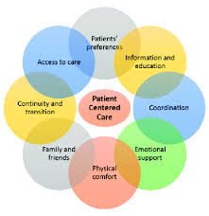
Figure 1.1: Person Centered Care

Partnership Working in Community Rehabilitation:
Partnership Working (PW) involves relationships between professionals, service users, and informal careers whereby both parties work together to realize a common outcome. Some of the important collaborators in community rehabilitation are physiotherapists, occupational therapists, GPs, social workers, family members, and district nurses. Smart PW provides flawless alignment between hospital discharge and recovery at home to avoid duplication and diversity in misdiagnoses (Probst et al. 2025).
Communication, respecting one another, and making decisions together are the keys to good partnerships. Everyone has a particular area of expertise: physiotherapists specialize in mobility, nurses specialize in wound care, social workers specialize in the organization of home adaptations and careers specialize in daily emotional assistance. The client is kept at the center of the service, and priorities include preferred therapy time and lifestyle aspirations (Nelson, 2025).
When PW is properly working it reflects the foundational elements of attachment and inclusion at Kitwood, where the individual does not feel solely as an isolated patient, but distinguished as a part of a caring community. This sense of shared responsibility fosters continuity of care and detects issues early (pain, fatigue or safety concerns), which could then be promptly and effectively dealt with by the relevant professional (Hill et al., 2025).

The Pros of Partnership Working:
Good teamwork leads to quality and safety of care. Interagency communication minimizes duplication of advice, facilitates holistic support, and fosters consistency in advice. To the rehabilitate, it will mean a quicker healing as well as joy. Professional trust is also created through cooperation; staff inside an organization is better informed about issues, little time is spent on figuring out what happens, and decisions in the organization are well-coordinated (OConnor et al., 2025).
Good relationships help to reinforce the emotional and mental advantages of the Kitwood model. When experts engage the individual with care and dignity, they maintain a sense of comfort and individuality (Manning et al., 2025). Professional cooperation establishes a web of stability around the service user through involvement of family attachment and encouragement. The approach is a relational method that enhances wellbeing and minimizes unexpected rehospitalizations and total healthcare expenditure (Dews et al., 2025).

Hurdles to Partnership Working:
There are a number of obstacles that inhibit effective partnership working in practice, even in the light of policy support. The most standard difficulty is communication breakdown. Care can be disseminated when different record systems are used or when agencies do not share updates among themselves. Say a physiotherapist alters the exercise program and the nurse is not informed, contradictory directions can startle the service user (Gobat et al., 2025).
There is also tension due to organization differences. Health and social care teams do not always work under the same management and funding models, and coordinating them can become challenging. Individual and group managers are under strain, which hinders group discussion or reflections. Consequently, influencing the values of person-centered care, professionals can pay too much attention to task performance instead of building a relationship (Hall, 2025).
Role ambiguity is the resulting barrier, as duplications or omission of important duties are due to an unclear responsibility. The voice of service users or of staff in a lower status can be silenced by power imbalances. It can also serve to limit inclusion due to cultural and linguistic differences when interpreters are ready or available information. To address these obstacles, leadership, common systems, and training fostering equality and cooperation is essential (Frank et al., 2025).

Policies and Legislation Advocating PCC and PW:
The health and social care systems in the UK firmly support practice based on partnerships and person-centered approaches. The Care Act 2014 has laid personal wellbeing and independence as the guiding principle. It involves professionals engaging people and careers when deciding on assessments- this is because Kitwood believes that wellbeing requires them to have a sense of dignity and extravagance (Weddle, 2025).
Integrated Care Systems (ICSs) were proposed in the Health and Social Care Act 2012, to unite NHS organizations, local authorities and voluntary sectors. These systems foster community-wide planning, common resources and collective responsibility, facilitating a smooth transition of care among hospital and community environments (Mahase, 2025).
The Equality Act 2010 covers temporary discrimination aspects and reasonable accommodations to those with disabilities or communication difficulties. The Data Protection Act 2018 regulates the sharing of information by managing the wisdom of secrecy. Lastly, the NHS Long Term Plan focuses on personalized care and self-management, which would coincide well with the relational values of the Kitwood personhood approach (Petrova and Nuur, 2025).

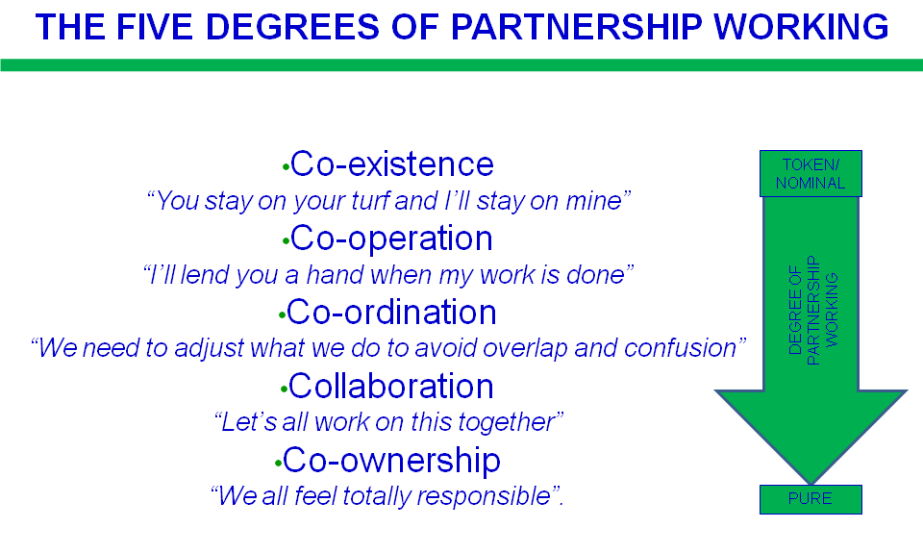
Figure 1.2: Degrees of Partnership Working

Policy in Practice: Problems and Development:
Though laws give good guidelines, there is a lot of deficiency in enforcing them. Community services have been associated with a lack of funds, a shortage of human resources and some administrative burdens making it time bound to administer services that are really consultancy centered. Interagency cooperation is intermittent; in certain regions, it is a developed cooperation, whereas in other ones, the interagency interaction is based on the outdated communication methodology (Hill et al., 2025).
An example can include separate descriptive systems in use even by the professionals, which results in time wastage and fewer evaluations. Services require to be better equipped with infrastructure, such as a joint digital record, a standardized set of protocols, and a leadership style that cherishes collaboration in order to put policy into practice (Hall, 2025).
Nevertheless, there are bright examples. Other rehabilitation teams invest in joint home visits mean that physiotherapists and nurses can conceive care together. Others post their updates in real time on online platforms. These practices reinforce trust and openness and assist entrench the values of partnership working. Once the staff members experience the beneficial outcomes of cooperation in increased recovery rates, positive morale, and the reduction of mistakes, they will be more inclined towards the continuation of a specific strategy (Dews et al., 2025).

Recommendations:
Develop Shared Systems of Communication:
Adopt e-record systems that can be accessed by all the professionals in the field of community care. This is so that no one is left out in the information and therefore they are able to coordinate safely.

Offer Relationship-Centered Training:
Integrate the model of Embed Kitwood into staff development program in order to encourage empathy, active listening, and respect towards personhood in all professions (Sikombe et al., 2025).

Facilitate Family and Career delivery:
Engage family members in coming up with plans and also hold regular review sessions to enhance emotional support and continuity of care. Knowing the preferences of the person aids them in the alignment of the professional goals and the real life.

Elaborate Roles and Responsibilities:
Make inter-agency pacts to determine who is responsible with what kind of care such as equipment, medication or home safety to ensure that no parts of the care overlap (Matas et al., 2025).

Enhance Leadership and Reflective Practice:
Designate partners conveners that make communication structuring and shared decision making easy. Provide frequent reflection periods during which the professionals should share what they have seen and what has been problematic with each other.

Become More Culturally Competent:
Educate the staff on board of all trains in regards to non-discriminatory measures, cultural sensitivity as well as inclusive communication to make each party feel included and respected (Probst et al., 2025).

Make an assessing decision based on the whole picture.
Create performance measures that encompass physical recovery, but also emotional health, assurance, and engagement akin to an emphasis on identity and comfort when presenting a holistic person-centered approach, as proposed by Kitwood.

Conclusion:
The community rehabilitation is essential to effective and compassionate work, which presupposes Person-Centered Care and Partnership Working. The Personhood Model created by Kitwood emphasizes that recovery is not merely a case of providing physical stamina, but of maintaining dignity, being and affiliation. The model makes practitioners remember that the quality of care is determined by the quality of relationships (Gobat et al., 2025).
Partnership Working operates these values through significant unforeseen associations of professionals, families and service users pursuing the same outcomes responsibilities. When teamwork and communication are well established persons feel empowered, respected as well as supported. Nonetheless, such obstacles to improvement as lack of information sharing, limited resources, and undefined roles still exist (Frank et al., 2025).
Already, a framework is solid with references to such policies as the Care Act and the Integrated Care Systems. What remains behind the requirements is steady implementation by the means of leadership, infrastructure in common technology and constant staff training. By following the advice contained in this report, the integration will be boosted, equality will be improved, and all the individuals in rehabilitation will not be seen as a case to handle, but as a human being with their own history and mission (Weddle, 2025).
Simply, the key point is, in the actual person-centered care a professional must see an individual prior to the sickness. The collaboration of the philosophy by Kitwood and appropriate partnership working is capable of contributing to rehabilitation of people in communities that will empower them to not just regain their mobility, but also foresee their dignity and sense of belonging (Mahase, 2025).

References:
Deuling, M., Bagchus, C., Jacobs, G. and Wallner, C., 2025. Mapping Leadership in a Person‐Centred Care Context: A Scoping Review. Journal of Nursing Management, 2025(1), p.3535620.
Furmenti, M.F., Bertarelli, G. and Ferrè, F., 2025. Person-centred care in oncological home services: a scoping review of patients’ and caregivers’ experience and needs. BMC health services research, 25(1), p.232.
Matas, E., Bhar, S., Collins, R., Bhowmik, J., Anderson, K. and Blair, A., 2025. Digital Life Stories Within Residential Aged Care Settings: Implications for Staff Knowledge and Person‐Centred Care Practices. Journal of Clinical Nursing.
Kjällman Alm, A., Hellzen, O. and Rising‐Holmström, M., 2025. Registered Nurses' Experience of Person‐Centred Care Through Digital Aids in Primary Care Setting During the COVID‐19 Pandemic. Nursing Open, 12(1), p.e70134.
Sikombe, K., Mody, A., Goss, C.W., Simbeza, S., Beres, L.K., Pry, J.M., Eshun-Wilson, I., Sharma, A., Mukamba, N., Mulenga, L.B. and Rice, B., 2025. Effect of a multicomponent, person-centred care intervention on client experience and HIV treatment outcomes in Zambia: a stepped-wedge, cluster-randomised trial. The Lancet HIV, 12(1), pp.e26-e39.
Linnanen, C., Hemberg, J., Bjerga, G.H., Ueland, V. and Bergdahl, E., 2025. Possibilities and Limitations in Person‐Centred Cancer Care: A Qualitative Study. Scandinavian Journal of Caring Sciences, 39(1), p.e70002.
Rose, T. and Dening, K.H., 2025. Who am I? Identity, person-centred care and dementia. Nursing older people, 37(3).
Probst, S., Menon, T., Stefanelli, A., Bergin, S.M., Brand, G. and Tehan, P., 2025. Empathy in wound care: a scoping review of its role, impact, and barriers to person‐centred healing. International wound journal, 22(6), p.e70687.
Nelson, A., 2025. Medical authority and expectations of conformity: crystallising a key barrier to person-centred care during labour and childbirth. Journal of medical ethics, 51(2), pp.107-110.
Hill, K.L., Desimone, L., Marianno, L., Polanco, C. and Bendel, T., 2025. Role of the policy environment in shaping the work of professional learning partnerships. AERA Open, 11, p.23328584251316465.
OConnor, D., Wilkinson, R. and Hamshire, C., 2025. " Students are part of our team and they’re part of our workforce": The role of student partnerships in collaborative physiotherapy practice-based education. International Journal for Students as Partners, 9(1), pp.109-127.
Manning, M.L., Monsees, E. and Larson, E., 2025. Beyond Burnout: The Power of Purpose, Partnership, and Serving Others. Clinical Infectious Diseases, p.ciaf133.
Dews, S.A., Corner, L., Butfield, R., Araghi, M., Monelle, H., Westergaard, P., Moloney, S., Wontor, V. and Burton, A.C., 2025. Co-creating tools for embedding meaningful patient and public involvement and engagement in real-world data and evidence research in the pharmaceutical industry setting: a multistakeholder participatory co-design study. BMJ open, 15(2), p.e088914.
Gobat, N., Slack, C., Hannah, S., Salzwedel, J., Bladon, G., Burgos, J.G., Purvis, B., Molony-Oates, B., Siegfried, N., Cheah, P.Y. and Conway, M., 2025. Better engagement, better evidence: working in partnership with patients, the public, and communities in clinical trials with involvement and good participatory practice. The Lancet Global Health, 13(4), pp.e716-e731.
Hall, J.L., 2025. Still Together After All These Years: Partnerships, Cooperation, and Collaboration in Public Works Management. Public Works Management & Policy, 30(3), pp.283-291.
Frank, A., Dillman Taylor, D., Diaz, M.J. and Hasan, S., 2025. From the Eyes of Students: Benefits and Opportunities within Partnership. Journal of Professional Counseling: Practice, Theory & Research, pp.1-14.
Weddle, H., 2025. Developing a research–practice partnership with policy intermediaries: An examination of collaboration with state education agency leaders. Educational Evaluation and Policy Analysis, 47(2), pp.311-328.
Mahase, E., 2025. GP partner model: Alternatives are urgently needed to avoid “disastrous consequences,” says think tank.
Petrova, L. and Nuur, N., 2025. Mentoring and Strategic Partnerships for SMEs´ Cybersecurity Resilience Amid Digital Transformation: A Qualitative Case Study on Connecting Windsor-Essex.

