University of Wales Trinity Saint David
School of Engineering

Engineering Design Project - Drill Press Main Sliding Unit
L4 – Engineering Design ACMA4008

Craig Petherbridge
1904036
08 February 2021

Contents
1 Introduction i
2 Critical Appraisal ii
3 House of Quality – QFD iii
4 Design Specification iv
6 Material Selection vii
7 Final Design Concept viii
8 References ix

Introduction

Aims
We aim to develop and improve an existing concept design of a new to market drill press stand, we will be responsible for improving the Drill Press Main Sliding Unit (DPMSU).

Objectives
The Objectives will be to improve the overall design of the DPMSU using a variety of design methodologies, we will look at the customers desires and improve the design to suit the requirements whilst considering material selection and manufacturing method to meet the production target of 1000 units per week.

Drill Press
The Drill press is used to hold a portable rotary tool such as a drill and provides a platform to drill holes in various materials including wood, metal and polymers. Its operating environment will typically be in a workshop or shed and can be used in industry or at home.

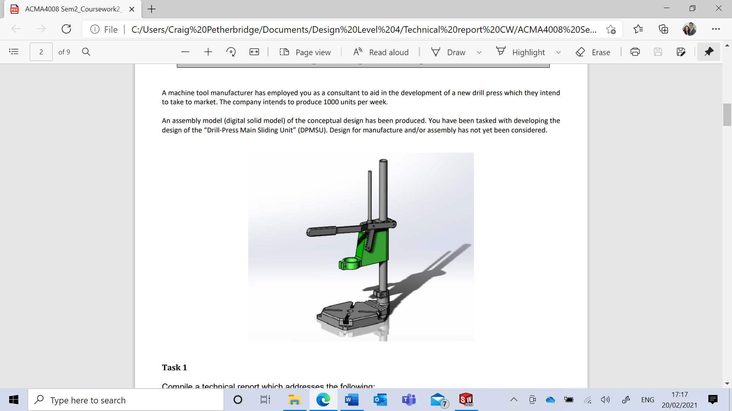

Critical Appraisal
On looking at the conceptual design of the DPMSU it is clear to see that the overall shape and design is good, the item works for its intended purpose. However there are a number of areas we must look to improve or implement change.

Customer Needs
The drill press will need to be easy to use with minimal set up time. The customer will also need the DPMSU to provide a stable platform for accurate drilling.

Functional Requirements
The main function for the DPMSU is to clamp the drill in position, this will also need to move up and down to allow the user to drill holes.

Aesthetic Considerations
The current colour is not in keeping with the rest of the drill press, material is currently not specified.

Serviceability
Access to the components needs to be simplified this will ensure that the DPMSU will be easy to maintain and ensures components can be replaced.

Ethics
To ensure we meet ethical standards we must look to use materials which are easy to recycle. Lower melting temperatures will be easier to manufacture and will reduce the overall carbon footprint.

Codes of Practice
To comply with safety legislation we will look at fitting a safety label sticker on the DPMSU.

House of Quality – QFD
The purpose of QFD is to aide us in getting higher quality products to market much faster and at lower cost, we will gain customer driven product design and will provide future tracking system for design or process improvements, the table below shows the results gained from our own research.
Table 1: House of Quality for conceptual design
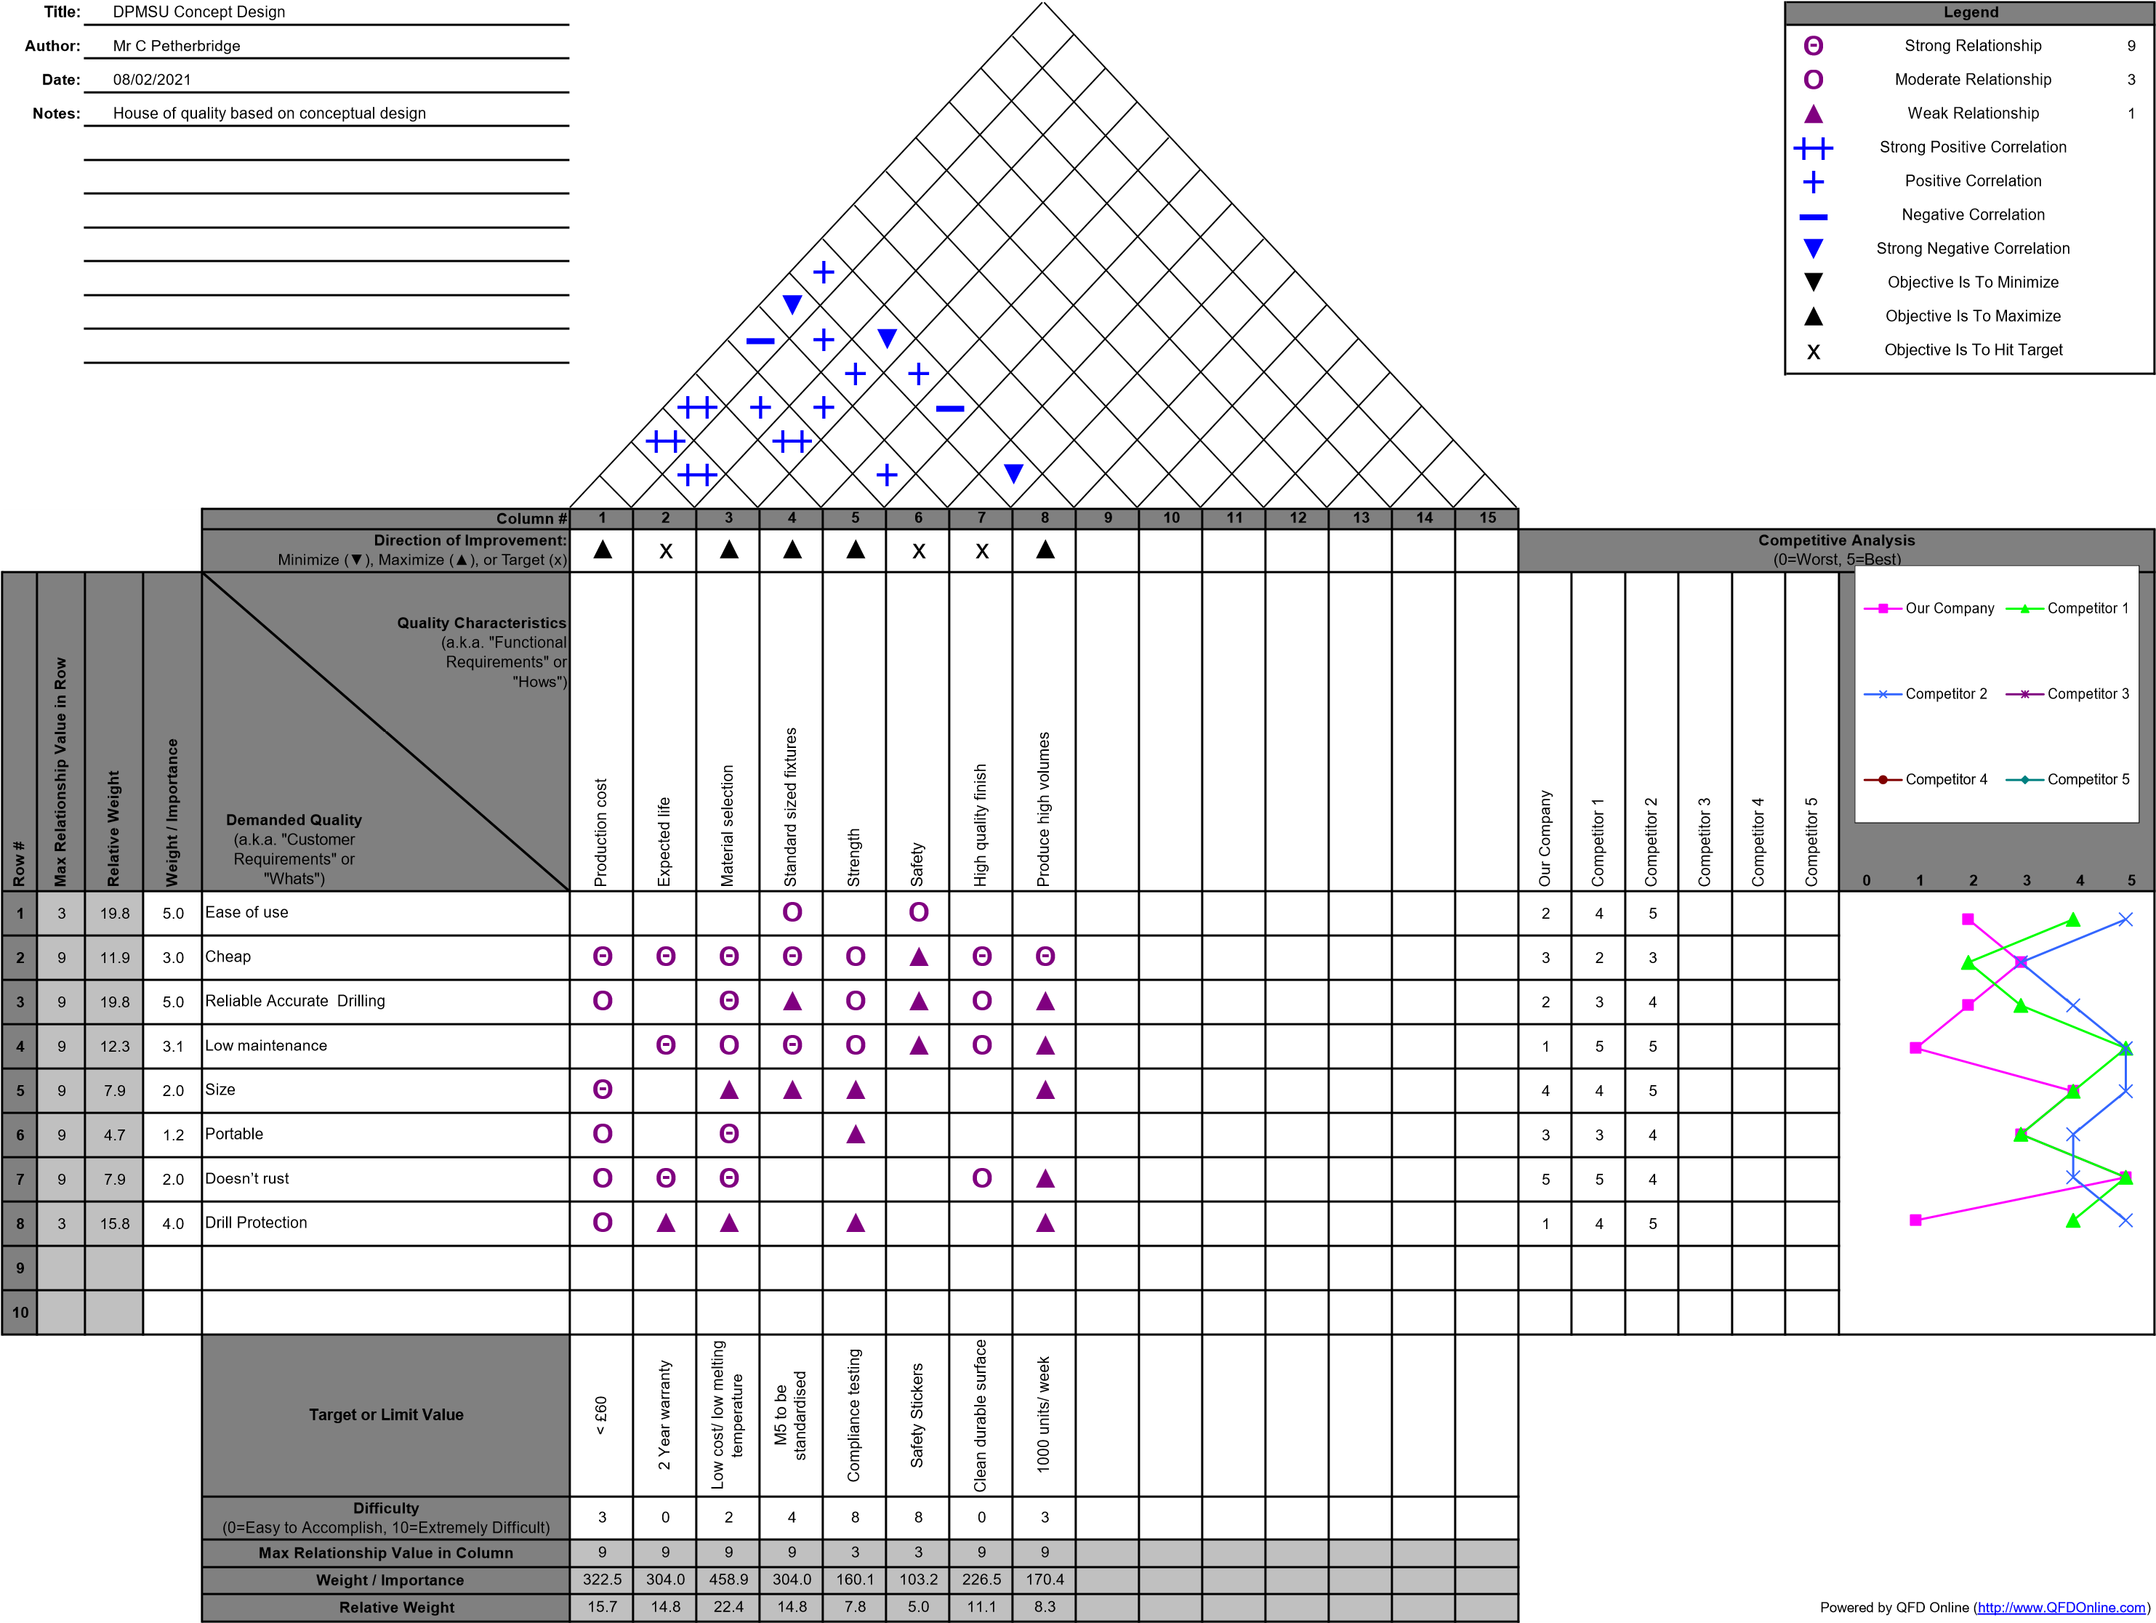
The House of Quality has allowed us to look at the customer needs and help us understand how we can directly meet these needs. It has allowed us to compare our own design with that of our competitors gaining further tactical advantage. This QFD highlights the need for improvements to the design as it is falling short of the customer needs and fails to meet the standards of our competitors, we must look to improve the concept design. (Unknown, 2020)

Design Specification

Market Requirements
Target Price – The target price must be comparable to our competitors but we cannot afford to lose quality this is a conflict from the QFD as the customer would like high quality at low cost. From our competitor research we found that the price of a drill press machine would vary from £40 for bottom of the range, upwards of £130 for top branded item.
Product Performance – Provide a stable drilling platform.
Appearance image and style – It is important for the product to look appealing with robust feel and good surface finish.
Point of sale requirements – Product will include operator’s manual. The product should be well protected and packed ready for delivery.

Life in Service
Target life – Minimum warranty of two years, this should cover all parts under normal daily use.
Disposal/recycling – We will look to use a material which can be recycled.
Maintenance - All components will be replaceable, we will standardise fixings making it easy to remove and adjust components.
Product information – Data sheet will be available to download and instruction manual will be included.

Production
Target cost – Keeping the costs low without compromising on quality.
Manufacturing quantities – 1000 Units per week, 200 units a day Production target
Product size and weight – under 8Kg will be the target, this is comparable to our competitors which range from 9.5Kg to 6Kg, the product weight will not be a defining factor in the design but will influence the cost of manufacture.
Bought in vs manufactured in house – Fittings could be bought in over manufacturing.
Manufacturing constraints – We will look to use a material that is easy to manufacture with a good surface finish to ease production times.

Conformance Requirements
Statutory – Compliance with ISO9001 ensuring confidence in the product.
Company standards – The company has ethical beliefs and would like to reduce the carbon footprint to reduce global warming.
Testing – Conformance testing will be carried out on the drill press
Table 2: Design Specification
Table 3: Design Brief

- Manufacturing Process
There are several manufacturing processes that would be suitable to produce the DPMSU however due to the large volumes needed my conclusion and recommendation is that the DPMSU should be produced using high pressure die casting. During this process molten metal is forced under pressure into a locked metal die cavity, once the cavity is filled the molten metal is cooled until it freezes. This process takes milli seconds to complete. (Unknown, 2021)
  - Advantages
Easy for mass production – Since die casting is made from die casting mould, they can be obtained within specified tolerance and shapes. Little or no machining is required, and thousands of identical castings can be produced before additional tooling is required. Making it ideally suited to mass production. (Unknown, 2021)
Dimensional accuracy and stability – Die casting produces parts that are durable and dimensionally stable, while maintaining close tolerances. They are also heat resistant. (Unknown, 2021)
Strength and weight – Die cast parts are stronger than plastic injection mouldings having the same dimensions. Thin wall castings are stronger and lighter than those possible with other casting methods. Plus, because die castings do not consist of separate parts welded or fastened together, the strength is that of the alloy rather than the joining process. (Unknown, 2021)
  - Disadvantages
- Limited material selection
- The cost of machines, dies and other equipment used is high.
- It’s not cheap to start with small quantity production.
- Special precautions are necessary for evacuation of air from die cavity, otherwise cause porosity.
- It’s impossible to get a die casting prototype when product development process.
(Unknown, 2021)
  - Other Methods
Injection moulding is another suitable method for consideration, however the DPMSU would need to be produced using a polymer, some polymers with a high modulus would meet the requirements. The quality of product may be questioned as the customer may feel the item is cheap and low quality.
- Material Selection
The manufacturing process has limited our choice of materials as high pressure die casting can only be done on soft metals with lower melting temperatures such as lead, magnesium, zinc and aluminium.
Zinc and aluminium would be two suitable materials for the DPMSU. Aluminium is lighter but zinc has a lower melting point, this means that manufacturing is faster and more energy efficient.
Zinc due to its lower melting temperatures is considered the most castable material, it requires lower pressures for casting. By having lower melting temperatures this enables the zinc die to last much longer and will be a more cost-effective way to manufacture high volumes. (Unknown, 2016)
Zinc is known as one of the toughest alloys and surpasses aluminium in its toughness, this robust alloy that can withstand impact making it a good choice for its operating environment. (Unknown, 2016)
When designing a DPMSU one of the most important aspects to consider is the material selection, ensuring it has the ability to withstand force during the drilling operation, the material needs to have good mechanical properties, Zinc meets these demands making it a good material.

Final Design Concept
Changes were made to meet and exceed the expectations of the customer, firstly the shape was altered by shortening the body reducing material to improve cost. All external edges were chamfered improving the durability and aesthetic appearance of the component.
There was a significant change to the return spring chamber, the small surface area where the spring sits is a stress raiser and a certain week point on the component. this material under load could have caused the component to fail we improved this by shortening the depth of the hole, the spring will now be fixed with a removable fixing, this will improve the life, serviceability and ease of manufacture.
We recommend that the fixings should be purchased over manufacturing to save on production costs.
Hexagonal recesses were added to the back of the drill clamp to secure the nut, an allen key holder was added to the main body making it easier for the operator to make further adjustments.
The body of the DPMSU lends itself to a large space, this can be incorporated to hold the company logo for marketing purposes but also space for a safety information to comply with safety legislations.
Figure 1: Final Design 2D Drawing
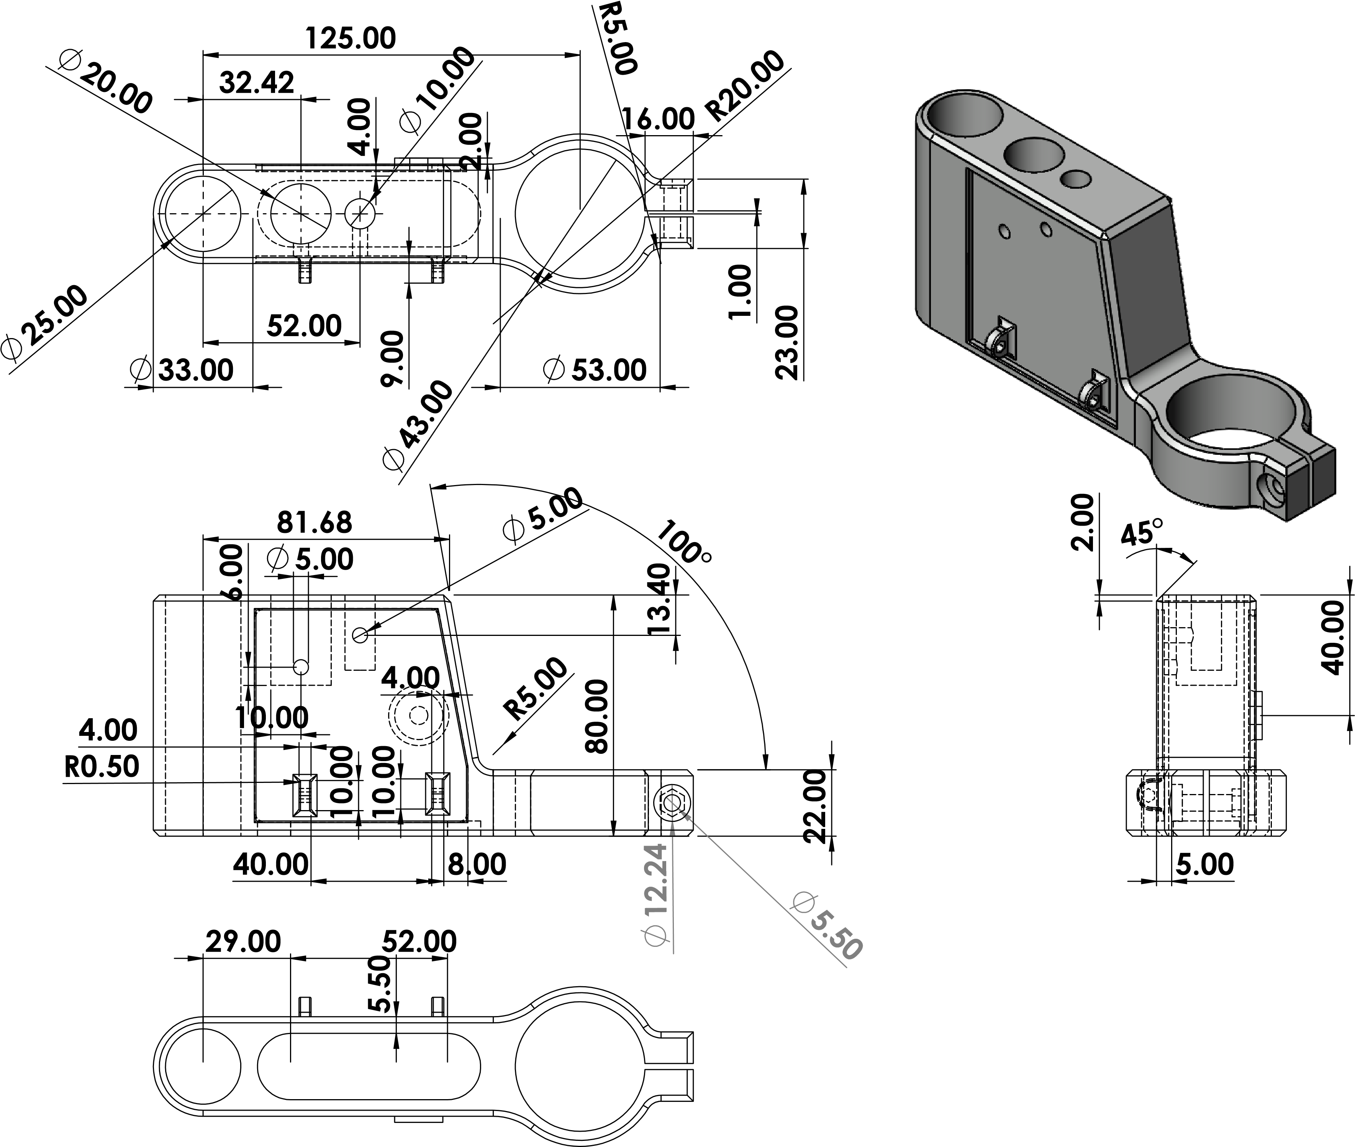

References

Unknown. (2016, April 19). Premier Die Casting Company. Retrieved from The Difference Between Aluminum, Magnesium and Zinc Alloys: https://diecasting.com/blog/2016/04/19/the-difference-between-aluminum-magnesium-and-zinc-alloys/
Unknown. (2020, July 13). HOQ - House of quality. Retrieved from Digital Guide IONOS: https://www.ionos.co.uk/digitalguide/online-marketing/web-analytics/house-of-quality-hoq/
Unknown. (2021, February 20). Advantages and Disadvantages of Die Casting. Retrieved from Eco Die Casting: https://www.ecodiecasting.com/wp-content/uploads/2017/05/buttom-housing-1.jpg

