Gym programme card

Warm up
Overview of content (including mobility, pulse raising (CV machine) | Equipment and duration | Level/speed | RPE/HR | Adaptation(s) or alternatives
CV machine  Stretching/Mobility | Treadmill or,  Bike or,  ……..  (personal preface)  8 minutes  Based on personal ‘needs’ or activity  – stretch/mobilise major muscles/joints  Stretch = 10 seconds  Mobility = 10 reps |  | 1-4  1-2
Preparatory stretches – circle static stretches and list the muscles groups stretched dynamically
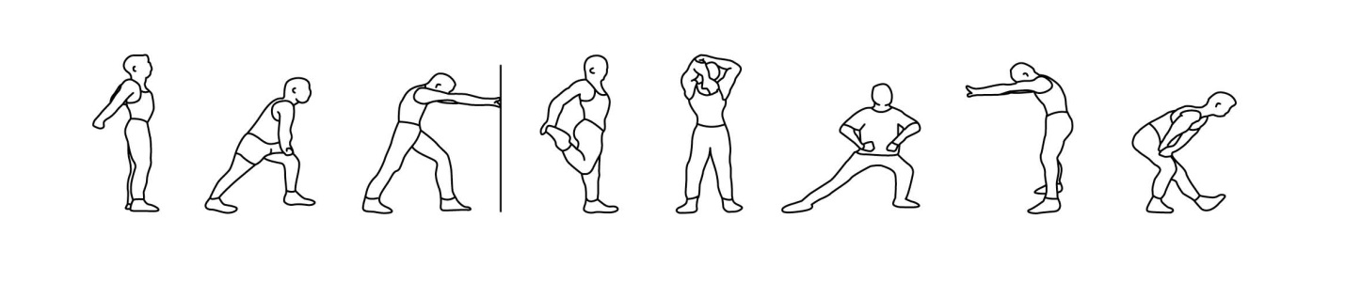
Cardiovascular training
Equipment and approach | Programme timings | Level/speed | RPE/HR | Adaptation(s) or alternatives
Treadmill, bike, rower, …. (personal preface)  Or  As above | 20 minutes – continuous  10 minutes - intervals (W:R 20/40seconds x 10) |  | 4-7  8-9

Resistance training
Exercise/machine | Resistance | Reps | Sets | Rest | Adaptation(s) or alternatives
Leg press or BB squat |  | 3 | 10-12 | 45secs
Chest press or DB press |  | 3 | 10-12 | 45secs
Seated Row or DB row |  | 3 | 10-12 | 45secs
Bicep curl (FW) |  | 3 | 10-12 | 30secs
Tricep extension (machine) |  | 3 | 10-12 | 30secs
Cool down/flexibility
Cool down (if a re-warm or pulse lowering phase is required please detail in the space below)
CV machine | Time and intensity range
Machine of choice | 8 minutes + stretching (15-20 seconds each stretch)
Post-workout stretches (circle as applicable) - indicate which stretches are maintenance (M) and which are developmental (D)


