Kirsty Charnley
Student number – 2104787
Lecturer – Dr Gareth Morgan
Module – Introduction to health research (BMNS4005)
Assignment – Written report

Contents

Front cover – Page 1

Contents – Page - 2

Introduction – Page 3-4

Hepatitis C Research – Page 5-10

Conclusion – Page 11

References – Page 12-13

Introduction

Hepatitis C virus (HCV) infection has surfaced as a considerable problem for public health and has now become known as a significant cause for chronic hepatitis. Hepatitis C can be acute symptomatic with 1 in 5 people clearing the virus in the first 6 months of being infected, with more than 80 percent of people catching the virus becoming chronically infected. Wales has an estimated 12,000-16,000 confirmed cases and about 50% of that undiagnosed.

Hepatitis C is treatable with direct-acting antiviral tablets, they are extremely effective in clearing the virus in more than 90 percent of individuals who have taken them, because the virus mutates it has mutated into 6 genotypes. Depending which genotype a person has will depend on what medication they can be given to treat the virus it also determines the treatment length. The hepatitis C trust (2022) implies the most common genotype found within the UK is genotype 1 and 3, there has been research evidence that type 3 progresses more quickly than the other genotypes causing liver damage at a faster pace. Although transmission of the virus can be through unprotected sex, or from an infected mother to a newborn baby during birth but this is rare.

The most common way of transmission of hepatitis C is through drug users injecting with unsterile needles, body piercing or tattoos or, Healthcare workers who are in Contact with blood products and prison officers. Before 1991 blood donors’ blood wasn’t routinely checked for blood borne virus and some people who received a blood transfusion before 1991 are at risk of contracting the virus during the transfusion. Many people who have contracted the virus may not even know they have it as most people do not have any symptoms and those who do symptoms are in most cases mild such as flu-like symptoms, tiredness, feeling sick and loss of appetite (NHS 2021).

Undetected and not treated hepatitis can lead to liver damage and in worse cases can cause cancer of the liver (Public Health Wales 2022). Registered medical practitioners have a duty by law to report any new cases of infectious diseases. Wales signed up to the World Health Organisation action plan to eliminate hepatitis C by 2030 and the steps that has been actioned to accomplish this goal and prevent the spread of the virus.

This paper will look at quantitative research from data collected from the laboratory reports for Public Health Wales to break down the pattern in which the transmission of HCV in confirmed cases from 2018-2022. Laboratory confirms hepatitis by detecting the antibody for hepatitis C virus (anti-HCV) in serum. As one of the main ways of contracting hepatitis C is through injecting needles. This paper will also investigate the quantitative research collective from the harm reduction database Wales for prevention and detection of infectious disease amongst people accessing substances misuse services annual report 2020-21. The opt-out testing scheme that has been put into force will also be discussed. Wales is aiming to eliminate hepatitis C by 2030, research within this paper will also show a clear view on whether that target will be reached, and whether future improvements are needed for this goal to be reached.

Hepatitis C Research

A total number of cases reported to public health Wales during the period of 2019 – 2022 was a total of 1,177. A decrease from 2019-2020 then a slight increase in 2021, from the total over the 3 years 72.3% (856/1,177) of the confirmed cases of infections occurring in males and 27.2% (326/1,177) of the confirmed infection occurring in females. In these confirmed cases it is shown that age range of 40-45 years old were the highest confirmed age range with 30-39 coming in second, data showed that the age range of 10-19 <10 were significantly low figures in table 1.

Table 1
Gender figures & Average age 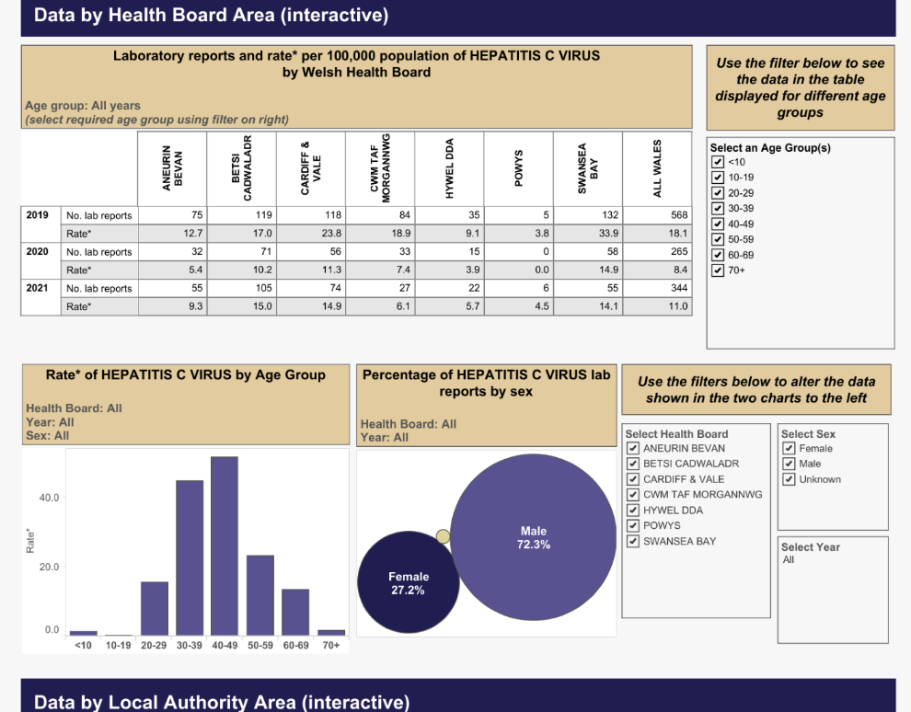

As of 2022 leading into week 8 of the year only 24 confirmed cases have been reported by laboratories in Wales so far with no data on gender or age range to analysis. Data from local authority areas have also been published, in 2019 the local authority of Swansea reported the highest number of cases during that year period. The years 2020 and 2021 the local authority of Cardiff reported the most confirmed cases for both years, see tables 2,3 and 4 (Public Health England 2022).
Table 2.
Local authority cases (2019)
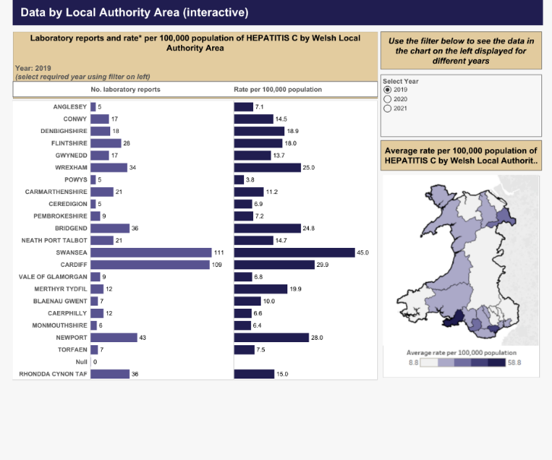
Table 3.
Local authority cases (2020)
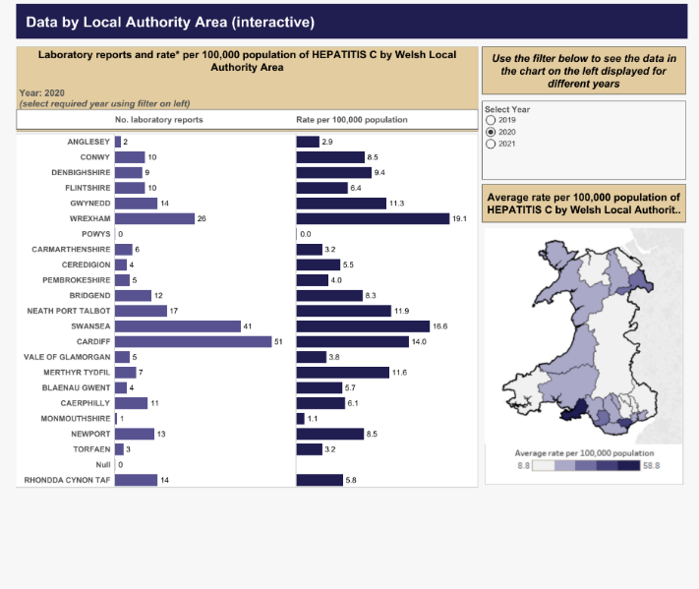

Table 4
Local authority cases (2021)
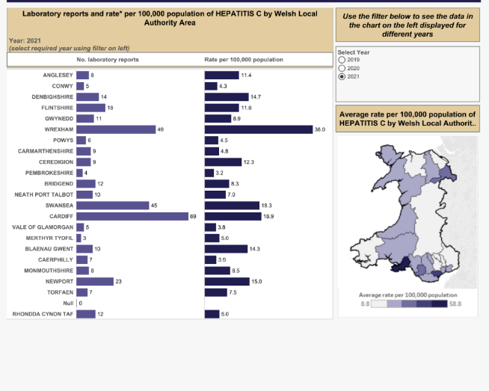
Public Health Wales was set up to improve health and well being of the people in Wales. The substance misuse programme runs in line with public health Wales to address current threats to health in Wales. The needle and syringe programme (NSP) provide a service to the public in Wales for sterile needles and also offer foil as a deterrent for injecting. In a new development of hepatitis C treatment now widely available in Wales a shorter and more effective course of treatment is available to people with confirmed positive cases. The blood borne virus module was started in all substance misuse services, all clients who inject drugs are to be routinely tested on site on an annual basis.

In 2020-2021 the number of individuals who received a test for blood borne virus hepatitis C was 795 this number was considerably lower than the previous year of 2019-20 with 3761 receiving a test, this is a decrease of 79%. Please see table 5

Table 5
Number of HCV testing during 2020-21
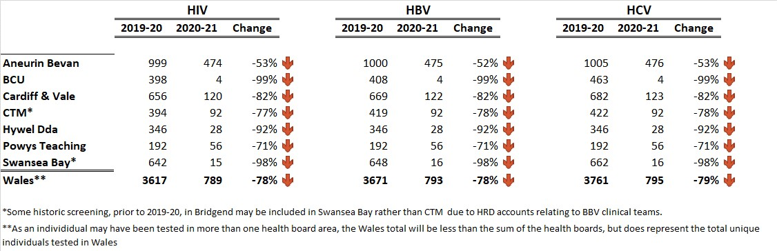
There are three ways of testing for blood borne virus including hepatitis C, which are dried blood spot testing (DBST), Oral swabs only for hepatitis C and venepuncture which is a blood sample drawn from the vein but this form of testing isn’t always available or possible in areas such as pharmacies and community settings that provide screening. Table 6 shows the three ways of testing and where they were used within the health boards of Wales during 2020-21.

Table 6
Three techniques of testing for hepatitis C in local authority areas in Wales during 2020-21.
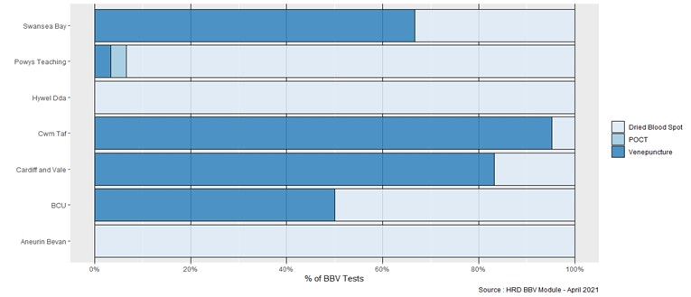
Blood borne virus screening over the past few years has been positive, but screening within substance misuse services is still low. Data from the substance misuse services show in 2020-21 that of men between the ages of 35–39-year-olds are the most common users of this service and women considerably lower with the age range of women who use the service the most being 30-34 years old.

Table 7
Average age and gender data from sustance misuse database 2020-21
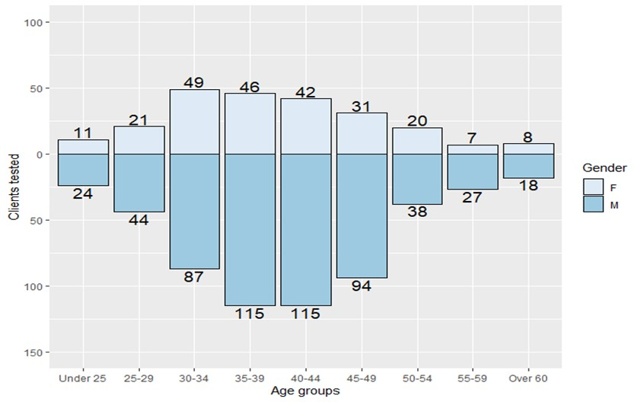
Other statics were collected such as unemployment within 67% of service users, prositution within 9%. From April 2020 to March 2021 56 people had positive result hepatitis C in substance misus service, 25 of which had chronic infection and needing treatment. Services users who were tested and had a positive result, who were referred to the blood borne virus team for treatment was 362 between the time of 2019-2021. Of these 362 only 126 (34.8%) where down as showing to of started treament (Public Health Wales 2021). Research has shown that the cost of treatment per person to be between £8000-£16000 and that the Welsh Government needs to put in more funding, if they are to meet the target of eliminating hepatitis by 2030. With hepatitis effecting a high percentage of men the Welsh Government in 2016 has also introduced the opt-out testing for prisons around Wales. Prisons in Wales have been routinely testing for blood borne viruses since 2010, and prisons will play a role in meeting the World Health Orginistions target of eliminating hepatitis C by 2030.

Prisons are within the World Health Orginisations action plan as an enviroment with the higest risk catogary of people who may be infected with blood borne visuses such as heptatits C. World Health Orginasation (2021) adds that in 2016 they marked out a stragy for countrys to follow to try and eliminate the virus by 2030. The advice marked out in the plan of action was to make testing more widely available, and easier access to testing and to ensure treatment is available for people who test positive so treatment can be commenced straight away. Men are the highest effected gender with 70% of men in prison being drug users who inject. Public Health Wales (2022) adds that prisons are being encouraged to promote health and give the prisoners within a 48 hour period the offer to be tested. In 2018 3888 prisoners in Wales had been tested for blood borne visuses, this occumilated to 44.4% of the populations of prisoners across Wales (Public Health Wales 2022). Public Health Wales (2022) adds that HMP Swansea is the first remand prison in the United Kingdom to eliminate hepatitis C. Although males are the highest infected gender of hepatitis, women do still contract it so its surprising to find out that hepatitis C is not routinely offered to pregnant women during antinatal screening, not just in Wales but in the uk (Public Health Wales 2022). Other blood borne viruses are within the antinatal screening such as HIV and hepatitis B, although research has shown that hepatitis C has a lower chance of passing on from mother to baby than HIV and hepatitis B, there is still a risk it can be transmitted. Reseach has also shown that babies born to mothers that are positive who contract hepatitis C during birth only have a 20% chance of clearing the virus on there own, and the new HCV medications are not suitable for children to take.

Conclusion

The World Health Orginisation has set a target to elminate hepatitis C, Wales have signed up in hope to elminate hepatitis C. The research found, Public Health Wales have progressed in advancements in making screening for hepatitis C more widley available to the public. The substance misuse programme has been able to offer not only sterile needles ensuring safe health of the person using it. They also offer heptatitis screening annually for the public who use the substance misuse programme. This offer for screening is optional and public can decline. Drug users are the highest risk group for contracting hepatitis C the screening should be made mandatory on a six months basis ensuring the health of the public.

This paper has shown during the years of 2019-2021 1,177 people have tested positive for hepatitis with 362 of which were screened within the substance misuse programme. Heptatitis C is a course for concern in Wales although low numbers of new cases are being detected, there are still new cases being detected. Research has also shown that even when a person has tested positive a very low percentage are being refered to be treated on the new hepatitis C medication. This could be down to the cost of each treatment per person.

Research has also shown that hepatitis screening is not offered to the general public like other blood borne virus screening, this should be something to consider in the future, specially when the syptoms for hepatitis C can be hard to detect from other general illnesses. Lastly this research paper has also found that pregnant woman are not rountinely tested for hepatitis C at anatinatal appointment when other blood bourne virus are offered to pregnant women such as HIV and hepatitis B. This screening should become part of the antinatal screening as babys who contract the virus from a positive mother only have a 20% chance of clearing the virus. Eliminating hepatitis C is not achivable for Wales while screening is limited to only high risk groups when this virus can be contracted others ways such as sexual intercourse and from mother to baby.

Reference
NHS (2021) Symtoms: Hepatitis C. Available at: https//www.nhs.uk/conditions/hepatitis-c/syptoms/ (Accessed 18 February 2022)
Public Health England (2021) Laboratory reports of hepatitis c in england and wales, 2019. Available at https//assets.publishing.service.gov.uk/government/uploads/system/uploads/attachment_data/file/993399/hpr1021_hcv19.pdf (Accessed 18 February 2022)
Public Health Wales (2022) About antenatal screening: What is antenatal screening?. Available at:https//phw.nhs.wales/screening-and-teams/screening/antenatal-screening-wales/about-antenatal-screening/ (Accessed 20 February 2022)
Public Health Wales (2022) Blood bourne viruses in welsh prisons. Available at: https//phw.nhs.wales/topics/prison-health-in-wales/blood-bourne-virus-in-welsh-prisons/ (Accessed 20 Fberuary 2022)
Public Health Wales (2022) Health protection: Laboratory reports of hepatitis c in wales 2018-2021. Available at:https//public.tableau.com/app/profile/public.health.wales.health.protection/viz/laboratoryreportsofhepatitisinwales2014-2017/dashboard2. (Accessed 20 February 2022)
Public Health Wales (2022) Hepatitis C. Available at:https//phw.nhs.wales/topics/hepatitis-c/ (Accessed 20 February 2022)
Public Health Wales (2022) Hepatitis C eliminated in HMP Swansea: A UK first for remand prison. Available at: https//phw.nhs.wales/news/hepatitis-c-eliminated-in-hmp-swansea-a-uk-first-for-a-remand-prison/ (Accessed 18 February 2022)
Public Health Wales (2021) Substance misuse programme: Harm reduction database wales prevention and detection of infectious disease amoungts people accessing substance misuse services, annual report 2020-21. Available at:https//phw.nhs.wales/publication/publications1/harm-reduction-database-wales-prevention-and-detection-of-infectious-disease-amongst-people-accessing-substance-misuse-services-annual-report-202-21/
The Hepatitis C Trust (2022) Genotypes of hepatitis c. Available at: https//www.hepctrust.org.uk/information/about-hepatitis-c-virus/genotypes-hepatitis-c (Accessed 18 February 2022)
World Health Organisation (2021) Who releases first ever global guidance for country validation of viral hepatitis B and C elimination. Available at: https//www.who.int/news/item/25-06-21-who-releases-first-ever-global-guidance-for-country-validation-of-viral-hepatitis-b-and-c-elimination (Accessed 18 February 2022)

