Effective Teamworking For
Team Success

Student Name: Louise Catherine Franklin
Student ID: 2025915
Module Code: BMSW4002
Module Name: Effective Teamworking and Communication
Lecturer: Suzannah Ogwu

Table of Contents

Abstract….……………………………………………………………………………. p3
Introduction……………………………………………………………………………. P4
Developing an Effective Team………………………………………………………. P5-6
The Impact of Effective Team working………………………………………………p7-8
Barriers to Effective Team working…………………………………………………. P9-10
Roles Needed to Create a Cohesive and Effective team…………………………. P11
Reference List…………………………………………………………………………. P13

Abstract

This report aims were to show how developing an effective team could impact on a team in a care home. In my research I have found I have demonstrated many ways that are used to help build an effective team. My research has outlined barriers to effective team working and roles which are needed to have an effective care team. I have concluded for a Team to be successful you need effective leadership they need to have effective communication skills and be able to delegate different roles and manage all Team members and be able to implement a professional approach to the work and their patients.

Introduction

This report will demonstrate how Trinity Social Care Home can develop and effective team. This could help with the barriers between staff which could lead to better quality of care for patients and to boost the whole team’s reputation. The impact of an effective team in the health care setting could result in patients been happier with the quality of care received and coworkers collaborating with each other effectively. Bad communication could reduce team moral and motivation. Roles in a team are particularly important for a team to be effective and cohesive. These roles include Directors and Area managers, care worker and many more further on in the paper I have given more examples.

Developing an Effective Team

When it comes to developing a team, you will have to overcome allot of barriers. Developing an effective team can help over come certain barriers that get in our way. Hierarchy is important in developing an effective team the separate roles within the hierarchy system contributes overall. If we look at Bruce Tuckman’s model for team development, the model shows the stages of forming an effective group.

Forming
First, we have (Forming) this is where Team member should focus on the leader of the team for guidance and instructions but also being polite to everyone else within the team. If leaders and team members emphasize with each other and listen to one and other, this will be effective in the later stages of forming an effective team.

Storming
Secondly, we have (Storming) at this stage of team development Tuckman, (1965) describes this to be where there is major conflict and members of the team are battling with on another for the approval of their leader. Members try to establish who will listen and who will undermine them. If there is good leadership, The leader should be able to bring the team back together.

Norming
Thirdly, we come to (Norming) if your team can make it to this stage of the model this should mean they have been able to over come disagreements and can listen and show empathy to each other. This could help the team to move forward and concentrate on the task at hand and apply current ideas for growth for the whole entire Team.

Performing
Fourthly, performing, this stage is where your team has developed effectively and should now be running smoothly, the team should be working towards the same goal and achieving success. This achievement could be through the team leader and the rest of the team members giving their absolute best effort to achieve effectiveness.

Fifthly, we come to the last stage of the team development model. This stage is where your team have effectively and cohesively collaborated with one another to achieve the goals and reach their targets. If your team has gone through the first four stages of this model and over come them then they been able to reach their full potential and have become effective on the whole if this able to happen when team members leave to join another team, they will be able to implement what they have learnt from the previous team to a new team. This could potentially help develop another effective team.

For your team to develop effectively and over come these stages to be cohesive, they should have good leadership who are effective communicators, effective listeners, show empathy to one another and be able to take criticism and over come it and make rational decisions to overcome obstacles.

Bruce Tuckman’s Team Development Model
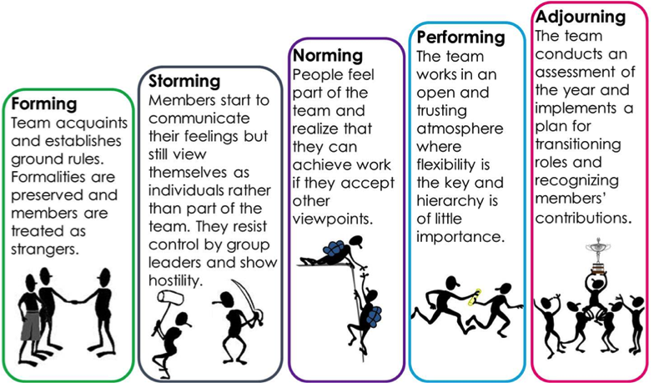NS4B, (2018)

The Impact of Effective Teamworking

When your team establishes effectiveness the work surroundings and team member’s flourish. This is due to the team’s ability to work effectively and cohesively. The impact of effective teamworking can help a Team to accomplish targets they set out they achieve and overcome obstacles. According to Linda Chapman, (2018) effective teamworking in a healthcare setting is necessary. The impacts are flexibility. Offering team members flexibility relieves pressure for example time to address important situation at home which leads to team members having more of an incentive to work more effectively. This could also encourage motivation, with team workers motivated, this can cause the team to achieve the workload together bringing a good impact fort he team. This could encourage team members to try new skills and try new roles with progression the whole team can benefit as this could help with reputation as well, encouraging other members to join the team, having an effective impact on the company.
(A, Stead and M.C Leonard), 1995. The impacts of effective team working can higher the quality of care received by patients this will increase patients’ satisfaction a care targets set. With patients cared for effectively will also ensure a good reputation. Having a quality leader with effective communication skills, empathy and assertiveness will have an effective impact on a team as they can communicate the tasks or roles needed to carry out effectively this will ensure team members understand what it is needed having a good leader will encourage workers to work more cohesively together. For the impact of your team to be effective all members of the team must be willing and enthusiastic to working towards achieving the same goals. When a team can work effectively together this could a good impact on not just work life but for home life, making work more effective as when your home life less stressed, you’ll find your work life also less stressed impacting the team effectively.

Barriers to Effective Teamworking

Barriers are obstacles that a team needs to overcome to achieve effectiveness. There are barriers you must face when developing an effective team, poor communication is one of them if your team are not able to communicate, they may not be as effective when working together to achieve a goal and overcoming a barrier. Having effective leadership could help overcome this barrier as they could communicate to other team members what it is their role entails in an effective way. Not being able to this could lead to team members failing their work through lack of clear instructions (Dorethy Wicke), 2004.

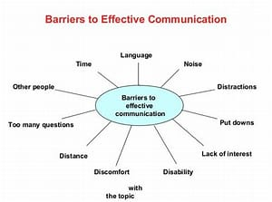S. Nguyen. (2016)

When your team can overcome these barriers, they will be at there most effective with overall team satisfaction. Providing the team with the necessary skills to provide better care and deliver their selves and their work in an appropriate manner. Teams with barriers and bad leadership will not be able to overcome them this creates even more barriers to creating and effective and cohesive team (Cassidy2007,).
Roles we need to create a cohesive and Effective Team

When creating an effective team, the roles of the members must be considered as high priority. This could lead the team to be uncoordinated and will not exactly know what is needed. Belbins theory of team roles demonstrates effective roles of a developed team.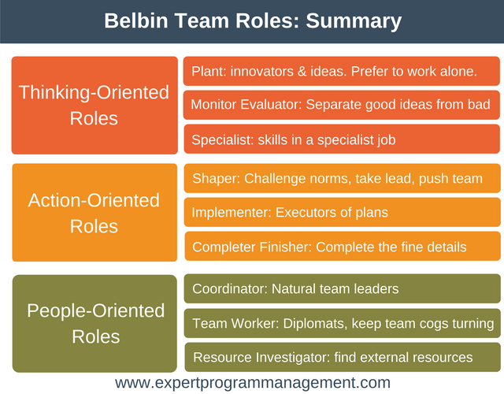
The roles in a team are what makes the team effective as not everyone on the team can deal with the same pressures. Having a hirearchy within a team also leads for progression . here are some examples of the roles within a care home and what the roles entitle.
Job title Role Requirement
Director of Care- This position is accountable and resposible for the care received by residents from nurses. They are resposible for leading a care unit.
Area Manager- In this role you support and advise the paitients their famililies and workers. They work to the strict leagal accuirments for example healtha and safety.Encourage paitents to join activities and help them access local services.
Care Manager- A Care Mangers role is to be resposible for day to day operations in the care home. This includes mangaing staff, managing budgets and making sure the quality of care is up to national standard.
Team leader- Lead a team of care workers that provide a high quality service to paitients.
Senior support worker- A senior support workers role is to support and manage at the same time.you carry out support working jobs while also managing a team at the same time.
Support worker- a support workers role is to support paitients with cooking,cleaning and paying bills and any other day to day activity the paitent requires support with.

With these roles within your team the teamork should be effective having different hirearchy roles enables less stress amongst workers and enables workers to go for roles witch support their skills this couls bring order and cohesiveness to your team making the working outcome great.without these roles you will not be able to achieve an effective team according to S. Fisher, T. hunterand W Macrosson , (1998).
When all Team members know the roles that are given to them there is better understanding though the whole team without roles of leaders the rest of team will feel stressed and not work effectivly. So establishing your role is vital. With different backgroung and diversity within teams roles are important as not all team members are on the same skill level allowing team members to change roles and learn new skill sets can bring more effectivness amongst the team and provide a better reputation for the team.

My experiences with working in a team

I have experienced working in many different teams and all the teams I have been apart of the ones without effective communication and good leadership have not thrived were as the teams which have had these skills and qualities have thrived. They have produced quality services and seem to work cohesively together working towards the same goals. Due to my own experiences with barriers in amongst a team I approach any team with a assertive and positive way this way members are more likely to talk to me with more ease this is what I have learned from my experiences also to not judge on age or diversity those differences we have from each other could help all parties in the team benefit gaining more knowledge and gain more skills needed. Learning from team members diversity has helped me to be able to have a better understanding of communication and its importance and help me to be able to settle allot more easier when joining a team. I can take criticism and learn from it to move forward in helping my team. Overall, anyone working in a team with good understanding of communication, and you can show empathy then these approaches to joining a team will help towards making an effective team.

Reference List
Belbin (2021). Belbin Team Roles. [online] Belbin.com. Available at: https://www.belbin.com/about/belbin-team-roles.
Cassidy, K. (2007). Tuckman Revisited: Proposing a new model of group development for practitioners. Journal of experiential education, 29(3), pp. pp413–pp417. Fisher, S.G., Chapman, L. (2008). Effective teamwork. Nursing Management, 15(6), pp.18–21. Denis (2017). Belbin Team Roles. [online] Expert Program Management. Available at: https://expertprogrammanagement.com/2017/06/belbin-team-roles/.Hunter, T.A. and Macrosson, W.D.K. (1998). The structure of Belbin’s team roles. Journal of Occupational and Organizational Psychology, 71(3), pp.283–288. admin (16AD). admin | NS4B - Net Solution For Business. [online] ns4b. Available at: https://ns4business.com.br/author/admin/ [Accessed 26 Oct. 2021].
Nguyen, S. and Ph.D. (2016). Characteristics of a Team and Barriers to Effective Team Functioning. [online] Workplace Psychology. Available at: https://workplacepsychology.net/2016/12/03/characteristics-of-a-team-and-barriers-to-effective-team-functioning/#:~:text=%20Seven%20Barriers%20to%20Effective%20Team%20Functioning%20%28West%2C [Accessed 26 Oct. 2021].
Stead, A. and Leonard, M.C. (1995). Changing to a client focused-quality service through more effective teamwork. [online] emerald insight. Available at: https://doi.org/10.1108/09552069510092746.

