

Module: Accounting for managers
Module code: LCBB 5010
Lecturer: Babar Syed
Assignment Title – Individual report
Task 1: Amazon, management accounting tools and techniques
Student name – Elena Ene
Student ID – 2310121

Table of Contents
Introduction 3-4
Cost Analysis and Business Model 4-6
Revenue Model 4-5
Cost Structure: Fixed vs. Variable Costs 5-6
Budgeting and Financial Planning 7-8
Role of Budgeting in Amazon's Operations 7
Year-on-Year Operating Expense Changes: Internal and External Drivers 7-8
Measurement and decision making for performance 8-11
Key Performance Indicators 8-9
Strategic Decisions Based on Financial and Non-Financial Data 10-11
Sustainability and Ethical Considerations 11-12
Sustainability in Financial Decision-Making 11-12
Ethical aspects of cost management and pricing 12
Conclusion and Recommendations 13
References 14-15
Appendix 16-19

Introduction
Amazon.com, Inc. is a global technology and e-commerce company based in Seattle, WA. Amazon began as an online bookstore in 1994, and today it is one of the largest companies in the world, serving in a variety of industries including e-commerce, cloud computing, digital advertising, subscription services, and consumer electronics. Amazon's net sales for FY 2025 (31st December 2025) were $716.9 billion, with a workforce of about 1.56 million employees across the globe (Amazon, 2026).

Image 1: Company logo of Amazon Inc. (Amazon, 2026)

Management accounting is an important component of business because it gives internal financial information to help with the planning, budgeting, cost control and performance evaluation of a business, and to inform and guide strategic decision making. Management accounting is about analysing and communicating relevant financial information to enable managers to fulfil the organisation’s goals, according to Drury (2018). Managing the company's finances is a crucial part of Amazon's operations, particularly in a company as large as it is. This report examines Amazon's use of management accounting tools and techniques in assisting with the financial decision-making process.

Cost Analysis and Business Model

Revenue Model
Amazon's revenue model is very diversified, with a view to keeping no one source of revenue more than 50% of their income, but also to be able to subsidise one business segment from another. Amazon's total net sales for FY25 were $716.9 billion, with $296.3 billion from net product sales and $420.7 billion from net service sales (Amazon, 2026). The increasing share of service revenue is a result of a long-term service strategy shift towards higher margin and scalable digital and subscription-based revenue streams. The revenue growth of the services segment has been much higher than that of products from FY2023 to FY2025, further emphasising the need for digital transformation in Amazon's business model.
Table 1: Amazon Segment Revenue and Total Net Sales (USD millions) (Amazon Inc, 2025)
Amazon Web Services (AWS) is the most profitable segment and is a major contributor to the overall profitability. AWS revenue increased from $90.8 billion in FY2023 to $107.6 billion in FY2024 and $128.7 billion in FY2025, representing strong year-on-year growth of 19.6% in FY2025 alone (Amazon, 2026). While AWS represents a smaller portion of the total revenues, it has considerably higher operating margins than retail businesses, effectively subsidising lower margin businesses like e-commerce.
Also contributing to the growth is Amazon Advertising, which accounted for approximately $56.2 billion in FY2024, making Amazon one of the top digital advertising platforms worldwide (Amazon, 2025). Subscription services had a net contribution of $44.4 billion in FY2024 and are expected to grow at a stable rate each year, as they are being integrated into the Amazon ecosystem and members are increasingly staying engaged (Amazon, 2025). Third-party seller services also add to the revenue efficiency as Amazon doesn't carry the risk of stocking any inventory, but can still generate commissions and fulfilment fees.

Cost Structure: Fixed vs. Variable Costs
Amazon's cost base is large, but growing efficiently, meaning that it is highly cost-effective. According to FY2025 MD&A, costs fall into two categories: variable costs and fixed costs, broadly speaking, based on the relationship between the costs and the decisions regarding sales volume and capacity (Amazon, 2026).
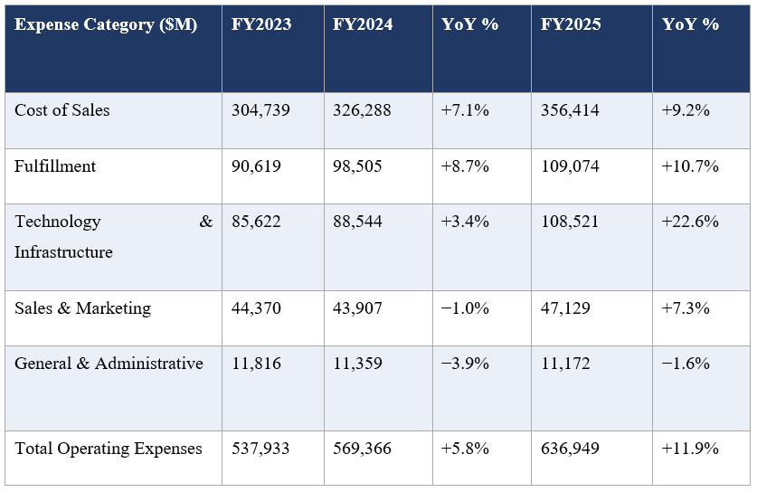
Table 2: Operating Expenses Year-on-Year (USD millions)
Fixed costs are mainly technology infrastructure, research and development and administration costs. The investment in technology and infrastructure jumped from $88.5bn in FY2024 to $108.5bn in FY2025, largely due to growth in the abilities of AI and cloud computing (Amazon, 2026). General and administrative expenses grew slightly to $11.2 billion, reflecting good management of overheads.
Amazon's cost strategy mirrors Kaplan and Atkinson's (2015) advice to focus on ongoing cost efficiencies as well as strategic investments. Likewise, Drury (2018) points out that there are scale efficiencies and process optimisations to be gained by high-volume firms in cost reduction per unit. Amazon's cost-to-revenue ratio for FY2023 was 93.6%, which is better than it was in FY2025 at 89.2%, indicating greater operational efficiency.

Budgeting and Financial Planning

Role of Budgeting in Amazon's Operations
A budget is not a one-off annual activity at Amazon; it's a dynamic process that is strategic. Amazon is a very capital-intensive company and in FY2025, had reported capital expenditure of $131.8 billion as compared to $83.0 billion in FY2024 (Amazon, 2026). The firm has an ongoing investment plan that sees budgets adjusted to long-term priorities, especially in areas such as infrastructure and logistics investments on AWS. The company has a flexible budgeting system, and financial forecasts and segment performance are reviewed quarterly, according to the FY2025 10-K (Amazon, 2026).
Amazon's cost management philosophy is to focus on free cash flow, rather than short-term profit. Net cash from operating activities rose from $115.9 billion in FY 2024 to $139.5 billion in FY 2025, driven by improved operational efficiency and the return of investments made in the past on logistics and infrastructure to support cloud operations (Amazon, 2026). This is in line with Drury's (2018) opinion that rolling budgets are useful in a rapidly changing environment because they can be continually adapted to the new information.
Amazon's budgeting system is also based on segments. AWS, North America and International are considered as three distinct profit centres with specific budgets for fulfilment, technology, marketing and administration expenses (Amazon, 2026). This is in line with the Responsibility Accounting principles explained by Horngren, Datar and Rajan (2015), which assigns responsibility for performance to managers within specified areas.

Year-on-Year Operating Expense Changes: Internal and External Drivers
Technology and infrastructure costs rose by 3.4% to $88.5 billion in FY2024, and total operating expenses rose 5.8% while revenues rose 11%, which resulted in the improvement in operating margin expansion from 6.4% to 10.8% (Amazon, 2025). The improvement was primarily due to restructuring of internal costs, such as a transition to a regionalised fulfilment network and the optimisation of their workforce, resulting in a decrease in General and Administrative costs from $11.8 billion to $11.4 billion (Amazon, 2026).
FY2025, on the other hand, witnessed a significant surge in technology and infrastructure investments, reaching $108.5 billion, reflecting a 22.6% increase. This increase was primarily due to the acceleration of investment in AI infrastructure, AWS generative AI services, and data centre expansion. Capital expenditure also rose substantially from $83.0 billion to $131.8 billion (Amazon, 2026), a testament to the competition that capital expenditure is facing from Microsoft Azure and Google Cloud.
Other factors affected costs, too. Foreign exchange fluctuations have had an impact on revenue of $4.4 billion (Amazon, 2026), and inflation has driven up fulfilment and labour expenses. The impact of higher rates on leasing-related costs throughout Amazon's property portfolio around the world was further felt.

Measurement and decision making for performance

Key Performance Indicators
Amazon employs a mix of financial and non-financial KPIs, which are reported in its annual reports and investor filings (Amazon, 2026). Operating margin is an important financial KPI that indicates how effectively the firm converts revenue into profit despite significant reinvestment. This rose from 6.4% in FY2023 to 10.8% in FY2024 and 11.2% in FY2025, reflecting the company's operating leverage, meaning that fixed costs are being applied to a larger revenue base (Amazon, 2026). The net income also grew significantly from $30.4 billion in FY2023 to $77.7 billion in FY2025, which led to a corresponding increase in earnings per share (EPS) from $2.90 to $7.17.
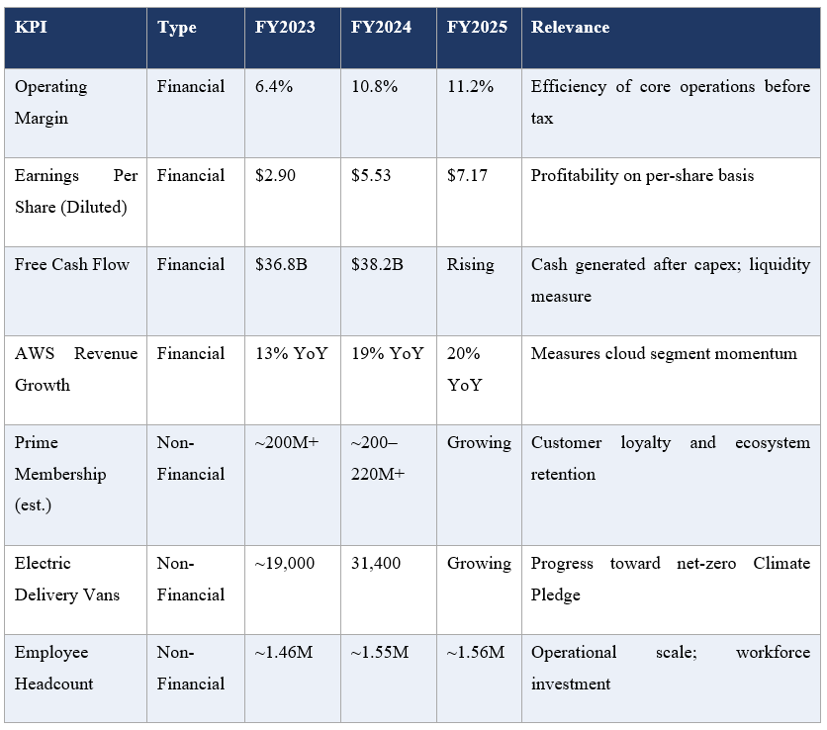
Table 3: Amazon Key Performance Indicators Sources: Amazon.com, Inc. Form 10-K (2026); Amazon Sustainability Report (2025); Amazon Q4 2024 Earnings Release.

Amazon's leadership in cloud and AI infrastructure is reflected in its AWS revenue growth, which increased by 19.6% to $128.7 billion in FY2025. (Amazon, 2026) Prime membership, which is estimated to reach more than 200 million users, is also a crucial non-financial KPI that is associated with customer retention and long-term revenue growth, as Prime members have been seen to spend more consistently (Statista, 2025). The expansion of electric vehicles in Amazon's fleet (31,400 to 19,000 between FY2023 and FY2024) is indicative of progress toward Amazon's Climate Pledge goals (Amazon Sustainability, 2025).

Strategic Decisions Based on Financial and Non-Financial Data
Amazon's decisions are made strategically in a way that combines both financial and operational KPIs. AI infrastructure investment will be a key component of AWS's capital expenditures, totaling $131.8 billion for FY2025, driven by the company's high operating margin of approximately 37% and the competitive pressure from Microsoft Azure and Google Cloud (Amazon, 2026). This is in line with the Balanced Scorecard of Kaplan and Norton (2001), who put forward the importance of non-financial leading indicators for strategic decision making.
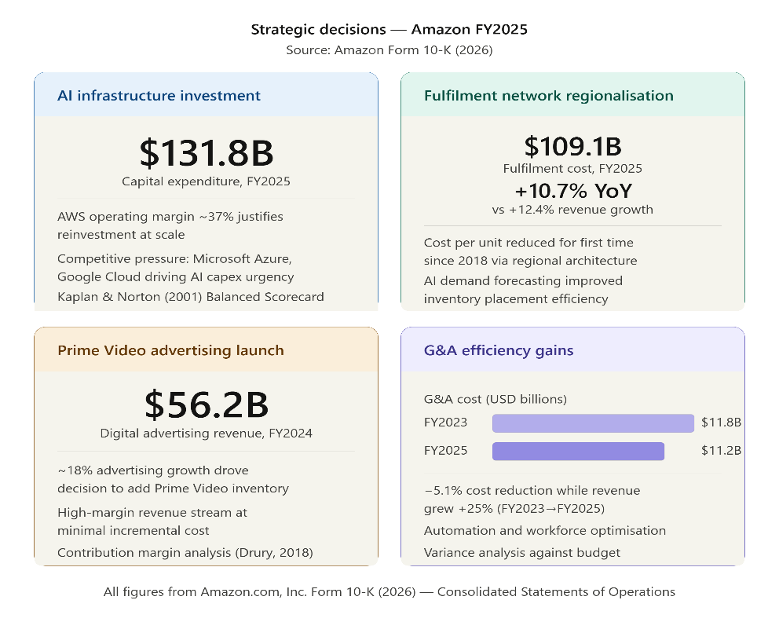
Image 2: Amazon’s financial indicators (Source: Author’s creation)
Cost analysis, cost per unit logistics and AI forecasting of demand, and better stock placement (Amazon, 2025) were the factors that led to network regionalisation. Likewise, the launch of advertising on Prime Video in 2024 has been driven by robust digital advertising growth of $56.2 billion in FY2024, which allows high-margin revenue growth at minimal incremental cost.
Last, but not least, General & Administrative (G&A) costs fell from $11.8 billion in FY2023 to $11.2 billion in FY2025, even as revenue increased by 25% due to G&A efficiency gains through automation and workforce optimisation with the help of variance analysis (Amazon, 2026).

Sustainability in Financial Decision-Making
Amazon has incorporated sustainability into financial planning with The Climate Pledge, which will see it reach net-zero carbon emissions by 2040 (Amazon Sustainability, 2025). This includes significant capital investment, such as $2 billion in EV deliveries and expanded decarbonization of logistics and AWS infrastructure. These are seen as strategic investments in capital and not as expenditure on CSR.
For the second year in a row, Amazon matched 100% of its electricity use with renewable energy sources by powering more than 600 renewable energy projects across the globe in FY2024 (Amazon Sustainability, 2025). These are investments that must be made initially, but the costs of energy use and regulatory risk are lowered over the long term. Amazon also increased its spending on technology and infrastructure, from $88.5 billion in FY2024 to $108.5 billion in FY2025, and now ties the investments more strongly to sustainability goals.
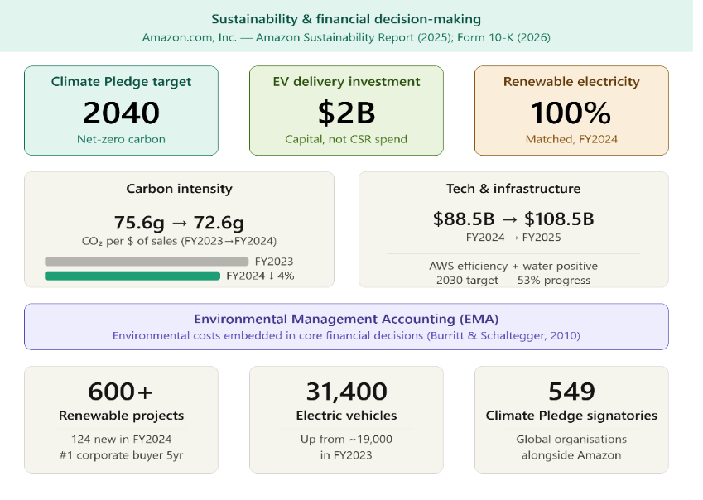
Image 3: Sustainability in financial decision-making (Source: Author’s creation)
AWS data centres are engineered to be extremely energy efficient, and Amazon is on track to be water positive by 2030 (to date, 53% progress- Amazon Sustainability, 2025). The carbon intensity went down from 75.6g of CO₂ per dollar in sales to 72.6g of CO₂ per dollar in sales, indicating efficiency. It is in line with the principles of Environmental Management Accounting, which incorporate the environmental costs into the main financial decision-making process (Burritt and Schaltegger, 2010).

Ethical aspects of cost management and pricing
Amazon's pricing policy also creates moral dilemmas because the company's low pricing is achieved through cross-subsidisation from its AWS and advertising businesses, which could result in regulatory issues and competitive distortions (European Commission, 2023). Labour practices also raise ethical issues because of their 1.56 million employees and the continuous issues regarding working conditions in the warehouses and unionisation rights under the UN Guiding Principles on Business and Human Rights (2011). Bhimani et al. (2019) state that from a management accounting point of view, the social and environmental costs should be included in the cost systems, and it is recommended that a stronger integration of social and environmental costs in the supply chain of Amazon is needed.

Conclusion and Recommendations
This report used the management accounting principles as applied to Amazon with FY2023 – FY2025 data. Amazon's revenue went up from $574.8 billion to $716.9 billion, thanks to its Amazon Web Services growth, advertising revenue and steady Prime membership (Amazon, 2026). Operating income grew from $36.9 billion to $80.0 billion, and operating margins went from 6.4% to 11.2%, driven by the significant economies of scale and the efficiency of the company's operations. The company's investment in infrastructure and AI, reflected in capital expenditures of $131.8 billion for the year, underscores the company's strategic priorities. Sustainability has become a more integral part of financial planning, with the company's investments in infrastructure and AI highlighted by its capital expenditures of $131.8 billion for FY2025.
Some of the key recommendations are: Activity Based Costing (ABC) should be adopted in fulfilment operations to correctly allocate costs, Environmental Management Accounting should be introduced to account for the environmental costs in financial decisions and the budgeting system should be strengthened by using AI-based rolling forecasts for better flexibility and efficient resource allocation (Burritt and Schaltegger, 2010; Drury, 2018).

References
Amazon Sustainability (2025). Amazon 2024 sustainability report.
Available at: https://sustainability.aboutamazon.com
Accessed: 11 June 2026
Amazon.com, Inc. (2025a) Annual report on Form 10-K for the year ended December 31, 2024. Seattle: Amazon.com, Inc.
Available at: https://s2.q4cdn.com/299287126/files/doc_financials/2025/ar/Amazon-2024-Annual-Report.pdf
Accessed: 12 June 2026
Amazon.com, Inc. (2025b) Fourth quarter and full year 2024 earnings release.
Available at: https://s2.q4cdn.com/299287126/files/doc_financials/2024/q4/AMZN-Q4-2024-Earnings-Release.pdf
Accessed: 10 June 2026
Amazon.com, Inc. (2026) Annual report on Form 10-K for the year ended December 31, 2025. Seattle: Amazon.com, Inc.
Available:https://www.sec.gov/cgi-bin/browse-edgar?action=getcompany&CIK=0001018724&type=10-K
Accessed: 15 June 2026
Bhimani, A., Horngren, C.T., Datar, S.M. and Rajan, M.V. (2019) Management and cost accounting. 7th edn. Harlow: Pearson Education.
Burritt, R.L. and Schaltegger, S. (2010) 'Sustainability accounting and reporting: fad or trend?', Accounting, Auditing & Accountability Journal, 23(7), pp. 829–846.
Drury, C. (2018) Management and cost accounting. 10th edn. Andover: Cengage Learning.
European Commission (2023) Antitrust: Commission opens formal proceedings against Amazon. Brussels: European Commission.
Available at: https://ec.europa.eu/commission/presscorner/detail/en/ip_23_4443 Accessed: 12 June 2026
FourWeekMBA (2026) Amazon cost structure.
Available at: https://fourweekmba.com/amazon-cost-structure
Accessed: 14 June 2026
Horngren, C.T., Datar, S.M. and Rajan, M.V. (2015) Cost accounting: a managerial emphasis. 15th edn. Harlow: Pearson.
Kaplan, R.S. and Atkinson, A.A. (2015) Advanced management accounting. 3rd edn. Upper Saddle River: Prentice Hall.
Kaplan, R.S. and Norton, D.P. (2001) The strategy-focused organization: how balanced scorecard companies thrive in the new business environment. Boston: Harvard Business School Press.
Statista (2025) Estimated number of Amazon Prime members worldwide from 2014 to 2025.
Available at: https://www.statista.com/statistics/546894/number-of-amazon-prime-paying-members
Accessed: 13 June 2026
Strategic Management Society (2023) Labour practices and firm strategy: the Amazon case. Chicago: SMS.
United Nations (2011) Guiding principles on business and human rights: implementing the United Nations 'protect, respect and remedy' framework. New York: United Nations.

Appendix

