LITERATURE REVIEW ON THE
INCIDENCE OF COVID 19 AMONG THE ETHNIC MINORITIES IN THE UK
omeneke yusuf (2009232)
LECTURER: ROBERT NARTOWSKI
BMPH 5005

TABLE OF CONTENTS
ABSTRACT 2
BACKGROUND OF STUDIES 2
ETHIC OF STUDY 2
DEFINITIONS OF TERMS 2
INTRODUCTIONS 2
METHODOLOGY 4
FINDINGS 0
FINDINGS 0
DISCUSSIONS 1
RECOMMENDATION 5
CONCLUSION 5
REFERENCES 6

ABSTRACT

BACKGROUND OF STUDIES
The incidence of Covid 19 has greatly affected the black, Asian and minority Ethnicity. The mortality and morbidity rate were highest among the ethnic minority during the 2020 Covid-19 pandemic which brought the question of why these group of people were more susceptible. Inequality faced by people of different racial backgrounds in the UK has been thoroughly documented throughout the course of the last half century, (Lymperopoulou and Finney, 2016, (Khunti et al., 2020); (Aldridge et al., 2020).
This literature review comprises of all the 27articles including the grey literatures and 22 articles used to summarise the finding from all the authors. The finding is that large Data were collected mostly from the hospitals and inequalities that already existed among the ethnic Minorities accounts for disparities when compared to the White Majorities in the United Kingdom.
The observations from the review provided by the indicates that people of African ancestry and other Ethnic minorities are more likely to be affected negatively by COVID-19 than other ethnic groups; with a higher likelihood of needing to be admitted to intensive care for those of South Asian, Black, and Other Ethnic Minority groups, (Khunti et al., 2020); Centres for Disease Control and Prevention (2020).

ETHIC OF STUDY
This Study is a review of literature on the Incidence of Covid-19 among People from Minority Ethnicity to the Fulfilment of Academic requirement of level 5 Bachelor of Science in Health and social care about an existing health condition of Interest.
This study prevents manipulating research data and interpreting improperly, as well as promote trust, responsibility, and respect in the research community. In the study, vulnerable groups were shielded from any aspects that would have been harmful to them.

DEFINITIONS OF TERMS
Black Asian and Minority Ethnicity (BAME), World Health Organisation (WHO), Centers for Diseases Control and Prevention (CDC), Covid-19 (of SARS-COV2)

INTRODUCTIONS
The onset of Covid 19 has been a worldwide concern on health and livelihood of the general public. When unexplained pneumonia was found in Wuhan, China, experts realised a new strain of SARS-COV2 had arisen. Huang et al, (2019). According to research from both the UK and internationally, members of Black, Asian, and Other Minority Ethnic (BAME) communities are at a greater risk of contracting this new strain of Virus (COVID-19) and dying as a result. (Aldridge et al., 2020). In general, World Health Organisation (WHO) reported 23,930,041 confirmed cases of COVID-19 in the UK from 3 January 2020 to 4 November 2022. 11 September 20, (WHO Coronavirus Disease (COVID-19), 2022). This literature review finds about 27 articles and 22 of the articles were used to summarise the commonest finding which are equalities among the ethnic minorities which predisposes them to the high incidence of Covid.

METHODOLOGY
Google scholar was used to search for the research question ‘When conducting nation research to investigate the relationship of COVID-19 and race, Included in the search were the terms "ethnic" , "ethnic background or black, Asian and Minorities Ethnicity (BAME)" "COVID" or "coronavirus," or "SARS-CoV-2," and "UK" or "England."’ and generated about 128,000 articles, advanced search done to filter 10,000 literatures and 5 grey literatures were found. Four relevant resources from the grey literature and articles selected for this Literatures review. This literature review comprises of all the 27 articles including the grey literatures 22 articles were used to summarise the finding from all the authors. The commonest Statistical finding is that large Data were collected mostly from the hospitals and existing Inequalities in health and socioeconomic status among the ethnic Minorities accounts for disparities when compared to Ethnic Majorities in the United Kingdom.
Google search:
108,000 articles

Advance search and reduced to 10,000

4 Selected from grey literature
Grey Literature:7 sources from search

22 selected Articles.

Discussion

Recommendation And Conclusion

FINDINGS
This literature review finds 27 articles that meet the study topic and generated a table of findings from 22 articles with the grey literature to compare the different themes from the Authors. Commonest among the findings is the inequalities that existed before the Pandemic among the Black, Asian and Ethnic minorities (BAME) predispose them to Covid 19. The finding observes the Sample size, weaknesses and strength of the study findings. The Study finds some consistent factors responsible are the inequalities that existed in health, socioeconomic status and housing or overcrowding accounts for the high mortality and morbidity rate among the Ethnic Minorities in the United Kingdom.

FINDINGS

AUTHOR | TYPE OF RESEARCH | STRENGTH | WEAKNESS | SAMPLE SIZE | POOR HEALTH | SOCIOECONOMIC FACTORS | HOUSING AND OVERCROWDING | MORTALITY  RATE
1.Aldridge, et.al, (2020). | Quantitative | Large data from NHS patient who died in hospital used. | No sex differentiation.  Short period data collected. Ethnicity not recorded on death Certificate. | 16,272 deaths | Presence of pre-existing health Conditions | More people in BAME groups have low incomes. | Overcrowding in dwellings is associated with an elevated risk of disease transmission. | high mortality rate among racial minorities. COVID-19 fatalities in health and social care professionals.
2.(WHO Coronavirus Disease (COVID-19), 2022) | Grey/  Meta-analysis | Large data monitored by the world health Organisation | Novel disease and no prior Knowledge of BAME Susceptibility |  | Presence of previous health problems | Deprived more communities hardest hit by Covid-19 |  | High record of death than Normal Time.
3.(Niedzwiedz et. al.,2020) | Quantitative | Large sample size used, thus can be generalised. | Health and behavioural risk factors were adjusted, while socioeconomic characteristics had very slight decrease. | 392,116 | Health Inequalities | Poor socioeconomic Status of Ethnic Minorities | Poor housing and overcrowding.
4.(Lymperopoulou and Finney,2016) | quantitative | ONS Data, Location with all ethnic representations and effect of Deprivations on BAME Communities. | Data did not mention Covid as it was only focused on Other Inequalities before Covid-19 |  | Pre-existing health Inequalities in the UK. | Yes | Yes
5.(Mathur et al.,2022) | Quantitative | Largest research in the UK to evaluate ethnic differences in SARS-CoV-2(Covid-19) among 30% of England's population. | insufficient current data due to the absence of certain predictors | 17 288 532 adult Population | the presence of other illnesses, and other clinical considerations | a lack of available resources and equitable distributions. | Greatest number of members per family among the BAME groups. | Blacks and those of mixed racial backgrounds had a higher mortality rate.
6.Office for National Statistic (ONS) 2020 | Quantitative | Data collected from nationwide.  Official government statistic | Some data may not be recorded from the self-reported ethnicity.  More Study needed. | Per  100,000  People. | Comorbidities as contributing Factors | Presence of socioeconomic disadvantage and high-risk jobs. | Large family size and Compositions | Higher statistics of Death among the black and Asians.
7.(Garg et al., 2020) | Meta analysis | Valid Data collected from patient who were admitted in the ICU | It was not able to match the rate of underlying illnesses in inpatient against non-hospitalized patients. |  | Many of the hospitalised people were suffering from pre-existing ailments. |  |  | Have higher tendencies of dying from Covid-19
8.(Khunti et al., 2020) | Quantitative | Data collected from intensive Unit with different ethnicity | Needs a Comprehensive national statistics broken down by ethnicity. | 2249 | Cardiovascular disease risk factors are more common in BAME Community | Most likely to be working in important low-paying occupations | Number of disadvantages, including inadequate housing and overcrowding. | Black people are almost six times more likely to die from Covid-19
9.(Alaa et al., 2020) | Quantitative | Large Data from hospital patients. The results agree with previous research and common sense. | reliance on observed data, leaves result open to the possibility of bias from unmeasured variables. No adjustments could be made for obesity or smoking. | 72,358 | Compared to white individuals of the same age, racial minorities had an increased incidence of heart disease, endocrine illness, and high blood pressure. | socioeconomic disadvantages.  lack of resources and environmental hazards in the workplace |  | Death rates that are significantly higher than average
10.(Han et al., 2021) | Meta-analysis | Discovered from studies of ICU Covid-19 patients that Asthma is a predisposing factor for Covid-19 | Study was based on One health Condition only and no account of other issues which can worsen Covid outcome. | 854,405 | Patient with Asthma has a higher Intensive Unit Number than non
11.(Zakeri et al., 2020) | Quantitative | Study was able to get data on poverty at the postcode level. | Number of Asians included in the analysis was limited. Most household, Ethnicity and employment detail missing. | 872 | Social and economic determinants of illness and diseases found to be Present | Presence of economic and social inequalities | Living in households with different generations and mostly Overcrowded
12.(Holmes et al., 2022) | Quantitative | Analyse how race, a socioeconomic determinant, affects the risk of contracting and dying from COVID-19 | Some states lack comprehensive racial/ethnic statistics.  only utilise the information available at that time. | 19,062 | Pre-existing health conditions present in most of the samples. | Mostly live in poverty and low-income jobs. |  | High mortality rate observed in the study.
13.(Bhatia, 2020) | Review | Data collected from various European countries and can be generalised. | This study did not utilise statistical data to arrive at conclusion |  | Health Inequalities existed before the Pandemic. Possible comorbidities |  |  | Higher mortality among BAME  Working in the NHS
14.(Kakkar, Dunphy and Raza, 2020) | Quantitative | The group sampled was nearly evenly distributed across the sexes. | The data gathered lacks comorbidity information and employment health data. | 3018 | Hereditary susceptibility to COVID-19 or co-morbidities
15.(Hoebel et al., 2021) | Quantitative | The study employed a national database of mortality linked to economic deprivation. | Results cannot be used to establish cause-and-effect, and environmental error cannot be ignored. | 32,193 men and  31,31-women |  | Differences in death rates due to COVID-19 by socioeconomic status |  | There was increase death rate among the ethnic minority groups.
16.(Centres for Diseases Control and Prevention (CDC), 2020) | Quantitative  (Grey) | Official Government Statistic | The health of racial and ethnic minorities is still developing. | Per 100,000 people | due to poor underlying health and difficulties accessing medical care.
17.(Bambra et al., 2020) | Peer review | Data collected across Europe and examined the inequality that already existed before Covid-19. | The study did not take the statistic of people affected. |  | Chronic health Problems is a determinant fact | Unemployment and poor living conditions Predominant. | Living in the poorest communities and unsafe living conditions. | Reduce life expectancy already existed leading to increase death rate
18.(Cook et al., 2020) | Quantitative | Data compared total number of deaths as a percentage of the population. | No systematic analysis to substantiate the observations from the records. Not known if news and social media catch most fatalities or if there are media biases. | 116 people who died from Covid | Presence of Covid-19 risk factors related to hypertension and diabetes. | Occupation and working practises promote susceptibility and spreading |  | 116 NHS Staff who died from Covid, BAME people account for 63%, 64%, and 95% of staff fatalities.
19.(Sapey et al., 2020) | Quantitative | Study included all the inpatient in University of Birmingham Hospital | Studies haven't given any clues about why covid outcomes might be worse. | 2217 | Patients presented a history of existing health Issues | Lack and associated conditions |  | There was a connection between being of South Asian descent and a higher mortality rate.
20.(Rentsch et al., 2020) | Quantitative | Examine coronavirus 2019 (Covid-19) testing with death by racial and ethnic background in the largest American health service. Identified National electronic health record data. | Study was conducted on Veterans Only.  Few women in Veterans Studied thus cannot be generalised in respect of sex. Veterans are mostly old. | 5,834,543 | Existence of previous health conditions
21.(Hu, 2020) | Quantitative | The statistics demonstrate that COVID-19 affects racial and native-migrant inequality. | Samples was restricted to adults aged 20-65 in order to account for their job status. | 10,336 |  | Economic disparities, such as losing a job, getting behind on expenses, and being unable to reduce work hours
22.(Thomas et al., 2021) | Quantitative | This research adds to the increasing body of data showing that members of Wales's ethnic minority are adversely affected by the COVID-19 outbreak. | low rates of noting ethnicity in medical records was a major limitation. One problem is that there aren't enough personal data on chronic health conditions. | 4046 |  |  |  | Compared to females, the male BAME have higher Mortality rates. BAME group have younger age mortality rate than the White Community

DISCUSSIONS
The findings of the 22 articles included in this literature is summarised in a table above which shows the strength, weaknesses and the inequalities that existed among the Black, Asian and Ethnic minorities, (BAME). BAME patients make up a substantially high percentage of hospital and intensive care unit admissions, particularly in younger age groups in various studies, (Alaa et al., 2020); (Holmes et al., 2022); (Rentsch et al., 2020)
Although most minority groups already resided in Britain for decades, studies demonstrate that ethnic inequities continued to exist, (Whitehead, Taylor-Robinson and Barr,2021). Historically and currently in other part of Europe, societal inequality has been connected to the transmission of harmful microorganisms like viruses, (Holmes et al., 2022). The living, learning, working, and recreational environments influence the health of individuals. With time, these situations can contribute to differing degrees of health concerns, (Centres for Diseases Control and Prevention (CDC), 2020)
A study analysed ''hospitalisation, death, ''and ''primary care electronic health data associated with'' COVID-19 PCR testing ''of 17 288 532 people in England ''(30% of the population) using OpenSAFELY'', Minority ethnic groups had a greater rate of SARS-CoV-2 and COVID-19 infections, hospitalisation, ICU admission, and death. (Mathur et al.,2022). In the total of 872 cases studies, 48.1% were Black, 33.7% White, 12.6% Mixed/Other, and 5.6% Asian, (Zakeri et al., 2020).Figures released by the Office for National Statistics (ONS) on April 24, 2020, shows the statistics of death among Asians were (8.4%) and Blacks (3.8%).
There was information on the ethnicity of 72,358 (92%) out of the 78,443 individuals who were diagnosed with COVID-19, (Alaa et al., 2020).64.8% of 2249 patients in critical care units admitted with Covid 19 in England were white, 13.8% were Asian, 13.6% were black, and 7.8% were from other or mixed ethnic groups, (Khunti et al., 2020). Deaths by ethnicities were collected from March 1, 2020, to April 21, 2020, from the NHS record, Indian (492 fatalities) and Black/ Caribbean (460 deaths) ethnic groups had the highest overall mortality tolls among minority ethnicity, (Aldridge, et.al,2020). Due to a greater prevalence of pre-existing sickness, poorer populations are therefore more susceptible to severe disease once infected, (Whitehead, Taylor-Robinson and Barr,2021). However, a study conducted on American Veteran shows that; An excessive load of Covid-19 has been seen in the Black and Hispanic populations, which cannot be fully explained by demographics or other diseases (Rentsch et al., 2020).
Another research findings adds to the increasing body of data showing that members of Wales's ethnic minority are adversely affected by the COVID-19 outbreak, (Thomas et al., 2021). These complex and linked set of characteristics, such as socioeconomic disadvantage, participation in high contact/risk employment, (Alaa et al., 2020), location, family size and composition, and comorbidities, are likely to be responsible for a considerable portion of the elevated risk of getting COVID-19 among the black and Asian communities, (Sapey et al., 2020), (ONS, 2020). Predisposing factors are well acknowledged as a potential cause for severe COVID-19 illness, (Alaa et al., 2020); (Kakker, Dunphy and Raza,2020).
The most socially disadvantaged people had higher death and morbidity rates due to COVID-19's exacerbation of chronic health inequities, (McGowan and Bambra, 2022). A study in England shows that, 2658 people were tested for SARS-CoV-2 between 16 March and 3 May 2020, and 948 tested positive (726 in hospitals) Compared to White Britons, racial minorities and those of South Asian descent had higher relative risks (RRs) (4.0 and 2.1) of infection in research conducted in the United Kingdom, (Niedzwiedz et. al.,2020). More deaths have been attributed to COVID-19 among the obese than among the normal weight, (Office for National Statistics (ONS), 2022). The rate of death from all causes, not only COVID-19, was also greater for this group. South Asian, Black, and Other Ethnic Minority groups have a higher likelihood of needing to be admitted to intensive care, (Garg et al., 2020) and higher chance of dying from Covid -19 when compared with those of White racial heritage (ONS,2020), (Hu, 2020).
People from underprivileged backgrounds are already at a higher risk of contracting COVID-19 due to a combination of factors, (ONS,2020). including discrimination and poverty and unemployment; 37% of Bangladeshis and 31% of Pakistanis are unemployed, compared to 29% and 13% for black Caribbeans and blacks, (Institute of Race Relations, 2020).
Ever since beginning of this epidemic, it has been clear that COVID-19 is not neutral and displays certain discriminatory behaviours, (Bhatia, 2020). In terms of Age, the study shows striking disparity between the prevalence of positivity among black, Asian, and minority ethnic (BAME) men and that among black, Asian, and minority ethnic , (Kakkar, Dunphy and Raza, 2020).Evidence shows that males are more likely to die from COVID-19, especially because higher-risk jobs include more men than women, (Holmes et al., 2022); this increased mortality could also be unknown biological origins (genetic susceptibility), (Cook et al., 2020). Black males had the greatest COVID-19 death rate, at 255.7 per 100,000, while White males had the lowest, at 87.0, (ONS,2020). However, some of the studies did not differentiate between sex of the Ethnic groups, Aldridge, et.al, (2020)

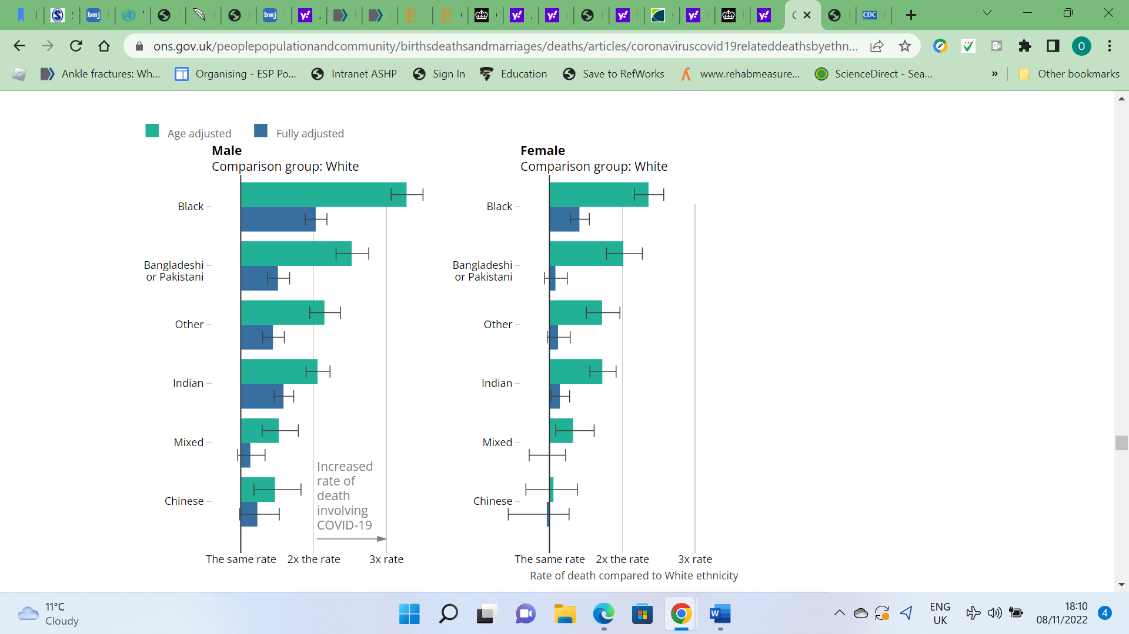 Fig1. Office for National Statistics (ONS), (2020).
Figure 1 illustrates how the rate of COVID-19-related deaths differs by ethnic community for both males and females in comparison to the White ethnic group. When compared with those of White racial heritage, males and females belonging to any ethnic minority group, apart from females of Chinese ethnic ancestry, have a much higher chance of dying from COVID-19, (ONS,2020); (ONS, 2022). Several underrepresented communities in Britain experienced a greater rate of SARS-CoV-2 infection and hospitalisation as compared to the white British majority (Niedzwiedz et al.,2020); (Bhatia, 2020); (Zakeri et al., 2020)
Obesity and hypertension accounted for 21% of COVID-19 mortality in the general population; the proportion was 43% in the Asian group and 45% in the black group, compared to Whites, (ONS, 2022), In the United States, for example, infection and mortality rates are substantially greater in mostly black regions than in predominantly white regions. Blacks and African Americans have ahigh COVID-19 Case Fatality and mortality rates in the United States, despite making up just 13% of the U.S. population, Blacks and African American accounted for 34% of all deaths caused by COVID-19, (Holmes et al., 2022).
Similar findings have been found in the United Kingdom, where people of black, Asian, (Sapey et al., 2020), and minority ethnicity (BAME) experience worse health results than the white population (Bhatia, 2020),
In England, the geographic spread of the disease, poverty, and employment risk all contribute to the disproportionately high rates of COVID-19 infection among people of black, Asian, ethnicity, (Alaa et al., 2020); (Bhatia, 2020). The most impoverished areas had mortality rates up to 1.52 times greater than the least impoverished areas, (Bambra et al., 2020), and there was a similar pattern among the NHS's BAME workforce also., (Bhatia, 2020); (Rentsch et al., 2020).
Administrative workers could work from home during the lockdowns, while others with fewer resources couldn't. Service, care, and company employees may have relied more on public transit during lockdowns, (Holmes et al., 2022).
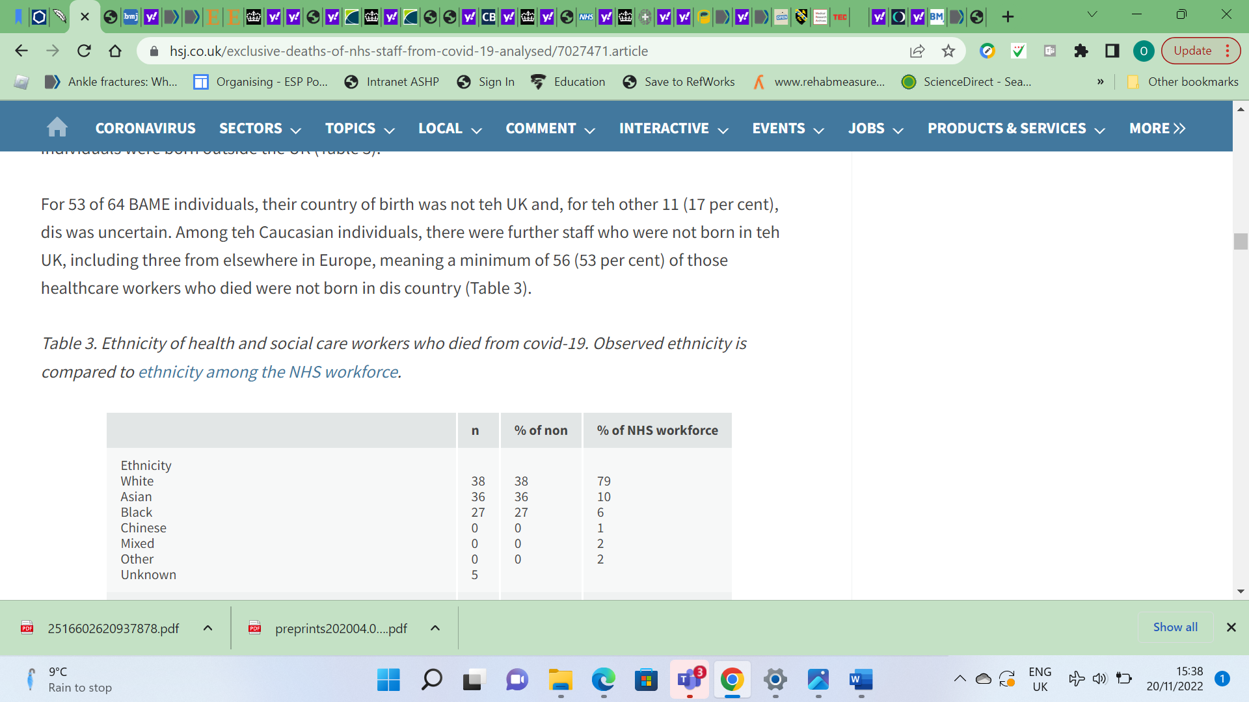
Fig 2. (Cook et al., 2020).
Workers in the health and social care industries (NHS) who passed away as a result of Covid-19. A comparison is made between the observed ethnicity of those employed by the NHS.
While others have noted the disproportionate number of people of colour employed in health and social care who have lost their lives during this epidemic, no systematic analysis has yet substantiated these observations. About 21% of NHS employees are people from Minority Ethnicity; this includes about 20% of the healthcare and support team and 44% of the medical personnel, (Cook et al., 2020). This accounts for the great disproportions observed among the Ethnic Minorities. Historically, the Ethnic Minorities and the poor have borne a disproportionate share of the burden during pandemics, (Lymperopoulou and Finney, 2016). Although there has been some speculation that this is also occurring with the current SARS-CoV-2 epidemic, (Rentsch et al., 2020), there has been very little actual study done on the subject, (Niedzwiedz et al.,2020).
Most of the studies have shown that socioeconomic factors, high risk jobs, sex, and overcrowding are likely factors accounting for the high incidence(ONS, 2020); (Alaa et al., 2020, Current research has found that people of Black, Asian, and Minority Ethnic (BAME) backgrounds are more likely to experience negative medical consequences as a result of exposure to COVID-19 through high risk job.(Pan et al., 2020); (Holmes et al., 2022) ; (Rentsch et al., 2020).They equally tend to work over tie and also when ill when predisposes them more to being negatively affected by the Pandemic. Some Study findings discovered that most of the inequalities that existed in health, socioeconomic status (Niedzwiedz et. al.,2020) ;( Zakeri et al., 2020) and housing accounts for the high mortality and morbidity rate among the Ethnic Minorities in the United Kingdom, (Aldridge, et.al, 2020); (Hu, 2020).
However, disparities in socioeconomic status, baseline self-reported health, and psychological risk factors did not explain the increased probability of identified SARS-CoV-2 infection across several minority ethnicity in the UK Life science research (Niedzwiedz et al.,2020). Ethnic minority groups may be more vulnerable to viral transmission since they are more likely to live in extended cohabiting households and to be economically disadvantaged, (Khunti et al., 2020); (Aldridge et al., 2020). The difficulty is that the government does not consistently disclose all data on deaths and major illnesses caused by COVID-19 among workers in the health care industry, together with information about their ethnicity. It has been shown that during the COVID-19 Pandemic, (BAME) groups are more likely to lose their jobs than white British citizens, less likely to have job protection, like furloughing and less likely to cut back on their hours, (Hu, 2020).

RECOMMENDATION
There must be more focus on disadvantaged communities in pandemic preparation, infection control, and illness prevention to ensure that they have a fair chance of staying healthy throughout and after the epidemic. More studies need to be done to determine the best possible method of removing the predisposition to Infection among the BAME Community in future Pandemic. When planning, governments in the United Kingdom and abroad need to think carefully about how to safeguard vulnerable populations from suffering more inequality and associated health consequences throughout the recovery phase.
A thorough national statistics provided by ethnic group to acquire a better understanding of ethnic differences in prevalence and result in the UK is needed, (Khunti et al., 2020)

CONCLUSION
Observations from the review indicates that people of African ancestry and other Ethnic minorities are more likely to be affected negatively by COVID-19 than other ethnic groups; with a higher likelihood of needing to be admitted to intensive care Unit and dying from it.
Socioeconomic factors, poor health and inadequate facilities are among the inequalities that predisposes the BAME Communities to the high incidence of Covid-19 and its negative effects.

REFERENCES
Alaa et al., (2020). Ethnicity and Outcomes of COVID-19 Patients in England. [online] Available at: https://vanderschaar-lab.com/papers/Ethnicity_COVID19_Cambridge_NHS.pdf [Accessed 10 Nov. 2022].
Aldridge et al., (2020). Black, Asian and Minority Ethnic groups in England are at increased risk of death from COVID-19: indirect standardisation of NHS mortality data. Wellcome Open Research, 5, p.88. doi:10.12688/wellcomeopenres.15922.1.
Bambra et al., (2020). The COVID-19 pandemic and health inequalities. Journal of Epidemiology and Community Health, [online] 74(11), p.965. doi:10.1136/jech-2020-214401.
Bhatia, M. (2020). COVID-19 and BAME Group in the United Kingdom. The International Journal of Community and Social Development, 2(2), pp.269–272. doi:10.1177/2516602620937878.
Centres for Diseases Control and Prevention (CDC) (2020). COVID-19 in racial and ethnic minority groups. [online] stacks.cdc.gov. Available at: https://stacks.cdc.gov/view/cdc/87103 [Accessed 12 Mar. 2022].
Cook, T., Kursumovic, E. and Lennane, S. (2020). Exclusive: deaths of NHS staff from covid-19 analysed. [online] Health Service Journal. Available at: https://www.hsj.co.uk/exclusive-deaths-of-nhs-staff-from-covid-19-analysed/7027471.article [Accessed 20 Nov. 2022].
Garg, S. (2020). Hospitalization Rates and Characteristics of Patients Hospitalized with Laboratory-Confirmed Coronavirus Disease 2019 — COVID-NET, 14 States, March 1–30, 2020. MMWR. Morbidity and Mortality Weekly Report, [online] 69(15). doi:10.15585/mmwr.mm6915e3.
Han et al., (2021). Significant association of pre-existing asthma with an increased risk for ICU admission among COVID-19 patients: Evidence based on a meta-analysis. Journal of Infection. doi: 10.1016/j.jinf.2021.11.021.
Hoebel et al., (2021). Emerging socio-economic disparities in COVID-19-related deaths during the second pandemic wave in Germany. International Journal of Infectious Diseases, [online] 113, pp.344–346. doi: 10.1016/j.ijid.2021.10.037.

Holmes et al., (2022). Black/African Americans (AA) and Disproportionate Burden of SARS-COV-2 (COVID-19) Mortality in the United States. Medical Research Archives, 10(6). doi:10.18103/mra. v10i6.2786.
Hu, Y. (2020). Intersecting ethnic and native–migrant inequalities in the economic impact of the COVID-19 pandemic in the UK. Research in Social Stratification and Mobility, 68, p.100528. doi: 10.1016/j.rssm.2020.100528.
Institute of Race Relations (2020). Inequality, housing and employment statistics. [online] Institute of Race Relations. Available at: https://irr.org.uk/research/statistics/poverty/ [Accessed 21 Nov. 2022].
Kakkar, D.N., Dunphy, D.J. and Raza, D.M. (2020). Ethnicity profiles of COVID-19 admissions and outcomes. Journal of Infection. doi: 10.1016/j.jinf.2020.05.059.
Khunti, K., Singh, A.K., Pareek, M. and Hanif, W. (2020). Is ethnicity linked to incidence or outcomes of covid-19? BMJ, [online] 369(8243). doi:10.1136/bmj.m1548.
Lymperopoulou, K. and Finney, N. (2016). Socio-spatial factors associated with ethnic inequalities in districts of England and Wales, 2001–2011. Urban Studies, 54(11), pp.2540–2560. doi:10.1177/0042098016653725.
Mathur et al., (2022). Ethnic differences in SARS-CoV-2 infection and COVID-19-related hospitalisation, intensive care unit admission, and death in 17 million adults in England: an observational cohort study using the OpenSAFELY platform. The Lancet, 397(10286), pp.1711–1724. doi:10.1016/s0140-6736(21)00634-6.
McGowan, V.J. and Bambra, C. (2022). COVID-19 mortality and deprivation: pandemic, syndemic, and endemic health inequalities. The Lancet Public Health, 7(11), pp.e966–e975. doi:10.1016/s2468-2667(22)00223-7.
NHS Confederation (2020). PHE review on disparities in the risk and outcomes of COVID-19 NHS Confederation. [online] www.nhsconfed.org. Available at: https://www.nhsconfed.org/publications/phe-review-disparities-risk-and-outcomes-covid-19#c-table-of-contents__list-key-findings-2 [Accessed 17 Nov. 2022].
Niedzwiedz et al., (2020). Ethnic and socioeconomic differences in SARS-CoV-2 infection: prospective cohort study using UK Biobank. BMC Medicine, [online] 18(1). doi:10.1186/s12916-020-01640-8.
Office for National Statistics (ONS) (2020). Coronavirus (COVID-19) related deaths by ethnic group, England and Wales - Office for National Statistics. [online] www.ons.gov.uk. Available at: https://www.ons.gov.uk/peoplepopulationandcommunity/birthsdeathsandmarriages/deaths/articles/coronaviruscovid19relateddeathsbyethnicgroupenglandandwales/2march2020to15may2020#ethnic-group-differences-in-deaths-involving-covid-19-adjusted-for-socio-demographic-factors.
Office for National Statistics (ONS) (2022). Obesity and mortality during the coronavirus (COVID-19) pandemic, England - Office for National Statistics. [online] www.ons.gov.uk. Available at: https://www.ons.gov.uk/peoplepopulationandcommunity/birthsdeathsandmarriages/deaths/articles/obesityandmortalityduringthecoronaviruscovid19pandemicengland24january2020to30august2022/24january2020to30august2022 [Accessed 17 Nov. 2022].
Rentsch et al., (2020). Covid-19 by Race and Ethnicity: A National Cohort Study of 6 million United States Veterans. medRxiv. [online] doi:10.1101/2020.05.12.20099135.
Sapey et al., (2020). Ethnicity and risk of death in patients hospitalised for COVID-19 infection in the UK: an observational cohort study in an urban catchment area. BMJ Open Respiratory Research, [online] 7(1), p.e000644. doi:10.1136/bmjresp-2020-000644.
Thomas et al., (2021). Ethnic variation in outcome of people hospitalised during the first COVID-19 epidemic wave in Wales (UK): an analysis of national surveillance data using Onomap, a name-based ethnicity classification tool. BMJ Open, 11(8), p.e048335. doi:10.1136/bmjopen-2020-048335.
Whitehead, M., Taylor-Robinson, D. and Barr, B. (2021). Poverty, health, and covid-19. BMJ, [online] 372(376). doi:10.1136/bmj.n376.
WHO Coronavirus Disease (COVID-19) (2022). WHO Coronavirus Disease (COVID-19) Dashboard. [online] covid19.who.int. Available at: http://covid19.who.int.
Zakeri et al., (2020). A case-control and cohort study to determine the relationship between ethnic background and severe COVID-19. EClinicalMedicine, 28, p.100574. doi: 10.1016/j.eclinm.2020

