Damian Walczak (2015478)
Module
Applied Programmable Logic Controllers ACDA6000
LEVEL 6 ASSESSMENT
BEng Electrical and Electronic Engineering

Contents
Introduction 2
Literate PLC Review 3
Factory design 7
Ladder logic program 11
HMI 31
Conclusion 34
Reference 35

Introduction
This report provides an overview of the design and control of a factory system capable of sorting packages based on size and weight. Using the Factory I/O simulation platform, the system include a range of components, including conveyor belts, pushers, sensors, and a conveyor scale, to automate the sorting process. The system design prioritizes safety, efficiency, and ease of use, with features such as an emergency stop, warning indicators, and an Human Machine Interface (HMI).

The report addresses the key tasks involved in the project:
- A literature review of programmable logic controllers commonly used in industrial applications.
- The design of the factory process with detailed component descriptions.
- Development of a ladder logic program to control the system.
- Integration of an HMI for operator interaction and system monitoring.

By systematically addressing these tasks, the report aims to provide framework for implementing the factory system while ensuring operational efficiency.

Literate PLC Review
Programmable Logic Controllers are essential in industrial automation, functioning as specialized computers that automate processes by receiving input data, processing it based on predefined logic, and executing commands through output devices. Their primary role involves monitoring, controlling, and optimizing industrial equipment operations.
Key Features of PLCs
- Input/Output Modules:
  - Inputs: Sensors, switches, or other devices provide real time data to the PLC's CPU. Examples include temperature sensors, push buttons, or weight scales.
  - Outputs: Based on the processed data, the PLC sends signals to devices like motors, relays, valves, or alarms.
  - Modularity: PLCs allow customization of I/O modules to suit specific applications, ensuring scalability and flexibility.
- Communication Capabilities:
PLCs are equipped with communication protocols like Modbus, Ethernet/IP, and Profinet, enabling them to interact with other PLCs, Supervisory Control and Data Acquisition (SCADA) systems, or databases. This connectivity ensures seamless integration in modern industrial networks.
- Human Machine Interface (HMI):
An HMI allows operators to interact with the PLC in real time, monitor system status, and make adjustments. These interfaces range from basic text displays to sophisticated touchscreens.
- Real Time Processing:
PLCs operate in deterministic cycles, ensuring timely response to inputs and outputs critical for industrial automation.
- Design:
PLCs are built to withstand harsh industrial conditions, including temperature extremes, vibrations, and electrical noise.
Programming Languages for PLCs
PLCs are programmed using software on a computer, then uploaded to the controller. The most common programming languages are:
- Ladder Logic which simulates electrical relay logic, with "rungs" representing input-output operations. Visually seen and widely used in industrial settings for straightforward logic representation.
- Structured Text which is an object oriented language C or Python, offering more advanced and flexible programming capabilities.
(UNITRONICS, 2023)

Comparative Analysis of Popular PLC Brands
SIMATIC S7-300
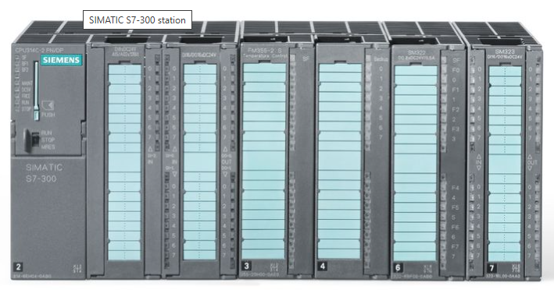
The Siemens SIMATIC S7-300 is designed for a wide range of industrial applications. Key features include its proven reliability, flexible modular design, and compatibility with a broad selection of input/output modules. It supports system expansions, enabling tailored solutions for various automation needs. It is also supported until 2033, ensuring long-term usability.​
The module integrates seamlessly with the SIMATIC automation system, enabling efficient incorporation of AI algorithms with PLC logic. This integration supports cost effectives and enhance productivity and precision in industrial processes.
(siemens.com Global Website, n.d.)

Micro820™ Programmable Logic Controller
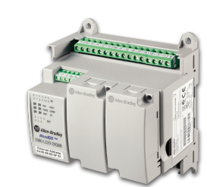
The Allen-Bradley Micro820 controller is optimized for small standalone machines and remote automation projects however there are scalable solutions for different needs. Key features include embedded Ethernet for ‘EtherNet/IPTM for Connected Components WorkbenchTM programming, RTU applications and HMI connectivity’, and remote terminal unit (RTU) functionality. An embedded microSD slot allows program backup. It has built in RTC with no battery required to operate.
(Micro820TM Programmable Logic Controller , n.d.)
Modicon M221
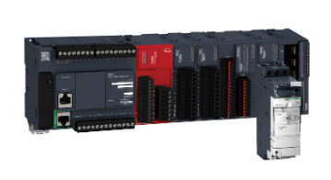
The Modicon M221 Controller from Schneider is a efficient controller designed for all sized industrial applications. Its key features include flexibility to scale machine control to allow easy upgrade to higher performance platforms, connectivity to stay connected using ethernet port or wireless, application support with embedded machine safety and easy programmability using the EcoStruxure Machine Expert. The controller supports multiple communication protocols such as Modbus TCP/IP and serial communication, making it suitable for a range of automation needs.
(Se.com, 2018)

Table 1 presents a summary of prominent PLC brands, highlighting their features, advantages, and limitations.
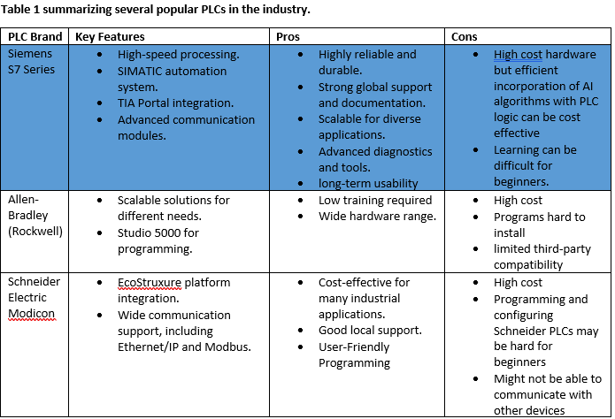
Sources (Siemens Xcelerator, 2024, Rockwell Automation, 2024, Se.com, 2024)
Conclusion
In conclusion Programmable Logic Controllers are used in modern industrial automation, offering robust and scalable solutions for controlling and optimizing processes. The comparative analysis highlights that each PLC brand brings unique strengths tailored to specific applications:
- Siemens S7 Series excels in reliability and modular scalability, making it suitable for complex, large-scale systems but requiring significant investment and expertise.
- Allen-Bradley can be user friendly and well-integrated with Rockwell's ecosystem, a higher cost with limited third-party compatibility.
- Schneider Electric Modicon balances cost effectiveness and user friendly programming while integrating well into energy efficient applications, though it can present compatibility challenges.
Selecting the optimal PLC requires balancing budget, system complexity, and integration requirements. The strengths and limitations of each brand offer valuable insights for key decision in industrial automation projects.

Factory design
The factory system is designed to sort four different package types based on their size and weight. The design incorporates the following components:
- Conveyor Belts: Seven conveyors, started sequentially to limit current draw.
- Pushers: Two pushers to sort packages onto designated paths.
- Conveyor Scale: Measures weight for sorting.
- Diffuse Sensors: 4 sensors to detect package size.
- Emergency Stop: Halts all operations immediately.
- Buttons: Two buttons for start and stop functionality.
- Siren and Warning Lights: Alert’s operators of issues or alarms.
- Stack Lights: Indicate the system’s operational status.
- Package Emitter and Removers: Manually controlled to emit or remove packages as needed.
Operational flow chart.
Steps for designing the factory system would involve defining inputs and outputs, these will be:
Inputs
- Package emitter
- Diffuse sensors
- Conveyor scale
- Buttons
- Emergency stop button
Outputs
- Package removers (for removing packages based on size/weight criteria).
- Conveyor belts and pushers (control of package movement and sorting).
- Display indicators (on HMI for counters, fault warnings, etc.).
- Stack lights (indicates the operational status of the system).
- Siren (alarm system)
- Warning light (indicates issues)
- Conveyor belts
Figure 1 provides conveyor layout,
- Conveyor 1: Will receive the packages from the emitter.
- Conveyor 2: Positioned for size detection and sorting medium boxes.
- Conveyor 3: For medium sized packages after they are measured.
- Conveyor 4: For small and large packages that are sorted accordingly.
- Conveyor 5: For large sized packages after they are measured.
- Conveyor 6: For packages over 4.5kg.
- Conveyor 7: For packages below 4.5kg
Sequence the conveyors to start up one by one to reduce startup current draw
Fig. 1. Conveyor layout
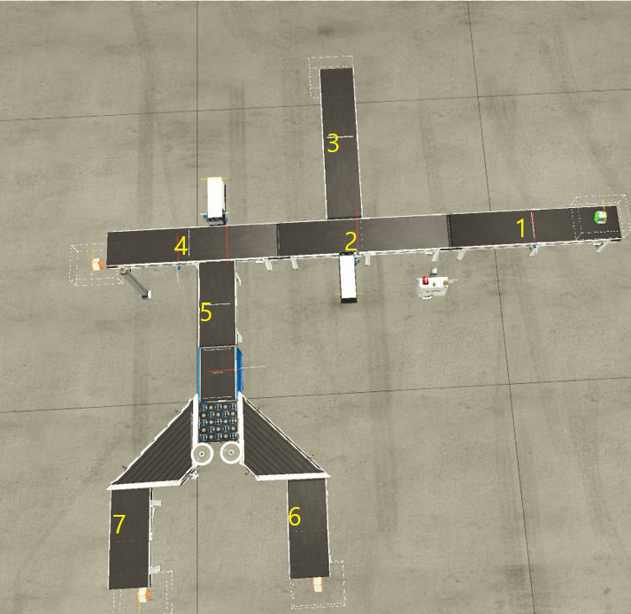
All belts are configured to start sequentially to minimize initial current draw.
System will sort packages based on size and weight. Each diffuse sensor will detect the presence of packages on the conveyor. Their input will help in the decision making for sorting. Based on the measurements, the system will decide if the package is small, medium or large and direct them accordingly. Another sensor will count appropriate size box and add it to display. Diffuse sensors are used for size and presence detection due to their ability to provide accurate, non-contact measurements
Pushers will direct packages to the correct conveyor (small, medium, or large) after determining their size by diffuse sensors. Pushers need to be controlled efficiently to avoid jams and boxes falling out.
System to sort medium boxes based on weight, packages over 4.5kg will be sorted to heavy box conveyor and then removed. Packages under 4.5kg weight will go to lighter box sorter.
Emergency stop should be available as close to control panel as possible to halt all operations immediately if pressed, siren and warning light should be visible to trigger alarms when specific conditions are met. Stack light will be visible to provide visual feedback of the system status.
HMI design will provide start/stop buttons for operational control. It will include reset buttons for resetting counters. Must include fault and warning indicators to alert the operator to any issues. Master Alarm reset options will be available once the issue is resolved only be engineer. HMI must designed to be user-friendly and efficient with a clear layout. Stack light status is mirrored on the HMI for monitoring. The design prioritizes safety by integrating the emergency stop button on the HMI.
If the system is sorting small, medium, and large packages, an engineer might set the maximum acceptable count for each category (e.g., 100 small packages, 80 medium packages, 60 large packages). When the count for any package type exceeds its preset threshold, the HMI triggers a warning to alert the operator. This functionality ensures the system operates within defined limits
To ensure system reliability and operational safety, warnings will address cases where the number of packages exceeds the allowable limits. These warnings should cover scenarios involving excessive counts of medium, small, or large boxes. Additionally, incorporate safety features to detect issues related to package jams, sensor malfunctions, and conveyor belt breakdowns, ensuring smooth and uninterrupted operation.

Alarm and warning strategy
The system must be capable of identifying faults and displaying them on error screens to enable engineers to recognize and resolve issues, ensuring the safety and functionality of the system.
Warnings will notify the user when the counted number of boxes exceeds the predefined limit. While these warnings will not affect the system's operation, they will alert the user to take appropriate actions. Warning lights will indicate when the number of large, medium, or small boxes exceeds the set limits defined in the engineer's configuration page. Additionally, a warning light will signal a potential missing or jammed parcel when the total boxes counted do not match the total boxes output. This warning will be displayed if the discrepancy exceeds four. Warning indicators on the HMI will be synchronized with warning lights and stack lights.
For alarms, the system will stop immediately and await for engineer solution. Once resolved, the engineer must confirm the fix by resetting the master alarm in the engineer’s page, ensuring the system can safely resume operation.
Alarms will be linked to the emergency stop switch and will notify engineers via the error screen. An alarm will also indicate when the total box count does not match the total output, triggering if the discrepancy exceeds six.

Ladder logic program
The ladder logic program is designed to:
- Control the sequence of conveyor belt startup to limit initial current draw.
- Coordinate sensors, conveyor scales, and pushers to sort packages accurately.
- Trigger warning and fault systems when necessary, ensuring operational safety.
- Integrate with the HMI for operator interaction, allowing manual controls, alarms, and counters to function seamlessly.
Network 1: start up
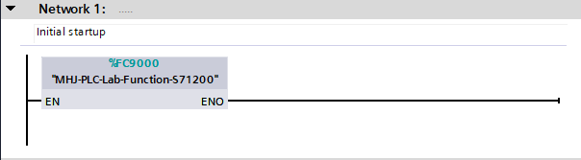
Objective of this network is to connect TIA/PORTAL with factory i/o
Explanation:
- The start button acts as the initial trigger.

Network 2: start up
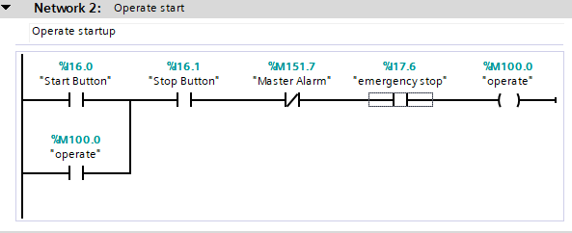
Its purpose is to control the startup of a system using memory bit %M100.0 (“operate"). This logic ensures that specific conditions are met before allowing the system to operate.
Explanation:
- Input:
    - Start button must be pressed.
    - Stop button, master alarm, and emergency stop must not be activated.
- Output:
    - The %M100.0 (Operate) bit is energized, and the system starts or continues operating.

Network 3: Conveyor start up
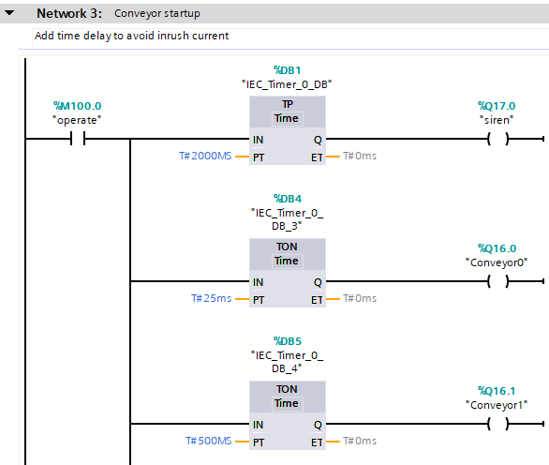
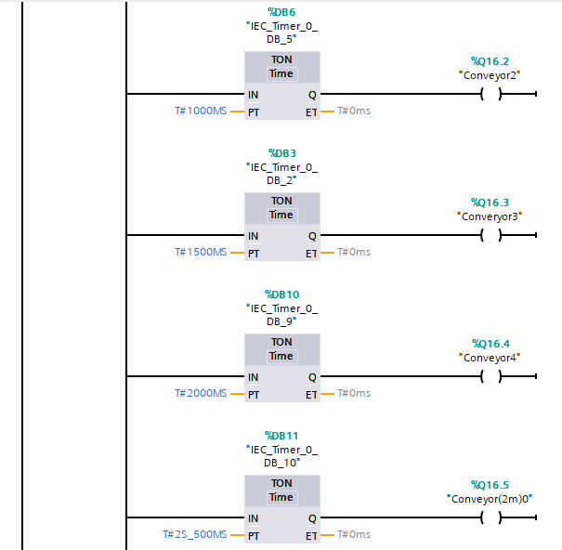
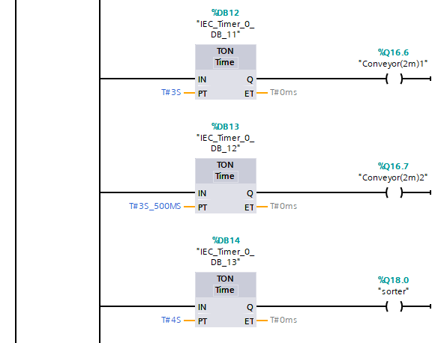
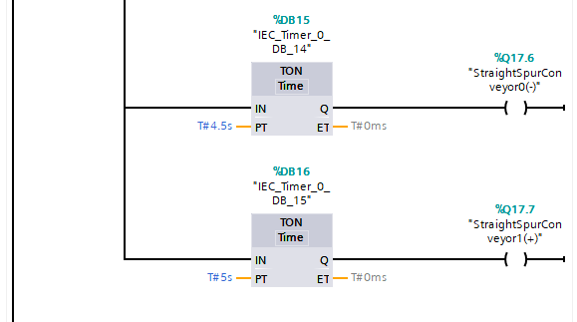
Objective: To ensure that the conveyor belts start in sequence, reducing the risk of high current draw during startup. Siren will notify everyone of startup.
Explanation:
Input
- %M100.0 (Operate) is set, allowing the system to run.
  - When this bit is set to true, it triggers multiple timers and outputs.
- Multiple timers are started here, each with different time delays:
  - %DB1 timer (TP): Starts timing for a delay of 2000ms.
  - %DB4 to %DB16 timers (TON): Start timing for their respective delays, each having different time settings (e.g., 25ms, 500ms, 1000ms, 1500ms, etc.).
Output
- %Q17.0 (Siren): This output activates a siren to notify that the startup process is beginning. It remains active for 2000ms.
- %Q16.x (Conveyors): Multiple conveyor outputs are activated once timer stops counting.
- %Q18.0 (Sorter) this output starts the sorter.
- %Q17.6 and %Q17.7 (Straight Spur Conveyors): These outputs start conveyors with different orientations.

Network 4: Large pusher
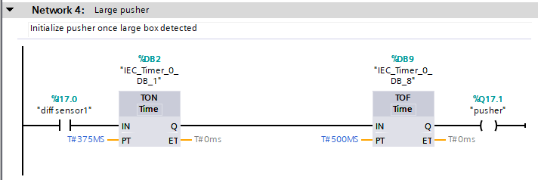
Objective: The system relies on a diffuse sensor to detect the presence of a box and activates two timers (TON for delay and TOF for output hold). The pusher mechanism is then activated, and it pushes the box for a controlled duration, ensuring smooth operation and timing between detection and action.
Explanation:
Inputs:
- %17.0 (diff sensor 1):
  - Diffuse sensor detects the presence of a box. When the sensor detects the box, it triggers the timers to begin their operations.
- %DB2 (TON):
  - The TON timer introduces a 375ms delay, this delay ensures that the pusher doesn't act too soon,
- %DB9 (TOF):
  - TOF is used to keep the output active for 500ms after the sensor %17.0 has been activated and the timer %DB2 has finished counting.
Output:
- %Q17.1 (pusher):
  - Pusher activates when the conditions from the timers are met.
  - Once the TON timer 375ms delay finish, the pusher activates and pushes the box to the next position.
  - The pusher will remain active for 500ms due to the TOF timer, ensuring that the box is fully pushed before the output is turned off.

Network 5: Medium pusher
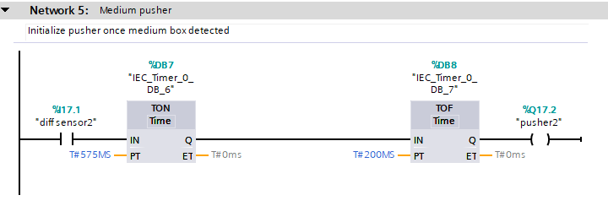
Objective: Same objective as in network 4, please refer back to understand objective.
Explanation:
Same process at network 4 but timings slightly changed, please refer to network 4.

Network 6: Master alarm
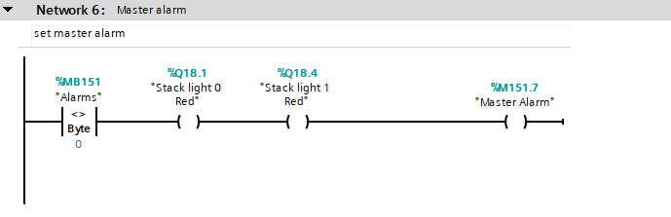
This network monitors byte 151, and based on its value, it triggers indicators, such as stack lights and a master alarm. These indicators alert the operator to an issue that requires attention.
Explanation:
Input:
- %MB151 (Alarms) <> 0:
  - If there is an active alarm (i.e., %MB151 is any value other than 0), the system will trigger specific outputs to alert the operator.
Outputs:
- Stack lights:
  - When the alarm condition is active, the stack light 0 and 1 colour RED turns on
- %M151.7 (Master Alarm):
  - Sets this status in memory and to be used in different networks

Network 7: Weight control
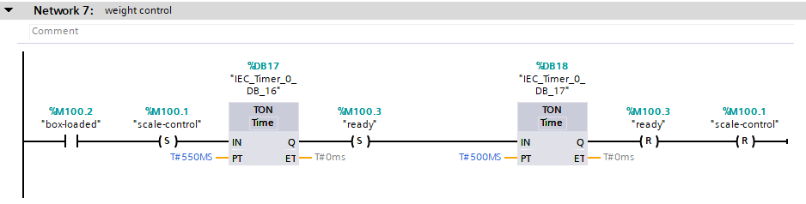
This network controls the operation of a weighing scale system. It uses a series of inputs and timers to determine the state of the system (whether a box is loaded and whether the system is ready)
Explanation:
Inputs:
- %M100.2 (box-loaded):
  - Monitors this input to verify whether the scale is ready to measure the weight of the box.
- %M100.1 (set) (scale control):
  - ‘Scale control’ memory has been initialized.
- %DB17 (TON) 550ms:
  - The timer introduces a 550ms delay before the system proceeds to the next actions.
- %M100.3 (set) (ready):
  - Allowing the system to start network for weighing the box and sort depending on weight.
- %DB18 (TON) 500ms:
  - It introduces a 500ms delay ensuring the system stays in the "ready" state for a brief period before proceeding with further actions or resetting the system.
Outputs:
- %M100.3 (reset) (ready):
  - After the timers have completed their delays, the ready status (%M100.3) is reset. This output ensures that the system resets its ready memory bit after the necessary time delays have passed, signalling that network with ready input is no longer sorting box weight.
- %M100.1 (Reset) (scale control):
  - The scale control reset output (%M100.1) is activated after the timers have elapsed, ensuring that the scale's control system is also reset.

Network 8: box loaded
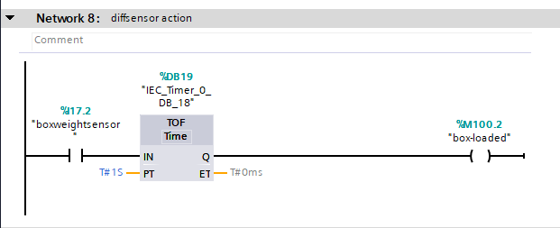
Objective: To detect when box is loaded onto a conveyor using a diffuse sensor and maintain an indication signal for a fixed duration of 1 second. This ensures the system reliably identifies the loading status.
Explanation:
Input
- %17.2 (boxweightsensor)
  - A diffuse sensor is used to detect the presence of a box.
- %DB19 (TOF) Timer
  - The timer is set to 1 second, meaning it will hold the output signal %M100.2 for 1 second after the input signal from %17.2 turns off.
Output
- %M100.2 (box-loaded)
  - This is a memory bit used to indicate the "box-loaded" status. It remains ON for 1 second, providing a stable signal.

Network 9: weight sorter
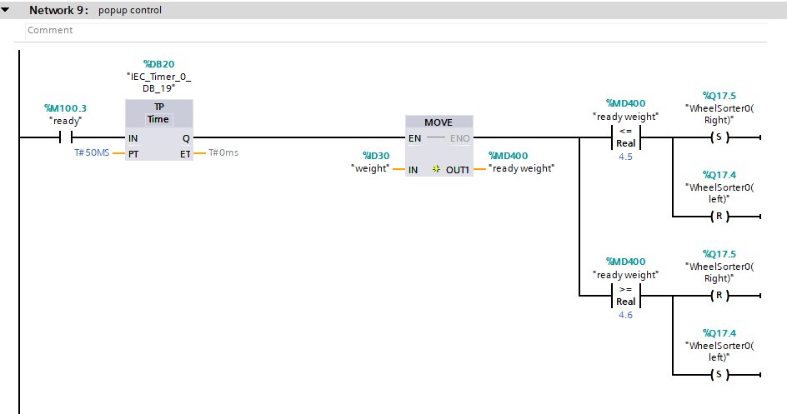
Objective: To control a wheel sorter system that routes items based on their weight. It evaluates the weight of each item and determines whether the item should be sorted to the left or right.
Explanation:
Inputs
- %M100.3 (ready): This memory bit indicates that the system is ready to process an item.
- %DB20 Timer: A pulse timer is configured with a preset time (PT) of 50 ms. When %M100.3 is active, the timer generates a short pulse.
Weight processing
- %MD30 (weight): This variable holds the input weight value of the item to be sorted.
- MOVE Instruction: The value of %MD30 is copied to %MD40 (ready weight) when the timer pulse is active.
Sorting conditions
- %MD40 (ready weight) is compared
  - If %MD40 < 4.5: The sorter directs the item to the right (%Q17.5).
  - If %MD40 > 4.6: The sorter directs the item to the left (%Q17.4).
Outputs
- %Q17.5 (WheelSorter0(Right)): Activates when the weight is below 4.5, sending items to the right.
- %Q17.4 (WheelSorter0(Left)): Activates when the weight is above the 4.6, sending items to the left.

Network 10: Display weight
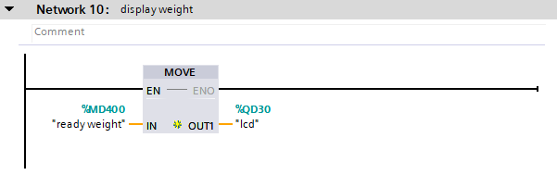
Objective: To move weigh value of the box to an LCD.
Explanation:
- Ready weight value is being moved into LCD to show the value on the screen.
Network 11: Scale conveyor control
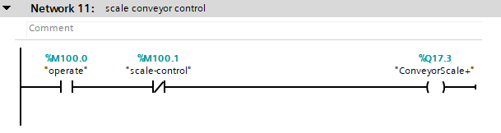
Objective: To control a conveyor scale system. The conveyor scale operates when the system is in the operating state (%M100.0) and scale control (%M100.1) conditions are met. This triggers the conveyor motor (%Q17.3) to move items across the scale.
Explanation:
Inputs
- %M100.0 (operate): This input indicates that the system is in the operational mode
- %M100.1 (scale-control): This input determines if %M100.1 (scale-control) is not set then turn on %Q17.3
Output
- %Q17.3 (conveyourScale+): This output controls the conveyor motor.

Network 12: Master counter
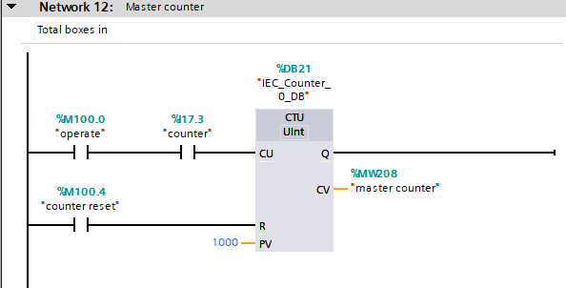
Objective: To count the number of boxes passing through a conveyor system using diffuse sensor. The system also includes a reset function, allowing the counter to be cleared after reaching a set value.
Explanation:
Inputs
- %M100.0 (operate): This input signals show the system is in an operational mode.
- %I17.3 (counter): This is a diffuse sensor detecting a box.
- %M100.4 (counter reset): This input resets the counter. It can be used manually or automatically to reset the counter to 0 after reaching a predefined value.
Count up block
- %DB21: This is the data block that holds the information related to the counter. It stores the current count.
Outputs
- %MW208 (master counter): This memory bit stores the current value of the counter (CV)

Network 13: Small Counter
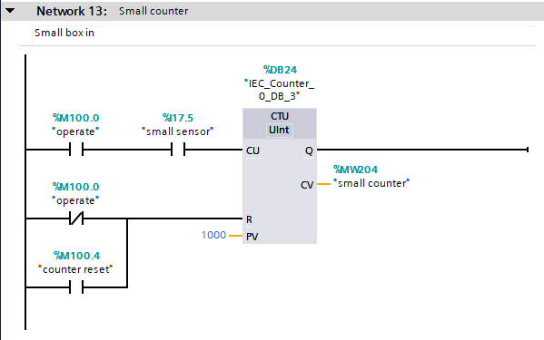
Objective: To count the number of small boxes passing through a conveyor system using diffuse sensor. The system also includes a reset function, allowing the counter to be cleared after reaching a set value.
Explanation:
Inputs
- %M100.0 (operate): This input signals show the system is in an operational mode.
- %I17.5 (small sensor): This is a diffuse sensor detecting a box.
- %M100.4 (counter reset): This input resets the counter. It can be used manually or automatically to reset the counter to 0 after reaching a predefined value.
Count up block
- %DB24: This is the data block that holds the information related to the counter. It stores the current count.
Outputs
- %MW204 (small counter): This memory bit stores the current value of the counter (CV)

Network 14: Large counter
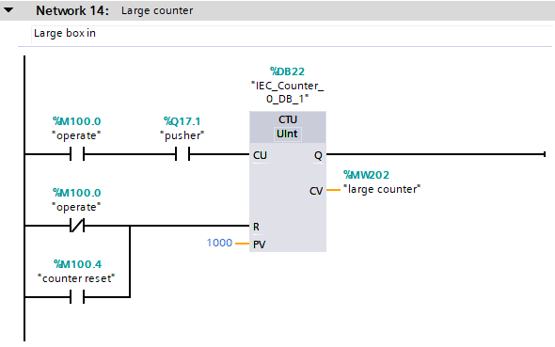
Objective: To count the number of large boxes passing through a conveyor system using pusher. The system also includes a reset function, allowing the counter to be cleared after reaching a set value.
Explanation:
Inputs
- %M100.0 (operate): This input signals show the system is in an operational mode.
- %I17.1 (pusher): This is a pusher, once activated it sets a pulse.
- %M100.4 (counter reset): This input resets the counter. It can be used manually or automatically to reset the counter to 0 after reaching a predefined value.
Count up block
- %DB22: This is the data block that holds the information related to the counter. It stores the current count.
Outputs
- %MW202 (large counter): This memory bit stores the current value of the counter (CV)

Network 15: Error counter
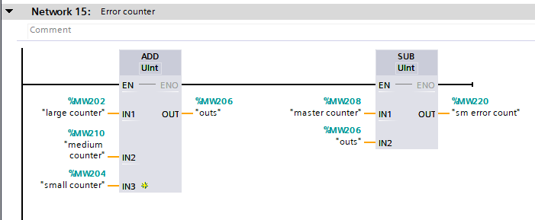
Objective: To monitor and manage errors in the system. The network increments or decrements error counts. The final error count (sm error count) is calculated as the difference between the total increments and decrements.
Explanation:
Increment Counter
- %MW202 (large counter): This memory holds the value of the large error counter
- %MW210 (medium counter): This memory holds the value of the medium error counter
- %MW204 (small counter): This memory holds the value of the small error counter.
- The total count from each counter is summed up and stored in %MW206 (outs)
Decrement Counter
- MW206 (outs): The total count from each counter is summed up
- %MW208 (master counter): The total count of boxes entered.
- The SUB instruction is used to decrement the (%MW208) by (%MW206). This helps in tracking the error count by knowing total is not correct.
Network 16: Medium counter
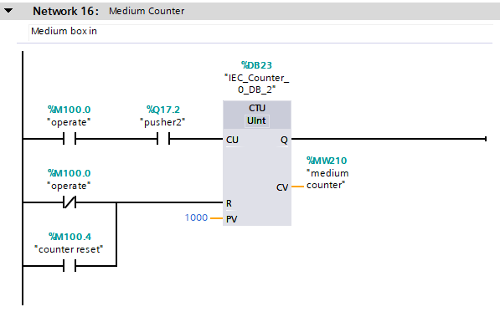
Objective: To count the number of medium boxes passing through a conveyor system using pusher. The system also includes a reset function, allowing the counter to be cleared after reaching a set value.
Explanation:
Inputs
- %M100.0 (operate): This input signals show the system is in an operational mode.
- %I17.2 (pusher2): This is a pusher, once activated it sets a pulse.
- %M100.4 (counter reset): This input resets the counter. It can be used manually or automatically to reset the counter to 0 after reaching a predefined value.
Count up block
- %DB23: This is the data block that holds the information related to the counter. It stores the current count.
Outputs
- %MW210 (medium counter): This memory bit stores the current value of the counter (CV)

Network 17: Green stack light
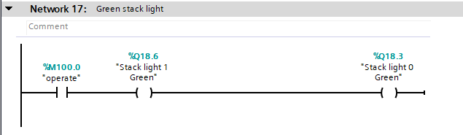
Objective: To ensure that green operational status is shown when in operational mode.
Explanation:
- To turn on both green stack lights when in operational mode.

Network 18: Warnings
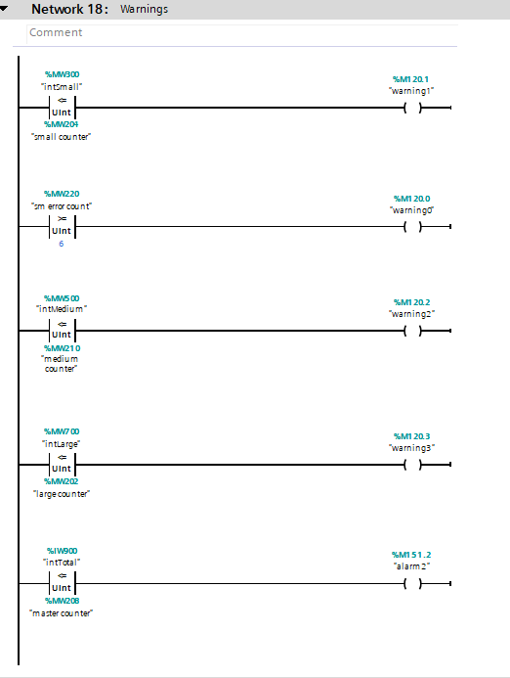
Objective: To turn on warning on HMI depending on what the warning is.
Explanation:
Rung
1 | If intSmall (set in engineer screen) is less or equal to small counter turn on warning 1
2 | If smErrorCount is more or equal to 6 turn on warning 0 to indicate that box is out or jammed somewhere.
3 | If intMedium (set in engineer screen) is less or equal to medium counter turn on warning 2
4 | If intLarge (set in engineer screen) is less or equal to large counter turn on warning 3
5 | If intTotal(set in engineer screen) is less or equal to master counter turn on alarm 2
Network 19: Warning lights
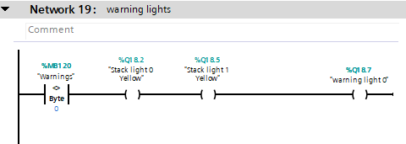
Objective: To turn on warning light and yellow light on both stack lights if any of the warning come on.

Explanation:
- If any warning address inside memory bit %MB120 come on it will turn on both yellow stack lights and warning light.

HMI
HMI in the factory system enables efficient and safe interaction between operators and the system. The HMI is a critical component of the factory process, providing controls for starting, stopping, and monitoring operations, as well as addressing warnings and alarms. HMI is designed to have different screens so user and engineers have different options available for them.
The HMI is designed to meet the following operational and safety requirements:
Main screen features
- Start and Stop Buttons: Enables operators to start or stop factory operations.
- Emergency Stop Button: A prominent button designed to immediately stop all system operations during critical situations.
- Counter Reset Button: Allows operators to reset the package count for all sorting categories.
- Stack Light Replication: Visual indicators on the HMI mirror the status of stack lights, providing immediate feedback on system operations (e.g, normal operation, warnings, faults).
- Navigation button: Enables operators and engineers to navigate between different screens.
- Master Alarm light: Indicates the status of master alarm, it can be either green or red depending on what status.
Fig 2 Main screen
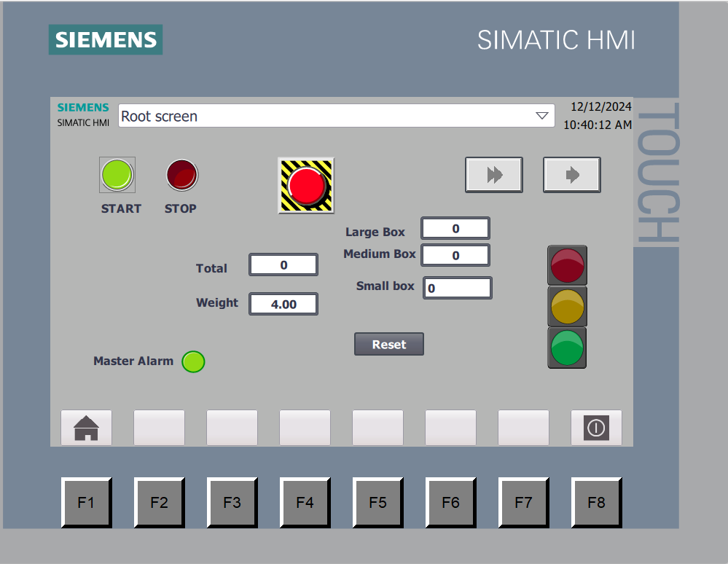

Error screen features
- Warning Indicators: Alerts operators to specific issues, such as excessive package counts or sensor detected error.
- Alarm Indicators: Alerts operators to specific issues, such as emergency stop pressed or sensor detected error.
- Master Alarm: Alerts operators master alarm status for engineer to reset once issue is corrected.
- Navigation button: Enables operators and engineers to navigate between different screens.
Fig 3 Error screen
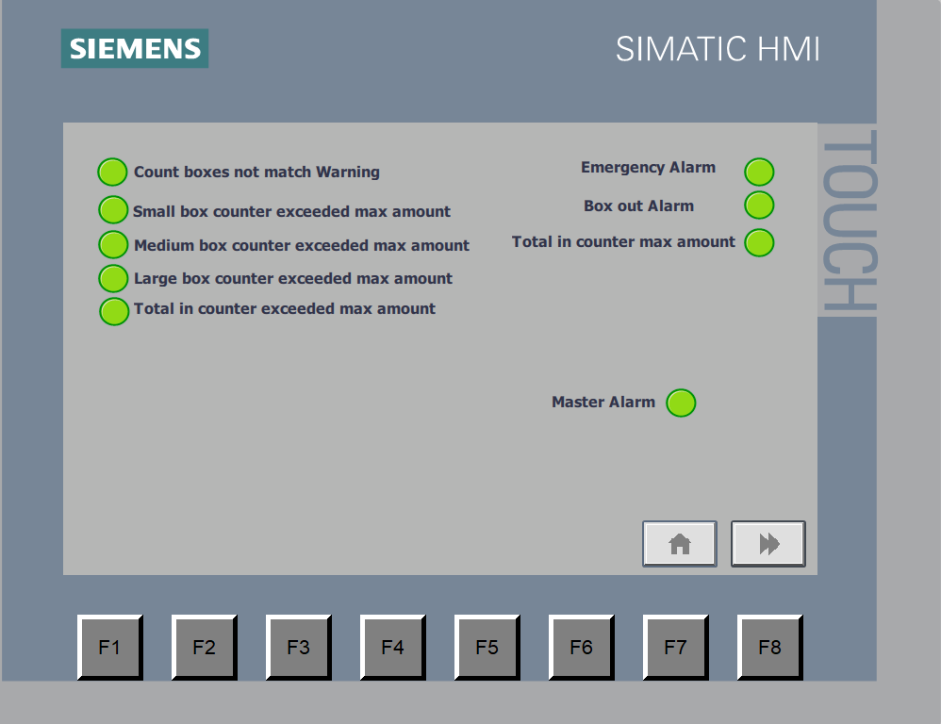

Engineer screen features
- Master Alarm Button: Enables engineers to reset the alarm status once issue is corrected.
- Entry points: Data entry points for pre-setting counter Warning numbers
- Navigation button: Enables operators and engineers to navigate between different screens.
- Manual buttons: Buttons to enable or disable warnings or alarms manually.
Fig 4 Engineer screen
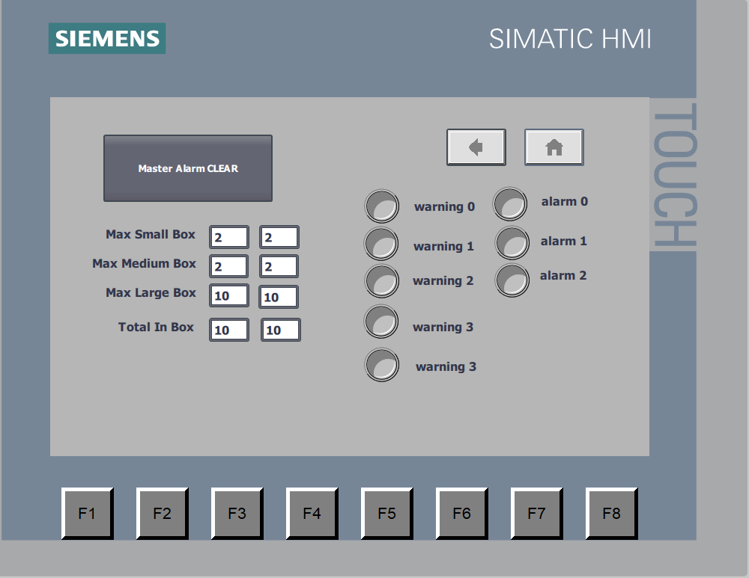

Conclusion
The report outlines the design and control system for a factory setup capable of sorting packages by size and weight using the Factory I/O simulation platform. By integrating programmable logic controllers (PLCs), sensors, conveyor belts, pushers, and a user-friendly Human-Machine Interface (HMI), the system demonstrates a modern approach to industrial automation that prioritizes efficiency, safety, and ease of operation.
The literature review highlights the critical role of PLCs in industrial environments, their adaptability, reliability, and integration capabilities. An analysis of leading PLC brands, such as Siemens, Allen-Bradley, and Schneider Electric, highlights the importance of selecting the right PLC to match project requirements.
The factory design has been considered for different components and operational features to ensure system operates to sort and handle packages. Design considers key safety mechanisms, such as emergency stops, warning systems, and alarms, protecting against operational failures. HMI monitors outputs in real time, lets user to control different features, and indicates warnings for troubleshooting whenever fault occurs. The system’s ladder logic program ensures different features work as they should, including package detection, sorting, scaling, and fault handling.

Reference
UNITRONICS (2023). What is PLC ? Programmable Logic Controller. [online] unitronics. Available at: https://www.unitronicsplc.com/what-is-plc-programmable-logic-controller/.

Siemens Xcelerator. (2024). SIMATIC S7 Controllers. [online] Available at: https://xcelerator.siemens.com/global/en/all-offerings/products/s/simatic-s7-controllers.html?gclid=CjwKCAiAjKu6BhAMEiwAx4UsApSO38p-EDzop_EvawkJ8mQ9QXkin-UgVRj3Y6rgV87Y-zW1AMvxBhoChnYQAvD_BwE&utm_campaign=21891445335&utm_source=google&utm_medium=cpc&gad_source=1 [Accessed 30 Nov. 2024].

Rockwell Automation. (2024). PLC Programmable Controllers | Allen-Bradley | UK. [online] Available at: https://www.rockwellautomation.com/en-gb/products/hardware/allen-bradley/programmable-controllers.html.

Se.com. (2024). Programmable Logic Controllers (PLCs)| Schneider Electric UK. [online] Available at: https://www.se.com/uk/en/product-subcategory/3910-plc-programmable-logic-controllers/ [Accessed 30 Nov. 2024].

siemens.com Global Website. (n.d.). SIMATIC S7-300 - Proven multiple times! [online] Available at: https://www.siemens.com/global/en/products/automation/systems/industrial/plc/simatic-s7-300.html.

Micro820TM Programmable Logic Controller . (n.d.). Available at: https://abmarketotomasyon.com/wp-content/uploads/2021/03/Micro820-PLC-%C3%9Cr%C3%BCn-profili-1.pdf.

Se.com. (2018). Logic Controller - Modicon M221 | Schneider Electric UK. [online] Available at: https://www.se.com/uk/en/product-range/62128-logic-controller-modicon-m221/?parent-category-id=3900&parent-subcategory-id=3910&filter=business-1-industrial-automation-and-control#overview [Accessed 12 Dec. 2024].

