THE MEANING OF LEADERSHIP
There are many ways of looking at leadership and many interpretations of its meaning. Leadership might be interpreted in simple terms, such as ‘getting others to follow’ or ‘getting people to do things willingly’, or interpreted more specifically, for example as ‘the use of authority in decision-making’. It may be exercised as an attribute of position or because of personal knowledge or wisdom. Leadership might be based on a function of personality or it can be seen as a behavioural category. It may also be viewed in terms of the role of the leaders and their ability to achieve effective performance from others. Leadership can also be discussed in terms of a form of persuasion or power relationship. From a comprehensive review of leadership theory and research, Bass concludes that: ‘There are almost as many different definitions of leadership as there are persons who have attempted to define the concept.’1 According to Crainer there are over 400 definitions of leadership and ‘it is a veritable minefield of misunderstanding and difference through which theorists and practitioners must tread warily’.2 It is difficult, therefore, to generalise about leadership, but essentially it is a relationship through which one person influences the behaviour or actions of other people. This means that the process of leadership cannot be separated from the activities of groups and effective teambuilding.
Changing nature of the work organisation
The changing nature of work organisations involves moving away from an emphasis on getting results by the close control of the workforce and towards an environment of coaching, support and empowerment. This places an ever growing importance on leadership. The leader–follower relationship is reciprocal and effective leadership is a two-way process that influences both individual and organisational performance. Leadership is related to motivation and interpersonal behaviour.3 A major report from the Advanced Institute of Management Research refers to the dual role of leadership.
Teamwork and inspiration
Leadership today is increasingly associated not with command and control but with the concept of teamwork, getting along with other people, inspiration and creating a vision with which others can identify. According to Levine, leaders need to focus on moving people and organisations forward by increasing the competency of staff and the co-operation of teams in order to improve the organisation. A leader’s job is constantly to challenge the bureaucracy that smothers individual enthusiasm and the desire to contribute to an organisation. Leaders in the new millennium will create an environment that encourages the development of skills, learning and openness so that those on their team can participate in the deployment of financial and human resources.5 A CBI report makes the point that ‘Effective leaders, who can inspire their people to realise their personal and collective potential, are often the deciding factor between a company being good at what it does and achieving greatness.’6
APPROACHES TO LEADERSHIP
Due to its complex and variable nature there are many alternative ways of analysing leadership. It is helpful, therefore, to have some framework in which to consider different approaches to study of the subject.
One way is to examine managerial leadership in terms of:
■ the qualities or traits approach;
■ the functional or group approach, including action-centred leadership;
■ leadership as a behavioural category;
■ styles of leadership;
■ contingency theories;
■ transitional or transformational leadership; and
■ inspirational or visionary leadership. (See Figure 10.1.)
THE QUALITIES OR TRAITS APPROACH
The first approach assumes that leaders are born and not made. Leadership consists of certain inherited characteristics, or personality traits, which distinguish leaders from their followers: the so-called Great Person theory of leadership. The qualities approach focuses attention on the man or woman in the job and not on the job itself. It suggests that attention is given to the selection of leaders rather than to training for leadership.
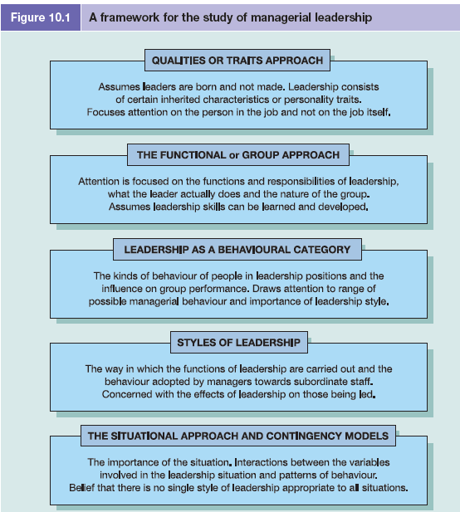
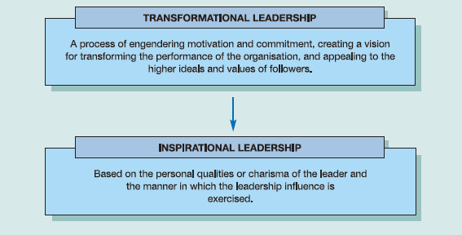
Figure 10.

There have been many research studies into the common traits of leadership. For example, Bass reports on numerous studies of traits of leadership from 1904 to 1970 including those relating to personal characteristics such as chronological age, physical appearance (including a positive correlation between height and weight), speech, capacity, achievement, participation, responsibility and status. A conclusion, perhaps not surprisingly, suggests that although personality is a factor in differentiating leadership it is not a matter of the mere possession of some combination of traits. Leaders acquire status through a working relationship with
members of a group.15
Attempts at identifying common personality, or physical and mental, characteristics of different ‘good’ or ‘successful’ leaders have met with little success.16 Investigations have identified lists of traits that tend to be overlapping, contradictory or with little correlation for most features. It is noticeable that ‘individuality’ or ‘originality’ usually features in the list. This itself suggests that there is little in common between specific personality traits of different leaders. It is perhaps possible therefore to identify general characteristics of leadership ability, such as self-confidence, initiative, intelligence and belief in one’s actions, but research into this area has revealed little more than this.
Limitations of the traits approach
There are three further limitations with this approach.
■ First, there is bound to be some subjective judgement in determining who is regarded as
a ‘good’ or ‘successful’ leader. (This can make for an interesting class discussion.)
■ Second, the lists of possible traits tend to be very long and there is not always agreement
on the most important.
■ Third, it ignores the situational factors.
Even if it were possible to identify an agreed list of more specific qualities, this would provide little explanation of the nature of leadership. It would do little to help in the development and training of future leaders. Although there is still limited interest in the qualities, or traits, approach, attention has been directed more to other approaches to leadership. The qualities or traits approach gives rise to the questions of whether leaders are born or made and whether leadership is an art or a science. The important point, however, is that these are not mutually exclusive alternatives. Even if there are certain inborn qualities that make for a good leader, these natural talents need encouragement and development. Even if leadership is something of an art, it still requires the application of special skills and techniques.
THE FUNCTIONAL (OR GROUP) APPROACH
This approach to leadership focuses attention not on the personality of the leader, nor on the man or woman in the job, per se, but on the functions of leadership. Leadership is always present in any group engaged in a task. The functional approach views leadership in terms of how the leader’s behaviour affects, and is affected by, the group of followers. This approach concentrates on the nature of the group, the followers or subordinates. It focuses on the content of leadership. Greater attention can be given to the successful training of leaders and to the means of improving the leaders’ performance by concentrating on the functions which will lead to effective performance by the work group. The functional approach believes that the skills of leadership can be learned, developed and perfected. In contrast to the view of Drucker (referred to above), Kotter makes the point that successful companies do not wait for leaders to come along. ‘They actively seek out people with leadership potential and expose them to career experiences designed to develop that potential. Indeed, with careful selection, nurturing and encouragement, dozens of people can play important leadership roles in a business organisation.’17 A similar point is made by Whitehead:
ACTION-CENTRED LEADERSHIP
A general theory on the functional approach is associated with the work of John Adair and
his ideas on action-centred leadership which focuses on what leaders actually do.19 The
effectiveness of the leader is dependent upon meeting three areas of need within the work
group: the need to achieve the common task, the need for team maintenance, and the
individual needs of group members. Adair symbolises these needs by three overlapping
circles (see Figure 10.2).
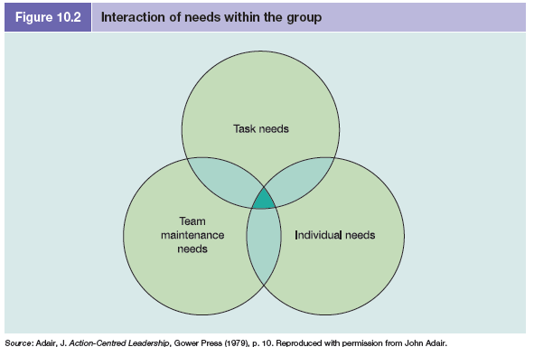
Task needs involve:
■ achieving the objectives of the work group;
■ defining group tasks;
■ planning the work;
■ allocation of resources;
■ organisation of duties and responsibilities;
■ controlling quality and checking performance;
■ reviewing progress.

Team maintenance needs involve:
■ maintaining morale and building team spirit;
■ the cohesiveness of the group as a working unit;
■ setting standards and maintaining discipline;
■ systems of communication within the group;
■ training the group;
■ appointment of sub-leaders.
Individual needs involve:
■ meeting the needs of the individual members of the group;
■ attending to personal problems;
■ giving praise and status;
■ reconciling conflicts between group needs and needs of the individual;
■ training the individual.
The action by the leader in any one area of need will affect one or both of the other areas of need. The ideal position is where complete integration of the three areas of need is achieved. Adair draws attention to the value of the three overlapping circles in emphasizing the essential unity of leadership: a single action can be multi-functional in that it touches all three areas. The three-circle approach used by Adair also serves to illustrate the close relationship between leadership and management. The list of leadership functions can be connected with Henri Fayol’s classic list of common management activities. Building the team and satisfying individual needs would include leadership. Achieving the common task clearly involves the process of management.
LEADERSHIP AS A BEHAVIOURAL CATEGORY
This approach draws attention to the kinds of behaviour of people in leadership situations. One of the most extensive research studies on behavioural categories of leadership was the Ohio State Leadership Studies undertaken by the Bureau of Business Research at Ohio State University. The focus was on the effects of leadership styles on group performance. Results indicated two major dimensions of leadership behaviour, labelled ‘consideration’ and ‘initiating structure’.21
■ Consideration reflects the extent to which the leader establishes trust, mutual respect and rapport with the group and shows concern, warmth, support and consideration for subordinates. This dimension is associated with two-way communication, participation and the human relations approach to leadership.
■ Initiating structure reflects the extent to which the leader defines and structures group interactions towards attainment of formal goals and organises group activities. This dimension is associated with efforts to achieve organisational goals. Consideration and initiating structure can be seen as the same as maintenance function (building and maintaining the group as a working unit and relationships among group members) and task function (accomplishment of specific tasks of the groups and achievement of goals) that were discussed in Chapter 9. Consideration and initiating structure were found to be uncorrelated and independent dimensions. Leadership behaviour could, therefore, be shown on two separate axes. A high-consideration, high-structure style appears to be generally more effective in terms of subordinate satisfaction and group performance, but the evidence is not conclusive and much seems to depend upon situational factors. However, later findings suggest that the best leadership style entails high levels of both people-centred and task-centred dimensions.22
STYLES OF LEADERSHIP
Attention to leadership as a behavioural category has drawn attention to the importance of leadership style. In the work situation it has become increasingly clear that managers can no longer rely solely on the use of their position in the hierarchical structure as a means of exercising the functions of leadership. In order to get the best results from subordinates the manager must also have regard for the need to encourage high morale, a spirit of involvement and co-operation, and a willingness to work. This gives rise to consideration of the style of leadership and provides another heading under which to analyse leadership behaviour. The attention given to leadership style is based on the assumption that subordinates are more likely to work effectively for managers who adopt a certain style of leadership than for managers who adopt alternative styles. Attention to the manager’s style of leadership has come about because of a greater understanding of the needs and expectations of people at work. It has also been influenced by such factors as:
■ increasing business competitiveness and recognition of efficient use of human resources;
■ changes in the value-system of society;
■ broader standards of education and training;
■ advances in scientific and technical knowledge;
■ changes in the nature of work organisation;
■ pressure for a greater social responsibility towards employees, for example through
schemes of participation in decision-making and work/life balance; and
■ government legislation, for example in the areas of employment protection, and the
influence of the European Union.
Broad framework of leadership style
There are many dimensions to leadership and many possible ways of describing leadership style, such as dictatorial, unitary, bureaucratic, benevolent, charismatic, consultative, participative and abdicatorial. With so many potential descriptions of leadership styles it is useful to have a broad framework in which to focus attention and study. The style of managerial leadership towards subordinate staff and the focus of power can therefore be considered within a simplified three-fold heading.
■ The authoritarian (autocratic) style is where the focus of power is with the manager and all interactions within the group move towards the manager. The manager alone exercises decision-making and authority for determining policy, procedures for achieving goals, work tasks and relationships, control of rewards or punishments.
■ The democratic style is where the focus of power is more with the group as a whole and there is greater interaction within the group. The leadership functions are shared with members of the group and the manager is more part of a team. The group members have a greater say in decision-making, determination of policy, implementation of systems and procedures.
■ A laissez-faire (genuine) style is where the manager observes that members of the group are working well on their own. The manager consciously makes a decision to pass the focus of power to members, to allow them freedom of action ‘to do as they think best’, and not to interfere; but is readily available if help is needed. There is often confusion over this style of leadership behaviour. The word ‘genuine’ is emphasised because this is to be contrasted with the manager who could not care, who deliberately keeps away from the trouble spots and does not want to get involved. The manager just lets members of the group get on with the work in hand. Members are left to face decisions that rightly belong with the manager. This is more a non-style of leadership or it could perhaps be labelled as abdication.
CONTINUUM OF LEADERSHIP BEHAVIOUR
One of the best-known works on leadership style is that by Tannenbaum and Schmidt (see Figure 10.4).24 Originally written in 1958 and updated in 1973, their work suggests a continuum of possible leadership behaviour available to a manager and along which various styles of leadership may be placed. The continuum presents a range of action related to the degree of authority used by the manager and to the area of freedom available to nonmanagers in arriving at decisions. The Tannenbaum and Schmidt continuum can be related to McGregor’s supposition of Theory X and Theory Y (discussed in Chapter 12). Boss-centred leadership is towards Theory X and subordinate-centred leadership is towards Theory Y.
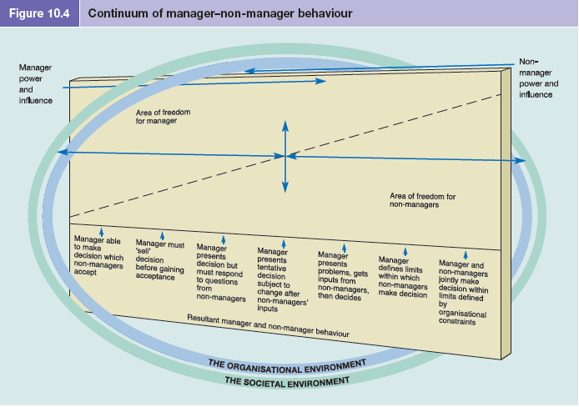
Four main styles of leadership
Moving along the continuum, the manager may be characterised according to the degree of control that is maintained. Neither extreme of the continuum is absolute as there is always some limitation on authority and on freedom. This approach can be seen as identifying four main styles of leadership by the manager: tells, sells, consults, joins.
■ Tells. The manager identifies a problem, makes a decision and announces this to subordinates, expecting them to implement it without an opportunity for participation.
■ Sells. The manager still makes a decision but recognises the possibility of some resistance from those faced with the decision and attempts to persuade subordinates to accept it.
■ Consults. The manager identifies the problem but does not make a decision until the problem is presented to the group, and the manager has listened to the advice and solutions suggested by subordinates.
■ Joins. The manager defines the problem and the limits within which the decision must be made and then passes to the group, with the manager as a member, the right to make decisions.
CONTINGENCY THEORIES OF LEADERSHIP
The continuum of leadership behaviour draws attention to forces in the situation as one of the main forces influencing the nature of managerial behaviour. The situational approach emphasises the situation as the dominant feature in considering the characteristics of effective leadership. There are, however, limitations to the situational approach. There are people who possess the appropriate knowledge and skills and appear to be the most
suitable leaders in a given situation, but who do not emerge as effective leaders. Another limitation is that it does not explain fully the interpersonal behaviour or the different styles of leadership and their effect on members of the group. Finally, in the work organisation, it is not usually practicable to allow the situation continually to determine who should act as the leader. Despite the limitations of the situational approach, situational factors are important in considering the characteristics of leadership. More recent studies focus on the interactions between the variables involved in a leadership situation and patterns of leadership behaviour, and provide another general approach to the study of leadership – contingency theory. Contingency theories are based on the belief that there is no single style of leadership appropriate to all situations. Major contingency models of leadership include:

■ Favourability of leadership situation – Fiedler
■ Quality and acceptance of leader’s decision – Vroom and Yetton and Vroom and Jago
■ Path–goal theory – House, and House and Dessler
■ Readiness level of followers – Hersey and Blanchard.

FIEDLER’S CONTINGENCY MODEL
One of the first leader–situation models was developed by Fiedler in his contingency theory of leadership effectiveness.25 Fiedler’s contingency model was based on studies of a wide range of group situations and concentrated on the relationship between leadership and organisational performance. In order to measure the attitudes of the leader, Fiedler developed
a ‘least preferred co-worker’ (LPC) scale. This measures the rating given by leaders about the person with whom they could work least well. The questionnaire contains up to 20 items. Examples of items in the LPC scale are pleasant/unpleasant, friendly/unfriendly, helpful/ frustrating, distant/close, co-operative/unco-operative, boring/interesting, self-assured/hesitant, open/guarded.
Each item is given a single ranking of between one and eight points, with eight points indicating the most favourable rating. For example:
Pleasant : : : : : : : : Unpleasant
8 7 6 5 4 3 2 1
The LPC score is the sum of the numerical ratings on all the items for the ‘least preferred coworker’. The original interpretation of the LPC scale was that the leader with a high LPC score derived most satisfaction from interpersonal relationships and, when relationships with subordinates need to be improved, is motivated to act in a supportive, considerate manner. The leader with a low LPC score derived most satisfaction from performance of the task and achieving objectives. Establishing good relationships with subordinates is a secondary motivation. It was thought that high LPC scores would be associated with effective performance by the group. However, the interpretation of LPC has changed a number of times and there is still uncertainty about its actual meaning.
Favourability of leadership situation
Fiedler suggests that leadership behaviour is dependent upon the favourability of the leadership situation. There are three major variables which determine the favourability of the situation and which affect the leader’s role and influence:
■ Leader–member relations – the degree to which the leader is trusted and liked by group members, and their willingness to follow the leader’s guidance.
■ The task structure – the degree to which the task is clearly defined for the group and the extent to which it can be carried out by detailed instructions or standard procedures.
■ Position power – the power of the leader by virtue of position in the organisation, and the degree to which the leader can exercise authority to influence (for example) rewards and punishments, or promotions and demotions.

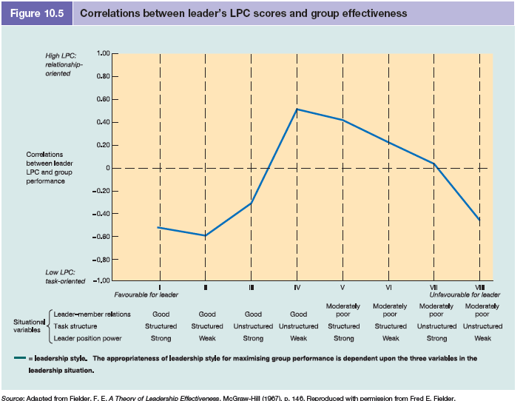
From these three variables, Fiedler constructed eight combinations of group–task situations through which to relate leadership style (see Figure 10.5). When the situation is
■ very favourable (good leader–member relations, structured task, strong position power), or
■ very unfavourable (poor leader–member relations, unstructured task, weak position power),
■ then a task-oriented leader (low LPC score) with a directive, controlling style will be more effective.
When the situation is
■ moderately favourable and the variables are mixed, then the leader with an interpersonal relationship orientation (high LPC score) and a participative approach will be more effective.
Fiedler is suggesting, therefore, that leadership style will vary as the favourability of the
leadership situation varies.
VROOM AND YETTON CONTINGENCY MODEL
Another contingency model of leadership is provided by Vroom and Yetton.27 They base their analysis on two main aspects of a leader’s decision: its quality and its acceptance.
■ Decision quality, or rationality, is the effect that the decision has on group performance.
■ Decision acceptance refers to the motivation and commitment of group members in implementing the decision.
A third consideration is
■ the amount of time required to make the decision.

The Vroom and Yetton model suggests five main management decision styles:
■ Autocratic
A.I: Leader solves the problem or makes the decision alone using information available at the time.
A.II: Leader obtains information from subordinates but then decides on solution alone.
■ Consultative
C.I: The problem is shared with relevant subordinates, individually. The leader then makes the decision that may or may not reflect the influence of subordinates.
C.II: The problem is shared with subordinates as a group. The leader then makes the decision that may or may not reflect the influence of subordinates.
■ Group
G.II: The problem is shared with subordinates as a group. The leader acts as chairperson rather than an advocate. Together the leader and subordinates generate and evaluate alternatives and attempt to reach group consensus on a solution.

THE VROOM AND JAGO REVISED DECISION MODEL
In a revised version of the original model, Vroom and Jago retain the five main decision-making styles but incorporate a larger number – 12 – of contingency variables.28 The new model specifies that any of the five decision styles may be effective in given situations. The contingency variables relate to:
■ quality requirement;
■ commitment requirement;
■ leader information;
■ problem structure;
■ commitment probability;
■ goal congruence;
■ subordinate conflict;
■ subordinate information;
■ time constraint;
■ geographical dispersion;
■ motivation time; and
■ motivation development.
Unlike the Vroom and Yetton model that requires a definite yes/no answer, ten of these situational variables are answered on a five-point scale.
For example, to the question ‘How important is subordinate commitment to the decision?’, the manager selects one of the following responses: no importance; low importance; average importance; high importance; critical importance.
PATH–GOAL THEORY
A third contingency model of leadership is the path–goal theory, the main work on which has been undertaken by House, and by House and Dessler.30 The model is based on the belief that the individual’s motivation is dependent upon expectations that increased effort to achieve an improved level of performance will be successful, and expectations that improved performance will be instrumental in obtaining positive rewards and avoiding negative outcomes. This is the ‘expectancy’ theory of motivation.
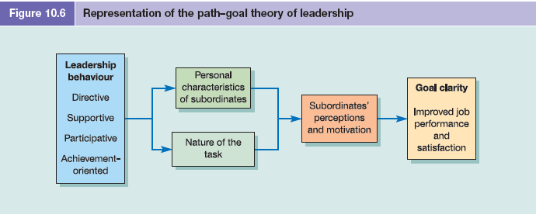
Main types of leadership behaviour
The path–goal theory of leadership suggests that the performance of subordinates is affected by the extent to which the manager satisfies their expectations. Path–goal theory holds that subordinates will see leadership behaviour as a motivating influence to the extent that it means:
■ satisfaction of their needs is dependent upon effective performance; and
■ the necessary direction, guidance, training and support, which would otherwise be lacking, is provided.

House identifies four main types of leadership behaviour:
■ Directive leadership involves letting subordinates know exactly what is expected of them and giving specific directions. Subordinates are expected to follow rules and regulations. This type of behaviour is similar to ‘initiating structure’ in the Ohio State Leadership Studies.
■ Supportive leadership involves a friendly and approachable manner and displaying concern for the needs and welfare of subordinates. This type of behaviour is similar to ‘consideration’ in the Ohio State Leadership Studies.
■ Participative leadership involves consulting with subordinates and the evaluation of their opinions and suggestions before the manager makes the decision.
■ Achievement-oriented leadership involves setting challenging goals for subordinates, seeking improvement in their performance and showing confidence in subordinates’ ability to perform well.

Path–goal theory suggests that the different types of behaviour can be practised by the same person at different times in varying situations. By using one of the four styles of leadership behaviour the manager attempts to influence subordinates’ perceptions and motivation, and smooth the path to their goals (see Figure 10.6).
Two main situational factors
Leadership behaviour is determined by two main situational factors: the personal characteristics of subordinates and the nature of the task.
■ The personal characteristics of subordinates determine how they will react to the manager’s behaviour and the extent to which they see such behaviour as an immediate or potential source of need satisfaction.
■ The nature of the task relates to the extent that it is routine and structured or non-routine and unstructured.
For example, when a task is highly structured, the goals readily apparent and subordinates are confident, then attempts to further explain the job or to give directions are likely to be viewed as unacceptable behaviour.

However, when a task is highly unstructured, the nature of the goals is not clear and subordinates lack experience, then a more directive style of leadership behaviour is likely to be welcomed by subordinates. Effective leadership behaviour is based, therefore, on both the willingness of the manager to help subordinates and the needs of subordinates for help. Leadership behaviour will be motivational to the extent that it provides necessary direction, guidance and support, helps clarify path–goal relationships and removes any obstacles which hinder attainment of goals.
READINESS OF THE FOLLOWERS OR GROUP
A major variable in the style of leadership adopted by the manager is the nature of subordinate staff. This view is developed by Hersey and Blanchard who present a form of situational leadership based on the ‘readiness’ level of the people the leader is attempting to influence. Readiness is the extent to which followers have the ability and willingness to accomplish a specific task. It is not a personal characteristic of the individual but how ready the individual
is to perform a particular task.31 Readiness (R) is divided into a continuum of four levels: R1 (low), R2 and R3 (moderate)
and R4 (high).
■ R1 – low follower readiness – refers to followers who are both unable and unwilling and who lack commitment and motivation; or who are unable and insecure.
■ R2 – low to moderate follower readiness – refers to followers who are unable but willing and who lack ability but are motivated to make an effort; or who are unable but confident.
■ R3 – moderate to high follower readiness – refers to followers who are able but unwilling, and who have the ability to perform but are unwilling to apply their ability; or who are able but insecure.
■ R4 – high follower readiness – refers to followers who are both able and willing and who have the ability and commitment to perform; or who are able and confident.

Task behaviour and relationship behaviour
For each of the four levels of maturity, the appropriate style of leadership is a combination of task behaviour and relationship behaviour.
■ Task behaviour is the extent to which the leader provides directions for the actions of followers, sets goals for them and defines their roles and how to undertake them.
■ Relationship behaviour is the extent to which the leader engages in two-way communication with followers, listens to them and provides support and encouragement. From the combination of task behaviour and relationship behaviour derive four leadership styles (S): telling (S1), selling (S2), participating (S3) and delegating (S4). The appropriate leadership style corresponds with the readiness of the followers (see Figure 10.7).
■ S1 – telling – emphasises high amounts of guidance (task behaviour) but limited supportive (relationship) behaviour. This style is most appropriate for low follower readiness (R1).
■ S2 – selling – emphasises high amounts of both directive (task) and relationship behaviours. This style is most appropriate for low to moderate follower readiness (R2).
participating – emphasises a high amount of two-way communication and supportive (relationship) behaviour but low amounts of guidance (task behaviour). This style is most appropriate for moderate to high follower readiness (R3).
■ S4 – delegating – emphasises little direction or support with low levels of both task and relationship behaviours. This style is most appropriate for high follower readiness (R4).

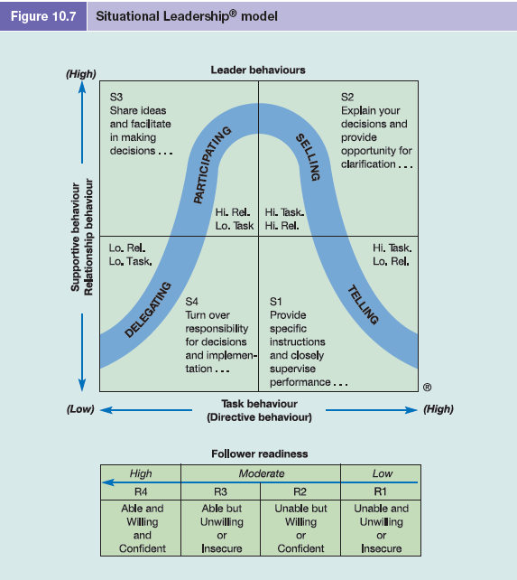

TRANSFORMATIONAL LEADERSHIP
Increasing business competitiveness and the need for the most effective use of human resources has resulted in writers on management focusing attention on how leaders revitalize or transform organisations. Based on the work of writers such as Burns this has given rise to a distinction between two fundamental forms of leadership: transactional or transformational.
■ Transactional leadership is based on legitimate authority within the bureaucratic structure of the organisation. The emphasis is on the clarification of goals and objectives, work task and outcomes, and organisational rewards and punishments. Transactional leadership appeals to the self-interest of followers. It is based on a relationship of mutual dependence and an exchange process of ‘I will give you this, if you do that.’
■ Transformational leadership, by contrast, is a process of engendering higher levels of motivation and commitment among followers. The emphasis is on generating a vision for the organisation and the leader’s ability to appeal to higher ideals and values of followers, and creating a feeling of justice, loyalty and trust. In the organisational sense, transformational leadership is about transforming the performance or fortunes of a business.
Components of transformational leadership
According to Bass, the transformational leader motivates followers to do more than originally expected and the extent of transformation is measured in terms of the leader’s effects on followers. Applying the ideas of Burns to organisational management, Bass proposed a theory of transformational leadership that argues that the leader transforms and motivates
followers by:
1 generating greater awareness of the importance of the purpose of the organisation and task outcomes;
2 inducing them to transcend their own self-interests for the sake of the organisation or team; and
3 activating their higher-level needs.33 Transformational leadership is comprised of four basic components:
■ idealised influence – the charisma of the leader, and the respect and admiration of the followers;
■ inspirational motivation – the behaviour of the leader which provides meaning and
challenge to the work of the followers;
■ intellectual stimulation – leaders who solicit new and novel approaches for the performance of work and creative problem solutions from followers; and
■ individualised consideration – leaders who listen and give special concern to the growth and developmental needs of the followers.

Yukl provides a set of guidelines for transformational leadership:
■ Articulate a clear and appealing vision of what the organisation could accomplish or become to help people understand the purpose, objectives and priorities of the organisation, and to help guide the actions and decisions of members.
■ Explain how the vision can be attained and establish a clear link between the vision and a credible conventional yet straightforward strategy for attaining it.
■ Act confident and optimistic about likely success, demonstrate self-confidence and conviction, and emphasise positive aspects of the vision rather than the obstacles and dangers.
■ Express confidence in followers and their ability to carry out the strategy for accomplishing the vision, especially when the task is difficult or dangerous, or when members lack confidence in themselves.
■ Use dramatic, symbolic actions to emphasise key values and demonstrate leadership behaviour through dramatic, highly visible actions including risking personal loss, self sacrifice or acting unconventionally.
■ Lead by example by recognising actions speak louder than words, through exemplary behaviour in day-to-day interactions with subordinates and by demonstrating consistency in daily behaviour.

INSPIRATIONAL OR VISIONARY LEADERSHIP
Many writers see transformational leadership as the same thing as charismatic, visionary or inspirational leadership. Kreitner et al. refer to charismatic leadership as transforming employees to pursue organisational goals over self-interests:
Writers such as Burns and Bass identified leaders by their actions and the impact those
actions have on other people.
Successful transformational leaders are usually identified in terms of providing a strong vision and sense of mission, arousing strong emotions in followers and a sense of identification with the leader. As mentioned at the start of this chapter, leadership today is increasingly associated with the concept of creating a vision with which others can identify,
getting along with other people and the concept of inspiration. This might be considered as part of transformational leadership or arguably it has given rise to a new approach to leadership – that of inspirational or visionary leadership. Inspirational leadership is not concerned so much with the theory of leadership but more with the skills of motivating and
inspiring people.

Personal qualities or charisma
Leadership may be based on the personal qualities, or charisma, of the leader and the manner in which influence is exercised. The concept of charismatic or inspirational leadership is not new and has been applied in the organisational context by writers such as Max Weber (1864–1920).40 The importance of charisma for effective leadership today is emphasised by Conger, who also believes that many of the traits that make a successful leader can be taught,
including charisma.
Now the big question is whether you are born with charisma or whether you can develop it. I believe you can develop elements of it. For example, you can take courses to improve your speaking skills. You can learn to stage events that send powerful messages. You can learn to think more critically about the status quo and its shortcomings. You can do more on a daily basis to motivate your team. What you simply cannot learn is how to be passionate about what you do. You have to discover that for yourself,
and passion is a big part of what drives a charismatic leader. It is also what motivates and inspires those who work for the charismatic leader.

Need for visionary leadership
Many writers are calling for leaders at all levels with vision and who can inspire with passion and emotion, as well as deliver bottom-line results.
For example, during the American presidential election of 2008 there was considerable debate over the comparative appeal between the experience of Hillary Clinton and the charisma of Barack Obama. In her discussion of the creation of the democratic enterprise (organisations that can flourish economically and can also be places of excitement and stimulation, fulfilment and tranquillity), Gratton maintains that it is the creation of a shared purpose and the role of the leadership team that are most vital. The role of the leader as visionary is fundamental to creating the broad philosophical context of democracy and as the architect of shared purpose. Referring to the work of Goffee and Jones, Witzel suggests: ‘Leadership is one of the most vital and yet elusive ingredients in modern business. Leaders provide vision, direction, inspiration,
give the business a sense of purpose and at the same time act as a moral compass.’47 Goffee and Jones point out that the need for visionary leadership is becoming increasingly important. Traditional business hierarchies gave managers and workers a sense of their own position and what was expected of them. Now, as these hierarchies break down, it is leaders
themselves who must fill the void, helping subordinates to understand their place and purpose. Personal leadership is beginning to replace organisational structure.

The inspirational gap
According to a survey by the Chartered Management Institute, the power to inspire is rated highest among desirable leadership qualities. A detailed survey of almost 1,500 practising managers in a broad cross-section of organisations found that the key characteristic that leaders should ideally possess, inspiration, was identified by 55 per cent of managers.
However, most leaders appeared to lack this characteristic, with only 11 per cent of respondents saying they experienced this in reality.50
The survey from the Chartered Management Institute highlighted a significant ‘inspirational gap’ in leadership across UK organisations. The Department of Trade and Industry undertook a research project to explore how to start closing this critical leadership inspiration gap.51 ‘It is now accepted that for the UK to maintain its competitiveness there is a growing need for companies to adopt strategies that will enable a greater level of innovation and the provision of higher value and services.’ The report is based on a study of 568 followers at different management levels working in a wide variety of organisations. It confirms that today’s workforce is more diverse, informed and sophisticated than ever before. Ultimately people are still looking for something different and better in organisational leadership.
Key conclusions of the report include:
■ For the past 30 years there have been increasing amounts of data to suggest that leadership has a lot more to do with inspiration and vision than with straightforward technical competence. Leadership is now recognised as a transferable skill, and it can be developed by continued learning and development throughout a person’s career.
■ Managers demand visionary leaders who win not only results but also the trust and respect of their teams. It is the relationship between people that results in action.
■ In order to keep followers motivated and committed in an era of unrelenting change, leaders must be able to create organisation cultures that foster not only performance but also a sense of pride and fun.
THE LEADERSHIP RELATIONSHIP
Whatever the perceived approach to leadership, the most important point is the nature of the leadership relationship and the manner in which the leader influences the behaviour and actions of other people. Leadership is a dynamic form of behaviour and there are a number of variables that affect the leadership relationship. For example, Bass reviews leadership
influence in terms of persuasion, a power relation, an instrument of goal achievement, an emerging effect of interaction and the initiation of structure.53 Four major variables are identified by McGregor as:
■ the characteristics of the leader;
■ the attitude, needs and other personal characteristics of the followers;
■ the nature of the organisation, such as its purpose, its structure, and the tasks to be performed; and
■ the social, economic and political environment.
McGregor concludes that ‘leadership is not a property of the individual, but a complex relationship among these variables’.54
According to Kouzes and Posner, ‘credibility is the foundation of leadership’. From extensive research in over 30 countries and response to the question of what people ‘look for and admire in a leader, in a person whose direction they would willingly follow’, people have consistently replied that they want
leaders who exemplify four qualities: they want them to be honest, forward-looking, inspiring and competent. In our research our respondents strongly agree that they want leaders with integrity and trustworthiness, with vision and a sense of direction, with enthusiasm and passion, and with expertise and a track record for getting things done.
Power and leadership influence
Within an organisation, leadership influence will be dependent upon the type of power that the leader can exercise over the followers. The exercise of power is a social process which helps to explain how different people can influence the behaviour/actions of others. Five main sources of power upon which the influence of the leader is based have been identified by French and Raven as reward power, coercive power, legitimate power, referent power and
expert power.57 We shall consider these in terms of the manager (as a leader) and subordinate relationship.
■ Reward power is based on the subordinate’s perception that the leader has the ability and resources to obtain rewards for those who comply with directives; for example, pay, promotion, praise, recognition, increased responsibilities, allocation and arrangement of work, granting of privileges.
■ Coercive power is based on fear and the subordinate’s perception that the leader has the ability to punish or to bring about undesirable outcomes for those who do not comply with directives; for example, withholding pay rises, promotion or privileges; allocation of undesirable duties or responsibilities; withdrawal of friendship or support; formal reprimands or possibly dismissal. This is in effect the opposite of reward power.
■ Legitimate power is based on the subordinate’s perception that the leader has a right to exercise influence because of the leader’s role or position in the organisation. Legitimate power is based on authority, for example that of managers and supervisors within the hierarchical structure of an organisation. Legitimate power is therefore ‘position’ power
because it is based on the role of the leader in the organisation, and not on the nature of the personal relationship with others.
■ Referent power is based on the subordinate’s identification with the leader. The leader exercises influence because of perceived attractiveness, personal characteristics, reputation or what is called ‘charisma’. For example, a particular manager may not be in a position to reward or punish certain subordinates, but may still exercise power over the subordinates because the manager commands their respect or esteem.
■ Expert power is based on the subordinate’s perception of the leader as someone who is competent and who has some special knowledge or expertise in a given area. Expert power is based on credibility and clear evidence of knowledge or expertise; for example, the expert knowledge of ‘functional’ specialists such as the human resources manager, management accountant or systems analyst. The expert power is usually limited to narrow, well-defined areas or specialisms.
LEADERSHIP EFFECTIVENESS
Goleman reports that the most effective executives use a collection of distinct leadership styles, each in the right measure, at just the right time. Although the authoritative style of leadership can be occasionally overbearing, it was found to be most effective and can motivate and inspire commitment to the goals of the organisation. The affiliative style has potential
to create harmony within teams and can be used in conjunction with the authoritative style.
The democratic approach was seen as positive, and encourages input from staff and helps build consensus through participation. The coaching style, although the least frequently used, can help staff identify their strengths and encourage long-term development goals. The study concludes that the most effective leaders rely on more than one leadership style, and were able to master a mixture of authoritative, democratic, affiliative and coaching styles.
Leaders with the best results use most of the styles in a given week – seamlessly and in different measure – depending on the business situation.
Goleman also reminds us that whatever a leader is wanting to achieve it is all done with people and from his recent research identifies six leadership styles. Each style springs from different components of emotional intelligence, and help build commitment and improve the emotional climate. They are:
1 Visionary – provides long-term vision
2 Coaching – develops people long-term
3 Affiliative – creates harmony in work
4 Democratic – commitment through consultation
5 Pace-setter – pushes to accomplish tasks
6 Commanding – demands compliance.

Variables affecting leadership effectiveness
Clearly, there is no one ‘best’ form of leadership that will result in the maintenance of morale among group members and high work performance. Three main aspects to be considered in determining the most appropriate style of leadership are the manager, the group and the work environment. However, there are many variables that underlie the effectiveness of leadership in work organisations. More specifically, these include the following:
■ the characteristics of the manager, personality, attitudes, abilities, value-system, and the personal credibility of the manager;
■ the type of power of the manager and the basis of the leadership relationship;
■ the characteristics of the followers: diversity, their needs and expectations, attitudes, knowledge, confidence and experience, and their motivation and commitment;
■ the relationship between the manager and the group, and among members of the group;
■ the type and nature of the organisation, organisation culture, and different stages in innovation and development;
■ the nature of the tasks to be achieved, the extent to which structured or routine;
■ the technology, systems of communication and methods of work organisation;
■ organisation structure and systems of management;
■ the type of problem and the nature of the manager’s decisions;
■ the nature and influence of the external environment;
■ the social structure and informal organisation, and the psychological contract;
■ the influence of national culture.
The shadow of leadership
Leadership is clearly a major feature of effective teamwork. Good leaders surround themselves with talented and capable members of staff, and then in their behaviour and actions serve as a role model. McCabe suggests that leaders who want to transform their performance and the effectiveness of the team should look at how their own shadow could be getting in
the way. Leaders focus on what they see as important and they are typically quite unconscious of the unintended but massive impact they are having on their colleagues, teams and clients. All leaders cast a shadow and whatever a particular leadership style, the shadow will affect others and can compromise people’s engagement at work and business effectiveness. Leaders need to be fully aware of the shadow they cast and the impact they have on others.
Authority without arrogance
The turbulent and uncertain economic situation of recent times has resulted in many commentators drawing attention to the expectations for clear, decisive and authoritative leadership.
For example, Masson refers to the leadership attribute of self-assurance, being authentic and comfortable with whom you are. What leaders need is an acute self-awareness and to avoid arrogance.
Reeves and Knell suggest that being a successful leader is less about who you are or what you do than about what you know. This includes four pieces of knowledge: where the organization is heading; what is going on; who they are; and how to build a strong team. Leaders in the most successful organisations are authoritative but their secret is that they use their authority without arrogance. Successful leaders
■ build a ‘culture of discipline’ and are about getting things done, controlling costs and marshalling resources;
■ keep in touch with how people are feeling. They don’t waste time worrying if everyone is happy but understand the emotional temperament of the organisation and emotional responses from people;
■ know where they are strong but also know their weaknesses and display a fierce humility;
■ are motivated by what they build, such as great teams and talent people, rather than what they get;
■ have a clear sense of where the organisation is going, but very often this is the result of collective decision-making in a talent team.

LEADERSHIP DEVELOPMENT
Education and training in management needs to emphasise not only interpersonal skills but also a flexibility of approach, diagnostic ability and the realisation that the most effective form of leadership behaviour is a product of the total leadership situation. According to Investors in People, leadership development is not just a corporate issue.

Seven principles for developing leaders
Referring to his action-centred leadership model (discussed earlier in this chapter), Adair identifies seven key principles of leadership development that can be applied successfully in different kinds of organisations in both the public and private sectors.
1 Development of a strategy for leadership development for each of the three levels of leadership – operational, strategic and team.
2 Selection of those with high potential for becoming effective leaders.
3 Training for leadership that implies instruction with a specific end in view. Identify your business training needs in the leadership context and assign them priorities.
4 Career development through giving a person the right job at the right time. People grow as leaders through the actual practice of leading.
5 Line managers as leadership developers by developing the individual’s potential and sharing their knowledge of leadership.
6 Corporate culture that is valued at all levels and should encourage a climate of self development in leadership.
7 The chief executive who should be leading from the front and who owns the problem of growing leaders.
The seven principles are complementary and are likely to have a synergetic effect if applied as a whole. Although a simple framework, Adair maintains the seven principles form the first coherent and effective approach for growing leaders.

NO ONE BEST FORM OF LEADERSHIP
We have seen that there are many alternative forms and styles of managerial leadership. Within an organisation different individuals may fulfil the functions of leadership and there are many different styles of leadership. A potential danger with the contingency approach is that the manager may appear to lack consistency in leadership style. However, although subordinates may reasonably expect some degree of consistency from the manager in approaching the same type of problem with the same style, this is not to say that different types of problems should be approached in the same manner. Subordinates would ordinarily expect a different style of managerial leadership according to the contingencies of the situation.
The right leader for the right situation
A good manager will clearly recognise that different styles of leadership are called for in different situations. As an obvious and (hopefully) extreme example, emergency situations such as a major fire in a building demand an assertive, directive style of action. As Rajan also points out: ‘Of course, different leadership styles are needed to cope with different situations: for example, the autocratic style makes sense when an organisation is in deep trouble and needs
to achieve a rapid turn-around. That style would be counter-productive when the organization is in a growth situation.’7
And Stern maintains that although in more carefree times business gurus exalted leaders who admitted to frailty, this is not so any more. The task of sustaining growth in a sluggish market calls for driven, leather-skinned bosses. Instead of touchy-feely management the quality of ‘mental toughness’ is needed to help elite performers to prevail.

LEADERS OF THE FUTURE
Gratton points out that while we are part of organisations shaped by technology that created the patents, ideas and innovations that brought success, the past will not bring sustainable competitive advantage for the future. To do this we have to build the potential of people in our organisations, the knowledge they bring and their commitment and enthusiasm.
Building human potential demands a new agenda, a new set of challenges for leaders and a redefined set of managerial capabilities. This new agenda creates a set of expectations of the leaders. Gratton sets out four expectations as the message for leaders.
■ Expectation 1: dream collectively – create a time and a process for you and your colleagues to dream about the future; create enthusiasm and excitement and a vision for the future; view the present as a pathway to the future; allow people to work independently but within the frame of the general direction; and work to identify and co-ordinate the major themes for action.
■ Expectation 2: balance the short term with the longer term – think in the past, the present and the future; be aware of the human scale of change and create plans of action that reflect human time scales and a capacity in human potential; build a vision for the future that engages people and allows them to understand their future role.
■ Expectation 3: build an organisation that values people – treat people with respect and have their ideas taken seriously and allow them to believe they can make a difference; be aware of the need to create communication channels with employees; demonstrate a commitment to people; treat people with politeness, respect and dignity and create a strong role model for others to follow.
■ Expectation 4: understand the reality of the organisation – create a deep, shared understanding of the current state of the business, and examine the metaphor of the organisation; put the building of a highly committed workforce at the centre of strategy; build a model of your organisation around high levels of trust, commitment and inspiration; develop
an understanding of process fairness and justice, and understand employees’ perceptions of integrity, consistency and pride.
New skills and competencies
Bennis hails the arrival of new leadership and suggests that ‘the leaders of the future will have to cast off the heavy burden of command and control, hierarchically based leadership’.
Leaders will have to learn an entirely new set of skills and four competencies will determine the success of new leadership.
1 The new leader understands and practises the power of appreciation – as a generalization most organisations are woefully neglectful of bestowing acknowledgement or appreciation, yet it is one of the most powerful motivators, especially for knowledge workers.
2 The new leader keeps reminding people of what is important – organisations drift into entropy and bureaucratisation of imagination when they forget what’s important. Reminding people of what is important can give meaning and value to work, and collective focused energy.
3 The new leader generates and sustains trust – the terms of the new social contract of work have changed and no one can depend on lifelong loyalty or commitment to any organisation. Trust has powerful connotations and the ingredients are a combination of competencies, constancy, caring, fairness, candour and, most of all, authenticity.ical reflection
4 The new leader and the led are intimate allies – new leadership is all about great leaders being made by great groups and by organisations that create the social architecture of respect and dignity, and great leadership brings that about. Without each other, the leader and the led are culturally impoverished.

