Morgan Discombe-Hughes
The Role of AI and Modern Data Pipelines in Driving Innovation
Module: Changemakers: Creativity and Value Creation

Table of Contents
Contents
Table of Contents 1
Introduction 2
Task 1: Project Management 2
Q1. Project Management & Planning 2
Q2. Project Design 4
Task 2: Enterprise & Innovation 5
Conclusion 9

Introduction
This report explores the role of Artificial Intelligence (AI) and modern data pipelines in driving innovation across various industries. It outlines the project management and design aspects of a proposed solution, evaluates enterprise and innovation strategies, and reflects on the potential societal impact and personal development opportunities associated with the project.

Task 1: Project Management

Q1. Project Management & Planning

Project Scope
This project explores how Databricks Lakeflow Declarative Pipelines can be used to streamline AI-driven innovation by simplifying the development and operation of scalable, reliable data pipelines. The aim is to demonstrate how Lakeflow enables real-time data ingestion, transformation, and delivery to AI models, reducing complexity and accelerating time-to-insight.

The proposed solution involves building a prototype pipeline that ingests social media data, processes it using Lakeflow, and feeds it into an AI model for sentiment analysis. This showcases how declarative pipelines can support innovation in customer experience, marketing, and product development.

Technologies and Resources
- Data Pipeline: Databricks Lakeflow Declarative Pipelines
- AI/ML Tools: Python, Hugging Face Transformers, TensorFlow
- Data Sources: Simulated social media feeds via Kafka or Event Hubs
- Storage: Delta Lake on Databricks
- Orchestration: Lakeflow Jobs (native orchestration)
- Visualization: Power BI or Databricks dashboards

Lakeflow supports both batch and streaming ingestion, automatic orchestration, and built-in data quality checks. It allows developers to declare transformations in SQL or Python, and handles execution, scaling, and recovery automatically.

Project Timeline & Schedule
The project will be structured as follows:
1. Week 1–2: Research and environment setup
2. Week 3–4: Pipeline design and data ingestion
3. Week 5–6: AI model integration and testing
4. Week 7: Evaluation and optimization
5. Week 8: Final report and presentation
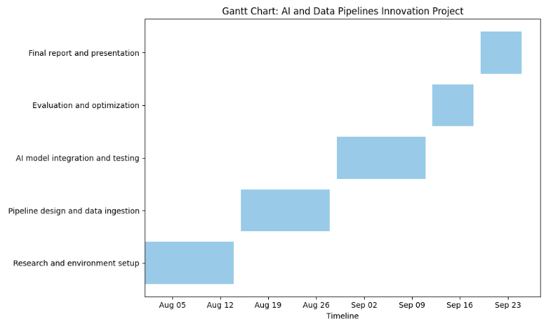

Constraints
- Data Access: Real-time data may need to be simulated
- Compute Resources: Cloud usage may incur cost
- Time: Limited to 8 weeks
- Ethical Considerations: Ensuring fairness and transparency in AI outputs

Development Methodology
The project will follow an Agile methodology, allowing for iterative development and continuous feedback. Agile is particularly effective for AI and data engineering projects due to its flexibility and adaptability. Tasks will be organized into sprints, with regular reviews and adjustments.

Q2. Project Design
Design Artifact 1: Data Flow Diagram
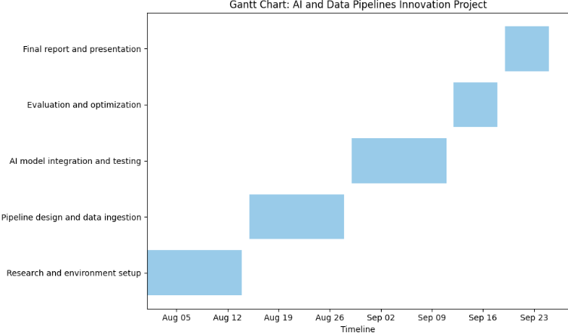
Lakeflow handles ingestion, transformation, and orchestration declaratively, reducing manual coding and improving reliability.

Design Artifact 2: UML Component Diagram
The system architecture will include:
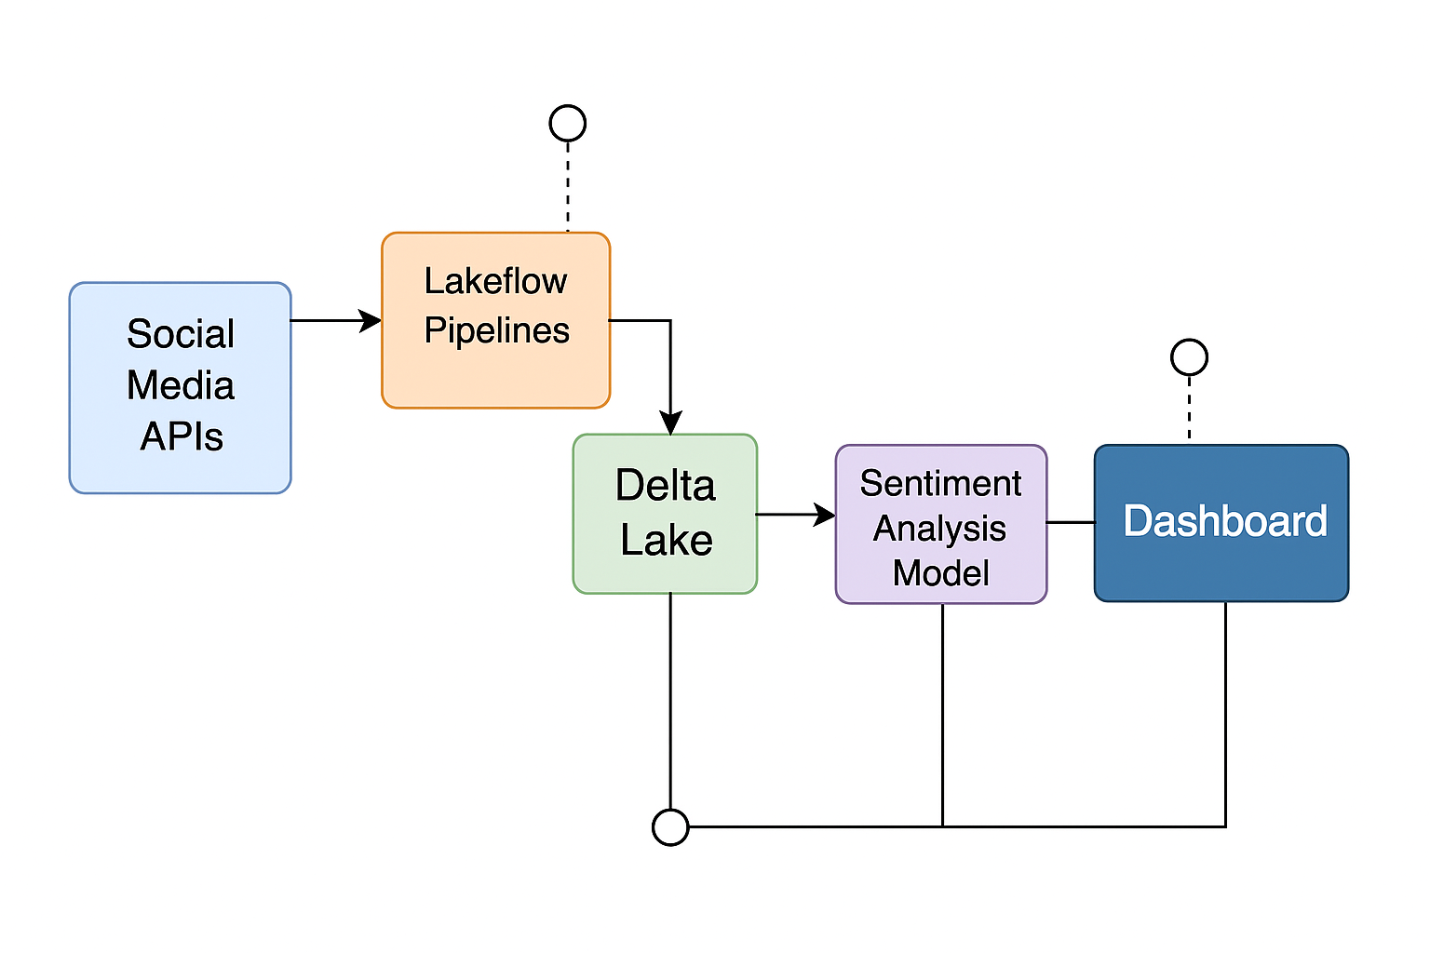
References
[2] Datics AI. “How to Use Agile Methodologies for AI & ML Projects in 2024.” https://datics.ai/how-to-use-agile-methodologies-for-ai-ml-projects-in-2024/
[14] Databricks. “Introducing LakeFlow: The Unified Data Pipeline Platform.” https://www.databricks.com/blog/introducing-lakeflow-unified-data-pipeline-platform
[15] Databricks. “LakeFlow Documentation.” https://docs.databricks.com/en/lakeflow/index.html
[18] Databricks. “Declarative Data Pipelines with LakeFlow.” https://www.databricks.com/blog/declarative-data-pipelines-lakeflow

Task 2: Enterprise & Innovation

Q1. PEST & SWOT Analysis for a Tech Company

To contextualise innovation, we examine Databricks, the company behind Lakeflow, using a PEST and SWOT analysis.

PEST Analysis
- Political: Increasing government investment in AI infrastructure and digital transformation in the UK.
- Economic: AI and data engineering are seen as key to improving public sector efficiency and reducing costs.
- Social: Public demand for faster, more personalised digital services is growing, especially in areas like transport and licensing.
- Technological: Rapid advances in cloud computing, real-time analytics, and declarative data pipelines like Lakeflow are enabling scalable innovation.

SWOT Analysis
- Strengths:
- Unified platform for data ingestion, transformation, and orchestration.
- Declarative approach reduces complexity and boosts productivity.
- Weaknesses:
- Requires cloud infrastructure and skilled personnel.
- Opportunities:
- Integration into public services (e.g. DVLA) for real-time analytics and automation.
- Supports open standards (e.g. Spark Declarative Pipelines), enabling interoperability.
- Threats:
- Data privacy concerns and regulatory compliance (e.g. GDPR).
- Resistance to change in legacy government systems.

Legal & Ethical Considerations
- Data Protection: Must comply with GDPR and UK Data Protection Act.
- Bias & Fairness: AI models must be audited for bias, especially in public-facing services.
- Transparency: Use of explainable AI (XAI) is encouraged in government settings.

Q2. Innovation Strategy in a Large Organisation (e.g. DVLA)

Concepts & Methods
To implement this project within DVLA or a similar government agency, the following innovation practices would be applied:
- Agile Delivery: Using Agile sprints and cross-functional teams to iterate on pipeline and model development.
- MLOps: Integrating machine learning operations for continuous deployment, monitoring, and retraining of AI models.
- DataOps: Ensuring data quality, lineage, and governance across the pipeline lifecycle.

Tools & Technologies
- Databricks Lakeflow: For declarative pipeline orchestration, supporting both batch and streaming data.
- Delta Lake: For scalable, ACID-compliant data storage.
- Azure DevOps: For CI/CD pipelines and version control.
- MLflow: For model tracking and lifecycle management.
- Power BI: For internal dashboards and reporting.

Deployment Strategy
1. Pilot Phase: Deploy a small-scale prototype (e.g. real-time vehicle registration insights).
2. Integration: Connect to existing DVLA systems via APIs and secure data connectors.
3. Governance: Apply the UK Government’s Data Ethics Framework to ensure transparency, accountability, and fairness.
4. Scaling: Expand to other services (e.g. fraud detection, customer service automation).

Maintenance & Evolution
- Monitoring: Use built-in Lakeflow observability tools and MLflow metrics.
- Retraining: Schedule model updates based on data drift or performance degradation.
- Feedback Loops: Incorporate user and stakeholder feedback into future iterations.

References
[1] OpenAI and UK Government Strategic Partnership. https://www.gov.uk/government/news/openai-to-expand-uk-office-and-work-with-government-departments-to-turbocharge-the-uks-ai-infrastructure-and-transform-public-services
[2] EY: AI in Government for Public Value. https://www.ey.com/en_gl/insights/government-public-sector/how-data-analytics-and-ai-in-government-can-drive-greater-public-value
[3] Databricks Lakeflow Overview. https://www.databricks.com/blog/whats-new-lakeflow-declarative-pipelines-july-2025
[4] UK Government Data Ethics Framework. https://cddo.blog.gov.uk/2025/03/10/developing-frameworks-and-tools-to-support-responsible-data-and-ai-use-across-the-public-sector

Conclusion

This report has explored the transformative potential of Artificial Intelligence and modern data pipelines—particularly through Databricks Lakeflow Declarative Pipelines—in driving innovation within public sector organisations like DVLA. By combining scalable data engineering with intelligent automation, the proposed solution demonstrates how real-time analytics can enhance operational efficiency, decision-making, and citizen services.
Through structured project management, innovative design, and ethical implementation strategies, the project aligns with broader digital transformation goals and public value creation. The reflection highlights the importance of skill development, societal impact, and risk mitigation, reinforcing the project's relevance and feasibility.
Looking ahead, this initiative offers a strong foundation for future exploration, collaboration, and deployment within government and enterprise settings.

