LEVEL 6 ASSESSMENT SPECIFICATION

Student name: | Jack Starkey | Student ID number: | 2000916
Programme: | Physical Education
Module: | Assessment in Physical Education
Module code: | BMPE6001 | Contribution to Overall Module Assessment (%): | 50%
Lecturer: | Dylan Blain | Internal Verifier: | Kate Piper
Assignment Title: | Assessment 1 – Portfolio | Word count (or equivalent): | 3000
Submission deadline: | 14th April 2023 | Return date of provisional marks & written feedback: | 14th May 2023
Submission method: | All written assessments, where practical and possible, must be submitted via Turnitin unless otherwise instructed by the Lecturer. (Please DO NOT put this assessment specification into Turnitin or it will match many similarities with other students’ submissions.)  Alternative submission method (if applicable):  Late submission of the assessment will result in a late penalty mark. Penalties for late submission: Up to one week late, maximum mark of 40%. Over one week late, 0%. Only the Extenuating Circumstances Panel may approve a change to submission dates.
Academic honesty / referencing: | Academic honesty is required. In the main body of your submission you must give credit to authors on whose research and ideas your work is based. Append to your submission a reference list that indicates the books, articles, etc. that you have used, cited or quoted in order to complete this assessment.

Student FEEDBACK FORM

This section details the extent to which the assessment criteria are demonstrated by you, which in turn determines your mark. The marks available for each category of skill are shown. Lecturers will use the space provided to comment on the achievement of the task(s), including those areas in which you have performed well and areas that would benefit from development/improvement.
Generic Assessment Criteria | Marks available | Marks  awarded
1. Engagement with Literature Skills  . | 25
2. Knowledge and Understanding Skills | 25
3. Cognitive and Intellectual Skills | 20
4. Practical Application Skills | 20
5. Transferable Skills for Life and Professional Practice | 10

1)Rationale

Introduction:

This portfolio will be presenting a rubric that has been designed for assessing a student specifically in the subject of physical education who is moving from their current school and joining a new school. The student that is being spoken about throughout this portfolio will be referred to as ‘ Student A’ and they are currently in their final year of primary education (year 6). Before the creation of the rubric, this portfolio will be using published literature such as the work of William (2018) to discuss the importance of assessment as well as what is assessment through the discussion of different methods of practice in the case of Williams (2018) research it would be formative assessment and the strengths or limitations that can be provided This will lead on to the creation of the assessment rubric which will be designed to focus on Student A’s learning and development of athletics whilst taking part in a Physical education lesson whilst also being able to establish Student A’s level of progress to determine where they can further develop skills to improve in the subject. Once designed the assessment rubric will be displayed in the professional format and will be referred back to throughout this portfolio from the appendices. An overall report will be conducted to provide a narrative to the new physical education teacher, this will involve presenting the results and areas of improvement that Student A will need to work on. The results that have been collected will be created into a radar graph this is due to the alternative approach the graph provides from typical statistical analysis to provide a focus on concepts such as the four domains of physical education in order to visualise possible patterns from the results that can indicate what domains need improving (Casals and Daunis-i-Estadella, 2023). Finally, the portfolio will finish with a reflection to critically evaluate the rubrics' purpose as well as the ability to effectively assess Student A’s learning outcomes whilst linking these aims to the curriculum aims of PE.

What is assessment?

There have been numerous debates around the various new strategies that can and have been used as a tool for assessing students to provide value for students' educational journey as well as methods to gain the best performance from students (Metzler, 2017; Rowntree, 2015). In most subjects a form of assessment typically will be through the use of summative assessments by an end-of-term exam, however, assessment has been a troublesome issue for physical educators (López-Pastor et al. 2013). López-Pastor et al (2013) discuss how a main method of assessment in physical education was standardised testing in the form of fitness testing to grade students strictly on their performance and fitness levels. This led to a 20-year-old debate in which Cale, Harris, and Chen (2007) discussed how the process of fitness testing as a form of assessment is an outdated method to which physical educators should adapt to a new method which will work towards the whole curriculum and provide a new pedagogy for physical education. Therefore, the consideration of Whitehead (2001) and her concept of physical literacy is an example of an approach that would focus on creating physically literate students through the process of their experiences in an educational environment. Young et al (2021) use Whiteheads (2001) physical literacy approach as an opportunity to develop students ‘ motivation, confidence, physical competence, and knowledge and understanding of physical activities (PA) and the responsibility that comes with engaging in PA during and outside of a lesson. The developments that have been highlighted fall into the categories of the domains for physical education which are cognitive, affective, social, and physical, and provide a pivotal role in supporting students' lifelong participation in PA (Bailey et al. 2009). Bailey, et al (2009) highlight how the implementation of an assessment around these domains encapsulates the policies of Every Child Matters which aims to raise students' achievements whilst creating a framework for physical education that will lead to inclusive education (Cheminais, 2014). Therefore, leading to a framework that can use the creation of a rubric to assess the four domains working towards creating a generation of physically literate students. Andrade, (2000) discusses the use of assessment rubrics as a method of assessment, their research highlights how the use of rubrics is an efficient approach to assessing students as well as an easy method of justifying the grades achieved to parents and students. The use of rubrics is a promising method that can support students learning and development as well as the ability to evaluate their performances (Andrade, 2000). The use of instructional rubrics is more common due to their ability to be concise and easy to digest the information which is useful when giving feedback in the form of a report allowing a summative method of learning to be introduced (Andrade, 2000; Edwards, 2017). Due to the simplicity of rubrics, this portfolio will include a rubric to assess Student A’s development of the four domains; cognitive, affective, social, and physical competence in the subject of physical education.

Rubric:

The concept of these domains has been significant to which Bailey, et al (2009) express that if introduced the subject of physical education would be able to monitor and assess not only practical performance but knowledge and understanding through summative assessments such as exams. The design of the rubric to assess Student A following the use of these domains as well as physical literacy’s concept of this goal for the lifelong activity being a journey, which can be assessed through the progression shown in each domain. In this particular rubric, the journey will represent the progression from ‘Beginner, Improver, Competent, and Advanced’. Referring back to the work of Cale, Harris, and Chen (2007) they discussed how fitness testing was an old method of assessing practical performance, within this rubric the practical performance will still be assessed, however, it will be focused on the competence of the movements and technical skills compared to that of Student A’s fitness. The next segment will be focussing on the participation and attitude of the student focusing upon the affective domain, to assess the student's engagement levels as well as their ability to remain motivated or to motivate peers. Leading onto the final segment which introduced the Social and cognitive domain through the coaching segment, aims to assess Student A on their ability to use their knowledge and understanding to begin assessing themselves and their peers to improve their abilities. The work of Williams (2018) described the use of instructional methods, the rubric that was created was instructional to provide benefits to teachers and students due to the students being a part of their education. Therefore, students will be able to use feedback provided to them by the teacher who acts as a facilitator, return to activity, and being to develop to progress to the next stage of their journey (Williams, 2018). As a result of including these categories the focus on assessing the domains would be able to highlight the importance of developing students' movement and knowledge and understanding, to create a physically literate child. Jurbala (2015) describes the process of being physically literate would entail the student being aware of what it means to be physically literate as well as how to progress in physical activity with confidence to excel when these opportunities are available. The research conducted by Young, et al (2021) provides evidence that the Canadian Sport for Life has been used to enhance the development of physical literacy through the use of the four domains found within this rubric, which provided further encouragement to design the rubric around this approach. On completion of each lesson, the design of the rubric allows for a decision to be made as to which section of the journey the student has reached as well as what progress needs to be developed.

2) Assessment Rubric

Please find the assessment rubric in the ‘Appendices’ section of this portfolio

3) Student A’s Report

In this report, Student A’s current level of progress in physical education will have been identified and discussed in a structure that follows the assessment rubric. As a result of this, the report should entail an explanation of each segment of the rubric that identifies the level Student A corresponds to provide an overview of where Student A needs to improve their learning.

Figure 3.1: Radar graph representing the themes of the assessment rubric and scores achieved by Student A.
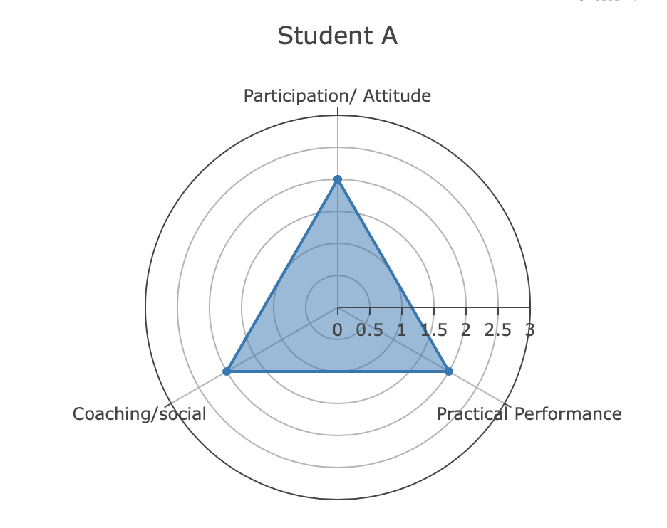

Figure 3.1 will be referred to throughout the report due to its ability to easily display the 3 themes focused upon within the assessment rubric. It also can display the differences in the progression that can be seen for example attitude is at level 3 (Competent) compared to that of performance which is at level 2.5 (Improver/competent) showing that Student A is in the process of reaching progression stage 3.

Student A’s Participation/Attitude:
As can be seen from Figure 3.1 Student A was graded at a level 2 for participation and attitude which equates to the improver level on the assessment rubric. Student A began very strongly in this segment of the assessment by showing a good engagement within the introduction of the lesson by showing up in their appropriate kit establishing they are ready to take part in the whole lesson. Moreover, they were able to demonstrate further skills of engagement by answering questions that the teacher had asked concerning the theme of the lesson's athletics events. However, as the rubric assessment and Figure 3.1 has stated Student A has only progressed to improve, this is due to the lack of willingness shown to attempt new activities. For example during the warm-up they were intrigued by the activities set and showed a willingness to take part and try their hardest, however, this soon changed once the teacher had set the main task. Student A showed lower intensity movement compared to the high-intensity movements they demonstrated throughout the warm-up. On the contrary, Student A showed an excellent attitude throughout the lesson, even when their participation was inadequate, they showed eagerness to answer questions from their peers as well as their teacher. When set with a task such as answering questions or having a discussion based around the work Student A was able to demonstrate a high level of confidence, highlighting that Student A’s motivation and attitude to participate grew when given an activity that they enjoyed or felt confident in. A target that Student A should focus on would be to maintain a consistent level of engagement in tasks throughout the lesson. This also will rely on the teacher to provide positive feedback and guidance to encourage Student A to attempt new activities even when they may lack the confidence to take part.

Student A’s Practical Performance:

From Figure 3.1 it can be analysed that student A’s practical performance was also ranked at 2.0 meaning they were in the improver category. The reasoning behind this assessment was due to the analysis made on student A’s practical ability within the lesson, to begin with, it was clear to see that student A was capable of performing a range of fundamental movement skills such as running, hopping, jumping, and throwing. On the contrary student, A could be seen being unable to consistently perform this range of movements during activities, for example during the warm-up game involving running/walking at different speeds which student A successfully achieved. However, as the teacher began to challenge the class asking pupils to begin moving in different directions such as backward and diagonally Student A could be seen having to move at a much slower speed compared to their classmates due to losing balance and bumping into other students.When referring back to the assessment rubric the improver stage suggests that students should be able to modify their skills to positively affect the task, as previously said this could be seen at the beginning stage of the warm-up task. Additionally, this could also be identified during the main activity when Student A was able to modify two fundamental skills of running and throwing into one process to successfully throw the javelin at a greater distance. However, as previously mentioned Student A was unable to consistently maintain this level of technique, therefore illustrating their physical competence to only progress to an improver level. Moreover, it can be advised, for student A to progress to a competent level within the assessment rubric the use of games that novel traveling will aid the progression of spacial awareness that student A lacks. Furthermore, the consideration of more object control sessions would prove to provide additional support for their confidence and consistency in their techniques.

Student A’s Coaching/Social :

Following on from Figure 3.1 it can be identified that student A has been given the level of 2 which equates to an improver level on the assessment rubric. Identification of Student A’s ability to coach was made such as an analysis of performance, and the ability to use these performance analyses to begin modifying techniques and start goal setting. Whilst displaying an ability of social skills to work with their peers to discuss the strengths and weaknesses of each group member to set personal goals for the next attempt at the task. Student A could be seen being extremely confident in collaborating with their peers during tasks, for example during the warm-up game cups and domes. Student A could be seen with a member of their team discussing the use of levels to better their speed of picking up cones due to being closer to the ground. However, this process took place during the warm-up whilst the teacher was present at all times and also was included in providing a suggestion for better performances. Moreover, Student A was identified as being less confident during the main activity relying heavily on their peers to discuss the analysis of their performances. Once the teacher returned and had a conversation with Student A and their group, student A returned to confidence and could be recognised as advising their peers in regards to what point the javelin should be released to better its flight. From this analysis, it would be suggested that Student A should receive regular guidance from the teacher to keep Student A on track with the task throughout the lesson and to avoid their confidence from dropping for Student A to remain socially included.

4) Reflection:

To fully recognise how efficient and effective the assessment rubric as it is critical to undergo a reflection on the overall process that leads to the completion of the assessment. Moreover, Hamblin (2014) and William (2018) confirm that the use of formative assessment has a positive ability to provide feedback to teachers and students enabling progression to be seen in performance as well as the quality of teaching. Additionally, Hay and Penney (2012) provided evidence to suggest that the use of effective pedagogy can contribute to overall assessment and provide essential feedback to better student learning, similar to that of formative assessment (Hamblin, 2014; William, 2018). Therefore, a critical aspect of this assessment process was to design a rubric that was able to follow the lessons which were designed around the theme of athletics. However, due to the activities focussing solely on athletic events and related skilled attributes, it limited the content that Student A could be assessed on. This led to the assessment rubric being styled as an analytical rubric to follow a formative assessment method (Panadero and Jonsson, 2020). Unfortunately, in this assessment process, the use of an analytical rubric was unable to provide enough detail to critically analyse Student A due to Student A not being present for every lesson that was observed (Panadero and Jonsson, 2020). Moreover, this was not the only complication that was found in the rubric design, for future reference a task-level specificity should be considered (Panadero and Jonsson, 2020). Due to the task focussing solely on athletics, it was identified that the rubric design focussed on a singular task, although it referred to fundamental movement skills. The majority of the lessons observed focussed on throwing technique and object control skills, which are discretely mentioned throughout the rubric, Therefore, in future rubric designs it would apply to multiple tasks rather than singular ones (Panadero and Jonsson, 2020). Finally, the rubric created used a lot of evaluative language such as ‘good’ and ‘great’, for next time the use of descriptive language would be beneficial to guide students and teachers, therefore facilitating students into the reflection of their grades and performance (Panadero and Jonsson, 2020). This reflection has justified the use of a rubric as a method for assessing the learning of a pupil, therefore supporting how rubrics can be a useful tool in the development of a student in their learning by having a form of assessment that provides feedback.

References:

Andrade, H.G. (2000) Using rubrics to promote thinking and learning. Educational leadership, 57(5), pp.13-19.

Bailey, R. et al. (2009) The educational benefits claimed for physical education and school sport: an academic review. Research papers in education, 24(1), pp.1-27.

Cale, L., Harris, J. and Chen, M.H. (2007) More than 10 years after “The horse is dead…”: Surely it must be time to “dismount”?!. Pediatric exercise science, 19(2), pp.115-131.

Casals, M. and Daunis-i-Estadella, P. (2023) Violinboxplot and enhanced radar plot as components of effective graphical dashboards: An educational example of sports analytics. International Journal of Sports Science & Coaching, 18(2), pp.572-583.

Cheminais, R. (2014) Every Child Matters: A practical guide for Teachers. Routledge.

Edwards, F. (2017) A rubric to track the development of secondary pre-service and novice teachers’ summative assessment literacy. Assessment in Education: Principles, Policy & Practice, 24(2), pp.205-227.

Hamblin, D. (2014) Physical Education assessment from 2014: assessing without limits. Research in Teacher Education, 4(2), pp.25-33.

Hay, P. and Penney, D. (2012) Assessment in physical education: A sociocultural perspective. Routledge.

Jurbala, P. (2015) What is physical literacy? Quest, 67(4), pp.367-383.

López-Pastor, V.M. et al (2013). Alternative assessment in physical education: a review of international literature. Sport, Education and Society, 18(1), pp.57-76.

Metzler, M., (2017) Instructional models in physical education. Taylor & Francis.

Panadero, E. and Jonsson, A. (2020) A critical review of the arguments against the use of rubrics. Educational Research Review, 30, p.100329.

Rowntree, D., (2015) Assessing students: How shall we know them? Routledge.

Whitehead 1, M. (2001) The concept of physical literacy. European Journal of Physical Education, 6(2), pp.127-138

William, D. (2018) Embedded Formative Assessment. 2nd edition: Solution Tree Press.

Young, L. et al. (2021) Assessing physical literacy in health and physical education. Curriculum Studies in Health and Physical Education, 12(2), pp.156-179.

Appendices :

Levels of progress-> | Beginner | Improver | Competent | Advanced
Participation/attitude  (Affective/cognitive) | They would be changed into their kit and show a willingness to take part in the lesson.  They would show enough self-confidence to ask/answer questions 1 on 1 with the teacher. | They are beginning to show a willingness to participate in new activities, whilst demonstrating a positive attitude towards the lesson and peers.  Beginning to show good self-confidence they will be able to start answering/ asking questions infant of peers as well as towards peers. | They always want to participate in the activities during the lesson and show progress as they complete tasks.  They are beginning to show confidence in group work during the lesson. | They show a willingness to participate in all activities during the lesson and show excellent engagement in terms of learning and wanting to make progress.
Practical Performance  (Physical, cognitive) | They can demonstrate simple skills (FMS) such as running, jumping, and throwing. With some confidence and success.  They can use these skills during an activity with some effect.  They can demonstrate some degree of coordination with some accuracy and success. | They can demonstrate a range of skills and begin to combine these skills to correctly perform in a range of situations with control.  They can modify the skills during the activities as situations change to provide a positive effect on the task.  They show the ability to consistently perform balance, speed, strength, and agility movements whilst participating in a range of activities. | They can perform a range of skills as well as combine these skills correctly during different activities whilst showing consistency of control and coordination throughout the activities.  They can adapt new skills and techniques which are slightly more advanced in a range of activities. Whilst continuing to confidently perform these skills leading to a successful performance of the skills as well as activity.  They show the ability to consistently perform balance, speed, strength, and agility movements whilst participating in a range of activities.3 | They can choose advanced skills and combine them with techniques and other skills in a range of situations such as activities, drills, and games. Whilst maintaining consistent control and coordination.  They can modify the skills being used to suit different situations in an activity such as the change of role. To show a positive and effective influence on the task at hand.  They can perform in complex and high-pressure situations showing high levels of advanced skills as well as high levels of fitness components e.g endurance, speed, and agility.
Coaching/Social  (Cognitive/social) | They can compare their performance to that of the demonstration shown at the start of the activity.  They can take in the information provided by peers/teachers to begin suggesting ways that they can improve their performance  They can recognise what makes a good performer and provide reasoning as to how they recognise these traits. | They can begin to analyse their performances focusing on the skills/techniques they have applied to each activity.  They can use this analysis to begin to question how they can use this information to improve their performances by refining their skills/techniques. Or through modifying when these skills/techniques should be used.  Through their recognition of what a good performer is, they can begin to encourage other students to encourage better performance. | They show a good understanding from their skills of analysing how they can identify strengths and weaknesses of their performances as well as their peers and provide comments to provide ways of improvement.  They will have made a better understanding of the activities performed in lessons and be able to start goal setting to improve performance (PBs)  They will be able to take on the role of coach/trainer to aid peers throughout the lesson to some success. | They show a great understanding of how to comment on their own and others' work to highlight what can impact their performances and how to improve.  They show a wider range of knowledge in a range of activities using goal setting as well as advanced techniques to execute techniques and skills to improve their performance.  They can successfully organise activities and effectively communicate to peers about successful performance as well as areas for improvement.

