COMPONENT 1: PORTFOLIO (POSTER AND ESSAY)
INTRODUCTION TO HEALTH AND SOCIAL CARE

LCHS4003
DR RAHEELA SHEIKH
PORTFOLIO – TWO TASKS

Student Name: Majolie Ther
Student Number: 2441312

Word count: 1500 (Including poster)

Table of Contents
Task 1: Poster presentation 3
Task 2: Essay 4
Introduction 4
Origin and historical context of National Health Service (NHS) 4
Key principles associated with NHS establishment 4
Current structure and functioning of NHS 4
Conclusion 5
Reference list 6

Task 1: Poster presentation
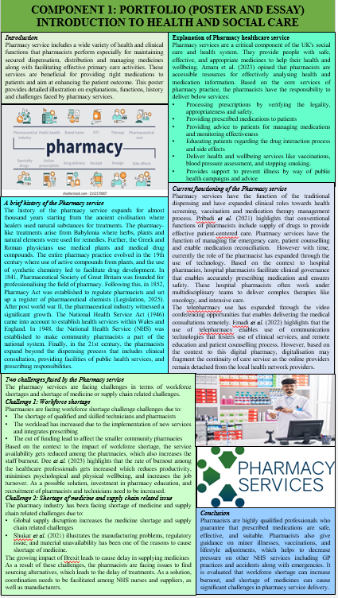

Task 2: Essay

Introduction
The National Health Service (NHS) is one of the greatest social reforms in the history of Britain, based on the premise that access to health care should be made available to everybody, irrespective of income. The essay explains the background and fundamental principles that contributed to its establishment and analyses critically the current structure and operation of the NHS.

Origin and historical context of National Health Service (NHS)
Prior to 1948, the healthcare within the United Kingdom was solely dependent on the person’s ability to pay for the medical services. Also, the medical treatment was basically provided through local, private and charitable authorities so that it can be affordable by families of middle to high income class people. The Second World War revealed profound disparities in access to medical care, which led to political discussion regarding post-war reconstruction and social justice. Also, in the 1942 Beveridge Report, Sir William Beveridge identified five giants which needed to be handled by Britain to acquire success economically and socially including Want, Disease, Ignorance, Squalor and Idleness (Parliament, 2025).
The driving force for establishing the NHS was Aneurin Bevan who was the Minister of Health in 1945. Aneurin Bevan’s vision was to keep the medical service free for all (Davies, 2024). The NHS officially started working in 1948 that brings together both hospitals, dentists, general practitioners, opticians, and pharmacists under one single system that is publicly funded. Hence, currently the NHS works on its values of commitment to quality, respect and dignity, working together for patients, compassion, improving lives and counting everyone (Nhs, 2025).

Key principles associated with NHS establishment
Based on the key principles associated with the establishment of the NHS, the principle of universality has been maintained for providing access to medical services to all. Also, the charge for the medical services remains free, and it is ensured that the medical services are to be provided based on clinical need, and not on the ability of individuals to pay (Gov.uk, 2025). NHS, as per the principles, need to provide support and promote health and wellbeing to the patients. NHS ensures fair use of resources, works across organisational boundaries, and remains accountable to patients, communities and publics.

Current structure and functioning of NHS
The contemporary NHS has developed into an intricate, multi-faceted system and is made up of hundreds of different organisations of differing sizes. The UK's health services have evolved, with four distinct NHS systems such as Wales, England, Scotland and in Northern Ireland that deal with local health policy and provision (Nhs, 2025). In England, the NHS is governed by the Department of Health and Social Care (DHSC), headed by the Secretary of State for Health. Policy guidance and funding are coordinated by NHS England, which commissions services through Integrated Care Systems (ICSs) collaborations between local councils, hospitals, and GPs to organize care within areas. Based on functioning, the NHS works with the government for effectively funding along with providing support to local organisations to plan for high-quality service delivery (Nhs, 2025). NHS supervises safe healthcare service, facilitates innovation, and improvement across the NHS.

Conclusion
It can be concluded that establishment of the NHS in the year 1948 helps in bringing transformative responses to social inequalities, and demand for universal healthcare practice. This essay highlights that the NHS works strictly on its key principles and has evolved with time that enables the NHS to provide universal medical solutions. Therefore, its future viability will depend upon successful reform, innovation, and a resounding reaffirmation of its founding principles: health care for all, on the basis of need, not affluence.

Reference list
Task 1
Amara, N., Naser, A.Y. and Esra’O, T., (2023). Patient satisfaction with pharmaceutical services in Jordan: A cross-sectional study. Jordan Journal of Pharmaceutical Sciences, 16(1), pp.1-10.
Dee, J., Dhuhaibawi, N. and Hayden, J.C., (2023). A systematic review and pooled prevalence of burnout in pharmacists. International Journal of Clinical Pharmacy, 45(5), pp.1027-1036.
Emadi, F., Ghanbarzadegan, A., Ghahramani, S., Bastani, P. and Baysari, M.T., (2022). Factors affecting medication adherence among older adults using tele-pharmacy services: a scoping review. Archives of Public Health, 80(1), p.199.
Legislation (2025) The Pharmacy Act 1852. Available at: https://www.legislation.gov.uk/ukpga/Vict/15-16/56/contents/enacted (Accessed: 12 October 2025)
Pribadi, P., Kristina, S.A. and Syahlani, S.P., (2021). Building Patient Loyalty in Pharmacy Service: A Comprehensive Model. Indonesian Journal of Pharmacy/Majalah Farmasi Indonesia, 32(2).
Shukar, S., Zahoor, F., Hayat, K., Saeed, A., Gillani, A.H., Omer, S., Hu, S., Babar, Z.U.D., Fang, Y. and Yang, C., (2021). Drug shortage: causes, impact, and mitigation strategies. Frontiers in pharmacology, 12, p.693426.
Task 2
Davies, N., (2024). The language of priorities: Aneurin Bevan, Welsh labour and the politics of the past. The British Journal of Politics and International Relations, 26(1), pp.62-78.
Gov.uk (2025) The NHS Constitution for England. Available at: https://www.gov.uk/government/publications/the-nhs-constitution-for-england/the-nhs-constitution-for-england (Accessed: 12 October 2025)
Nhs (2025) The NHS values. Available at: https://www.healthcareers.nhs.uk/working-health/working-nhs/nhs-constitution (Accessed: 12 October 2025)
Nhs (2025) UK health systems. Available at: https://www.healthcareers.nhs.uk/working-health/uk-health-systems (Accessed: 12 October 2025)
Nhs (2025) What we do. Available at: https://www.england.nhs.uk/about/what-we-do/ (Accessed: 12 October 2025)
Parliament (2025) 1942 Beveridge Report. Available at: https://www.parliament.uk/about/living-heritage/transformingsociety/livinglearning/coll-9-health1/coll-9-health/ (Accessed: 12 October 2025)

