Atanas Atanasov Maslev (2115672)

Lecturer: Suneth Fernando

Cloud computing Architecture

Contents
Introduction in Cloud Computing 1
Clustering 2
Grid Computing 2
Virtualization 2
Virtual machine 2
Benefits of moving to the cloud 3
Explain the differences in service types. 4
IaaS: 4
Resource groups 7
Security 8
Authentication 8
Network security groups. 10
Reference 11

Introduction in Cloud Computing
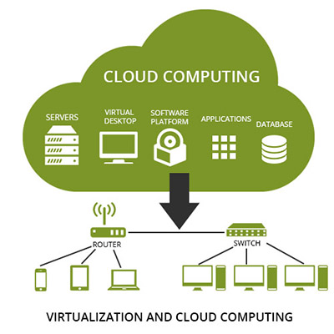
What is cloud computing? Cloud computing is a simple IT resource which you can ask from The Cloud providers (AWS, Azur, or Google Cloud Platform). They maintain physical center for data and servers. Instead of buying the cloud providers give you a wide variety of IT resources such as email, virtual machines, web applications and more and more via with pay as you go pricing. [1]
A Brief History of Cloud Computing
Cloud Computing is evolution on all the time. It starts in the 1950s when Large-scale mainframes with high-volume processing power became available. The practice of time sharing, or resource pooling evolved. Using the dump terminal how to make access to the mainframe. Multiple users were able to access the same data storage layer and CPU power from any terminal. In the 1970s with the release of a virtual machine or call virtual machine (VM) it is possible mainframe to have multiple virtual systems or virtual machines on a single physical node. In the late 1990s, Salesforce.com pioneered the notion of bringing remotely provisioned services into the enterprise. In 2002, Amazon.com launched the Amazon Web Services (AWS) platform.[1]
The Rise of Cloud Computing
Clustering: 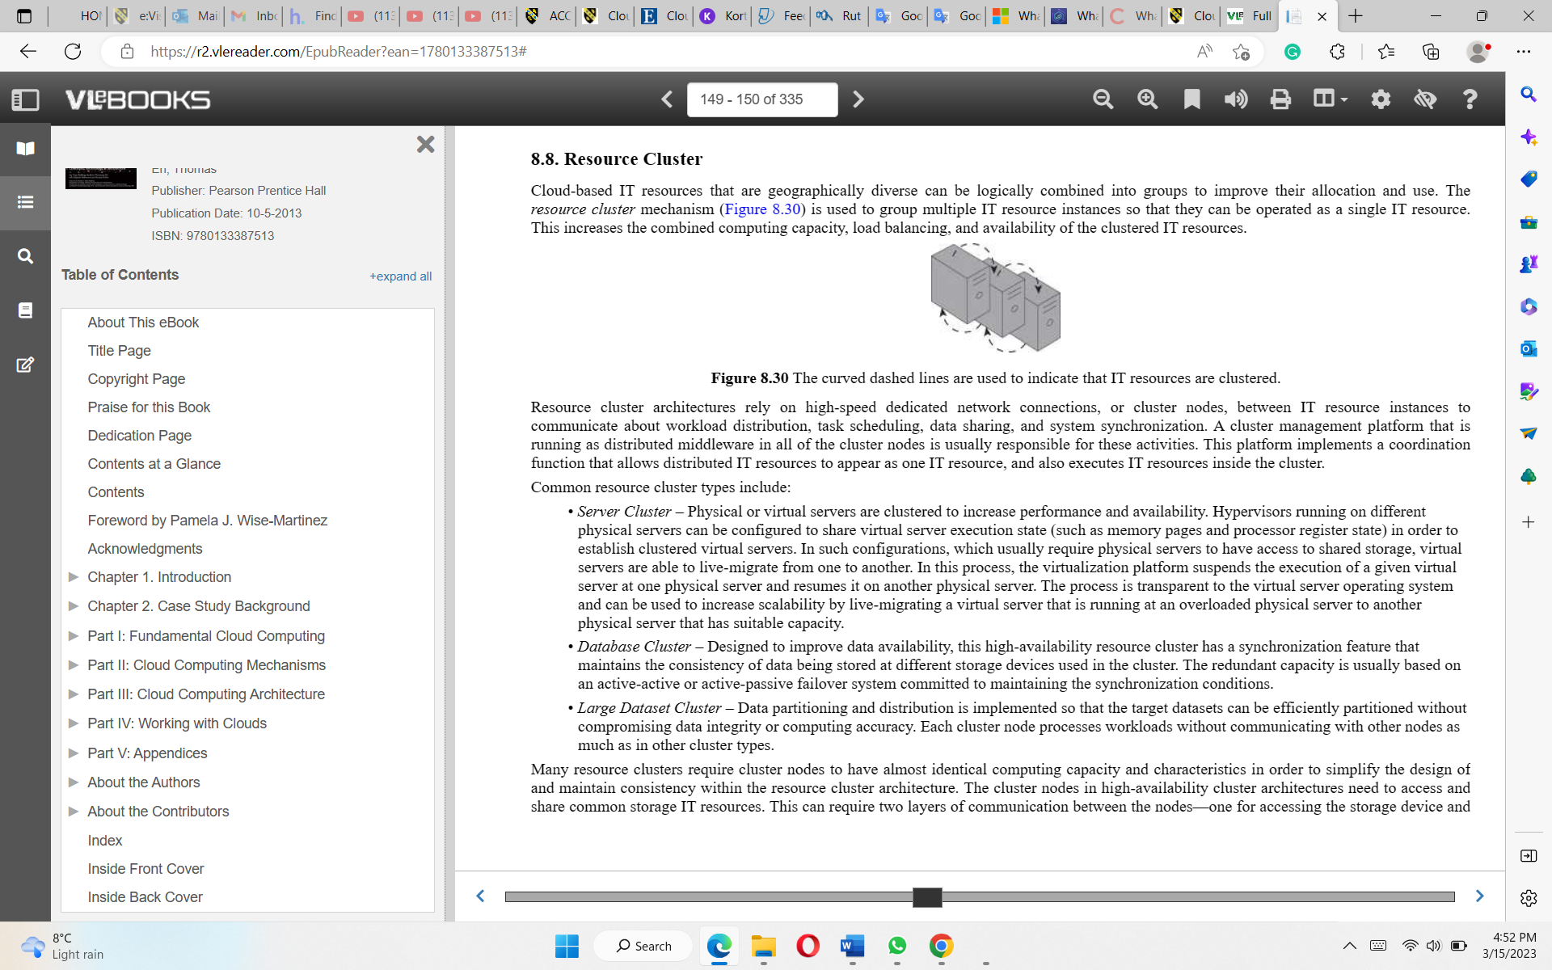 A cluster is a group parallel or distributed computer system, a simple inter-connected stand-alone computer, that can be logically combined to work such as one machine. This increases computing capacity and IT resources. When crashing the "cluster" has identical hardware and operating system that can be replaced by another immediately and this to not impact the process.[2]
Grid Computing:
Grid Computing is a group of networked computers that work together with that concept that appeared in the 1990s. It is a new type of computing as virtual supercomputing developed especially for complex scientific computing and analyzes huge sets of data. Through the cloud, you can assemble and use vast computer grids for the task that you need and the time that you need, and you pay only for that period.[3]
Virtualization:
Virtualization is a process via the allocation of physical IT resources. Hardware elements of a single computer—processors, memory, storage, and more—to be divided into multiple virtual computers, commonly called virtual machines (VMs), followed by the installation of an operating system to create a new independent virtual server. Today, virtualization is a standard practice in cloud computing and allows cloud providers to serve their users with what they need and when they need it. [1][3]
Virtual machine:
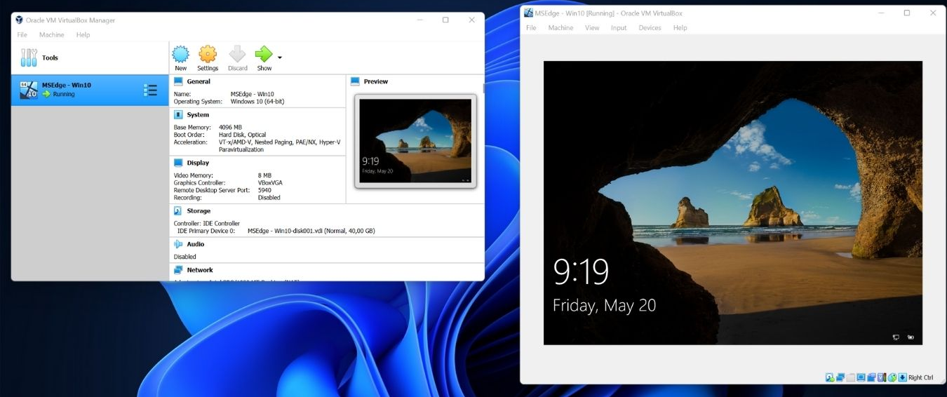
A virtual machine is a software computer that, like a physical computer, runs an operating system and application. An operating system installed on a virtual machine is called a guest operating system. Because every virtual machine is an isolated computing environment, you can use a virtual machine as a desktop or workstation environment, as a testing environment, or to consolidate server applications. Virtual machines are often referred to as a guest while the physical machine they run on is referred to as the host. A VM cannot interact directly with a physical computer. Instead, it needs a lightweight software layer called a hypervisor to coordinate between it and the underlying physical hardware. [1][2]
Benefits of moving to the cloud:
Your company can become more nimble, cut costs, rapidly scale, and deploy globally in a matter of minutes with cloud computing. Instance, access to a wide range of technologies through cloud computing enables you to innovate more quickly and create almost anything you can think. These technologies include internet of things, machine learning, data analytics, and many more. Technology services may be deployed quickly, allowing you to move from idea to implementation much more quickly than in the past. This allows you the opportunity to try new ideas and experiment with your business to distinguish client experience, such as integrating machine learning and intelligence to your application to personalize experiences for your consumers and enhance their engagement. Your company can become more nimble, cut costs, rapidly scale, and deploy globally in a matter of minutes with cloud computing. Instance, access to a wide range of technologies through cloud computing enables you to innovate more quickly and create almost anything you can think. These technologies include internet of things, machine learning, data analytics, and many more. Technology services may be deployed quickly, allowing you to move from idea to implementation much more quickly than in the past. This allows you the opportunity to try new ideas and experiment with your business to distinguish client experience, such as integrating machine learning and intelligence into your application to personalize experiences for your consumers and enhance themBy using the cloud, you can focus on the things that are most important to your organization instead of maintaining infrastructure and data centers.[1][2][3]

Explain the differences in service types.
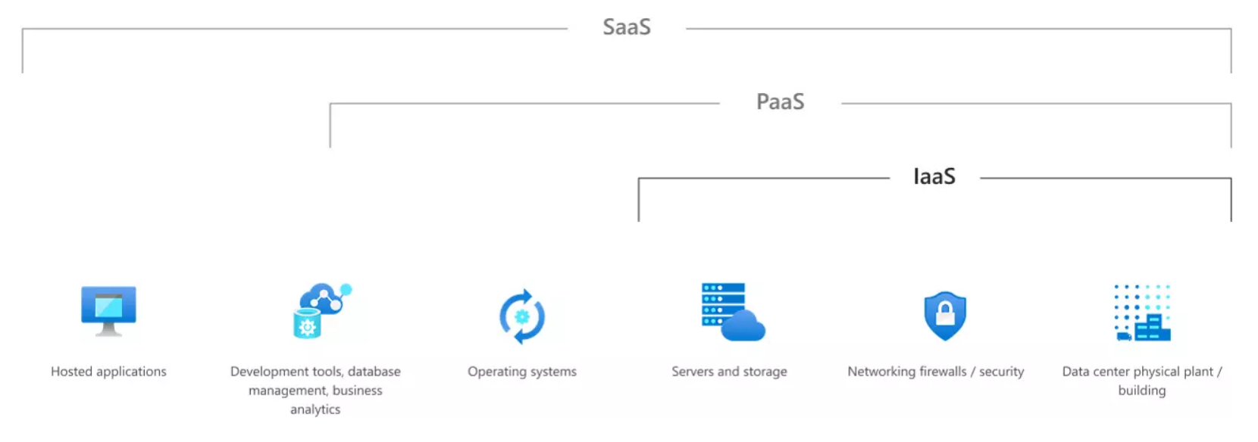

IaaS:
The IaaS delivery model represents a self-contained IT environment such as hardware, network, connectivity, operating systems, and other raw IT materials. Infrastructure as a service (IaaS) is a type of cloud computing service that offers essential computing, storage, and networking resources on demand, on a pay-as-you-go basis. IaaS is one of the four types of cloud services.[3][4]
Benefits:
Migrating your organization's infrastructure to an IaaS solution helps you reduce maintenance of on-premises data centers, save money on hardware costs. IaaS solutions give you the flexibility to scale your IT resources up and down. IaaS lets you bypass the cost and complexity of buying and managing physical servers and datacenter infrastructure. Each resource is offered as a separate service component, and you only pay for a particular resource for as long as you need it. A cloud computing service provider like Azure manages the infrastructure, while you purchase, install, configure, and manage your own software, including operating systems, middleware, and applications. [1][2][3][4]
Drawbacks:
Security issues:
100% security cannot be guaranteed by cloud computing because it is not as secure as a physical server and hackers can easy into in cloud environment.
Interoperability issues:
There are no common standards followed among the different IaaS providers. It is very difficult to migrate any VM from one IaaS provider to the other.
Performance:
In IaaS, all the distributed servers are connected over the network. Latency of the network plays an important role in deciding the performance.[1]
PaaS:
Platform as a service is mainly the environment for the development testing and delivery of software applications. It provides a quick creation of web or mobile applications without worrying about setting up or managing the underlying infrastructure needed for development.[1][2][3][4]
Benefits:
Platform as a service is a complete environment for the development and deployment of the entire life cycle of the application from interface to deployment in the cloud. You have access to IT resources which enable you to manage from underlying infrastructure such as servers, storage, and networks to sophisticated, cloud-enabled enterprise applications. PaaS allows you to avoid the expense and complexity of buying and managing software licenses on and pay-as-you-go basis. Developers can use browsers, remote consoles (running development tools in the console), and other technologies to directly develop applications remotely, without the need to install development tools locally. [1][2][3][4]
Drawbacks:
Vendor lock-in:
The main reason for vendor lock-in is lack of standards. There are no common standards followed among the different PaaS providers.
Security issues:
Like in the other cloud services, security is one of the major issues in PaaS services. Since data are stored in off-premises third-party servers, many developers are afraid to go for PaaS services.
Less flexibility:
PaaS providers do not give much freedom for the developers to define their own application stack. Most of the PaaS providers provide many programming languages and other development tools but it is not extensive and does not always satisfy all developer needs.
Depends on Internet connection:
Since the PaaS services ae delivered over the Internet, the developers should depend on Internet connectivity for developing the application. Some of the providers allow offline access, most of the PaaS providers do not allow offline access. With slow Internet connection, the usability and efficiency of the PaaS platform do not satisfy the developers requirements. [1][2][3][4]
SaaS:
SaaS is a method for delivering software applications that allows users to connect and use cloud-based apps over the internet. With SaaS, cloud providers host and manage the software applications like emails, calendar, and office tool (Microsoft Office 365). Users connect to the application over the internet, usually with a web browser on their phone, tablet, or PC on a pay-as-you-go basis.[1][2][3][4]
Benefits:
The cloud providers host and manage the software application, hardware and software and handle any maintenance, like software upgrades and security patching you. You don’t need to purchase, install, update, or maintain any hardware, middleware, or software and your users connect to it over the Internet, usually with a web browser. It is a mode of providing software through the Internet. You have software solution that you purchase on a pay-as-you-go basis from a cloud service provider. Users can access their information from any Internet-connected computer or mobile device. And when app data is stored in the cloud, no data is lost if a user’s computer or device fails. [1][2][3][4]
Drawbacks:
Security of data:
- Integration requirements with existing applications
- Security of data
- Lack of competitive differentiation
- Less ability to negotiate customized contracts
- Weakened IT management control
- More basic functionality in some cases
- New vendor management skills required
- For existing software houses:
- Organizational implications of moving from a product-centric to a service-centric delivery model
- Beware cannibalizing the on-premise market
- For start-ups:
- Cashflow develops over time – building a business is hard
- For both:
- Strong incentive to make adoption as viral as possible so usability is key
- Reliability of hosted service is critical
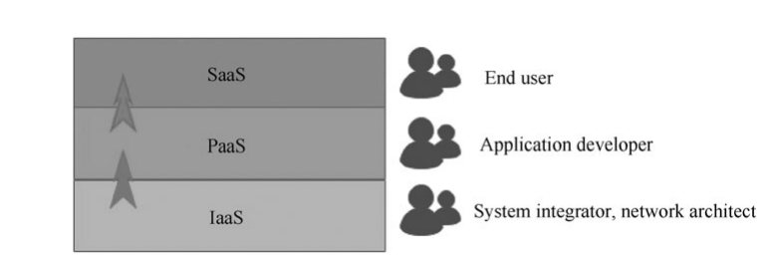
Locations
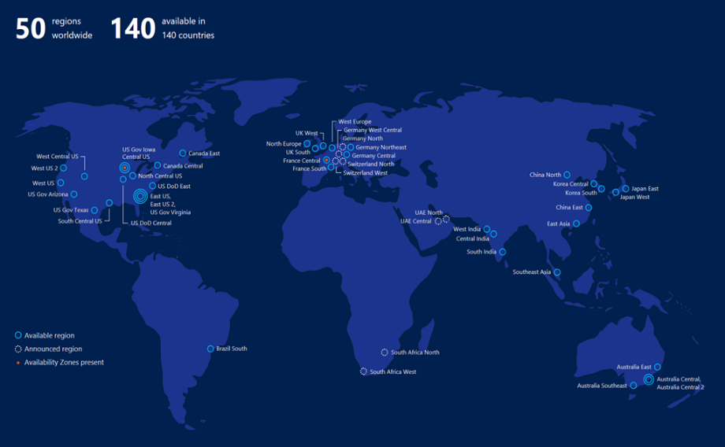 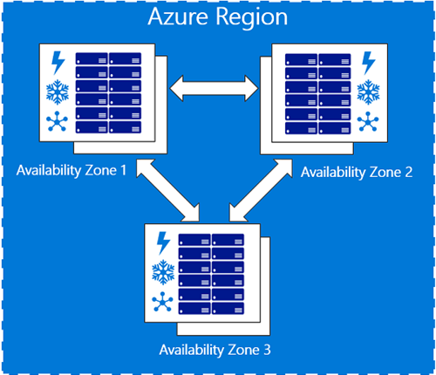
What is the Region?
The region is a set of unique physical data centers deployed in the zone with high-security of access and equipped with independent power, cooling, and networking. This is a solid infrastructure of databases being accessed from multiple locations.[7]
Availability zones
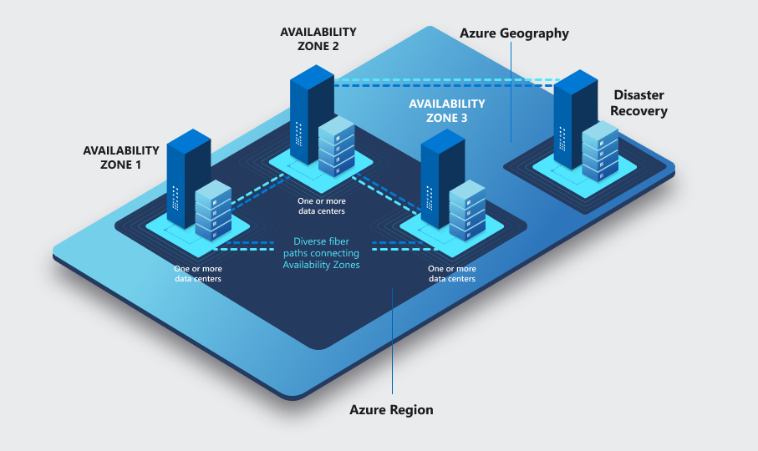 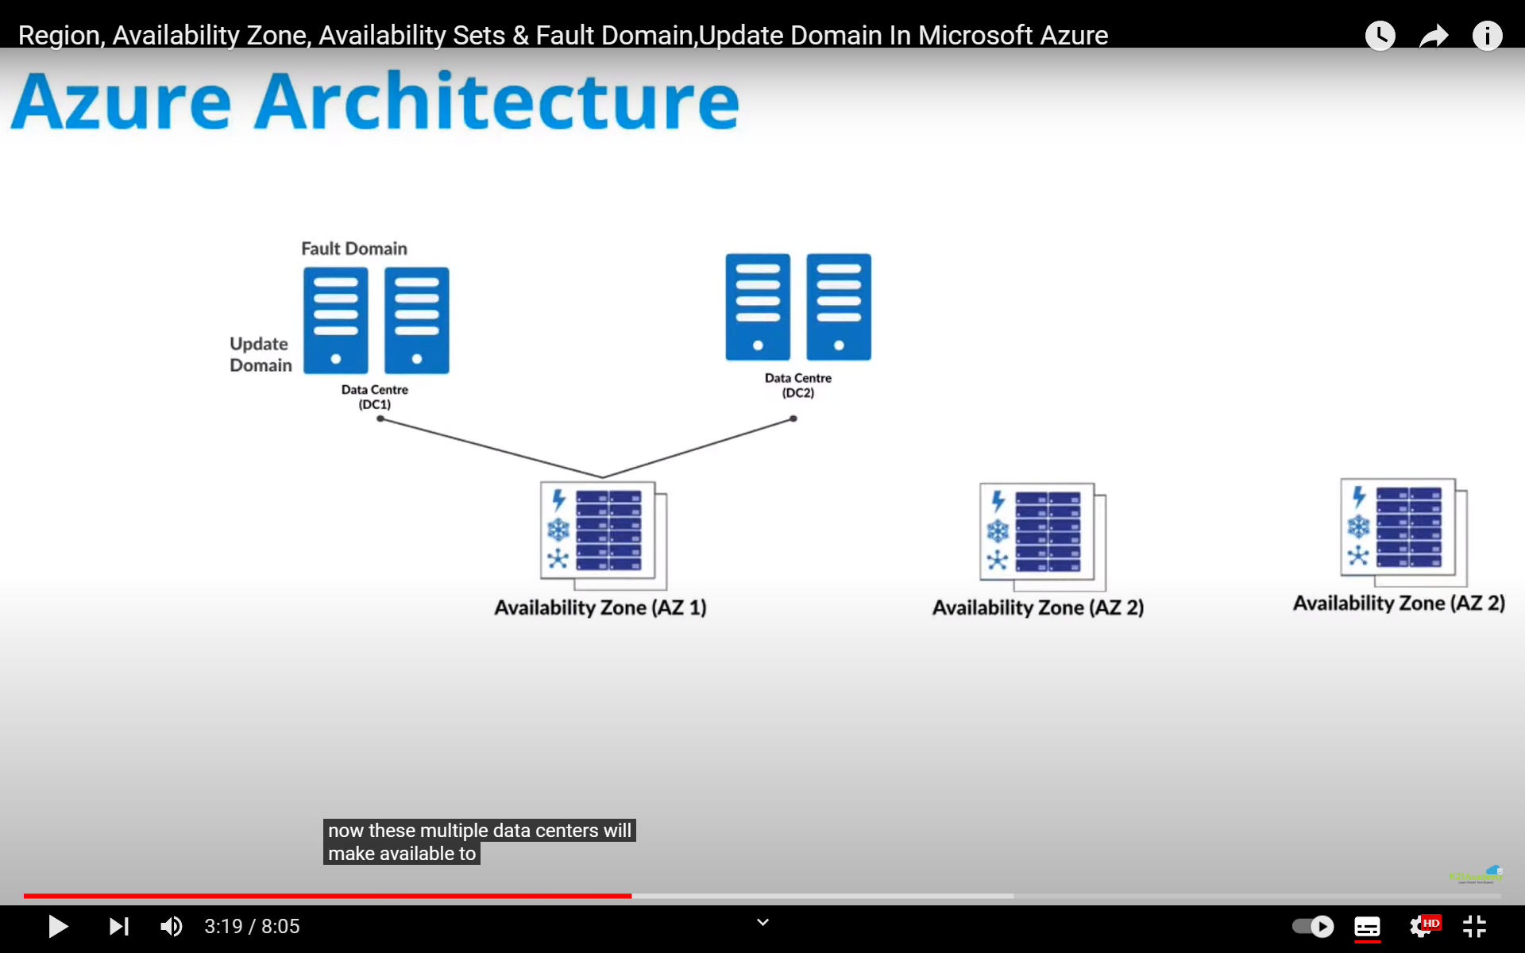
What are availability zones?
Availability zone is a collection of data centers. In data centers you have set of server rack and in that server rack you have multiple servers. These multiple data centers will make available zones.[7]

Resource groups
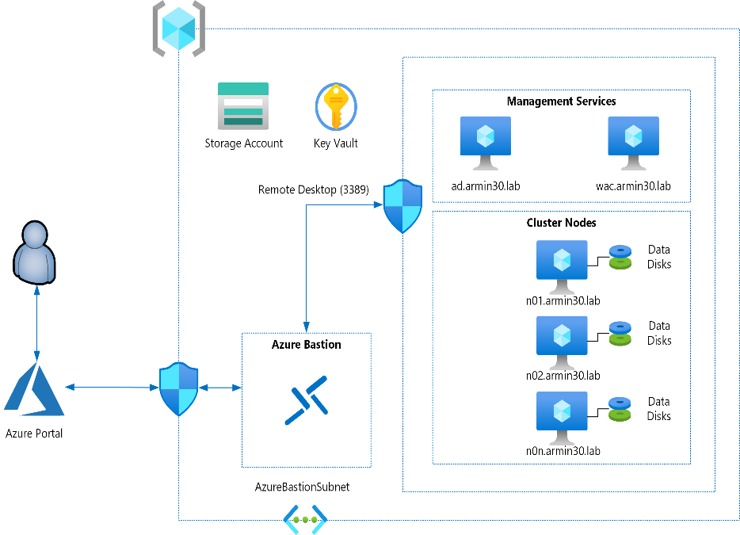
What is a resource group in Microsoft Azure?
Resource group is a simple container in which there is connected resources such as network, virtual machine, application and so on. The goal on that container via deploying on many resources would be able to communicate and have access to one another such as access control, management, and billing to be visible. The real power of resource groups is you can be deployed simply and no limits to the number of resources in a resource group.[8]

Security
Authorization
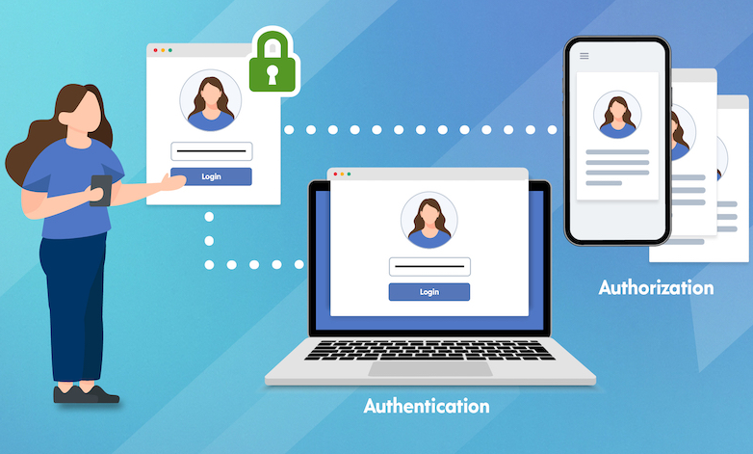
Authorization is a process by which a server determines if the client has permission to use a resource or access a file. Authorization is usually coupled with authentication so that the server has some concept of who the client is that is requesting access. The type of authentication required for authorization may vary; passwords may be required in some cases but not in others. In some cases, there is no authorization; any user may be using a resource or access a file simply by asking for it. Most of the web pages on the Internet require no authentication or authorization.[7]
Authentication
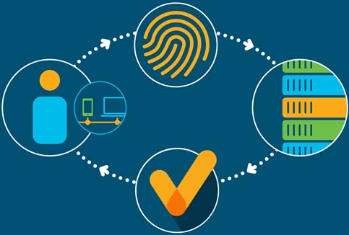
Authentication is used by a server when the server needs to know exactly who is accessing their information or site. Authentication is used by a client when the client needs to know that the server is the system it claims to be. In authentication, the user or computer has to prove its identity to the server or client. Usually, authentication by a server entails the use of a username and password. Other ways to authenticate can be through cards, retina scans, voice recognition, and fingerprints. Authentication by a client usually involves the server giving a certificate to the client in which a trusted third party such as Verisign or Thawte states that the server belongs to the entity (such as a bank) that the client expects it to. Authentication does not determine what tasks the individual can do or what files the individual can see. Authentication merely identifies and verifies who the person or system is.[7]
Importance of multifactor authentication (MFA)
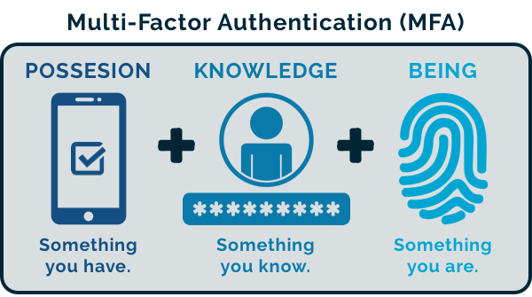
MFA is the simplest way to be sure the users are really who they say. It works by requiring users to confirm face authorization or fingerprint (biometric data) before permitting access, to your account or paying process.[8]
Applying the least-privilege permissions.
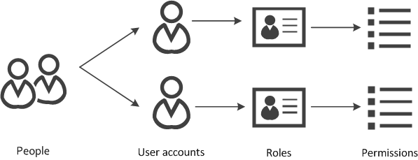
The basic idea is to give each user, permission to only services, applications, or data that they need to finish their work and no more. You will reduce to minimal risk from viruses or install of malware installed because they do not have administrative privileges required to install them.[8]

Network security groups.
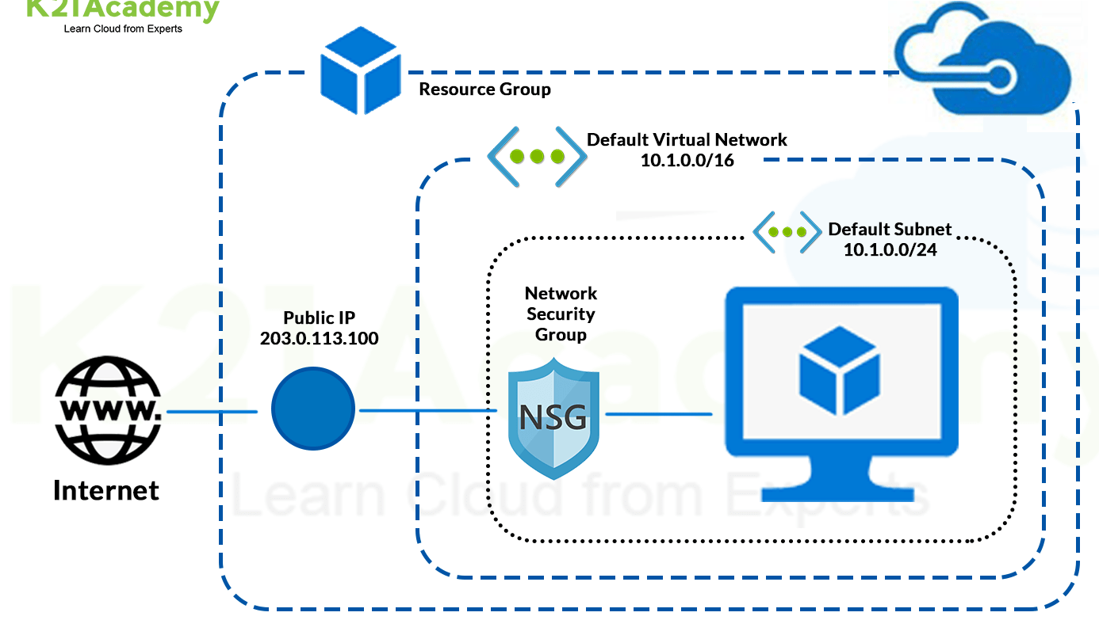
Network secure group is a process by which separate physical and virtual IT environments is via create barriers between IT resources. One network can be created to protect from internet access and the second one to be inside unable to access to the internet.[1]
Bastion.
What is Bastion?
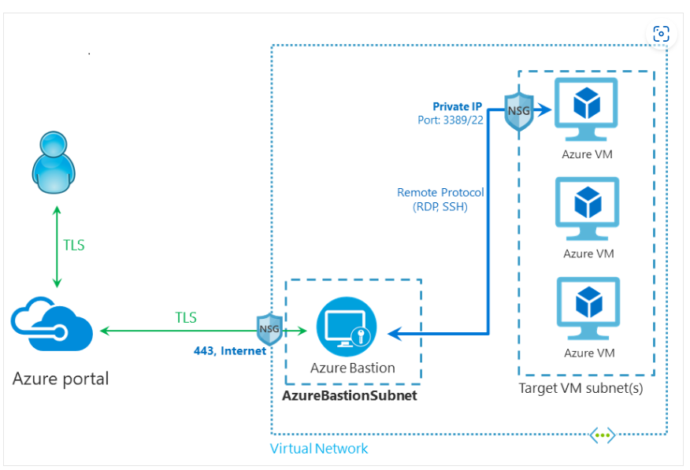
Bastion is a service with a set of rules that allow you to connect to a virtual machine using your browser and prevent unwanted entry of malicious software. Bastion provides secure RDP and SSH connectivity to all virtual machines in the virtual network. The simple way to achieve this is to allow SSH access only through the IP of the bastion host by setting restrictions in private security.[7]

Reference
- Erl, T., Mahmood, Z. & Puttini, R. (2013). Cloud Computing Concepts, Technology & Architecture. London. Prentice Hall
- Handbook of Research on Grid Technologies and Utility Computing: Concepts for Managing Large-Scale Applications, edited by Emmanuel Udoh and Frank Zhigang Wang
- Cloud Computing Technology by Huawei Technologies Co., Ltd. 1st ed. 2023.; 2023; Springer Nature Singapore
- Cloud Computing Service Models: Traditional and User-Centric Approaches ByKrishna Choudhary, Kshitij Gupta, Rahul Chawla, Prerna Sharma, Moolchand Sharm
- Zen of cloud: learning cloud computing by examples. Haishi Bai.
- IBM.com
- Azure.com
- Azure Virtual Network Resource Groups. Savill, John. Windows IT Pro (Online); Chicago (Nov22,2014)

