Academic Discipline of Hospitality and Tourism Management

International Meetings Management for the Hotel Industry
BMIH6007


“Equality, Diversity and Inclusion within hotel Industry”
An event in Nailcote Hall, Berkswell, UK.

Student Name: Diana Vukov
Student ID: 2234549
Lecturer Name : Christopher Wilkin
Word Count: 2632

Table of Contents
1.0 Introduction 3
2.0 The Event Cycle: Brief Understanding of the Said Event 3
2.1 Event Cycle for the Said Event 4
3.0 Event Concept: A Detailed Journey of the Said Event 5
4.0 Aim and Objectives of the Event 7
4.1 Aim of the Event 7
4.2 Objectives of the Event 7
5.0 Event Management 7
6.0 Event Budget: Cost and Revenue Analysis 11
7.0 Industry Trends, Issues and Impacts: Risk Management 13
8.0 Situational and Cultural Analysis 14
9.0 Conclusion 14
10.0 References 16
11.0 Appendices 18

1.0 Introduction
This is found in Seraphin's (2018) report, which states that event management refers to a whole range of activities concerning planning, organisation, and actual delivery of events. These range from travel and tourism to hospitality and media, among others. This brings the theoretical aspects to reality by combining theory and practice. The purpose of this paper is to demonstrate the planning for an event organised for “Equality, Diversity and Inclusion (EDI) within the hospitality Industry” through a seminar held for the hospitality industry stakeholders. The key aim of this report is to analyse the stages in the event management program for the seminar for the MICE industry professionals and to plan for the details like the budget, risk management, and project completion.
A brief discussion of the event is as follows. The said event focuses on the key issues and trends over the topic of equality, diversity and inclusion in the international hospitality industry. The whole event is organised targeting the key stakeholders of the said industry and is estimated to be successful in the competitive market scenario. The venue of the event is Nailcote Hall, Berkswell, UK.
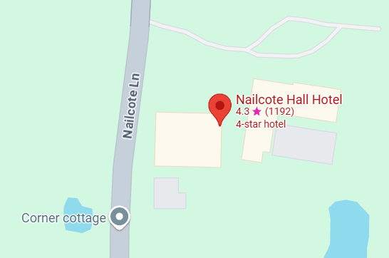
Figure 1: Location of the Venue: Source: Google Map

2.0 The Event Cycle: Brief Understanding of the Said Event
As mentioned by Perry and Burnfield (2024), Event cycles are those sets of phases, which must occur in sequence for the event to run successfully. These stages include planning and preparation, promotion and marketing, registration and logistics, execution, and evaluation and follow-up. Each one is important to make sure the goals of an event are realised, and every phase is as seamless and trouble-free as possible. The authors also have mentioned this as the "Gait Cycle".
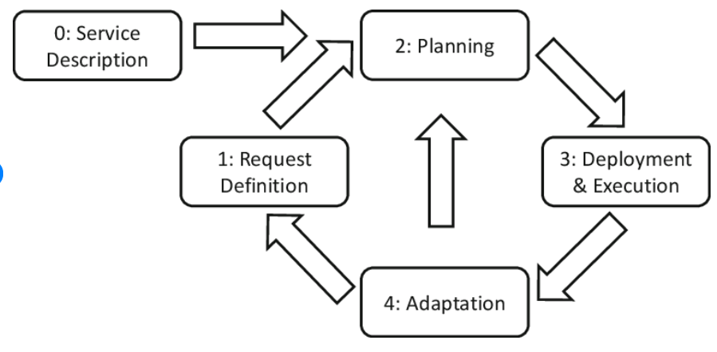
Figure 2: Scientific Diagram of Event Cycle (Source: Curry et al., 2020)

2.1 Event Cycle for the Said Event
The event cycle for the said event is as follows –

Figure 3: Event Cycle for the Said Event, (Source: Created by the Learner)
2.1.1 Planning and Preparation
The said event is focused on the topic of equality and diversity in the international hospitality industry and this takes longer planning and preparation. Planning involves factors like selection of a target market, venue selection, marketing and promotion and risk management. The planning stage for the seminar for promoting the EDI MICE industry will also include the price of the tickets, stakeholder analysis, and the activities to be done such as presentation, speech, catering etc.
2.1.2 Promotion and Marketing
The promotional activities will include social media marketing on social media channels. The contents will be presented in both images and videos related to the prevalent issues of EDI such as the gender gap in leadership positions. Additionally, the employees and managers will be invited to attend the seminar with the details of the seminar, ticket prices, and the offerings.
2.2.3 Logistics and Risk Management
The lecturers and performers will be invited by a common bus to the logistics services. It will welcome all the people on the committee of the seminar and will reach the stage 1 hour prior the gate to being opened for the audience. The risk management process will include the inclusion of fire extinguishers, medical kits, crowd management initiatives, emergency exits etc.
2.2.4 Execution of the Event
The main event will be executed with some major steps which include keynote speeches, group discussions, presentations and FAQ rounds. Each event will take place for a particular time frame and be completed successfully. However, short breaks and periodic safety check-ups were also included.

3.0 Event Concept: A Detailed Journey of the Said Event
According to Bladen et al. (2023), the conceptual journey of an event is based on the full itinerary of the same that denotes the key areas of the event's success and the experience of the guests. Taking this concept for the said event of EDI, this can be said that the whole event is being managed and handled properly and timely gestures helped in the success of the event. The said event followed a proper step-by-step approach that made a clearer concept for the successful completion of the same. A detailed itinerary of the said event is as follows –
Line-ups | Description | Time
Guest arrival and registration | Guests arrived and registered to their said panels along with the marketers and partners. | 8:00 AM to 9:00 AM
Opening Remarks | Welcome speech and opening remarks of the event manager. | 9:00 AM to 9:30 AM
Keynote Speech | Keynote speeches by the industry leaders on the said topic. | 9:30 AM to 11:00 AM
Panel Discussion | The panel discussions would entail speakers shedding light on diversity issues like the gender gap in the hospitality industry and possible interventions | 11:00 AM to 12:00 Noon
Networking Break | Short Break for relaxation and discussion for the participants, guests and audiences. | 12:00 Noon to 12:30 PM
Interactive Session | Workshops on the pragmatic approaches toward diversity and inclusion. | 12:30 PM to 2:00 PM
Lunch Break | Full-course lunch for the guests and participants. | 2:00 PM to 3:00 PM
Case Study Presentation | Discussion on taken steps on EDI presented with case-studies | 3:00 PM to 5:00 PM
Closing Remarks | Key takeaways on future steps and directions on EDI factors in the contemporary hospitality industry | 5:00 PM to 6:00 PM
Post-event Reception | Post-event informal networking for the guests and participants | 6:00 PM to 8:00 PM
Figure 4: Complete Itinerary of the Event on EDI in the International Hospitality Sector(Source: Self-made)

4.0 Aim and Objectives of the Event
Following the report of Bowdin et al. (2023), this can be said that a clear aim and objective serve as important and necessary guidance in directing and focusing all efforts and resources on achieving specific goals.

4.1 Aim of the Event
The event aims to create awareness among the hospitality industry stakeholders about the EDI-related issues prevalent in the industry and the ways initiatives might be taken to sort out those issues like the gender pay gap and marginalised representation of people from certain communities.

4.2 Objectives of the Event
As the event was conducted to understand the present and future insights on EDI in the hospitality industry, this focused on some key SMART objectives that ensure a bright and developed future on the same. The key objectives taken for the event are as follows –
- Increase attendee understanding of EDI factors in hospitality management by 25% through workshops, presentations and panels within 30 minutes from the start of the seminar
- Improving the depth of information in the speeches by at least 30% by presenting at least 5 case studies and industry practices to develop a theoretical EDI framework within 2 hours of the seminar
- Enhance EDI skill sets for 80% of the participants through interactive sessions and practical exercises at least 30 minutes before the completion of the seminar

5.0 Event Management
Taking the report of Thomas and Stephens (2022), this can be said that the successful implementation of the event requires a variety of skills and resources in operational, planning, and marketing activities. The said event on EDI in the hospitality industry also required a set of skills for planning, marketing and operational activities that will follow the EMBOK guide matrix to plan for the detailed tasks to be covered in the events to ensure successful completion and risk mitigation.
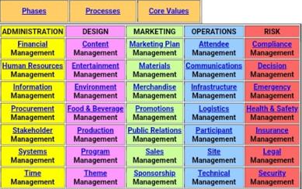
Figure 5: "EMBOK guide matrix", Source: Study Material.
EMBOK analysis
Administration | Responsible person | Responsibilities
Financial management | Accountant | Developing a feasible budget, attracting investment, preparing revenue reports and cash flow statements, and spending forecasting will be the responsibilities of the accountant to manage spending and allocate financial assets effectively.
HR management | HR manager | Scheduling the schedule and sequence of the speakers, managing needs like transportation, communicating with the stakeholders, and conflict resolution will be the role of HR to complete the project.
Information management | IT manager | Collecting and storing data from each department and uploading on a cloud platform
Procurement management | Event manager | Collecting supplies from caterers, and decorators, and maintaining quality standards
Stakeholder management | HR manager and Event manager | Scheduling periodic meetings for the team members both face-to-face and through digital platforms
System management | IT manager | Ensuring immediate resolution of any technical issues
Time management | HR manager and Event manager | Developing a Gantt chart and motivating members to follow the benchmarks

Design | Responsible person | Responsibilities
Content | Event manager | Creating finalised content by working closely with all the participants
Entertainment | Event manager | Including quality audio-visual equipment
Food and beverage | Event manager | Collecting food ingredients from suppliers, maintaining optimisation in inventories and supervision of the caterers
Production | Marketing and Event manager | Developing attractive content and rehearsal of the performance
Programme | Marketing and Event manager | Managing the audience and maintaining the sequence
Theme | Marketing and Event manager | Maintaining the themes close to EDI and attracting people from all backgrounds

Marketing | Responsible person | Responsibilities
Marketing Plan | Marketing Manager | Developing a detailed marketing plan including a selection of tools, target customers, and marketing mix
Materials | Event manager | Materials to select for promotional activities and content like video and image posts design
Merchandises | Event manager | Developing a marketing team and allocating responsibilities
Promotions | Marketing Manager | Developing social media post content and communicating with users
Public relations | Marketing Manager | Including marketing employees to reply to the queries of social media users interested in attending the seminar
Sales | Marketing Manager | Confirming the payments and sending e-tickets to customers
Sponsorships | Marketing Manager | Attracting sponsors by demonstrating the intention of the seminar and promoting the need for such EDI-related seminars for the MICE industry

Operations | Responsible person | Responsibilities
Attendee | Event manager | Including experienced crowd management team members
Communications | Event and HR manager | Including communication tools like wireless interaction mouthpieces
Infrastructure | IT and Event manager | Monitoring the event stage, seats, decorations, and IT tools before the start of the event
Logistics | HR manager | The HR manager will ensure transport facility in case any participant needs
Participants | Event manager | Taking attendance of the participants, and keeping them in touch for communication
Site | Event manager | Monitoring the details of the sites and communicating with members of each team to manage quality
Technical | IT manager | Last time checking of the IT tools and all the IT requirement

Risk mitigation planning | Responsible person | Responsibilities
Compliance | HR manager | HR will be responsible for the actions of the participants and team members and to avoid any compliance.
Decision | All the managers | Collaboratively making decisions through team meetings
Emergency | Event manager | Making decisions on an emergency basis in case of any emergency
Health & Safety | HR manager and Event manager | Including a healthcare professional team for handling any health-related issues
Insurance | Marketing manager and Event manager | Insurance will be purchased for the health and safety of employees, fire insurance, and equipment insurance.
Legal | Event manager | All the legal liabilities like the fire extinguisher system and emergency exit will be followed to avoid any legal issues.
Security | Event manager | An experienced security and crowd management team will be included

6.0 Event Budget: Cost and Revenue Analysis
Krishnasamy and M.Arul (2017) have mentioned that financial analysis is important in event management because it ensures the financial viability of the event, guides strategic decisions and facilitates risk management. The seminar to promote EDI in the hospitality industry also became successful with a complete understanding of the key budgetary approaches. This has been seen from the previous feasibility study that the estimated cost and revenue tables have served for the event which serves a key understanding of the approaches taken for it. The cost and revenue tables for the event are as follows –
Areas | Allocated Budget (in £)
Venue Rental | 10,000
Catering | 8,000
Marketing and Promotion | 3,000
Speakers Fees | 5,000
Staffing (Event Staff) | 4,000
AV and Technical Support | 2,000
Accessibility Services | 1,000
Contingency | 2,000
Medical Expenses | 2,000
Risk Management Expenses | 3,000
Total | 40,000
Figure 6: Financial Projection (Cost) for the said Event(Source: Self-made)
Areas | Details | Cost (in £)
Ticket Sales (Early projection) | Incentives on early registrations, discount offers | 10,000
Ticket Sales (Regular) | Standard-priced ticket | 12,000
Ticket Sales (Students) | Reduced-price tickets for wider participation | 8,000
Sponsorship (Gold) | Premium sponsorship with extra benefits | 8,000
Sponsorship (Silver) | Mid-tier sponsorship package | 3,000
Exhibitor Booth | Opportunities for organisations to present their EDI initiatives | 5,000
Total |  | 46,000
Figure 7: Financial Projection (Revenue) for the said Event, (Source: Self-made)
Positive projections for the financial outcome of the event include a net income of £6,000 with total revenue amounting to £46,000 against £40,000 as costs. This healthy margin demonstrates that the event is financially viable and thus ensures the possibility of growth and reinvestment in the EDI initiatives. The positive results and sound financial planning support the development of the event into the planning phase, signifying its potential success.

7.0 Industry Trends, Issues and Impacts: Risk Management
Bernaueret al. (2023) have shown that the MICE industry fosters EDI, which leads to a more inclusive and equitable workplace, enhancing employee satisfaction and retention. Organisations are implementing specialised training, mentoring programs, and unconscious bias training to address these issues. However, challenges remain, such as gender pay gaps and underrepresentation of diverse groups in leadership positions. Addressing these challenges through comprehensive EDI strategies can drive innovation, improve service quality, and create a more inclusive environment for both employees and guests.
This is also found from the report of Suri (2023) that the hospitality industry is doing well in DEI but is lagging in retention and leadership diversity. Companies are investing in DEI through training and inclusive policies, but progress is uneven. This is critical to fostering innovation and improving service quality. One of the most important factors that can be seen from the report of Statista Daily Data (2023) is that around 54% of the employees in international hospitality are women working at a lower payment rate.
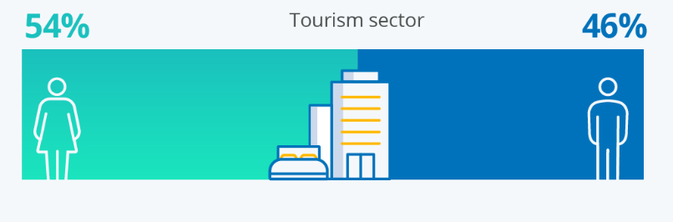
Figure 8: Gender Equality in the Hospitality Industry, (Source: Statista Daily Data, 2023)
Taking the above discussion into account, this can be said that the overall scenario around EDI in the hospitality industry is facing a tottering situation. This serves the idea that such an event was important for the industry.

8.0 Situational and Cultural Analysis
Cultural events play a significant role in the development of an individual's emotional, cognitive, and social development; despite the individual peculiarities and differences of the participants, cultural events strengthen the unity of the group members (Gurgenidze and Mamuladze, 2017). It creates a better collaboration among stakeholders and ensures mutual effort toward mutual objectives. A brief understanding of the situational and cultural approaches of the event using the SWOT analysis is as follows –
Strengths | Weaknesses
- The event focuses on EDI that aligns with industry demand and trends  - The event includes the possibility of making decisions based on personalised needs in the hospitality industry  - This will offer a wider network for collaboration within the MICE industry. | - The event might be lengthy and might not engage attendees  - The inclusion of lunch might distract attendees  - Limited perspectives might come to the front due to less participation.
Opportunities | Threats
- This event will ensure a proper share of knowledge on the topic of EDI in the said industry.  - This is estimated that the collaborative approach will ensure a broader future on the factor. | - A lack of participation can create conflicts in the industry.  - The external factors can be a challenge to implement EDI in the process.

9.0 Conclusion
The event on Equality, Diversity, and Inclusion (EDI) in the international hospitality industry effectively addressed key issues and trends. It helped build awareness and foster collaboration among the stakeholders. External factors and lack of participation might have been among the challenges but did not compromise the event's success. Attendees gained an understanding of EDI, developed a theoretical framework, and improved participant skills. It offers a useful vehicle for the hospitality industry to take up the challenge of EDI and pave its way to an inclusive and equal future.

10.0 References
Bernauer, V.S., Bhati, A. and Thirumaran, K. (2023). Guest editorial:(In) equalities in hospitality and tourism–exploring diversity and equity issues. Equality, Diversity and Inclusion: An International Journal, 42(4), pp.465-468.https://doi.org/10.1108/EDI-05-2023-378.
Bladen, C., Kennell, J., Abson, E. and Wilde, N. (2023). Events management: An introduction: an introduction.https://www.taylorfrancis.com/books/mono/10.4324/9781003102878/events-management-charles-bladen-nick-wilde-james-kennell-emma-abson.
Bowdin, G.A., Allen, J., Harris, R., Jago, L., O'Toole, W. and McDonnell, I. (2023). Events management. Routledge.https://www.taylorfrancis.com/books/mono/10.4324/9781003044963/events-management-glenn-bowdin-ian-mcdonnell-rob-harris-william-toole-johnny-allen-leo-jago
Curry, E., Gao, F. and Curry, E.(2020). Quality of service-aware complex event service composition in real-time linked dataspaces. Real-time linked dataspaces: enabling data ecosystems for intelligent systems, pp.169-190.https://doi.org/10.1007/978-3-030-29665-0_11.
Gurgenidze, M. and Mamuladze, N. (2017). The Role of Cultural Events in Rehabilitation, Therapy and Education of People with Special Needs. Journal of Education and Practice, 8(13), pp.35-38.https://eric.ed.gov/?id=EJ1143863.
Krishnasamy, Krishnakumar and M.Arul. (2017). Financial issues in event management practices- A study with reference to unorganised event management practitioners in Salem district. 4. 34-38.
Perry, J. and Burnfield, J.M. (2024). Gait cycle. In Gait Analysis (pp. 3-6). CRC Press.
Seraphin, H. (2018). International event management: bridging the gap between theory and practice.https://winchester.elsevierpure.com/en/publications/international-event-management-bridging-the-gap-between-theory-an-3
Statista Daily Data. (2023). Infographic: Women are the main workforce in the tourism sector. [online] Available at: https://www.statista.com/chart/31353/women-are-the-main-workforce-in-the-tourism-sector/. [Accessed on: 06/0//2025]
Suri, A. (2023). The State of DEI in the Hospitality Industry.
Thomas, K. and Stephens, S. (2022). Understanding the Management Theory in Event Management: A Conceptual Framework. Available at SSRN 4051469.

11.0 Appendices
Appendix 1: Budget for the project
Areas | Allocated Budget (in £)
Venue Rental | 10,000
Catering | 8,000
Marketing and Promotion | 3,000
Speakers Fees | 5,000
Staffing (Event Staff) | 4,000
AV and Technical Support | 2,000
Accessibility Services | 1,000
Contingency | 2,000
Medical Expenses | 2,000
Risk Management Expenses | 3,000
Total | 40,000

Areas | Details | Cost (in £)
Ticket Sales (Early projection) | Incentives on early registrations, discount offers | 10,000
Ticket Sales (Regular) | Standard-priced ticket | 12,000
Ticket Sales (Students) | Reduced-price tickets for wider participation | 8,000
Sponsorship (Gold) | Premium sponsorship with extra benefits | 8,000
Sponsorship (Silver) | Mid-tier sponsorship package | 3,000
Exhibitor Booth | Opportunities for organisations to present their EDI initiatives | 5,000
Total |  | 46,000

Appendix 2: SWOT analysis
Strengths | Weaknesses
- The event focuses on EDI that aligns with industry demand and trends  - The event includes the possibility of making decisions based on personalised needs in the hospitality industry  - This will offer a wider network for collaboration within the MICE industry. | - The event might be lengthy and might not engage attendees  - The inclusion of lunch might distract attendees  - Limited perspectives might come to the front due to less participation.
Opportunities | Threats
- This event will ensure a proper share of knowledge on the topic of EDI in the said industry.  - This is estimated that the collaborative approach will ensure a broader future on the factor. | - A lack of participation can create conflicts in the industry.  - The external factors can be a challenge to implement EDI in the process.

Appendix 3: Workplace gender gap


