Representation of the Athenian Law courts in Aristophanes’ ‘The Wasps’
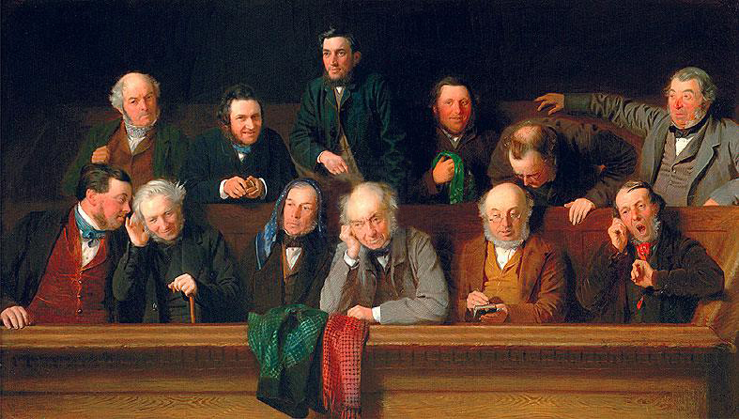
The Wasps is an Old Comedy play written by Aristophanes, being first performed in Athens at the Lenaia Festival in 422 BC (D. Barrett, 1964). The play is about a father and son who hold a mock trial at the home as the son’s father is addicted to participating in the Law courts (Aristophanes, 422 BC). The main underlying message of the play was targeted at the Athenian Law Court system for how mad the system had become with the overuse of ostracism and the certain items that were required for the courts to work.
Figure 1: J. Morgan’s 1861 Oil painting of ‘The Jury’. The Chorus in The Wasps comprises elderly jurors who briefly resemble wasps in their behaviour. https://commons.wikimedia.org/wiki/File:The_Jury_by_John_Morgan.jpg
The Athenian law courts had once been the prize of Athens during the 5th Century and
This can be clearly seen in Aeschylus’ ‘Eumenides’, where we see the creation of the Athenian Law Courts led by the patron Goddess of Athens, Athene. “I now establish this court. Neither profit nor lust should violate it” (Aeschylus, 458 BC, line 705). However, the system became the stage for popularity contests between Strategos (P.J. Rhodes 2010).
An example being one of the reforms advised by Pericles to included payment for people who were selected to be in the law courts (P.J. Rhodes 2010). Now everyday citizens who were unable to take part in the system due to not being able to take a day off work so that they could make a living, could now do so as they would be payed for the work they did (P.J. Rhodes 2010). The Old Aristocratic Family’s and the Elite were the main people who opposed this as they viewed those who couldn’t come to the law courts unless paid, were uneducated in the ways of politics and shouldn’t take part in the courts (P.J. Rhodes 2010). It was in the midst of these reforms advised by Cleon that Aristophanes wrote his play.

Old Comedy was intently aimed or raised issues about Athenian and other democracies across the Greek colonies and because most of the audience was made up of assemblymen, it was an ideal platform to share ideas on democracy’s flaws and how they could be fixed (). Therefore, democracy become an integral part of Old Comedy. Aristophanes was known for raising important issues of the time within his plays. A few years before the Wasps was performed, One of Aristophanes previous plays, ‘The Knights’ performed in 424 BC, had nearly gotten himself ostracised from Athens, due to his pretrial of the Strategoi Cleon, which portrayed him as a sausage seller who was of low birth and unfit to advise on such matters like Politics. Therefore, he had to use his rhetoric and language more carefully as to not get himself into any more political trouble, like using characters in the play to be a mouthpiece for him, such as Bdelycleon, instead of him preaching onstage like he did in The Knights (D.Konstan, 1985). D. Konstan states that the “Wasps, and two other Aristophanic comedies written about the same time…are set off from what we may call the utopian comedies.” (D. Konstan, 1985). These comedies had the aim and “desire for peace and plenty, or for the restoration of civic and poetic decorum” (D. Konstan, 1985). Meaning that they intended to make the audience made up of assembly members to think about how they could make democracy better for every citizen.

Lines 471 through to 712, are the most useful when discussing how the law courts are presented to Aristophanes’ audience as most of the jokes and digs are presented here.
It can be seen in the behaviour of the Chorus by them Constantly accusing Bdelycleon of “dictatorship” (referencing the overuse of ostracism and the power held by the elite over the common citizen) (Aristophanes, 422 BC). Also, in the trial, we hear issues being raised about the “Kingly power of the juries” as even Cleon doesn’t mess with the courts as he knows it can be sued as a tool for popularity (Aristophanes, 422 BC). In all, The Wasps is an interesting piece of source material for us to have as it allows moderns scholars to debate on the state of the Athenian Law Court system and is a funny piece of comedic writing.

Reference List:
Aristophanes (422 BC), Translated by David Barrett (1964), ‘The Wasps, The Poet and the Women and the Frogs’, London, Penguin Books

D. Konstan, 1985, ‘The Politics of Aristophanes' Wasps, Transactions of the American Philological Association (1974-2014)’, Vol. 115 (1985), pp. 27-46, The Johns Hopkins University Press, Accessed: 17-01-2020 14:43 UTC, https://www.jstor.org/stable/284188

J. Morgan (1861), ‘The Jury’, [Oil on Canvus], England, Bucks County Museum. https://commons.wikimedia.org/wiki/File:The_Jury_by_John_Morgan.jpg

P.J. Rhodes (2010), ‘A history of the classical Greek world, 478-323 BC’, 2nd ed, Chichester, West Sussex, U.K. ; Malden, MA: Wiley-Blackwell, p115

J. Morgan’s 1861 Oil painting of ‘The Jury’. The Chorus in The Wasps comprises elderly jurors who briefly resemble wasps in their behaviour. https://commons.wikimedia.org/wiki/File:The_Jury_by_John_Morgan.jpg

