report
SMART TECHNOLOGY IN A WORKPLACE
APPROPRIATE USE OF TECHNOLOGY
PREPARED BY;

RACHEL TUSHABOOMWE
STUDENT NO. 1711367

This report shows the appropriate use of technology in a workplace including devices like smartphones, tablets and web conferencing. The report also demonstrates how to use professional accounts namely: Facebook, twitter and LinkedIn in how to search for work or getting a better job.

Table of content

INTRODUCTION 2
TABLETS 2
SMARTPHONES 3
What are the benefits of using smartphones and tablets in improving workplace efficiency??? 4
I. Autonomy 4
II. Relationships in a workplace 5
III. Improve Business Presentations 5
IV. The Perks of Using tablets and smartphones at Trade Shows 5
V. Tablets and smartphones can save a Company Money 6
VI. Conclusion and further study 6
WEB CONFERENCING 6
How does web conferencing improve workplace efficiency? 7
a. Application and Desktop Sharing 7
b. Increase Productivity 8
c. Conduct Employee Training Easily 8
d. Improve Customer Relations 8
e. Business Processes are No Longer Constrained by Location 8
f. Conclusion in summarry. 9
REFERENCES 9
HOW CAN FACEBOOK BE USED IN A WORKPLACE? 10
1) Workplace by Facebook 10
How is Workplace Facebook being adopted and adapted? 11
What are the long-term aims for Workplace Facebook? 12
Why use LinkedIn in a workplace? 13
1. Increased Visibility for Your Brand 14
2. Consistent Brand Ambassadors. 15
3. Improved Morale. 15
Workplace Facebook vs. LinkedIn 16
So what does Facebook’s sudden interest in the workplace mean for LinkedIn? 16
Twitter 16
How Does Twitter Work? 17
Use of twitter for business 17

SMART TECHNOLOGIES IN A WORKPLACE

INTRODUCTION
The last couple of years have seen mobility emerge as one of the key trends in the enterprise IT space. With smartphones and tablets becoming more powerful, there's a growing recognition that they have a major role to play in the business world. This is partly driven by people's increasing familiarity with these devices in their personal lives. For many consumers, it's just as natural to browse the internet, buy products online and stay in touch with friends and family on a mobile device as a PC, and this trend is only set to grow in the coming years.
For instance, Gartner has forecast that by 2019, the average consumer will use three to four main devices, including a laptop, smartphone and tablet, as well as more niche items like smart watches. Anshul Gupta, research director at the firm, said: "The combination of the high level of adoption of technology, the availability of faster networks, and decision making becoming increasingly dependent on real-time information, will undoubtedly lead to more devices per user."

TABLETS
A tablet is a wireless, portable personal computer with a touchscreen interface. The tablet form factor is typically smaller than a notebook computer, but larger than a smartphones.

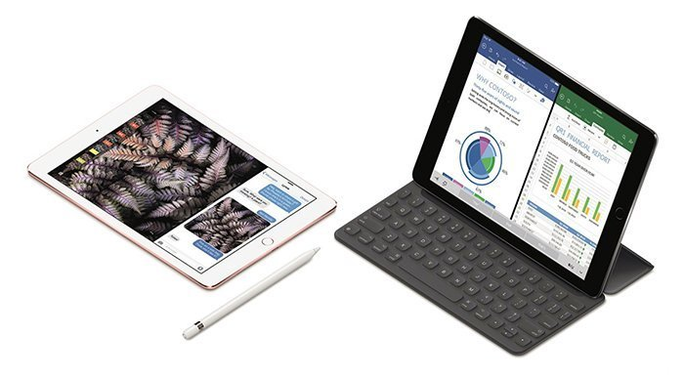
The New York Times reported that “tens of millions of tablets would be in use in America's workplaces by 2015”. Tablets provide businesses with enhanced functionality, while enabling employees to access important information quickly, and while they are on-the-go. Smart phones are still a major component of the on-the-go approach, but anyone who is utilizing a tablet will be able to load documents to a much more user-friendly screen size. As a result, most executives and individuals who travel on a regular basis for work have added a tablet into their travel kit.

SMARTPHONES
The word ‘Smartphone’ was introduced years ago, but the meaning has been changed over time. It began in the past when people only had mobile phones or cellular phones. Smartphones are wireless-transmission-devices that can receive and transmit through digital or analog shortwave (Rouse, 2007). Thus, people can communicate with each other by using these devices. Later on, there were developments and evolutions of the mobile phone, which made the mobile phone smarter; eventually people started calling it ‘Smartphone.’
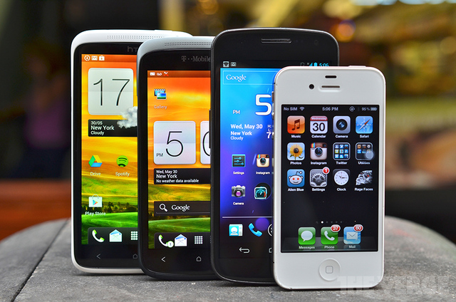

The main factor that distinguishes between a mobile phone and a Smartphone is that “[a] smartphone is a mobile phone that offers more advanced computing ability and connectivity than a contemporary basic ‘feature phone’” (Litchfield, 2010, para. 8). additionally, the internet also makes the Smartphone even better. Litchfield concludes in his article “Defining the Smartphone” by defining the Smartphone as a device that “runs an open (to new apps) operating system and is permanently connected to the internet” (Litchfield, 2010, para.21). He may be right about this because the Smartphone with accessibility of the internet lets people do many things on this device.
https://www.researchgate.net/publication/271340378_Smartphones_in_the_workplace_Changing_organizational_behavior_transforming_the_future

What are the benefits of using smartphones and tablets in improving workplace efficiency???
According to Statista, there are 46.4 million smartphones in the UK. In January 2017, the Labor Force Survey found that there were 31.85 million people in employment. When there are 10.55 million more smartphones per user than there are employees in the UK, it becomes clear how and why the smartphone has changed our day-to-day working practices — but is it for better or for worse?

Autonomy
Gagne and Deci (2005), shows that one of the important contexts in a job that can promote autonomy is choices. When employees, who have individual differences, are supported by their company’ system, they will have a high motivation to work. Other research by Zielinski (2012) states that “Business leaders find that offering greater choice in work technologies can boost productivity and satisfaction levels of most employee generation” (p.71). When employees know that their company supports their Smartphones and wants them to use for working purposes, they will have satisfaction and tend to do their best for their company. If companies were to use a method like Ford Motor Co.’s or Wells Fargo’s, they would be more likely to improve their employee autonomy and morale, which would have positive impacts in their work environments.

Relationships in a workplace
Smartphones helps improve relationships with peers as well as superiors. Smartphone is a high potential device that gets people together through the internet platform. CEOs or Managers should take this chance to turn their employees’ Smartphones into engagement tools. They could make an internal application or system that can connect people in companies together, instead of connecting with their friends outside workplaces. For instance, one of the Fortune 500 companies tried improving on improving employees’ relationships by using internal social-communication systems such as an internal blog, Microsoft SharePoint, etc within the company. The result was impressive, “Employee feedback from the beta testing was extremely positive, as employees developed deeper relationships with their fellow employees, increasing their satisfaction with the company culture and work environments. Beta-project leaders reported no incidents of employee misuse, and even at present employees self-police their network use” (Miller-Merrell, 2012, p.4). This example only uses their internal computer system to run the experimental project, but the Smartphone is a higher capable than computers because people always carry it all the time. If companies use this model to connect their employees together, not only employees’ relationships with their peers will be stronger, but also their relationships with their superiors will be better

Improve Business Presentations
Rather than walking into a meeting with a “heavy” laptop (or worse yet, a stack of paper and a couple of large charts), a tablet—such as Apple’s iPad or Amazon’s Kindle Fire—can be utilized to showcase a slideshow or a video presentation. Using a tablet or a smartphone instead of a laptop makes the setup easier and it also makes the entire process less cumbersome—especially if you have to travel to another location to participate in the meeting. In addition to portability, integrating the latest technology into your presentation can serve to demonstrate an innovative spirit to potential clients or business partners.

The Perks of Using tablets and smartphones at Trade Shows
Just as a tablet can be useful in a business presentation, it can be ideal for a trade show environment. Most trade show setups require vendors to walk a long distance from the car to the booth, and no one wants to lug large electronics with them to and fro. Instead, you can store videos that highlight product or services on a tablet and set it up at the booth so that people can easily watch the videos and access any other pertinent information. As an added bonus, credit card authorization software can be seamlessly installed onto your tablet to make it easy to collect orders remotely. As a lower cost alternative, businesses also mitigate financial loss due to theft.

Tablets and smartphones can save a Company Money
As long as your company has an actual need for tablet technology, then they can save you money. The increased productivity that comes along with making it easier for traveling employees to stay connected to the workplace is one of the most compelling reasons to purchase at least a couple of tablets. Make sure that you prioritize who has an actual need for that level of connection while they are on the road. If someone only has to be able to check in and respond to occasional emails, then a smart phone makes more sense than a tablet. On the other hand, if an employee is an integral piece of your business and they need to be able to review documents and easily access the Internet from anywhere, then they would benefit from using a tablet.

Conclusion and further study

WEB CONFERENCING
Web conferencing may be used as an umbrella term for various types of online collaborative services including web seminars ("webinars"), webcasts, and peer-level web meetings. It may also be used in a more narrow sense to refer only to the peer-level web meeting context, in an attempt to disambiguate it from the other types of collaborative sessions. Terminology related to these technologies is inexact, and no generally agreed upon source or standards organization exists to provide an established usage reference.
In general, web conferencing is made possible by Internet technologies, particularly on TCP/IP connections. Services may allow real-time point-to-point communications as well as multicast communications from one sender to many receivers. It offers data streams of text-based messages, voice and video chat to be shared simultaneously, across geographically dispersed locations. Applications for web conferencing include meetings, training events, lectures, or presentations from a web-connected computer to other web-connected computers.

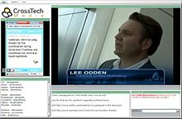

How does web conferencing improve workplace efficiency?

Application and Desktop Sharing
One of the most important advantages of web conferencing is desktop and application sharing. The ability to present information through PowerPoint Presentations, Excel Spreadsheets, and any number of other applications ensures that your meeting runs smoothly and that everyone is on the same page despite the distance.

Increase Productivity
Web conferencing does save travel time, but that’s the only way it can save you time. Through web collaboration solutions, companies can give online demos of products and services without wasting time in the planning process. By having a webinar demo or tutorial ready to deploy online, you save all the time that’s usually spent on coordinating with clients, employees, and customers.

Conduct Employee Training Easily
Most people think of the advantages of web conferencing in terms of internal meetings, but you can also utilize it for employee training. Vendors like Blackboard specialize specifically on training and education, making it easier than ever to train employees located in various locations at the same time.

Improve Customer Relations
Web conferencing tools can even be used to improve customer support and relationships. Utilizing the advantages of web conferencing solutions can give your support team more ability to take control of a client’s computer and fix problems in a more efficient and timely manner.

Business Processes are No Longer Constrained by Location
Finally, the biggest web conferencing benefit is that it allows your organization to act without geographical limitations. You can manage and run all the operations of your company through web conferencing and the best webinar tools, and the technology is improving at such a meteoric rate that the distance between employees and team members will soon be a non-issue.
As you can see, leveraging the advantages of web conferencing solutions ensures that your entire organization is operating on the same page, vastly improving the information flow of the company. What are your favorite aspects of web conferencing? What kinds of web conferencing features would you like to see in the future?

Conclusion in summarry.

REFERENCES
- Anderson, J.Q. & Rainie, L. (2010). The future of cloud computing. Pew Research Center’s
Internet& American Life Project. Retrieved from
http://pewinternet.org/Reports/2010/The-future-of-cloud-computing.aspx
- Bakker, A.B., (2011). An evidence-based model of work engagement. Sage Publications, 20(4),
265-269.
- Bakker, A.B. & Demerouti, E. (2008). Towards a model of work engagement. Career
Development International, 13(3), 209-223.
- Bozeman, M. (2011, July 27). Smartphone obsession the latest addiction. Bozeman Daily
Chronicle.
- Brodkin, J. (2011). Wells fargo says no to personal smartphones and tablets, period. Network
PART TWO
As per the case, the researcher created professional accounts such as; a Facebook account, twitter account and LinkedIn. These accounts will help her most in her search for work or better job as illustrated below; Attached are screen shots of the professional accounts created.
e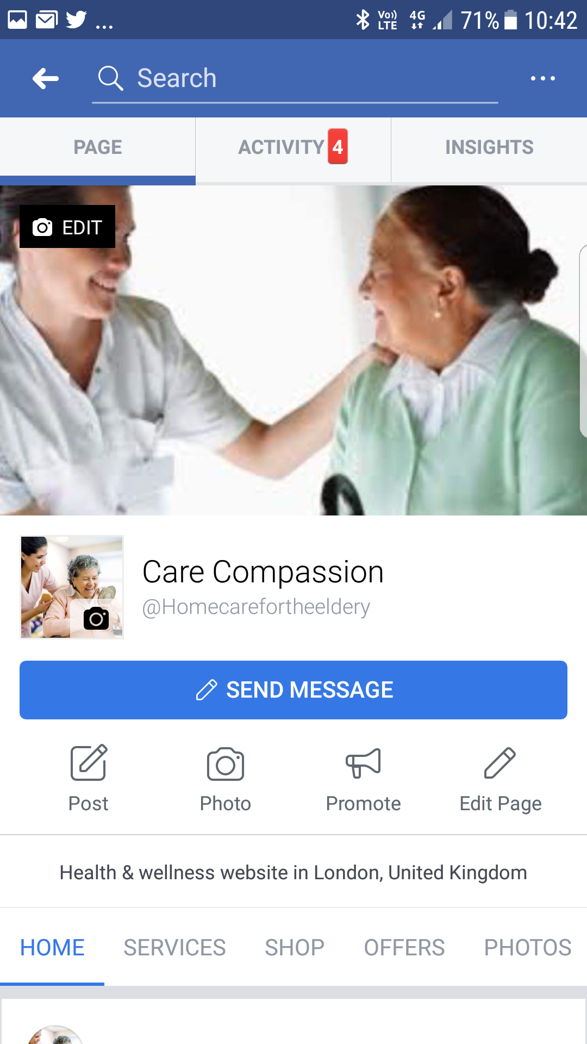
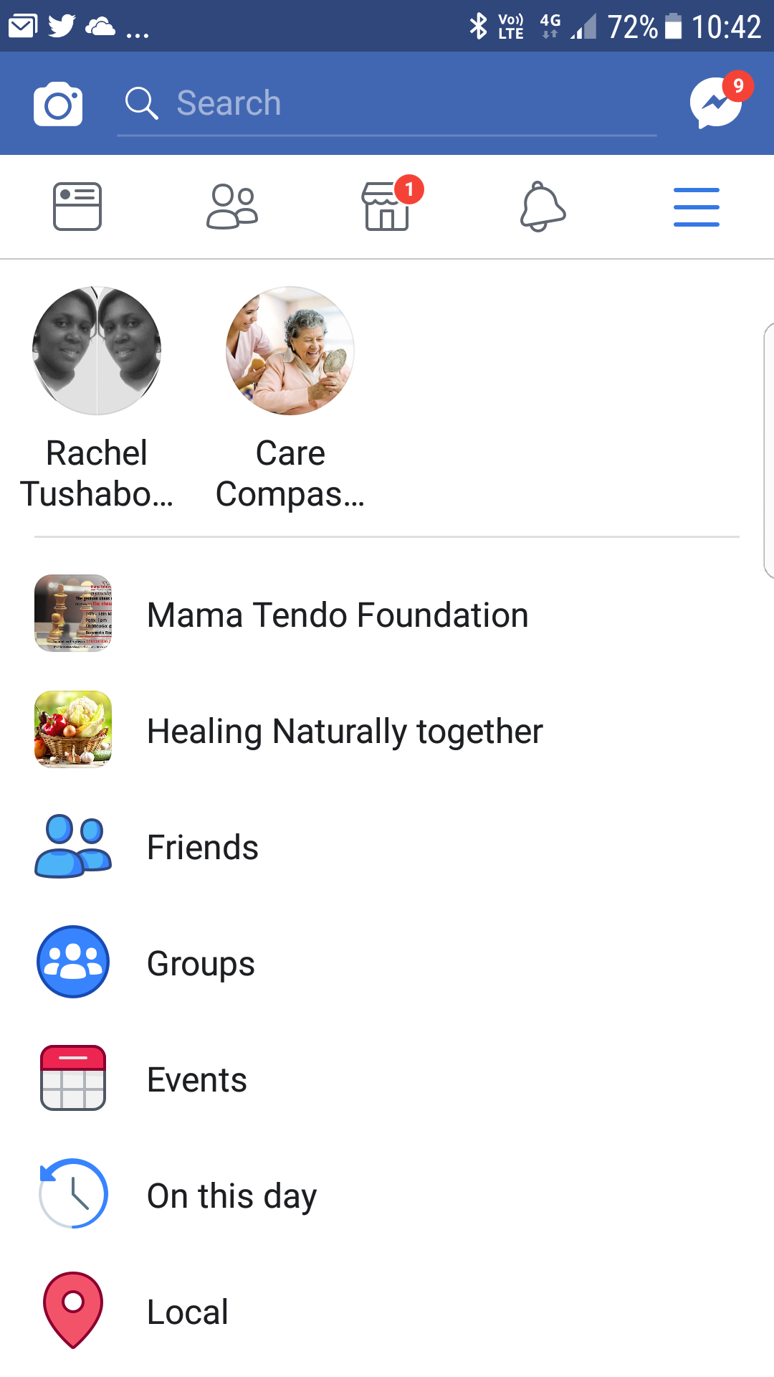

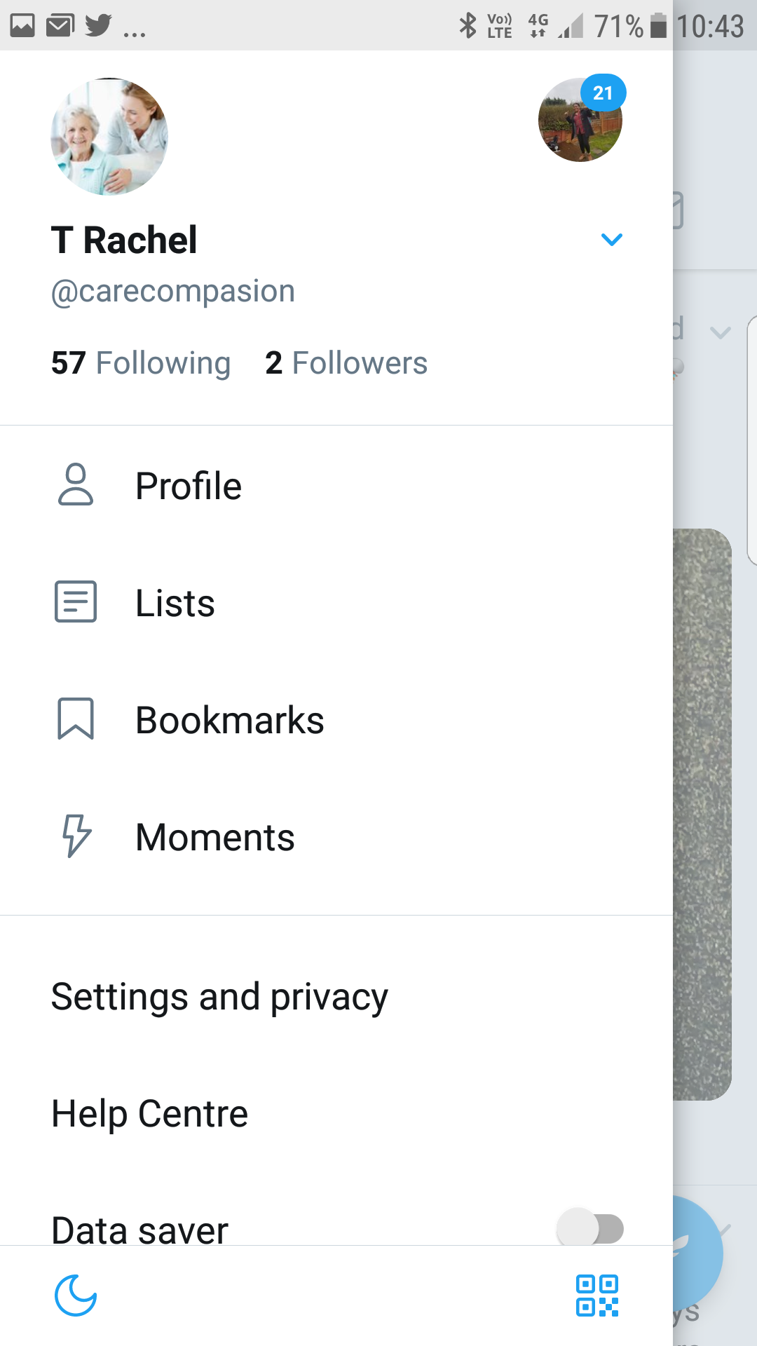

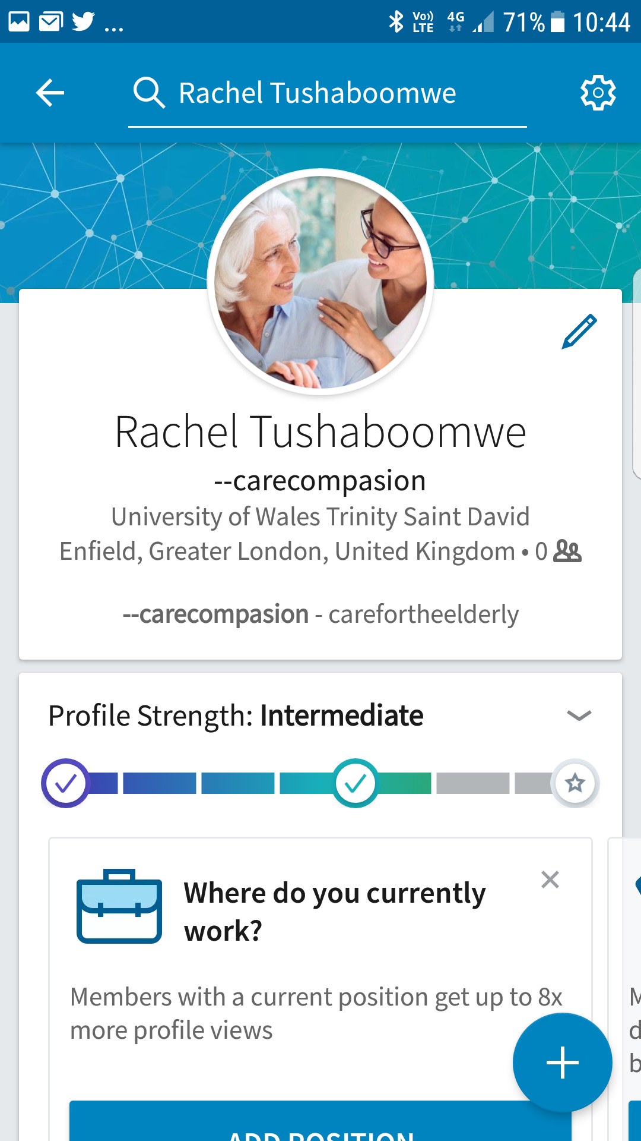

HOW CAN FACEBOOK BE USED IN A WORKPLACE?

Workplace by Facebook
Rentalcars.com is one of the first companies to use Workplace by Facebook, the recently launched enterprise social media platform. The service has now been live for staff for two months, according to Graham Benson, CIO at Rentalcars.com. "We've decided to take an internal social media approach, as opposed to using an intranet," he says. "Workplace has worked brilliantly. We've got more than 75 per cent of our 1,400-strong workforce signed in and using the system actively just weeks after our initial rollout."
Rentalcars.com adoption of Workplace is part of a much wider trend, where organizations are adopting communications platforms, such as Slack and Yammer, to help employees collaborate. Gartner has long-expected social networks to become the primary communication channel for work activities. However, the analyst estimates 80 per cent of social business efforts do not achieve the intended benefits, due to inadequate leadership and an overemphasis on technology. So how will Workplace be different? Benson explains to ZDNet how his business is making the most of the new social platform.
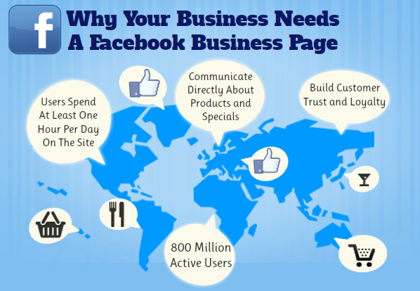

How is Workplace Facebook being adopted and adapted?
A key advantage of social media is that it has made business more human. The more your employees use social media to engage with your brand community, the more connected they become to the company’s identity. Externally, the more human your brand becomes, the easier it is to build emotional connections and trust with clients and shareholders. Customer centricity comes from your people, not your products. If you’re serious about building a trusted organization that has strong emotional bonds with customers (and employees!) it’s time to engage all your people in the process – not just your sales people.
Rentalcars.com CIO Graham Benson: "Everyone in the company already knows how to use Facebook.
Benson says an encounter with the platform feels a bit like bumping into a familiar friend. "It does look slightly different to the consumer version of Facebook," he says, before adding the technology provides a secure base for internal social networking. "It's locked down, so that no one outside the business can access the information."
Innovative Business Models that Increase Revenue
Is a consumption-based pricing and billing strategy the next big disruptor? We explore this question and what it takes to successfully support subscription offers with the addition of usage-based services in your business. The familiarity of the platform provides instant benefits in terms of user experience. "It's great because everyone in the company already knows how to use Facebook," he says. "And because all our employees can use the platform, we don't have to spend time and resources on training people, as we would if we'd chosen to implement a different system or an internal intranet."
More importantly, the workers seem to enjoy using the platform to connect and communicate. Benson says Workplace is already helping to boost collaboration. "Everyone's really keen on using it," he says. "We've got groups, such as one that's for members of the leadership team."
A single owner curates the content associated to each group. One example is a group that allows employees to put ideas to the firm's leadership team. An executive assistant curates the content and c-suite members guarantee to give a response to anyone who posts an idea on the forum.
"We've made sure that we've implemented Workplace from the chief executive down," says Benson, who adds that groups on the network cover a wide spread of work and non-work interests, including a forum for cat lovers.
"It's fascinating to see people using the technology in many different ways," he says. "And in a work context, the platform is allowing us to generate a huge amount of useful content."

What are the long-term aims for Workplace Facebook?
Perhaps one of the most crucial elements of the implementation is that the support issues that can sometimes plague a new technology project have not affected Benson and his IT team. "There have been no significant challenges," he says. "It's just accepted as the normal way to communicate across the business."
Raise brand awareness and promote positive word-of-mouth
You can increase your business's profile on Facebook by encouraging existing and potential customers to click the 'Like' button on your Facebook page. Once they like your page, your customers will receive your updates on their wall, where their friends will also see them. This helps to build awareness of your business, and to associate your friends with your brand. Customers can also post positive messages about your products or services, shared on their walls for all their friends to see.

Benson accepts that some might feel that the firm's rapid embrace of a leading-edge platform is a bit of a risk, and he also recognizes that the stance of Rentalcars is different to that which might be seen in other companies, yet he believes it is an approach that is likely to be rewarded.
"One of our values as an organization is that we like to do things differently," says Benson. "Our strapline for recruiting is 'anything but ordinary'. Looking at innovative projects and technologies, like Workplace, helps us to create a interesting and creative culture in the workplace."
More specifically, he encourages other CIOs, who might have shied away from making the most of collaboration in an enterprise context, to get involved. "I think social media has its place -- it's increasingly becoming a hygiene factor for good business practice," he says.
"If you're going to be customer-centric as a business, you've got to provide the platforms to allow your workers to talk with you in the way they want to." And in the case of Rentalcars, Benson is confident that Workplace will provide lasting benefits for the business and its employees.
"It's a forum that helps us bring all our colleagues together in a single place," he says. "You wouldn't be able to get 75 per cent of your workforce on the platform if you were using a bespoke tool that was technically-oriented or sales-oriented. Familiarity with the platform really helps foster social success."

Why use LinkedIn in a workplace?
Having your entire workforce use LinkedIn could become your company’s rocket fuel. Yet many employers block company computers from accessing LinkedIn. They’re afraid employees will look for a new job, be poached by a recruiter or waste precious work time socializing online. According to a recent study by Statista, 10% of U.S. employees are not allowed to use LinkedIn in the workplace because access is blocked. These companies are missing out on major opportunities to build business, increase loyalty and fortify employee engagement. Here’s how your company can benefit from a focused program that encourages employees to use LinkedIn … every day.


Increased Visibility for Your Brand

LinkedIn’s Best Practices Blog states that “Employees are 70% more likely to engage with your company updates.” When your employees “like” and “share” status updates, they make them visible to their contacts. This is living proof that every employee is a brand ambassador. The more views your company page has, the more potential followers. A study by BrightEdge backs this up: “Companies that have a greater proportion of their employees on LinkedIn have more followers on their company pages. In fact, 9 out of the top 10 brands with the most followers on LinkedIn have at least 60% of their employees on LinkedIn.” And when employees comment on your communications, the visibility of that item increases. The more company page followers, the higher your page will rank in LinkedIn search results, sparking greater reach and potential interaction with your content.
When your staff selects your company from the LinkedIn list when creating or updating their Experience, they automatically show up on your company’s LinkedIn page. And your company logo shows up on their page with a link back to your company page. They also become automatic followers of your company.

2. Consistent Brand Ambassadors.
When someone looks at a profile of one of your employees, it not only speaks to their personal brand, but to your company brand as well. If you help your staff builds stellar, compelling profiles and show them how to engage and stay connected to their brand community, you’re sending a message about your company brand to everyone who visits their pages or interacts with them. This is valuable to clients, potential customers, business partners and existing and future employees. It supports competitive advantage. Through the collective profiles of your employees, people can see the talent and specific skills of your people.

3. Improved Morale.
If you’re preventing your employees from accessing LinkedIn or are discouraging them from having profiles, you’re sending the message that you don't trust them. And trust is essential for building strong relationships. If your relationship with employees is defined by accusations, you’ll only make them want to leave.
Encouraging your employees to link to each other keeps them connected as well, and your company becomes the basis for the shared bond. LinkedIn also serves as a great informational tool, helping different departments stay on top of what others are doing based on what they share. The new endorsements feature, along with recommendations, can also be helpful. Beyond giving kudos to a colleague during a meeting, endorsing them online for a specific skill makes this acknowledgement visible to a much larger community. Public praise and recognition are powerful rewards for great work. That level of gratitude not only reinforces the bonds among your people but is also a confidence builder.

Workplace Facebook vs. LinkedIn
LinkedIn is full of industry news, pictures of smartly dressed professionals, career development advice and its very own job board. It helps job seekers research prospective companies. It makes it easier for recruiters to identify and discover potential talent. And, most importantly, it lets you keep in touch with fellow professionals in the one place online where Aunt Daisy won’t post an embarrassing baby picture of you. It’s all about the work.
Facebook, on the other hand, is filled with cat pictures, top 10 articles, snaps of that person you went to high school with and constant Candy Crush requests from the uncle you met at a family gathering five years ago. Company pages on Facebook tend to be lighter and a little bit fun. There are personality tests, listicles, and pictures of people doing volunteer work and wearing goofy Halloween costumes. It’s about the human connection and shared fun.
LinkedIn pages are about staying informed and up to date. If your LinkedIn page is your company at a fancy cocktail party, your Facebook page is the after party where the real fun happens. The two aren’t at war; they complement each other.

So what does Facebook’s sudden interest in the workplace mean for LinkedIn?
After all, Facebook has 1.71 billion active monthly users and while LinkedIn has hit 450 million members, only 112 million use it actively every month!
Is Workplace Facebook in competition with LinkedIn?
Naturally, the mysterious beta and lack of information sparked a lot of debate, discussion and rumors! The most prevalent one was that Facebook was moving in on LinkedIn’s turf.
And so, for the better part of 2015, a huge number of major news outlets including Forbes, Time, The Guardian and Fast Company reported that Facebook was coming for LinkedIn. And, on their side, LinkedIn executives like Ariel Eckstein were preparing for the fight. But, when Workplace finally made its entrance in October complete with a brand new name, it seemed to put some of those worries at bay. The two platforms appeared to have very little in common — at least for now.

Twitter
Twitter is on online news and social networking site where people communicate in short messages called tweets. Tweeting is sending short messages to anyone who follows you on Twitter, with the hope that your messages are useful and interesting to someone in your audience. Another description of Twitter and tweeting might be microblogging.
Some people also use Twitter to discover interesting people and companies online and to follow their tweets for as long as they are interesting.

How Does Twitter Work?
Twitter is very simple to use as broadcaster or receiver. You join with a free account and Twitter name. Then you send broadcasts daily, or even hourly. Go to the 'What's Happening' box, type 280 characters or less, and click 'Tweet'. You will most likely include some kind of hyperlink.
To receive Twitter feeds, you simply find someone interesting (celebrities included), and 'follow' them to subscribe to their tweet microblogs. Once a person becomes uninteresting to you, you simply 'unfollow' them.
You then choose to read your daily Twitter feeds through any of various Twitter readers.
Twitter is that simple.

Use of twitter for business
People Use Twitter as a Marketing Tool?
Yes, absolutely. Thousands of people advertise their recruiting services, their consulting businesses, their retail stores by using Twitter. And it does work.
The modern internet-savvy user is tired of a television advertisement. People today prefer advertising that is faster, less intrusive, and can be turned on or off at will. Twitter is exactly that. If you learn how the nuances of tweeting work, you can get good advertising results by using Twitter.
Identifying and Targeting Customers is easy
Because of the openness of Twitter, customer identification and targeting is extremely easy.
You have everything at the ready, interests of people, their websites, their profile bios. It helps you develop context before approaching or even targeting your customers.
If you have a persona that you are targeting, you can search for almost any information about your customer that your persona actually has on Twitter.
Twitter ads allow you to choose from a different objective and provide you with a variety of demographic data to target your customers and make your ads based on the persona that you are targeting.
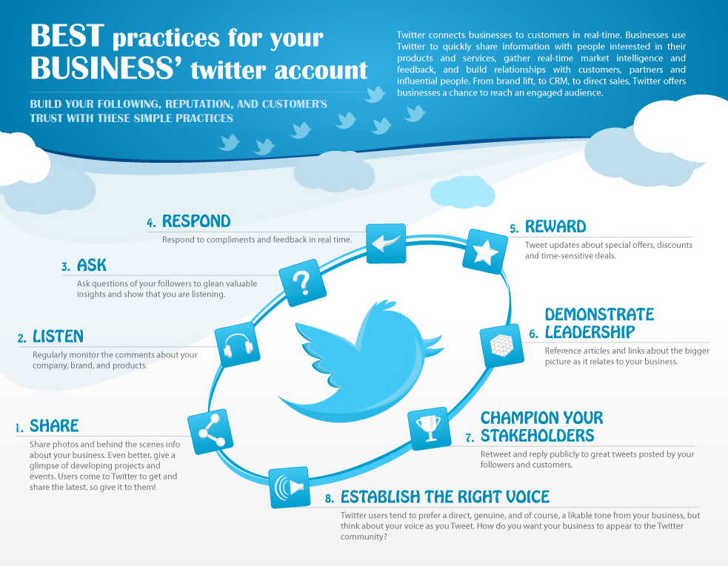

It is one of the best platforms for Customer Support
What do you do when you best friend needs your help? You call them (with the same cell phone that you purchased) because that's the fastest way you can get in touch with them and solve their problem. Because everything on Twitter happens in real time, having your presence there is a great asset in terms of handling customer support.
Unlike other platforms where you have to open different chat windows to talk to different customers, in Twitter, you have a steady feed dedicated to just your customer's queries. This allows your customer support team to be very efficient in prioritizing which queries to reply first and develop context before you actually reply them.
You can considerably cut down your response time for your customers who are facing any issues.

