
Hilton Hotel
Report on Ratio analysis

[Date]
University of Wales Trinity Saint David

Student Name William Thorpe

Student no 2018536

Module BMIH5007

Lecturer Name Dale Clarke

Executive Summary
The purpose of this report is to analyse……..
DO THIS SECTION LAST!!!!!!
NOT INCLUDED IN WORD COUNT

The report on Hilton has a conclusion

Table of Contents
Executive Summary 1
Introduction Hilton Hotel Financial Report 3
Financial Analysis 4
Financial Analysis Trends 4
Benefits and Limitations of Ratio Analysis 4
Conclusion (average of 10% of word count) 5
Bibliography 6
UPDATE TABLE FREQUENTLY – CHECK IT HAS BEEN UPDATED BEFORE SUBMISSION

Introduction

Hilton Hotel is a global firm with one of its hotels established in central London in the united kingdom, management to prepare this report will address - the chief executive, this is to evaluate the firm’s performance profitability, liquidity, and gearing ratios in 2019 and 2020 fiscal year.
A ratio is a useful tool, the benchmark for future performance is therefore comparing the cost of goods sold gauging methods to identify areas for improvement, in the organisation and hights the importance of financial health, and performance of the organisation, whereas it segments the hotel departments, and analyses accounting, demonstrating to interpret evaluating the company’s profit and loss statement by examining the balance sheets, Jackson, (2009).
Wheelen, (2017), elaborates, that the concept of comprehending the financial ratios identifies and collates the financial data calculated ratios, over a time in accounting for the balance sheet, income statement and cash flow statement, and the significance, of the company portfolio, financial performance and how will it impact the company prudent assets managing the assets efficiently and emphasizes, creating adding value and maintaining competitive advantage, tends to perform evaluation, measure different segments of the economy that equable the hospitality sector, financial outcome to apprehend the firm growth developing a positive influence, innovate and adapt to different the markets, for stakeholder employees, and equity, creditors and banks.
Corgel and Woodworth (2012) state that sustainability is at the forefront of government legislation and increased public awareness. businesses, can’t overlook sustainability, acquire economic matters rather than social administrative, and ratio analysis has a significant relationship that exists between the various items on the balance sheet, profit and loss statement, comparing base years figures from the current year, therefore the Chief Exclusive would normally examine the ratios to evaluate the health of the company, determining individual financial ratios can calculate the change in value over time, does and spot trends can result in either weakness or strength but don’t describe the weaknesses or strengths, of the business enterprise, therefore, the relevant examination will have to be determined, and implemented useful dissections for the firm’s investors, shareholders, auditors, banks, and creditors, their interest in the companies revenue and returns of their old investment.

Atkinson, brown (2001) argues that the figures for 2020 is concerning, moreover we saw the figures dip, with the profitability ratio on account of the pandemic’ (ROI) are the returns of the capital invested, adopted as a financial inductor and mainly used by hotel managers, making key dissection, about capital investment there is considerable clarity in its forms of calculation, moreover the fiscal year 2020 the gross profit was 583000 this figure was divesting compare to the fiscal year 2019, the figures is 2435000 was healthier and therefore argued that covid 19, crippled the economy, with its lockdown rules travel restations, and isolation 2020, saw an exchange of -1852000 and percentage -76% this is taking into account fiscal year 2020, compare to 2019, moreover the trend continues with net income of -715000 the fiscal year 2020, and 2019, figures 881000 the figures are better for 2019 change the base year against the current year 166000 the percentage reads 19% this again is not the best figures we hoped for, this income before the tax fiscal year 2020,- -924000 this is poor compare to 2019,- 1244000 and there the change would read as -2168000 percentage for both years -174 % this again is not good.

Chat 1
According to the P&L accounting, Hilton Hotels’ 2019 and 2020 gross profit is significantly 2020 was lower than the base year it is a poor native figure of -1852,000 gross profit for 2020 their net profit is surprisingly has a value of 19% due to d current assets and stakeholder equity.

Chat2
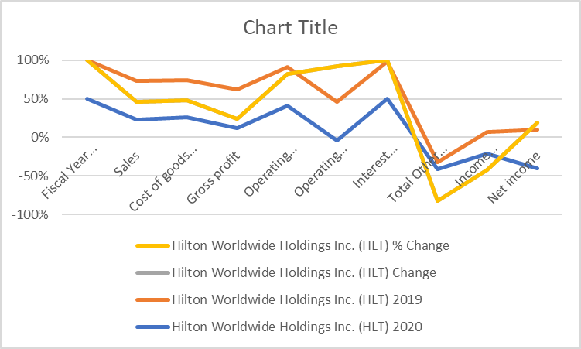

When examining these figures, for 2020, shows that the Hilton hotel the year went through various trends one thing that dictated the decline in revenue shown during this period was the performance of the Hilton was extremely poor results due to the pandemic, travel industries and hospitality affected by government rules and restrictions, therefore understanding the Hilton’s analysing the fiscal year of 2020 is negative -50% compared to 2019 saw a net income of 19%, Jackson, (2009).

The fiscal year 2019 and 2020

,

Liquidity Ratio

Row Labels | Sum of 2019 | Sum of 2020
Total Liabilities | 15,429,000 | 18,241,000
Total Asset | 14,957,000 | 16,755,000
Total Liabilities and Stockholder | 14,957,000 | 16,755,000
Non Current Asset | 12,558,000 | 15,810,000
Non current Liabilities | 12,558,000 | 15,810,000
Current Liabilities | 2,871,000 | 2,431,000
Common Stock | 3,000 | 3,000
Total Stockholders' Equity | -482,000 | -1,490,000
Retained Earnings | -5,965,000 | -6,732,000
Grand Total | 66,886,000 | 77,583,000

Table 2
Hong; Huang; Wu (2014), Suggest the Features for 2020 were bad, 2431,000 compared to 2019 – 2,871,000 when considering figures of the fiscal year, therefore when considering the liquidity Ratio for Hilton, however, these figures did not match the 2019 figures liquidity measures definition of the systemic liquidity risk, liquidity measures are relatively frequent, that is no common definition of systemic liquidity risk, concerning when entering the risk was great, the breaking down in the entire money market Fiscus 2020, the hospitality industry moreover the, in general, the market was drying up on account of the pandemic and their assists, were decreasing in value with travel being restricted and hospitality having to close their door, therefore, the company to fulfil the organisation by using most of the liquids argues the hospitality sector has seen a dramatic fall in the figures 2020 that might not recover for some time to come,

Liquidity Ratio
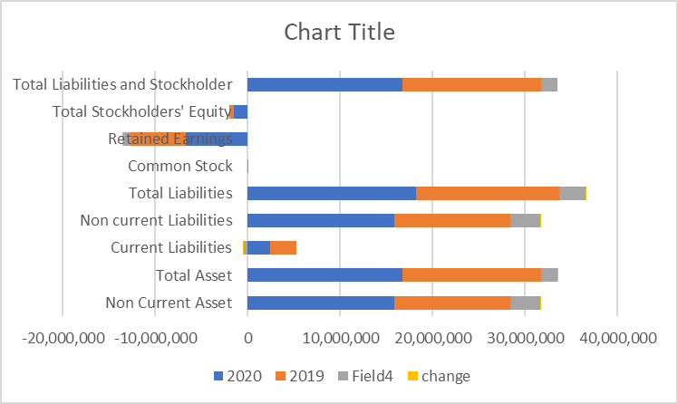

Chat 3

Bunker et, al (2019), argue that the current ratio, current assets/current liabilities, and the quick ratio example the inventory of the current assets/liabilities abilities are the most widely used measures of the organisation’s liquidity, moreover further examining info to companies, it can repay its most current creditors with a study floor of the liquidity ratio 2020 has was a bad fiscal year for the firm, therefore for the analysis to examine the effect of short -term POs on the most important aspects of the company liquidity.
Ratio Formula 2020 2019
ratio-forms -interest-2019-liq-net-working-capital-current-assets-current-liab-103-867-5-q76291365
Answer to Ratio Formula 2020 2019. Ratio. Formula. 2020. 2019. Liq. Net Working Capital = Current Assets - Current Lab

Row Labels | Sum of 2019 | Sum of 2020
net profit +cash in | 2435000 | 583000
loan capital/total | 2431000 | 2431000
100
capital employed)*
hand/ loan interest
Grand Total | 4866000 | 3014000

Titman, Tsyplskov (2007); Brusov et al, (2014) suggest that businesses when faced with a situation that a business can impact solvency it could be any number of reasons between equity and debt, this type of finance their advantages and disadvantages, therefore the main advantage of finance resides in the lack of the financial burden, with no revenue coming in the company could either go into sharing the business or it could into solvency, for example, the Hilton their 2020 figure total for the fiscal year, 3014000 is bad compare to the base year.

Chat 04
Philips, (2008), Interest cover ratio is the profit before interest and tax excluding extraordinary items divided by the interest payment, therefore the interest in 2020 as indicated was an increased due to interest payments not being paid regularly therefore according to this figure on account of the declining of the economic and negative sale figures fiscus year 2020.

Table o4

Ohlson, (2002), suggested that a company’s long-run expected earnings can continue the net dividend payout is fixed at 100% in this sense growth is expected earnings, and conservative accounting, are two sides of the same coin because of its prosperity explains, how capital earnings dominate book value example one can display growth, value the concept applies when setting in analytical terms the difference, explained that 2020 fiscus bad year financial.

Goodell; Huynh (2020) argued, examine the results financial results of the family firms they were a lot stronger and moreover many hotels survived the impact of covid 19 investing the global hospitality industry it is important to identify the variable moreover to identify the ESG is an important ,these factors social factors and environmental

Financial Analysis Trends

- Calculate Horizontal ratios for 2019 and 2020 to aid the analysis of the financial information included within the attached financial statements. You should discuss the trends seen in these ratios in detail, and draw appropriate conclusions.

- Outline the importance of using ratio analysis for decision making.

- You are to investigate the limitation of ratio analysis, including why an understanding of ratios and their fluctuations is essential for Hotel management in analysing the information seen in their financial statements.

Conclusion (average of 10% of word count)

Bibliography

