Bad behaviour sells; does visual culture glamourise violence or Spread Awareness.

by Hannah Davies

Student number: 2203436
Module: Independent project – ADAA6000

Supervisor: Paul Duerinckx

Submission date: 2nd January 2025
Word count:

Contents

Illustrations......................................................................... Pg.

Abstract.............................................................................. Pg.

Introduction......................................................................... Pg.

Chapter 1- Historical and Theoretical Context........................Pg.

Chapter 2- How Consumerism Sells violence........................ Pg.

Chapter 3- Violence as Awareness........................................ Pg.

Conclusion...........................................................................Pg.

Appendix............................................................................ Pg.

References...........................................................................Pg.

Bibliography......................................................................... Pg.

List of illustrations

Figure 1: Sorenti, D. (1990s) Kate Moss in Calvin Klein “Heroin Chic” campaign. Available at: https://en.wikipedia.org/wiki/Heroin_chic (Accessed: [add date]).
Figure 2: Klein, S. (2007) Dolce & Gabbana advertising campaign. Available at: https://www.artribune.com/progettazione/moda/2023/09/controversa-pubblicita-dolce-6-gabbana/ (Accessed: [add date]).
Figure 3: Zecchin, F. (1992) Benetton Spring/Summer 1992 “Murder” campaign. Available at: https://medium.com/@darpan93/how-benetton-mastered-the-art-of-going-viral-through-causevertising-4ad98a870be0(Accessed: [add date]).
Figure 4: Reynolds, J. (2010) Diesel “Be Stupid” campaign. Available at: https://www.james-reynolds.com/diesel-be-stupid (Accessed: [add date]).
Figure 5: Kruger, B. (1989) Your Body is a Battleground. Available at: https://www.moma.org (Accessed: [add date]).
Figure 6: Peress, G. (1993) Mostar, Bosnia-Herzegovina. Available at: https://www.magnumphotos.com (Accessed: [add date]).
Figure 7: Goldin, N. (1977) Couple in Bed, Chicago. Available at: https://www.tate.org.uk (Accessed: [add date]).
Figure 8: Emin, T. (1998) My Bed. Available at: https://www.tate.org.uk (Accessed: [add date]).

abstract

This thesis examines the representation of violence and "bad behaviour" in visual culture, interrogating whether such imagery perpetuates the glamorisation of harm or serves as a mechanism for exposure. In a society that is heavily influenced by the media, the constant circulation of images depicting crime, rebellion, and risk influences the way in which violence is perceived and understood. This study examines the transformation of violence into visual language, divorced from its original context, through the analysis of significant theoretical frameworks such as spectacle, myth, and hyperreality. By examining fashion and advertising campaigns in conjunction with contemporary artistic practices, the thesis clarifies how consumer culture frequently recontextualises violence as an appealing aesthetic, whereas alternative forms of visual art counter this trend by preserving a connection to lived experience and its repercussions. The article investigates the construction of meaning through representation and the dual role of visual imagery in reinforcing and contesting existing institutions. Ultimately, it contends that the influence of violent imagery is not set, but rather is influenced by framing, circulation, and interpretation.

Introduction

In today's visual culture, transgression and violence are highly visible. Fashion editorials, advertising campaigns, and social media all feature images that allude to crime, dominance, and social harm. These images are frequently displayed in visually striking and culturally appropriate ways. What once signified disruption or danger is now frequently reworked into something stylised, designed to capture attention within a fast moving and image saturated environment. As a result, violence is not only represented but reshaped, raising questions about how it is understood when translated into visual form.

A major issue in this shift is how visual culture employs the same visual language to represent both harm and critique. Dramatic composition, strong contrast, and emotional intensity are common techniques in imagery ranging from commercial campaigns to socially engaged work. In some cases, these strategies present violence as aesthetic and even desirable. Others use them to confront the viewer and highlight real world consequences. This overlap raises questions about meaning, making it difficult to tell whether violent imagery is being used to attract attention or to communicate something more serious.

The growing prevalence of stylised violence in consumer culture further complicates this distinction. Advertising and fashion often utilise themes of defiance, risk, and aggression to generate impact and maintain relevance. Simultaneously, artists and awareness focused imagery employ comparable visual strategies to confront issues such as abuse, conflict, and inequality. The recurrence of these visual forms in various domains of visual culture indicates that meaning is not static, but rather influenced by context, framing, and interpretation.

This dissertation investigates the following question: when visual culture depicts "bad behaviour”, does it encourage violence, or can it be used to raise awareness? Rather than assuming that violent imagery serves a single purpose, this study investigates how its meaning varies depending on how it is constructed and presented. It seeks to investigate how violence operates within contemporary visual culture and what determines whether it is perceived as aesthetic or critical, considering both theoretical perspectives and visual examples.

Chapter 1- Historical and Theoretical Context

Before determining whether visual culture glamourises violence or raises awareness, it is crucial to comprehend the reasons why violence functions so effectively as an image. Representations of crime, rebellion, and transgression persist within contemporary visual culture not simply because they exist, but because they carry a particular symbolic intensity when translated into visual form. Violence interrupts normality. It provokes reaction, creates tension, and demands attention. However, the significance of this is not only that violence appears within imagery, but that it is especially suited to being transformed into something visual. The question is therefore not just why violence is shown, but why it translates so effectively into an image that can be circulated, repeated, and reinterpreted.

Guy Debord's concept of the spectacle serves as an ideal starting point for understanding this process. Debord (1967) argues in The Society of the Spectacle that contemporary society is progressively experiencing reality through representation, rather than direct experience. Images mediate social interactions, which are not simply experienced but also observed. Violence is integrated into a more extensive system in which all objects are transformed into visual representations within this framework. It is no longer merely an action with immediate social repercussions; it is also a product that can be ingested, reproduced, and observed. The spectacle does not inherently diminish the reality of violence; rather, it alters how it is seen. Once violence enters this system, it is vulnerable to aesthetic considerations regarding framing, composition, and presentation. In this sense, violence transforms from an event to a visual construct, allowing it to be sculpted in ways that influence how it is perceived.

Roland Barthes develops this idea further in Mythologies, where he explores how media transforms complex realities into simplified and recognisable signs (Barthes, 1957). According to his concept of “myth”, images are severed from their original contexts and acquire new meanings that appear natural or familiar. Applied to representations of violence, this suggests that acts of aggression or rebellion can be reduced to visual shorthand. A broken window, a weapon, or a confrontational pose may no longer signify harm or disruption in a literal sense. Instead, these elements begin to represent ideas such as power, resistance, or authenticity. Over time, repeated exposure to these visual codes means they are no longer shocking. Violence becomes less about the event itself and more about what it symbolises. In this change, violence isn't taken out of visual culture; instead, it's made easier to understand and incorporated into it as a type of style.

This process becomes more complex when considered through Jean Baudrillard’s theory of hyperreality. In Simulacra and Simulation, Baudrillard (1994) argues that in contemporary culture, representations do not simply reflect reality but begin to replace it. Images circulate independently, resulting in a form of reality generated by media rather than lived experience. Within this context, violent images may have meaning even if they have little to do with real events. The image of rebellion, for example, can have emotional or cultural weight even if it is fake or staged. Hyperreality makes it hard to tell the difference between what is real and what is shown. This means that violence can appear as an image without having to be directly linked to real life. This makes it even more powerful as a visual form because it can be copied and modified repeatedly without losing its power.

The transformation of violence into image is not only cultural but also economic. Naomi Klein’s No Logo introduces the idea that contemporary brands rely heavily on symbolic meaning rather than material products (Klein, 2001). In saturated markets, visibility becomes crucial, and imagery plays a key role in achieving this. Rebellion, taking risks, and breaking the rules all have cultural influence because they make people notice and change the rules. These elements often serve as symbols instead of actual meanings when they are used in visual culture, especially in advertising and fashion. In this case, violence is not seen as harm but as an edge. It becomes a way to show that you are different, authentic, or bold. Klein's research helps to explain why images of "bad behaviour" are so common in consumer culture. With their intense visuals, they allow brands to stand out and show who they are and why they're important.

However, while these frameworks explain how violence becomes image, they do not determine how it is interpreted. Stuart Hall’s theory of encoding and decoding highlights the instability of meaning within representation (Hall, 1980). According to Hall, images are produced with intended meanings, but audiences do not passively accept them. Instead, people interpret visuals using their own cultural perspectives and experiences. This means that a representation of violence might be interpreted in various ways. One observer may interpret it as glamorous or strong, while another may find it intimidating or critical. As a result, meaning is shaped by the interaction between the image and the observer, rather than being fixed within the image. This is especially significant when assessing whether visual culture glamorises violence, as it implies that those who generate the imagery do not have complete control over interpretation.

Laura Mulvey's gaze theory complicates the viewer's function even more. Mulvey (1975) argues that visual culture is constructed in ways that situate the observer within power systems, particularly through gendered seeing. Images are frequently designed to connect the spectator with power, encouraging them to observe from a position of control. When violence is depicted within this framework, it can become visually appealing rather than disturbing. The viewer may be encouraged to identify with control rather than vulnerability. This has substantial implications for the way in which violent imagery is perceived. Violence may appear appealing or desirable if the image's structure emphasises control, strength, or dominance. Consequently, the composition of an image is a critical factor in determining whether it is perceived as detrimental or appealing.

Judith Butler extends this discussion by focusing on how violence is valued differently depending on how it is represented. In Frames of War, Butler (2009) contends that media portrayal does not regard all lives as equally “grievable.” Certain manifestations of pain are acknowledged and made visible, whereas others are overlooked or rendered abstract. This implies that whether violence is perceived as meaningful depends on how it is framed.
Regarding The Pain of Others, which was published in 2003 by Susan Sontag, provides an additional viewpoint on the way violence functions within visual culture, particularly in relation to that of spectatorship. It is Sontag's opinion that depictions of suffering are never objective; rather, they influence how viewers comprehend and react to acts of violence. While these kinds of images have the potential to educate and raise awareness, they also have the ability to create distance, enabling viewers to absorb misery without really dealing with the reality of the situation. During this process, repetition is an extremely important factor. These individuals may experience a type of desensitisation as they become more accustomed to seeing pictures of violence, which might cause their initial shock to lessen. When viewed in this manner, the act of watching becomes more challenging; pictures that are meant to disclose harm run the risk of converting it into something that is merely noticed. Taking into account the circumstances surrounding this thesis, Sontag's theory brings to light the conflict that exists between aestheticisation and exposure. Not only does violence become susceptible to interpretation once it is translated into picture, but it also becomes subject to patterns of consumption, where its impact is formed by the frequency with which it is seen and the manner in which it is experienced.

Violence runs the risk of becoming meaningless or symbolic when it is separated from vulnerability or consequence. It regains moral relevance when it is presented in a way that highlights loss, fragility, or human impact. Butler's work emphasises that representation is about whose experiences are made to matter, not merely about visibility.

What begins to emerge from these theoretical perspectives is not a single explanation, but a series of factors that make violence especially appropriate for visual culture. Violence carries emotional weight; therefore, it is immediately compelling. Through processes of mediation and repetition, it becomes simplified into recognised visual symbols. It becomes detached from its original context because of the circulatory systems. Through framing, it is transformed into something that can be understood in a variety of ways. Because of these interconnected processes, violence is transformed rather than simply observed. Understanding how violence becomes image sets the groundwork for evaluating how it is used in visual culture. The following chapter expands on these concepts by investigating how consumer culture uses violent imagery, and how "bad behaviour" can become visually appealing and commercially lucrative.

Chapter 2 - How Consumerism Sells Violence

The first chapter investigated how violence becomes an image; this chapter looks at what happens when that image enters consumer culture. In advertising and fashion, visual impression is crucial. Brands battle for attention in saturated markets, so intensity becomes a strategy. In this environment, aggressiveness, rebellion, and even harm is transformed into visual instruments intended to differentiate and provoke. Violence becomes visually productive, moving away from social reality and toward consumption. As a result, this chapter investigates how consumer culture glamourises crime and "bad behaviour," repackaging it as a visual language that can be exploited to promote style, identity, and products.

One of the most frequently cited examples of this shift can be seen in Calvin Klein’s 1990s “Heroin Chic” campaign. The girls in the ads were incredibly pale and slender, and they were photographed in minimalist interiors with little to no design. Their faces seemed emotionally detached, exhausted, and vacant. The advertisement made extensive use of the unmistakable visual language of addiction, such as empty eyes, thin cheeks, and frail bodies, even though it did not specifically show drug use.

The way this aesthetic was presented was what made the campaign so controversial. Addiction was not portrayed as terrible or harmful. It was stylised instead. The models were meticulously positioned within minimal environments, the lighting was regulated, and the compositions were deliberate. The indicators of danger were transformed into emotions. According to cultural critic Susan Bordo, the advertisement "turned emaciation into fashion and pathology into pose" (Bordo, 1999), emphasising how the visual indicators of addiction were reframed as aesthetic minimalism and separated from their social ramifications.

Figure 1, a Calvin Klein commercial with Kate Moss, makes this process particularly evident. The image presents the body as an item to be observed rather than comprehended, isolating it from any larger social context. The image's symbolic rather than social function is strengthened by the lack of narrative. The indicators of addiction lose their original significance and are linked to identity and style thanks to Barthes' idea of myth (1957). Thinness now signifies cultural edge and authenticity rather than disease. According to Naomi Klein (2001), brands frequently use subcultural imagery to stay relevant, and in this case, fashion incorporates the visual language of drug culture. The campaign illustrates how violence against the body is aestheticised through detachment, enabling it to serve as a desirable visual code rather than a societal concern, which is relevant to the argument of this chapter.
Figure 1


A more apparent example of this transition may be found in Dolce & Gabbana's 2007 advertisement, which shows a lady held to the ground by a male model while other men watch. The composition is well controlled, with dramatic lighting, sculpted bodies, and balanced framing resulting in a visually appealing image. Although the advertising was heavily condemned for appearing to romanticise sexual violence (The Guardian, 2007), its aesthetic framework prioritises visual appeal over ethical implications.
Figure 2

This is especially clear in Figure 2, where the organisation of the image transforms the act itself. Rather than appearing chaotic or damaging, the scenario is structured in a cohesive and almost theatrical manner. Rosalind Gill claims that such imagery turns "coercion into choreography" (Gill, 2008), implying that violence is repurposed for performance. Debord's concept of the spectacle (1967) is relevant here because the image serves as something to be devoured visually rather than critically engaged with. The observer is positioned as a spectator, lured into the composition rather than prompted to question it. In respect to this chapter's theme, the image clearly shows how violence is glamourised through aesthetic control. The act is stripped of its significance and reimagined as a visually appealing scenario, underlining its role as a tool for attention and corporate branding.

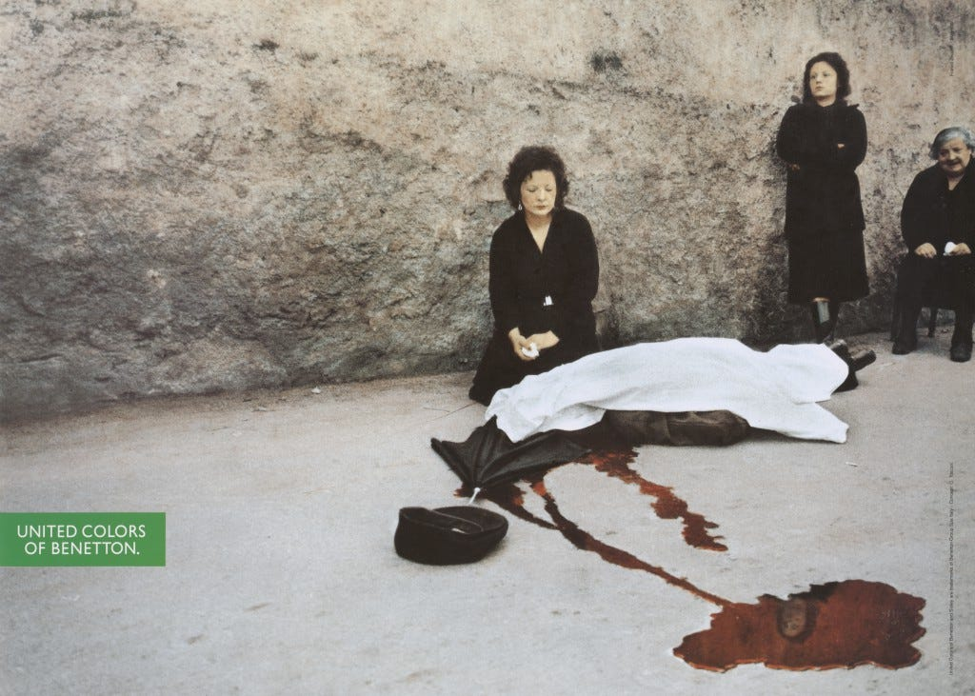
Despite the fact that Benetton's advertisements provide a more nuanced picture, they nonetheless operate under the same framework of visual consumerism. Campaigns that were launched in the early 1990s, such as Franco Zecchin's Murder series that was released during the spring and summer of 1992, utilised documentary style photos of actual murders. When compared to traditional forms of advertising, the Benetton logo was typically placed next to these photos rather than the actual garments being advertised. Even though it was marketed as being socially concerned, the campaign was, in fact, deeply anchored in the world of business.
Figure 3
This is obvious in Figure 3, which shows the aftermath of violence in a clear and disturbing way. In spite of its realism, the image continues to be ingrained in consumer culture through branding. Klein (2001) says that campaigns that use shock value make brands more visible by involving them in societal debate.

In terms of this chapter's statement, the picture shows that even real violence can be turned into aesthetic capital when used in a business setting. When the Benetton logo is added to a picture, it changes its purpose from documentation to brand identity. Violence is not taken away; instead, it is transformed so that it can help people see and understand it. This shows that consumer culture doesn't just show violence; it uses it in a planned way to make sense and get people's attention.

A similar dynamic may be seen in Diesel's Be Stupid campaign (2010), which takes commercialisation of "bad behaviour" beyond direct portrayals of violence and into the broader aestheticisation of danger. The ad intentionally promoted impulsive and dangerous action, portraying it as a positive expression of uniqueness and freedom. Rather than portraying such behaviours as destructive or reckless, Diesel portrayed them as bold and aspirational, generating attention and debate through inflammatory slogans and staged settings. Because of its public exposure and influence on younger audiences, the ad was heavily critiqued and investigated by the Advertising Standards Authority for possibly promoting antisocial behaviour (Advertising Standards Authority, 2010).

Figure 4

This is clearly illustrated in Figure 4, which depicts a man racing along a street with a large costume head while being pursued by police, followed by the phrase "Smart is in the shade, stupid is in the spotlight" (Reynolds, 2010). The image symbolises anarchy and confrontation with authority, yet it is presented in a humorous and dynamic manner, eliminating any feeling of consequence. In response to the dissertation question, this demonstrates how visual culture may glamorise risky activity by changing it into spectacle and identity. Through Barthes' idea of myth (1957), the act is stripped of its real-world repercussions and reinterpreted as a symbol of confidence and visibility, with "in the spotlight" implying acknowledgement rather than consequences. This is consistent with Klein's claim in No Logo (2001) that companies use anti-social or countercultural behaviour to establish identity and sustain relevance, with Diesel transforming risk into a type of aesthetic capital. As Wells (2010) points out, the campaign glorifies disobedience through provocative images, embracing controversy as a weapon for visibility. In this approach, the campaign indicates that "bad behaviour" does not have to be outwardly violent to be glamourised, but may instead function through deception, making disorder and resistance visually appealing and marketable as style.
This system goes beyond conventional advertising and into broader visual culture, including streetwear and music videos. Travis Scott's Sicko Mode (2018) is a prime example. The video uses highly stylised editing and cinematic framing to portray fractured, fast-paced scenes that include urban settings, police motifs, and moments of implied confrontation. Although these components are meticulously managed and aesthetically pleasing, the visual language hints to danger and disturbance.

The video illustrates how violence can be glamorised through suggestion rather than explicit representation, which is relevant to the premise made in this chapter. Instead of being shown as dangerous, the imagery of conflict and surveillance is presented as visually captivating, supporting concepts of power and cultural significance. These visual signals contribute to the artist's brand and become an integral part of their identity. This is also reflected in streetwear culture, where companies like Supreme use images linked to disruption, criminality, and protest. These elements serve as indications rather than realities according to Barthes' framework (1957). Their meaning has been detached from social consequences and reconnected to identity, allowing violence to function as an aesthetic shorthand. Aggression then becomes a desirable visual language that shows rank and authenticity.

A consistent pattern can be seen in these examples. Violence isn't typically shown in a way that puts its effects on society first. Instead, decisions about style, abstraction, and reframing change it. It can be seen differently depending on the lighting, composition, and background, so it can be used as a visual strategy instead of a social fact. Even debate helps this process along because more attention makes something more visible and culturally relevant.

Returning to the main point, it's clear that in consumer society, images of ‘bad behaviour” do not simply demonstrate violence; they make it look acceptable. By taking away consequences and focusing on visual impact, this is achieved. When violence is linked to power, identity, and societal relevance, it becomes something that people want to do. By showing these things over and over, they become normalised, which reinforces their place in visual society as art forms instead of social issues. This does not imply that violence is inherently desirable, but rather that its visual characteristics may be easily incorporated into systems that value attention and impact. Consumer culture uses intensity to set itself apart, and violence is a strong visual tool for this. This makes "bad behaviour" something that can be sold, not as something bad, but as something stylish.

Chapter 3 - Violence as Awareness

In Chapter Two, we examined at how consumer culture separates violence from its effects and turns it into artistic capital. This chapter looks at how visual culture can work in a different way. Instead of making "bad behaviour" look appealing, certain photographers and artists use the same visual techniques, composition, intensities, and confrontations to connect violence to its personal, political, or social meanings. What makes a difference is not whether violence is shown or not, but how it is presented. When consequences, fragility, and lived experience are put front and centre, violent imagery refuses to be made beautiful and instead demands to be recognised. In this regard, visual culture has the capacity to challenge the transformation of violence into style by refusing its detachment from reality, thereby disrupting the processes stated in Chapter Two.
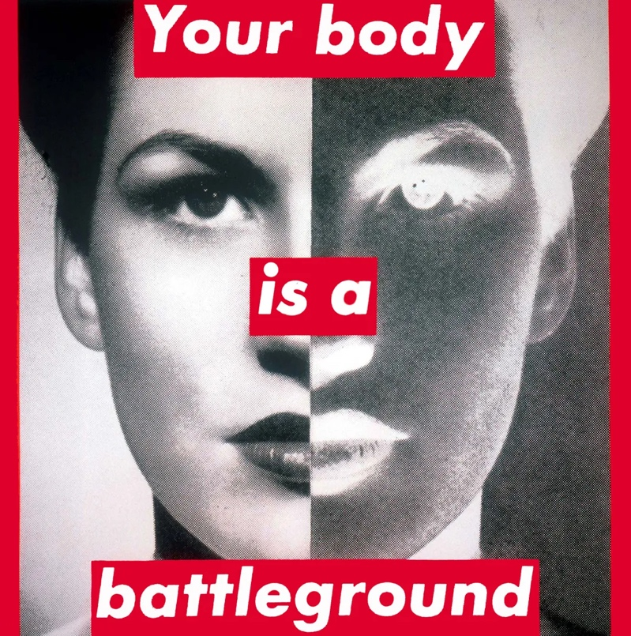
Your Body is a Battleground by Barbara Kruger (1989) is a powerful illustration of how visual culture can challenge power structures without making them look good. Bold typography, high contrast imagery, and graphic layout are examples of the visual language of advertising that Kruger appropriates and uses for criticism. Rather than employing these methods to promote a product, she employs them to highlight how bodies, particularly female bodies, are controlled and commodified in visual culture.
Figure 5
This is seen in Figure 4, where the face is divided into positive and negative halves, resulting in a tense and fragmented appearance that defies visual harmony. The design is interrupted by the bold writing, which discourages passive watching and compels interaction. By grounding the image in meaning, Kruger's art defies the stylisation and presentation of the body in the imagery covered in Chapter Two. "Your body is a battleground" guarantees that the piece cannot be separated from its political setting. This illustrates how violence, in this case systemic rather than physical, can be depicted without being glamorised in regard to the dissertation subject. This work demonstrates how visual language can be used to question rather than support aestheticisation by exposing control systems rather than hiding them.

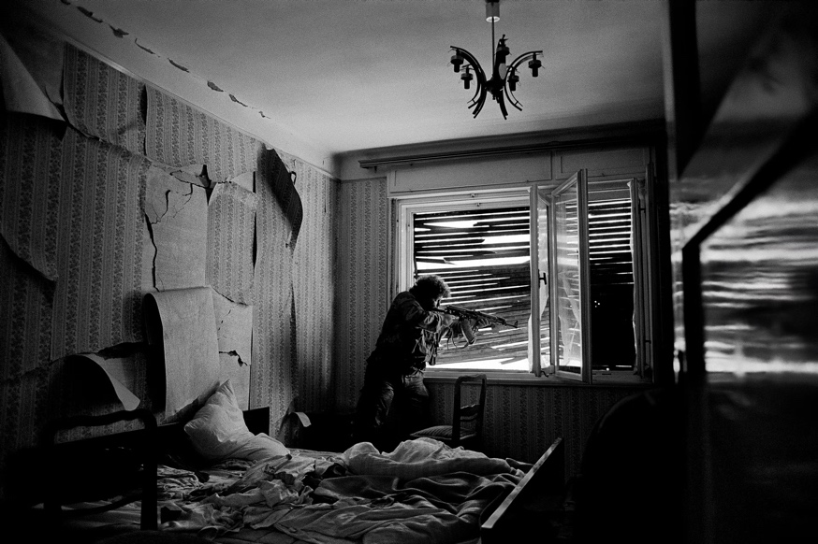
A similar emphasis on consequence can be seen in documentary photography, and more specifically the work of Gilles Peress, places an emphasis on consequence in a manner that is similar. He does not separate violent acts into visually appealing bits in his photographs of conflict; rather, he places them inside the context of daily situations, highlighting the impact that violence has on both space and subject. This is made clear in Figure 5, which depicts Mostar, Bosnia-Herzegovina (1993), where the presence of a weapon within the interior of a residential space underlines the entrance of violence into normal life. In contrast to the highly controlled imagery, we talked about in Chapter Two, this picture doesn't fit together visually. Instead, it suggests instability that matches the conditions it records. There is no attempt made to establish visual harmony or balance; rather, the image maintains a sense of disturbance and urgency all throughout. This demonstrates how violence can be depicted without being glamourized, since it remains embedded within its environment rather than being abstracted into visual form. This is relevant to the question that was posed in the dissertation. Instead of being a spectator of a display, the viewer is placed as a witness to a real event. This emphasises the seriousness of the picture over its artistic potential.
Figure 6


This emphasis on intimacy and lived experience is expanded upon in Nan Goldin's pictures, which depict relationships influenced by vulnerability, emotional pressure, and personal suffering. In Figure 6, Couple in Bed, Chicago (1977), the photograph captures a moment of emotional distance between two persons, implying that there is tension beneath the surface without depending on dramatic or stylised visual clues. Goldin's work, on the other hand, doesn't want to be refined in terms of style. Its casual composition and natural lighting give it a feeling of immediacy. It is not a coincidence that this lack of visual polish is essential to the functioning of the work; rather, it is essential because it prevents the picture from becoming overly aestheticised and instead strengthens its link to the experience of living things.
Figure 7

In response to the dissertation question, Goldin's work reveals how violence can exist in visual culture without being glamourised, exactly because it is buried in the complexities of everyday life. Rather than isolating or amplifying the event for visual impact, she leaves it unfinished and unclear, refusing the clarity that frequently makes photos easy to consume. This is consistent with Susan Sontag's argument that representations of suffering must remain connected to reality in order to avoid becoming spectacle (Sontag, 2003). Goldin's images avoid Sontag's warning about the distancing effect by drawing the spectator into the emotional tension of the scenario rather than positioning them as a detached observer. At the same time, Stuart Hall's theory of representation (1980) becomes especially relevant, because meaning is not fixed within the image but is created by interpretation. Goldin does not enforce a single interpretation; rather, she invites the viewer to interact critically, allowing the tension inside the image to unfold rather than be resolved. Violence, in this context, is not something to be devoured visually, but rather something that arises from emotional and relational instability, preventing it from becoming spectacle or artistic form but more personal to the viewer.


Tracey Emin's My Bed (1998) broadens this examination of lived experience by depicting the consequences of personal trauma in a direct and unfiltered manner. In contrast to photography, which depicts a moment within a frame, Emin's installation occupies physical space, confronting the viewer with the material traces of experience.
Figure 8

In Figure 7, the unmade bed is surrounded by personal objects that represent absence, excess, and emotional discomfort. This creates a scenario that seems both intimate and exposed at the same time. It is also crucial that the room was not organised or made more aesthetically pleasing; the work continues to be disorganised, fragmented, and unresolved, which reinforces its relationship to reality rather than visual fabrication.

The piece "My Bed" reveals how visual culture might resist the glamourisation of "bad behaviour" by rejecting aesthetic manipulation. This is relevant to the subject that was posed in the thesis. The art does not have the ability to transform human hardship into something that is visually pleasing; rather, it reveals the implications of that struggle in a manner that is both urgent and inevitable. A connection can be made between this and Judith Butler's concept of "grievability" (2009), which proposes that representation is the factor that determines whether suffering is acknowledged as having significance. In her art, Emin insists on this acknowledgement, refusing to allow personal experience to be abstracted or disregarded in any way. While this is going on, the installation poses a challenge to the processes that Barthes (1957) articulated, which are mechanisms in which meaning is frequently reduced to easily recognised signals. The objects in this instance are resistant to such reduction; they continue to be particular, personal, and materially present, and they refuse to assume the role of symbolic shorthand. To break the detachment that allows violence or distress to be absorbed into visual culture as style, the audience is not allowed to understand the work as attractive; rather, they are urged to confront it as proof.

A similar aversion to aestheticisation can be observed in awareness raising graphic efforts, particularly those addressing gendered violence. The United Nations' "Stop Violence Against Women" campaign uses vivid, often disturbing visuals to confront viewers with the realities of violence. These advertisements usually blend photographic portraits with text or data to ensure that the image and its meaning are inseparable. Unlike the stylised imagery mentioned in Chapter Two, which abstracts violence into mood or identity, these campaigns ground representation firmly in consequence, restricting the potential of aesthetic reinterpretation.

This exemplifies how violent imagery can exist within visual culture without being portrayed as glamorous when the context of the imagery is made clear. Not only does the incorporation of language and statistics play an important part in directing interpretation, but it also helps to reinforce the importance of the subject matter and eliminate ambiguity. This is another example of Sontag's argument from 2003, which states that in order to avoid becoming spectacles, images must keep their link to actual suffering throughout their existence. By putting an emphasis on pain, vulnerability, and witness, these commercials make certain that violence cannot be construed as something that is visually beautiful. For the same reason that the intended meaning is heavily organised through framing, which reduces the chance of alternate interpretations, Hall's theory of encoding and decoding (1980) is also significant in this context. Rather than being positioned as a spectator, the viewer is placed in the position of someone who is confronted with proof of injury, which reinforces the ethical weight of the image.
There is a coherent approach that is beginning to emerge across all of these examples, which implies that violence is not isolated from its context but rather is reinforced through it. These works oppose the processes of abstraction and repetition that allow violence to become aestheticised within consumer culture. Instead of being simplified into visual shorthand, these works maintain their sense of intricacy. Despite the fact that they continue to make use of powerful visual methods such as contrast, composition, or fragmentation, the purpose of these strategies is not to generate desire but rather to draw attention back to the subject matter, so preserving its relationship to the lived experience. This provides more support for a major point that is presented in the thesis, which is that visual culture does not intrinsically glorify violence; but it does provide the conditions under which violence can be aestheticised when it is separated from the consequences of its actions. When this detachment is rejected, the same visual language can work in different ways, turning from spectacle to conflict.
Conclusion

The purpose of this dissertation was to investigate whether or not visual culture has the potential to expose violence, or whether it instead has the ability to glamorise violence. Examining both theoretical views and a variety of visual examples reveals that violent imagery does not have a set meaning. Rather, its meaning is determined by how information is formed, structured, and interpreted. Depending on the context, the same visual language; tension, confrontation, and intensity can either aestheticise or reveal harm.

Chapter One established that violence is portrayed through methods of mediation, simplification, and repetition. Theories like Debord's spectacle (1967) and Barthes' concept of myth (1957) show how acts of violence are turned into visual forms that may be shared and interpreted. Violence, once turned into picture, is no longer experienced directly but rather through representation. Baudrillard's concept of hyperreality (1994) complicates this further by claiming that these representations can become completely disconnected from reality, allowing violence to exist as a visual construct separate from its original context. Sontag (2003) emphasises the role of spectatorship in this process, claiming that frequent exposure to images of pain can change how they are experienced, transforming them from shock to something more familiar. Together, these ideas demonstrate that violence is especially vulnerable to aestheticisation because it may be altered, recreated, and consumed within visual culture.

Chapter Two expanded on this by demonstrating how consumer culture actively participates in this shift. Violence is routinely separated from its effects in fashion, advertising, and other visual media and repackaged as a form of aesthetic capital. Campaigns such as Calvin Klein's "Heroin Chic" and Dolce & Gabbana's 2007 advertising demonstrates how visual signals of harm can be modified to convey mood, identity, and desire. Even in cases where real violence is represented, such as in Benetton's commercials, its placement within a commercial framework distorts its meaning, allowing it to increase brand visibility. A clear trend emerges from these examples: violence becomes glamorous when it is devoid of context and connected with aesthetic appeal. Instead of being presented as something to comprehend, it becomes something to observe. This lends weight to the claim that in consumer culture, "bad behaviour" is not only portrayed, but transformed into a weapon for marketing style, identity, and products.

The contrast between these two chapters exposes a major difference: visual culture does not necessarily portray violence as glamorous; rather, it is responsible for creating the conditions under which violence can be portrayed as artistic. Violence transforms into a sort of aesthetic capital that is easily absorbed into systems of consumption when it is separated from the consequences of its actions and reframed as the intensity of its visual manifestations. In contrast, it is able to resist this transition when it continues to be tied to the context and the experience that it has lived. It is not the presence of violence itself that makes the difference; rather, it is the manner in which it is framed and comprehended that makes the difference.

Having said that, this distinction is not a strong one. It has been suggested by Sontag (2003) that images of pain are formed by the way in which they are viewed and repeated. This implies that even images that are designed to oppose violence might become acquainted with time. This results in a continuing tension within the realm of visual culture, where the boundary between exposure and aestheticisation is in a state of constant flux.

Finally, visual culture has a dual function: it may both reveal and transform violence. However, in today's consumer culture, there is a clear trend toward aestheticisation, motivated by the desire for attention and visibility. Violence becomes a great visual resource due to its intensity, making it easily adaptable to style. "Bad behaviour" sells not because it is fundamentally desirable, but because visual culture has evolved ways to show it as such.

Appendix

References

Advertising Standards Authority (2010) Diesel “Be Stupid” campaign ruling. Available at: https://www.asa.org.uk(Accessed: [add date]).

Barthes, R. (1957) Mythologies. Paris: Éditions du Seuil.

Baudrillard, J. (1994) Simulacra and Simulation. Ann Arbor: University of Michigan Press.

Bordo, S. (1999) The Male Body: A New Look at Men in Public and Private. New York: Farrar, Straus and Giroux.
Butler, J. (2009) Frames of War: When Is Life Grievable? London: Verso.

Debord, G. (1967) The Society of the Spectacle. Paris: Buchet-Chastel.

Gill, R. (2008) ‘Empowerment/Sexism: Figuring Female Sexual Agency in Contemporary Advertising’, Feminism & Psychology, 18(1), pp. 35–60.

Hall, S. (1980) ‘Encoding/Decoding’, in Hall, S. et al. (eds.) Culture, Media, Language. London: Routledge.

Klein, N. (2001) No Logo. London: Flamingo.

Mulvey, L. (1975) ‘Visual Pleasure and Narrative Cinema’, Screen, 16(3), pp. 6–18.

Reynolds, J. (2010) Diesel Be Stupid campaign. Available at: https://www.james-reynolds.com/diesel-be-stupid(Accessed: [add date]).

Sontag, S. (2003) Regarding the Pain of Others. London: Penguin.

The Guardian (2007) ‘Dolce & Gabbana advert banned’. Available at: https://www.theguardian.com (Accessed: [add date]).

Wells, M. (2010) ‘Diesel’s “Be Stupid” campaign controversy’, The Drum. Available at: https://www.thedrum.com

Bibliography
Advertising Standards Authority (2010) Diesel “Be Stupid” campaign ruling. Available at: https://www.asa.org.uk(Accessed: [add date]).

Barthes, R. (1957) Mythologies. Paris: Éditions du Seuil.

Baudrillard, J. (1994) Simulacra and Simulation. Ann Arbor: University of Michigan Press.

Berger, J. (1972) Ways of Seeing. London: Penguin.

Bordo, S. (1999) The Male Body: A New Look at Men in Public and Private. New York: Farrar, Straus and Giroux.

Butler, J. (2009) Frames of War: When Is Life Grievable? London: Verso.

Debord, G. (1967) The Society of the Spectacle. Paris: Buchet-Chastel.

Eco, U. (1986) Travels in Hyperreality. London: Picador.

Gill, R. (2008) ‘Empowerment/Sexism: Figuring Female Sexual Agency in Contemporary Advertising’, Feminism & Psychology, 18(1), pp. 35–60.

Hall, S. (1980) ‘Encoding/Decoding’, in Hall, S. et al.
(eds.) Culture, Media, Language. London: Routledge.

Klein, N. (2001) No Logo. London: Flamingo.

McLuhan, M. (1964) Understanding Media: The Extensions of Man. New York: McGraw-Hill.

Mirzoeff, N. (2015) How to See the World. London: Penguin.

Mulvey, L. (1975) ‘Visual Pleasure and Narrative Cinema’, Screen, 16(3), pp. 6–18.

Reynolds, J. (2010) Diesel Be Stupid campaign. Available at: https://www.james-reynolds.com/diesel-be-stupid(Accessed: [add date]).

Sontag, S. (2003) Regarding the Pain of Others. London: Penguin.

Sturken, M. and Cartwright, L. (2009) Practices of Looking: An Introduction to Visual Culture. 2nd edn. Oxford: Oxford University Press.

The Guardian (2007) ‘Dolce & Gabbana advert banned’. Available at: https://www.theguardian.com (Accessed: [add date]).

Wells, M. (2010) ‘Diesel’s “Be Stupid” campaign controversy’, The Drum. Available at: https://www.thedrum.com(Accessed: [add date]).

