University of Wales Trinity Saint David

Reflection On
Academic and Employability Skills
Assignment 2

Md Kawsar Mazid
ID: 1708619

Contents
Introduction 3
Academic Concepts 4
Academic writing 7
Skill Audit 9
Skill Gap and Skills for Professional Practice 10
Conclusion 12
Reference 13

Introduction
Reflective report is a report that helps to determine our involvement, knowledge and understanding in preparing such report. The following reflective journal has been generated by me to reflect my work, personal records and to include my experiences and thoughts that I have gained during the course. The instructor instructed me to prepare an individual reflective journal on employability skills which must be analytical. This reflective journal comprises a brief description of how I managed my time, what did I learn from the course, what skills I have derived and how I handled challenges with enthusiasm and confidence. I tried to refer and implement knowledge as well as understanding regarding pertinent theories, synthesis of how I would attempt to try things in different way next time and how the workshops supported developing my study (Fanthome, 2004). A brief analysis is also made how I gained and applied knowledge from modules which have been taught throughout the course. This report also confirms that all the heading sections have followed the structure of work, aligned with the marking outline and precise language. At the end, this reflective journal is produced in accordance with the course guideline.

Academic Concepts
There are several ways of learning. The more we can develop and practise several ways of learning, the more we can realize the method we prefer to learn (Honey, 1992). Thus we can become more efficient learners in different contexts by using the strategies or academic framework in following way:

A theory of learning Kolb
The theory is based on large amount of research into how the people learn. As a result of this research, Kolb suggested in his theory that people usually learn in a cyclic pattern which is shown in the following diagram. Kolb also suggested that, since we grow up, we tend to build preferences and tendencies to learn new things in a certain method, without necessarily understanding that it is so. If we have more choices to learn new things, we are most likely to have our preferred learning method influencing our choice. It is also essential to take into account both the informal and formal ways of learning.

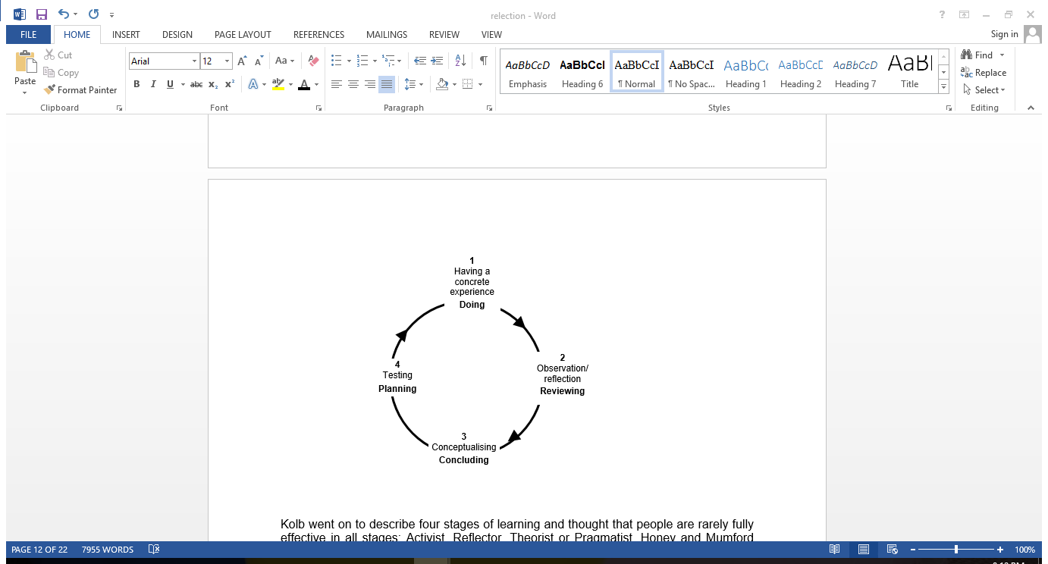
Figure 1: Kolb learning style (Kolb, 1984)

In his theory, Kolb suggested four stages of learning and he considered that people are hardly fully effective in all the stages (Kolb, 1984). Here, I have encountered a new experience while preparing a reflective journal which is phased as concrete experience. I observed that it is always challenging to learn new things and manage time effectively, in spite of that the experience was delightful and efficient one. I have undertaken challenges to learn new academic and employability skills and made abstract conceptualization. I have been able to experiment the new learning actively on my reflective report and overcome my weaknesses regarding time management, communication skills etc.
Technical Skills
Such programs enable students to reinforce essential technical skills which can be transferred to job. The most vital one is to be able to meet deadlines. I think I am one of the laziest person in this universe due to lack of organisation, so I had to adjust otherwise I will be left alone. Planning was the only way to reduce my laziness and meet deadlines. The following section has the more details regarding this. It enables to improve writing skills by doing assignments similar to this one as well as the communication skills. Feedbacks are regarded as centre to the subject and answers are in a structured way. Moreover, it enables to work in a team, understand the aspects of a group, importance of group brainstorming as well as the drawbacks (Moon, 2000).
Time Management
For a lazy person like me, this acts as a black beast. I always attempted to manage my time by posting it in diary or phone application which successfully resulted in failure. I have the tendency to give up very quickly and keep postponing my work for the next day which I had to finish the day before and it has become another mean cycle. The British system assumes that students are enough responsible and wise to manage the time so things are now more serious. But it became a challenge for lazy students like me since without adapting any system it will be an automatic failure. So I take this challenge very seriously to manage my time as effectively as possible. And once again thankfully this assignment has made me realize that I have failed to fulfil the challenge, now I am 2days before my submission deadline where I have finished only 1/3 of the assignment till now. At this moment I am counting words and realizing that I could have finished the work earlier with effective planning. I can still remember while the slides were projected of this chapter and the valuable advices given by our teachers regarding weekly planning, prioritizing assignments and goal settings. Even I was advising other students to follow the same strategy but I didn't imply it on myself, resulted in nothing useful (Schon, 1991).

Creativity skills
Creativity skills brainstorming were the next lesson and I had some idea regarding this before attending the class. But after seeing some slides projected on the screen, I realized that I had a vague concept regarding brainstorming. The new definition categorized brainstorming in two types: Group brainstorming and Individual Brainstorming. I always considered that brainstorming is a group activity but the slides made me realize that brainstorming done lonely creates a wider range of ideas compared to group brainstorming. Though group brainstorming widens the emerging ideas, opens door to new opportunities which couldn't be generated lonely, individual brainstorming however draws a better, more specific and detailed image of the situation (Perry, 1986).
Decision tree and Statistics
The tree in which each branch node reflects a selection between a range of alternatives and each leaf node reflects a decision or classification is known as decision tree. The decision tree is used in decision analysis to represent decisions as well as decision making visually and explicitly. Decision tree outlines data, not decisions in data mining. The resulting classification tree rather acts as an input in decision making (Boud, 2001). In data mining, the course includes decision trees and this approach to my course is named database analysis and design. I already started reading a book and found it quite interesting since it involves economic situation which deals with money. I thought of continuing my studies through the database analysis area so I had to deal with a lot of decision trees. The concept which I derived during my first years of college helped me to have a quick touch of it. For example, a decision tree might help a financial institution to decide whether an individual should be offered a loan.
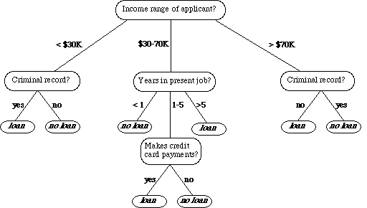

Figure 2: Decision tree
Academic writing
After a long gap, I decided to enrol in Certificate of Higher Education in Skills for the Workplace so that I can enhance my employability skills. Finally it was time to use my brain for some productive work which will help me in getting back to the real world after anenjoyable free time. Since I always had a fascination towards computers, I decided to enrol in a software development program Academic Skills for Business to modify my skills. I was surprised when I noticed in my routine that I received a course named Academic and employability Skills for Business. At first I was confused about the benefit of such course being a software developer but after attending three lectures, I started to take interest in the course since it made me notice things which I never considered before. When a report of 2000 words was assigned, I was confused whether I know this much vocabulary. Since this will help me to improve my language and writing skills, I took this as a challenge. I think this is a great method to evaluate my progress in this course and I can do it for other courses in my spare time (Cottrell, 2003).
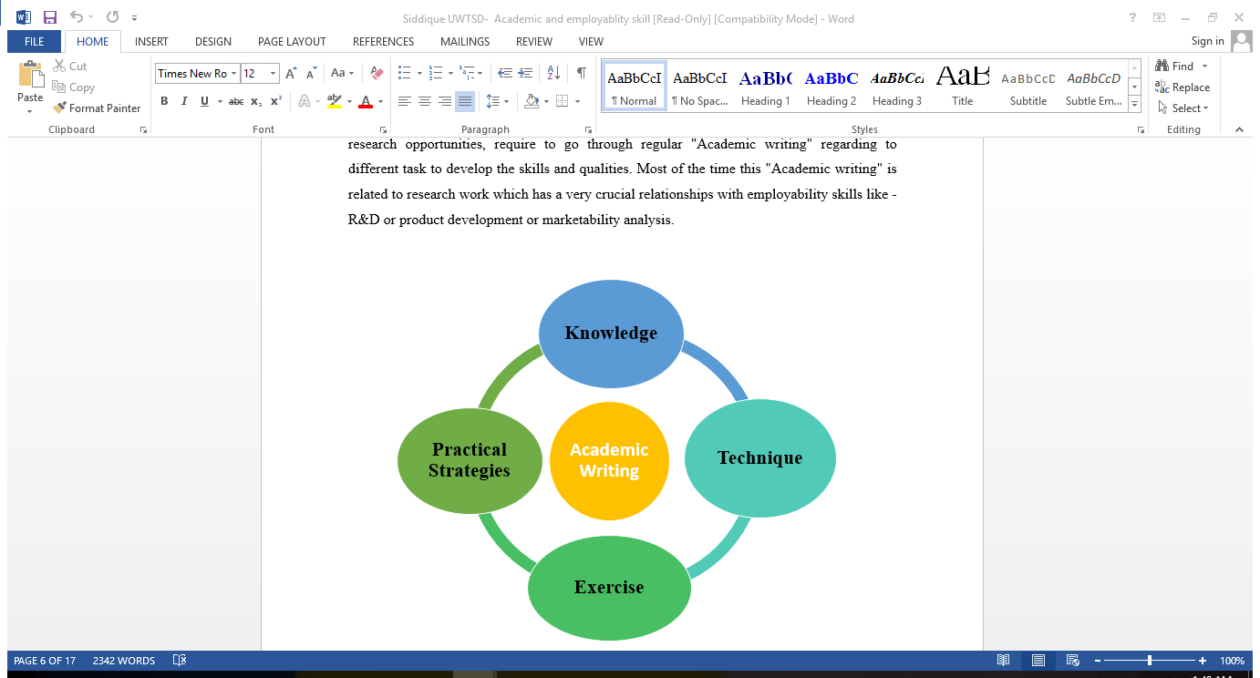
Figure 3: Academic Writing, Source: (Boud, 2001).
The first chapter describes the skills which employers generally require for job and the skills we learn as a student in this course. From this course, I realized there are mainly five skills which are required for a job of high level responsibility such as communication, interpersonal, leadership, time management, organizing and planning. An efficient manager has to maintain good relations and lead his subordinate in a way that motivates them. After evaluating all the available resources, he must have the ability to initiate better ideas and implement them for the benefit of the organization (Boud, 2001).
Knowledge
I had already an idea of what employers generally look for in employees but I was avoiding interpersonal aspect which appeared to be the most vital one. It is the key to attain the organizational top ladder. So I have to improve my communication skill which is related to negotiating, getting proper feedback, understanding nonverbal messages, accepting responsibility, interviewing, initiating new plans to enforce work survival and attaining goals. In order to achieve my goal of success, I have to initiate changes in my life and that is the difference between an adult and a teenager. This is the ability to have changes in behaviours for adapting the demand of the society. Without compromises, the path to rich is not easy to make. The path requires much effort and sacrifices to make otherwise the success won’t feel tasty (Coffield, 2004). Thankfully I can develop some of the skills and all credit goes to the Higher Education program.

Techniques

I still faced some problems despite my sincere efforts. I would prefer to change my approach a littlein future for solving the problems properly. I would have to emphasis on issues like interest, self-motivation and time management. I also need to improve my skills regarding critical thinking and analyzing. Some other factors also contributed to improve my understanding and knowledge. I learnt to undertake the research practically that were discussed in workshops and lectures theoretically during the course. Experience gained from reflective journal will surely help to improve future decision making and team working (Coffield, 2004).

Exercise
As a student of University, I was expected to think and analyze critically. The lectures and the courses I have attended helped me a lot to critically analyze my research. I got both theoretical and practical understanding by applying theories and knowledge of the books into practical context. Theory also explained how to implement different models according to my context and prepared a whole report. Theory also taught me the methods to conduct research in practically collecting data. The understanding from the lectures also helped me in searching various data sources.
After successfully writing this report, I learnt to use examples and facts. Since my researching skills have improved considerably, it has enabled me to find sources for my future research process. It also improved my conclusive argument, clear presentation of the paper, collection of data, analysis skills which helped to write report in an appropriate format. Compared to my own skills prior to writing reflection, I made a huge progress (Felder, 1988).

Skill Audit

A personal skills audit is essential for a person in order to keeping himself or herself on career track. It is a beneficial way to identify a person’s strengths, to monitor existing skills and to emphasis on the skills which are required at present and in the future as well. While compiling a personal skills audit, qualifications, education, knowledge, work history and experience etc are mainly considered. A skill audit is conducted below:

Skill | Self-Evaluation

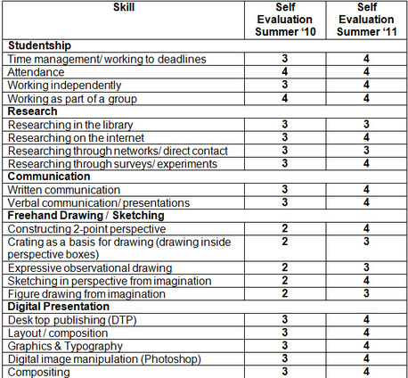

Skill Gap and Skills for Professional Practice
The gap between what employers expect their employees to have the ability to do and what the employees can actually able to do in the workplace is known as a skill gap. A variety of skills such as managing time, setting goals, problem-solving and communicating etc. are needed to be effective both in our daily lives and at work. Regardless of previous experience in personal and key skills, I need to develop higher level skills continuously in new contexts considering the skill audit (Gibbs, 1988). To transfer those skills into new experience and situation, I have to update them all the time.

Ways to improve skill gaps

Goal | Action
To improve presentation skills | - To attend presentations skills course and seminars  - To practice group presentation & receive feedback on how to improve  - To set aside time for self-evaluation  - To practice PowerPoint techniques
To improve communication and people Skills | - To develop a rapport with other people  - To effectively communicate message by using tone, words and expressions  - To gain more confidence by practice  - To attend networking events  - To volunteer for presenting in groups
To enhance personal responsibility | - To remain focused on which can be controlled  - To brainstorm all relevant factors that influence the ability to do job  - To redefine past examples for doing things better
Conflict Resolution | - To understand my tendency for conflict  - To build willingness for dealing with a difficult issue  - To develop an action plan required to reflect conflict style
To improve empathy | - To pay full attention to others and learn from them  - To suspend judgment and evaluate own assumptions  - To develop relationships with various people or read books  - To practice listening skills

To assess my strengths and weaknesses, a SWOT analysis can be helpful:

SWOT Analysis:

Strengths  - ability to get along with people  - reliable and honest  - hard-working  - initiative and innovative  - research skills and analytical skills | Opportunities  - gaining experience of how to deal with people  - gaining experience of the world of work  - working abroad  - working in a team
Weaknesses  - managing deadlines  - lack of confidence while interacting  - lack of experience regarding academic studies  - lack of skill in spreadsheet and database | Threats  - being unwelcomed at work  - dealing with the company culture  - unreliability due to transport problems (Fanthome, 2004)

So these are the most common employability skills gaps and the ways to overcome them.

Conclusion
Here, we are close to the end after several months of courses. The course has taught us a lot of new things and I enjoyed attending the classes. Writing this reflective essay actually helped me putting things into retrospective. Technical skills have improved due to the course and I would like to continue practicing for surviving in the workplace. I regained some energy to overcome and fight back challenges by prioritizing important things and wisely managing my time. Time has come to act. I had fun finishing this reflective journal but still I cannot believe that I could finally do it. I never thought that I would be able to finish it on due time. I am just few words far away to the milestone of 2000 words. During the process, it enabled me to learn many things about myself by revealing my writing skills. Finally, putting everything in reflective paper helped me to draw a perfect picture of myself that assisted me in modifying my strengths and evaluating weaknesses (Cottrell, 2003).

Reference

Boud, D. & Soloman, N. (Eds) (2001) Work-based Learning – A new higher education. Buckingham, SHRE/Open University Press.
Coffield, F., Moseley, D., Hall, E., Ecclestone, K. (2004), Learning Styles and Pedagogy in Post-16 Learning: a systematic and critical review, London, The Learning and Skills Research Centre (LSRC), UK
Cottrell, S. (2003), Skills for Success: The Personal Development Handbook. Basingstoke: Palgrave Macmillan.
Fanthome, C. (2004) Work Placements: A survival guide for students. Palgrave
Felder, R. M., & Silverman, L. K. (1988). Learning and Teaching Styles in Engineering Education. Eng. Education, 78(7), 674--681.
Gibbs, G. (1988), Learning by Doing: A Guide to Teaching and Learning Methods. Further Education Unit, UK
Honey, P. and Mumford, A. (1992). The manual of learning styles: Revised version. Maidenhead: Peter Honey
Kolb, D. (1984), ‘Experiential Learning: Experience as the source of Learning and Development.’ PHI, New Jersey.
Moon, J. (2000), Reflection in learning and professional development: theory and practice. London: Routledge Falmer.
Perry (1968) Patterns of development in thought and values of students in a liberal arts college.
Schon, D. (1991), Educating the Reflective Practitioner: Towards a new design for teaching and learning. San Francisco. Jossey-Bass.

