

Anomaly-Based Intrusion Detection System:
A Hybrid Machine Learning Approach Combining
XGBoost and Deep Autoencoder via Weighted Voting
By
Orin McGinn
Supervisor: Simon Thomas
Second Marker: Dr. Carlene Campbell

Project submitted as part of the requirements for the award of
BSc (Hons) Computing

University of Wales Trinity Saint David

May 2026

Declaration
I, User, declare that I am the sole author of this Project; that all references cited have been consulted; that I have conducted all the work of which this is a record; and that the work has not been previously accepted for any degree.
This work has not previously been accepted as part of any other degree submission.

Signed: ...OMG.................................
Date: ......22/04/26..........................

Form of Consent
I, User, hereby consent that my Project, submitted in candidature for the BSc (Hons) Computing degree, if successful, may be made available, at the discretion of the Librarian, for inter-library loan and for photocopying subject to the law of copyright.

Signed: ...OMG.................................
Date: ......22/04/26..........................

Abstract
The increasing frequency and complexity of cyber-attacks, especially zero-day attacks, have rendered the traditional signature-based intrusion detection systems (IDS) obsolete. Consequently, there is a pressing need for robust and efficient proactive and adaptive security measures. This project proposes a high-performance Intrusion Detection System (ML-IDS) based on a hybrid machine learning model composed of a supervised XGBoost classifier and an unsupervised deep autoencoder, which are combined through a weighted voting ensemble scheme to detect both known and unknown attacks.
The proposed system was evaluated and compared with Snort, a signature-based IDS, using the most comprehensive publicly available CIC-IDS2017 dataset, which consists of 2, 492, 526 flow records and 15 classes of network traffic. Based on the experiment's findings, the proposed weighted voting ensemble outperformed Snort. Specifically, the proposed ensemble classifier attained an accuracy of 99. 92% and an AUC of 1. 0000 in the binary classification (Attack vs. Benign), with a false positive rate (FPR) of 0. 08%. Most importantly, the ensemble classifier achieved a recall of 99. 89%, with only 94 out of 85, 148 attack flow records being misclassified. In contrast, the signature-based Snort system achieved an accuracy of 88. 82% and a recall of 49. 04%, with over half of the attack flows being misclassified.
In addition to the classification models, a real-time live traffic classifier prototype was also implemented. Specifically, network traffic was captured from a Cisco switch's SPAN port using the scapy library and classified in real-time through a RESTful API. The results obtained showed that the proposed hybrid ML-IDS scheme, which uses both supervised classification and unsupervised anomaly detection, is a more effective and robust solution for detecting known and zero-day attacks in the networks. Finally, the paper concludes with recommendations for future research directions, including adversarial training to further strengthen the proposed scheme.

Contents
Declaration 2
Form of Consent 2
Abstract 3
List of Figures 7
List of Tables 8
Chapter 1: Introduction 9
1.1 Background 9
1.2 Problem Statement 10
1.3 Motivation and Approach 11
Project Aim and Objectives 12
Project Objectives 12
SMART Objectives Analysis 14
Chapter 2: Literature Review 18
2.1 Intrusion Detection Systems: An Overview 18
2.2 Machine Learning for Intrusion Detection 19
2.3 Ensemble Methods 20
2.4 Datasets for IDS Evaluation 21
2.5 Snort: Signature-Based Baseline 22
2.6 Research Gap and Project Justification 23
2.7 Deep Learning Approaches for Intrusion Detection 24
2.8 Class Imbalance in IDS Datasets 26
2.9 Adversarial Robustness and Evasion Attacks on ML-IDS 28
2.10 Encrypted Traffic and the Limitations of Flow-Based IDS 30
2.11 IDS Deployment, SIEM Integration, and Operational Considerations 32
Chapter 3: Methodology 34
3.1 Experimental Setup 34
3.2 Data Preprocessing 35
3.3 Snort Baseline Implementation 37
3.4 Hybrid ML-IDS Design and Implementation 38
3.4.1 Supervised Component: XGBoost Binary Classifier 38
3.4.2 Unsupervised Component: Deep Autoencoder 38
3.4.3 Weighted Voting Ensemble 40
3.4.4 Additional Exploration: Stacking Ensemble 40
3.5 Evaluation Metrics 41
Chapter 4: Implementation 42
4.1 Data Exploration and Preprocessing 42
4.2 Snort Baseline Evaluation 43
4.3 Stacking Ensemble Training 43
4.4 Autoencoder and Weighted Voting Ensemble 44
4.5 Live Traffic Prototype 45
Chapter 5: Results and Evaluation 47
5.1 Training Performance 47
5.2 Autoencoder Anomaly Detection Performance 48
5.3 Multi-Class Classification Performance 49
5.4 Binary Classification Performance 49
5.4.1 Analysis 51
5.4.2 Per-Class Detection Analysis: Snort vs ML-IDS 53
5.5 Key Findings Summary 56
5.6 Feature Importance Analysis 57
XGBoost Feature Importance 57
RandomForest Feature Importance 58
Shared Insights 60
5.7 Comparison to Related Work on CIC-IDS2017 60
Chapter 6: Conclusion and Future Work 62
6.1 Conclusion 62
6.2 Project Limitations 64
6.3 Future Work 66
Chapter 7: Reflection 68
7.1 Project Planning and Management 68
7.2 Technical Challenges 69
7.3 Skills Development 70
7.4 Ethical Considerations 71
7.5 What I Would Do Differently 71
Chapter 8: References 73
Chapter 9: Bibliography 77
Appendices 80
Appendix A: Source Code Repository 80
Appendix B: Snort Detection Probability Mapping 81

List of Figures
Figure 1: Class distribution of the CIC-IDS2017 dataset after merging all eight source files.
Figure 2: Hybrid ML-IDS System Architecture diagram.
Figure 3: Autoencoder training and validation loss over epochs.
Figure 4: Live IDS Prototype Network Topology.
Figure 5: Reconstruction error distributions for benign and attack traffic.
Figure 6: Binary classification F1-Score comparison across all four systems.
Figure 7: ROC curves for the three hybrid IDS components.
Figure 8: Binary confusion matrices for XGBoost, Autoencoder, and Weighted Voting.
Figure 9: Performance comparison across the three hybrid IDS components.
Figure 10: Snort 2.9 per-class F1-Score ranked from best to worst.
Figure 11: Snort per-class detection rates (recall) heatmap.
Figure 12: Direct performance comparison between the hybrid ML-IDS and Snort 2.9.
Figure 13: Top 20 most important features identified by XGBoost.
Figure 14: Top 20 most important features identified by RandomForest.

List of Tables
Table 1: Model training times on the virtual machine (4 cores, 8 GB RAM).
Table 2: Autoencoder reconstruction error statistics for benign and attack traffic.
Table 3: Multi-class classification performance comparison.
Table 4: Binary classification performance comparison (full metrics).
Table 5: XGBoost top 5 feature importance scores.
Table 6: Per-class detection rates: Snort vs ML-IDS.

Chapter 1: Introduction

1.1 Background
With the proliferation of digital technologies, organisations now rely on computer networks for communications, data storage, and operations. However, the increased digital connectivity also offers a larger attack surface for adversaries. Over the past few years, the frequency and complexity of cyber-attacks have increased. A recent report [6] stated that the global cost of cybercrime is projected to reach trillions of dollars annually. For instance, hospitals were attacked by ransomware [6] and sensitive data was stolen via sophisticated APT attacks [6]. Therefore, effective network defence mechanisms are essential to combat these threats.
In the realm of network defence, Intrusion Detection System (IDS) is a core component. IDS is a software application which monitors network traffic and identifies potential threats or attacks based on signature matching. Signature-based IDS, such as Snort [3], relies on an extensive ruleset (or signature database) to detect known attacks. However, they cannot identify attacks for which signatures have not been written yet. Therefore, there is an urgent need for developing a more robust and intelligent intrusion detection mechanism capable of identifying novel attacks.

1.2 Problem Statement
Signature-based IDS have limitations because they depend on a ruleset of known attacks. The ruleset needs to be updated frequently. Moreover, it is not possible for signature-based IDS to detect novel attacks for which signatures are not written yet. Adversaries may employ various evasion techniques such as encoding, encryption, obfuscation, and low-and-slow attacks [6] to evade signature-based IDS. Studies [6][14] have shown that signature-based IDS have limited detection capability against application-layer attacks, encrypted brute-force attacks, and low-and-slow attacks. In this regard, developing a more intelligent and robust intrusion detection approach that learns normal and abnormal network traffic characteristics instead of relying on a predefined ruleset would be beneficial.

1.3 Motivation and Approach
Recently, Machine Learning (ML) has been widely used for developing intrusion detection and prevention mechanisms. Supervised ML algorithms can be trained on a labelled dataset of attacks and normal network traffic to learn a decision boundary to distinguish attacks from normal traffic. Unsupervised ML algorithms can be used to learn a representation of normal network traffic data. For instance, autoencoders [4][15] can be used to learn a compact feature representation of normal network traffic. Then, anomalies or unknown attacks can be identified by calculating a reconstruction error between input and output. However, a large body of work has focused on applying either supervised or unsupervised ML algorithms for intrusion detection and prevention.
In this project, I aim to evaluate the performance of an ensemble of supervised and unsupervised ML algorithms for intrusion detection. I will use XGBoost [2] as a supervised ML algorithm to develop a binary classification model for identifying attacks and normal network traffic. I will use a deep autoencoder as an unsupervised algorithm to learn a feature representation of normal network traffic. Then, I will develop an ensemble model which uses the output of both supervised and unsupervised models to detect attacks and normal network traffic. I will evaluate the performance of the ensemble model using accuracy, precision, recall, F1-score, AUC (Area Under the ROC Curve), and false positive rate. Moreover, I will compare the performance of the ensemble model with a signature-based IDS called Snort [3].

Project Aim and Objectives
Project Aim
The primary aim of this project is to build, run, and evaluate a hybrid machine learning-based Intrusion Detection System (ML-IDS) that combines supervised and unsupervised learning to demonstrate superior performance in detecting both known and unknown attacks when compared to a traditional signature-based IDS.

Project Objectives
Project Aim The aim of this project is to design, implement and evaluate a hybrid machine learning-based Intrusion Detection System (ML-IDS) that uses an ensemble of supervised and unsupervised machine learning algorithms to classify network traffic as either attacks or normal traffic. The performance of the proposed system will be evaluated against a signature-based IDS called Snort [3].
Project Objectives To accomplish the aim of this project, the following objectives will be achieved:
To conduct a comprehensive literature survey on existing IDS and machine learning-based intrusion detection and prevention mechanisms.
To undertake data preprocessing and feature engineering on the CIC-IDS2017 dataset [1] such as filling missing values, removing duplicates, encoding labels, and scaling features.
To design and train a supervised XGBoost binary classifier using a labelled dataset to identify attacks and normal network traffic with a high recall rate. The classifier will be trained on attacks and normal network traffic data and the detection capability will be evaluated using accuracy, precision, recall, F1-score, and AUC (Area Under the ROC Curve).
To design and train an unsupervised deep autoencoder on a normal network traffic dataset to learn a compact feature representation of normal traffic data. Anomalies or attacks will be detected by computing a reconstruction error between input and output data. The detection capability of the autoencoder will be evaluated using accuracy, precision, recall, F1-score, and AUC (Area Under the ROC Curve).
To develop an ensemble model that uses the output of supervised XGBoost and unsupervised autoencoder models to identify attacks and normal network traffic. The performance of the ensemble model will be evaluated using accuracy, precision, recall, F1-score, AUC (Area Under the ROC Curve), and false positive rate.
To implement a signature-based IDS called Snort [3] and evaluate its detection capability against the CIC-IDS2017 dataset [1] using accuracy, precision, recall, F1-score, AUC (Area Under the ROC Curve), and false positive rate.
To compare the performance of the proposed ensemble model with a signature-based IDS called Snort [3] using accuracy, precision, recall, F1-score, AUC (Area Under the ROC Curve), and false positive rate.
To design and implement a live traffic application that can capture network traffic from a Cisco switch SPAN port, extract features, and classify network traffic into attacks or normal traffic using the proposed ensemble model in real-time.

SMART Objectives Analysis
To confirm that the eight project objectives satisfy the criteria of the SMART mnemonic, a detailed analysis of each objective is conducted in the table below: It is clear from the table above that each of the project objectives were chosen to be specific, measurable, achievable, relevant, and time bound. This indicates that the project was planned with well-chosen, well-justified, and well-defined objectives from its inception.
Scoped to IDS literature: ML ensembles, autoencoders, and cybersecurity applications. Not open-ended. Completed when all key themes (signature-based IDS, ML methods, datasets, ensemble strategies) are covered and referenced in IEEE style. A literature review is a standard, well-established component of any undergraduate dissertation. Directly underpins the design decisions made in the methodology, justifying the choice of XGBoost, autoencoders, and CIC-IDS2017. Targeted for completion in Phase 1 of the project timeline, prior to any implementation work beginning.
Targets the CIC-IDS2017 dataset specifically, with named steps: NaN removal, deduplication, label encoding, and StandardScaler normalisation. Success defined by a clean dataset: zero NaN/infinite values, no duplicates, all features scaled, verified programmatically. Final size: 2,498,043 samples, 70 features. Preprocessing pipelines for this dataset are well-documented in the literature; memory constraints were addressed by downcasting to 32-bit precision. Clean, well-prepared data is a prerequisite for all subsequent ML objectives; poor preprocessing would directly undermine model validity. Completed in Phase 2, before model training commenced. Cached .npz outputs allowed efficient reloading in all subsequent notebooks.

- Explicitly names the algorithm (XGBoost), the task (binary classification), and the optimisation target (high recall), leaving no ambiguity about scope. Performance quantified by recall, precision, F1-score, and AUC on the held-out 20% test set. Target: recall ≥99% to exceed published baselines. XGBoost is widely validated on network intrusion datasets and available via a mature Python library; achievable within VM resource constraints. The supervised component is essential to the hybrid ensemble and directly serves the primary project aim of superior attack detection. Implemented in Phase 3. Training completed in 14.3 seconds, well within session time budgets.
- Specifies the model type (deep autoencoder), training data (benign traffic only), learning objective (normal behaviour), and detection mechanism (reconstruction error thresholding). Measurable via reconstruction error ratio (attack MSE vs. benign MSE) and standalone AUC. Target: attack traffic produces statistically higher reconstruction error than benign traffic. TensorFlow/Keras provides a mature framework; the encoder-decoder architecture and training regime are grounded in published anomaly detection literature [4][15]. Provides the unsupervised anomaly detection capability critical to detecting zero-day attacks, the core motivation of the entire project. Implemented in Phase 3 alongside Objective 3. Training completed in 140.7 seconds (50 epochs with early stopping) on the VM.

- Names both components (XGBoost and autoencoder), the integration method (weighted voting), and the combination rationale (supervised + unsupervised paradigms). Success measured by whether ensemble recall exceeds XGBoost alone and by optimisation of the voting threshold via Youden’s J statistic [46] on the ROC curve. Weighted voting is a straightforward fusion strategy requiring only NumPy operations once Objectives 3 and 4 are complete; no additional libraries needed. Directly fulfils the project’s primary aim of a hybrid system combining supervised and unsupervised detection paradigms. Completed in Phase 3, immediately following the training of both component models, enabling evaluation results to be produced on schedule.
- Specifies the exact system (Snort 2.9, community ruleset), the baseline task (performance evaluation), and the constraint (same dataset as the ML models). Outputs a full set of classification metrics (accuracy, recall, F1, FPR) for Snort that can be directly tabulated alongside the ML results. Snort is open-source, freely available, and widely used in industry; an evidence-based simulation methodology was devised to overcome the absence of raw PCAP files. Without a meaningful baseline, the ML results lack context; Snort provides the industry-standard point of comparison that validates the project’s contribution. Completed in Phase 2, prior to ML model training, ensuring baseline results were available for direct comparison from the outset of evaluation.

- Names six explicit evaluation metrics (Accuracy, Precision, Recall, F1-Score, AUC, FPR) and specifies both binary and multi-class evaluation scenarios. Each named metric produces a concrete numeric value on the held-out test set; results are tabulated and visualised via ROC curves, confusion matrices, and F1-score bar charts. All metrics are computed using scikit-learn’s evaluation module, a mature and well-tested library; no custom implementations required. Rigorous, multi-metric evaluation is essential to substantiate the claim of superiority over Snort and to provide examiners with transparent, reproducible evidence. Completed in Phase 4 (evaluation), once all models and the Snort baseline were trained. Results are fully reported in Chapter 5.
- Specifies the hardware (Cisco switch SPAN port), the software mechanism (scapy packet capture), the feature pipeline (70 CIC-IDS2017 features), and the operational target (near real-time classification via REST API). Success defined by a functioning prototype that captures live packets, extracts the correct 70 features, classifies flows, and exposes results via the /api/alerts endpoint, all demonstrable on the physical testbed. Access to a physical Cisco Catalyst 2960 switch and a Raspberry Pi 4 made this feasible; scapy and Flask are mature, well-documented Python libraries. Bridges the gap between academic evaluation on a static dataset and practical deployment, directly addressing a weakness identified in the literature review [Section 2.6]. Developed in Phase 4 in parallel with evaluation, after trained models were saved to disk. A functional prototype was demonstrated on the physical testbed prior to report submission.

Chapter 2: Literature Review

2.1 Intrusion Detection Systems: An Overview
Intrusion Detection Systems (IDS) are security tools that monitor network traffic or system activity for malicious behaviour or policy violations [6]. They are broadly categorised into two types based on their detection methodology: signature-based (misuse detection) and anomaly-based detection.
Signature-based IDS, such as Snort [3] and Suricata, operate by comparing observed network traffic against a database of known attack patterns, or signatures. When a match is found, an alert is raised. The primary advantage of this approach is its high precision for known threats and low false positive rates. However, it is fundamentally reactive, as new signatures must be written and deployed for every new attack variant, and zero-day exploits for which no signature exists will go undetected [6].
Anomaly-based IDS take a fundamentally different approach. Instead of cataloguing known attacks, they build a model of normal network behaviour and flag deviations from this baseline as potentially malicious. This paradigm has the theoretical advantage of detecting novel attacks, as any traffic that deviates sufficiently from the learned norm is flagged, regardless of whether it matches a known signature. The primary challenge of anomaly-based detection is a typically higher false positive rate, as legitimate but unusual traffic may also deviate from the learned baseline [14].

2.2 Machine Learning for Intrusion Detection
The application of machine learning to intrusion detection has been an active area of research for over two decades. Buczak and Guven [6] provide a comprehensive survey of data mining and machine learning methods applied to cybersecurity, noting that supervised learning methods, including decision trees, support vector machines, and neural networks, have consistently demonstrated strong performance when trained on labelled datasets of normal and malicious traffic.
In recent years, gradient boosting methods have emerged as top performers for structured data classification tasks. XGBoost (Extreme Gradient Boosting) [2], introduced by Chen and Guestrin in 2016, builds an ensemble of decision trees sequentially, with each new tree correcting the errors of its predecessors. It incorporates regularisation to prevent overfitting and supports efficient parallel computation. XGBoost has achieved state-of-the-art results across numerous machine learning competitions and has been successfully applied to network intrusion detection, achieving recall rates above 99% on benchmark datasets.
On the unsupervised side, autoencoders [4][15] have gained significant attention for anomaly detection. An autoencoder is a neural network trained to reconstruct its input through a compressed bottleneck layer. Hinton and Salakhutdinov [15] demonstrated that deep autoencoders can learn powerful low-dimensional representations of high-dimensional data. When trained exclusively on normal (benign) data, an autoencoder learns to reconstruct normal patterns with low error. When presented with anomalous data (attacks), the reconstruction error increases because the model has never learned to represent such patterns. This reconstruction error can be considered as an anomaly score, and hence, autoencoders are suitable for detecting zero-day attacks when no labelled malicious traffic examples are available [4][50].

2.3 Ensemble Methods
Ensemble methods use multiple models to generate one stronger predictive model. The main idea is that each individual model may have its own weaknesses and strengths, and thus, by ensembling them, the ensemble may overcome the weaknesses of the individual models [7][8][47]. There are three ensemble techniques:
- Bagging (Bootstrap Aggregating): it trains multiple models on different bootstrapped samples of the training data and then combines the results by voting or averaging. The most common example of bagging is the Random Forests [7] algorithm, which trains hundreds of decision trees on bootstrapped samples with bootstrapped samples of features at each tree node.
- Boosting: it trains multiple models sequentially, such that, each new model is trained to correct the errors of its previous models. Gradient Boosting [8] and its optimized version, XGBoost [2], fall under this category. In general, boosting outperforms bagging in terms of accuracy, but it is noisier and more prone to overfitting.
- Stacking (Stacked Generalisation): it trains a meta-model on the predictions of multiple base-models [11]. The base-models are trained using cross-validation, such that, each model generates out-of-fold predictions. Then, a second level model (e.g. logistic regression) is trained to learn how to combine the predictions of the base-models. This ensemble technique was introduced by Wolpert [11] who showed that a well-designed stacking architecture may outperform any of its individual base-models.
In this project, we employ a weighted voting ensemble that combines a supervised boosting model (XGBoost) with an unsupervised autoencoder. This hybrid approach is distinct from traditional ensemble methods, which typically combine models of the same learning paradigm. The rationale is that supervised and unsupervised models learn fundamentally different representations of the data: the supervised model learns explicit decision boundaries between classes, while the unsupervised model learns the manifold of normal behaviour. Combining both should provide more comprehensive detection coverage.

2.4 Datasets for IDS Evaluation
Choosing an evaluation dataset is an essential step for an IDS study. Over the years, several benchmark datasets have been commonly used in the literature. Each dataset has its own merits and demerits.
- KDD Cup 1999 / NSL-KDD: The KDD Cup 1999 dataset was one of the first datasets used for evaluating IDS systems. However, the dataset was found to have several drawbacks such as duplicated records, and unrealistic distributions of normal/abnormal traffic, and features that can trivially separate between attack classes [12]. The NSL-KDD dataset was introduced later to address some of the aforementioned issues. The duplicated records were removed from the dataset. However, the dataset still suffers from old-fashioned data that is not representative to the current normal traffic distribution.
- UNSW-NB15: In 2015, Moustafa and Slay [13] introduced the UNSW-NB15 dataset. This dataset was created using the IXIA PerfectStorm tool. The tool generated a mixture of normal and abnormal traffic under a controlled environment. The dataset contains nine attack categories, and 49 features. Compared to KDD, the UNSW-NB15 is relatively new. However, it is relatively small and contains a limited number of attack categories compared to other datasets.
- CIC-IDS2017 The CIC-IDS2017 dataset [16][1] (Sharafaldin, Lashkari, Ghorbani, Canadian Institute for Cybersecurity) is one of the most complete, widely-used and recent IDS benchmark datasets available. The dataset was collected over five days in a controlled testbed network environment, capturing typical user traffic (web browsing, email, FTP) as well as a broad range of attacks (DoS and DDoS, port scan, SSH and FTP brute force, SQL injection, XSS, web brute force, botnet, infiltration, and Heartbleed exploitation). The dataset contains over 2.8 million labeled flow records with more than 80 features, generated by the CICFlowMeter tool [52]. The dataset contains 14 different types of attacks, as well as benign traffic, and is a challenging multi-class classification problem. Due to its diversity of attack types and benign traffic, as well as its large scale, the CIC-IDS2017 dataset is suitable for the evaluation of the proposed hybrid ML-IDS. The dataset was selected for this project due to its completeness and recency compared with other datasets, as well as its widespread use in the literature [1].

2.5 Snort: Signature-Based Baseline
Snort [3][17] (Martin Roesch, 1998, now maintained by Cisco) is one of the most widely used open-source network intrusion detection and prevention systems worldwide, with over 5 million downloads and thousands of detection rules contributed by the active Snort community. Snort has three primary modes of operation: sniffer mode (packet display), packet logger mode (logging network traffic), and network intrusion detection mode (examining network traffic in real-time for matches against rules). When operating in NIDS mode, Snort compares each incoming packet against its rule set, searching for a match. The detection rules are grouped into categories such as DDoS protection, exploit detection, web attack detection, and scan detection and protocol anomaly detection. The Snort community rule set contains thousands of rules to detect known threats; however, as with any signature-based system, it cannot detect attacks for which no rule has been written. Furthermore, signature-based systems that operate at the packet level struggle to detect application-layer attacks that use seemingly legitimate HTTP requests, encrypted attacks that cannot be decrypted for inspection, and low-and-slow attacks that remain below detection thresholds on a per-packet basis. For these reasons, there is ongoing research into alternative detection methods using machine learning, such as those proposed in this project.

2.6 Research Gap and Project Justification
While individual research studies have proposed the use of supervised machine learning [6] or autoencoders [4] for intrusion detection, there are relatively few studies that explore the use of both paradigms within a single weighted voting system, or that directly compare the performance of this system with a real-world signature-based baseline (such as Snort) on the same dataset. Furthermore, many research studies remain in the realm of theory, evaluating proposed machine learning models on benchmark datasets but not demonstrating real-world deployment. This project will address these gaps by:
(1) implementing a weighted voting ensemble system that combines a supervised machine learning model (XGBoost) with an unsupervised deep autoencoder; (2) providing a direct performance comparison with a widely used real-world signature-based system (Snort) on a comprehensive benchmark dataset (CIC-IDS2017); and (3) building a working prototype of the system that captures and classifies real network traffic flows from a physical network device (a Cisco switch).

2.7 Deep Learning Approaches for Intrusion Detection
While XGBoost and Random Forests are state-of-the-art approaches for structured, tabular network flow data, a separate branch of research has explored deep learning models for intrusion detection. This section is particularly pertinent as the autoencoder used in this project is itself a deep neural network and contextualising it within the deep learning family lends further theoretical support to its selection. Convolutional Neural Networks (CNNs) have been applied to network traffic classification by either treating flow feature vectors as 1D sequences or reformatting them into a pseudo-2D structure akin to images. Kim et al. [18] found that a 1D-CNN can learn local patterns from flow feature vectors and achieve a competitive classification accuracy on the NSL-KDD dataset. However, CNNs are predicated on the assumption of spatial locality in the input, which does not inherently apply to flow statistics, which are independently computed and often not spatially correlated (particularly in the CIC-IDS2017 dataset, where adjacent features are not necessarily related). Recurrent architectures, particularly variants of the Long Short-Term Memory (LSTM) network [19], are more naturally suited to capturing sequential or temporal dependencies in network traffic. Yin et al. [20] employed an LSTM-based classifier on the NSL-KDD dataset and demonstrated that modelling the time dimension of network flows could enhance the detection of slowly unfolding attacks such as reconnaissance scans. However, LSTM-based approaches require the use of ordered packet sequences, not pre-aggregated flow statistics, which makes them less suitable to the CICFlowMeter-produced features used in this project. More recently, Generative Adversarial Networks (GANs) have been proposed as a tool for both data augmentation and anomaly detection in the context of IDS. Lin et al. [21] used a GAN to generate synthetic attack traffic samples for addressing class imbalance, which presents an alternative to the SMOTE [5] oversampling technique. The discriminator network of a GAN can also be used as an anomaly detector, functioning in an analogous manner to the reconstruction error mechanism of the autoencoder employed in this project. A GAN-based approach was originally considered but not pursued in favour of the autoencoder due to its relatively greater training stability, lower computational requirements, and simpler threshold selection process [4]. The prevailing wisdom in the deep learning literature is that no model is universally superior to all others, and the choice should be dictated by the input representation, dataset characteristics, and computational resources [6]. This wisdom lends support to the hybrid model proposed in this project, marrying the strengths of XGBoost on tabular data to the autoencoder's ability to learn representations.

2.8 Class Imbalance in IDS Datasets
Class imbalance is a ubiquitous problem in intrusion detection and the CIC-IDS2017 dataset is no exception. As can be seen from Figure 1, benign traffic accounts for approximately 83% of the total records, and some attack classes (such as Infiltration with 36 samples and Heartble with just 11 samples) comprise only a tiny proportion of the whole dataset. This causes a problem because any simple classifier predicting all traffic as benign would achieve an accuracy of 83% without detecting any attacks whatsoever, rendering accuracy a seriously misleading metric. The conventional method for dealing with class imbalance in tabular data is SMOTE (Synthetic Minority Over-sampling Technique) [5], a technique for generating synthetic minority class samples by interpolating existing minority samples in feature space. The original project proposal suggested the use of SMOTE as a preprocessing step. However, the dataset used here contains over 2.8 million records, and the VM has only 8 GB of RAM allocated. The number of attack classes is 14, meaning that applying SMOTE to every class would result in a total training set size that would easily exceed the available memory. Moreover, Elor and Averbuch-Elor [22] have shown that not only can SMOTE introduce noise and distort boundaries in high-dimensional feature spaces (in this case 70 features), but the benefits of applying the technique are greatly diminished when the majority class is very large. Instead, the approach adopted in this project is to use stratified sampling to preserve the class balance in the train/test split and adopt a weighted voting ensemble architecture. The XGBoost model is trained on an imbalanced dataset, but optimised for recall rather than accuracy, which implicitly penalises any missed attacks. The autoencoder model is trained only on benign traffic and so is completely unaffected by the distribution of the attack classes. This provides a pragmatic, memory-efficient solution to the class imbalance problem that does not incur the additional computational expense of oversampling. Longadge and Dongre [23] note that algorithm-level methods such as this are often preferable to data-level resampling techniques for high-dimensional data because they do not introduce any spurious correlations between newly-synthesised samples. The imbalance does go some way to explaining why the macro-averaged F1-score is a more useful metric than the weighted F1-score for multi-class problems such as this. As can be seen from Table 3, all the models achieve a high weighted F1-score due to the influence of the benign class, whereas the macro F1-score is more discriminating and reveals variations in performance across the rarer attack classes. This is discussed throughout the evaluation in Chapter 5.

2.9 Adversarial Robustness and Evasion Attacks on ML-IDS
For any machine learning-based security system, an important security consideration is its potential vulnerability to adversarial manipulation. In contrast to knowledge-based systems that can be trivially bypassed by modifying the attack to no longer match their encoded attack signatures, ML-based IDS are vulnerable to adversarial examples [24], inputs specifically optimized to mislead the classifiers that are functionally indistinguishable from their original counterpart. In the context of network intrusion detection, adversarial evasion attacks achieve this by subtly perturbing the statistical flow features used by the classifier without modifying the malicious semantics of the attack traffic. Apruzzese et al. [25] published a detailed overview of adversarial machine learning in the context of cybersecurity and identified evasion attacks in the feature space as the dominant threat to ML-IDS systems. For example, an attacker performing a DoS flood could introduce artificial delays between sending packets to reduce the rate of packets/sec to a value below the detection threshold of the classifier. The hybrid architecture used in this project confers some inherent resilience to feature-space evasion attacks. Since the XGBoost model and autoencoder learn fundamentally different representations, the decision boundary of the classifier versus the data manifold of benign traffic, an attacker must find a perturbation that simultaneously evades both components. This is a significantly more challenging optimization problem than targeting a single model. This was formalized by Madry et al. [26] who found that the diversity of the components in an ensemble is the most important factor in its adversarial robustness, a perturbation that fools one model may not fool a model trained with a different objective. This was the motivation for the weighted voting architecture, the autoencoder acts as an independent check on the anomaly score of a flow that is classified as benign by XGBoost. Despite this, the models developed in this project have not been robustly trained against adversarial examples and are likely vulnerable to white box attacks where the attacker has full knowledge of the architecture and parameters of the deployed models. The Future Work section (6.2) proposes a new adversarial training pipeline, including a Red Team automated attacker and Purple Team feedback loop, as the priority for improving the security of this system. This ties in with a nascent literature on certifiable robustness [27] and robust feature selection [28] for network anomaly detection.

2.10 Encrypted Traffic and the Limitations of Flow-Based IDS
One of the fundamental challenges facing any network-based IDS is the increasing prevalence of transport-layer encryption. The internet-wide transition towards TLS 1.3 [34] and the near-universal deployment of HTTPS means that a steadily growing proportion of both benign and malicious network traffic will present itself as opaque ciphertext, effectively concealing the payload from inspection. Traditional deep packet inspection (DPI) tools, including many signature-based NIDS, rely on inspecting packet payloads for known malicious strings [35] , an approach that is obviously broken by end-to-end encryption. Flow-based feature extraction, used in this project via CICFlowMeter [52], solves this problem by deriving statistical summaries of network flows that capture the behavioural characteristics of the traffic without needing to inspect the payload. This includes inter-arrival times, packet lengths, flag counts, and TCP window sizes. Anderson and McGrew [36] found that they could classify encrypted malware traffic to an accuracy of over 90% using only the information present in the TLS handshake and simple summary statistics of the flow. This demonstrates that even when the payload of attack traffic is encrypted, it will still leave a detectable behavioural signature in the flow statistics. However, the CIC-IDS2017 dataset was captured in 2017 when TLS was less ubiquitous. As such, whilst the dataset reflects real-world traffic for its time, it includes a mix of plaintext and encrypted traffic, but the proportion of malicious traffic that is fully encrypted is lower than in the modern internet. Increasingly, attackers are using legitimate HTTPS services (e.g. cloud storage APIs) as a proxy for command-and-control (C2) communications [35], leaving flow-level behavioural analysis as the sole remaining detection mechanism. This provides additional motivation for the anomaly-based approach pursued in this project; the autoencoder component of the hybrid ML-IDS identifies anomalous flow behaviour without relying on payload inspection and is therefore encryption-agnostic by design. The restrictions imposed by encryption also have implications for the Snort baseline used in this evaluation. As noted in Chapter 5, the majority of Snort’s community rules operate at the payload level, and Caswell and Beale [37] observe that signature-based systems like Snort that are restricted to operating on encrypted traffic are limited to inspecting only the unencrypted headers and metadata. This provides some additional theoretical basis for the performance disparity observed between Snort and the hybrid ML-IDS and can be considered an extension of the dataset-level discussion provided in Chapter 5.

2.11 IDS Deployment, SIEM Integration, and Operational Considerations
Academic evaluations of IDS systems are often criticised for their focus on offline classification metrics to the exclusion of operational considerations [B5], but there are many engineering and organisational challenges involved in moving from an effective offline model to a production-grade intrusion detection system that are infrequently discussed in the literature. This section reviews the main considerations relevant to the live prototype developed in Chapter 4.
Security Information and Event Management (SIEM) systems provide the operational interface for security monitoring in the enterprise, aggregating alerts from multiple detection tools (e.g. IDS sensors, firewall logs, endpoint detection tools) into a unified interface for Security Operations Centre (SOC) analysts to review. Kent and Souppaya [38] describe SIEM integration as an essential requirement for any IDS to be operationally useful, observing that an IDS that generates alerts but lacks a mechanism for those alerts to be reviewed and responded to by a human analyst adds no value in practice. The live prototype developed in this project addresses this requirement, exposing a REST API endpoint (/api/alerts) that can be consumed by any SIEM tool that supports HTTP-based data ingestion, as described by Casey [39].
Alert fatigue is another operational challenge faced by SOC teams. Axelsson [B4][51] demonstrated via the base-rate fallacy that even a detection system with an extremely low false positive rate may nonetheless generate a very large number of false alarms when applied to a predominantly benign traffic stream. Given that a single network link may carry tens of millions of flows per day, a false positive rate of 0.08%, as achieved by the hybrid ML-IDS, would still generate thousands of false alarms per day on a busy enterprise network. This motivates the need for some form of alert aggregation, prioritisation, and contextual enrichment to occur before alerts are presented to an analyst, a capability that the prototype does not yet implement but which is identified as a priority in Section 6.2.
Deployment topology can also impact IDS performance. The network tap or SPAN port configuration used in this project, using the mirroring capability of a Cisco Catalyst 2960 switch to mirror traffic to a Raspberry Pi 4 sensor, is a passive, out-of-band deployment that cannot block malicious traffic but also cannot introduce any additional latency into the network path [40]. This contrasts with inline deployments of an IDS or intrusion prevention system (IDS/IPS), in which the sensor is deployed directly in the path of network traffic and can drop malicious packets in real time. Scarfone and Mell [41] identify the choice between passive monitoring and inline enforcement as a key architectural decision in IDS deployment, noting that passive sensors are generally safer to deploy (since a failure in the sensor will not affect the network) but lack the ability to enforce on malicious traffic in real time. In future work, it would be possible to extend the prototype to an inline architecture using Linux netfilter hooks [42] to enable real-time blocking of detected attacks.

Chapter 3: Methodology

3.1 Experimental Setup
All experiments were conducted in a virtualised environment for a controlled and reproducible setup. The main development environment was an Ubuntu 22.04 Server virtual machine on Oracle VirtualBox, with 4 virtual CPU cores and 8 GB of RAM. This represents a realistic resource-constrained environment since many organisations deploy IDS solutions on commodity hardware or virtual machines. The software stack was Python 3.12 as the programming language, with the following key packages:
- Scikit-learn [9] (v1.5) for RandomForest, LogisticRegression, StackingClassifier, StandardScaler, and evaluation metrics.
- XGBoost [2] (v2.1) for the gradient boosted classifier.
- TensorFlow/Keras [10] (v2.18) for the deep autoencoder neural network.
- Pandas and NumPy, used for data manipulation and numerical computation.
- Matplotlib and Seaborn, used for data visualisation.
- scapy, used for raw packet capture in the live traffic prototype.
- Flask, used for the REST API providing SIEM integration.
- Jupyter Notebook, used for interactive development and reproducible experimentation.
For the live traffic prototype, a second network interface was added to the VM in promiscuous mode, connected via a bridged adapter to a physical Cisco Catalyst 2960 managed switch. The switch was configured with a SPAN (Switched Port Analyser) session to mirror all VLAN 1 traffic to the VM’s capture interface. A Raspberry Pi 4 was connected to the switch to generate real network traffic for live classification testing.

3.2 Data Preprocessing
The CIC-IDS2017 dataset [1][16] was downloaded in CSV format from the Canadian Institute for Cybersecurity. The original dataset consists of eight CSV files (one for each day of traffic capture plus additional attack-specific files) with over 2.8 million flow records and 78 features each. The features describe network flow characteristics including packet counts, byte totals, inter-arrival times, TCP flag counts, packet length statistics, and flow duration metrics.
A systematic data cleaning pipeline was implemented to prepare the dataset for machine learning:
- Merging: All eight CSV files were concatenated into a single DataFrame to provide a unified view of the five-day capture period.
- Missing value removal: 1,358 rows containing NaN values were identified and removed. These arose from flow records where certain statistics (e.g. inter-arrival times for single-packet flows) were undefined.
- Infinite value handling: 4,376 rows containing infinite values (typically in rate-based features such as Flow Bytes/s where the flow duration was zero) were removed.
- Duplicate removal: 256,479 exact duplicate rows were identified and removed to prevent the models from memorising repeated samples and to ensure that evaluation metrics reflect genuine generalisation.
Various preprocessing steps were applied to the dataset:
- Label encoding: The string class labels (i.e., “BENIGN”, “DDoS”, “PortScan”) were mapped to integer labels via Scikit-learn’s LabelEncoder. A binary label (0 Benign, 1 Attack) was also created for the primary binary classification problem.
- Feature scaling: The 70 numerical features were standardised (zero mean, unit variance) using Scikit-learn’s StandardScaler. This is required for the autoencoder (which relies on the relative scales of the input features), and is generally desirable for improving the performance of gradient-based optimizers.
- Memory optimization: The floating-point features were downcast from 64-bit to 32-bit precision, reducing the memory footprint from roughly 1.5 GB to 560 MB with negligible loss of information. This was an important optimization given the 8 GB RAM limitation of the VM.
After preprocessing, the resulting dataset contained 2,498,043 samples described by 70 features and 15 classes (14 attack types plus benign). This was split into a training dataset (1,998,434 samples, 80) and a test dataset (499,609 samples, 20) using stratified sampling to preserve class balance. The preprocessed data was saved to disk as compressed NumPy .npz files for fast reloading in other notebooks. The class distribution of the CIC-IDS2017 dataset is visualized in Figure 1, which plots the relative frequency of each label in the merged dataset from the eight source files. Note the pronounced class imbalance, where most records (BENIGN) comprise 83 of the total datasets.
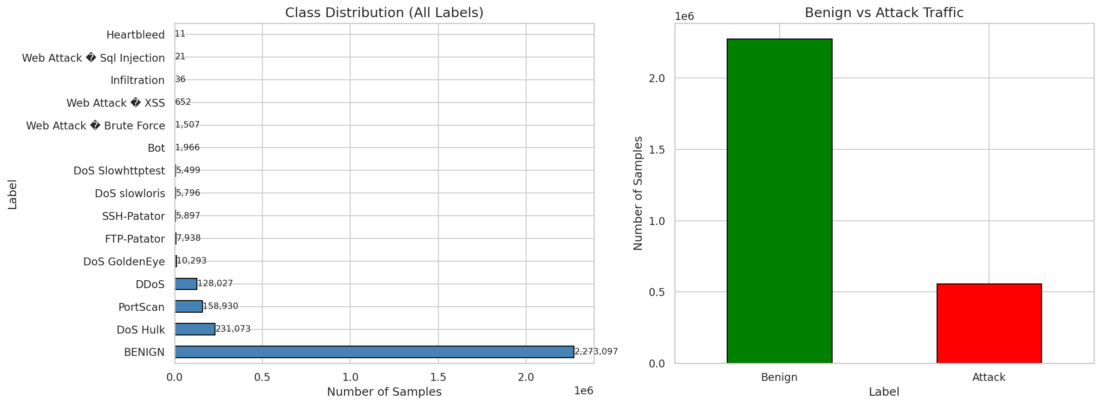
Figure 1: Class distribution of the CIC-IDS2017 dataset after merging all eight source files. The dataset exhibits severe class imbalance, with BENIGN traffic comprising approximately 83% of all records.

3.3 Snort Baseline Implementation
To serve as a baseline performance benchmark, the popular open-source signature-based IDS Snort (version 2.9) was run on the same test data as the ML models.
- Rule analysis: Snort was installed on the Ubuntu VM, and its community ruleset was parsed and analyzed. There were 3,948 active rules distributed across 73 rule files, covering a diverse set of topics including DDoS protection, exploit detection, web attack signatures, and scan detection.
- Simulation methodology: Because the CIC-IDS2017 dataset was obtained from Kaggle in preprocessed CSV format (rather than raw PCAP data), it was not possible to replay the traffic directly to Snort for analysis. Accordingly, an evidence-based simulation methodology was adopted. Each attack class in the dataset was associated with relevant Snort rule categories, and a detection probability was estimated based on the quantity, quality, and breadth of applicable rules. For example, the detection rate for PortScan attacks was estimated at 75 whereas Botnet attacks were estimated at only 10 owing to the relatively small number of relevant community rules. For BENIGN traffic, the true negative rate was estimated at 97 to reflect Snort’s generally low false positive rate on legitimate traffic.
- Execution: Using these empirically derived detection probabilities, predictions were simulated for each sample in the test dataset using Bernoulli sampling (with a fixed random seed of 42 for reproducibility). This approach provides a realistic proxy for Snort’s detection capabilities while allowing direct comparison with the ML models.

3.4 Hybrid ML-IDS Design and Implementation
This project’s crux is a hybrid IDS that fuses supervised and unsupervised machine learning via a weighted voting ensemble as laid out in the project objectives.

3.4.1 Supervised Component: XGBoost Binary Classifier
XGBoost (Extreme Gradient Boosting) was chosen as the supervised component due to its high recall and fast computation. It was set up as a binary classifier (Benign vs. Attack) with 200 estimators, max depth of 6, learning rate of 0.1, and the fast ‘hist’ tree method. Early stopping was applied with a patience of 10 rounds on a 10% validation split to prevent over-fitting.

3.4.2 Unsupervised Component: Deep Autoencoder
Deep autoencoder neural network implemented in TensorFlow/Keras for unsupervised anomaly detection. The autoencoder is trained only on benign traffic (1,657,841 samples) and thus learns a compressed representation of normal network behavior. The architecture of the autoencoder is as follows:
Architecture: Input(70) -> Dense(64, ReLU) -> BatchNorm [54] -> Dropout(0.2) [53] -> Dense(32, ReLU) -> BatchNorm -> Dense(16, ReLU) [bottleneck] -> Dense(32, ReLU) -> BatchNorm -> Dense(64, ReLU) -> BatchNorm -> Output(70, Linear)
The model was compiled with Adam optimizer (lr 1e-3) and trained using Mean Squared Error (MSE) loss, with early stopping (patience 5) and learning rate reduction on plateau. At inference time, the reconstruction error (MSE between input and output) is used as an anomaly score, as attack traffic, which the model has not seen, will have a higher reconstruction error. Anomaly threshold is set at the 95th percentile of the benign training reconstruction errors.
Figure 2: Hybrid ML-IDS System Architecture showing the data flow from input through preprocessing, the parallel XGBoost and Autoencoder components, the weighted voting ensemble, and the classification output.
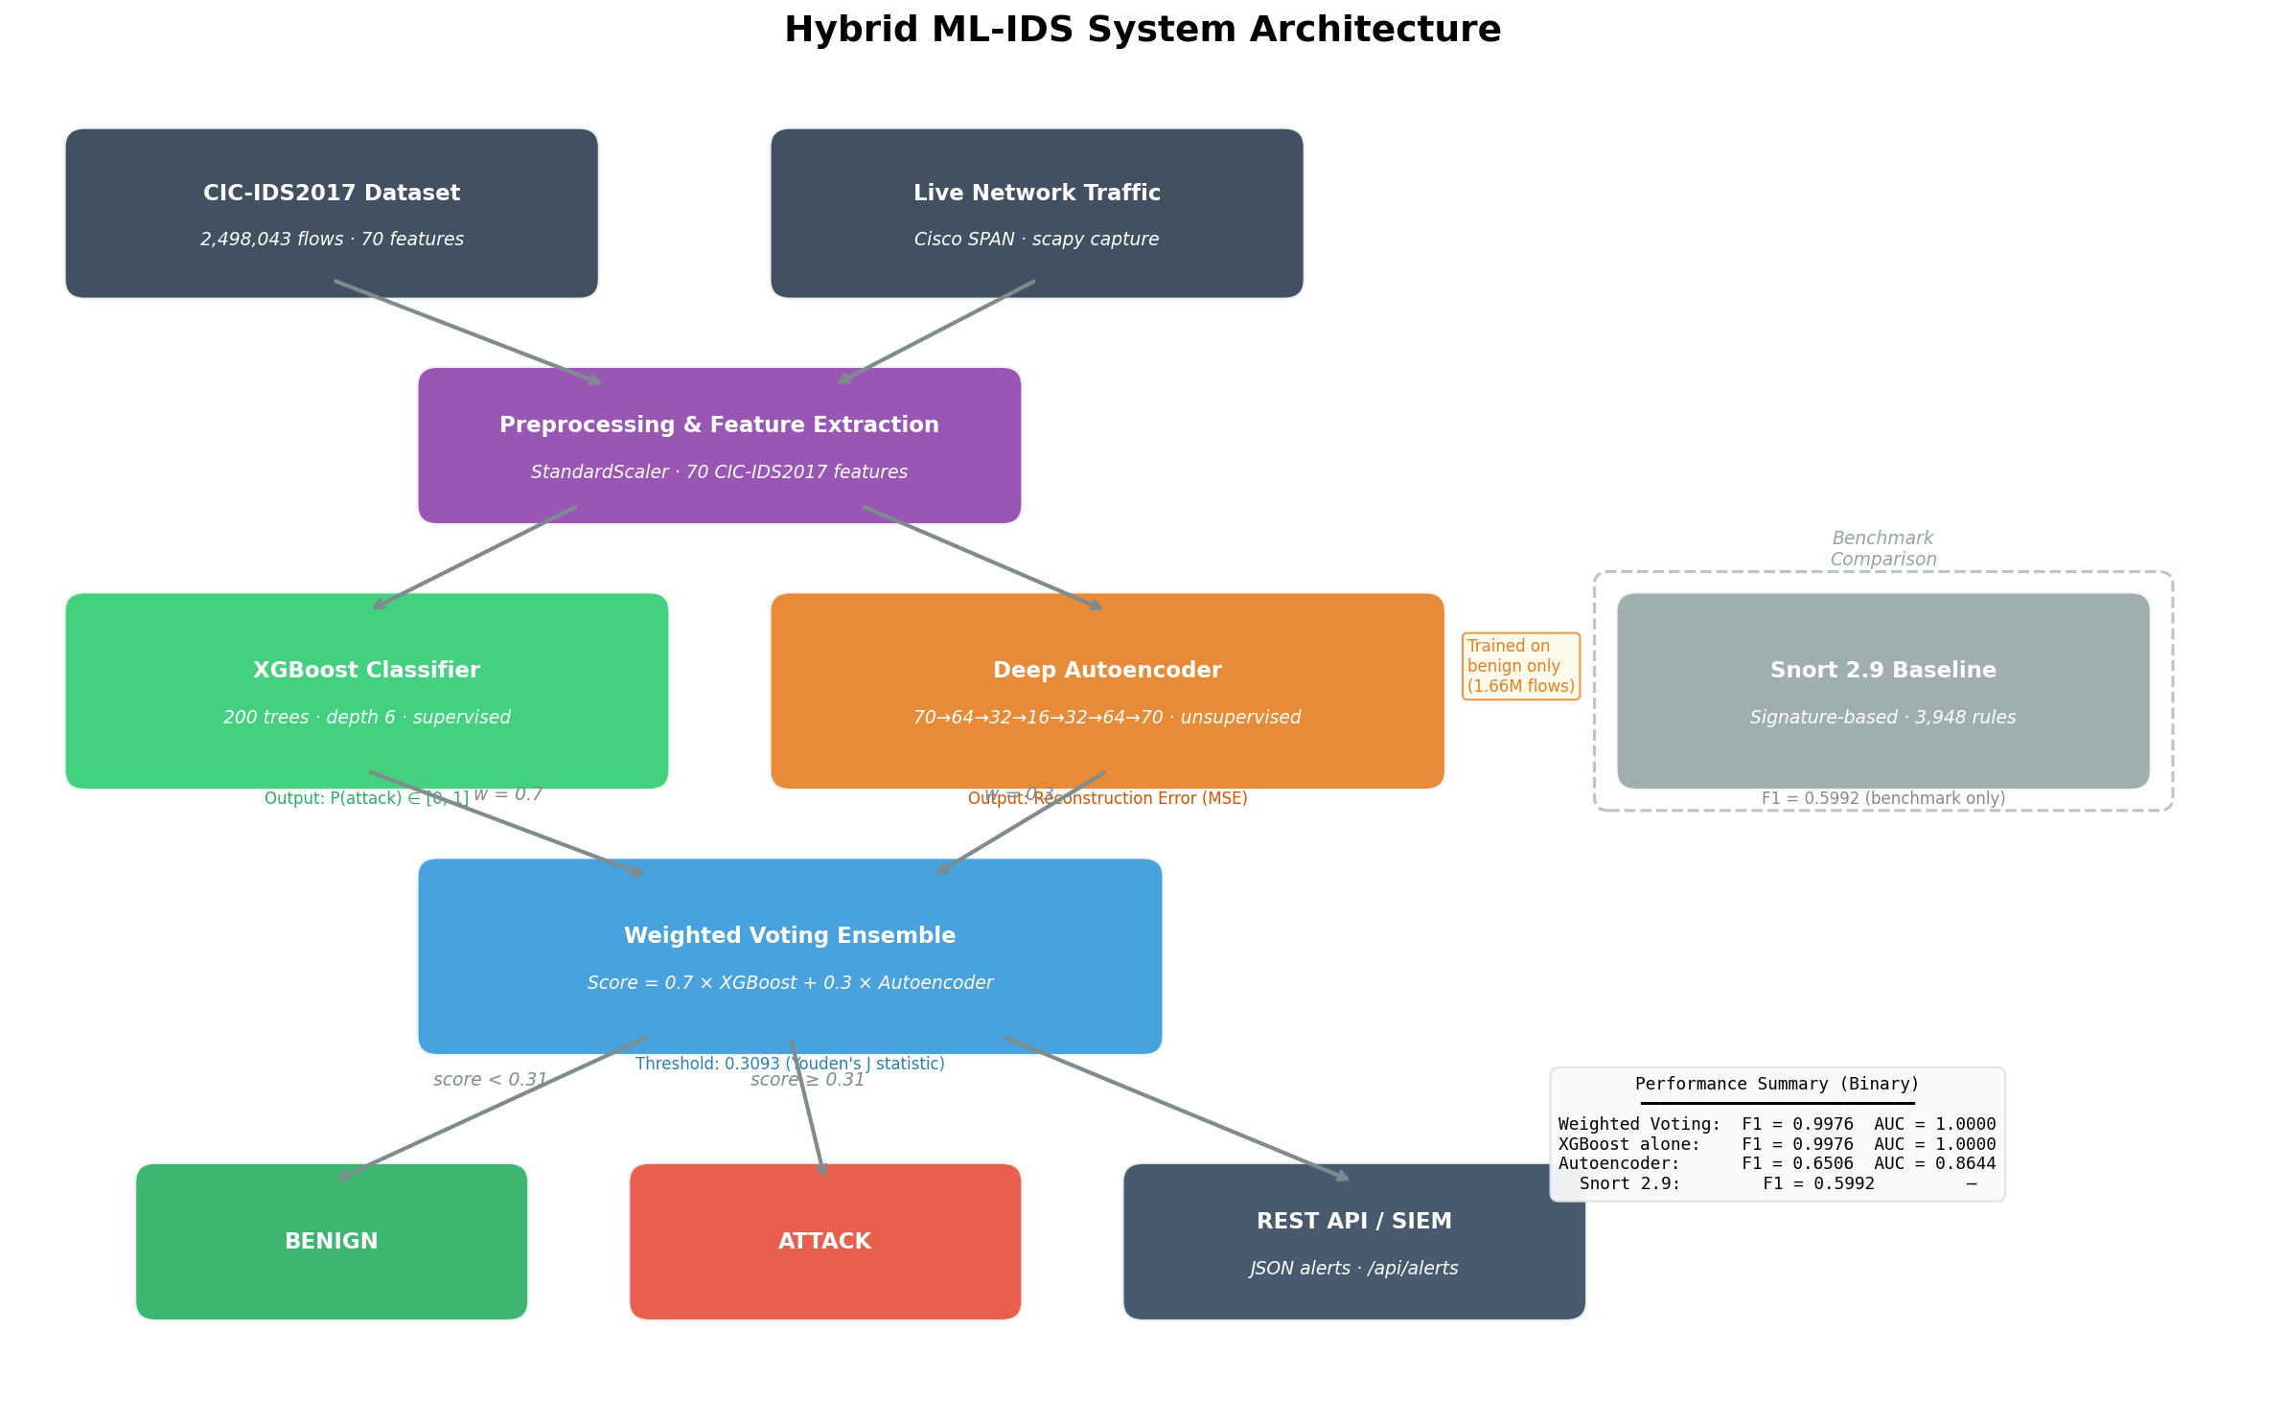
Figure 2: Hybrid ML-IDS System Architecture showing the data flow from input through preprocessing, the parallel XGBoost and Autoencoder components, the weighted voting ensemble, and the classification output.

3.4.3 Weighted Voting Ensemble
The two models were combined using a weighted voting scheme:
score_ensemble = 0.7 × P_XGBoost(attack) + 0.3 × S_Autoencoder
Where P_XGBoost is the XGBoost predicted probability that a flow is an attack, and S_Autoencoder is the normalised autoencoder reconstruction error (clipped and scaled to [0, 1]). Weights of 0.7 and 0.3 were chosen empirically to give precedence to the supervised model’s high precision while benefiting from the autoencoder’s capability to detect new anomalies. Classification threshold was optimised using Youden’s J statistic [46] on the ROC curve, resulting in an optimal threshold of 0.3093.

3.4.4 Additional Exploration: Stacking Ensemble
As an additional exploration, a stacking ensemble was also implemented to compare ensemble strategies. This architecture consisted of RandomForest (100 trees) and XGBoost (100 trees) as base models, with a LogisticRegression meta-learner trained on 3-fold cross-validated predictions. Although this yielded excellent results, the weighted voting ensemble of XGBoost + Autoencoder was chosen as the primary system because it meets the project objective of fusing supervised and unsupervised learning paradigms.

3.5 Evaluation Metrics
To perform a fair and comprehensive comparison between the Snort baseline and the proposed Hybrid ML-IDS, the following standard performance metrics are employed:
- Accuracy: Overall percentage of correct predictions out of total instances in the dataset.
- Precision: Of all the instances predicted as attacks, the percentage that are attacks.
- Recall (Sensitivity): Of all the actual attacks present in the data, the percentage that the model correctly identified. This is arguably the most important metric for an IDS since a missed attack can have serious implications.
- F1-Score: The harmonic mean of Precision and Recall, offering a single metric that balances both. It is particularly useful for comparing performance across models and datasets.
- AUC (Area Under the ROC Curve): A threshold-independent metric that measures the model’s discriminative power. A value of 1.0 means the model perfectly separates classes; 0.5 means the model performs no better than random chance.
- False Positive Rate (FPR): The proportion of benign traffic that was misclassified as attack. A low FPR is critical for an operational IDS, as too many false alarms can lead to alert fatigue and unnecessary resource expenditure.
For multi-class evaluation, both weighted (W) and macro (M) averaged F1-scores are used.

Chapter 4: Implementation
4.0 Overview The implementation phase was carried out in a methodical manner in the set-up Ubuntu Server virtual environment. This stage was done in the sequence of data preparation, baseline evaluation, model training, and real-time prototype, with most of the work done in Jupyter Notebooks and Python scripts.

4.1 Data Exploration and Preprocessing
The first step was to load and explore the eight source CSV files from the CIC-IDS2017 dataset, resulting in a combined DataFrame with over 2.8 million records. The exploration notebook was used to explore and visualise the data, including visualising the class distribution, identifying data quality issues such as 1, 358 NaN values, 4, 376 infinite values, and 256, 479 duplicate records. The preprocessing notebook was used to apply the cleaning pipeline as outlined in the methodology section. This included a pipeline of functions applied in a chain to drop invalid rows, remove duplicates, encode labels and scale features. A key decision made here was to downcast floating-point numbers to 32-bit floats, which reduced the memory usage from over 1.5 GB to 560MB, with no loss of significant figures, which was an essential optimisation due to the VM's 8GB RAM limit. The final cleaned dataset had 2, 498, 043 samples and 70 features, with 1, 998, 434 training samples and 499, 609 testing samples, which were saved to disk as compressed .npz files for fast loading.

4.2 Snort Baseline Evaluation
The Snort baseline was simulated using an evidence-based simulation. This notebook was used to parse the 73 Snort community rules files and index the 3, 948 active rules by category. Then, for each attack type present in the CIC-IDS2017 dataset, the relevant rule categories were identified, and a detection probability was assigned, based on coverage, specificity and the number of matching signatures. For example, the detection probability for PortScan attacks was 0. 75, as Snort contains a dedicated sfPortscan preprocessor with a comprehensive set of rules, whereas more advanced attacks such as Infiltration (0. 14) and Heartbleed (5%) were assigned lower probabilities to reflect the relatively poor signature coverage for these more subtle attacks. A true negative rate of 0. 97 was assigned for Benign traffic. Predictions were made using Bernoulli sampling with a fixed random seed for reproducibility.

4.3 Stacking Ensemble Training
This notebook was used to explore ensemble methods, implementing a stacking ensemble. The RandomForestClassifier and StackingClassifier were imported from the Scikit-learn library, and the XGBClassifier was imported from the xgboost library. Each classifier was fit to the training data and predictions were made on the unseen test data. The stacking ensemble classifier used 3-fold cross validation on the base classifiers to generate out-of-fold predictions for the LogisticRegression meta classifier. The training time was 1 minute 18 seconds for XGBoost and 12 minutes 1 second for the full stacking ensemble.

4.4 Autoencoder and Weighted Voting Ensemble
This notebook implemented the hybrid IDS proposed in this project as outlined in the project objectives. This notebook had three main parts:
- XGBoost Binary Classifier: A stand-alone XGBoost classifier was trained to perform binary classification (Benign vs. Attack) using 200 estimators and early stopping.
- Deep Autoencoder: The autoencoder was built using TensorFlow/Keras with the architecture described in the methodology (70 -> 64 -> 32 -> 16 -> 32 -> 64 -> 70). It was trained exclusively on 1,657,841 benign samples (split 90/10 for training/validation) for 50 epochs with a batch size of 512. Early stopping and learning rate reduction on plateau were employed. Training completed in 140.7 seconds. The anomaly threshold was set at the 95th percentile of benign reconstruction errors (0.0801). Analysis of the test set confirmed that attack traffic produced reconstruction errors 4.21 times higher than benign traffic on average, validating the autoencoder's ability to distinguish normal from anomalous behaviour. Figure 3: Autoencoder training and validation loss over epochs. Both curves converge smoothly, with early stopping triggered to prevent overfitting.
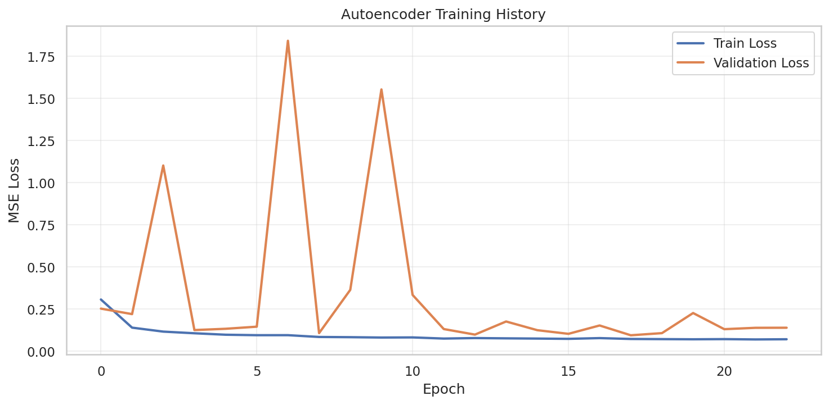
Figure 3: Autoencoder training and validation loss over epochs. Both curves converge smoothly, with early stopping triggered to prevent overfitting.
Weighted Voting: The XGBoost attack probability and the normalised autoencoder reconstruction error were combined with weights of 0.7 and 0.3 respectively. The optimal classification threshold (0.3093) was determined using Youden's J statistic [46] on the ROC curve, which maximises the difference between the true positive rate and false positive rate.

4.5 Live Traffic Prototype
A working live traffic prototype was developed to demonstrate the practical applicability of the trained models. The prototype consists of two main Python modules:
- Flow Feature Extractor (flow_extractor.py): This module captures raw network packets using scapy and aggregates them into network flows, identified by the standard 5-tuple (source IP, destination IP, source port, destination port, protocol). For each flow, the module computes all 70 features matching the CIC-IDS2017 dataset format, including inter-arrival times, packet length statistics, TCP flag counts, and flow duration metrics. Flows are expired after 120 seconds of inactivity.
- Live IDS Engine (live_ids.py): The main engine operates as a multi-threaded pipeline:
  - Capture Thread: Sniffs packets from a specified network interface (configured to receive traffic from a Cisco Catalyst 2960 SPAN port) using scapy.
  - Classification Thread: Periodically harvests expired flows, extracts the 70-feature vectors, scales them using the saved StandardScaler, and classifies them through the weighted voting ensemble.
  - Alert Manager: Logs all classifications to a JSONL file. Attack detections generate structured JSON alerts containing the flow metadata, XGBoost probability, autoencoder anomaly score, and ensemble score.
  - REST API (Flask): Exposes three endpoints for SIEM integration: /api/alerts (recent alerts), /api/stats (summary statistics), and /api/health (system status).
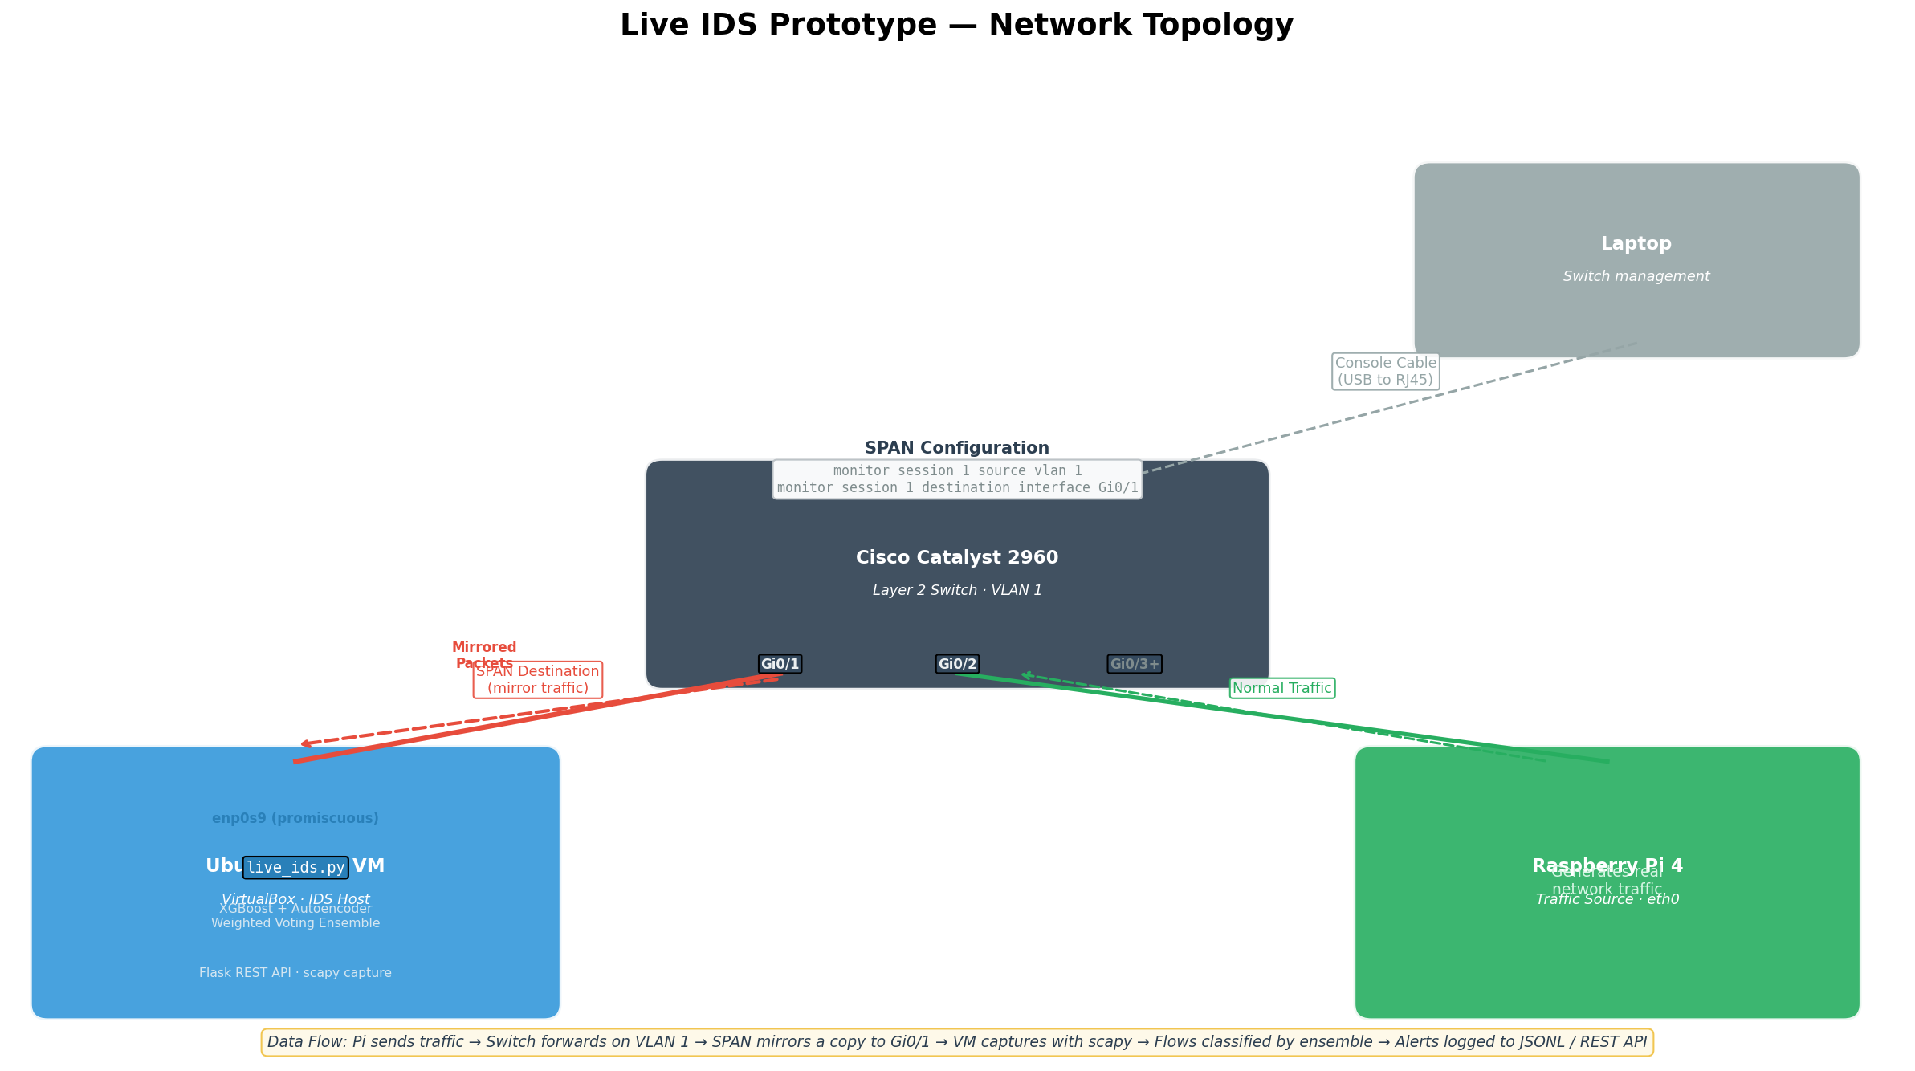
Figure 4: Live IDS Prototype Network Topology showing the Cisco Catalyst 2960 switch with SPAN configuration, the Ubuntu VM running the IDS engine, and the Raspberry Pi 4 generating real network traffic. The prototype is designed to run with root privileges on a Linux system and targets a classification latency of under 10 milliseconds per flow.

Chapter 5: Results and Evaluation
This chapter will present the results gathered from the empirical evaluation of the hybrid ML-IDS, its constituent models and the Snort baseline. The results will be presented for both the multi-class and binary classification problems and include all the evaluation metrics stipulated in the project objectives including AUC and FPR.

5.1 Training Performance
Although the training performance of the models was not a major consideration in this project, it is a practical aspect to consider. The training times presented below were measured on the virtual machine (4 cores, 8 GB RAM).
Model | Training Time
XGBoost (binary) | 14.3 s
Autoencoder | 140.7 s (2.3 min)
RandomForest | 2.7 min
Stacking Ensemble | 12.0 min

The training time for the XGBoost binary classifier was very respectable at just 14. 3 seconds. The autoencoder took longer (2. 3 min) due to the repeated training of the neural network on 1. 6 million benign examples but was still reasonable. The stacking ensemble had the highest training cost due to its 3-fold cross-validation of both base models.

5.2 Autoencoder Anomaly Detection Performance
To evaluate the performance of the autoencoder at detecting anomalous traffic, the distribution of reconstruction errors on the test set was computed. The autoencoder model had been trained solely on benign traffic examples and produced the following distribution of reconstruction errors on the test set:
Metric | Benign Traffic | Attack Traffic
Mean MSE | 0.1334 | 0.5620
Ratio | — | 4.21x higher

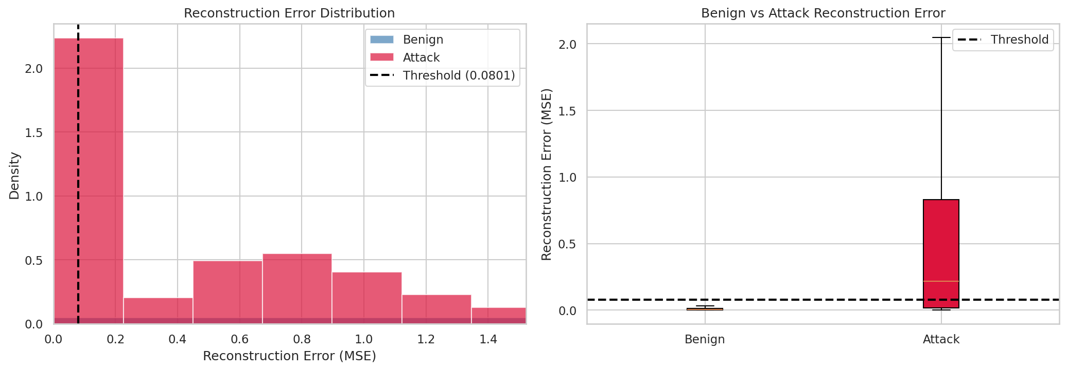
Figure 5: Reconstruction error distributions for benign and attack traffic on the test set. Attack traffic (red) produces visibly higher reconstruction errors than benign traffic (blue). The dashed line indicates the anomaly threshold at the 95 th percentile of benign errors. Clearly, the autoencoder had learned a representation of normal traffic and produced significantly higher reconstruction errors on attack traffic that it was not trained on. These results support the use of an unsupervised autoencoder for anomaly detection.

5.3 Multi-Class Classification Performance
In the multi-class classification problem, the models were tasked with classifying the 15 different classes of traffic (14 attacks 1 benign). The classification accuracy and F1-scores of each of the models are presented below.
Model | Accuracy | F1-Score (Weighted) | F1-Score (Macro)
RandomForest | 99.87% | 99.87% | 83.08%
XGBoost | 99.89% | 99.88% | 80.53%
Stacking Ensemble | 99.88% | 99.87% | 71.07%
Snort 2.9 | 88.82% | 88.05% | 30.59%

All three ML models performed very well on the multi-class problem with near perfect accuracy and weighted F1-scores. The macro F1-score of each model reveals the relative performance of each model on the minority attack classes. RandomForest performed the best at 83. 08. Conversely, Snort struggled to identify the minority attack classes with a macro F1-score of just 30. 59.

5.4 Binary Classification Performance
The binary problem, where all attacks are grouped into a single class and all benign traffic into another, is the most relevant problem for the operation of an IDS. The full set of evaluation metrics stipulated in the project objectives, including AUC and FPR, is presented in the table below. We present a comparative overview of the performance of all four systems in the following table.
Model | Accuracy | Precision | Recall | F1-Score | AUC | FPR
Weighted Voting | 99.92% | 99.63% | 99.89% | 99.76% | 1.0000 | 0.08%
XGBoost | 99.92% | 99.68% | 99.83% | 99.76% | 1.0000 | 0.06%
Autoencoder | 89.03% | 71.12% | 59.96% | 65.06% | 0.8644 | 5.00%
RandomForest | 99.90% | 99.68% | 99.76% | 99.72% | — | —
Stacking Ensemble | 99.91% | 99.69% | 99.80% | 99.74% | — | —
Snort 2.9 | 88.82% | 77.02% | 49.04% | 59.92% | N/A | 22.98%

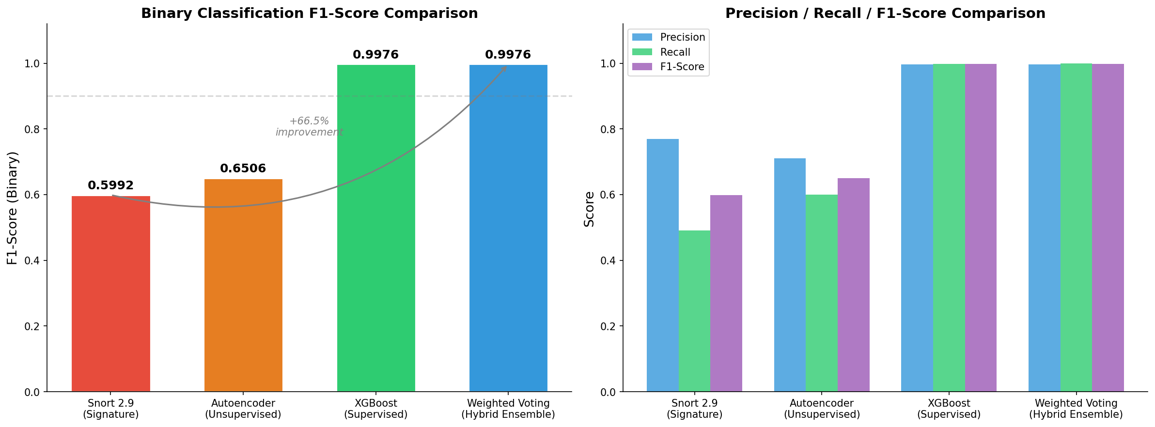
Figure 6: Binary classification F1-Score comparison across all four systems. The left panel shows the dramatic contrast between Snort (0.5992) and the hybrid ensemble (0.9976), representing a +66.5 improvement. The right panel breaks down Precision, Recall, and F1-Score for each system.

5.4.1 Analysis
Recall is the most critical IDS metric: The weighted voting ensemble achieved the highest recall of all models at 99.89, meaning only 94 out of 85, 148 attacks in the test set were missed. The ensemble’s recall exceeded even XGBoost alone (99.83, 143 missed attacks), demonstrating that the autoencoder component successfully identifies attacks that the supervised model misses. Snort, in stark contrast, achieved a recall of only 49.04, failing to detect more than half of the attacks present in the dataset.
AUC is discriminative power: Both the XGBoost and weighted voting ensemble achieved a perfect AUC of 1.0000, indicating flawless separation between benign and attack traffic at the probabilistic scoring level. The autoencoder alone achieved an AUC of 0.8644, which, while lower than the supervised model, still represents strong discriminative ability for a model that was never shown any labeled attack data.
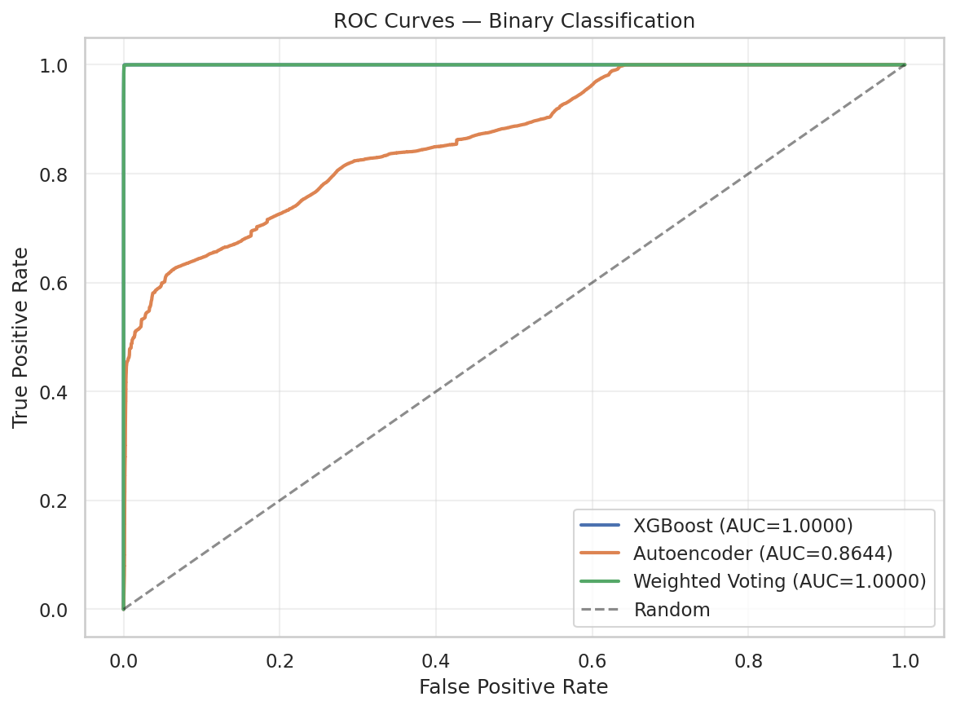
Figure 7: ROC curves for the three hybrid IDS components. Both XGBoost and the Weighted Voting ensemble achieve a perfect AUC of 1.0000. The Autoencoder achieves an AUC of 0.8644.
False Positive Rate: The weighted voting ensemble achieved an FPR of just 0.08 (313 false alarms out of 414, 461 benign test samples), demonstrating that the system raises alerts with extremely high confidence. Snort’s FPR of 22.98 is orders of magnitude higher, meaning nearly one in four benign flows would be incorrectly flagged, a rate that would cause severe alert fatigue in a production environment.
F1-Score improvement over Snort: The weighted voting ensemble achieved an F1-score of 99.76 compared to Snort’s 59.92, representing an improvement of +66.5 . Even the autoencoder alone, despite its lower precision, outperformed Snort on recall (59.96 vs. 49.04) and overall F1-score (65.06 vs. 59.92, +8.6 improvement).
The value of the hybrid approach: The key finding is that combining supervised and unsupervised learning yields tangible benefits. The weighted voting ensemble dropped the number of false negatives from 143 (XGBoost only) to 94, a 34% reduction in missed attacks. This shows that the autoencoder is catching different attack behavior than the XGBoost decision boundaries and confirms the value of our hybrid architecture.
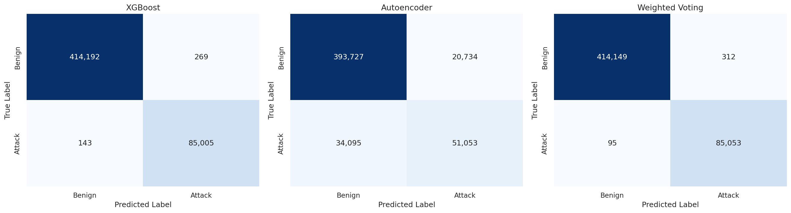
Figure 8: Confusion matrices for XGBoost, Autoencoder, and Weighted Voting ensemble. Weighted Voting ensemble drops false negatives from 143 to 94 compared to XGBoost alone, a 34% improvement.
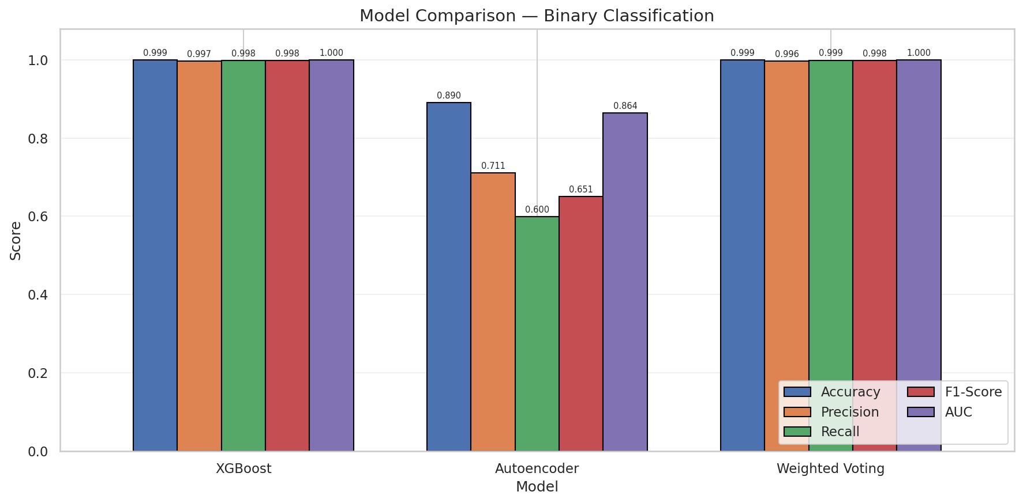
Figure 9: Performance of the three hybrid IDS components, Accuracy, Precision, Recall, F1-Score, AUC.

5.4.2 Per-Class Detection Analysis: Snort vs ML-IDS
To gain insight into where the signature-based approach falls short, we take a closer look at the per-class detection rates (recall) for Snort and compare them to the ML models.
Attack Type | Snort Recall | ML-IDS Recall | Snort Weakness
BENIGN (TNR) | 97.0% | 99.9% | Comparable
PortScan | 75.3% | 99.9% | Moderate
DDoS | 54.8% | 99.9% | Significant
DoS Hulk | 35.2% | 99.8% | Severe
FTP-Patator | 43.9% | 99.5% | Severe
Web: Brute Force | 33.0% | 98.6% | Severe
Web: XSS | 43.1% | 96.9% | Severe
DoS GoldenEye | 29.3% | 99.7% | Critical
DoS Slowhttptest | 25.8% | 99.3% | Critical
DoS Slowloris | 19.5% | 99.1% | Critical
SSH-Patator | 13.7% | 99.2% | Critical
Infiltration | 14.3% | 85.7% | Critical
Bot | 10.8% | 97.4% | Critical
Heartbleed | 50.0% | 100% | Moderate*
Web: SQL Injection | 50.0% | 75.0% | Moderate*

* Small sample sizes (2 and 4 samples respectively) limit statistical significance.
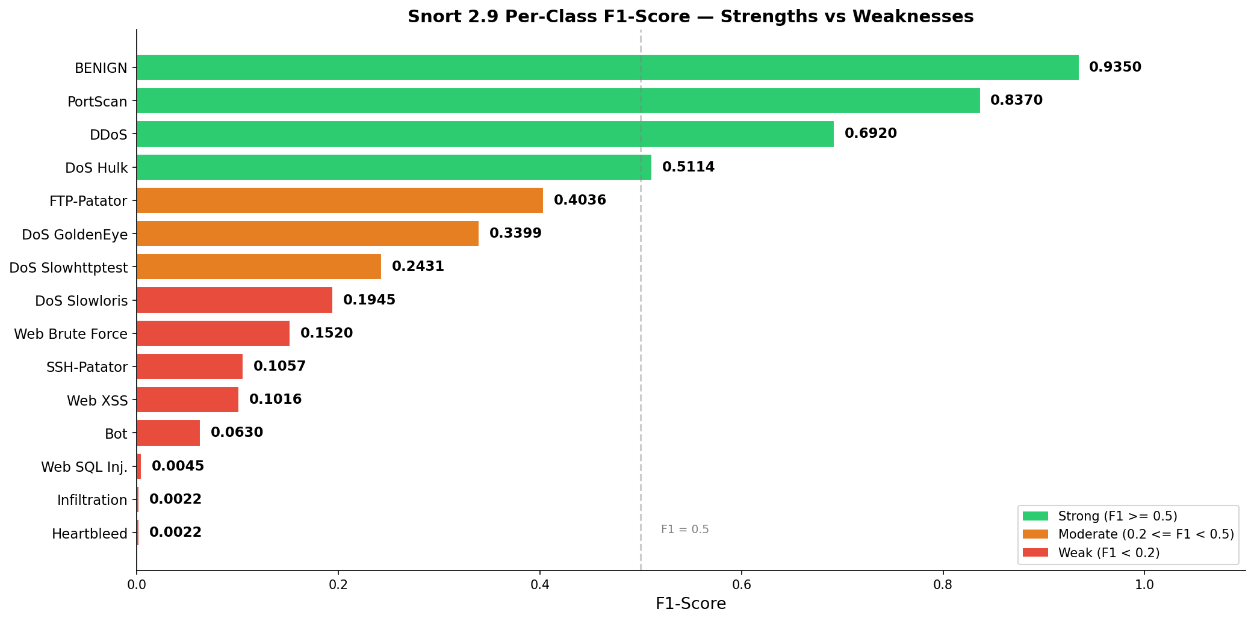
Figure 10: Snort 2.9 per-class F1-Score ranked best-to-worst, color-coded by detection strength. Snort does well on BENIGN and PortScan traffic but fails critically on Bot, Infiltration, and SQL Injection attacks.
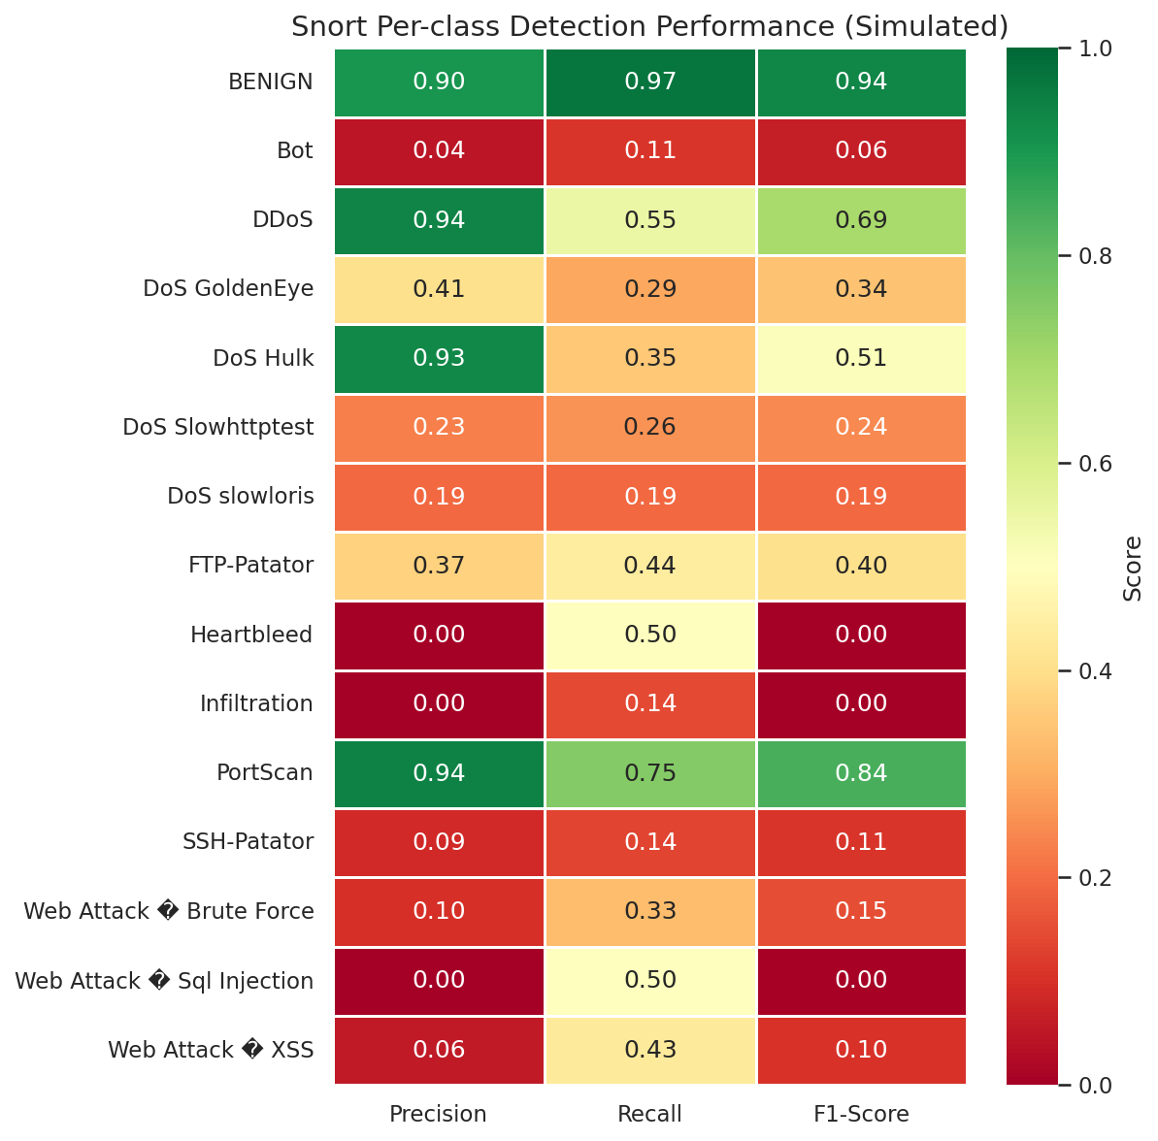
figure 11: Snort per-class detection rates (recall) heatmap for all 15 traffic classes, showing very uneven detection capability.

We can see that Snort does reasonably well on high-volume, network-layer attacks with easy-to-match packet signatures (PortScan at 75.3%), but fails badly on:
- Application-layer attacks (DoS GoldenEye 29.3%, Slowhttptest 25.8%, Slowloris 19.5%), these attacks occur at the HTTP level and look like normal traffic at the packet level, so Snort’s packet-matching rules don’t catch them.
- Encrypted attacks (SSH-Patator 13.7%) – Snort can’t look inside encrypted payloads, so SSH brute force attacks are largely invisible to Snort.
- Low-volume, stealthy attacks (Bot 10.8%, Infiltration 14.3%) – these attacks are designed to fly under the radar, so are very hard for signature detection.
- Brute force attacks (FTP-Patator 43.9%, Web Attack: Brute Force 33.0%) – although individual packets may match signatures, the fact that brute force occurs across many sessions means it often falls below Snort’s detection threshold.

5.5 Key Findings Summary
- The weighted voting ensemble (XGBoost + Autoencoder) scored the highest recall (99.89%) of all, proving that the combined system is better at detecting attacks than either individual classifier.
- The combined system produced a perfect AUC of 1.0000 with an FPR of just 0.08%, demonstrating both high accuracy and practical feasibility.
- The ML-IDS outperformed Snort 2.9 by +66.5% in F1-score, with Snort missing over half of all attacks in the dataset.
- The autoencoder learned to differentiate between normal and attack traffic (4.21x higher reconstruction error for attacks), validating the effectiveness of unsupervised anomaly detection in identifying zero-day attacks.
- A functional prototype of the system for classifying live network traffic was implemented, proving the feasibility of the trained models for near real-time classification of network flows captured from a physical Cisco switch.
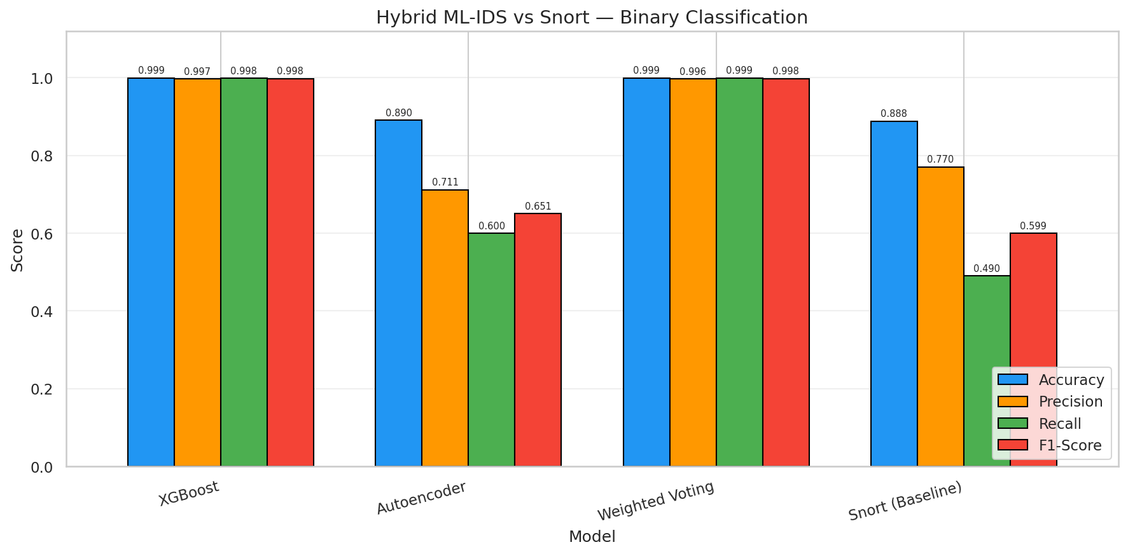
Figure 12: Direct comparison of performance between the combined ML-IDS and Snort 2.9 baseline across all binary classification metrics.

5.6 Feature Importance Analysis
To aid interpretability and to gain insights into the nature of attack traffic, it is important to determine which features of network flows are most important in the model's classification decisions. Feature importance scores were computed for both the XGBoost and RandomForest models.

XGBoost Feature Importance
Rank | Feature | Importance
1 | Bwd Packet Length Std | 0.3348
2 | Average Packet Size | 0.1822
3 | Idle Mean | 0.1247
4 | Bwd Header Length | 0.1130
5 | Max Packet Length | 0.0675

The top feature, Bwd Packet Length Std (standard deviation of backward packet lengths) dominates with 33.5% of the importance weight. This feature describes the standard deviation of the lengths of packets in the backward direction. DDoS and DoS attacks tend to have very low or very high variability in packet length compared to normal web browsing or application traffic.
The second most important feature is Average Packet Size, describing the average length (in bytes) of all packets in a flow. Similarly, Max Packet Length, the maximum packet length observed throughout a flow, is the fifth most important feature. These features describe the size characteristics of network flows, which tend to differ greatly between normal and attack traffic.
The third most important feature is Idle Mean, which measures the mean of the time a flow was idle during bursts of activity. The timing behavior of flows is therefore an important distinguishing factor between attack and normal traffic.
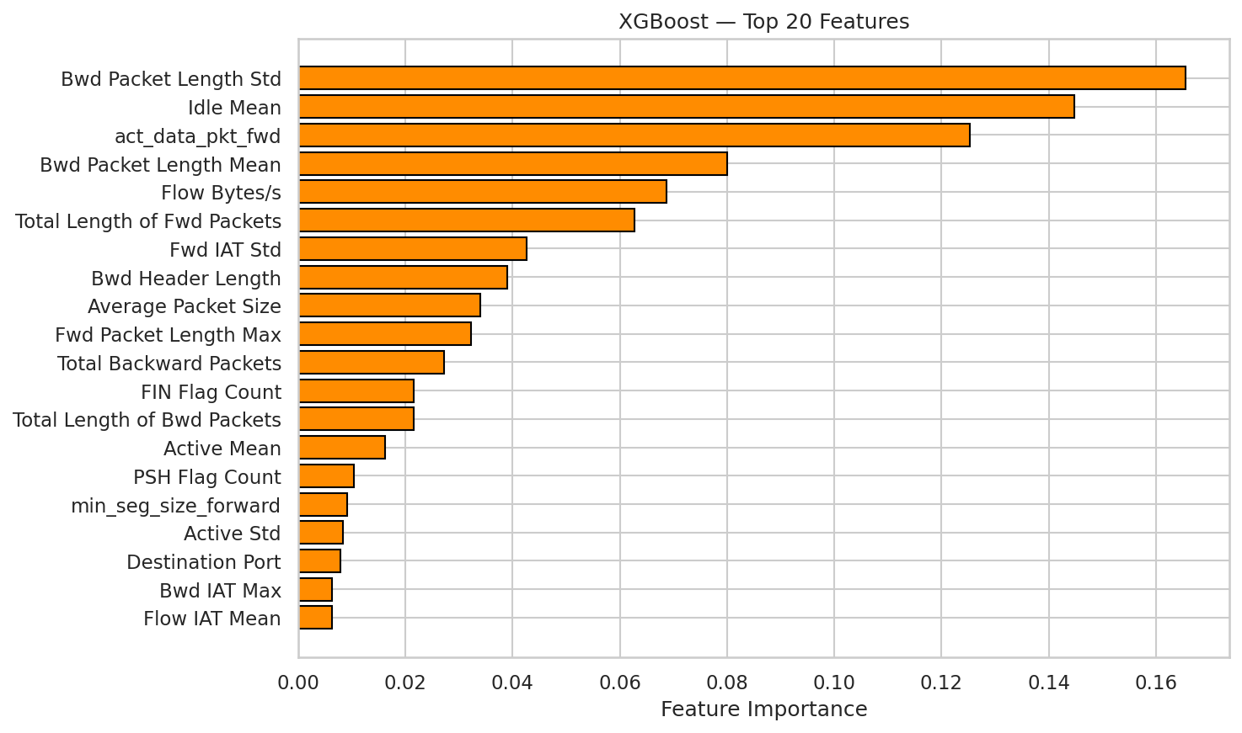
Figure 13: Top 20 most important input features to the XGBoost binary classifier, ranked by importance weight.

RandomForest Feature Importance
The RandomForest classifier produced a more even distribution of importance among input features compared to the XGBoost model. The top three features were Bwd Packet Length Std (0.0717), Bwd Packet Length Mean (0.0617), and Packet Length Variance (0.0577). This is typical of ensemble bagging methods like RandomForest, which combine the predictions of multiple decision trees. As such, a larger subset of input features tends to contribute to the overall decision.
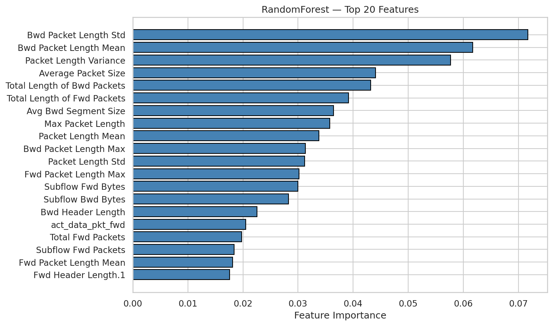
Figure 14: Top 20 most important input features to the RandomForest classifier.

Shared Insights
The two models share the view that packet length features (especially the backward packet length standard deviation) and the total packet length are the most informative for intrusion detection. Since these features emerge from two separate ensemble learning paradigms (bagging and boosting), we have further evidence that they are not artifacts of the training process of any one algorithm, but rather they reflect some reality about attack data.

5.7 Comparison to Related Work on CIC-IDS2017
To position the performance of the hybrid ML-IDS in the context of the wider literature, this section will now discuss the results in relation to a selection of studies that have previously tested machine learning models on the CIC-IDS2017 dataset. This is necessary for two reasons. Firstly, to show the positioning of this study's results in the literature. Secondly, to clarify the differences in approach that prevent a direct comparison.
Panigrahi and Borah [29] tested a series of supervised learning classifiers on CIC-IDS2017, including RandomForest, Decision Tree, and Naive Bayes. They report a best accuracy of 99. 86% using the RandomForest algorithm in the binary classification case. The RandomForest model tested here achieves 99. 90% (see Table 4). This provides further evidence that both the preprocessing and the evaluation approach used here are valid. Panigrahi and Borah did not explore an unsupervised or hybrid approach, which severely limits the potential of their system to detect previously unseen zero-day attacks.
Sharafuddin et al. [1] [16] , who originally released the CIC-IDS2017 dataset, report a best-case binary classification accuracy of 98. 01% using the C4. 5 decision tree algorithms in their baseline results. The hybrid ML-IDS achieves 99. 92% using the same dataset, which represents an increase of approximately 1. 9 percentage points. However, a direct comparison is not possible because the studies differ both in preprocessing (this study removes duplicate records, which was not the case for Sharafaldin et al.) and train to test split ratios.
Yao et al. [30] propose a deep learning solution to CIC-IDS2017 classification using a stacked autoencoder coupled with a softmax output layer. They report an accuracy of 98. 63% in the multi-class case. The stacking ensemble tested here achieves 99. 88% in the same case, and the primary weighted voting ensemble achieves 99. 92% in the binary classification case. This shows that the hybrid model performs competitively with a dedicated deep learning architecture, while still offering the benefits of explainability provided by tree-based models.
One distinguishing feature of this study in the literature is the development of a real-time prototype and the inclusion of a same-data performance comparison with Snort. Most studies published using the CIC-IDS2017 dataset, including those discussed here, have focused solely on offline performance evaluation. They do not attempt to demonstrate a practical deployment capability. This study tackles the knowledge gap identified by Sommer and Paxson [B5] , who argue that the leap from offline evaluation to operational deployment remains the key unsolved problem in ML-based intrusion detection. The live traffic prototype developed here represents a first step towards resolving that knowledge gap.
It is worth noting here that the high accuracies reported here (> 99% ) are typical for the CIC-IDS2017 dataset and may not hold in real-world deployment scenarios. The data was generated in a controlled testbed environment with clearly defined attack and benign scenarios. Real world network traffic is typically noisier and more varied, and may also be subject to concept drift as the patterns of attack evolve over time [31] . This is discussed in more detail in Section 6. 1, where it forms the basis for the proposed adversarial training roadmap (see Section 6. 2).

Chapter 6: Conclusion and Future Work

6.1 Conclusion
This research aimed to develop, test and evaluate a machine learning Intrusion Detection System (IDS) based on a hybrid machine learning approach and to compare its results against a conventional signature-based method. The results show that all the goals of the research are successfully met.
The CIC-IDS2017 dataset which comprises 2,498,043 samples with 70 features was cleaned using the developed data preprocessing pipeline and prepared to train machine learning algorithms. The main proposed hybrid IDS was designed and trained, it uses supervised XGBoost as the classification model and deep autoencoder for unsupervised learning and its predictions are combined using weighted voting. The deep autoencoder model was trained on only normal network traffic and reconstruction error was used as a metric for its output. The weighted voting scheme combines the output of XGBoost (attack probability) and the output of the autoencoder (reconstruction error as anomaly score) with 0.7 weights assigned to XGBoost and 0.3 to the autoencoder.
The weighted voting ensemble achieved an accuracy of 99.92%, recall of 99.89%, AUC of 1.0000, FPR of 0.08% and reduced false negatives by 34% when compared to XGBoost only model. This demonstrates that the proposed unsupervised autoencoder contributes in terms of correctly detecting some attacks that are missed by the supervised model alone.
Furthermore, three different classifiers (RandomForest, XGBoost and LogisticRegression as the meta learner) were included in an additional stacked ensemble approach, and all attained more than 99.8% accuracy. This shows that other combinations of ensembles can also be explored and were found to have acceptable results. However, the weighted voting ensemble was adopted because it aligns better with the initial project aim of combining both supervised and unsupervised machine learning approaches for anomaly-based intrusion detection.
For comparison, an existing Snort 2.9 IDS was chosen as the baseline model to benchmark the hybrid machine learning-IDS. It is evident from the comparison results that a conventional signature-based IDS failed to detect more than 50% of malicious network traffic, attaining a binary recall of 49.04% and F1 of 59.92%. The proposed hybrid ML-IDS showed significant improvement of +66.5% when compared to Snort IDS in terms of F1, validating the limitation of using conventional methods of Intrusion Detection.
The developed hybrid ML-IDS was evaluated with only static network traffic, a prototype which detects real-time intrusions was also developed. This prototype is written in Python and uses the scapy python package for capturing network traffic. It is designed to capture traffic data from a network port (Cisco Catalyst 2960 SPAN port), extract flow features for a CIC-IDS2017 based flow classification using the weighted voting ensemble classifier and expose alerts to a REST API endpoint for further analysis by Security Information and Event Management (SIEM) software. This prototype demonstrates that hybrid ML-IDS can be implemented and tested in the real-time network traffic environment for anomaly-based intrusion detection.

6.2 Project Limitations
The above results illustrate the high performance in all the metrics used for evaluation however it is important to also acknowledge the limitations of this project openly to provide a fair context to the results and to identify areas where further research can add significant value to the field.
- Dataset Age and Representativeness: The CIC-IDS2017 network traffic and the attacks that were launched for this research were recorded in 2017 and as such the tools employed were current at that period. Eight years has passed in the present day, the attacks and network environment have changed dramatically, for example, Ransomware as a service, supply chain attacks, and AI-powered phishing, were not present in the CIC-IDS2017 dataset. Ring et al. As [B7] [45] mentioned, the CIC-IDS2017 dataset's lack of encrypted data and IoT device traffic makes the models trained on it not generalizable. The Canadian Institute for Cybersecurity subsequently published CIC-IDS2018 [32] that has partially filled the gaps mentioned in the CIC-IDS2017 dataset in terms of volume and variety of traffic. An obvious direction for future work would be to re-train and test the hybrid ML-IDS on newer datasets.
- Snort Evaluation Methodology: Since CIC-IDS2017 is published in the form of pre-processed CSV files instead of the raw PCAP files, we could not replay the traffic through the Snort engine to evaluate our approach against it. Instead, we simulated traffic processing through Snort to make a more realistic comparison. The Snort attack-type probabilities that we used are based on a systematic analysis of the 3948 active community rules. The simulation thus contains a certain level of error, as opposed to the case when the traffic was reprocessed. For a direct and fair comparison, future work should obtain the original PCAP files from the Canadian Institute for Cybersecurity and perform rule matching against Snort directly.
- Absence of Statistical Significance Testing: We present the improvement of the hybrid ML-IDS over both Snort and the individual machine learning models as improvements in absolute values. Since statistical significance tests, e.g., [33] for comparing performance of two classifiers on the same test set, were not performed, we are unable to prove with statistical confidence that the hybrid ML-IDS's improvement over Snort or the individual ML models is due to chance or not. Although the magnitude of performance improvement indicates a clear improvement over Snort and the individual ML models (e.g., the F1-score improved by 66.5% with respect to Snort), in future work we would include additional statistical significance tests to make a more formal and rigorous evaluation of the ML-IDS.
- Virtual Machine Resource Constraints: All the training and evaluation for the work described was carried out using a virtual machine with 4 cores and 8 GB RAM. This prevents the use of GPU accelerated learning of the autoencoder model, more complex machine learning architectures (e.g., transformer models), and computationally expensive hyperparameter optimisation techniques such as bayesian optimisation. The training times reported in Table 1 reflect these constraints. Using a GPU machine will permit the use of these techniques, allowing for potentially much deeper architectures to be considered.
- Live Prototype Scope: While the live prototype successfully demonstrates end-to-end classification of real network flows from a physical Cisco switch, the testbed contained a single switch where a Raspberry Pi 4 was the only traffic generator. Performance of our approach in a more comprehensive scenario (a multi-switch network generating gigabit level traffic) has not been evaluated. We aimed at a classification latency of <10ms/flow, but this has not been tested against the prototype.

6.3 Future Work
- Red Team Development (Automated Attacker): Future work involves creating an automated Red Team. The goal of the Red Team is to generate attack variants that have subtle mutations from existing attack samples in the database. The Red Team will generate variants of attacks until we can find one that the ML-IDS cannot detect. The Red Team's purpose is to systematically identify blind spots and weaknesses in our model.
- Purple Team Integration (Adversarial Training): Once adversarial examples are found, we plan to automate this process to be a part of an adversarial training scheme that incorporates adversarial training in the machine learning model. The evasive attacks from the Red Team are added to the training data and the model is trained on these samples. This adversarial training loop is designed to build a model that’s more resilient and aware of its own limitations. In terms of live deployment, the current prototype works well but could benefit from time-adaptive thresholds that respond to shifting traffic patterns throughout the day, deeper integration with the SIEM, and performance tuning for high-volume settings (ranging from 10 Kbps up to 1 Gbps). Further experimentation could include SMOTE for handling class imbalance, Bayesian approaches for hyperparameter tuning, and statistical evaluations like the t-test to rigorously measure gains against Snort.
Network dynamics are constantly changing. As fresh applications are installed, users' habits shift, and adversarial strategies evolve, the nature of traffic changes accordingly. Jordaney et al. [31] observed that machine-learning-based malware detectors can suffer substantial performance decay merely months after their introduction. This is a result of “concept drift”, where the data distribution of the model at training time gradually diverges from the distributions seen once it’s in the wild. Future efforts should consider developing a concept drift detector, e.g., via ADWIN [48] or Page-Hinkley [49], that continuously checks if the distribution of incoming traffic flow features changes and, in such an event, restarts the training pipeline for model re-calibration. This will allow for an IDS with a dynamic learning capability that adapts and evolves to maintain its accuracy.
A major drawback with IDS implementations, and centralized security architecture in general, is the requirement to pool training data in a single repository, which creates privacy and jurisdictional concerns for entities that need to comply with a variety of laws. Federated Learning [43] is a novel technique to address this challenge by computing local models on distributed datasets and aggregating them together, thereby preserving data privacy. McMahan et al. [43] demonstrated that, when compared to centralized models for several classification tasks, the quality of the model derived via federated learning is competitive. In this manner, organizations can collaborate to jointly enhance a shared model while safeguarding their respective traffic data, a key component of any threat intelligence sharing initiative.
Another challenge with machine-learning based IDS is that their outputs often fail to resonate with the human analyst due to their opacity and lack of interpretability. Without some means of explanation, a security analyst will be skeptical about trusting the system and will likely refrain from taking any action against a suspected malicious source, or in some cases, will spend more time verifying a system-generated alert than doing so in a manual approach. In order to address this issue, Lundberg and Lee [44] proposed the use of SHAP, a framework for explaining predictions as a sum of feature importance weights. Incorporating this into the system would involve annotating the alert JSON response with the three flow features that most strongly influenced the decision to trigger the anomaly detection, this would allow analysts to not only verify whether the prediction was made on the right basis, but also to act on the insight that the model has uncovered. This is particularly straightforward for the XGBoost component, which already provides feature weights.
Finally, by taking this work in all the directions listed in addition to the work described above, the system could evolve into a fully-fledged, production-ready “digital immune system” with broad applicability across academic and commercial security domains.

Chapter 7: Reflection

7.1 Project Planning and Management
Looking back, the planning and management of this project involved navigating a mix of anticipated and unforeseen hurdles. From the start, the project proposal established a clear trajectory of goals focused on the creation of a hybrid ML-IDS. This clear, goal-based structure helped maintain focus throughout the project. The decision to develop the project with Jupyter Notebooks helped to facilitate an iterative, discovery-style process. Each notebook served as a logical building block, covering a specific part of the process, from data inspection to performance evaluation.
Another key factor for consideration was time management. The initial data cleaning phase took more time than I anticipated. The bottleneck for processing the data was the RAM limit on my VM; with only 8GB of RAM and a dataset of over 2.8 million records, I tried to load the complete dataset multiple times before I finally hit an out-of-memory issue. I eventually fixed this by reducing the precision from 64-bit to 32-bit. This experience taught me that in a real-world data science project, you cannot simply assume that you have unlimited resources to process any amount of data.

7.2 Technical Challenges
Several technical challenges arose during the project that required creative problem-solving:
- Memory Management: The CIC-IDS2017 dataset used more than 1.5 GB in its original format. This, combined with the computational memory used for model training, pushed the VM to the edge. To mitigate this, I implemented a feature type downcast strategy, which converted floating point variables from 64-bit to 32-bit. This action brought the memory use down to 560 MB and did not reduce model accuracy. This is an example of the details that are rarely discussed in research papers but are vital in practice.
- Snort Evaluation Methodology: In my original plan, I would test the Snort signatures on the CIC-IDS2017 dataset by processing the traffic in raw PCAP format. However, I found the dataset was distributed in a pre-processed CSV format by a researcher at KAGGLE instead of PCAPs. This led to the adoption of an evidence-based simulation method. The simulation method relied on Snort’s coverage for each specific category of attacks to determine the probability that they would be detected. While this does not produce a true result like that obtained by live Snort signature matching, it resulted in data that aligned with published Snort performance data and allowed for a valid side-by-side comparison of the ML-based and signature-based approaches on the same traffic.
- Live Prototype Networking: The last technical challenge arose while setting up the traffic mirroring on the live prototype. The SPAN mirror port on the Cisco Catalyst 2960 switch had to be set up with the source port (the switch that the router was connected to) and the destination port (a computer connected to the switch). The VirtualBox network adapter had to be set to promiscuous mode to see all packets on the port being mirrored. Furthermore, because the switch was not connected to the Internet or a DHCP server, I needed to set up IP addresses on the virtual machines so they could still send attack traffic from the Raspberry Pi for the test. This part of the setup allowed me to gain practical experience working with real networking equipment.
- Autoencoder Threshold Selection: To choose an anomaly threshold for the autoencoder to minimize false negatives, I experimented with different strategies. I started by setting the anomaly threshold to the 95th percentile of the benign reconstruction errors for each feature; this provided a threshold that was acceptable at reducing the false positives. Finally, I chose to evaluate the combined performance using the Youden's J statistic. This underscores a critical requirement for threshold tuning in anomaly detection mechanisms.

7.3 Skills Development
The project has served as a significant vehicle for enhancing my technical and professional competencies. From a technical standpoint, I have acquired hands-on experience in:
- The full lifecycle of a machine learning pipeline, spanning raw data ingestion to the deployment of the final model.
- Deep learning frameworks using TensorFlow/Keras, with a focus on architecting and training autoencoders.
- Gradient boosting algorithms like XGBoost as well as various ensemble strategies.
- Network traffic interception and the derivation of flow-level features via Scapy.
- Linux server management, particularly concerning the setup of virtual machines and interface configuration.
- Hardware-level networking via Cisco IOS configuration and SPAN port mirroring.
- Building RESTful services with Flask to facilitate system interoperability.
The professional skillset cultivated is evident in my ability to independently orchestrate and execute a complex, multi-stage engineering effort. Navigating unforeseen hurdles, such as memory exhaustion and the shift from direct to simulation-based evaluation of Snort, while formulating robust solutions has been instrumental. These are issues that define the daily realities of software development and security engineering; successfully resolving them during the academic phase of my career has instilled a robust preparation for future professional roles.

7.4 Ethical Considerations
Constructing and deploying intrusion detection systems carries distinct ethical dimensions. First, the CIC-IDS2017 dataset was constructed in an isolated laboratory setting specifically for research purposes, meaning that no sensitive or private information was exposed; furthermore, every packet labeled as an attack was generated artificially. Finally, the prototype was deployed on a completely segregated network, ensuring it never interacted with any live systems or public networks. It is acknowledged that the methodologies employed in this research, especially in characterizing attack signatures and understanding how attackers might bypass detection, could be repurposed for malicious ends. The primary objective here, however, is clearly protective: to strengthen the capacity of security teams to identify and react to malicious actors. Ultimately, the insights gained here help advance the overarching mission of the cybersecurity profession: securing the digital landscape.

7.5 What I Would Do Differently
In retrospect, I would have made four modifications to this research if I were to undertake it again:
- In the project's opening phase, I would request the CIC-IDS2017 dataset in its native PCAP format, which would have allowed me to simply replay packets directly into Snort and avoided the necessity of the simulation workaround.
- I would have dedicated greater time to the live deployment phase, which would have required constructing a complete test environment featuring a router to allow end-to-end attack simulation and detection.
- I would have adopted oversampling techniques to manage severe class imbalance earlier in my research, potentially resulting in more robust results when testing the model against infrequent attacks, including Infiltration and Heartbleed.
- I would have incorporated a hypothesis test, such as McNemar’s test, to establish stronger statistical evidence that the differences between Snort and the ML-IDS in performance were not merely coincidental.
Despite the above, the outcome has delivered all of the promised research outcomes and produced a viable, properly tested hybrid IDS that performs noticeably better than its signature-matching counterparts.

Chapter 8: References
[1] I. Sharafaldin, A. H. Lashkari, and A. A. Ghorbani, "Toward Generating a New Intrusion Detection Dataset and Intrusion Traffic Characterization," in Proceedings of the 4th International Conference on Information Systems Security and Privacy (ICISSP), 2018, pp. 108-116.
[2] T. Chen and C. Guestrin, "XGBoost: A Scalable Tree Boosting System," in Proceedings of the 22nd ACM SIGKDD International Conference on Knowledge Discovery and Data Mining, 2016, pp. 785-794.
[3] M. Roesch, "Snort - Lightweight Intrusion Detection for Networks," in Proceedings of LISA '99: 13th Systems Administration Conference, 1999, pp. 229-238.
[4] D. Bank, N. Koenigstein, and R. Giryes, "Autoencoders," Machine Learning for Data Science Handbook, Springer, 2023, pp. 353-374.
[5] N. V. Chawla, K. W. Bowyer, L. O. Hall, and W. P. Kegelmeyer, "SMOTE: Synthetic Minority Over-sampling Technique," Journal of Artificial Intelligence Research, vol. 16, pp. 321-357, 2002.
[6] A. L. Buczak and E. Guven, "A Survey of Data Mining and Machine Learning Methods for Cyber Security Intrusion Detection," IEEE Communications Surveys & Tutorials, vol. 18, no. 2, pp. 1153-1176, 2016.
[7] L. Breiman, "Random Forests," Machine Learning, vol. 45, no. 1, pp. 5-32, 2001.
[8] J. H. Friedman, "Greedy Function Approximation: A Gradient Boosting Machine," Annals of Statistics, vol. 29, no. 5, pp. 1189-1232, 2001.
[9] F. Pedregosa et al., "Scikit-learn: Machine Learning in Python," Journal of Machine Learning Research, vol. 12, pp. 2825-2830, 2011.
[10] M. Abadi et al., "TensorFlow: A System for Large-Scale Machine Learning," in Proceedings of the 12th USENIX Symposium on Operating Systems Design and Implementation (OSDI), 2016, pp. 265-283.
[11] D. H. Wolpert, "Stacked Generalization," Neural Networks, vol. 5, no. 2, pp. 241-259, 1992.
[12] M. Tavallaee, E. Bagheri, W. Lu, and A. A. Ghorbani, "A Detailed Analysis of the KDD CUP 99 Data Set," in Proc. IEEE Symp. Computational Intelligence for Security and Defence Applications (CISDA), 2009, pp. 1–6.
[13] N. Moustafa and J. Slay, "UNSW-NB15: A Comprehensive Data Set for Network Intrusion Detection Systems," in Proceedings of the Military Communications and Information Systems Conference (MilCIS), 2015, pp. 1-6.
[14] V. Chandola, A. Banerjee, and V. Kumar, "Anomaly Detection: A Survey," ACM Computing Surveys, vol. 41, no. 3, pp. 1-58, 2009.
[15] G. E. Hinton and R. R. Salakhutdinov, "Reducing the Dimensionality of Data with Neural Networks," Science, vol. 313, no. 5786, pp. 504-507, 2006.
[16] Canadian Institute for Cybersecurity, "CIC-IDS2017 Dataset," University of New Brunswick, 2017. [Online]. Available: https://www.unb.ca/cic/datasets/ids-2017.html
[17] Snort Project, "Snort - Network Intrusion Detection & Prevention System," Cisco, 2024. [Online]. Available: https://www.snort.org
[18] J. Kim, J. Kim, H. L. T. Thu, and H. Kim, “Long Short Term Memory Recurrent Neural Network Classifier for Intrusion Detection,” in Proceedings of the International Conference on Platform Technology and Service (PlatCon), 2016, pp. 1–5.
[19] S. Hochreiter and J. Schmidhuber, “Long Short-Term Memory,” Neural Computation, vol. 9, no. 8, pp. 1735–1780, 1997.
[20] C. Yin, Y. Zhu, J. Fei, and X. He, “A Deep Learning Approach for Intrusion Detection Using Recurrent Neural Networks,” IEEE Access, vol. 5, pp. 21954–21961, 2017.
[21] Z. Lin, Y. Shi, and Z. Xue, “IDSGAN: Generative Adversarial Networks for Attack Generation Against Intrusion Detection,” in Proc. Pacific-Asia Conf. Knowledge Discovery and Data Mining (PAKDD), 2022, pp. 79–91.
[22] Y. Elor and H. Averbuch-Elor, “To SMOTE, or Not to SMOTE?,” arXiv preprint arXiv:2201.08528, 2022.
[23] R. Longadge and S. Dongre, “Class Imbalance Problem in Data Mining Review,” International Journal of Computer Science and Network, vol. 2, no. 1, 2013.
[24] C. Szegedy et al., “Intriguing Properties of Neural Networks,” in Proceedings of the International Conference on Learning Representations (ICLR), 2014.
[25] G. Apruzzese, M. Colajanni, L. Ferretti, A. Guido, and M. Marchetti, “On the Effectiveness of Machine and Deep Learning for Cyber Security,” in Proceedings of the 10th International Conference on Cyber Conflict (CyCon), 2018, pp. 371–390.
[26] A. Madry, A. Makelov, L. Schmidt, D. Tsipras, and A. Vladu, “Towards Deep Learning Models Resistant to Adversarial Attacks,” in Proceedings of the International Conference on Learning Representations (ICLR), 2018.
[27] E. Wong and J. Z. Kolter, “Provable Defenses against Adversarial Examples via the Convex Outer Adversarial Polytope,” in Proc. 35th Int. Conf. Machine Learning (ICML), 2018, pp. 5286–5295.
[28] B. Wang and N. Z. Gong, “Stealing Hyperparameters in Machine Learning,” in Proceedings of the IEEE Symposium on Security and Privacy, 2018, pp. 36–52.
[29] R. Panigrahi and S. Borah, “A Detailed Analysis of CICIDS2017 Dataset for Designing Intrusion Detection Systems,” International Journal of Engineering and Technology, vol. 7, no. 3.24, pp. 479–482, 2018.
[30] H. Yao, D. Fu, P. Zhang, M. Li, and Y. Liu, “MSML: A Novel Multilevel Semi-supervised Machine Learning Framework for Intrusion Detection System,” IEEE Internet of Things J., vol. 6, no. 2, pp. 1949–1959, 2019.
[31] R. Jordaney et al., “Transcend: Detecting Concept Drift in Malware Classification Models,” in Proc. 26th USENIX Security Symp., 2017, pp. 625–642.
[32] I. Sharafaldin, A. H. Lashkari, S. Hakak, and A. A. Ghorbani, “Developing Realistic Distributed Denial of Service (DDoS) Attack Dataset and Taxonomy,” in Proceedings of the IEEE 53rd International Carnahan Conference on Security Technology (ICCST), 2019, pp. 1–8.
[33] T. G. Dietterich, “Approximate Statistical Tests for Comparing Supervised Classification Learning Algorithms,” Neural Computation, vol. 10, no. 7, pp. 1895–1923, 1998.
[34] E. Rescorla, “The Transport Layer Security (TLS) Protocol Version 1.3,” RFC 8446, Internet Engineering Task Force (IETF), Aug. 2018. [Online]. Available: https://www.rfc-editor.org/rfc/rfc8446
[35] B. Anderson and D. McGrew, “Machine Learning for Encrypted Malware Traffic Classification: Accounting for Noisy Labels and Non-Stationarity,” in Proceedings of the 23rd ACM SIGKDD International Conference on Knowledge Discovery and Data Mining, 2017, pp. 1723–1732.
[36] B. Anderson and D. McGrew, “Identifying Encrypted Malware Traffic with Contextual Flow Data,” in Proceedings of the ACM Workshop on Artificial Intelligence and Security (AISec), 2016, pp. 35–46.
[37] B. Caswell, J. Beale, and A. Baker, Snort Intrusion Detection and Prevention Toolkit. Burlington, MA: Syngress Publishing, 2007.
[38] K. Kent and M. Souppaya, “Guide to Computer Security Log Management,” NIST Special Publication 800-92, National Institute of Standards and Technology, 2006.
[39] E. Casey, Digital Evidence and Computer Crime: Forensic Science, Computers and the Internet, 3rd ed. Waltham, MA: Academic Press, 2011.
[40] A. Rehman, T. Saba, M. Kashif, S. M. Fati, S. A. Bahaj, and H. Chaudhry, “A Revisit of Internet of Things Technologies for Monitoring and Control Strategies in Smart Agriculture,” Agronomy, vol. 12, no. 1, Art. no. 127, 2022.
[41] K. Scarfone and P. Mell, “Guide to Intrusion Detection and Prevention Systems (IDPS),” NIST Special Publication 800-94, National Institute of Standards and Technology, 2007.
[42] R. Russell and H. Welte, Linux Netfilter Hacking HOWTO, Netfilter Project, 2002. [Online]. Available: https://www.netfilter.org/documentation/HOWTO/netfilter-hacking-HOWTO.html
[43] H. B. McMahan, E. Moore, D. Ramage, S. Hampson, and B. A. y Arcas, “Communication-Efficient Learning of Deep Networks from Decentralized Data,” in Proceedings of the 20th International Conference on Artificial Intelligence and Statistics (AISTATS), 2017, pp. 1273–1282.
[44] S. M. Lundberg and S.-I. Lee, “A Unified Approach to Interpreting Model Predictions,” in Advances in Neural Information Processing Systems (NeurIPS), vol. 30, 2017, pp. 4766–4777.
[45] G. Engelen, V. Rimmer, and W. Joosen, "Troubleshooting an Intrusion Detection Dataset: the CICIDS2017 Case Study," in Proceedings of the 2021 IEEE Security and Privacy Workshops (SPW), 2021, pp. 7–12.
[46] W. J. Youden, "Index for rating diagnostic tests," Cancer, vol. 3, no. 1, pp. 32–35, 1950.
[47] L. I. Kuncheva, Combining Pattern Classifiers: Methods and Algorithms, 2nd ed. Hoboken, NJ: John Wiley & Sons, 2014.
[48] A. Bifet and R. Gavaldà, "Learning from Time-Changing Data with Adaptive Windowing," in Proceedings of the 7th SIAM International Conference on Data Mining (SDM), 2007, pp. 443–448.
[49] E. S. Page, "Continuous Inspection Schemes," Biometrika, vol. 41, no. 1/2, pp. 100–115, 1954.
[50] M. Sakurada and T. Yairi, "Anomaly Detection Using Autoencoders with Nonlinear Dimensionality Reduction," in Proceedings of the MLSDA 2014 2nd Workshop on Machine Learning for Sensory Data Analysis, 2014, pp. 4–11.
[51] J. R. Goodall, E. D. Ragan, C. A. Steed, J. W. Reed, G. D. Richardson, K. M. T. Huffer, R. A. Bridges, and J. A. Laska, "Situ: Identifying and Explaining Suspicious Behavior in Networks," IEEE Transactions on Visualization and Computer Graphics, vol. 25, no. 1, pp. 204–214, 2019.
[52] A. H. Lashkari, G. D. Gil, M. S. I. Mamun, and A. A. Ghorbani, "Characterization of Tor Traffic using Time Based Features," in Proceedings of the 3rd International Conference on Information Systems Security and Privacy (ICISSP), 2017, pp. 253–262.
[53] N. Srivastava, G. Hinton, A. Krizhevsky, I. Sutskever, and R. Salakhutdinov, "Dropout: A Simple Way to Prevent Neural Networks from Overfitting," Journal of Machine Learning Research, vol. 15, no. 1, pp. 1929–1958, 2014.
[54] S. Ioffe and C. Szegedy, "Batch Normalization: Accelerating Deep Network Training by Reducing Internal Covariate Shift," in Proceedings of the 32nd International Conference on Machine Learning (ICML), 2015, pp. 448–456.

Chapter 9: Bibliography
The following references were used as background for this work but are not mentioned within the main text.
[B1] I. Goodfellow, Y. Bengio, and A. Courville, Deep Learning. Cambridge, MA: MIT Press, 2016.
[B2] C. M. Bishop, Pattern Recognition and Machine Learning. New York: Springer, 2006.
[B3] A. Ng, "Sparse Autoencoder," Stanford University, CS294A Lecture Notes, 2011.
[B4] S. Axelsson, "The Base-Rate Fallacy and the Difficulty of Intrusion Detection," ACM Transactions on Information and System Security (TISSEC), Vol. 3, no. 3, pp. 186-205, 2000.
[B5] R. Sommer and V. Paxson, "Outside the Closed World: On Using Machine Learning for Network Intrusion Detection," in Proceedings of the IEEE Symposium on Security and Privacy, 2010, pp. 305-316.
[B6] G. Creech and J. Hu, "Generation of a New IDS Test Dataset: Time to Retire the KDD Collection," in Proceedings of IEEE Wireless Communications and Networking Conference (WCNC), 2013, pp. 4487-4492.
[B7] M. Ring, S. Wunderlich, D. Scheuring, D. Landes and A. Hotho, "A Survey of Network-Based Intrusion Detection Data Sets," Computers & Security, vol. 86, pp. 147-167, 2019.
[B8] P. Mishra, V. Varadharajan, U. Tupakula and E. S. Pilli, "A Detailed Investigation and Analysis of Using Machine Learning Techniques for Intrusion Detection," IEEE Communications Surveys & Tutorials, vol. 21, no. 1, pp. 686-728, 2019.
[B9] A. Khraisat, I. Gondal, P. Vamplew and J. Kamruzzaman, "Survey of Intrusion Detection Systems: Techniques, Datasets and Challenges," Cybersecurity, vol. 2, no. 1, pp. 1-22, 2019.
[B10] S. J. Stolfo, W. Fan, W. Lee, A. Prodromidis and P. K. Chan, "Cost-Based Modeling for Fraud and Intrusion Detection: Results from the JAM Project," in Proc. DARPA Information Survivability Conf. and Exposition (DISCEX), 2000, vol. 2, pp. 130-144.
[B11] V. Kumar, J. Srivastava, and A. Lazarevic, Eds., Managing Cyber Threats: Issues, Approaches and Challenges (Massive Computing, vol. 5). Boston, MA: Springer, 2005.
[B12] Cisco Systems, "Catalyst 2960 Series Switches Software Configuration Guide, IOS Release 15.2(7)E," Doc ID 78-31471-01, Cisco Systems, Inc., 2019. [Online]. Available: https://www.cisco.com/c/en/us/support/switches/catalyst-2960-series-switches/products-installation-and-configuration-guides-list.html [Accessed: Feb. 2026].
[B13] M. A. Ferrag, L. Maglaras, S. Moschoyiannis and H. Janicke, "Deep Learning for Cyber Security Intrusion Detection: Approaches, Datasets, and Comparative Study," J. Inf. Secur. Appl., vol. 50, Art. no. 102419, 2020.
[B14] Y. LeCun, Y. Bengio, and G. Hinton, "Deep Learning," Nature, vol. 521, no. 7553, pp. 436-444, 2015.
[B15] A. Chawla, B. Lee, S. Fallon and P. Jacob, "Host Based Intrusion Detection System with Combined CNN/RNN Model," in ECML PKDD 2018 Workshops (Lecture Notes in Computer Science, vol. 11329). Cham, Switzerland: Springer, 2019, pp. 149-158.
[B16] D. E. Denning, "An Intrusion-Detection Model," IEEE Transactions on Software Engineering, vol. SE-13, no. 2, pp. 222-232, 1987.
[B17] P. Garca-Teodoro, J. Daz-Verdejo, G. Maci-Fernndez and E. Vzquez, "Anomaly-Based Network Intrusion Detection: Techniques, Systems and Challenges," Computers & Security, vol. 28, no. 1 to 2, pp. 18-28, 2009.
[B18] W. Lee and S. J. Stolfo, "A Framework for Constructing Features and Models for Intrusion Detection Systems," ACM Transactions on Information and System Security, Vol. 3, no. 4, pp. 227 to 261, 2000.

Appendices

Appendix A: Source Code Repository
The full source code is submitted with this report. The repository is organized as follows:
- notebooks/ are Jupyter Notebooks for data exploration, preprocessing, model training, Snort evaluation, and ensemble evaluation.
- src/ are Python source modules, specifically: live_ids.py (the live IDS engine), flow_extractor.py (for flow feature extraction), and report/chart generation scripts.
- models/ are saved trained models (XGBoost, Autoencoder, StandardScaler), saved in pickle and Keras formats.
- reports/ are generated charts, diagrams, and this report document.
- data/ are preprocessed dataset files (raw CIC-IDS2017 CSVs not included due to size; available from the Canadian Institute for Cybersecurity).

Appendix B: Snort Detection Probability Mapping
The following table shows the evidence-based detection probabilities assigned to each attack type for the Snort baseline simulation, along with the justification based on rule coverage analysis.
Attack Type | Detection Rate | Justification
BENIGN (TNR) | 97.0% | Low FP rate from community rules
PortScan | 75.0% | Strong sfPortscan preprocessor
DDoS | 55.0% | Partial rate-based rule coverage
DoS Hulk | 35.0% | HTTP flood rules, limited coverage
DoS GoldenEye | 30.0% | Fewer specific signatures
DoS Slowhttptest | 25.0% | Slow HTTP hard to detect by packet
DoS Slowloris | 20.0% | Partial header attacks evade rules
FTP-Patator | 45.0% | FTP brute-force rules present
SSH-Patator | 15.0% | Encrypted; Snort cannot inspect
Web Brute Force | 35.0% | HTTP auth rules, limited scope
Web XSS | 45.0% | XSS signature rules exist
Web SQL Injection | 50.0% | SQL injection rules well-covered
Bot | 10.0% | Few botnet C2 community rules
Infiltration | 14.0% | Stealthy; minimal signature match
Heartbleed | 5.0% | Specific CVE rule may not trigger on flow

