Marketing Essential

Module Code: M4X01916

Written Assignment Part 1

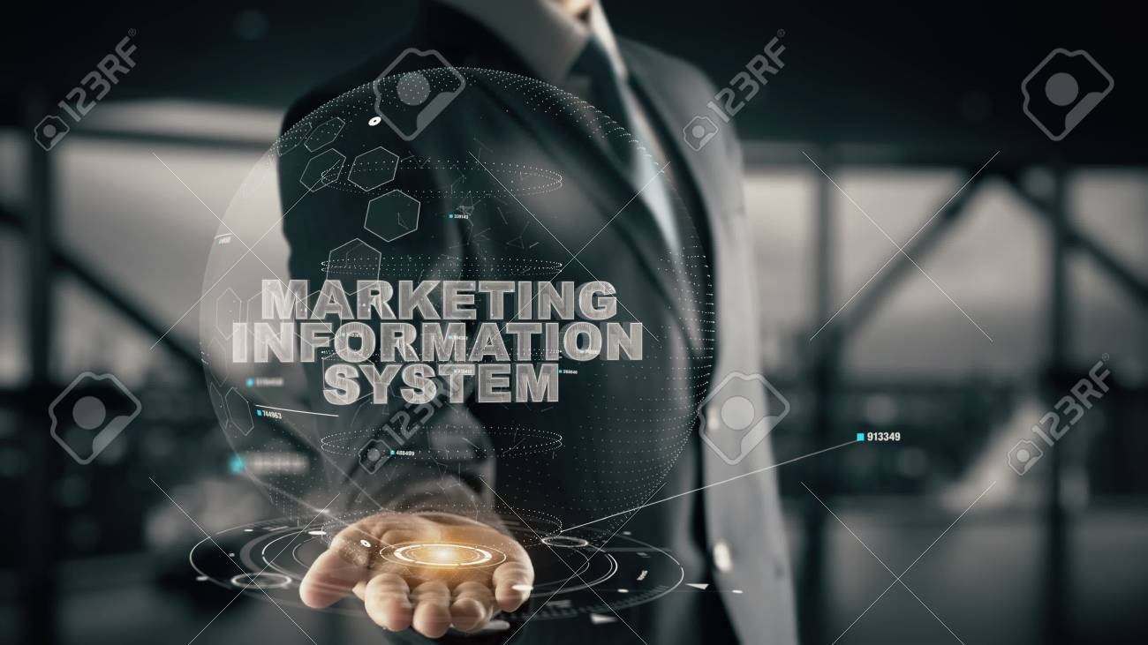

Student Name: Stilyana Mincheva
Student Number: 1816276

Lecturer: Olu Adegbite

Contents

- Introduction…………………………………………………….…page 3

- Types of Marketing Information system………………………. page 3

- Marketing in Hospitality and Tourism industry………………...page 5

- Internet ability within the Marketing Information system………page 5

- Case study- Marriott International………………………………page 6

- Conclusion……………………………….………………………...page 7

- References…………………………………………………………page 7

- Introduction
This course aims at identifying the effectiveness of the marketing information system in tourism enterprises and the hospitality and importance of any data collection and communication. The marketing information system is an interrelated form of human assets, a technical way and strategies for collecting, classifying, analyzing, evaluating and presenting accessible, relevant and available selection facts. According to Philip Kotler: "The marketing information system is a continuous and interactive machine of people, devices and procedures for collecting, sorting, researching and distributing relevant, timely and accurate facts for use through advertisements and marketing manufacturers improving their marketing planning, execution and control. "(Kotler, Armstrong, Harris and Pierce, 2017)
2.Types of Marketing Information System
Information is an exceptionally vital resource for the business of each enterprises. The want for updated and dependable statistics on the improvement of the external surroundings and the organization's internal circumstance is important to the fulfillment of advertising selections. In view of the kingdom of the outside and inner environment, advertising interest as an essential characteristic in any company should ensure an aggressive and solid position. The business enterprise's specialists need a spread of facts about clients, intermediaries, competition and corporation abilities within the method of making plans, analyzing, enforcing and controlling the advertising and marketing plan. The advertising and marketing records device refers to the creation and preservation of an everlasting device for the ordinary provision of the vital records. Marketing facts is amassed: in advance with defined goals, spontaneously as a result of trouble, continuously inside the process of researching the inner and external business advertising environment.
The system of marketing information includes four subsystems:
- Internal database
- Marketing intelligence
- Marketing research
- Marketing analysis
The information expires from the marketing environment (micro-environment and macro environment) of the company is collected, analysed, classified, evaluated, stored in real time and distributed through it. The subsystems themselves are united and coordinated through direct two-way links.
The predominant supply of advertising information is the inner database. It includes income, purchase, order machine, sales reporting gadget, stock level, receivables and payables, advertising personnel, costs, beyond studies work and different reports to be had within the business enterprises. For income orders and income reporting, laptop technologies are used excessively for correct, efficient and speedy transmission of records. While the inner database offers with the available facts from inner records of organizations, the marketing intelligence gadget provides information external environments. This machine includes fixed methods and assets that managers use to gain regularly every-day facts approximately applicable trends in advertising and marketing environments.
The marketing research generates specific datasets geared to various “possible “but not yet existing situations. It deals with solving specific problems in specific marketing areas.
Marketing analysis provides company-led processed, analysed, and highly valued marketing information for management purposes. As a result, the information flow is re-energised to trace whether the decision has had the desired effect on the market.
Marketing statistics enables to efficaciously adapt the corporation to the marketplace situation, to the necessities of centred users and impacts their movements. It allows making effective control selections associated with the uncertainty within the conduct of the marketing machine topics.
Marketing information contributes to:
• Reducing economic hazard;
• Promote and maintain long-term competitive benefits
• Quickly discover new market possibilities as a way to develop into a profitable enterprise
• Coordination of techniques
• Efficient assessment of advertising activity
• Support the intuition of managers

3.Marketing in the Hospitality and Tourism Industry
In the middle of the resort's marketing machine is the purchaser. The inns exist due to him and the pleasure of his wishes is the primary purpose. For this motive, the inn manager needs to recognize in detail the behaviour of his current and ability visitors. To impact customers, the inn uses four equipment: a product, an area, a rate, and a promotion that in their entirety shape the marketing mix equipment. The use of those gear takes place within the advertising method, which entails amassing and studying different statistics approximately the motel, customers, competition, the external environment, making plans, imposing and controlling the advertising interest, segmenting the target market section and positioning, setting marketing finance.
The main goal of hotel marketing is to identify customer behaviour and needs, development trends and changes to help the hotel marketing manager make the right decisions in the long term. Marketing is a complex tool for offering products that meet the needs of hotel guests. As a result, the marketing of the hotel emphasizes the study of consumers needs and aims to ensure quick adaptation to the changing environment and greater competitiveness of the hotel.

- Internet ability within the Marketing Information System

Every employer in each enterprise has realized the significance of making, preserving and the usage of databases for its clients, distributors, competition, and other users of their services or products.
According to Emma Wood, internet ability is a quick manner to get entry to beneficial environmental records to improve advertising and marketing choices. In order to apply these statistics in its high-quality benefit, it needs to be included in an advertising and marketing information machine. The Internet, as a supply, must complement existing assets of internal and outside facts through providing a fuller image on which to base the answer. (Emma Wood, 2001)
The use of IT inner an advertising facts gadget has emerge as a key component in an enterprise′s success of aggressive benefit. As Talvinen (1994, p.8) has argued, “Managing advertising statistics by IT has come to be one of the maximum important elements of powerful marketing.

The tourism and hospitality industry use a variety of technology applications that operate independently or are integrated into a unified management system that enhances operational efficiency and strategic organizational competitiveness. Buyers of travel services are among the active users on the internet. They are demanding, impatient, curious with an individuality, looking for information everywhere and deriving an effective benefit from online sales.
Today the successful development of the hotel and hospitality industry is unthinkable without the implementation of information communication strategies such as: developing a corporate website with a convenient interface; use of social media; connecting with web search engines for travel and tourism; advertising promotional offers and package travel. In this way, hoteliers collect information about their customer′s preferences as well as maintain constant contact with them by receiving feedback about their satisfaction and their experience.

5.Case study – Marriot International Hotel
Marriott international introduces its first ever-longer stays category marketing campaign, “Room for Possibility” that enable business travelers the freedom to maintain their lifestyles, uninterrupted on the road. To reinforce the unique style and offering of each brand's Residence Inn by Marriott, Element Hotels and TownePlace Suites by Marriott and to highlighting their spacious accommodations that provided the extra space and amenities business travelers desire. These brands are continually listening to research and guest feedback to evolve the brand experience for guests. The research shows that travelers more than ever are looking to blend the best part of being at home with the best part being on the road, free from the regular routines of life. A qualitative research study made led to the creation of the extremely new concept “Room for Possibility” that designed more space and a better experience. According to Paige Francis, vice president global brand marketing, Marriott Classic Select Brands when people travel, they should not have to compromise on the experience and Marriott designed the brands to allow guests flexibility and versatility to choose how they work, eat and experience destination. She said, “We know our guests crave the comforts of home as well as the freedom that travelers allows and inspiring this campaign to celebrate how business travelers can live their lives while on the road, beyond the business they come for.” (Francis, 2019) The three brands featured in the campaign offer three unique stay experiences. Residence Inn offers spacious suites with separate living, working, and sleeping areas with full kitchens; complimentary grocery delivery service and breakfasts; and outdoor spaces with fire pits that help guests travel the way they love to live. Element Hotels are designed for today’s healthy, active traveler who wants to maintain a balanced lifestyle while on the road, offering an outdoor-inspired design philosophy that is clean, modern and bright. TownePlace Suites offers a simple, yet innovative design, that features personal touches and cheerful details with fully equipped kitchens and Weber Grills outside. All experiences allow guests to live uninterrupted on the road, whether for a few days or a few weeks.

6.Conclusion
On the one hand marketing information system is a key element in hospitality and tourism industry, which makes a continuous connection with the consumers in order to offer newer experiences and feelings satisfying even the most demanding clients. On the other hand, determining factor in the development of innovation and creativity.

7.References
1.Beech, J., Chadwick, S. (2006). The business of Tourism Management. Person Education, London, p.252.
2.Connolly, D.J., and Lee, S. (2006). Developing facts era proficiencies and fluency in Hospitality students. Journal of Hospitality and Tourism Education, 18(3), 15-29.
3.Emma, W. (2001). International Journal of tourism research three, p. 283-299
4.Francis, P. (2019). Marriott International Unveils Category Marketing Campaign “Room for Possibility, Bethesda, MD
5.Ivanov, S., Zhechev, V. (2011). Hotel Marketing
6.Kotler, P. Armstrong, G. Harris, L.C. And Piercy, N. (2017). Principles of Marketing, Seven European Edition, Person.
7.Laskarin, M. (2012). Web Communication Management in Hotel Marketing, Informatologia, 45(4), p.314
8.Talvinen, J. (1994). Information system in Marketing. European Journal of Marketing 29(1), p.8-26

