

Postgraduate/Distance Learning
Assignment coversheet & feedback form

THIS SHEET MUST BE THE FIRST PAGE OF THE ASSIGNMENT YOU ARE SUBMITTING (DO NOT SEND AS A SEPARATE FILE)

For completion by the student:
Student Name: Kristopher Chambers

Student University Email: 2023849@student.uwtsd.ac.uk
Module code:  HPCA7019  Module title:  Sacred Skies | Student ID number:  2023849 |  |  | Educational support needs:  No
Assignment title: Sky Journal

Assignment due date: 19 March 2021
This assignment is for the 1st module of the degree
I confirm that this is my original work and that I have adhered to the University policy on plagiarism.
Signed …… ………………………………………………………
Email submission: if you are submitting this form via email, please tick this box □
(as a substitute for your signature) to confirm that you agree to the above declaration.
Assignment Mark
1st Marker’s Provisional mark
2nd Marker’s/Moderator’s provisional mark
External Examiner’s mark (if relevant)
Final Mark

NB. All marks are provisional until confirmed by the Final Examination Board.

ALL COMMENTS ARE ON THE PDF OF YOUR PAPER IN TURNITIN

For completion by Marker 1 :
Comments:

Marker’s signature: |  |  | Date:
For completion by Marker 2/Moderator:

Comments:

Marker’s Signature: |  | Date:
External Examiner’s comments (if relevant)

External Examiner’s Signature: |  | Date:

ESSAY BASED ON SKY JOURNAL
By Kristopher Chambers 11 March 2021
Word Count: 2551
Contents
Introduction 4
Methodology 4
Academic Review 5
Findings / Discussion 7
Conclusion 20
Appendix 1. Data Set of visual and emotional words for Word Cloud 22
Referencing 23
Primary Sources 23
Secondary sources 23

List of Figures
Figure 1 Map showing locations for Sky Journal and Scotland reference map 5
Figure 2 Colour chart highlighting what I saw. 7
Figure 3 Word Cloud for Primary Colour – Sky 9
Figure 4 Word Cloud for Primary Colour – Sunrise & Sunset 10
Figure 5 Word Cloud for the Visual Description of the Sky 11
Figure 6 Word Cloud for Emotional Description from the Sky 12
Figure 7 14th Feb. Location A Sunset. 13
Figure 8 16th Feb. location A Sunset. 14
Figure 9 24th Feb. Location A Sunset. 15
Figure 10 26th Feb. Location A Sunset. 16
Figure 11 27 Feb. Location A. Mid-morning 17
Figure 12 Images from Location B 18
Figure 13 Night images from location A. Early evening. 19
Figure 14 Author reading Bram Stoker’s Mystery of the Sky from location A 21

Introduction
This sky journal was my interview with the sky. The image of the sky seen by day or night is a once in an eternity snapshot into that time and space. Artisans like novelists, painters, sculptors etc through their work, have the ability to capture (and preserve) their perception of a specific time and space in a reflective way through their preferred medium. This sky journal represents my reflexive interview with the sky focused on an 18 day period in February 2021 from two locations in Cruden Bay in the northeast of Scotland. In it I will describe what I saw and I will record from my perception how the visual image affected my emotions using words and photographs. I will also reflect on the works of Bram Stoker who wrote two of his novels on life in Cruden bay in the late 1800’s and analyse his use of sky in his works to try to perceive Cruden Bay as he saw it. Essentially I will be phenomenologically projecting myself back to the world of Bram Stoker through his eyes in antiquity.

Methodology
For this sky journal I applied a reflexive methodology. Etherington describes Reflexivity as ‘an ability to notice our responses to the world around us, other people and events’. My sky journal was developed in Cruden Bay from 11th – 28th of February 2021. My daily dog walk offered me the perfect opportunity to document the sky and record the emotional impact that it had on me and allow me to contemplate the words of Stoker as he would have seen it.
The two views (figure 1) I had selected offer completely different optical perspectives. The first view (location A) looked out over the coastal bay into the North Sea capturing the sunset and extending up to Alt 60°. The second view (location B) was of the rugged wind-blown coast with the ruins of a 16th century granite castle (Slains Castle) capturing the late winter sunrise and extending up to Alt 45° which captured the suns late winter zenith. The views were also selected because they represented the inspiration platform for the author Bram Stoker to build on when he was working on his novels. To explore the everchanging sky I focused my periods of exposure to midmorning, late afternoon around sunset and early evening.
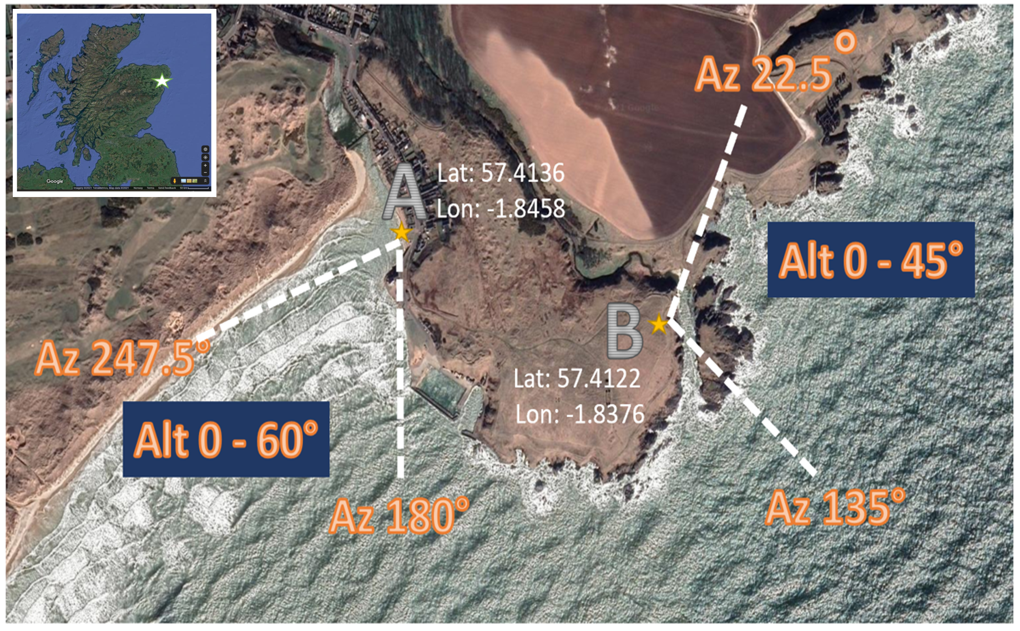
Figure 1 Map showing locations for Sky Journal and Scotland reference map
(Source: Google. 2021)
I decided to take photographs and to record daily key words that the image stimulated in me so I could present them as a visual word cloud. De Paolo and Wilkinson describe word clouds as ‘the ability to organize assessment data in a graphical representation makes the data easy to comprehend’. Additionally, I documented the primary colours using the Windsor & Newton Colour Chart for the sky and the associated rising and setting of the sun to provide some visual content for the reader.

Academic Review
Bram Stoker wrote his novels Watter’s Mou’ (1895) and The Mystery of the Sea ( 1902) on life in Cruden Bay, I decided to read the novels and see if there were any descriptive recollections of the sky and landscape and then apply the basis of phenomenology. Tilley stated that ‘Phenomenology involved understanding and describing of things as experienced by a subject’ and in this case the thing was the sky and Stoker was my subject. To relive Stokers experience I decided to read the books overlooking the same landscapes he most certainly would have looked at when he penned his works.
Watter’s Mou’ (published in 1895) is a sad love story focusing on a coastguard, his lover and his job to stop the struggling local fisherman (like her father) who have reverted to smuggling on the savagely rough Scottish coastline.
The Mystery of the Sea (published in 1902) is a complex political supernatural thriller based on an Englishman who relocates to Cruden Bay to live and becomes embroiled into the kidnapping of a rich American and what he is forced to do for love.
Stoker found inspiration from American Poet Walt Whitman and his collection of poems Leaves of Grass. At the time these novels were published Stoker was working as Sir Henry Irving’s manager at the Lyceum Theatre in London and between 1893 – 1910 spent twelve summers holidaying in Cruden Bay.
Vastly different to the hustle and bustle of life in London’s theatre scene, the peaceful tranquillity of Cruden Bay season after season was the inspiration for much of Stoker work. Shepard describes stories past down from the locals of seeing Stoker sitting in the front yard of his holiday let writing in his notebooks drawing in everything he saw and felt.
Stokers descriptive sky recollections in his novels capture the sudden visual change and rapid thermal fall when the haar or sea fog accelerates in. He also very realistically captures the immense sunrises over the mouth of Cruden Waters or Watter’s Mou’ as it is known in the local Doric dialect and the blinking sunsets over the Bay of Cruden towards the dangerous Skares which is the rocky offshore outcrop known to have swallowed many ships and claimed lives. In Watter’s Mou’ Stoker visualized great beauty in the sky describing the sky as ‘streaked with great mair’s-tails [sic]’ and:
lighter and lighter grew the expanse of sea and sky, until over the universe seemed to spread a cool pearly grey, against which every object seemed to stand starkly out.
In The Mystery of the Sea, Stoker continued this love affair with the sky stating ‘there was bright sunshine; and a sky of turquoise with here and there a flock of fleecy clouds’ and:
the whole western sky seemed ablaze with red and gold; great masses of cloud which had rolled up seemed like huge crimson canopies looped with gold over the sun throned on the western mountains.
Stoker associated the ominous blackness in the sky with dread and fear very eloquently as shown in this quote:
The sacrifice of the night had not fully appeased the storm-gods. Somewhere up in the Northern Unknown, where the fates weave their web of destiny, a tempest was brewing which would soon boil over. Darker and darker grew the sky, and more still and silent and oppressive grew the sky.
Its very hard to describe but his descriptions very accurately reflect life in this little fishing community.

Findings / Discussion
As I started this journal Mother nature in all her glory decided to interject. The clouds descended, the skies turned grey, ferocious winds picked up, the temperature plummeted, and the snow came tumbling down and so it stayed for the next few days. As Stoker described most elegantly, ‘a tempest was brewing’ and indeed it arrived with force.
The image I remember most in that first week was the skies was raging with very low, menacing black and grey clouds, the seas were huge causing a haze which engulfed the beach and sand dunes. The ominous ever present threat of snow clouds rolling across the sky. The temperature was freezing yet still beauty could be found in the ever-changing portrait that was the sky. I felt cold, cursed the bone chilling feeling but then I smelt the air, tasted the ocean, saw the large seas and appreciated the interconnectivity of this time and space. It was starting to turn into Groundhog Day and I needed a change.
Reviewing the descriptive works of Stoker, key words like cool pearly grey, turquoise, red and gold spring out and although I was blessed with the accuracy of a colour chart (figure 2 is a summary of colours found in my journal), the similarities certainly existed. Where he saw pearly grey, I saw Davy’s grey and very much associated it with storms and rain and drizzle. As for the colour of the sky at sunrise and sunset, the Cruden Bay sky truly was s a kaleidoscope of colours no matter what the weather.

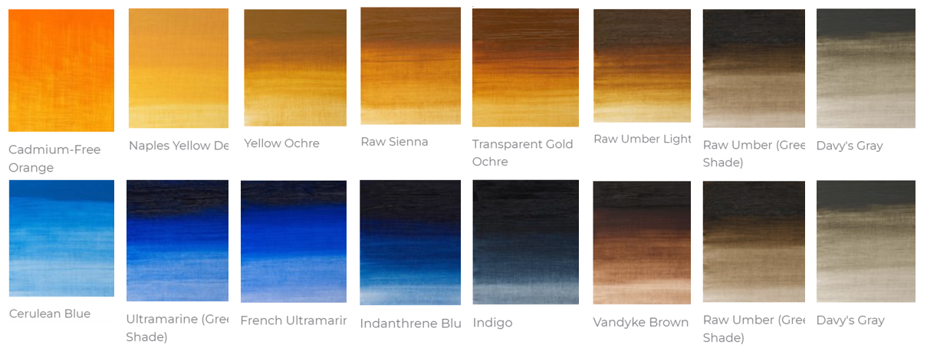
Figure 2 Colour chart highlighting what I saw.
(Source: W&N 2021)
At one stage I was sitting overlooking the Watter’s Mou’ imagining what he saw, The sky was grey, the weather was ominous, the temperature was piercing cold and the sea was so scary leading me to the thought of zero survivability for any one shipwrecked. Watter’s Mou’ and Mystery of the Sea were centred on this topic with the Skares and other hidden rocks along the rough coastline. You could sense this frightful scene focused his thoughts and inspired his work. It was in that moment that it really sunk in that the sky was all around me, inside of me, it impacted my emotion. I was at one with the sky.
After I ended my interview I correlated the data set and formalized the word cloud using a Microsoft Word add-on called Pro Word Cloud. The data (appendix 1) in the word clouds (figure 3 – 6) recorded that the sky was more often than not Davy’s Grey indicating extended periods of rain, snow and drizzle. I did find happiness and excitement associated with snow due to its rarity in Cruden Bay but I could understand why Sottish locals really hate the Scottish weather, groundhog day was evident with the constant weather.
To try to make my journal more visual I created a photographic collage from both location and recorded these below as figures 7 - 13.

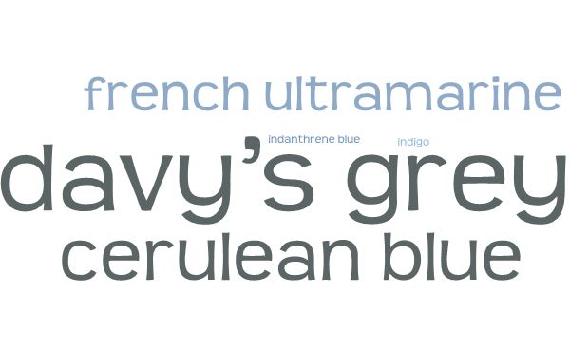
Figure 3 Word Cloud for Primary Colour – Sky
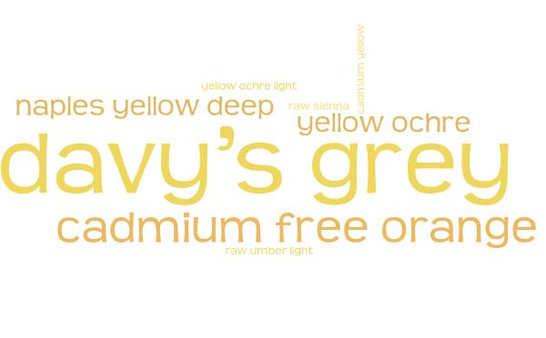
Figure 4 Word Cloud for Primary Colour – Sunrise & Sunset

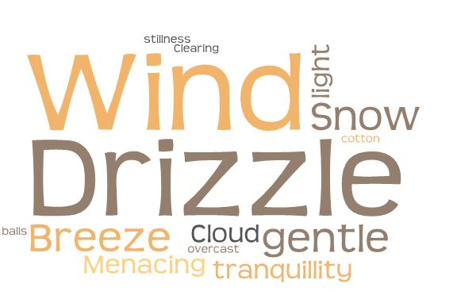
Figure 5 Word Cloud for the Visual Description of the Sky
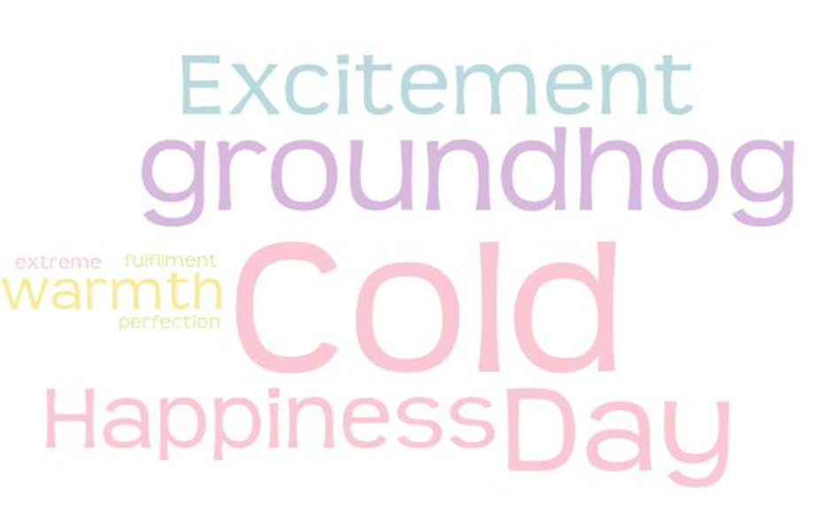
Figure 6 Word Cloud for Emotional Description from the Sky

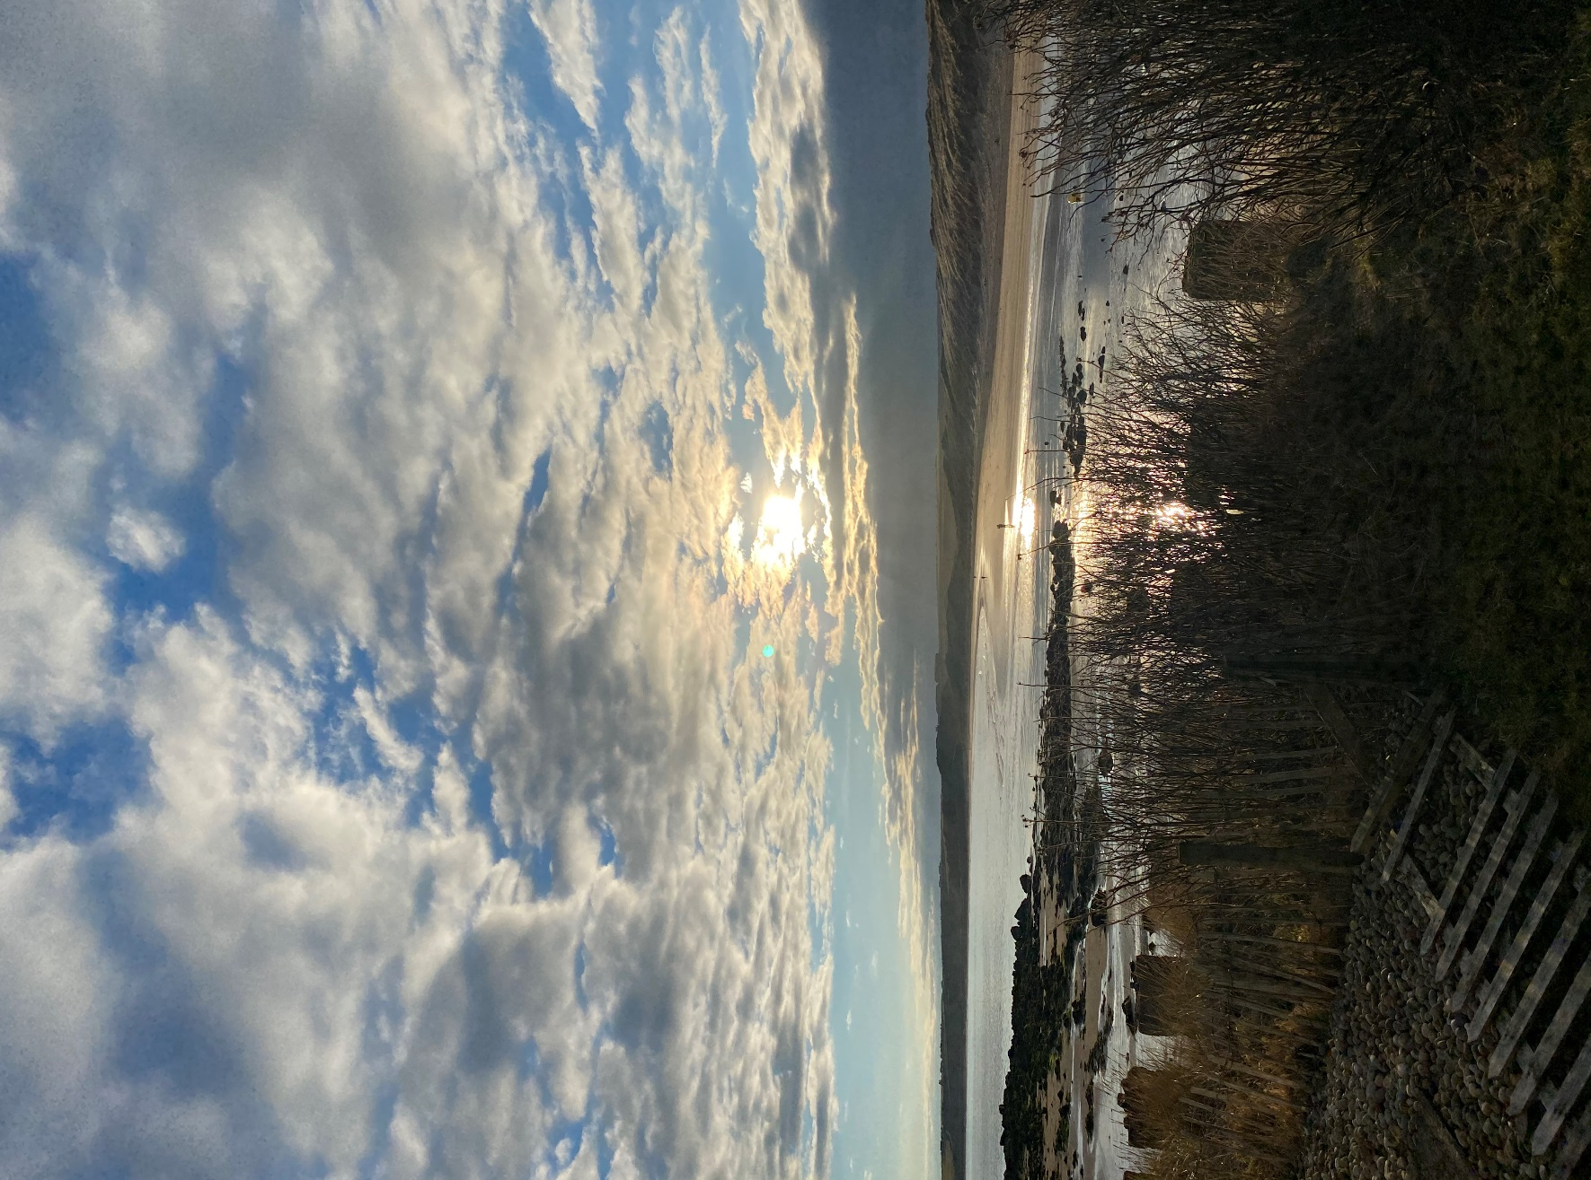

Figure 7 14th Feb. Location A Sunset.
Extract from sky journal “Beautiful sky of rich ultramarine (green shade), Sun was shades of raw umber light getting lost in low clouds. Sky was full of dancing cotton balls. I felt excitement watching the everchanging mural after period of snow.”

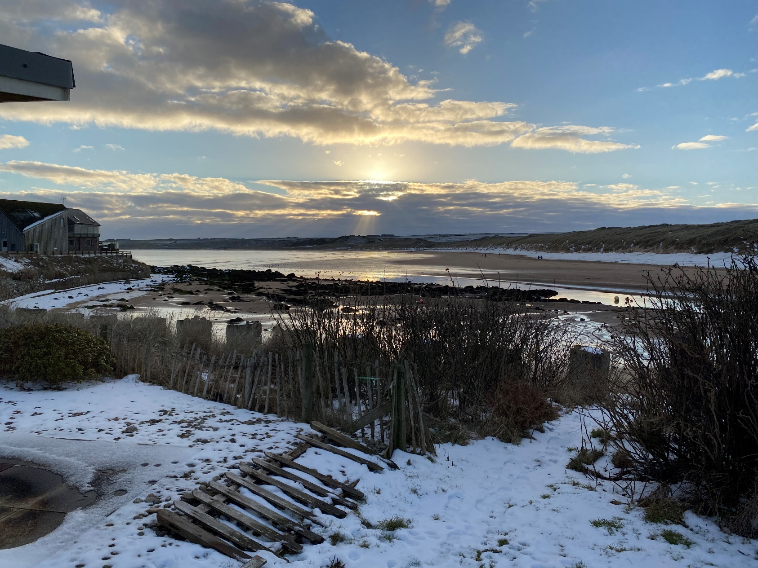
Figure 8 16th Feb. location A Sunset.
Extract from sky journal “Sky was ultramarine green shade with a stunning sunset of raw sienna. There was a gentle breeze and the snow had returned. I felt fulfilment and happiness.

Figure 9 24th Feb. Location A Sunset.
Extract from sky journal “The sky was cerulean blue, sunset was cadmium free orange, The sky was still, and I felt happy”
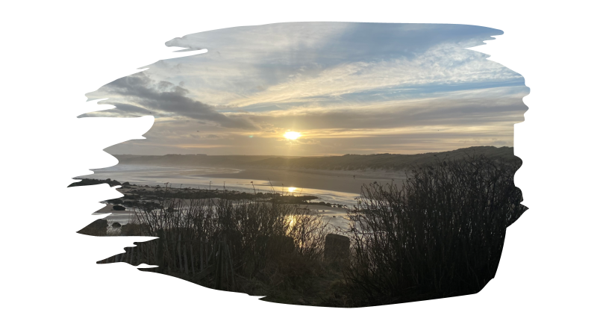
Figure 10 26th Feb. Location A Sunset.
Extract from sky journal “The sky was Davy’s grey with patches of cerulean blue, Setting sun was Naples yellow (deep) with light cloud. Felt warm”

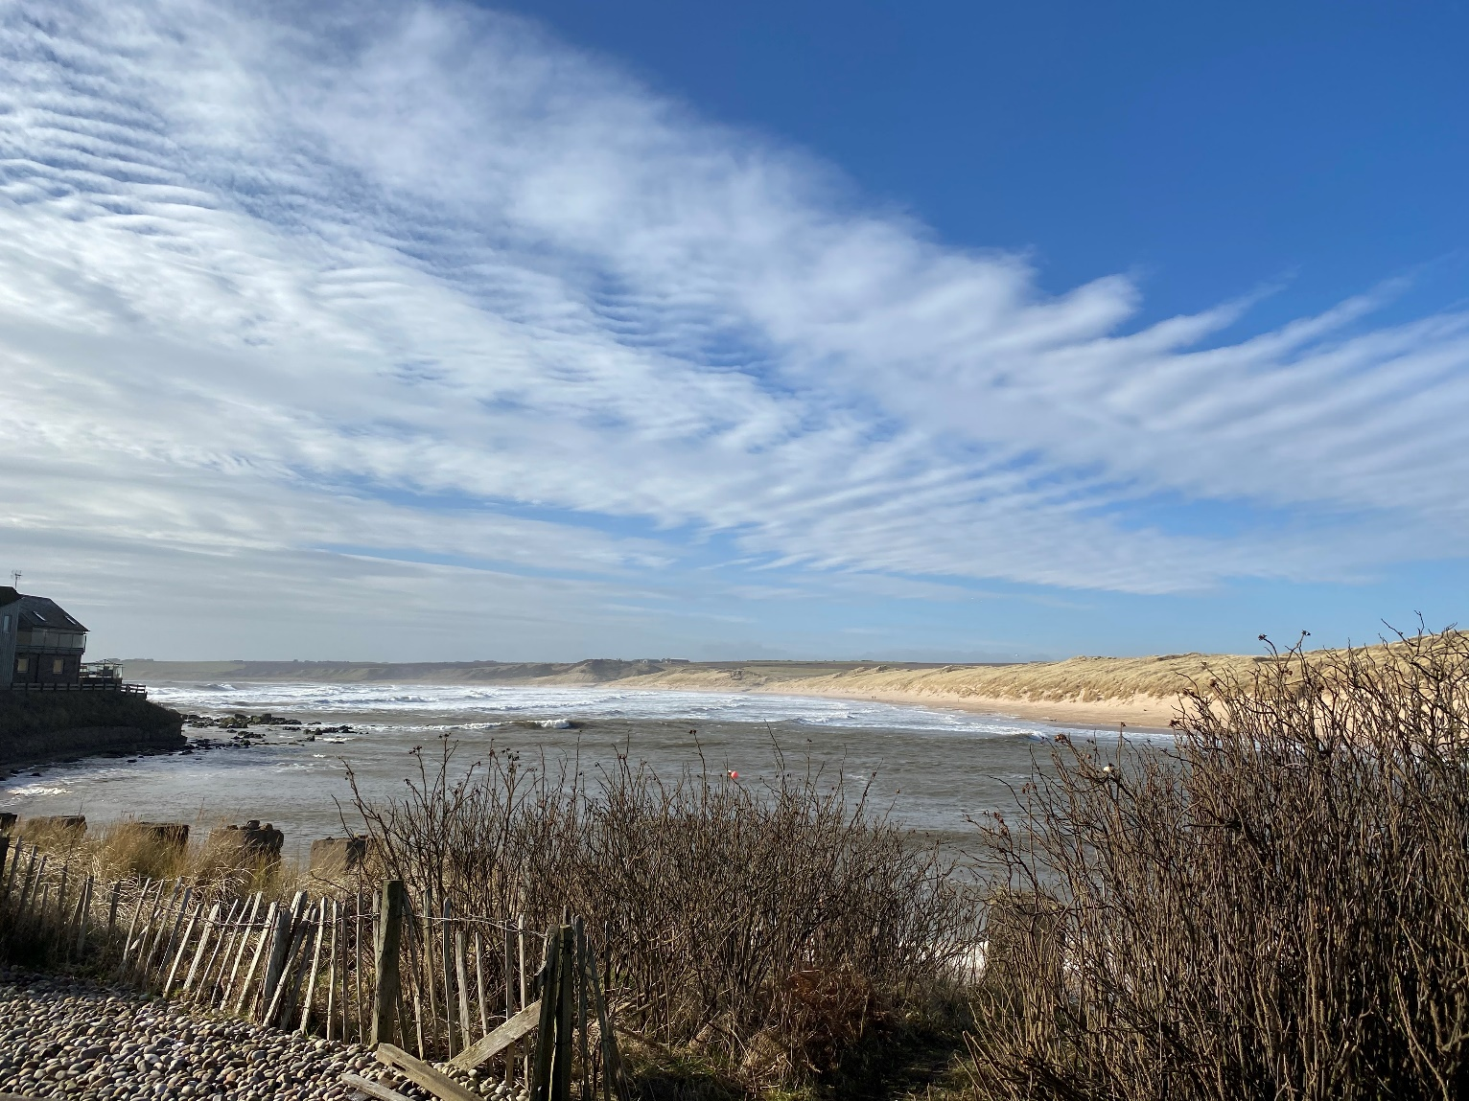
Figure 11 27 Feb. Location A. Mid-morning
Extract from Sky Journal “Sky was just gorgeous, maybe these were Stokers streaks of great mair’s-tails. Wind was increasing so sea was looking wild, sky varied from cerulean blue to French Ultramarine, sheer perfection and happiness. My perfect day culminating in a radiant cadmium free orange sunset.”
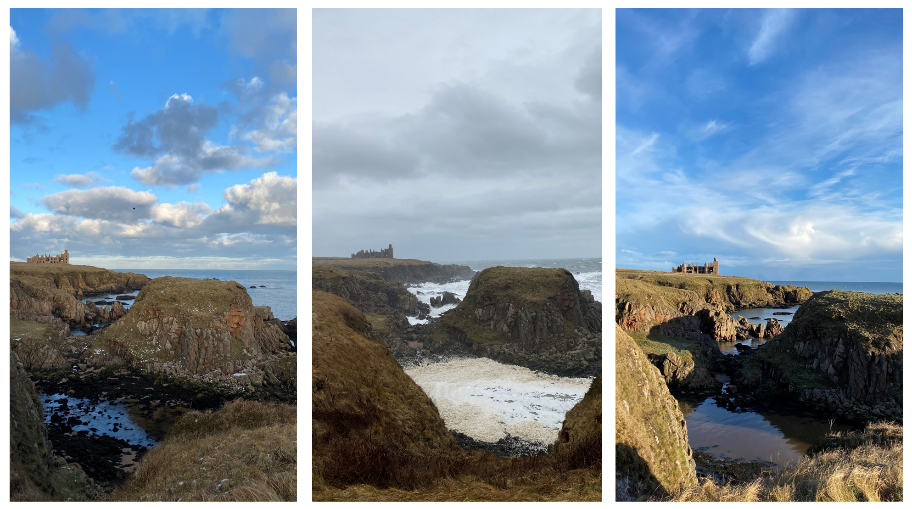
Image A. 28th Feb. Image B. 11th Feb. Image C. 27th Feb.

Figure 12 Images from Location B
The images from location B demonstrates dramatic visual impacts of the sky on the landscape. I felt two very significant emotions from these views, Figure 11 image A and C made me feel relaxed and glad to be alive yet figure 11 image B drew me in more because the wild weather brought the sea to life.
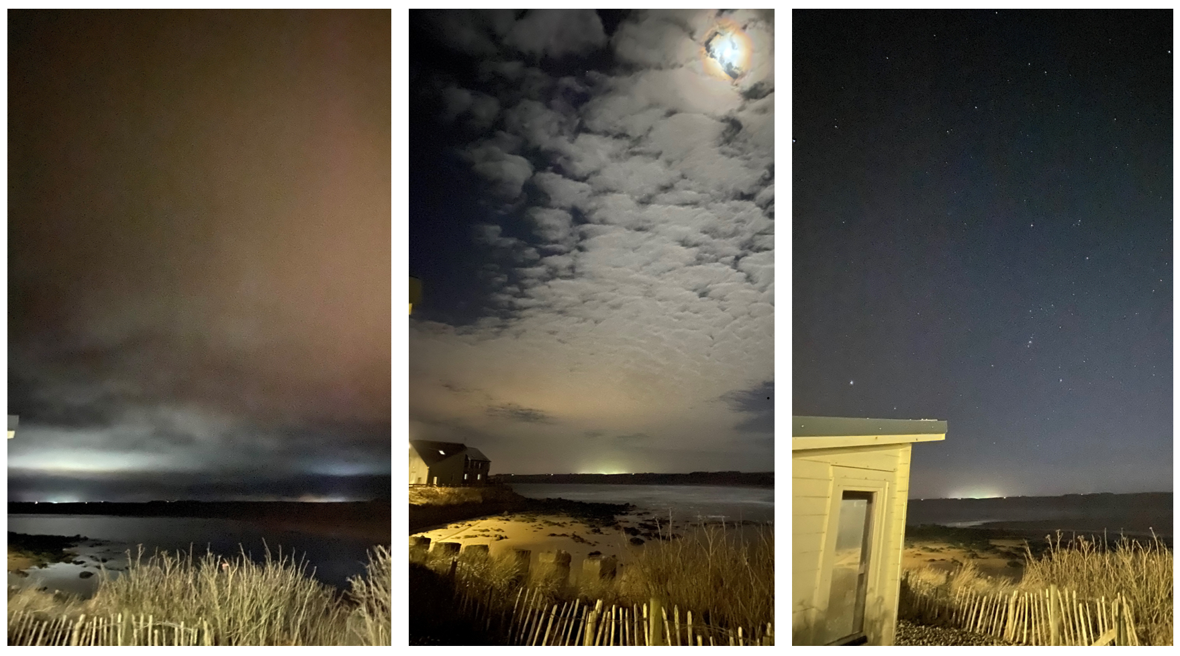
Image A. 24th Feb Image B. 14th Feb. Image C. 11th Feb.
Figure 13 Night images from location A. Early evening.
Night imagery using Apple I-Phone 11. The I-phone imagery brought the cloud to life in figure 13 image A and B.

Conclusion
The aim of this sky journal was to conduct a reflexive interview with the sky. I selected two fixed locations near my home in Cruden Bay to conduct my interview. These locations aligned with views I perceived Bram Stoker would have had of Cruden Bay and the mouth of Cruden Waters between 1893-1910. In addition to exploring how the sky made me feel, I extrapolated descriptive similarities drawn from a written review from the two pieces of written work by Stoker which focused on Cruden Bay. I tried to perceive what Stoker would have seen and felt. I also tabulated key words to identify reoccurrences of colours and emotion and displayed them with word clouds for visual comparatives.
When I read Stoker I really felt like we were looking at the exact same scene albeit from his eyes 120 years previous. I found this brought me closer to the author, As I sat reading I sensed that he was sitting beside me lost in the mystery of the never-ending sky in this beautiful place.
My final thoughts. The planet we all live on is actually in the sky although we generally don’t perceive it, Imagine standing on the moon looking toward the earth, The earth, planets, sun and stars all exist under one sky. The atmosphere we breath forms part of the sky therefore it could be argued the sky is not only around us but within us. I subsequently exist as an entity within the sky and the sky within me. Now as I live on this little planet my human senses govern my emotions, When I see an uncontrolled fire in nature I sense fear and danger yet when I look at a fire in a wood burner or a firepit I associate warmth and safety. The same is true with what we see in the sky, when I see clouds (especially in Scotland) I generally think cold and drizzle yet have a feeling of subliminal happiness. This joy is because overcast weather brings large wild seas and I love how these seas affects my mood in a positively manner. When I see sun, I think of warmth, vivacious colour and feel happiness primarily because I can sit outside my house and watch the tide ebb and flow everchanging the landscape. I associate the sunrise invigoratingly with a sense of what does the future hold, I see sunset as a reflection of the day never to be lived again. The sky is our world,
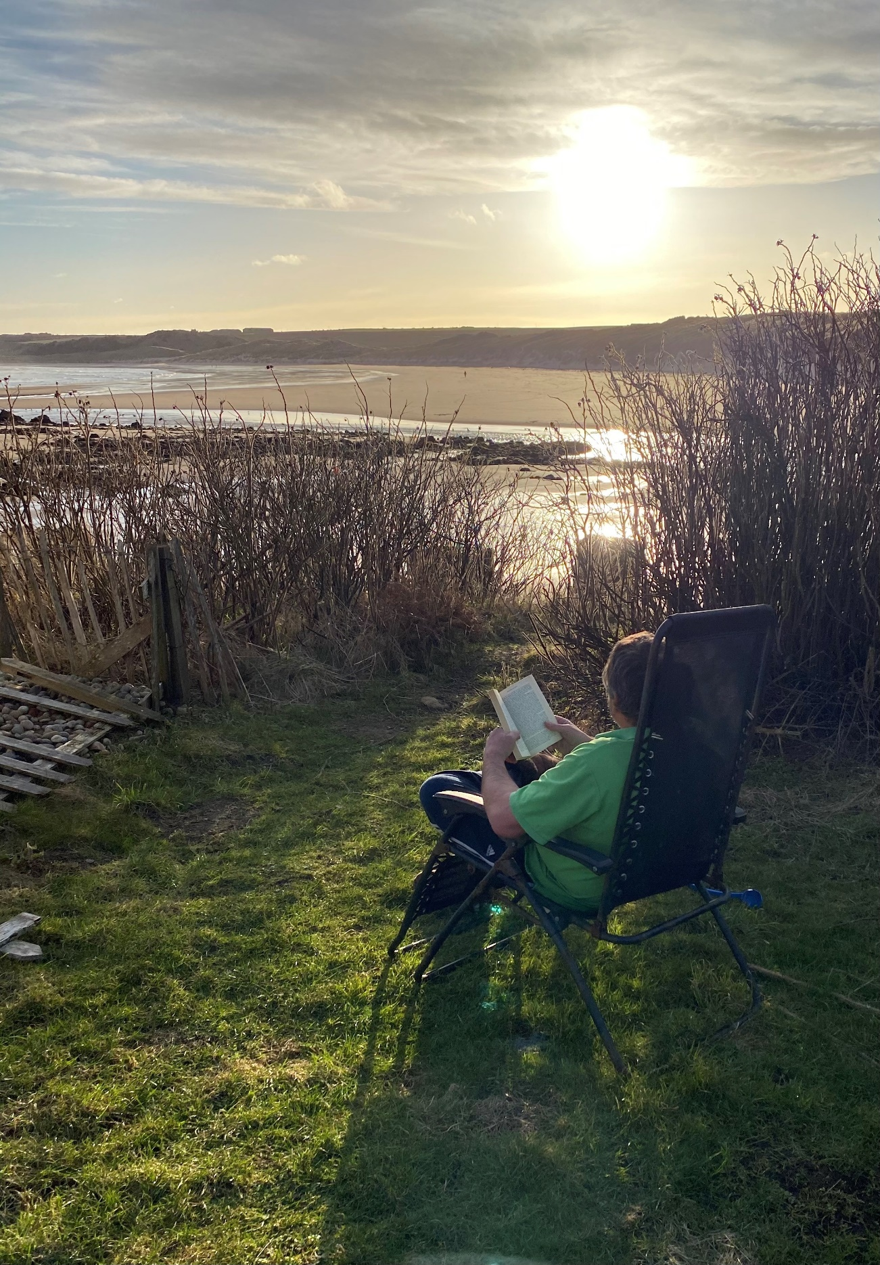
Figure 14 Author reading Bram Stoker’s Mystery of the Sky from location A

Appendix 1. Data Set of visual and emotional words for Word Cloud

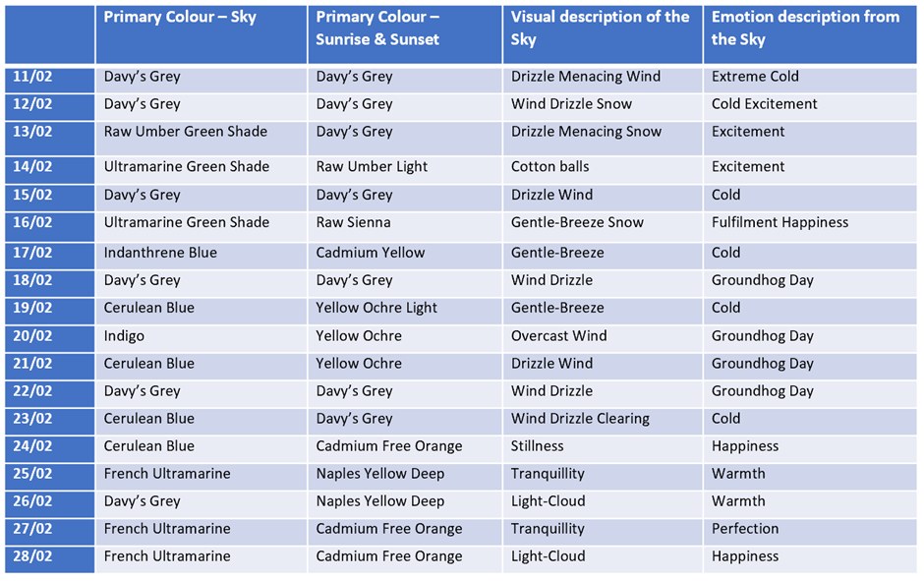

Referencing

Primary Sources
Stoker, Bram, Watter's Mou'. (A. Constable & Co, Westminster. 1895) <http://www.bramstoker.org/pdf/novels/03mou.pdf> [accessed 07 February 2021].
Stoker, Bram, The Mystery of the Sea, (William Heinemann, London. 1902). <http://www.bramstoker.org/pdf/novels/07sea.pdf> [accessed 08 February 2021].

Secondary sources
DePaolo, Concetta A and Kelly. Wilkinson, “Get Your Head into the Clouds: Using Word Clouds for Analyzing Qualitative Assessment Data,” Tech Trends, vol. 58, no. 3, pp. 38–44, May 2014.
Etherington, Kim, Becoming a Reflexive Researcher. Using our Selves in Research. (Jessica Kingsley. London. 2004).
Google. Google Maps (2021) <https://www.google.com/maps/> [accessed 14 February 2021].
Harris, Alexandria, Weatherland. Writers and Artists under English Skies. (Thames & Hudson. London. 2019).
Perry, Dennis R, Whitman's Influence on St s Influence on Stoker's Dracula. Walt Whiteman Quarterly Review, vol 3, no. 3, pp. 29-35, 1986.
Shepherd, Mike, When Brave Men Shudder; the Scottish origins of Dracula. (Wild Wolf Publishing 2018).
Tilley, Christopher, A Phenomenology of Landscape. (Berg: Oxford. 1994).
Whitman, Walt, Leaves of Grass.(Walter Scott: London. 1886).
W&N. Windsor & Newton Colour Chart. (2021) <https://www.winsornewton.com/uk/paint/oil/artists-oil/> [accessed 12 February 2021].

Christopher Tilley, A Phenomenology of Landscape. (Berg: Oxford 1994), p.12.
Kim Etherington, Becoming a Reflexive Researcher. Using our Selves in Research. (Jessica Kingsley. London. 2004), p.19.
Concetta A. DePaolo and Kelly Wilkinson, “Get Your Head into the Clouds: Using Word Clouds for Analyzing Qualitative Assessment Data,” Tech Trends, vol. 58, no. 3, May 2014, p.38.
Bram Stoker, Watter's Mou'. (A. Constable & Co, Westminster. 1895) <http://www.bramstoker.org/pdf/novels/03mou.pdf> [accessed 07 February 2021].
Bram Stoker, The Mystery of the Sea, (William Heinemann, London. 1902). <http://www.bramstoker.org/pdf/novels/07sea.pdf> [accessed 08 February 2021].
Christopher Tilley, A Phenomenology of Landscape. (Berg: Oxford 1994), p.12.
Bram Stoker, Watter's Mou'.
Bram Stoker, The Mystery of the Sea.
Walt Whitman, Leaves of Grass. (Walter Scott: London. 1886).
Mike Shepherd, When Brave Men Shudder; the Scottish origins of Dracula. (Wild Wolf Publishing 2018), p.15.
Dennis R. Perry, Whitman's Influence on St s Influence on Stoker's Dracula. Walt Whiteman Quarterly Review, vol 3, no. 3, pp. 29-35, 1986, p.29.
Mike Shepherd, When Brave Men Shudder; the Scottish origins of Dracula. pp.222-223.
ibid. pp.120-122.
Bram Stoker, Watter's Mou'. pp.2, 8, 24.
Bram Stoker, The Mystery of the Sea.p.177.
Bram Stoker, Watter's Mou’. pp.37,43.
Ibid. p.50.
Ibid. p.14.
Ibid. p.34.
Bram Stoker, The Mystery of the Sea. p.59.
Ibid. p.31.
Bram Stoker, Watter's Mou'. pp.49.
Ibid. p.49.

