Mind Bridge: A Digital Mental Health Support Platform
for Frontline NHS Workers

Module name: Creativity and value creation (BMHP5014_LON)
Student name: Huma Zafar
Student number:2324433
Lecturer’s name: Laila Surani

Task 1 poster
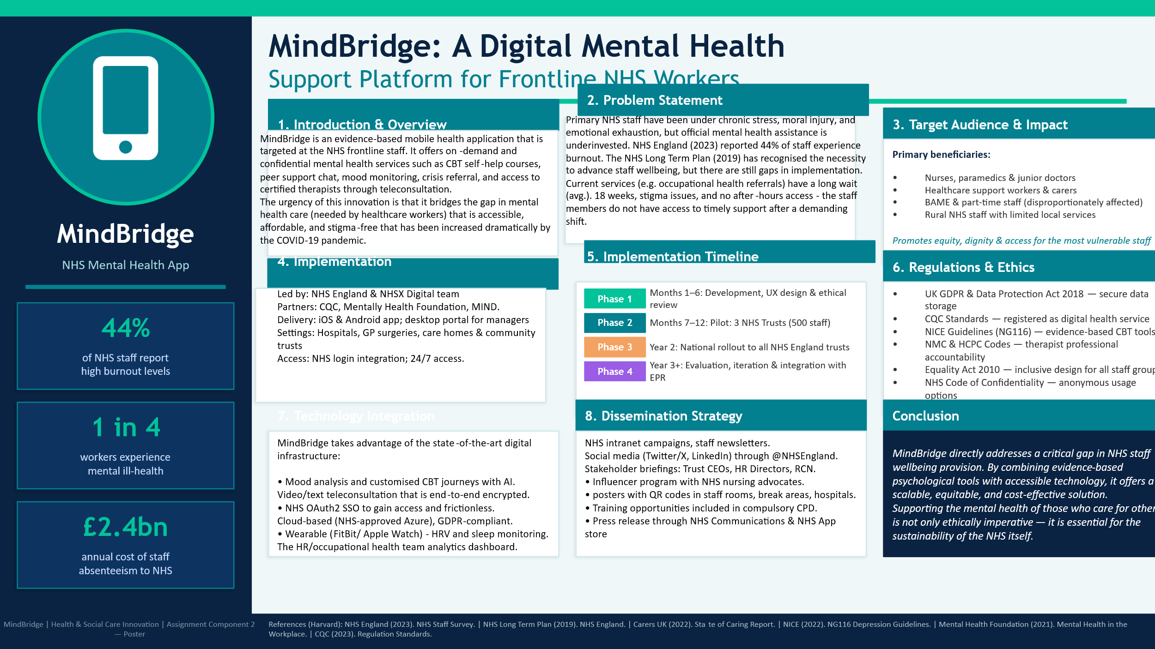

Introduction
Mental health and wellbeing of frontline National Health Service (NHS) workers is one of the most urgent and also one of the most under-discussed issues in modern health and social care. MindBridge is a proposed evidence-based mobile health app that will support NHS frontline employees with accessible, confidential, and clinically informed mental health support. The innovation is a direct reply to the gap in knowledge recorded between the psychological load of the healthcare workers and the insufficiency of existing formal means of support. With digital health technology, MindBridge presents a scalable and fair solution that can be of benefit to nurses, paramedics, and healthcare assistants, as well as, allied health professionals who are all those that are the most at risk of occupational stress and those who are least likely to seek traditional mental health services because of stigma, time, and systemic factors (Maben et al., 2021).

Background
The mental burden of being on the frontline of working in healthcare has been well-documented and has been severely aggravated by the COVID-19 pandemic. The NHS England (2023) survey indicated that 44% of NHS employees had recently experienced burnout over the last twelve months, with nurses and paramedics having a disproportionately high rate of burnout. Mental Health Foundation (2021) discovered that one out of every four health and social care workers has had a diagnosable mental health issue in the pandemic, which has led to high levels of absenteeism estimated to cost the NHS around 2.4 billion a year (NHS Employers, 2022).

These conclusions have a lot of policy implications. The NHS Long Term Plan (NHS England, 2019) has pledged to enhance the health and wellbeing of the staff, and the People Plan (NHS England, 2020) made the psychological safety and access to occupational mental health support as its strategic priorities. In spite of these promises, little has been done to enforce them. The occupational health service referral routes are associated with an average of up to eighteen weeks waiting times (NHS Staff Survey, 2023), and most employees have stated that they are afraid of losing their job because of revealing mental health challenges due to professional consequences (Maben et al., 2021). The inequalities in access to support are compounded among the ethnic minority staff and part-time workers (NHS Race and Health Observatory, 2021), which makes it even more urgent to introduce an equitable digital alternative.

Innovation Description
MindBridge is an evidence-based mobile health app, accessible on iOS and Android, which provides a collection of evidence-based psychological tools and peer support features to NHS employees directly. MindBridge is uniquely optimised to the occupational setting of healthcare, unlike generic wellbeing apps, and includes content validated to clinical populations (NICE, 2022). The main characteristics are: customised Cognitive Behavioural Therapy (CBT) self-help courses; an anonymous 24/7 peer support board with certified mental health champions; mood-tracking using AI and proposed adaptive resources; and on-demand sessions with certified therapists via encrypted video or text.

It is enabled by NHS login Single Sign-On (SSO), which enables smooth but secure access. The platform is connected to wearable technologies, allowing to conduct passive wellbeing tracking based on heart rate variability and sleep statistics. An analytics dashboard that a manager can view (with anonymised, aggregated data only) enables proactive planning of workforce wellbeing without undermining the confidentiality of individuals. The fact that MindBridge is both clinically rigorous, sector-specific, and accessible to technology is what makes it truly innovative in that it overcomes the limitations of available NHS digital wellbeing tools identified in the research, which are typically generic, not well promoted, or do not fit in shift-based working patterns (Waddell et al., 2023).

Impact on Health and Social Care
The expected effect of MindBridge is at the individual, organisational and systemic levels. To the individual staff, the platform would offer access to psychological support without stigma on-demand, shortening the time-to-intervention period that is related to formal referral pathways. In the case of organisations, a higher staff mental health is linked to less absenteeism, less staff turnover, and improved quality of patient care, which have significant economic and ethical implications to NHS Trusts (NHS Employers, 2022).

One of the strengths of MindBridge is its equity. The platform is specifically tailored to target the most marginalised in current support systems such as Black, Asian, and minority ethnic (BAME) workers, agency workers, and rural or understaffed environments by providing anonymity, multilingual content, and the ability to work during shifts. This is consistent with the principle of the common good, which requires that health innovations enhance the prosperity of every member of the society, irrespective of his or her backgrounds and circumstances (Care Act, 2014; Equality Act, 2010). In addition, MindBridge also helps in maintaining sustainability in the NHS workforce indirectly by promoting staff retention and minimizing burnout, which is a national issue of health concern.

Public and Stakeholder Involvement
The development and governance of MindBridge revolves around meaningful co-production. Based on NICE (2021) patient and public involvement advice, the app will be created by consulting frontline staff in various NHS environments (hospital wards, community care teams, ambulance services) through iterative consultation. Focus groups will be used to inform content design led by staff to make it relevant and culturally competent. Institutional advocates (RCN and UNISON) will be involved as it will allow promotion and trust of workforce to be done at a wide workforce level. All aspects of the platform, such as interface design to therapeutic content, will be advised by a lived experience panel, which will include NHS workers who have personal experience of mental ill-health. Continuous improvement and responsibility will be facilitated by ongoing feedback systems such as in-app surveys and quarterly stakeholder briefings.

Services, policies and professional connections.
MindBridge is situated on the background of a strong legislative and professional foundation. All data handling is regulated by the UK General Data Protection Regulation (UK GDPR) and the Data Protection Act (2018), and end-to-end encryption and NHS-approved cloud infrastructure (Microsoft Azure) maintain compliance. CQC digital health standards are also relevant to the teleconsultation purpose and all therapists working on the platform will be registered by either British Association of Counselling and Psychotherapy (BACP) or Health and Care Professions Council (HCPC). The CBT modules are based on the NICE guidelines (NG116, 2022). The application will be integrated into current NHS pathways - advertised via GP practices, occupational health teams and voluntary sector agencies like Mind and the Samaritans - and will operate as an addition, as opposed to replacement of, statutory services.

Conclusion
MindBridge is a well-timed, evidence-based, and ethically-grounded answer to one of the most far-reaching gaps in modern health and social care. This innovation will tackle a moral duty as well as a structural workforce crisis by directly putting accessible, clinically rigorous mental health support in the hands of those who give their working life to the care of others. Its design values, such as equity, confidentiality, clinical integrity, and co-production, make it not just a technological product, but a significant contribution to sustainability and humanity of the NHS.

References

Care Act (2014). Care Act 2014. London: HMSO. Available at: https://www.legislation.gov.uk/ukpga/2014/23/contents (Accessed: 1 April 2025).
Data Protection Act (2018). Data Protection Act 2018. London: HMSO. Available at: https://www.legislation.gov.uk/ukpga/2018/12/contents (Accessed: 1 April 2025).
Equality Act (2010). Equality Act 2010. London: HMSO. Available at: https://www.legislation.gov.uk/ukpga/2010/15/contents (Accessed: 1 April 2025).
Maben, J., Taylor, C., Jaggi, A., and Sturt, J. (2021) 'Realist evaluation of Schwartz Center Rounds® in England: exploring how and why they work for healthcare staff', BMC Health Services Research, 21(1), pp. 1–19. doi: 10.1186/s12913-021-06105-z.
Mental Health Foundation (2021). Mental Health in the Workplace. London: Mental Health Foundation. Available at: https://www.mentalhealth.org.uk/our-work/workplace (Accessed: 2 April 2025).
NHS Employers (2022). Health and Wellbeing and Staff Absence. London: NHS Employers. Available at: https://www.nhsemployers.org/articles/health-and-wellbeing-and-staff-absence (Accessed: 2 April 2025).
NHS England (2019). The NHS Long Term Plan. London: NHS England. Available at: https://www.longtermplan.nhs.uk (Accessed: 1 April 2025).
NHS England (2020). We Are The NHS: People Plan 2020/21 — action for us all. London: NHS England. Available at: https://www.england.nhs.uk/ournhspeople/ (Accessed: 2 April 2025).
NHS England (2023). NHS Staff Survey 2023: National Results Briefing. London: NHS England. Available at: https://www.nhsstaffsurveys.com (Accessed: 1 April 2025).
NHS Race and Health Observatory (2021). Workforce Race Inequalities and Inclusion in NHS Providers. London: NHS Race and Health Observatory. Available at: https://www.nhsrho.org (Accessed: 3 April 2025).
NICE (2022). Depression in Adults: Treatment and Management (NG116). London: National Institute for Health and Care Excellence. Available at: https://www.nice.org.uk/guidance/ng116 (Accessed: 2 April 2025).
Waddell, A., Lennox, A., Spassova, G., and Bragge, P. (2023) 'Barriers and facilitators to shared decision-making in hospitals: a systematic review of recent literature', Implementation Science, 18(1), pp. 1–15. doi: 10.1186/s13012-023-01261-4.

