The impact of engaging with Physical Education (PE) classes in secondary education on adolescent mental health and wellbeing.

Abstract
The positive outcomes associated with regular physical activity (PA), including the benefits to mental health and wellbeing, are well documented (Malm et al., 2019). Moreover, positive engagement with Physical Education (PE) at secondary school has been shown to reduce symptoms of depression and anxiety in adolescents (Bell et al., 2019) and, provided it is a positive experience, increase the likelihood of continued engagement with PA into adulthood.
This small-scale qualitative study sought the views of 2 BSc Applied Psychology undergraduates to examine the impact that engaging with PE classes, has on adolescent mental health (MH) and wellbeing (WB). The interview, consisting of 9 questions, was conducted by two interviewers each focussing on a different female participant. Data were combined for thematic analysis following Braun and Clarke’s (2015) Thematic Analysis: A Practical Guide to Research Methods.
Results showed that there were benefits to MH and WB in adolescence, and this resulted in continued engagement with PA in adulthood. However, the existing literature highlighted the school environment, the lack of appropriate equipment, and poor peer and teacher support, often resulted in a decline in engagement with PA in adulthood.
It is recommended that more UK-based research is conducted into the long-term impact of factors, including the environment, equipment, and peer and teacher attitudes, that could encourage positive changes in secondary school PE delivery and promote increased participation in PA adulthood.

Key words: Physical Education (PE), secondary school, adolescent mental health and wellbeing, physical activity in adulthood.

Introduction
Physical activity (PA) has been an important part of education in schools due to the contributions it has on individual development, according to Bailey (2006) it is suggested to help develop physical, lifestyle, social, cognitive, movement skills and physical competences. Furthermore, he continues to state that it represents positive development in social skills, behaviours, self-esteem, and pro-school attitudes and in some circumstances academic and cognitive development. There is evidence to show that positive experiences that involve enjoyment, diversity, and the engagement of all has a higher advantage of participation from students (Bailey, 2006). Moreover, Fernández-Bustos et al., (2019) says PA can benefit individuals to achieve a positive self-image and encourage psychological well-being in adolescents when improving physical understanding and body satisfaction.
Cataletto (2020) suggests children and adolescents should be taking part in an average of 60 mins/day from moderate to active intensity PA across the week as this provides health benefits. However more than three quarters (81%) of adolescents do not meet the recommendations for taking part in high intensity exercise, that was shown in the 2010 Global Recommendations on Physical Activity for Health (Cataletto, 2020).
According to Ennis (2017) pupils develop when taking part in transformative Physical Education (PE) as this type of activity can change students’ lives. She explained how this type of activity was better as it focused on their cognitive decision making, self-motivation and personal search for meaning which would increase students' PA levels and this then would continue at home.
Another important attribute is motivation it’s been linked in with PA engagement, especially when it comes to PE in schools and Jaakkola & Liukkonen (2006) wanted to see what motivated students. Their study saw what got students motivated, and they found that the students where assertive in getting tasks done, this concluded that teachers could promote motivation by highlighting the task involvement within the PA.
Bell et al. (2019) wanted to see if PA and healthy eating had positive effects on adolescence mental wellbeing. Their findings suggested that there was not strong enough evidence to show that PA is associated with better mental wellbeing, however they did find it has the potential to reduce symptoms of depression and anxiety in adolescents, which is positive for mental health.
Piñeiro-Cossio et al. (2021) found that negative behaviours are at their greatest in adolescence, and this effects their wellbeing. They state these problems causes disability worldwide, with depression being common among adolescents. They continue to say how schools are the best place for allowing students to develop skills and strategies that they may face in life that will challenge them, this giving them high levels of physical and psychological wellbeing.
According to Malm et al. (2019) there’s many positive impacts on individuals’ health through engaging with sports and essentially through PA. They state these benefits include psychosocial and personal development and that those who participate are also less likely to consume alcohol. They explain the negative effects in doing too much PA as this can lead to burnout, injuries, feelings of failure and eating disorders. Getting individuals to part take in sports has become increasingly important over the years as this has a substantial positive outcome on preventing mental health, including depressive symptoms and anxiety or stress related diseases (Malm et al., 2019). They conclude that sports can evolve into something greater.
However, even though evidence shows physical activity has a positive effect on mental health in young people, the research designs are often weak and there is also evidence showing a small but consistent connection with sitting for long periods of time and poorer mental health according to (Ennis, 2017).
Many have debated when it comes to the growing body of literature and the public regarding the role of PA in healthy child development. There are significant positives for partaking as the evidence increases around academic performance being enhanced. Meaning exercise has positive improvement on cognition and academic performance and is important for student to take part in PA whether that being at home or in schools Sattelmair & Ratey, (2009).
Woolner (2015) suggests that buildings and the physical location of schools are not only the sole interest of an education researcher but are linked to the practices and outcomes of teaching and learning. It also helps with developing relationships when designs are shared, as there is evidence that the physical environment is proving to be capable of positive change that can also alter and then integrate other developments. She explained that researchers and practitioners of education should focus more on the spaces and places education will be set as the physical environment has a positive outcome on students’ attendance, behaviour, and achievement.
Pearson et al. (2009) examined patterns of multiple health behaviours among adolescents in the UK, as poor diet and lack of physical activity can cause a greater risk of developing chronic diseases. They explain that young people eating healthily and exercising regularly, for example daily breakfast with enough fruit and vegetables, have shown important short- and long-term health protective effects from getting chronic diseases. They explain young people who take part in regular exercise can benefit from the risk of cardiovascular disease, obesity, and bone health, which can continue into adulthood. Also, across the board and continuing research has shown that adolescents who eat regular breakfast are less likely to be overweight compared to those who skip breakfast Pearson et al., (2009).
Tudor et al. (2018) wanted to see what caused adolescents to disengage from physical education (PE) as there is limited research that looks at the common stressors in PE lessons when in early adolescence as this is when they are more than likely to start disengaging. They found that the social environment had transaction between peers, different effort levels in PE, and working outside one’s peer group. They also found that the physical and organisational environment had an impact on the changing facilities, and the availability of activities caused adolescents to disengage when it comes to physical education in schools.
The current study was a small-scale qualitative study which sought the views of two BSc Applied Psychology undergraduates to examine the impact that engaging with PE classes, during their secondary education, had on their adolescent mental health (MH) and wellbeing (WB). Following the interviews the data underwent thematic analysis following Braun and Clarke’s (2015) A Practical Guide to Research Methods.

Method
Design
This small-scale qualitative study sought the views of two participants to examine the impact that engaging with Physical Education classes, during their secondary education, had on their adolescent mental health and wellbeing. The interview, consisted of 9 questions, and was conducted by two interviewers each focussing on a different female participant. Data were combined for thematic analysis. British Psychological Society (BPS) ethical guidance was adhered to and agreed by the University of Wales Trinity Saint David (UWTSD) ethics committee prior to the study commencing.
Participants
Two female participants were drawn from a purposive sample of UWTSD BSc Applied Psychology undergraduates.
Procedures
Please see appendix 8
Materials
- 9 pre-prepared open-styled interview questions
- Recording facility on mobile phone
- Laptop for recording and typing up responses (as a backup resource)
Results and discussion
The aim of this study was to establish the link between PE and its subsequent positive or negative impact on mental health and well-being in adolescent secondary school pupils. The objective was to see if the results of the current study correlated with the findings in existing literature. The current study was a small-scale qualitative study which sought the views of two BSc Applied Psychology undergraduates to examine the impact that engaging with PE classes, during their secondary education, had on their adolescent mental health (MH) and wellbeing (WB). Both participants had positively engaged in physical activities during adolescence, and at the time, believed in its value. Following the interviews, the data underwent thematic analysis following Braun and Clarke’s (2015) Thematic Analysis: A Practical Guide to Research Methods.
The results showed that there were a lot of negative responses regarding participants’ experiences in PE that they felt needed to be addressed (refer to table 1 below). There were 4 main themes that came out of the analysis, and these were:
- Healthiness
- Disadvantages
- Psychological health
- Physical Activity
Table 1- Main themes and codes
Healthiness | Disadvantages | Psychological health | Physical Activity
Healthy body and mind  Encourages better eating habits.  Better outlook on body image.  Stay on top of fitness.  Healthier lifestyle.  Positive impact on adulthood  Better outlook on image  Social confidence  Pleasant experiences  Thrive at sports.  Stay on top of fitness  Competitive | Negative experiences impact outlook on exercise and sports.  Feeling pressured  Feeling of anxiety  Feeling of embarrassment  Being weak at sports  Negative body image  Peer pressure  Bullying  Negative body image  Shameful of themselves  Not having the correct equipment  Not a secure environment and structure  Poor facilities  Poor choices  Discrimination among pupils  Gender specific  Specific skill level  Only taking part in Physical activities in school  Not routine part of their homelife | Helps with anxiety  Positive mental health  Positive impact on mind and body  Helps with solitude  Healthier lifestyle  Positive to social environment  Healthy behaviours  Effects on mental health  Feeling of relief  Better studying and grades  Positive outlook  Getting enjoyment from PE  Obesity rate down  Develop a lifelong interest in physical activity | Only taking part in Physical activities in school  Not routine part of their homelife  Competitive  Thrive at sports.  Stay on top of fitness  Develop a lifelong interest in physical activity  Getting enjoyment from PE  Obesity rate down  Specific skill level

The first theme was healthiness, and this linked to the positive impact of PE on adolescents’ well-being in 3 keyways.
Firstly, it encouraged better eating habits. This was seen by participants as a positive outcome of taking part in any form of physical exercise, as they believed that eating healthily runs alongside it which benefits overall health. Participant 1 said “I think it encourages being healthy overall and can encourage great eating habits to stay on top of fitness which can improve body confidence”. This links to Pearson et al.’s (2009) research which explains how eating healthy foods is beneficial and offers protection from chronic diseases in later life. Bell et al. (2019) also found that healthy eating had positive effects on adolescence mental wellbeing. Whilst Malm et al. (2019) suggested that those who participate in regular PA are less likely to consume alcohol.
Secondly, this study found that there was a better outlook on body image. Having positive feelings regarding body image was shown to increase feelings of self-worth and improve overall well-being. Participant 1 felt that taking part in PE at secondary school helped them “stay on top of fitness which can improve body confidence”. Whilst participant 2 suggested that “Participating in PE is important for a healthy mind and body” and “Having good experiences in physical education (PE) in school can have a positive impact on a person's adulthood, for mind and body”. This is in line with Bailey’s (2006) research which mentions how PA has a positive impact on self-esteem and this further improves when taking part in regular exercise. Also, Fernández-Bustos et al., (2019) mentions how PA can benefit positive self-image and encourage psychological well-being in adolescents when improving physical understanding and body satisfaction. However, participant 2 mentions how “students may feel embarrassed if they are singled out, as well as developing at different stages of adolescence, body image for girls and boys can be difficult and shameful for some students”
Thirdly was social confidence. This study found that PE allowed adolescents to be more sociable, resulting in increased self-confidence which enhanced overall well-being. Participant 1 stated that “participating in a sport or some form of physical exercise is great for building your social confidence, which can help with anxiety and the feeling of isolation”. However, they also acknowledged that “negative experience within PE… [such as] …peer pressure, when other children make fun of are watching it can cause them to disengage” and could result in “feelings of anxiety…affecting individuals mental health negatively”. This is supported in participant 2’s responses- “PE classes can be a social environment, and positive experiences in this setting can encourage a person to seek out social activities and form relationships in adulthood”. However, “Some people may feel embarrassed if they are weak at sports” resulting in negative social experiences. Bailey (2006) found there to be benefits regarding the development of social competences, saying that participating in PA represents positive development in social skills, behaviours, self-esteem, and pro-school attitudes as well as academic and cognitive development. Malm et al., 2019) also concluded that the importance of personal capacities, social situation, and biological and psychological maturation are important considerations of taking part in sports.
The second main theme was disadvantages, and this linked with negative experiences affecting adolescents engaging in PE. There were A lot of key codes around the reasons students disengage, this also has negative impact on mental health and well-being when not taking part in PA, however there where two main reasons for disengagement and these are:
Firstly, the environment had a negative effect on students disengaging from PE in secondary schools. As Participant 1 says “Not having the right or enough equipment to provide students with the correct PE. Having a secure, clean, and tidy place to do sport” This is then backed by participant 2 who says, “Lack of proper facilities, such as inadequate gymnasiums or outdoor fields, can limit the types of activities that can be taught and learned in PE,”. This links in with Woolner (2015) who mentions there is evidence that the physical environment is proving to be capable of positive change that can also alter and then integrate other developments. Also Tudor et al. (2018) found that the physical and organisational environment had an impact on the changing facilities. and the availability of activities caused adolescents to disengage.
Secondly, PE not being enjoyable enough is another reason students don’t want to take part, according to Participant 2, “If a person enjoyed PE classes in school, they are more likely to develop a lifelong interest in physical activity and exercise, [such as] …Fun and interactive activities”. This then links in with (Bailey, 2006) who found positive experiences that involve enjoyment, diversity, and the engagement of all has a higher prospect of participation from students.
The next main theme was psychological health, and this linked in with positive impact on mental health (MH) in 3 ways.
Firstly, it helps with anxiety- taking part in PA in schools has shown to be positive towards MH, according to participant 1 it “helps with anxiety”. This is linked with positive outcomes on preventing MH, including depressive symptoms and anxiety or stress related diseases as shown by Malm et al., (2019) and Bell et al. (2019) who both found that it has the potential to reduce symptoms of depression and anxiety in adolescents. However, Participant 2 mentions taking part in PE “can cause undue stress and feelings of anxiety due to the pressure of performing a certain”.
Secondly, PA has positive effects on academic performance and is good for MH, as it enhances cognition, according to Sattelmair & Ratey (2009), as the positives from partaking in PA is shown in the increased evidence around academic performance being enhanced. Also, Participant 1 mentioned that it “help[ed] with studying and getting better grades”. Ennis (2017) says transformative PE activity was better as it focused on participants’ cognitive decision making.
Thirdly, physical activity- there has been evidence showing the many positive outcomes it has on MH and well-being, and how these impact on individuals’ holistic health. Participant 1 says “I think by participating in PE it can encourage healthy behaviours” and Participant 2 mentions “Participating in PE is important for a healthy mind and body”. These benefits include psychosocial and personal development, as evidenced by Malm et al. (2019). Furthermore, this study found that there were positives to MH and wellbeing when taking part in physical activity as it helps towards anxiety, has a positive impact on the body and mind, increased social confidence and promoted a healthier lifestyle, which can continue into adulthood, all reinforced in Tudor et al.’s (2018) research.

Limitations of study
Additional participants would have allowed for more varied and in-depth responses in regard to some of the questions. This would potentially have broadened the discussion of wider themes, giving richer data and more detailed research outcomes.

Conclusion
It is recommended that more UK-based research is conducted into the long-term impact of factors, including the environment, equipment, and peer and teacher attitudes, that could encourage positive changes in secondary school PE delivery and promote increased participation in PA adulthood.
References
Bailey, R. (2006). Physical Education and sport in schools: A review of benefits and outcomes. Journal of School Health, 76(8), 397–401. https://doi.org/10.1111/j.1746-1561.2006.00132.x
Bell, S. L., Audrey, S., Gunnell, D., Cooper, A., & Campbell, R. (2019). The relationship between physical activity, mental wellbeing and symptoms of mental health disorder in adolescents: A cohort study. International Journal of Behavioral Nutrition and Physical Activity, 16(1). https://doi.org/10.1186/s12966-019-0901-7
Biddle, S. J., & Asare, M. (2011). Physical activity and mental health in children and adolescents: A review of Reviews. British Journal of Sports Medicine, 45(11), 886–895. https://doi.org/10.1136/bjsports-2011-090185
Cataletto, M. (2020). World Health Organization issues new guidelines on physical activity and sedentary behavior. Pediatric Allergy, Immunology, and Pulmonology, 33(4), 167–167. https://doi.org/10.1089/ped.2020.29005.mca
Clark, V. and Braun, V. (2015). Thematic Analysis: A Practical Guide to Research Methods. Retrieved from: https://researchspace.auckland.ac.nz/bitstream/handle/2292/43968/Thematic%20analysis_Journal%20Positive%20Psychology_ACCEPTED..pdf?sequence=4&isAllowed=y
Ennis, C. D. (2017). Educating students for a lifetime of physical activity: Enhancing mindfulness, Motivation, and meaning. Research Quarterly for Exercise and Sport, 88(3), 241–250. https://doi.org/10.1080/02701367.2017.1342495
Jaakkola, T., & Liukkonen, J. (2006). Changes in students’ self‐determined motivation and goal orientation as a result of motivational climate intervention within high school physical education classes. International Journal of Sport and Exercise Psychology, 4(3), 302-324. https://doi.org/10.1080/1612197X.2006.9671800
Malm, C., Jakobsson, J., & Isaksson, A. (2019). Physical activity and sports—real health benefits: A review with insight into the public health of Sweden. Sports, 7(5), 127. https://doi.org/10.3390/sports7050127
Pearson, N., Atkin, A. J., Biddle, S. J. H., Gorely, T., & Edwardson, C. (2009). Patterns of adolescent physical activity and dietary behaviours. International Journal of Behavioral Nutrition and Physical Activity, 6(1), 45. https://doi.org/10.1186/1479-5868-6-45
Piñeiro-Cossio, J., Fernández-Martínez, A., Nuviala, A., & Pérez-Ordás, R. (2021). Psychological wellbeing in physical education and school sports: A systematic review. International Journal of Environmental Research and Public Health, 18(3), 864. https://doi.org/10.3390/ijerph18030864
Sattelmair, J., & Ratey, J. J. (2009). Physically Active Play and Cognition: An Academic Matter? American journal of play, 1(3), 365-374. Retrieved from: https://files.eric.ed.gov/fulltext/EJ1068997.pdf
Tudor, K., Sarkar, M., & Spray, C. (2018). Exploring common stressors in physical education: A qualitative study. European Physical Education Review, 25(3), 675–690. https://doi.org/10.1177/1356336x18761586
Woolner, P. (2015, June 25). Using the physical environment to improve education [web log]. Retrieved from https://www.bera.ac.uk/blog/using-the-physical-environment-to-improve-education
Fernández-Bustos, J. G., Infantes-Paniagua, Á., Cuevas, R., & Contreras, O. R. (2019). Effect of physical activity on self-concept: Theoretical model on the mediation of body image and physical self-concept in adolescents. Frontiers in Psychology, 10. https://doi.org/10.3389/fpsyg.2019.01537

Appendices
Appendix 1: Ethics form
APPLICATION FOR ETHICAL APPROVAL

In order for research to result in benefit and minimise risk of harm, it must be conducted ethically. A researcher may not be covered by the University’s insurance if ethical approval has not been obtained prior to commencement.

The University follows the OECD Frascati manual definition of research activity: “creative work undertaken on a systematic basis in order to increase the stock of knowledge, including knowledge of man, culture and society, and the use of this stock of knowledge to devise new applications”. As such this covers activities undertaken by members of staff, postgraduate research students, and both taught postgraduate and undergraduate students working on dissertations/projects.

The individual undertaking the research activity is known as the “principal researcher”.

Ethical approval is not required for routine audits, performance reviews, quality assurance studies, testing within normal educational requirements, and literary or artistic criticism.

Please read the notes for guidance before completing ALL sections of the form.

This form must be completed and approved prior to undertaking any research activity. Please see Checklist for details of process for different categories of application.

SECTION A: About You (Principal Researcher)
1 | Full Name: |  | Kirsty Wilcox and Matthew campo
2 | Tick all boxes that apply: |  | Member of staff: | ☐ | Honorary research fellow: | ☐
 | Undergraduate Student | ☒ | Taught Postgraduate Student | ☐ | Postgraduate Research Student | ☐

3 | Institute/Academic Discipline/Centre: | BSc Applied psychology
4 | Campus: | SA31 Trinity Saint David campus, Carmarthen
5 | E-mail address: | 2114559@student.uwtsd.ac.uk  2232395@student.uwtsd.ac.uk
6 | Contact Telephone Number: | 447729484909  07419327713
 | For students:
7 | Student Number:
8 | Programme of Study: | BSc Psychology
9 | Director of Studies/Supervisor: | Dr Stuart Jones

SECTION B: Approval for Research Activity
1 | Has the research activity received approval in principle?  (please check the Guidance Notes as to the appropriate approval process for different levels of research by different categories of individual) |  | YES | ☒ | NO | ☐
 |  |  |  |  | Date
2 | If Yes, please indicate source of approval (and date where known): Approval in principle must be obtained from the relevant source prior to seeking ethical approval | Research Degrees Committee |  | ☐
2 |  | Institute Research Committee |  | ☐
2 |  | Other (write in)  Dr Stuart Jones |  | ☒

SECTION C: Internal and External Ethical Guidance Materials
 | Please list the core ethical guidance documents that have been referred to during the completion of this form (including any discipline-specific codes of research ethics, location-specific codes of research ethics, and also any specific ethical guidance relating to the proposed methodology). Please tick to confirm that your research proposal adheres to these codes and guidelines. You may add rows to this table if needed.
1 | UWTSD Research Ethics & Integrity Code of Practice | ☒
2 | UWTSD Research Data Management Policy | ☒
3 | UWTSD Data Protection and Storage Protocol | ☒
4 | BPS Code of Ethics and Conduct (July 2018) | ☒
5 | BPS Code of Human Research Ethics (April 2021) | ☒
6 | BPS Conducting Research with Human participants during covid-19 | ☒
7 | BPS Data Protection Regulation – Guidance for Researchers (2018) | ☒
8 | BPS Ethics Guidance for Internet-mediated Research (June 2021) | ☒

SECTION D: External Collaborative Research Activity
If there are external collaborators then you should gain consent from the contact persons to share their personal data with the university. If there are no external collaborators then leave this section blank and continue to section E.
1 | Institution
2 | Contact person name
3 | Contact person e-mail address
4 | Is your research externally funded? |  | YES | ☒ | NO |  | ☐
5 | Are you in receipt of a KESS scholarship? |  | YES | ☐ | NO |  | ☒
6 | Are you specifically employed to undertake this research in either a paid or voluntary capacity? | Voluntary | YES | ☒ | NO | ☐
7 |  | Employed | YES | ☐ | NO | ☒
8 | Is the research being undertaken within an existing UWTSD Athrofa Professional Learning Partnership (APLP)? | If YES then the permission question below does not need to be answered. | YES | ☐ | NO |  | ☒
9 | Has permission to undertake the research has been provided by the partner organisation? | (If YES attach copy)  If NO the application cannot continue | YES | ☒ | NO |  | ☐

Where research activity is carried out in collaboration with an external organisation
10 | Does this organisation have its own ethics approval system? | YES | ☐ | NO | ☒
 | If Yes, please attach a copy of any final approval (or interim approval) from the organisation (this may be a copy of an email if appropriate).

SECTION E: Details of Research Activity
1 | Indicative title: | The experiences and impact of engaging with PE classes in secondary education.
2 | Proposed start date: | 18/02/2023 | Proposed end date: | 18/02/2023
Introduction to the Research (maximum 300 words per section)
Ensure that you write for a Non-Specialist Audience when outlining your response to the points below:
- Purpose of Research Activity
- Proposed Research Question
- Aims of Research Activity
- Objectives of Research Activity
Demonstrate, briefly, how Existing Research has informed the proposed activity and explain
- What the research activity will add to the body of knowledge
- How it addresses an area of importance.
3 | Purpose of Research Activity  The purpose is to explore whether PE has had any impact on secondary school pupils on their mental health and wellbeing. Are the experiences positive or negative in taking part in PE and has this had any impact on their development physically, cognitively, and socially. There is evidence in the literature that changing the way students are taught by cognitive decision making and self-motivation can change their lives (Ennis, 2017) However, there is literature out there stating that PE has been on the decline over the years (Weedon et al., 2022) even though literature has shown positive outcome to mental health on children in secondary schools and having a healthy lifestyle when taking part in regular Physical education (Pascoe et al., 2020). There is evidence to show that also physical environments being drivers and enablers of change but mostly the one that is convincing is when the settings are united with other developments (Woolner , 2015)  (this box should expand as you type)
4 | Research Question  The impact on adolescent mental health and wellbeing through engaging with Physical Education (PE) classes in secondary education  (this box should expand as you type)
5 | Aims of Research Activity  The aim of this study is to see if there are negative or positives in taking part in PE on mental health and wellbeing and the impact it is having.  (this box should expand as you type)
6 | Objectives of Research Activity  Identify changes in Adolecents wellbeing through Physical education  Identify changes in mental health through Physical education  Understand the causes of negative effects towards Physical education and if environmental factors are having impact.  (this box should expand as you type)
Proposed methods (maximum 600 words)
Provide a brief summary of all the methods that may be used in the research activity, making it clear what specific techniques may be used. If methods other than those listed in this section are deemed appropriate later, additional ethical approval for those methods will be needed. You do not need to justify the methods here but should instead describe how you intend to collect the data necessary for you to complete your project.
7 | In order to explore the potential links between Physical education approach to mental health and wellbeing, this will be a qualitative design. Using interviews which will take place on the university campus in private room. The date will be recorded on mobile device as well as written down on a computer and then a thematic analysis (Braun & Clarke, 2014) will be done to see if there are patterns and themes that link between PE and mental health and wellbeing we then will extract themes from the data we have collected from the interviews. Each question being asked is related to secondary school PE and mental health and wellbeing.  (this box should expand as you type)
Location of research activity
Identify all locations where research activity will take place.
8 | Research activity will take place on the trinity saint David’s grounds in a private room. This has been pre-approved by Dr Stuart Jones  (this box should expand as you type)
Research activity outside of the UK
If research activity will take place overseas, you are responsible for ensuring that local ethical considerations are complied with and that the relevant permissions are sought. Specify any local guidelines (e.g. from local professional associations/learned societies/universities) that exist and whether these involve any ethical stipulations beyond those usual in the UK (provide details of any licenses or permissions required). Also specify whether there are any specific ethical issues raised by the local context in which the research activity is taking place, for example, particular cultural and/or legal sensitivities or vulnerabilities of participants. If you live in the country where you will do the research then please state this.
9 | N/A  (this box should expand as you type)

10 | Use of documentation not in the public domain: Are any documents NOT publicly available? | NO | ☒
10 |  | YES | ☐
11 | If Yes, please provide details here of how you will gain access to specific documentation that is not in the public domain and that this is in accordance with the current data protection law of the country in question and that of England and Wales.  (this box should expand as you type)

 | Does your research relate to one or more of the seven aims of the Well-being of Future Generations (Wales) Act 2015? | YES | NO
12 | A prosperous Wales | ☐ | ☒
13 | A resilient Wales | ☒ | ☐
14 | A healthier Wales | ☒ | ☐
15 | A more equal Wales | ☐ | ☒
16 | A Wales of cohesive communities | ☐ | ☒
17 | A Wales of vibrant culture and thriving Welsh language | ☐ | ☒
18 | A globally responsible Wales | ☐ | ☒
19 | If YES to any of the above, please give details:
 | (this box should expand as you type)

SECTION F: Scope of Research Activity
 | Will the research activity include: | YES | NO
1 | Use of a questionnaire or similar research instrument? | ☒ | ☐
2 | Use of interviews? | ☒ | ☐
3 | Use of focus groups? | ☐ | ☒
4 | Use of participant diaries? | ☐ | ☒
5 | Use of video or audio recording? | ☒ | ☐
6 | Use of computer-generated log files? | ☐ | ☒
7 | Participant observation with their knowledge? | ☐ | ☒
8 | Participant observation without their knowledge? | ☐ | ☒
9 | Access to personal or confidential information without the participants’ specific consent? | ☐ | ☒
10 | Administration of any questions, test stimuli, presentation that may be experienced as physically, mentally or emotionally harmful / offensive? | ☐ | ☒
11 | Performance of any acts which may cause embarrassment or affect self-esteem? | ☐ | ☒
12 | Investigation of participants involved in illegal activities? | ☐ | ☒
13 | Use of procedures that involve deception? | ☐ | ☒
14 | Administration of any substance, agent or placebo? | ☐ | ☒
15 | Working with live vertebrate animals? | ☐ | ☒
16 | Procedures that may have a negative impact on the environment? | ☐ | ☒
17 | Other primary data collection methods. Please indicate the type of data collection method(s) below. | ☐ | ☒
 | Details of any other primary data collection method:  (this box should expand as you type) | ☐ | ☒
If NO to every question, then the research activity is (ethically) low risk and may be exempt from some of the following sections (please refer to Guidance Notes).

If YES to any question, then no research activity should be undertaken until full ethical approval has been obtained.

SECTION G: Intended Participants
If there are no participants then do not complete this section, but go directly to section H.

 | Who are the intended participants: | YES | NO
1 | Students or staff at the University? | ☐ | ☒
2 | Adults (over the age of 18 and competent to give consent)? | ☒ | ☐
3 | Vulnerable adults? | ☐ | ☒
4 | Children and Young People under the age of 18? (Consent from Parent, Carer or Guardian will be required) | ☐ | ☒
5 | Prisoners? | ☐ | ☒
6 | Young offenders? | ☐ | ☒
7 | Those who could be considered to have a particularly dependent relationship with the investigator or a gatekeeper? | ☐ | ☒
8 | People engaged in illegal activities? | ☐ | ☒
9 | Others. Please indicate the participants below, and specifically any group who may be unable to give consent. | ☐ | ☒
 | Details of any other participant groups:  (this box should expand as you type) | ☐ | ☒

Participant numbers and source
Provide an estimate of the expected number of participants. How will you identify participants and how will they be recruited?
10 | How many participants are expected? | 2 Adult participants (this box should expand as you type)
11 | Who will the participants be? | BSC Applied Phycology students  (this box should expand as you type)
12 | How will you identify the participants? | Participants will be recruited in class and asked if anyone is happy to participate in the interviews.  (this box should expand as you type)

 | Information for participants: | YES | NO | N/A
13 | Will you describe the main research procedures to participants in advance, so that they are informed about what to expect? | ☒ | ☐ | ☐
14 | Will you tell participants that their participation is voluntary? | ☒ | ☐ | ☐
15 | Will you obtain written consent for participation? | ☒ | ☐ | ☐
16 | Will you explain to participants that refusal to participate in the research will not affect their treatment or education (if relevant)? | ☒ | ☐ | ☐
17 | If the research is observational, will you ask participants for their consent to being observed? | ☒ | ☐ | ☐
18 | Will you tell participants that they may withdraw from the research at any time and for any reason? | ☒ | ☐ | ☐
19 | With questionnaires, will you give participants the option of omitting questions they do not want to answer? | ☒ | ☐ | ☐
20 | Will you tell participants that their data will be treated with full confidentiality and that, if published, it will not be identifiable as theirs? | ☒ | ☐ | ☐
21 | Will you debrief participants at the end of their participation, in a way appropriate to the type of research undertaken? | ☒ | ☐ | ☐
22 | If NO to any of above questions, please give an explanation
 | (this box should expand as you type)

 | Information for participants: | YES | NO | N/A
24 | Will participants be paid? | ☐ | ☒ | ☐
25 | Is specialist electrical or other equipment to be used with participants? | ☐ | ☒ | ☐
26 | Are there any financial or other interests to the investigator or University arising from this study? | ☐ | ☒ | ☐
27 | Will the research activity involve deliberately misleading participants in any way, or the partial or full concealment of the specific study aims? | ☐ | ☒ | ☐
28 | If YES to any question, please provide full details
 | (this box should expand as you type)

SECTION H: Anticipated Risks

Outline any anticipated risks that may adversely affect any of the participants, the researchers and/or the University, and the steps that will be taken to address them.

If you have completed a full risk assessment (for example as required by a laboratory, or external research collaborator) you may append that to this form.
1 | Full risk assessment completed and appended? |  | Yes | ☐
1 |  |  | No | ☒
2 | Risks to participants  For example: sector-specific health & safety, emotional distress, financial disclosure, physical harm, transfer of personal data, sensitive organisational information
 | Risk to participants:  Risks to participants are low, however due to the nature of the topic (Mental health), some emotion may arise, though this is very unlikely.  (this box should expand as you type) | How you will mitigate the risk to participants:  The interview will be conducted in an approved certified manner. The researcher will be polite and professional during the interview and will reassure the participant that there is no wrong or right answers. All data collected from the interview will be kept confidential and in line with UWTSD data protection and storage protocol. Any names or identifying information will also be changed to uphold anonymity during analysis. Both the participants will receive a detailed information sheet explaining the reason for the interview. The questions being asked will be structured in ways to not upset the individual so the use of wellbeing and not mental health. The participants will also be given informative information on who to contact (myself, dissertation supervisor) should any issues arise, in a debrief form following their interview. All collected data will be kept confidential and in line with UWTSD Data Protection and Storage Protocol, as well as any information which could identify the participant, or their child will be changed to uphold anonymity.  (this box should expand as you type)
3 | If research activity may include sensitive, embarrassing or upsetting topics (e.g. sexual activity, drug use) or issues likely to disclose information requiring further action (e.g. criminal activity), give details of the procedures to deal with these issues, including any support/advice (e.g. helpline numbers) to be offered to participants. Note that where applicable, consent procedures should make it clear that if something potentially or actually illegal is discovered in the course of a project, it may need to be disclosed to the proper authorities
N/A

(this box should expand as you type)
4 | Risks to the investigator  For example: personal health & safety, physical harm, emotional distress, risk of accusation of harm/impropriety, conflict of interest
 | Risk to the investigator:  In addition to this, the researcher may find themselves  asked for information outside of their scope of knowledge  as an undergraduate student.  (this box should expand as you type) | How you will mitigate the risk to the investigator:  Prior to the commencement of data collection, the dissertation supervisor will sign off on all materials (consent, debrief, measures) if they are satisfied that adequate information has been provided for participants. In addition, contact details are provided on the consent and debrief for the supervisor and, either the participant or the researcher can contact the supervisor for clarification or to raise concerns. Interviews will only take place at pre-approved times and days, by lead and dissertation supervisor so that the university staff are aware when researcher is taking place.  (this box should expand as you type)
5 | University/institutional risks  For example: adverse publicity, financial loss, data protection
 | Risk to the University:  Whilst this is an undergraduate individual dissertation research project and so contains no plans for wider dissemination beyond the university, should this be considered it will be through the dissertation supervisor or module lead who are conversant in university regulations regarding dissemination and media engagement. However there is the potential for researcher or participant conduct, should it be of a nature unbecoming of the UWTSD Student Code of Conduct, to behave in a way that may be a risk to the university  (this box should expand as you type) | How you will mitigate the risk to the University:  All students in the academic discipline of Psychology are expected to adhere to the UWTSD Student Code of Conduct and all researchers and participants are provided with contact details for the supervisor, who is an experienced researcher and who has set out clear guidance for this study regarding ethical and code of conduct expectations.  (this box should expand as you type)
6 | Environmental risks  For example: accidental spillage of pollutants, damage to local ecosystems
 | Risk to the environment:  As the research will be taking place within the university, there is a small risk to the ecosystem.  (this box should expand as you type) | How you will mitigate the risk to environment:  The researcher will be respectful of the university environment and be mindful not to disrupt or cause damage to the area. The researcher will also ensure to follow the UWTSD procedures and guidelines for accessing the area.  (this box should expand as you type)

 | Disclosure and Barring Service
 | If the research activity involves children or vulnerable adults, a Disclosure and Barring Service (DBS) certificate must be obtained before any contact with such participants. | YES | NO | N/A
7 | Does your research require you to hold a current DBS Certificate? | ☐ | ☒ | ☐
8 | If YES, please give the certificate number. If the certificate number is not available please write “Pending”; in this case any ethical approval will be subject to providing the appropriate certificate number.

SECTION I: Feedback, Consent and Confidentiality

1 | Feedback  What de-briefing and feedback will be provided to participants, how will this be done and when?
Participants will be debriefed verbally after the interview has taken place and will outline the specifics of the study, how the data will be used and stored. A copy will be provided also this will contain the contact details of the researchers should they require more information following the study.

(this box should expand as you type)
2 | Informed consent  Describe the arrangements to inform potential participants, before providing consent, of what is involved in participating. Describe the arrangements for participants to provide full consent before data collection begins. If gaining consent in this way is inappropriate, explain how consent will be obtained and recorded in accordance with prevailing data protection legislation.
The university where the interviews is planned to be carried out will first be contacted to gain approval to conduct the research within their school and to agree a time for the observations to take place (Initial approval has already been obtained from the university). Once this has been agreed, information sheets explaining in detail what the interviews will involve and what the study is seeking to explore (including times and dates of interviews) will be sent. Additional assent will be obtained from the participants themselves. participants will be verbally informed of the study and the interview by the researcher. Those who are happy to be interviewed will be asked to tick a YES/NO box provided on a consent form.
All consent will follow the BPS ethical guidelines. Consent forms will be stored in a designated folder and kept separate from any collected data in order to uphold confidentiality in accordance with BPS ethics and UWTSD Data Protection and Storage Protocol.
(this box should expand as you type)
3 | Confidentiality / Anonymity  Set out how anonymity of participants and confidentiality will be ensured in any outputs. If anonymity is not being offered, explain why this is the case.
. Only the researcher and researcher supervisor (if requested) will have access to the raw data. Information will be always kept confidential, only the researcher and required UWTSD staff members will have access to it. Data will be kept in an encrypted file on a private laptop as per UWTSD Research Data Management Policy and UWTSD Data Protection and Storage Protocol guidelines.

(this box should expand as you type)

SECTION J: Data Protection and Storage

 | Does the research activity involve personal data (as defined by the General Data Protection Regulation 2016 “GDPR” and the Data Protection Act 2018 “DPA”)? | YES | NO
1 | “Personal data” means any information relating to an identified or identifiable natural person (‘data subject’). An identifiable natural person is one who can be identified, directly or indirectly, in particular by reference to an identifier such as a name, an identification number, location data, an online identifier or to one or more factors specific to the physical, physiological, genetic, mental, economic, cultural or social identity of that natural person. Any video or audio recordings of participants is considered to be personal data. |  | x
 | If YES, provide a description of the data and explain why this data needs to be collected:
2 | (this box should expand as you type)
 | Does it involve special category data (as defined by the GDPR)? | YES | NO
3 | “Special category data” means sensitive personal data consisting of information as to the data subjects’ –  (a) racial or ethnic origin,  (b) political opinions,  (c ) religious beliefs or other beliefs of a similar nature,  (d) membership of a trade union (within the meaning of the Trade Union and Labour Relations (Consolidation) Act 1992),  (e) physical or mental health or condition,  (f) sexual life,  (g) genetics,  (h) biometric data (as used for ID purposes), | ☐x | ☐
 | If YES, provide a description of the special category data and explain why this data needs to be collected:
4 | To see if physical education has positive impact on mental health  (this box should expand as you type)

 | Will data from the research activity (collected data, drafts of the thesis, or materials for publication) be stored in any of the following ways? | YES | NO
5 | Manual files (i.e. in paper form)? | ☒ | ☐
6 | University computers? | ☐ | ☒
7 | Private company computers? | ☐ | ☒
8 | Home or other personal computers? | ☒ | ☐
9 | Laptop computers/ CDs/ Portable disk-drives/ memory sticks? | ☒ | ☐
10 | “Cloud” storage or websites? | ☐ | ☒
11 | Other – specify: | ☐ | ☒
12 | For all stored data, explain the measures in place to ensure the security of the data collected, data confidentiality, including details of backup procedures, password protection, encryption, anonymisation and pseudonymisation:
 | (this box should expand as you type)

 | Data Protection
 | Will the research activity involve any of the following activities: | YES | NO
13 | Electronic transfer of data in any form? | ☐ | ☒
14 | Sharing of data with others at the University outside of the immediate research team? | ☐ | ☒
15 | Sharing of data with other organisations? | ☒ | ☐
16 | Export of data outside the UK or importing of data from outside the UK? | ☐ | ☒
17 | Use of personal addresses, postcodes, faxes, emails or telephone numbers? | ☐ | ☒
18 | Publication of data that might allow identification of individuals? | ☐ | ☒
19 | Use of data management system? | ☐ | ☒
20 | Data archiving? | ☐ | ☒
21 | If YES to any question, please provide full details, explaining how this will be conducted in accordance with the GDPR and Data Protection Act (2018) (and any international equivalents, where appropriate):
Research will be shared with UWTSD academic staff. This will be in the form of a final written report

(this box should expand as you type)
22 | List all who will have access to the data generated by the research activity:
BSC applied Phycology student (researcher) and Dr Stuart jones (supervisor)

(this box should expand as you type)
23 | List who will have control of, and act as custodian(s) for, data generated by the research activity:
Stuart jones (supervisor)

(this box should expand as you type)
24 | Give details of data storage arrangements, including security measures in place to protect the data, where data will be stored, how long for, and in what form. Will data be archived – if so how and if not why not.
Data will be both in paper form and electronic. Any paper form data collected will be stored in a private, locked cabinet by the researcher over the data collection period. Analysed data will be held electronically, in a password protected file on a private laptop. Consent forms will be kept separately to data at all times. All data (paper and electronic) will be passed to the researcher’s dissertation supervisor on completion and write up of the study. Data storage arrangements will all be in line with the universities data management policy.

(this box should expand as you type)
25 | Please indicate if your data will be stored in the UWTSD Research Data Repository (see https://researchdata.uwtsd.ac.uk/ ). If so please explain. (Most relevant to academic staff)
Data will not be held in the UWTSD Research Data Repository at this stage of study

(this box should expand as you type)
26 | Confirm that you have read the UWTSD guidance on data management (see https://www.uwtsd.ac.uk/library/research-data-management/) | YES | ☒
27 | Confirm that you are aware that you need to keep all data until after your research has completed or the end of your funding | YES | ☒

SECTION K: Declaration
The information which I have provided is correct and complete to the best of my knowledge. I have attempted to identify any risks and issues related to the research activity and acknowledge my obligations and the rights of the participants.

In submitting this application I hereby confirm that I undertake to ensure that the above named research activity will meet the University’s Research Ethics and Integrity Code of Practice which is published on the website: https://www.uwtsd.ac.uk/research/research-ethics/
1 | Signature of applicant: | K. wilcox | Date:  2.3.23

For STUDENT Submissions:
2 | Director of Studies/Supervisor: |  | Date:
3 | Signature: |  | Date:

For STAFF Submissions:
4 | Academic Director/ Assistant Dean: |  | Date:
5 | Signature: |  | Date:

Checklist: Please complete the checklist below to ensure that you have completed the form according to the guidelines and attached any required documentation:
☒ | I have read the guidance notes supplied before completing the form.
☒ | I have completed ALL RELEVANT sections of the form in full.
☒ | I confirm that the research activity has received approval in principle
☒ | I have attached a copy of final/interim approval from external organisation (where appropriate)
☐ | I have attached a full risk assessment (where appropriate) ONLY TICK IF YOU HAVE ATTACHED A FULL RISK ASSESSMENT
☒ | I understand that it is my responsibility to ensure that the above named research activity will meet the University’s Research Ethics and Integrity Code of Practice.
☒ | I understand that before commencing data collection all documents aimed at respondents (including information sheets, consent forms, questionnaires, interview schedules etc.) must be confirmed by the DoS/Supervisor, module tutor or Academic Director.

RESEARCH STUDENTS AND STAFF ONLY
All communications relating to this application during its processing must be in writing and emailed to pgresearch@uwtsd.ac.uk , with the title ‘Ethical Approval’ followed by your name.
You will be informed of the outcome of your claim by email; therefore it is important that you check your University and personal email accounts regularly.
STUDENTS ON UNDERGRADUATE OR TAUGHT MASTERS PROGRAMMES should submit this form (and receive the outcome) via systems explained to you by the supervisor/module leader.

This form is available electronically from the Academic Office web pages: https://www.uwtsd.ac.uk/academic-office/appendices-and-forms/

Appendix 3: Consent Forms

School of Psychology
Carmarthen Campus

Study Consent Form

I understand that this research study is being carried out by a 3rd year Psychology Student for their dissertation, and that taking part in this study will involve Interviewing two participants separately around the subject of Physical education in secondary school, and the impact it has on mental health and wellbeing on adolescence.
This task will take approximately 10 minutes to complete.
I understand that participation in this study is entirely voluntary and I am free to withdraw participation at any time without giving a reason. I am aware that if I have concerns about the study I can discuss these concerns with the researcher or academic supervisor at any time during or after the study.
I understand that the information provided by me will be held confidentially, with a code assigned in place of my name. These data will be stored indefinitely in accordance with the Data Protection Act.
I also understand that at the end of the study I will be provided with a debrief form and the opportunity to discuss any issues with the researchers.

I, ___________________________________( NAME) consent to participate in the study conducted by Kirsty Wilcox, School of Psychology, University of Wales Trinity Saint David, Carmarthen under the supervision of Stuart Jones

Participant Signature:________________________________________________
Date:___________________
Name and signature of researcher taking consent
___Kirsty Wilcox K.Wilcox____________________________________________________________

Appendix 4: Debrief Sheet
School of Psychology
Carmarthen Campus
Carmarthen

Study Debrief Sheet
The impact on adolescent mental health and wellbeing through engaging with Physical Education (PE) classes in secondary education.

Thank you for taking part in the study.

The aim of this study was to explore if taking part in Physical education in secondary schools had any impact on students mental health and wellbeing We specifically wanted to find out whether there was a certain theme from the answers given in the interview and if these themes are similar to the literature.

If you wish to withdraw your data from the study you must tell the researcher now. After this point, all of your data will remain confidential/anonymous and we will not trace it back to you.

If taking part in this study has raised any questions please speak to the researchers on Kirsty Wilcox 2114559@student.uwtsd.ac.uk or contact the academic supervisor Stuart Jones S.A.Jones@uwtsd.ac.uk

Thank you once again for taking time to participate in this study.

Kirsty Wilcox

BSc Honours Applied Psychology

University of Wales Trinity Saint David, Carmarthen

Appendix 2: Interview questions
- In what ways do you believe pupils can develop physically, cognitively, and socially through engaging in PE at secondary school?
- What impact do you think PE has on secondary pupils’ psychological and emotional wellbeing?
- What other benefits do you believe secondary pupils gain from engaging in PE, for example, academic performance, fitness levels, eating habits, body positivity?
- What factors do you believe cause pupils to disengage from PE?
- What environmental elements do you believe negatively affect the teaching and learning of PE in secondary education?
- Do you think being athletic affects how you are graded in secondary school PE?
- What about the way PE is structured in school do you think is flawed?
- What are factors that you think causes pupils to engage more in PE?
- Why do you think that the UK government make it mandatory for everyone in schools to participate in secondary PE?

Appendix 5: Interview Transcripts
- In what ways do you believe pupils can develop physically, cognitively, and socially through engaging in PE at secondary school?
Participant 1: I think by participating in PE it can encourage healthy behaviours which will go into later life. Also, participating in a sport or some form of physical exercise is great for building your social confidence, which can help with anxiety and the feeling of isolation.
Participant 2: Participating in PE is important for a healthy mind and body, some students may only do physical activity during PE lessons and not as a routine part of their homelife, also physical activity can benefit if a student struggles in other subjects, they may feel relieved that they have found something they excel at.
- What impact do you think PE has on secondary pupils’ psychological and emotional wellbeing?
Participant 1: Depending on the situation I think it differs. If you are good at sports and exercise it can have a very positive effect and be a pleasant experience, however, if you have a negative experience within PE it will impact the way you look at exercise and sport, affecting individuals mental health negatively – can cause undue stress and feelings of anxiety due to the pressure of performing a certain way in PE.
Participant 2: How a person feels about PE will depend on their individual perspective and experiences. It's important to remember that everyone has different strengths and weaknesses, and it's okay not to excel in every subject. Some people may feel embarrassed if they are weak at sports, others will be competitive and thrive at sport.
- What other benefits do you believe secondary pupils gain from engaging in PE, for example, academic performance, fitness levels, eating habits, body positivity?
Participant 1: I think it encourages being healthy overall and can encourage great eating habits to stay on top of fitness which can improve body confidence, also, I think exercise can help clear the mind and help with studying and getting better grades.
Participant 2: If a person enjoyed PE classes in school, they are more likely to develop a lifelong interest in physical activity and exercise. This can lead to a healthier lifestyle, which can have numerous physical and mental health benefits, PE classes can be a social environment, and positive experiences in this setting can encourage a person to seek out social activities and form relationships in adulthood.
- What factors do you believe cause pupils to disengage from PE?
Participant 1: I think the staff do not support their pupils enough and favour the people who are much better at sports, and this will cause the ones who may not be as good to disengage. Also, peer pressure, when other children make fun of are watching it can cause them to disengage.
Participant 2: Embarrassment: In some cases, students may feel embarrassed if they are singled out, as well as developing at different stages of adolescence, body image for girls and boys can be difficult and shameful for some students.
- What environmental elements do you believe negatively affect the teaching and learning of PE in secondary education?
Participant 1: Not having the right or enough equipment to provide students with the correct PE. Having a secure, clean and tidy place to do sport.
Participant 2: Lack of proper facilities, such as inadequate gymnasiums or outdoor fields, can limit the types of activities that can be taught and learned in PE, and may also pose safety concerns. And limited resources, such as equipment and supplies, can limit the variety of activities that can be offered in PE and may also limit the ability of teachers to effectively teach and assess student learning

- Do you think being athletic affects how you are graded in secondary school PE?
Participant 1: Yes, I think it will be easier to gain grades as favouritism comes into play!
Participant 2: Yes, I do! I think the more athletic students would be put into top grades in PE lessons and the non-physical student put into lower groups, which I found discriminating.
- What about the way PE is structured in school do you think is flawed?
Participant 1: The flaw in PE in school is that it doesn’t give choice, some sports are only available to boys or girls or by how good you are.
Participant 2: More choice in activities should be offered, and mixed gender sports.
- What are factors that you think causes pupils to engage more in PE?
Participant 1: Support by peers and the staff, incentives and choice.
Participant 2: Fun and interactive activities, inclusive and support from peers and staff.
- Why do you think that the UK government make it mandatory for everyone in schools to participate in secondary PE?
Participant 1: I think they have made it mandatory to encourage health behaviours, to bring the obesity rate down across the UK and to get students to love being active as it promotes healthy lifestyles and positive mental health.
Participant 2: Having good experiences in physical education (PE) in school can have a positive impact on a person's adulthood, for mind and body.

Appendix 6: Coded transcript
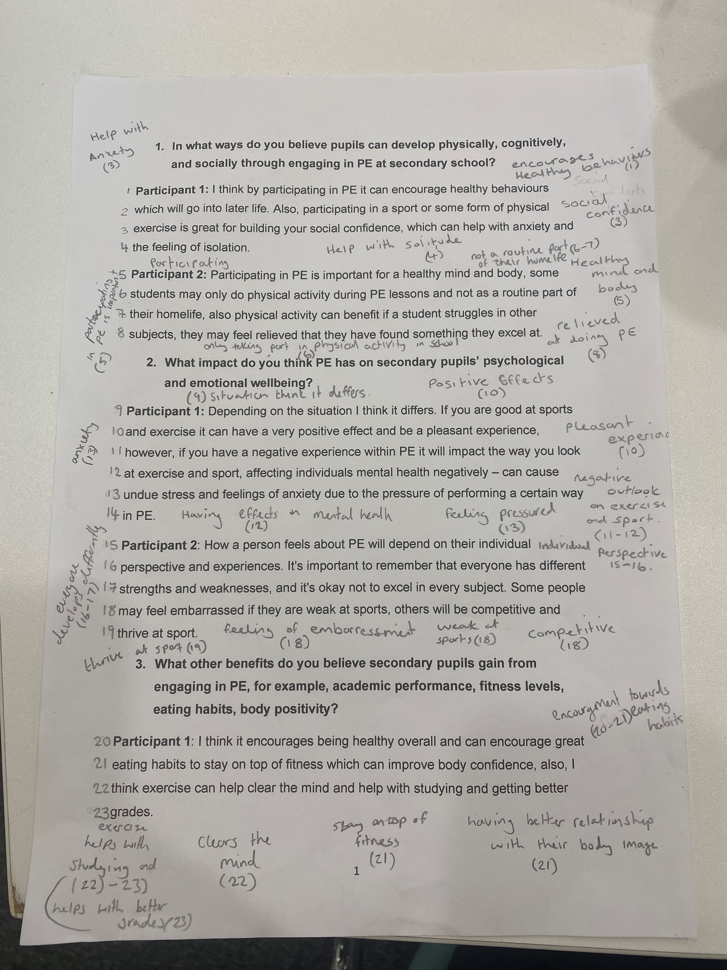
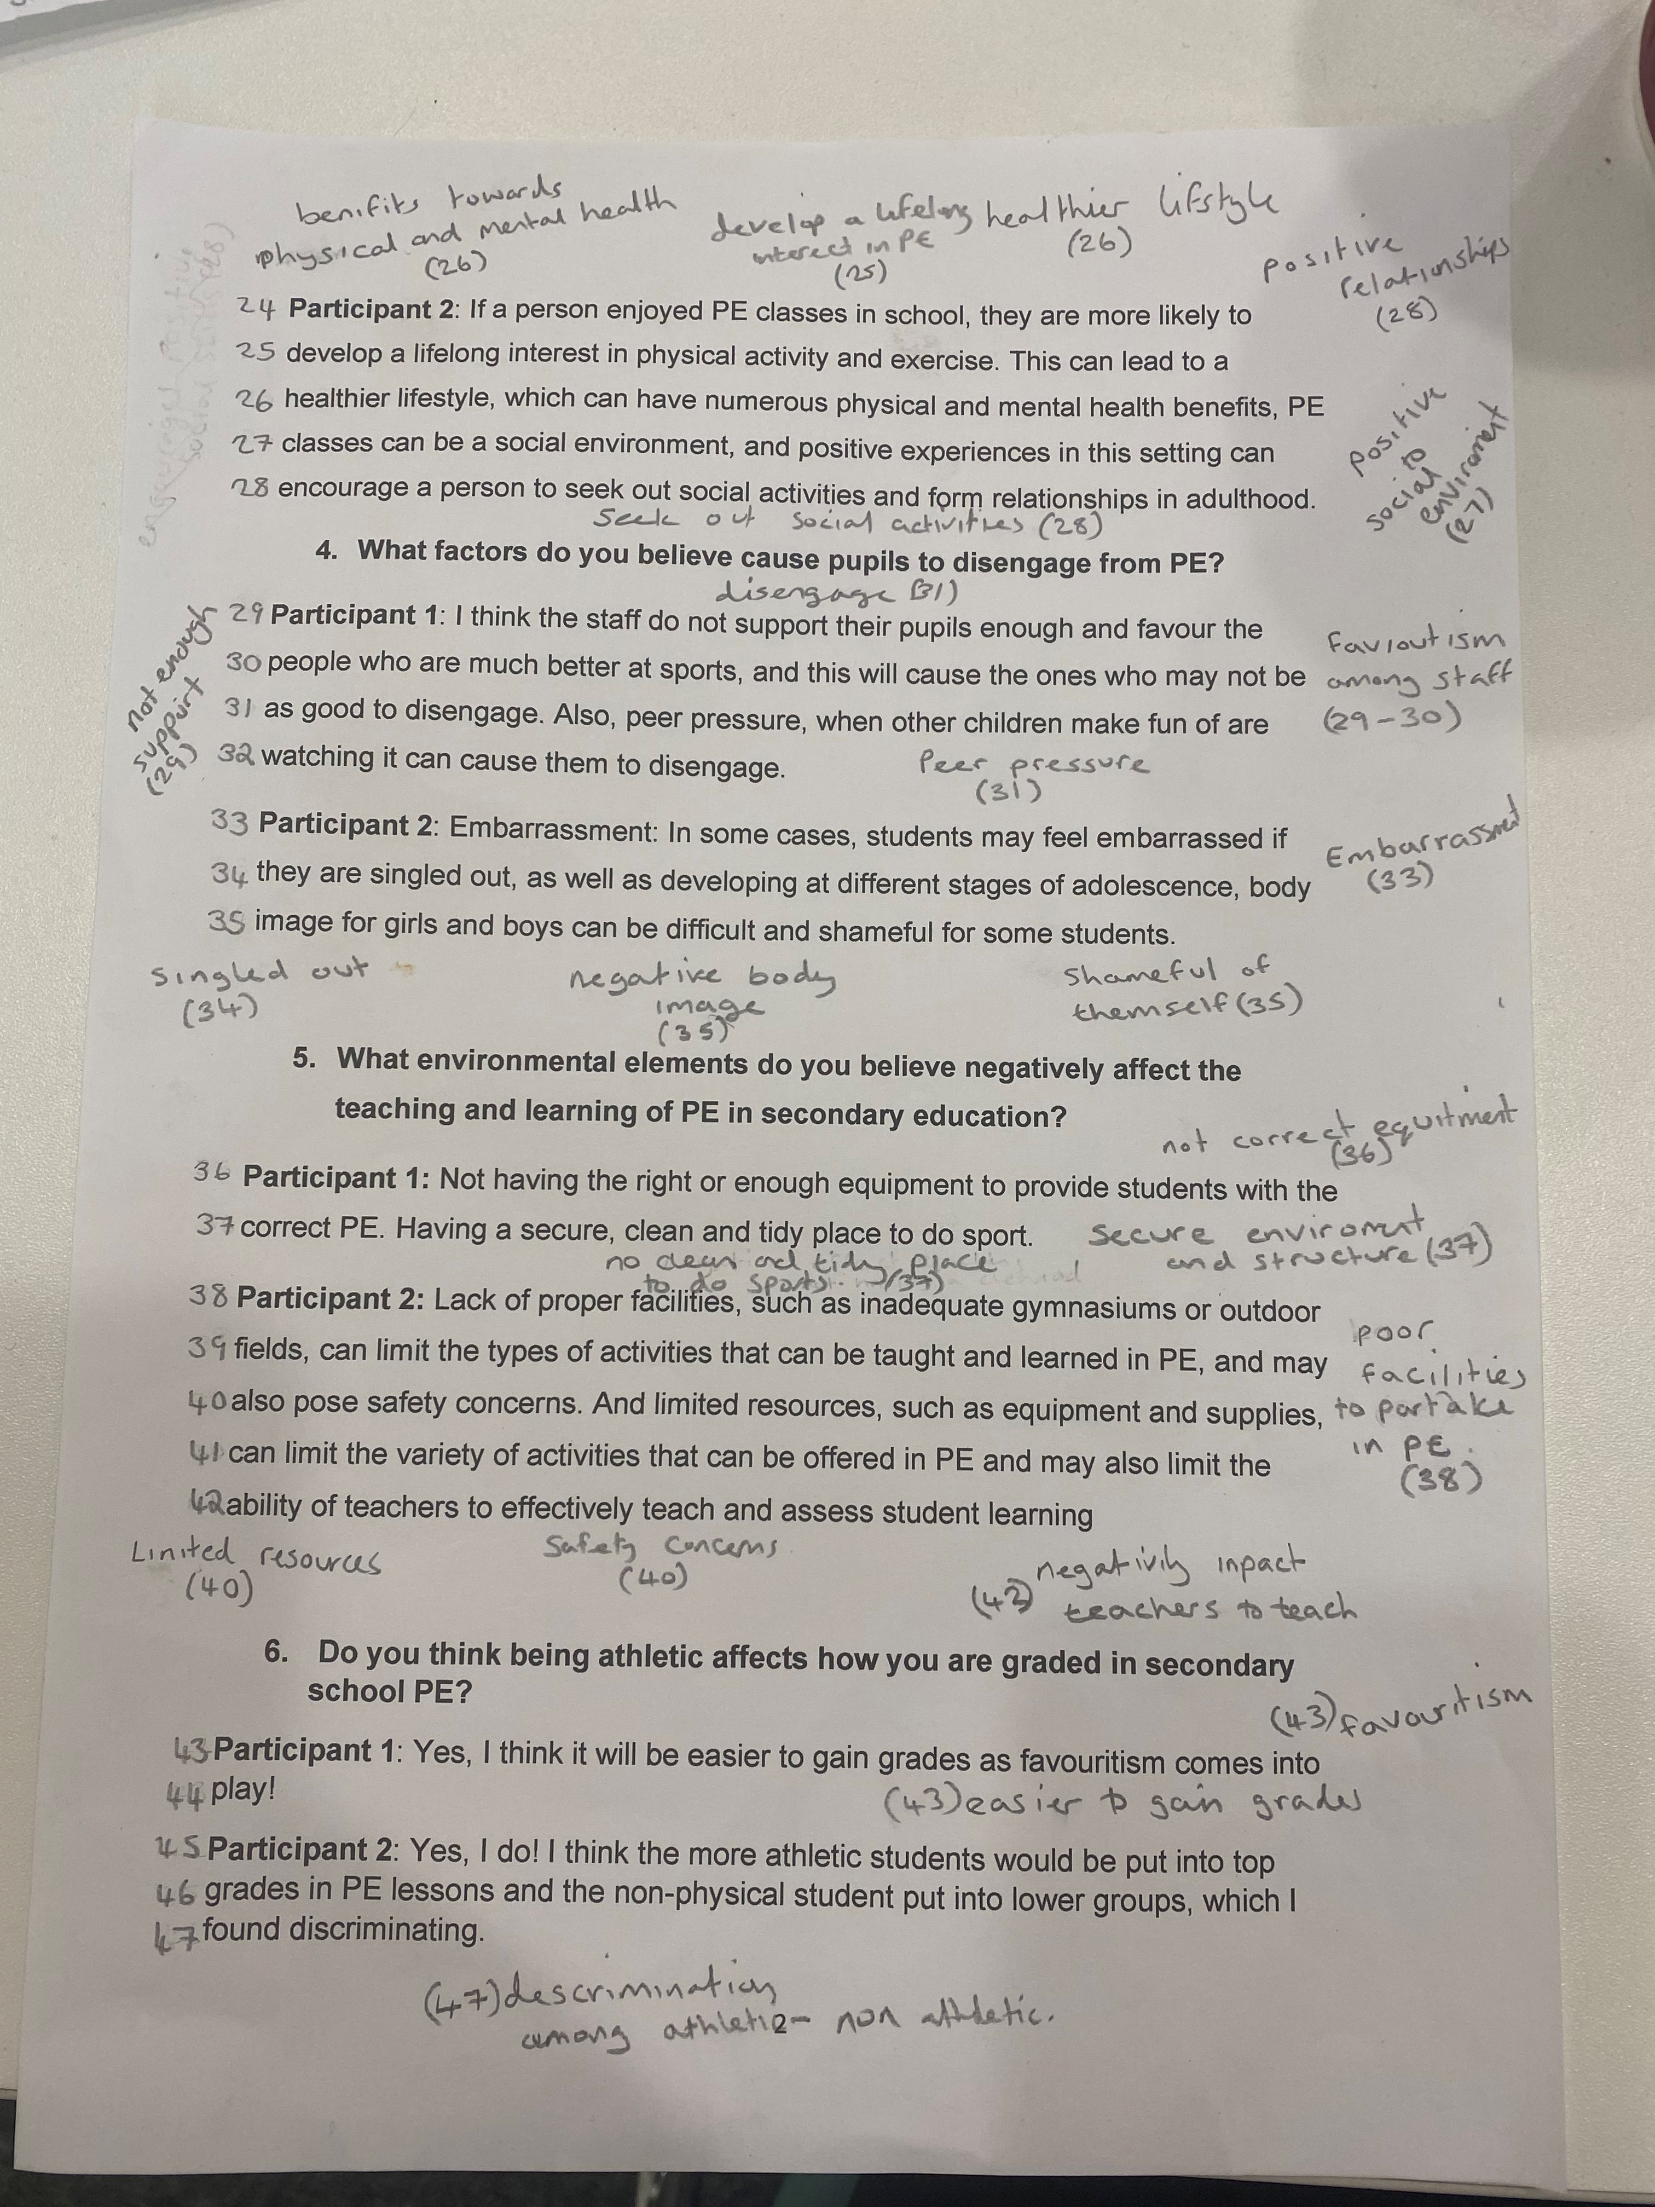
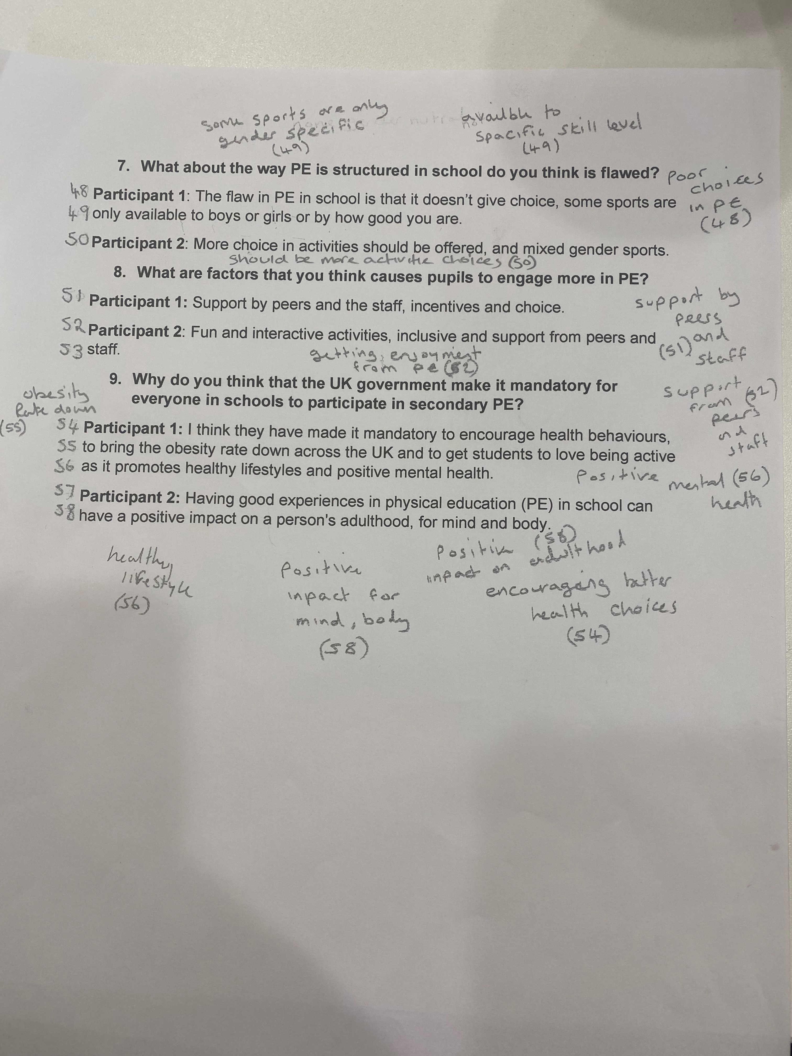

Appendix 7 Code with line numbers.

Encourages healthy behaviours. (1)
Positive impact on adulthood. (58)
Social confidence. (3)
Help with anxiety. (3)
Help with solitude. (4)
Participating in PE is important. (5)
Healthy body and mind. (5)
physical activity only in school. (6)
Not a routine part of their homelife. (6-7)
Feeling of relief. (8)
Depending on situations it differs. (9)
Positive effects. (10)
Pleasant experiences. (10)
Negative outlook on exercise and sport. (11-12)
Having effects on mental health. (12)
Feeling pressured. (13)
Feelings of anxiety. (13)
Individual perspective. (15-16)
Everyone develops differently. (16-17)
Feeling of embarrassment. (18)
Weak at sports. (18)
Competitive. (18)
Thrive at sports. (19)
Encouragement towards eating habits. (20-21)
Stay on top of fitness. (21)
Better relationships with body image. (21)
Exercise helps towards studying and better grades. (22-23)
lifelong interest in physical activities. (25)
Healthier lifestyle. (26)
Physical and mental health benefits. (26)
Positive to social environment. (27)
Seek out social activities. (28)
Positive relationships in adulthood. (28)
Not enough support. (29)
Favouritism among staff. (29-30)
Peer pressure. (31)
Bullying can cause disengagement. (31-32)
Embarrassment. (33)
Singled out. (34)
Negative body image. (35)
Shameful of themselves. (35)
Not right or enough equipment. (36)
Not having secure environment and structure. (37)
Not having clean and tidy place to do sports. (37)
Poor facilities to partake in PE. (38)
Limited resources. (40)
Safety concerns. (40)
Has negative impact on teachers teaching. (42)
Favouritism. (43)
Easier to gain grades. (43)
Discrimination among pupils. (45-47)
Poor choices in PE. (48)
Some sports are only gender specific. (49)
Available to specific skill level. (49)
Should be more activity choices. (50)
Support by peers and staff. (51-52)
Getting enjoyment from PE. (52)
Encourages better health behaviours. (54)
Obesity rate down. (55)
Positive mental health. (56)
Healthy lifestyles. (56)
Positive impact for mind and body. (58)
Appendix 8 Procedures

The participants undertook individual semi-structured interviews each with a separate interviewer. Interviews were carried out in a private room at the UWTSD Carmarthen campus. Responses were live recorded on a mobile phone, and later transcribed. The original recording was then deleted. Data were then combined and following Braun and Clarke’s (2015) Thematic Analysis: A Practical Guide to Research Methods, a thematic analysis carried out to extract common themes from the dialogues.

