Daniels Zelinskis (2104718)
Computer Networks and Cybersecurity
Network Operating System and Services (ACCD5023)
Component 2
Dr Nitheesh Murugan Kaliyamurthy
University of Wales Trinity Saint David

Contents

Abbreviations 4
Information 5
1. Introduction 6
2. Part 1: Practical Work – Teamwork 7
2.1. Task 1: Managing and Maintaining Network Resources Using Network Policy and Security Practices 7
2.1.1 Understanding NTFS and Share Permissions 7
2.1.1.1 NTFS 7
2.1.1.2 Share Permissions 13
2.1.1.3 Accessing the File Share/Server over the Network. 15
2.1.2 Utilizing Group Policy Management Console to better facilitate network object management. 16
2.1.2.1 Configuring User Environment and Computer Environment, ‘Network Group Policy Objects' 16
2.1.2.2 Moderating Access to the Control Panel 16
2.1.2.3 Removing Access to the Command Prompt. 20
2.1.2.4 Restricting Access to Removable Media Drives 21
2.1.2.5 Restricting Software Installs 22
2.1.2.6 Enforcing Password Policy in the ‘accatask.msft’ domain 24
2.2. Task 2: Routing and Packet Filtering within Core TCP/IP Services and Critical Failover/Redundancy Practices 26
2.2.1 Utilizing ARP and Routing Tables 26
2.2.2 Deploy Core Services (FTP Server) 27
2.2.3 Installing and Configuring the Routing and Remote Access Service 34
2.2.4 IP Packet Filtering 41
2.2.4.1 Stopping ‘anyone’ in PrivateNet1 from Pinging the Router Firewall Service 41
2.2.4.2 Filter 2: Restrict Access to FTP Service running on Server2 to only hosts in PrivateNet2. 43
3. Part 2: Observational Tasks/Work 48
3.1 Small Office and Home Office 48
3.2 Failover Cluster for high availability systems/services 49
4 Reflection 50
5. References 51

Abbreviations
Abbreviation | Definition
TCP | Transmission Control Protocol
IP | Internet Protocol
NTFS | New Technology File System
GPO | Group Policy Object
VB | Virtual Box
ARP | Address Resolution Protocol
FTP | File Transfer Protocol
SSL | Secure Sockets Layer
LAN | Local Area Network
SOHO | Small Office/Home Office
HA | High Availability
CA | Continuous Availability
OS | Operating System

Information
Name of the Team: Team NOS

Team Members:
Student Name | Student ID
James Frew | 2108660
Daniels zelinskis | 2104718
ALEX TZAFOS | 2104846
Josh Naylor | 2114259

Team Evaluation
 | Student 1 | Student 2 |  | Student 3 |  | Student 4
Student 1 | 5 |  | 5 |  | 5 |  | 5
Student 2 | 2 |  | 3 |  | 2 |  | 2
Student 3 | 4 |  | 5 |  | 4 |  | 5
Student 4 | 3 |  | 4 |  | 3 |  | 4

Comments on Team Evaluation:
Student 3: He did his job and helped to make the last decision.
Student 4: He did his job well and created a good atmosphere in the team.
Student 2: I did my part of job, because of attendance, I had to lower my evaluation.
Student 1: He did most of the work and helped us if something was not clear.

1. Introduction
In contemporary society, computer networks have become an essential component for many companies and organisations, enabling the exchange of information, cooperation, and the distribution of resources among various sites. However, managing and preserving network resources can be an enormous one, requiring a thorough comprehension of network policy, security protocols, and essential TCP/IP services.
This study seeks to demonstrate the effective manage and maintenance of network resources applying suitable policies and drafting security and redundancy practices.

2. Part 1: Practical Work – Teamwork

2.1. Task 1: Managing and Maintaining Network Resources Using Network Policy and Security Practices

2.1.1 Understanding NTFS and Share Permissions

2.1.1.1 NTFS

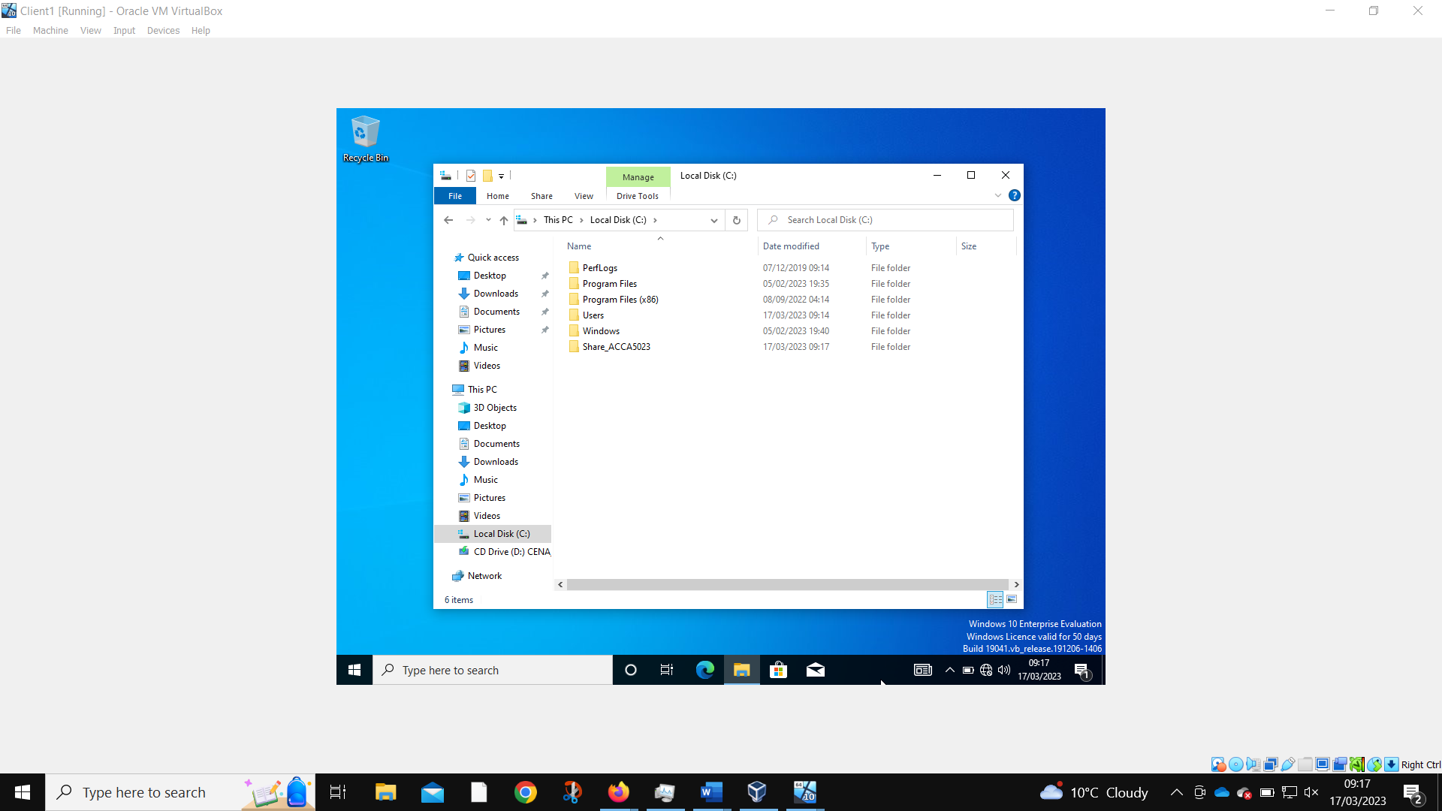The folder that will be used for sharing files is created.
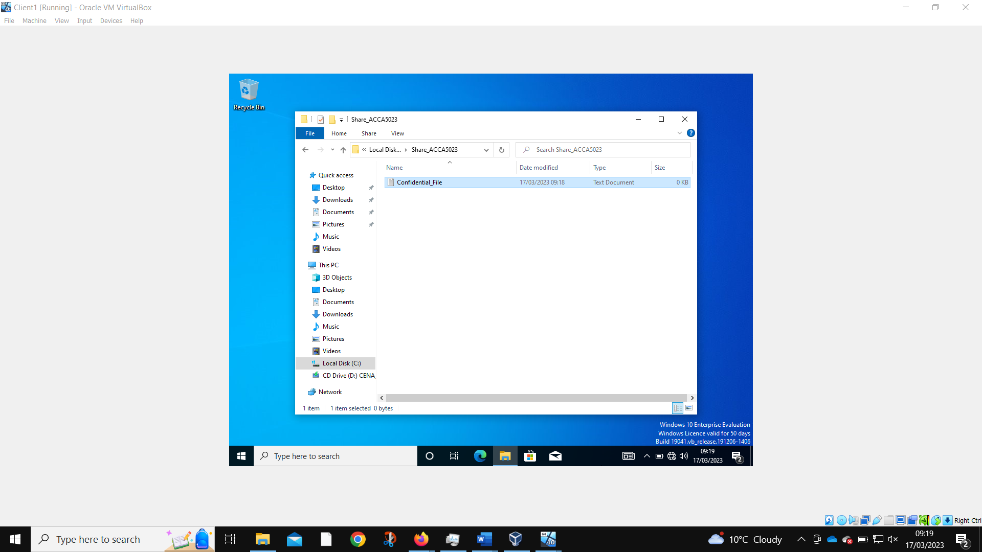A “confidential” file is created inside this folder.
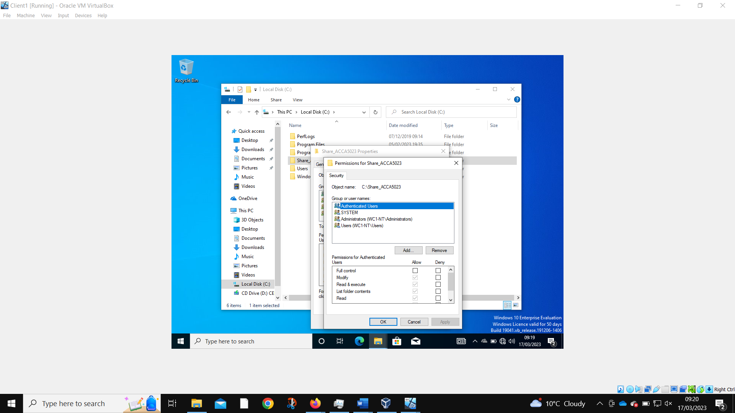This is a list of the default users that have access to the file.
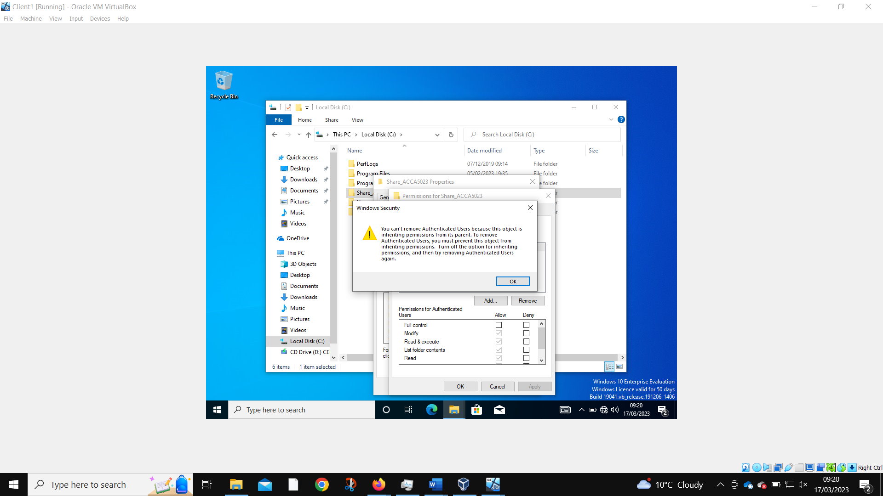When trying to remove the Authenticated Users permissions, we first must remove inherited permissions.
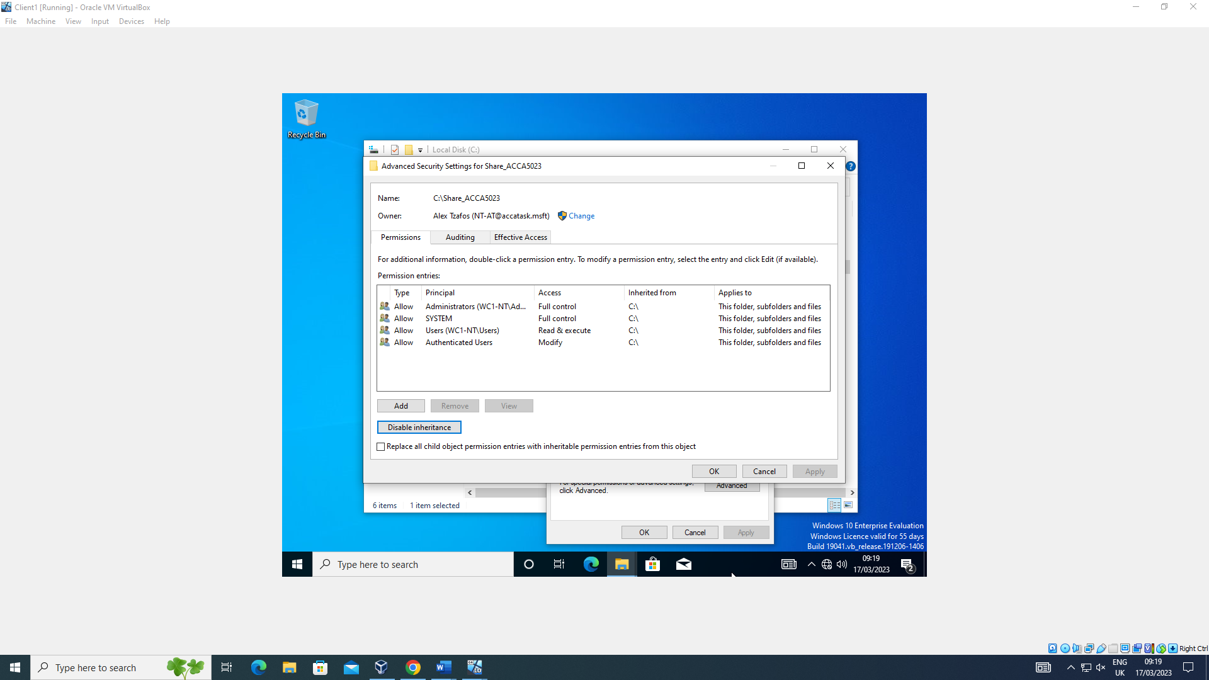Using the advanced security settings, we can turn off the file’s inheritance.
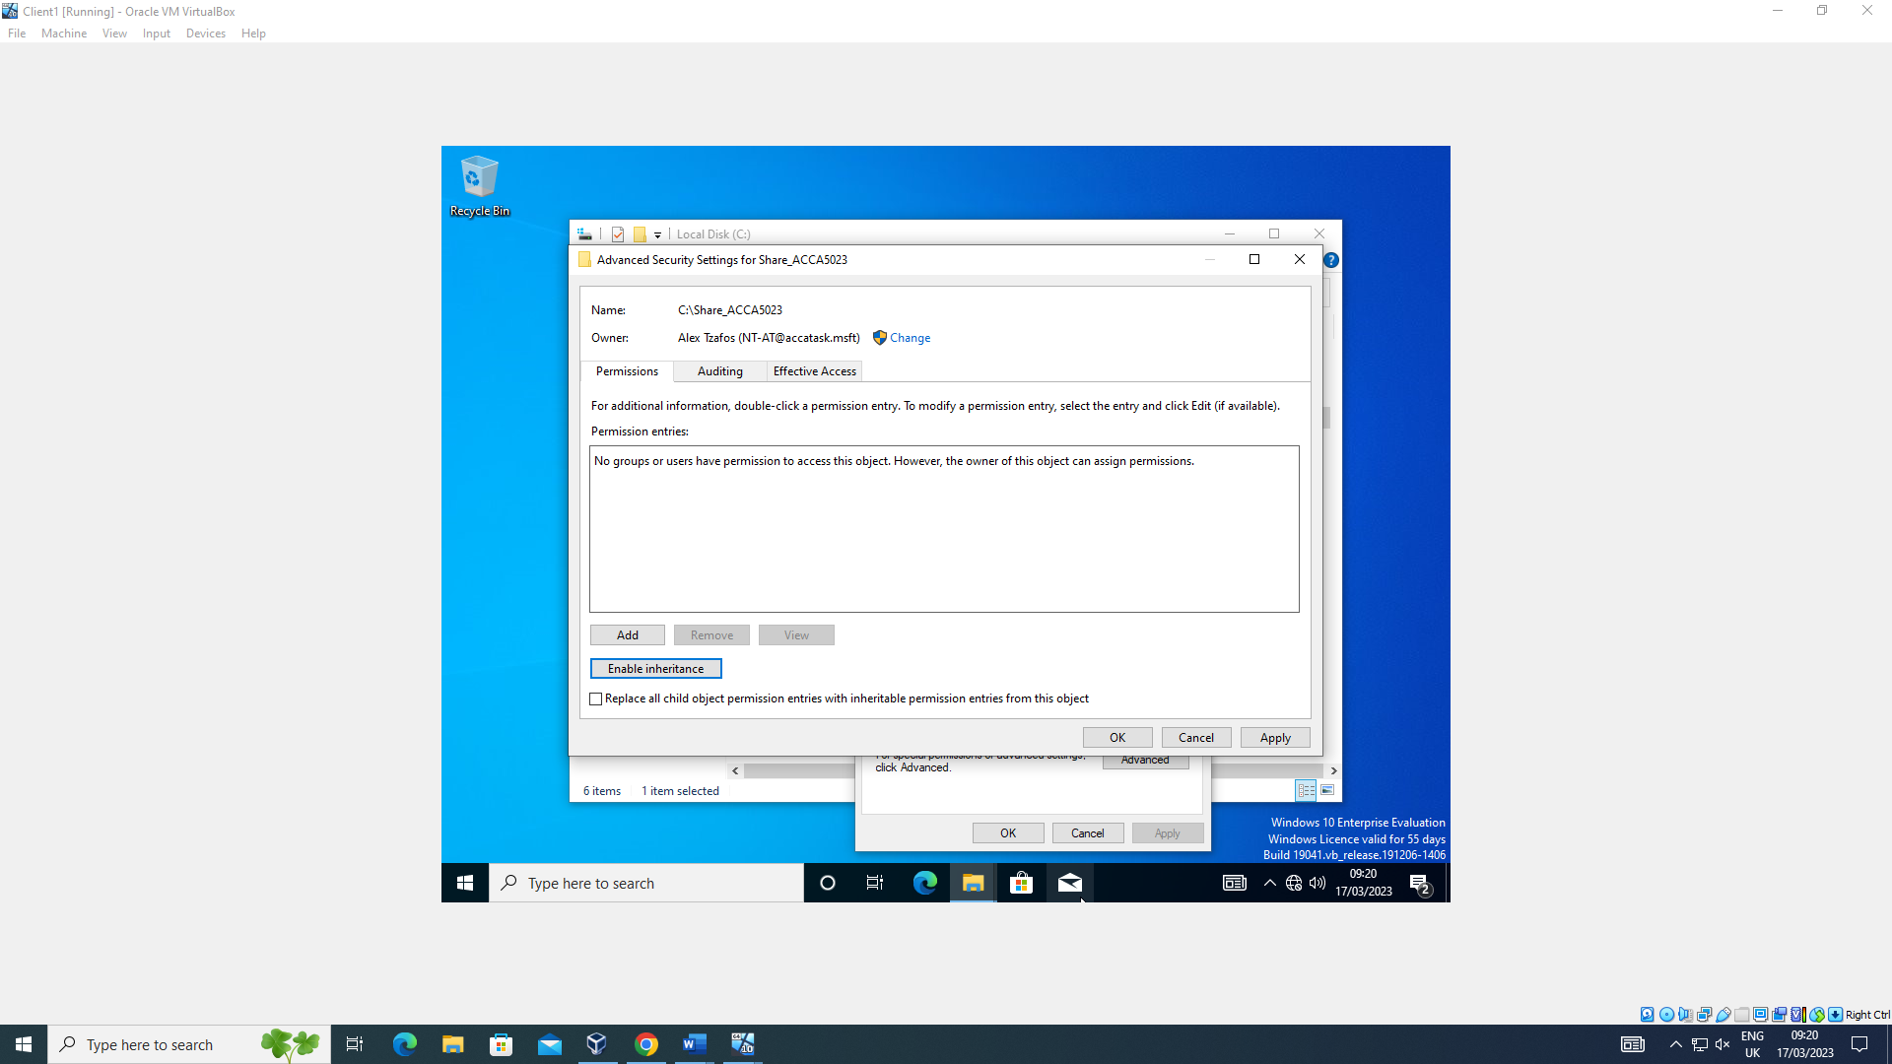
Allows the removal of inherited user permissions on the folder.
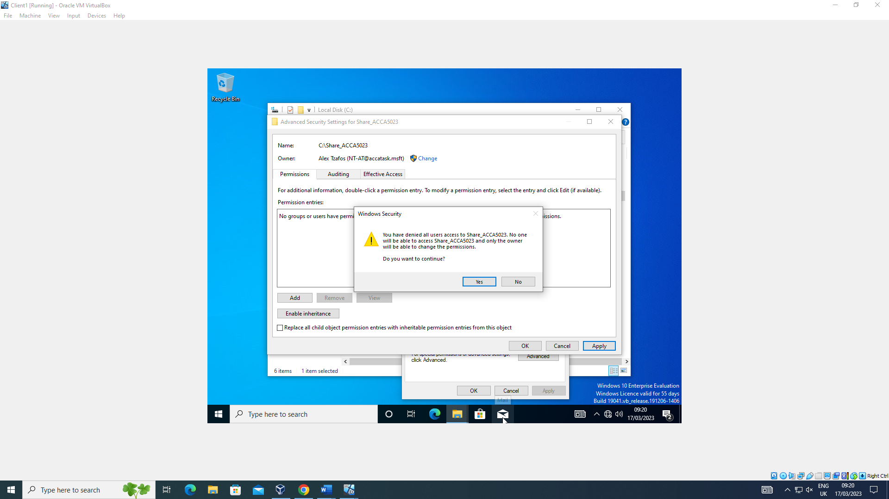
This prevents all but the folder owner from accessing it.
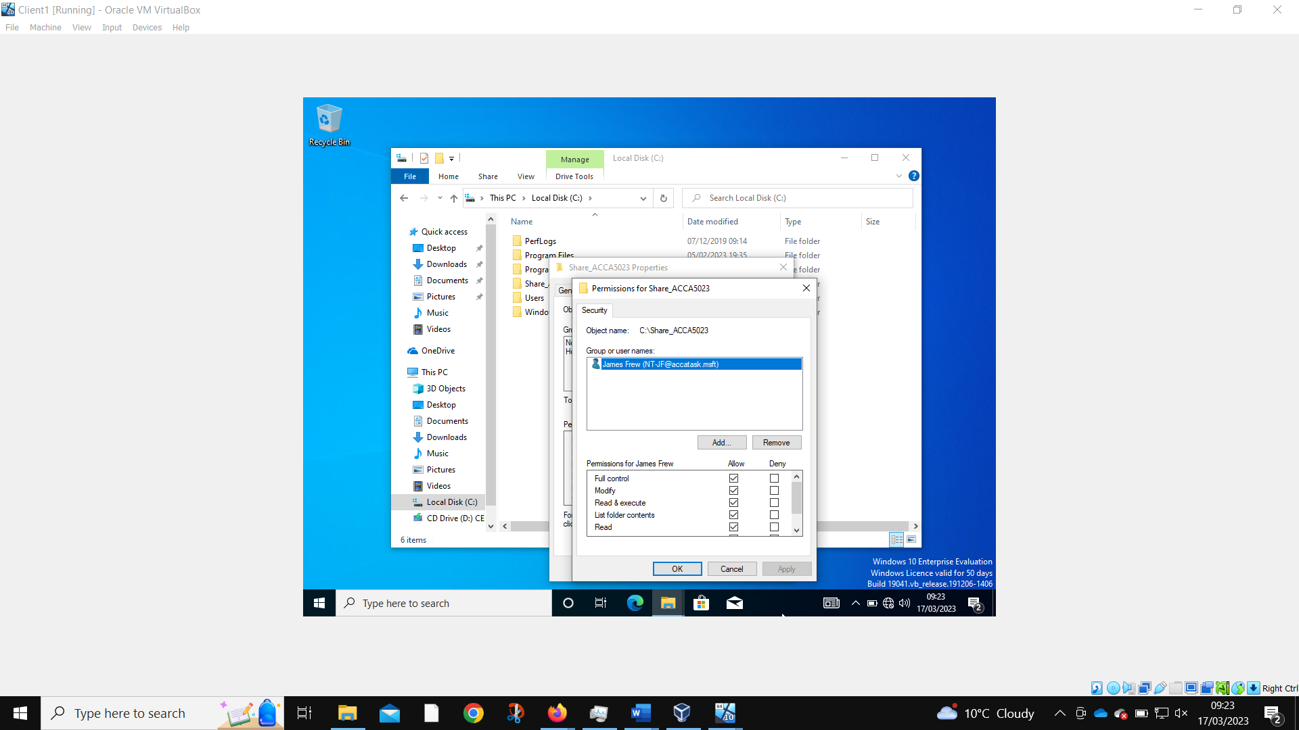
The desired account is added to the permissions list with full control allowed.
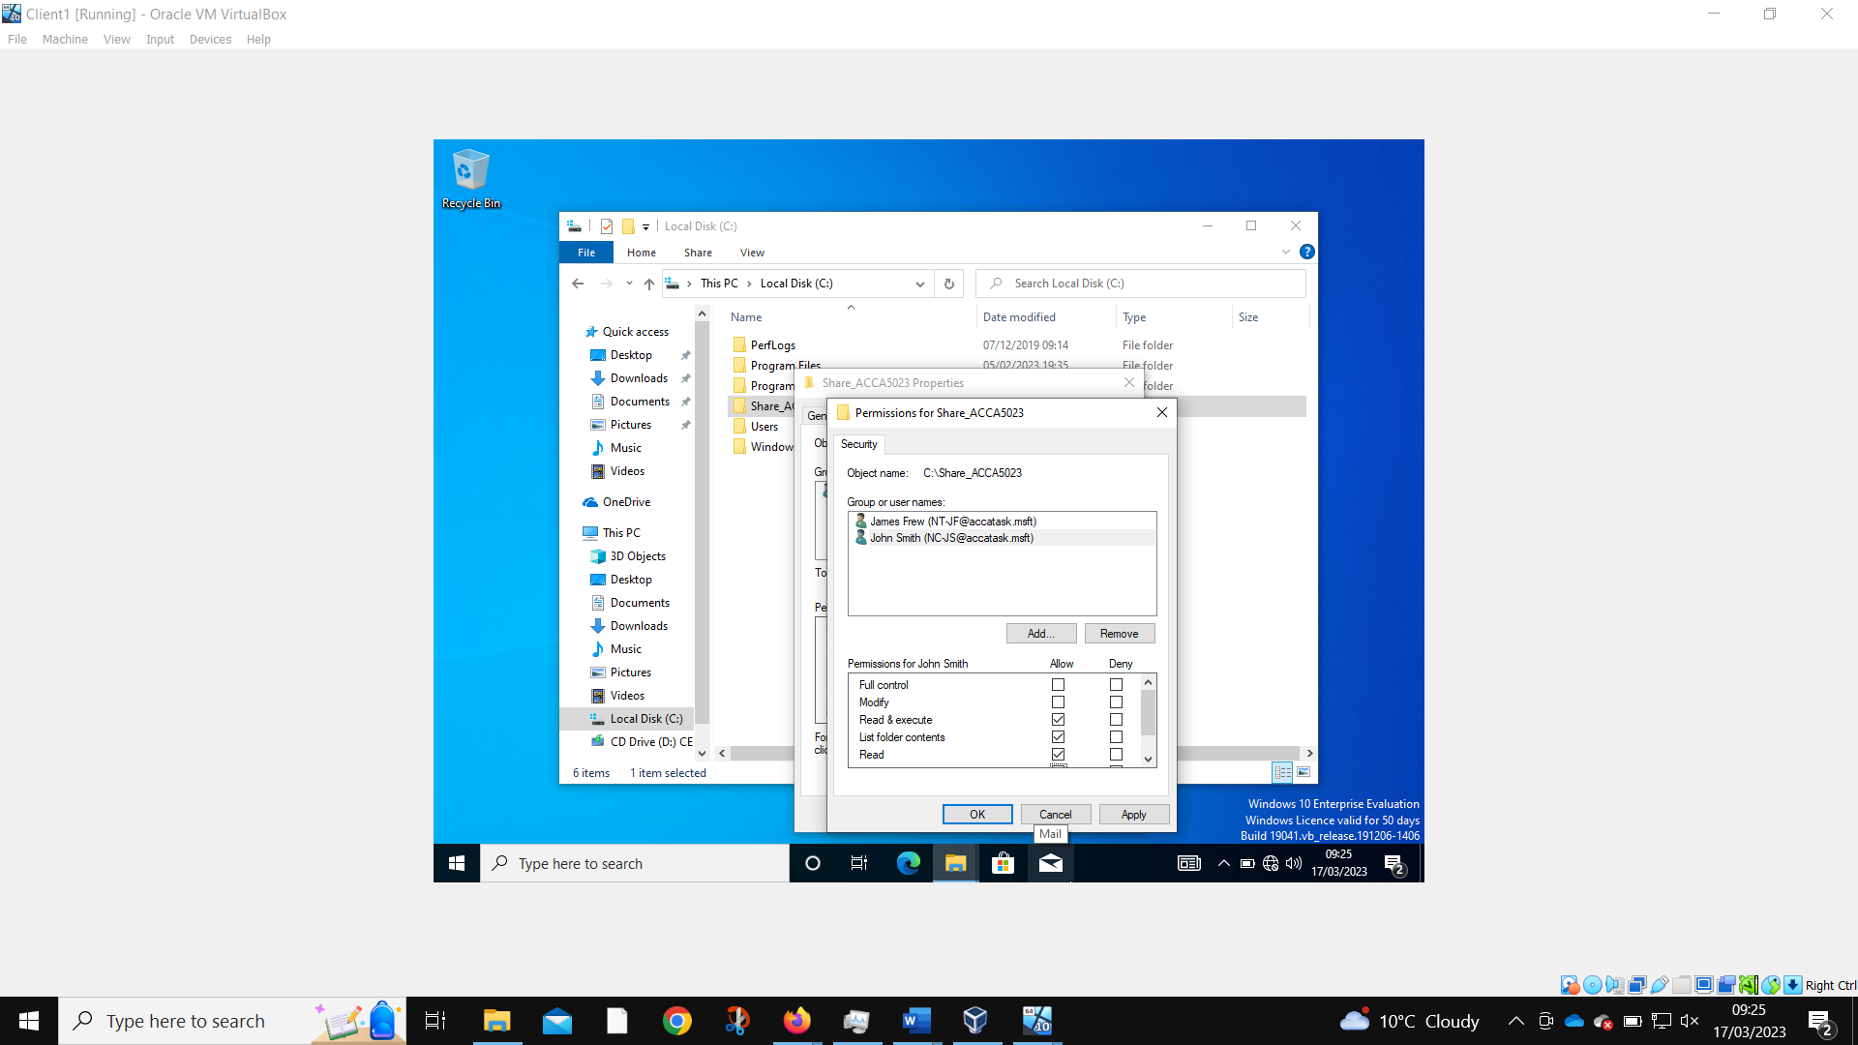
Another user can be added to the folder, but with fewer permissions.
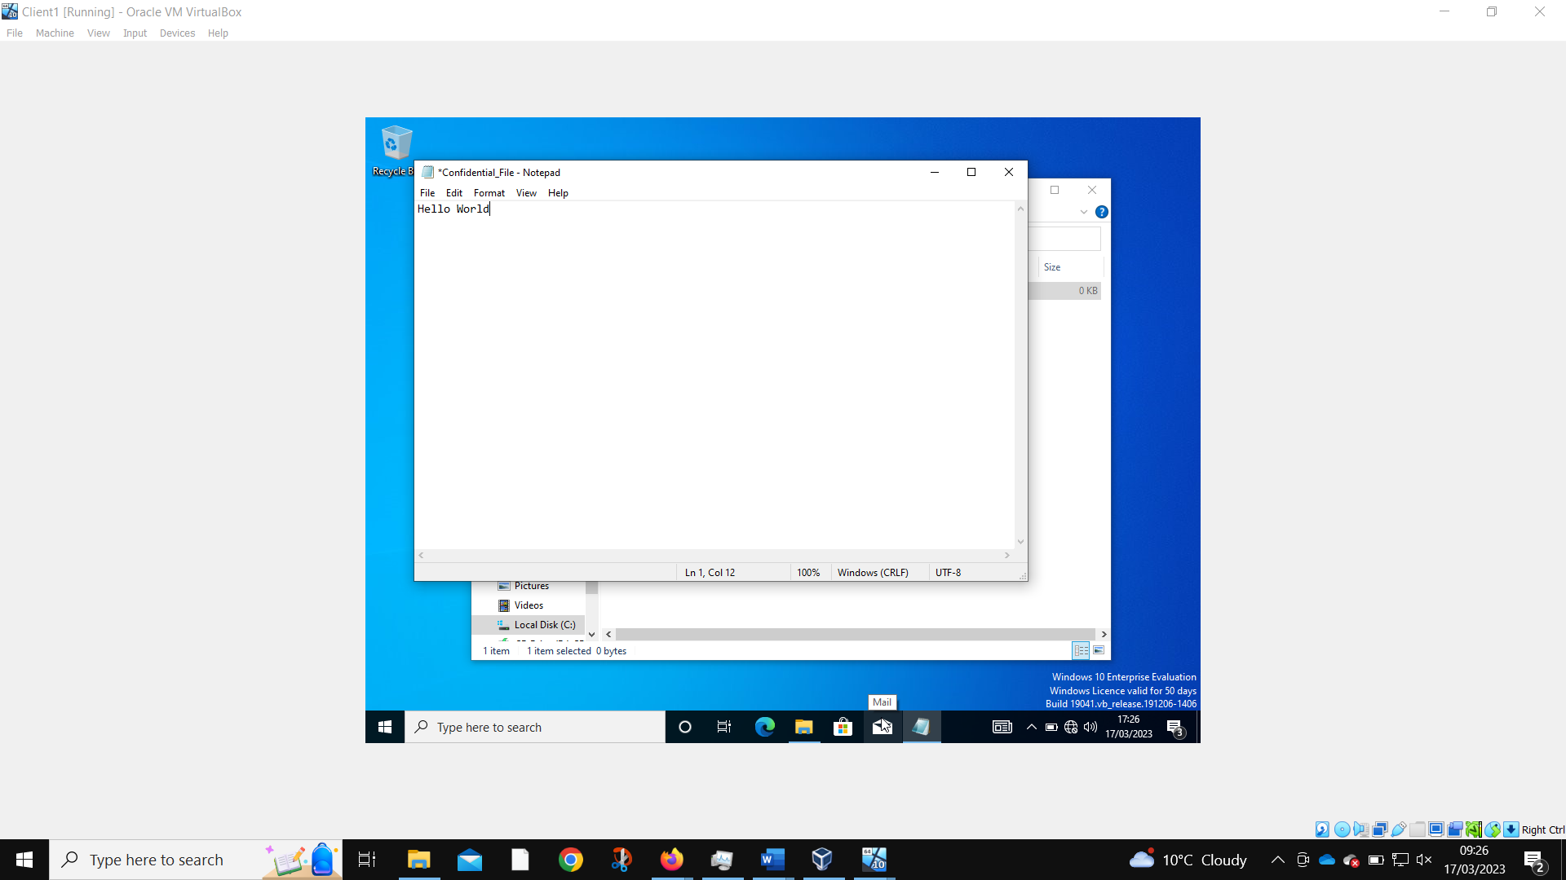
Only the admin account can now edit the file.
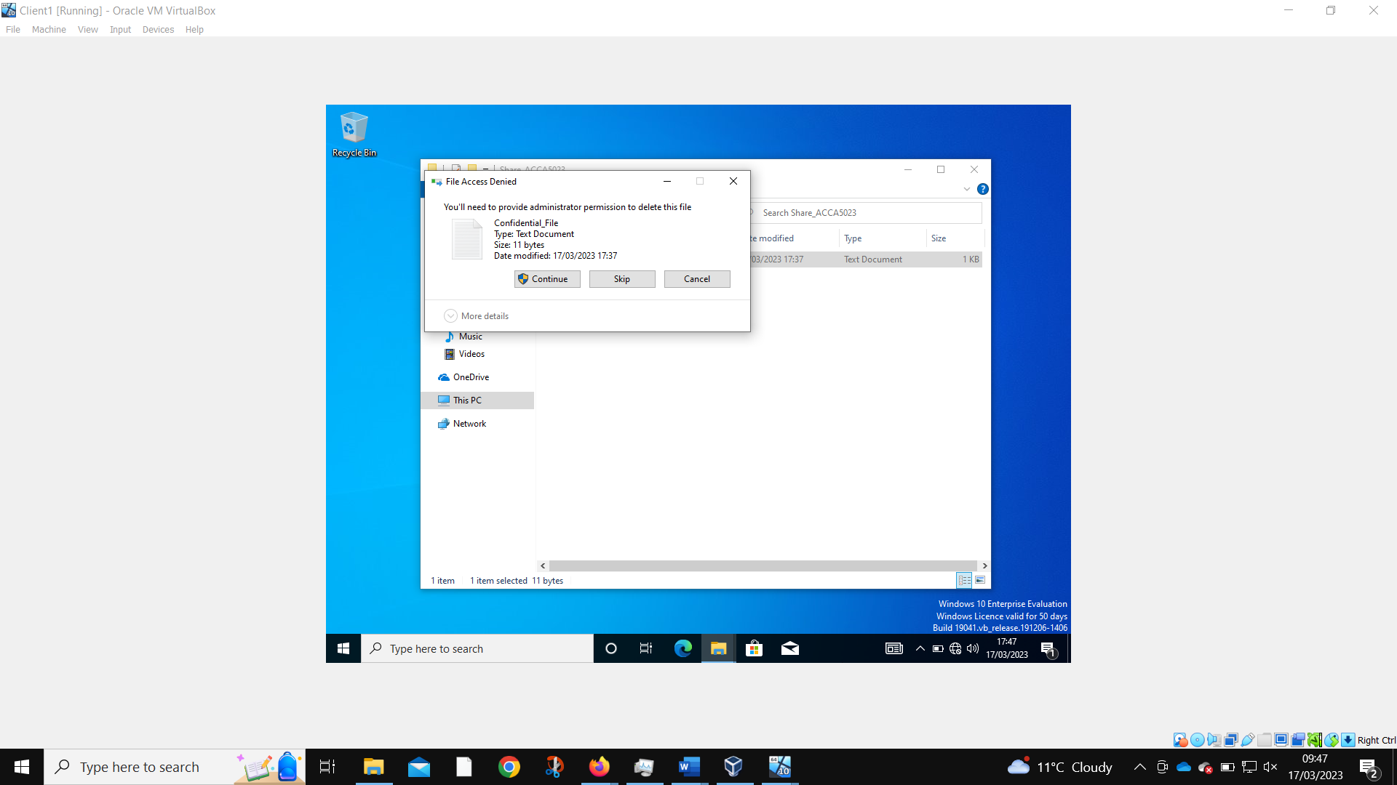
When the non-admin tries, they are required to give proper authentication.

2.1.1.2 Share Permissions

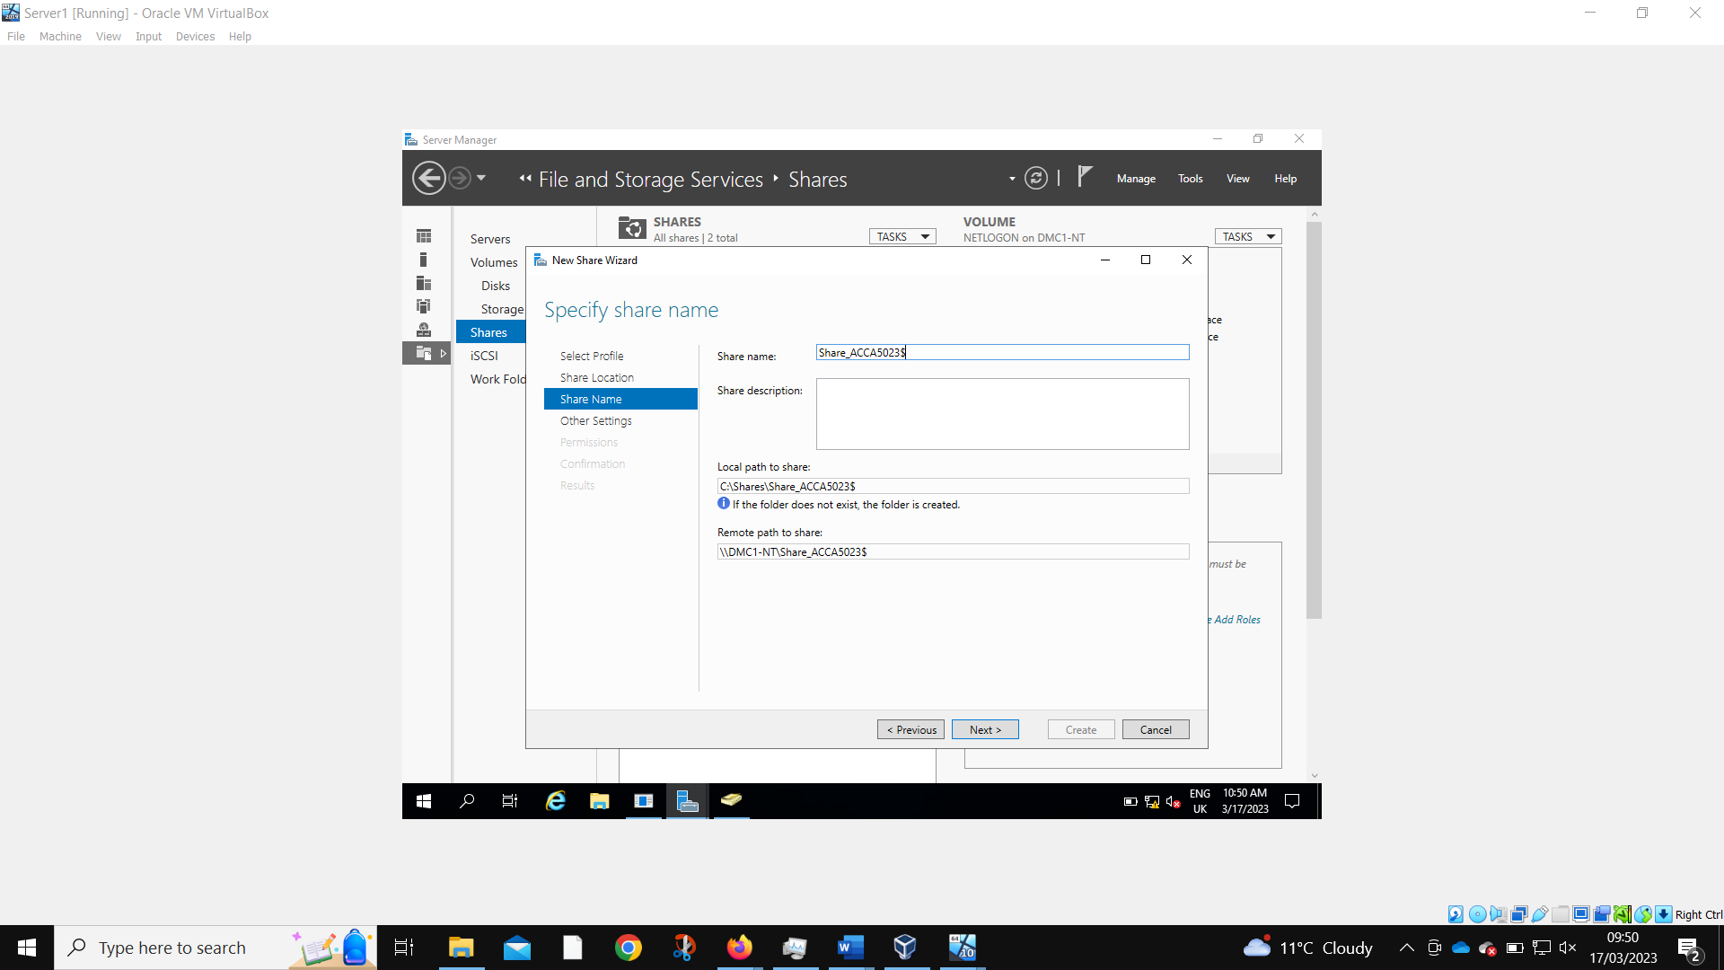
Share permissions are created on Server 1. The remote path name in the worksheet was wrong so has been corrected here.
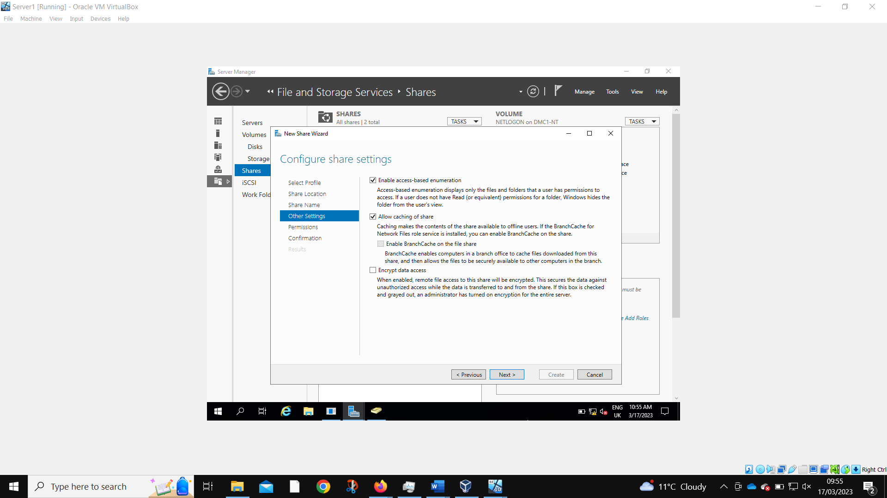
These settings will only show a user file that they have access and cache those files so they can still be accessed when offline.
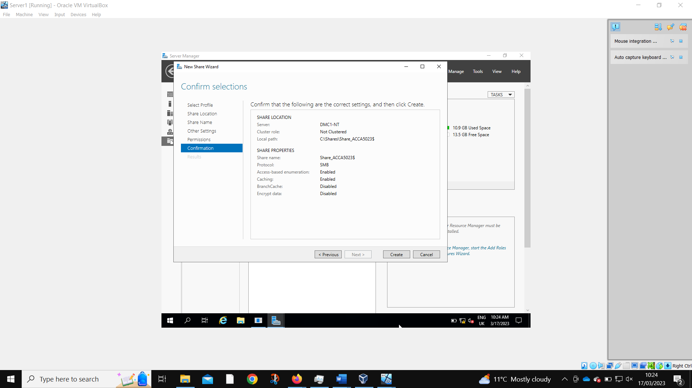
Confirmation of the desired settings.
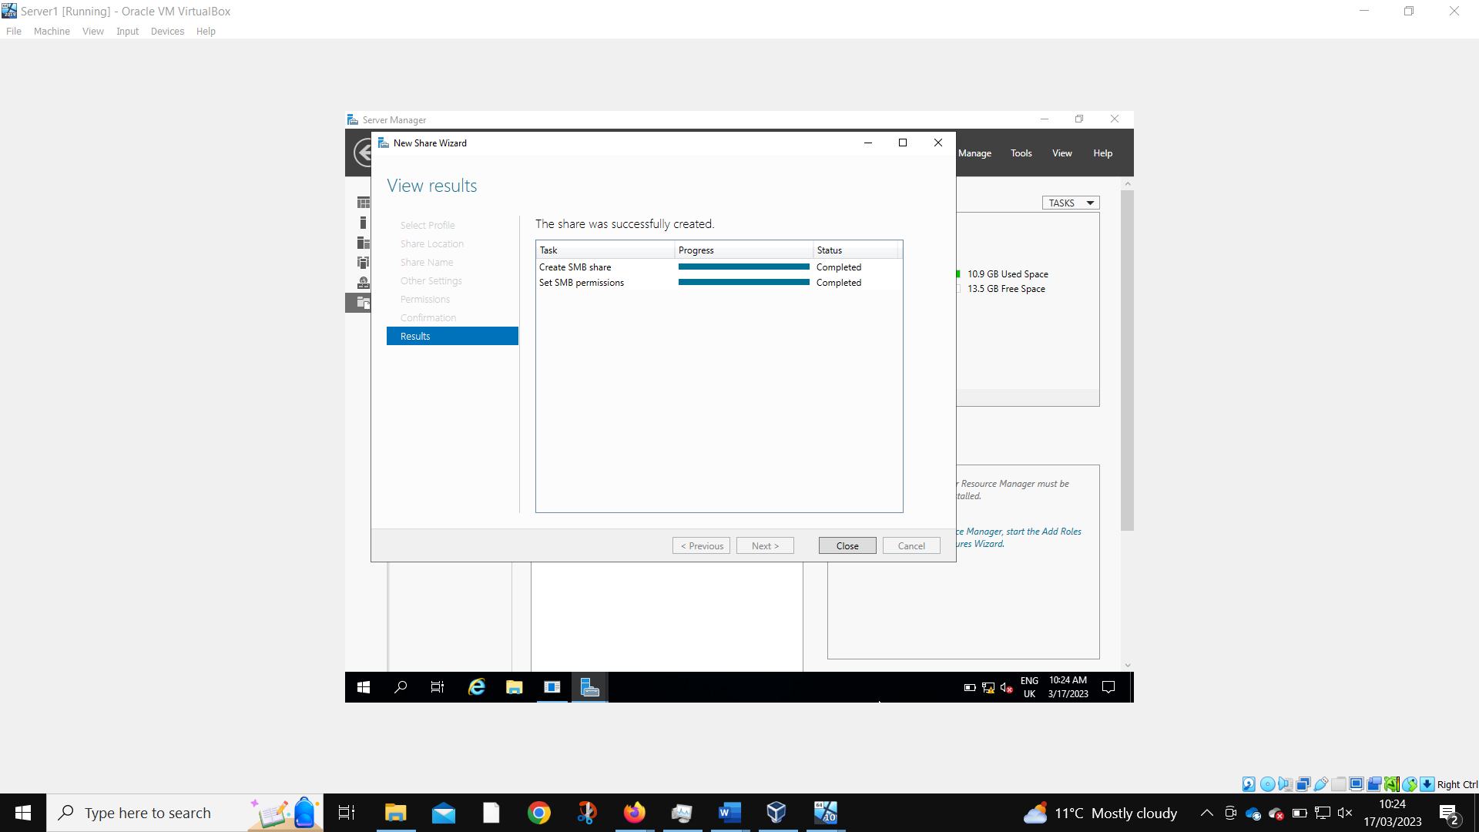
Share successfully created.

2.1.1.3 Accessing the File Share/Server over the Network.

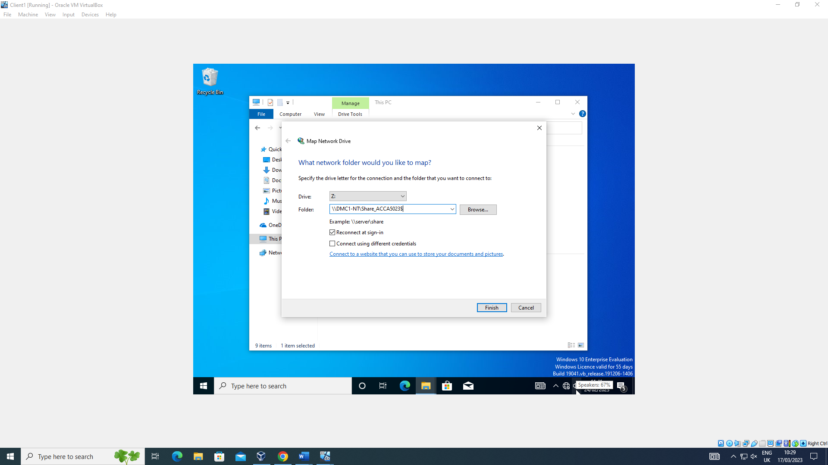
Mapping the network drive is required to access the share folder.
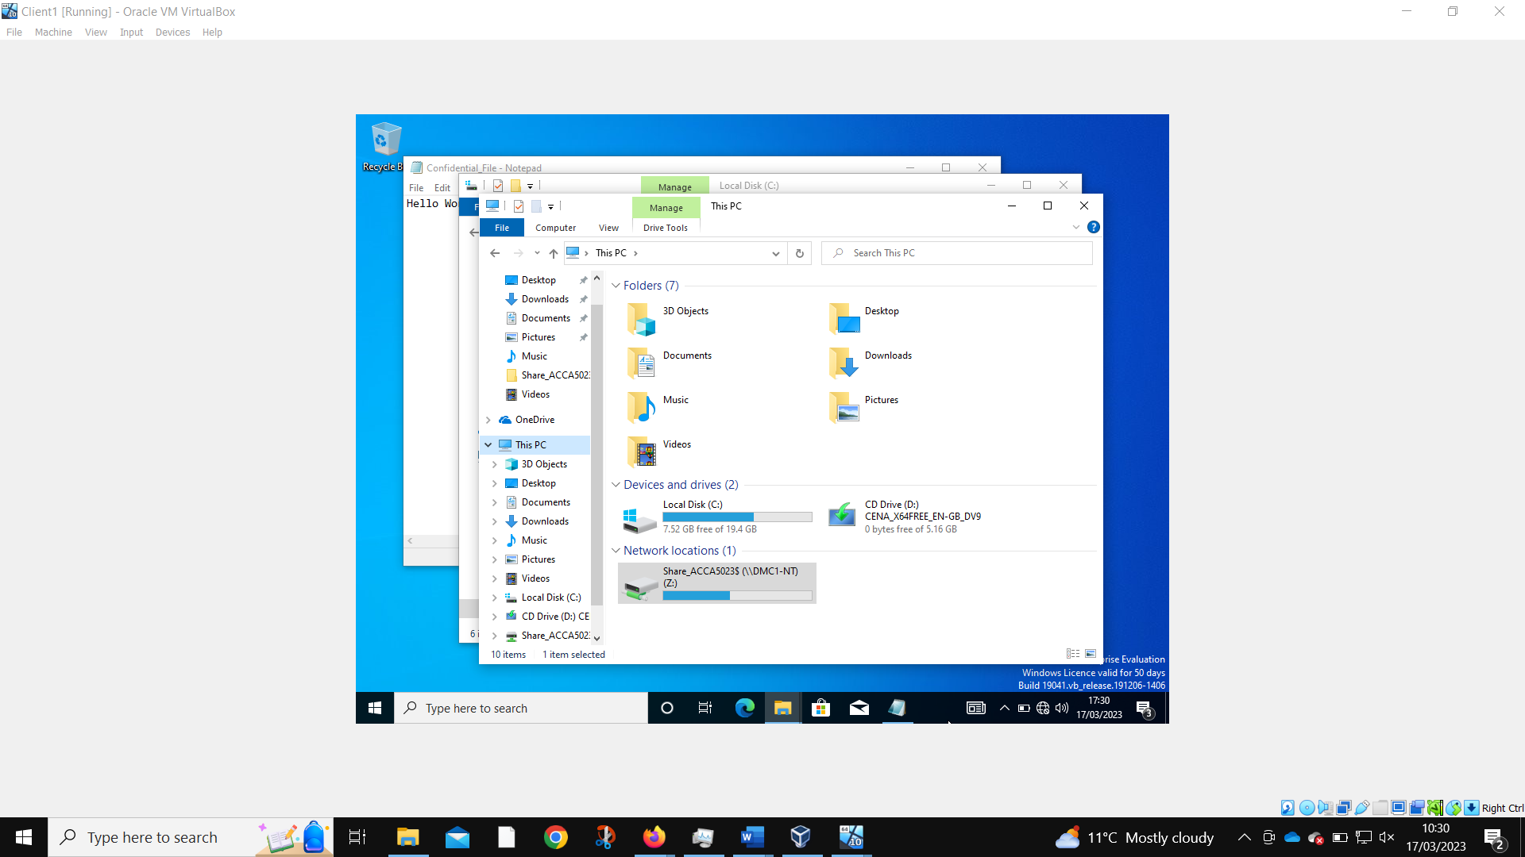
The share folder is now present on this local machine.

2.1.2 Utilizing Group Policy Management Console to better facilitate network object management.

2.1.2.1 Configuring User Environment and Computer Environment, ‘Network Group Policy Objects'

2.1.2.2 Moderating Access to the Control Panel

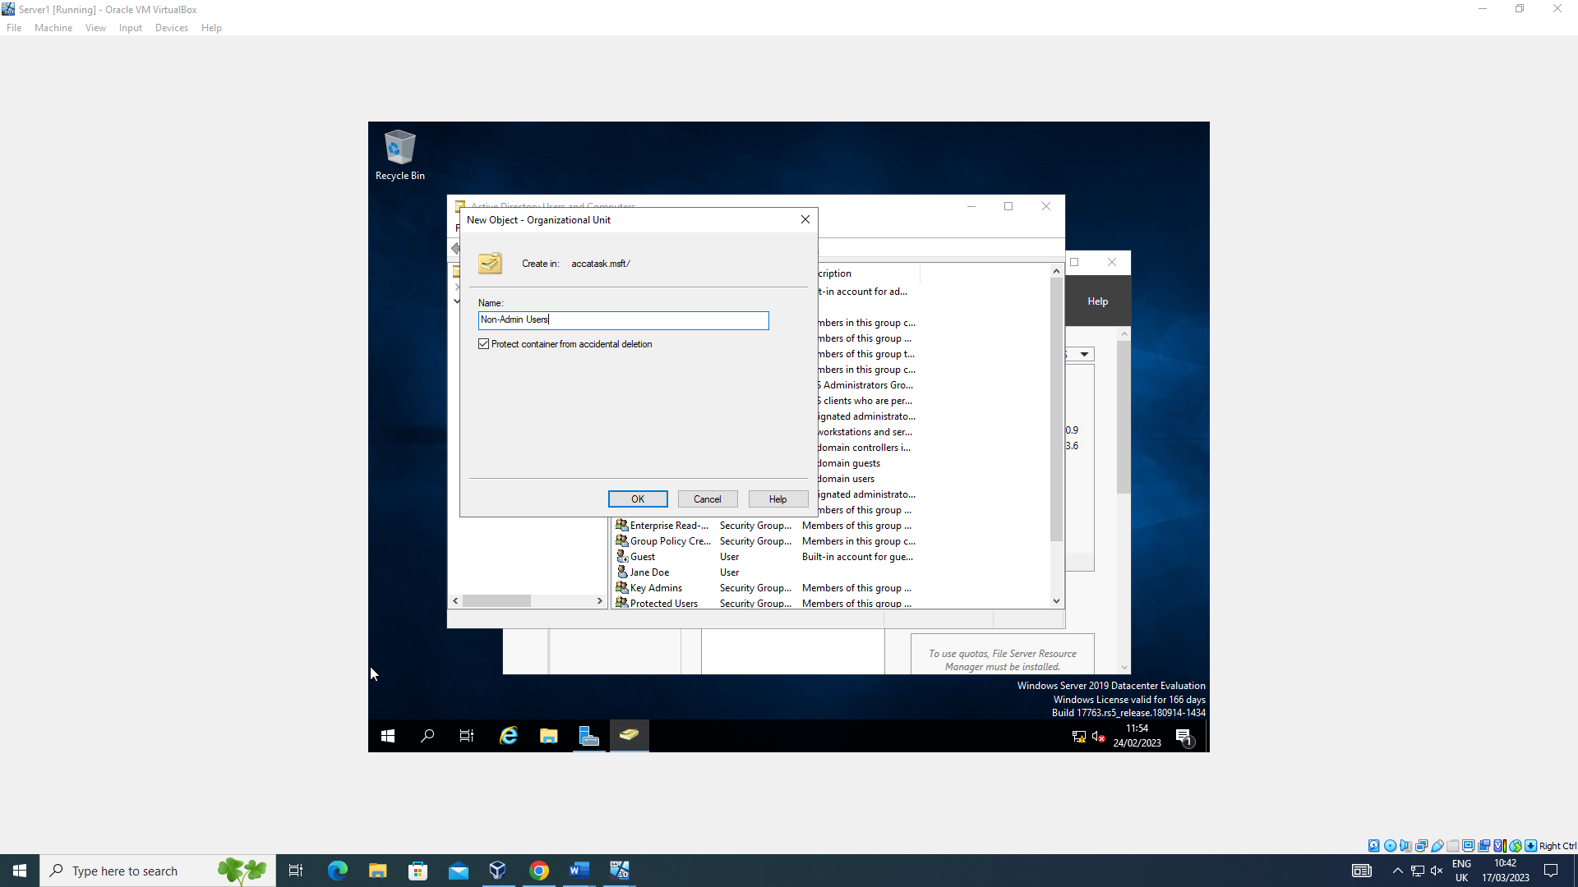
A new non-admin users organizational unit object is created to set group policies.
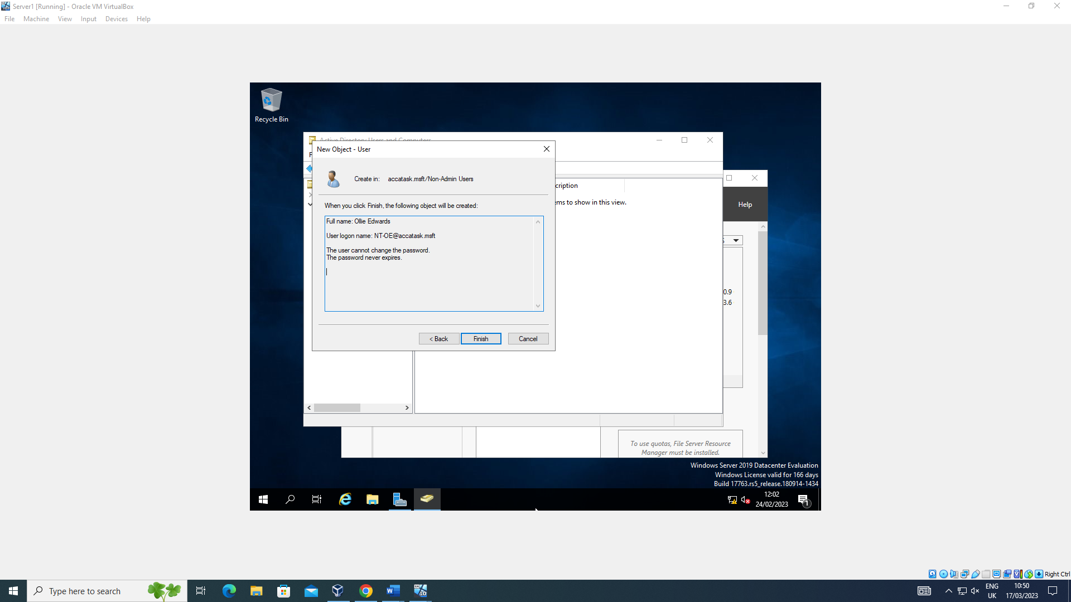
A new user is created to test the working functionality of the policy.
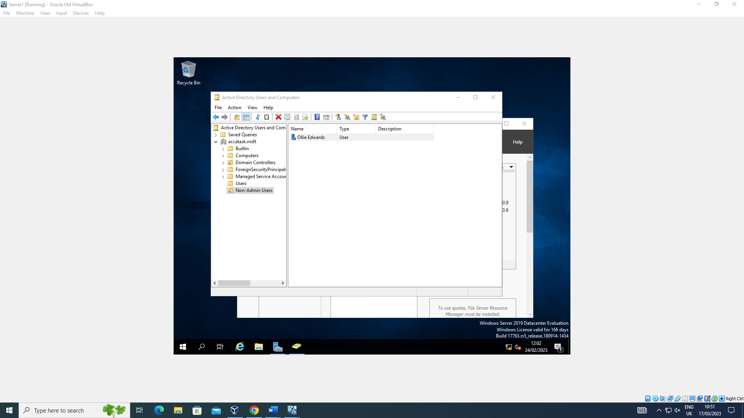
This user resides inside the newly created folder.
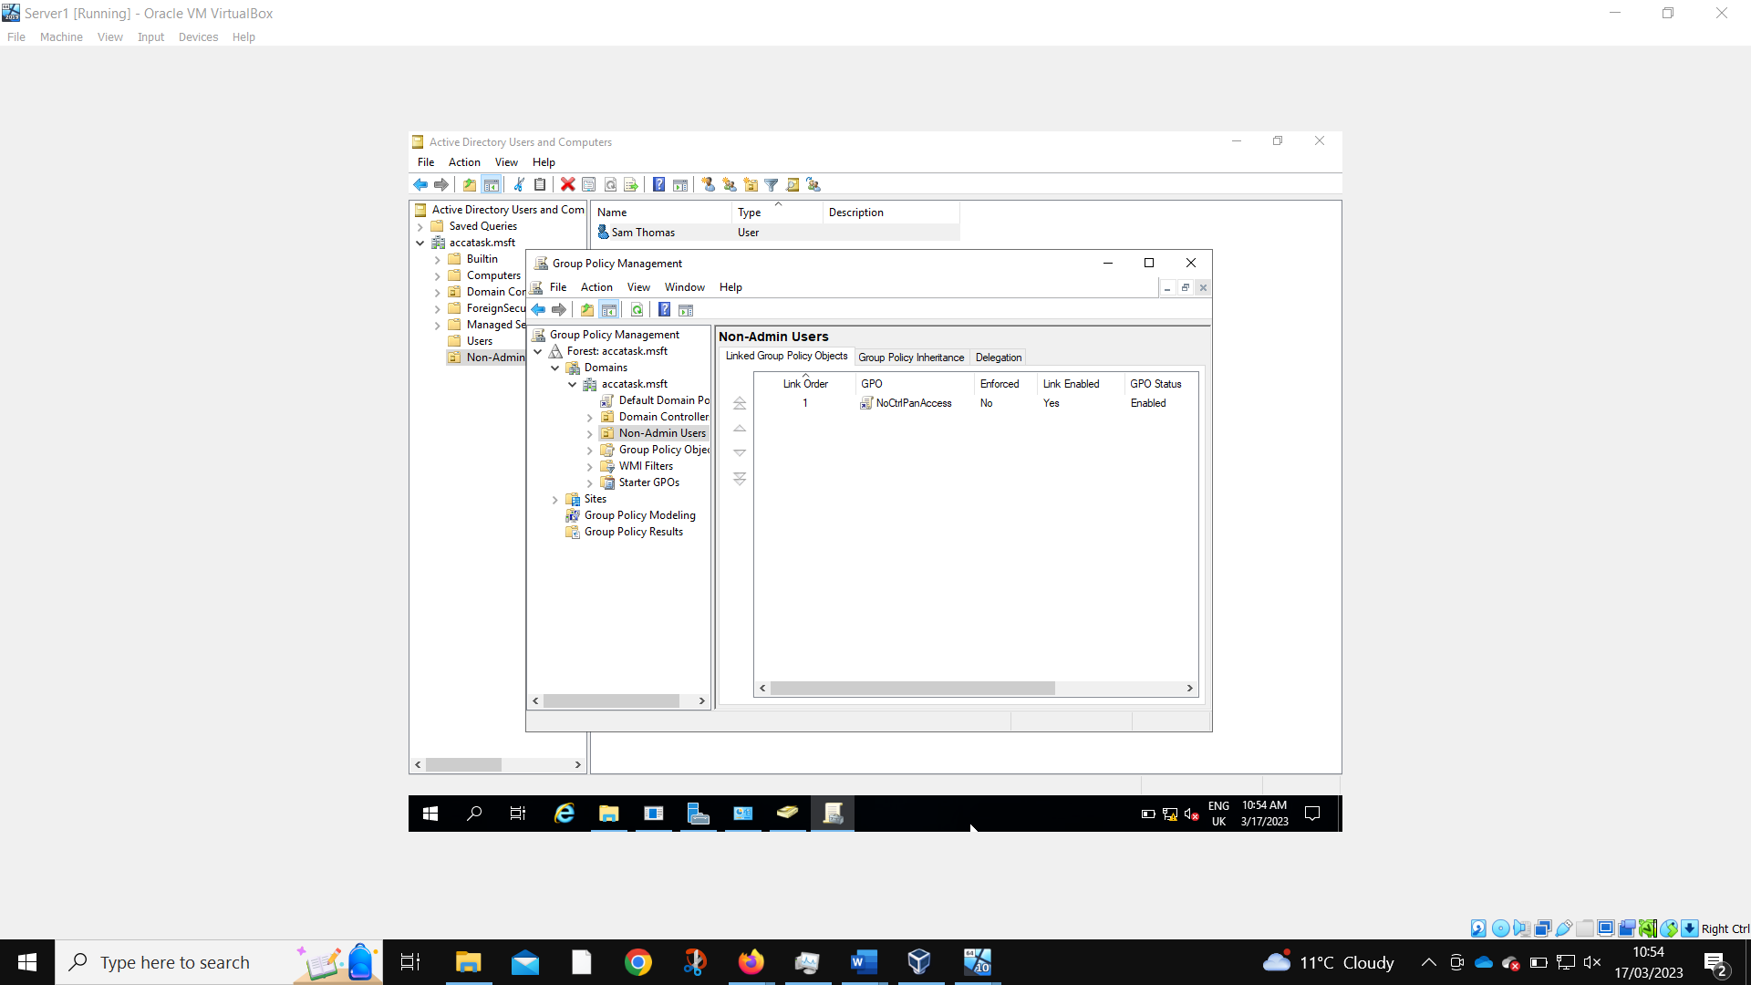
A new GPO is created to prevent access to the control panel.
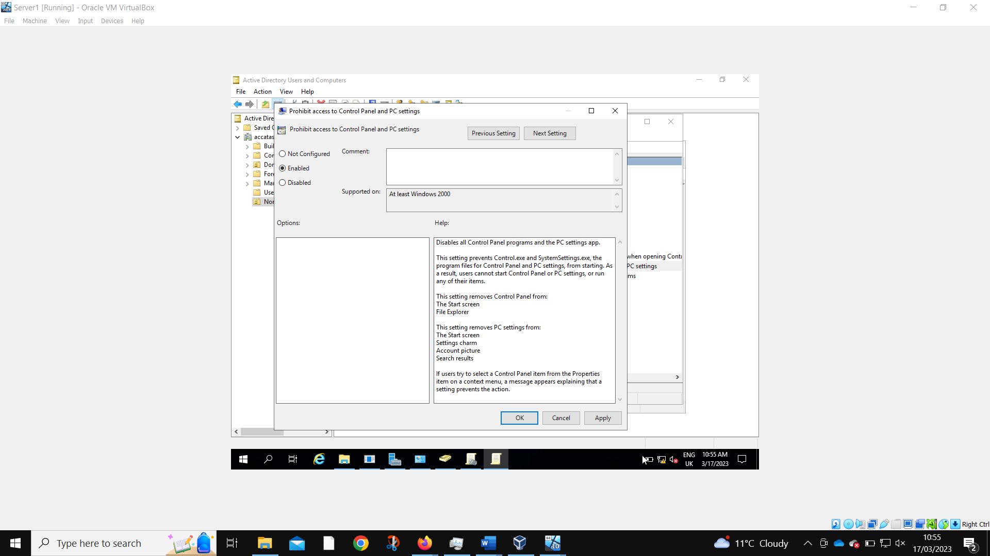
As is configured to do.
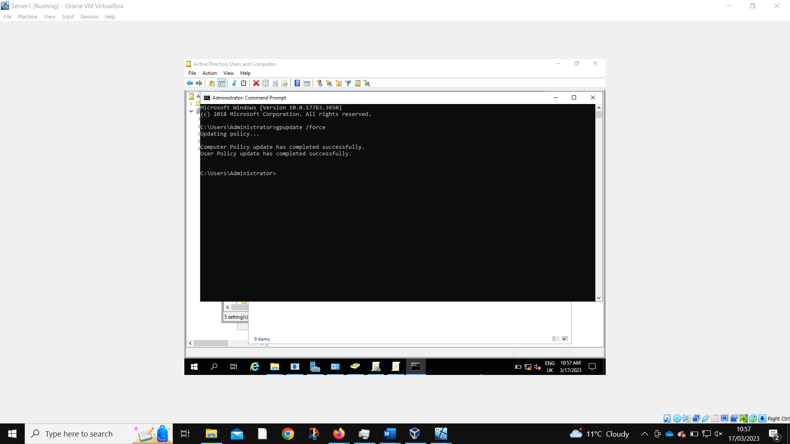
The server must force gpupdate to get the new policy working.
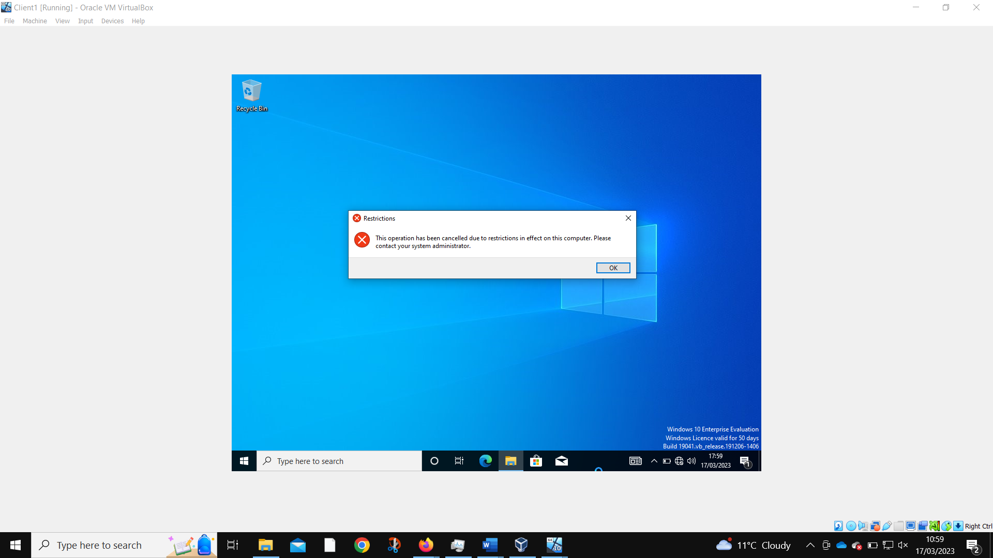
Logged in as the new user, they are no longer able to access the control panel.

2.1.2.3 Removing Access to the Command Prompt.
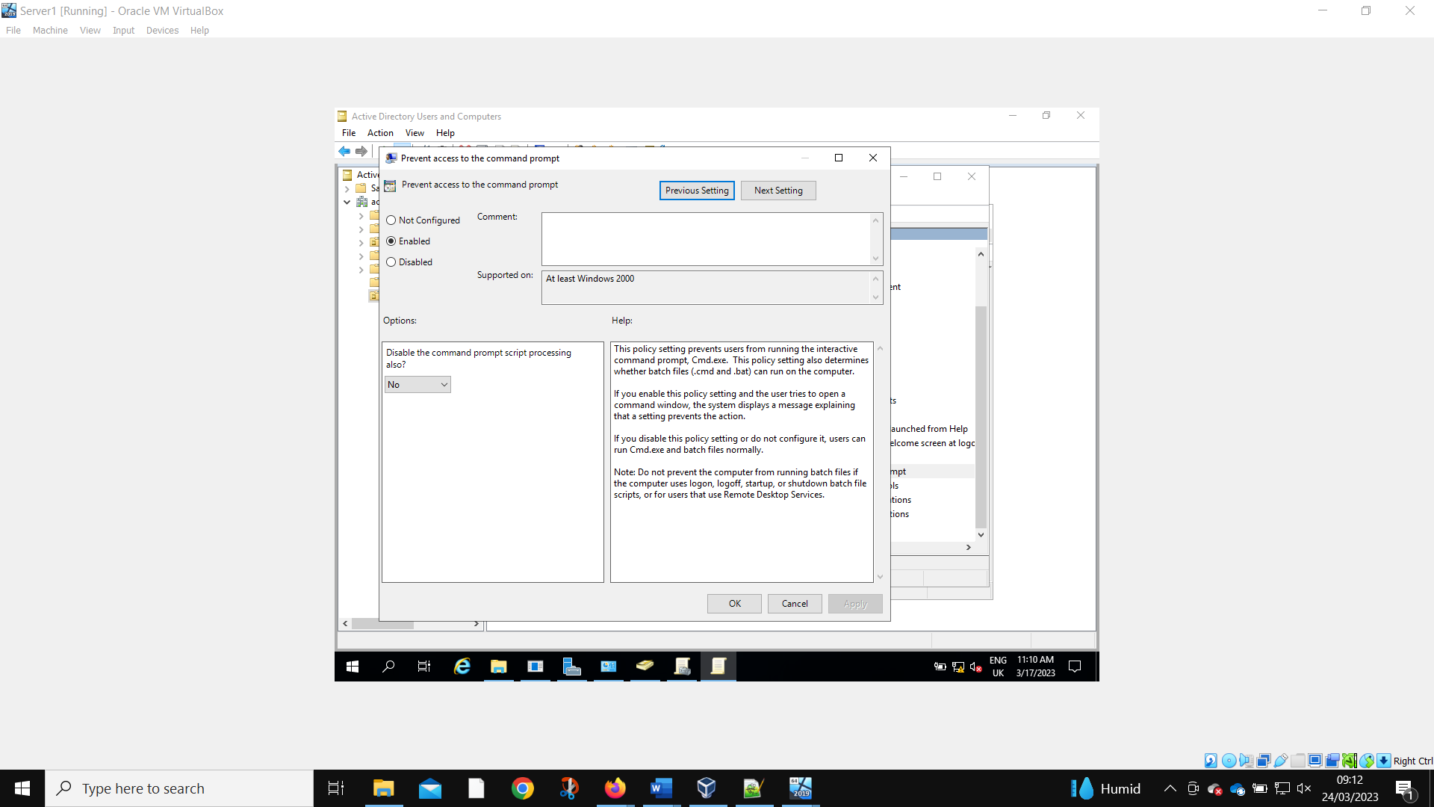
The same process is conducted, with a new GPO made to prevent access to command prompt.
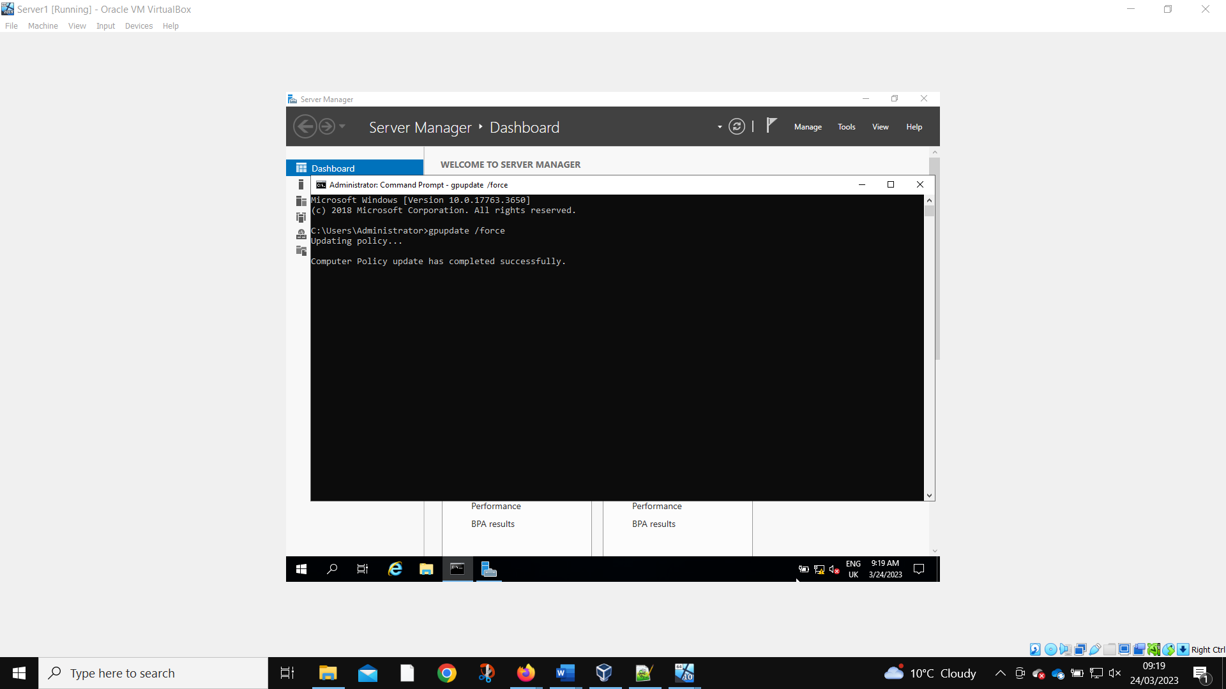
Force gpupdate is needed again.
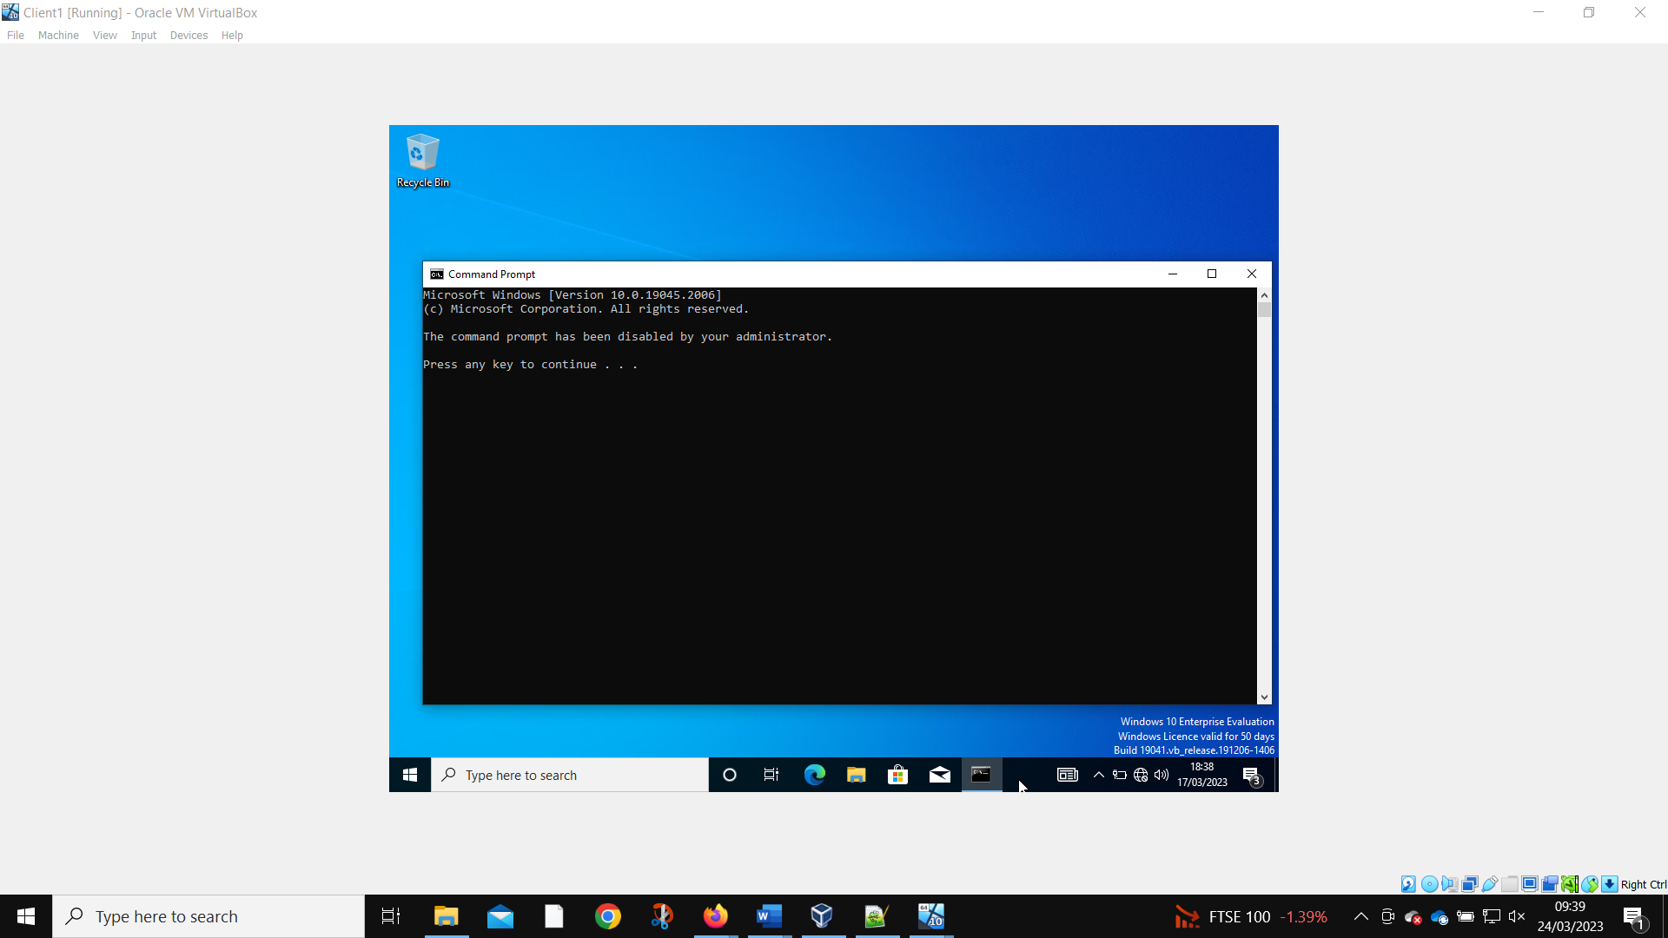
The new user is no longer able to use the command prompt.

2.1.2.4 Restricting Access to Removable Media Drives

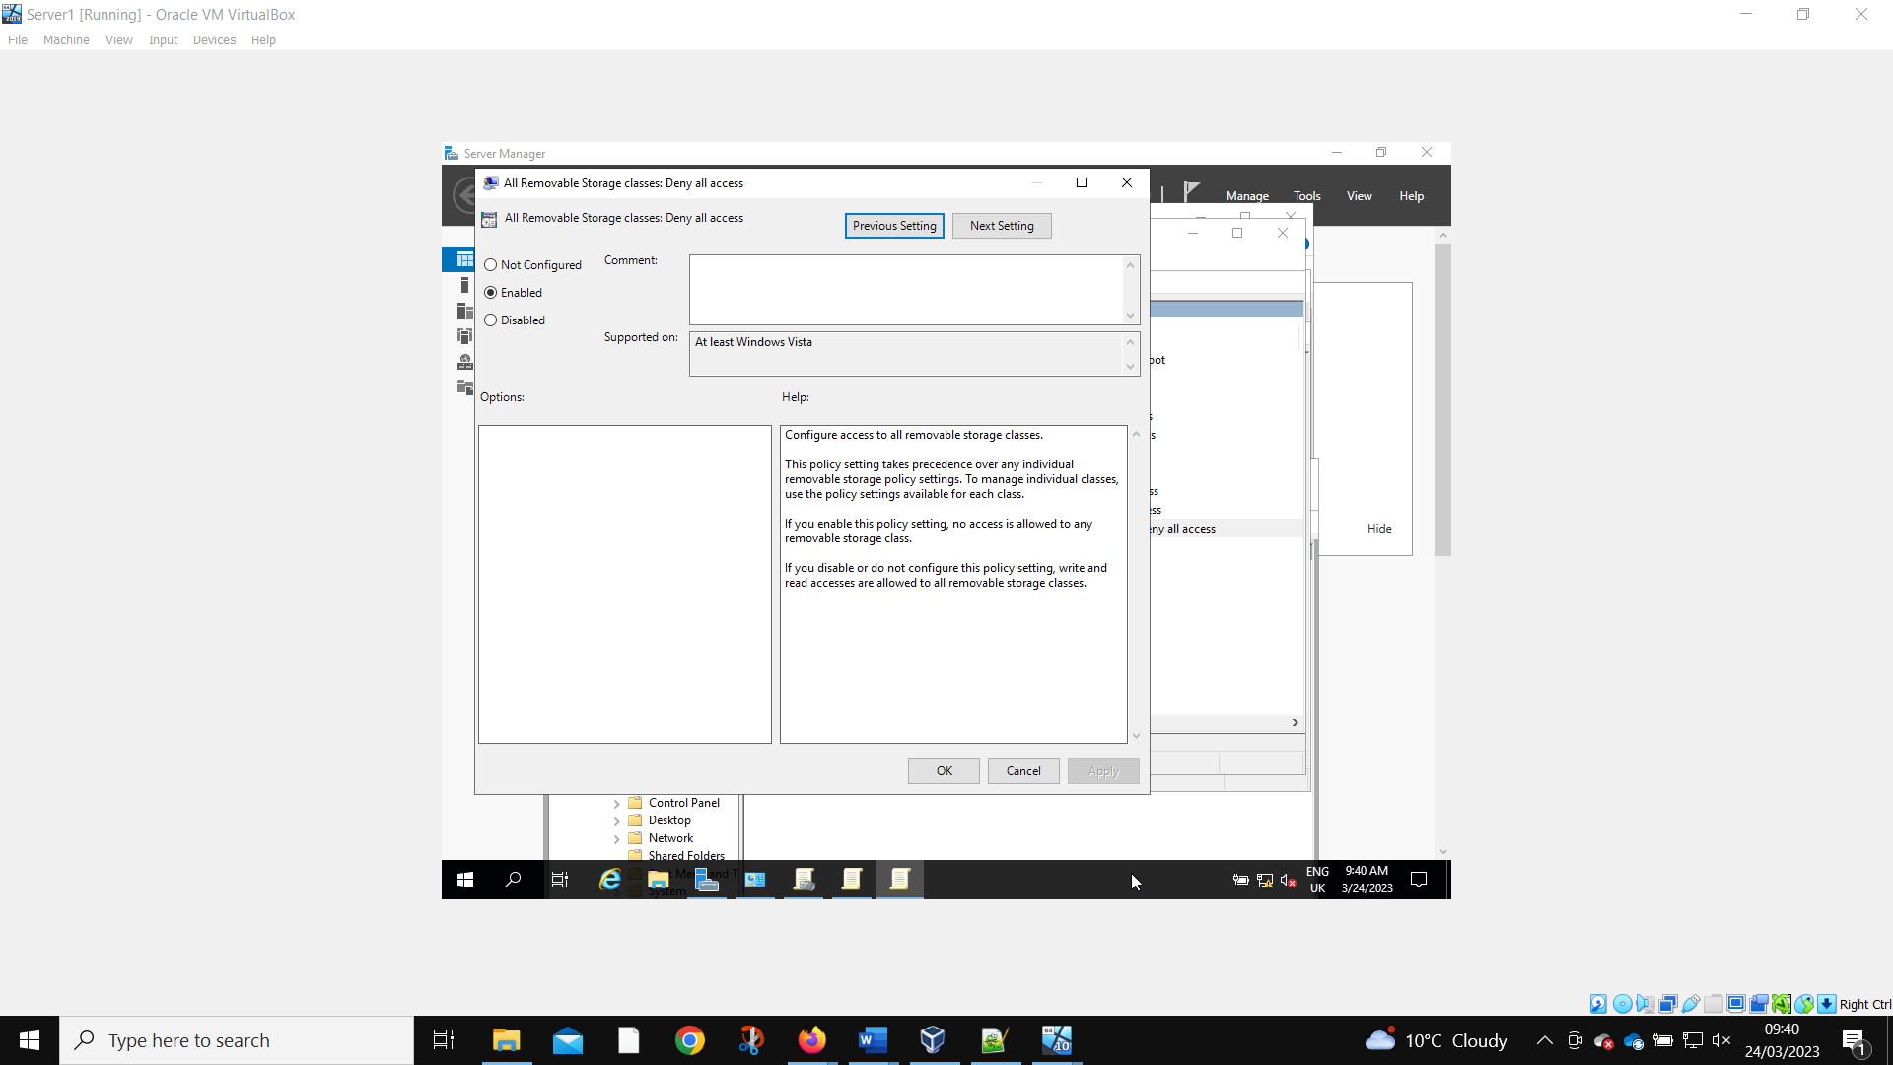
Another GPO is made to prevent the use of removable storage devices. This is unable to feasibly be tested using the current setup of VB.

2.1.2.5 Restricting Software Installs

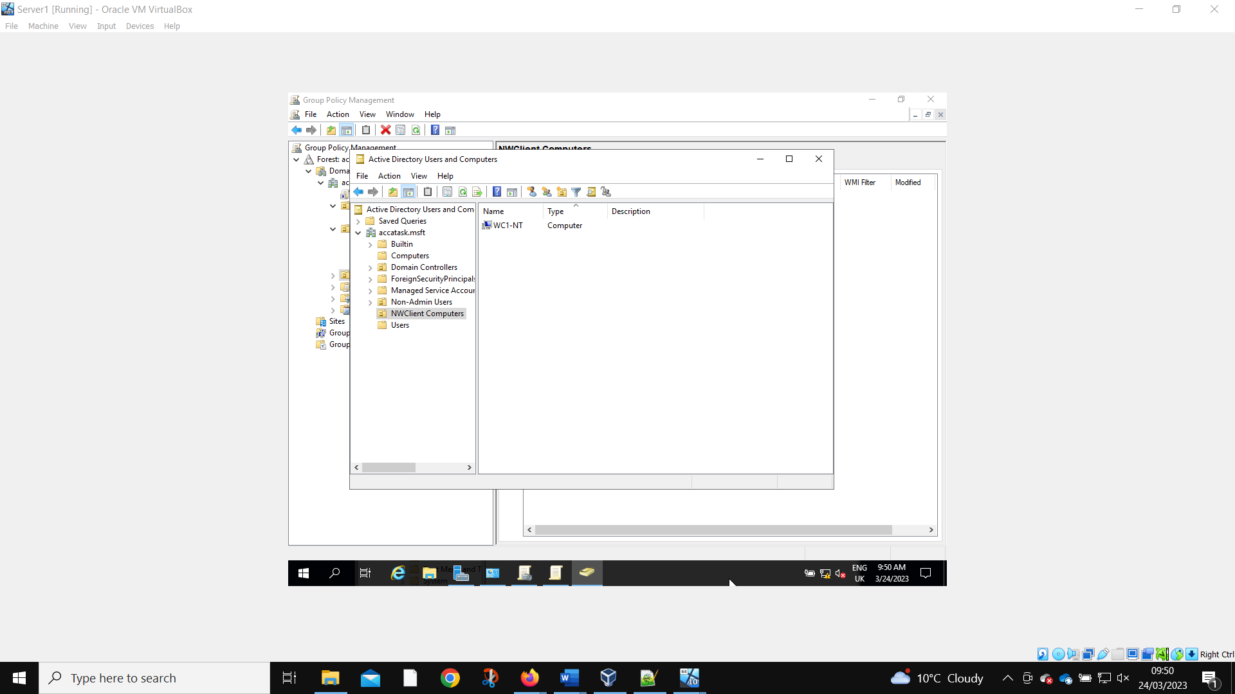
A new organizational unit is created to prevent specific computers from being able to install software.
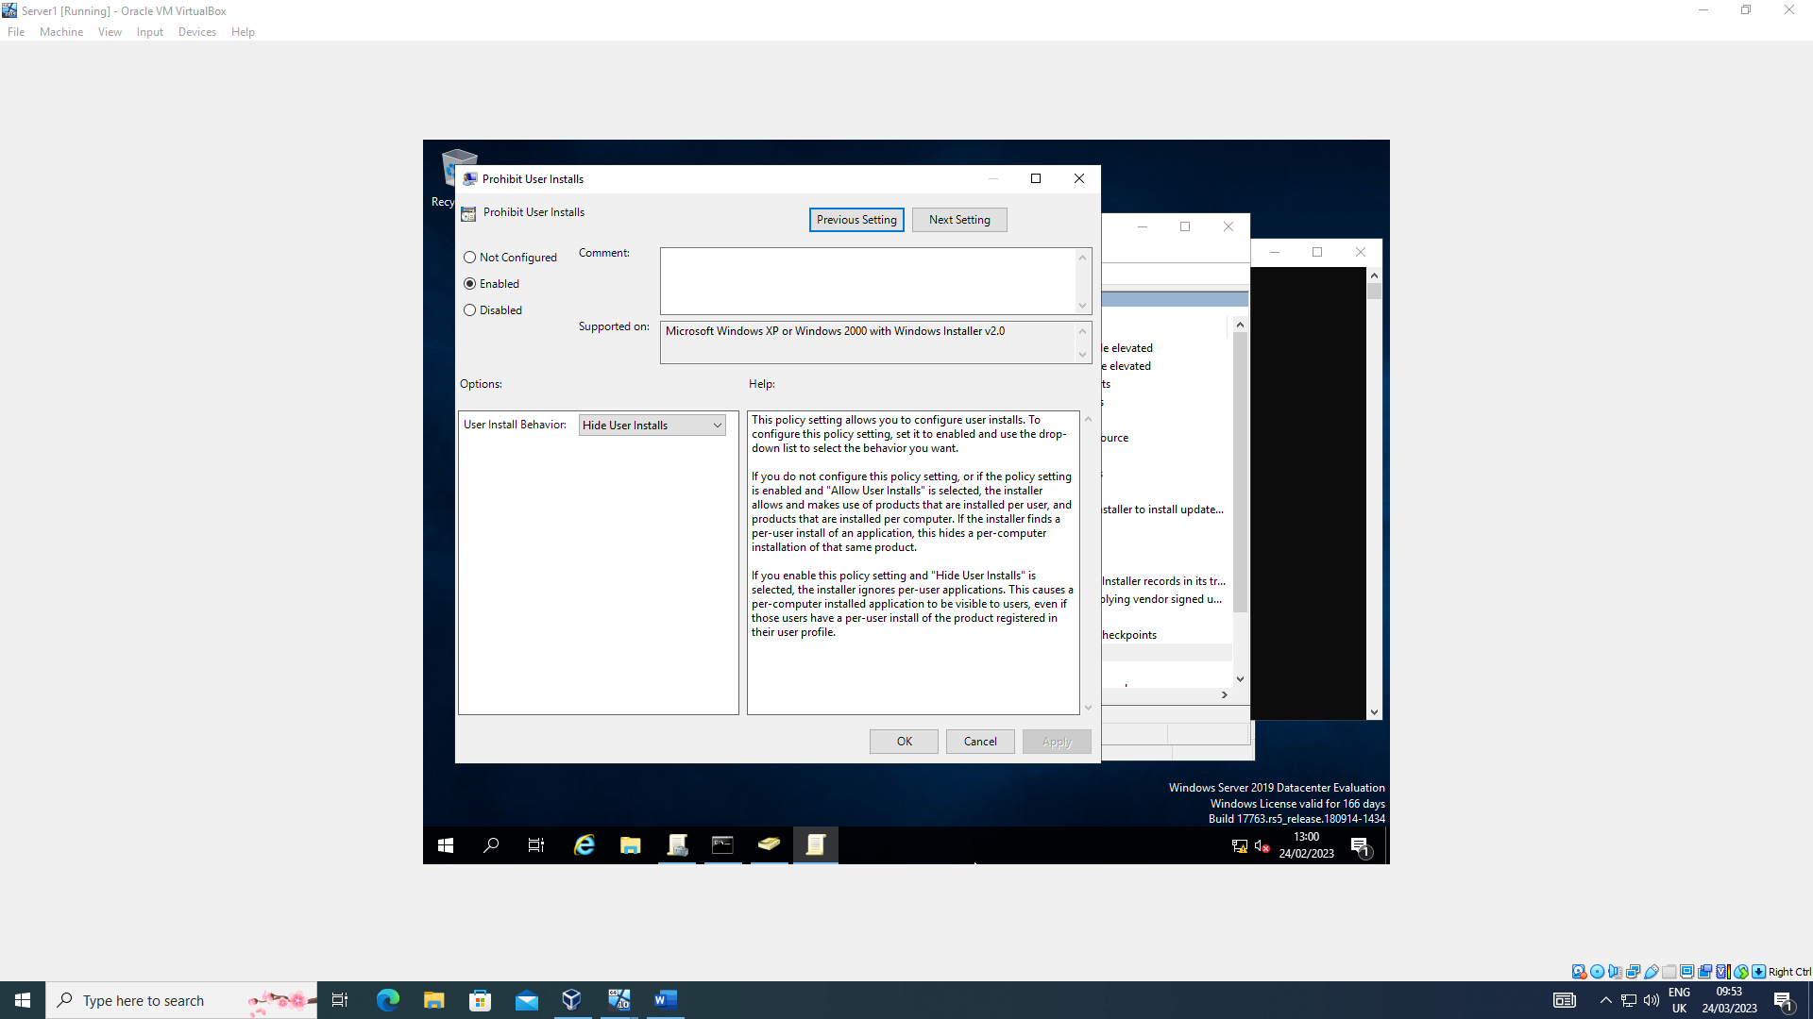
The rules are configured.
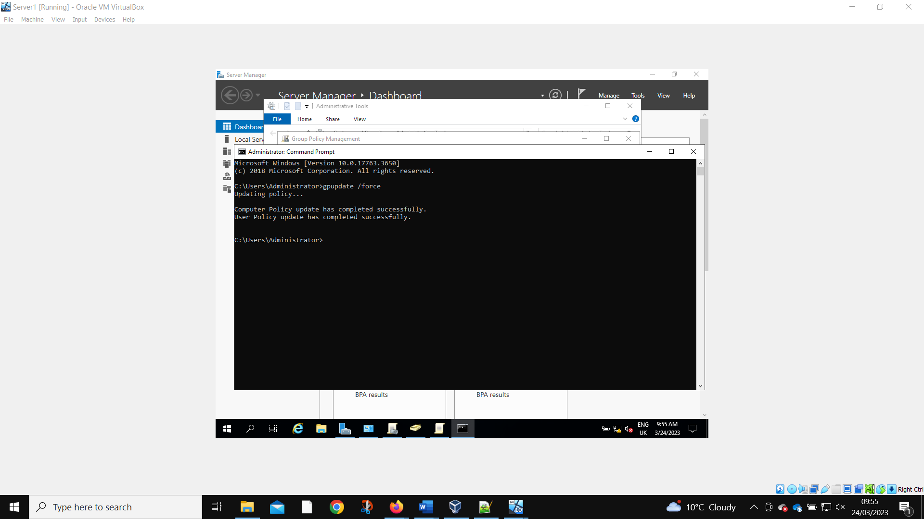
Force gpupdate is performed.
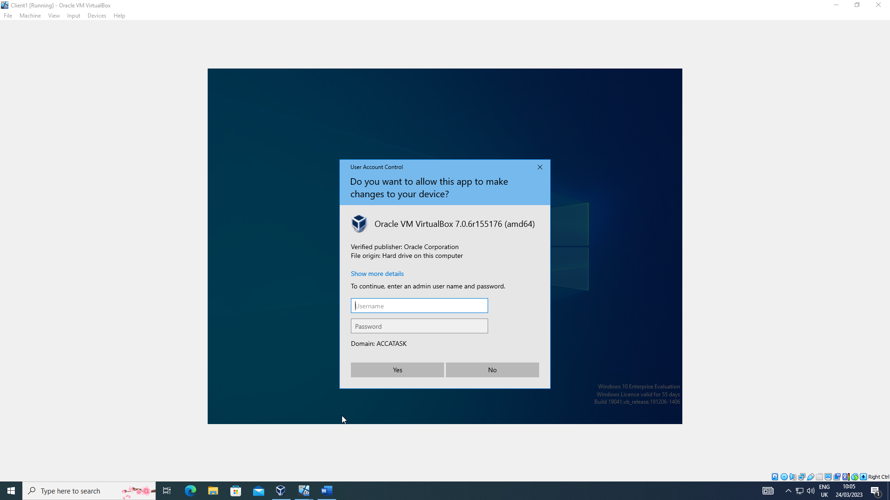
And the new user now requires admin privileges to install software on Client 1.

2.1.2.6 Enforcing Password Policy in the ‘accatask.msft’ domain

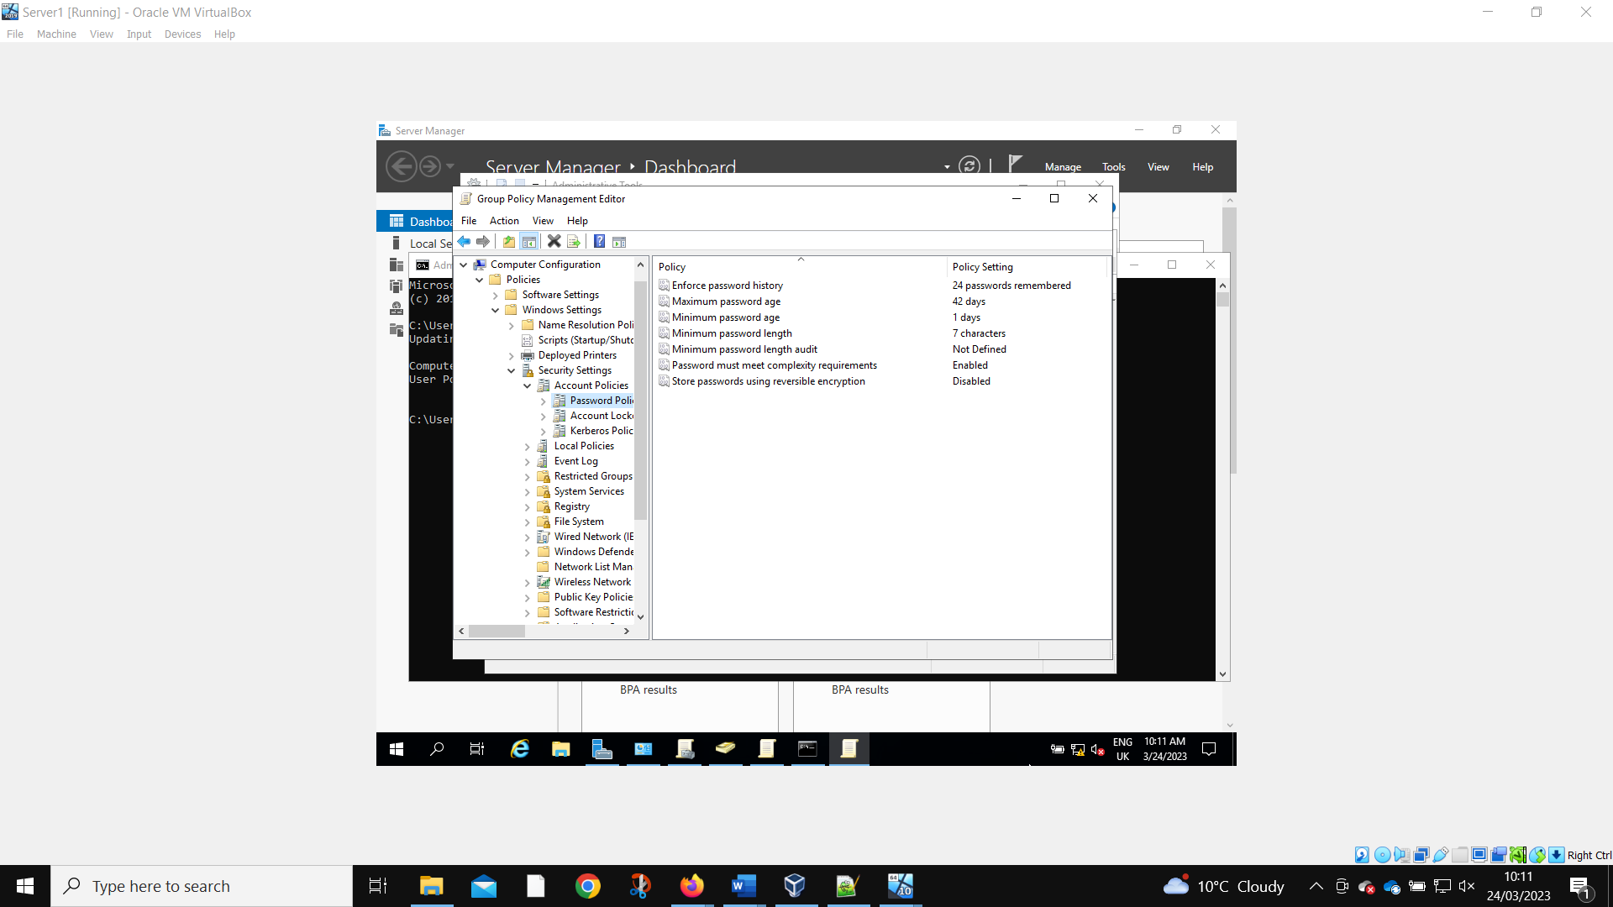
The default password polices.
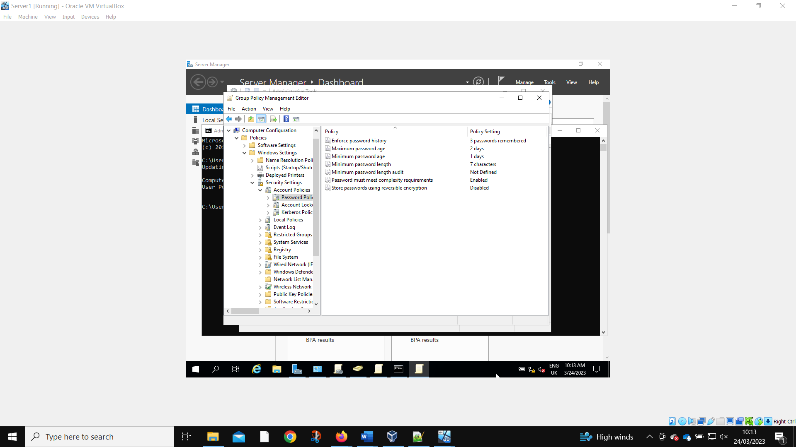Are changed to reflect the requirements.
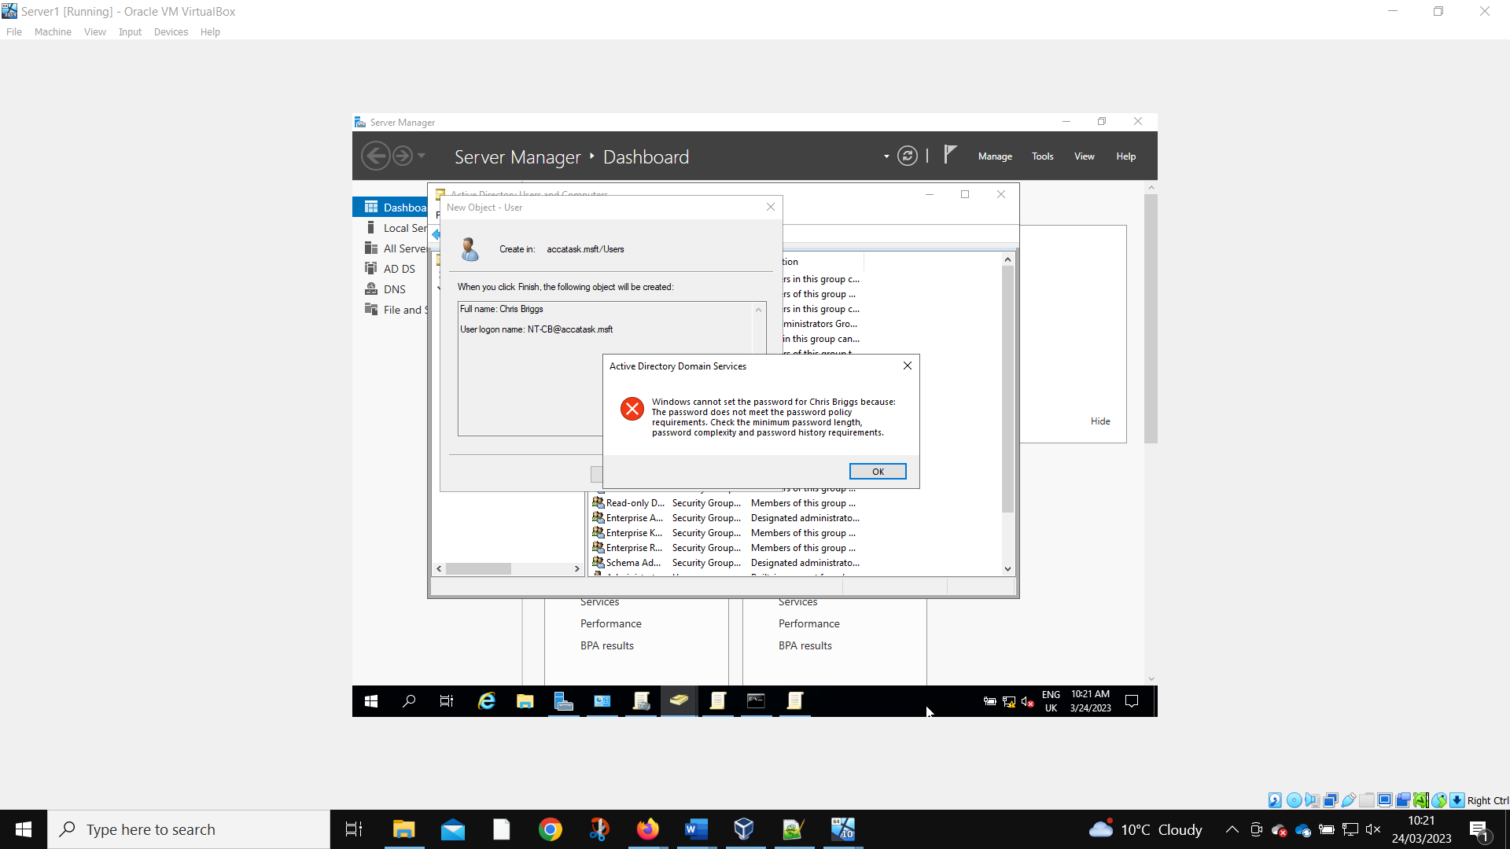
When a new user is created, they are prevented from using a password that does not meet the requirements.

2.2. Task 2: Routing and Packet Filtering within Core TCP/IP Services and Critical Failover/Redundancy Practices

2.2.1 Utilizing ARP and Routing Tables

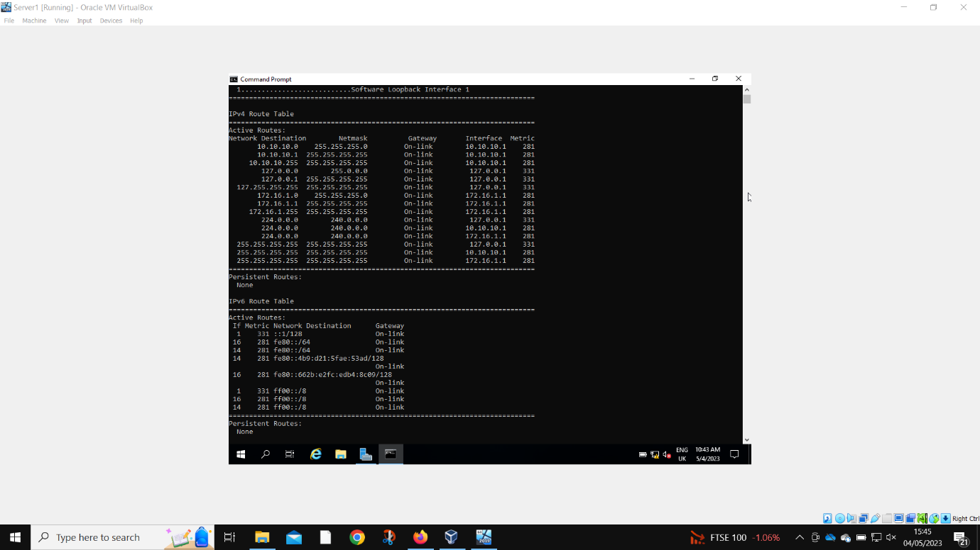
Running the route print command to find all the networks that are connected to Server 1.

2.2.2 Deploy Core Services (FTP Server)

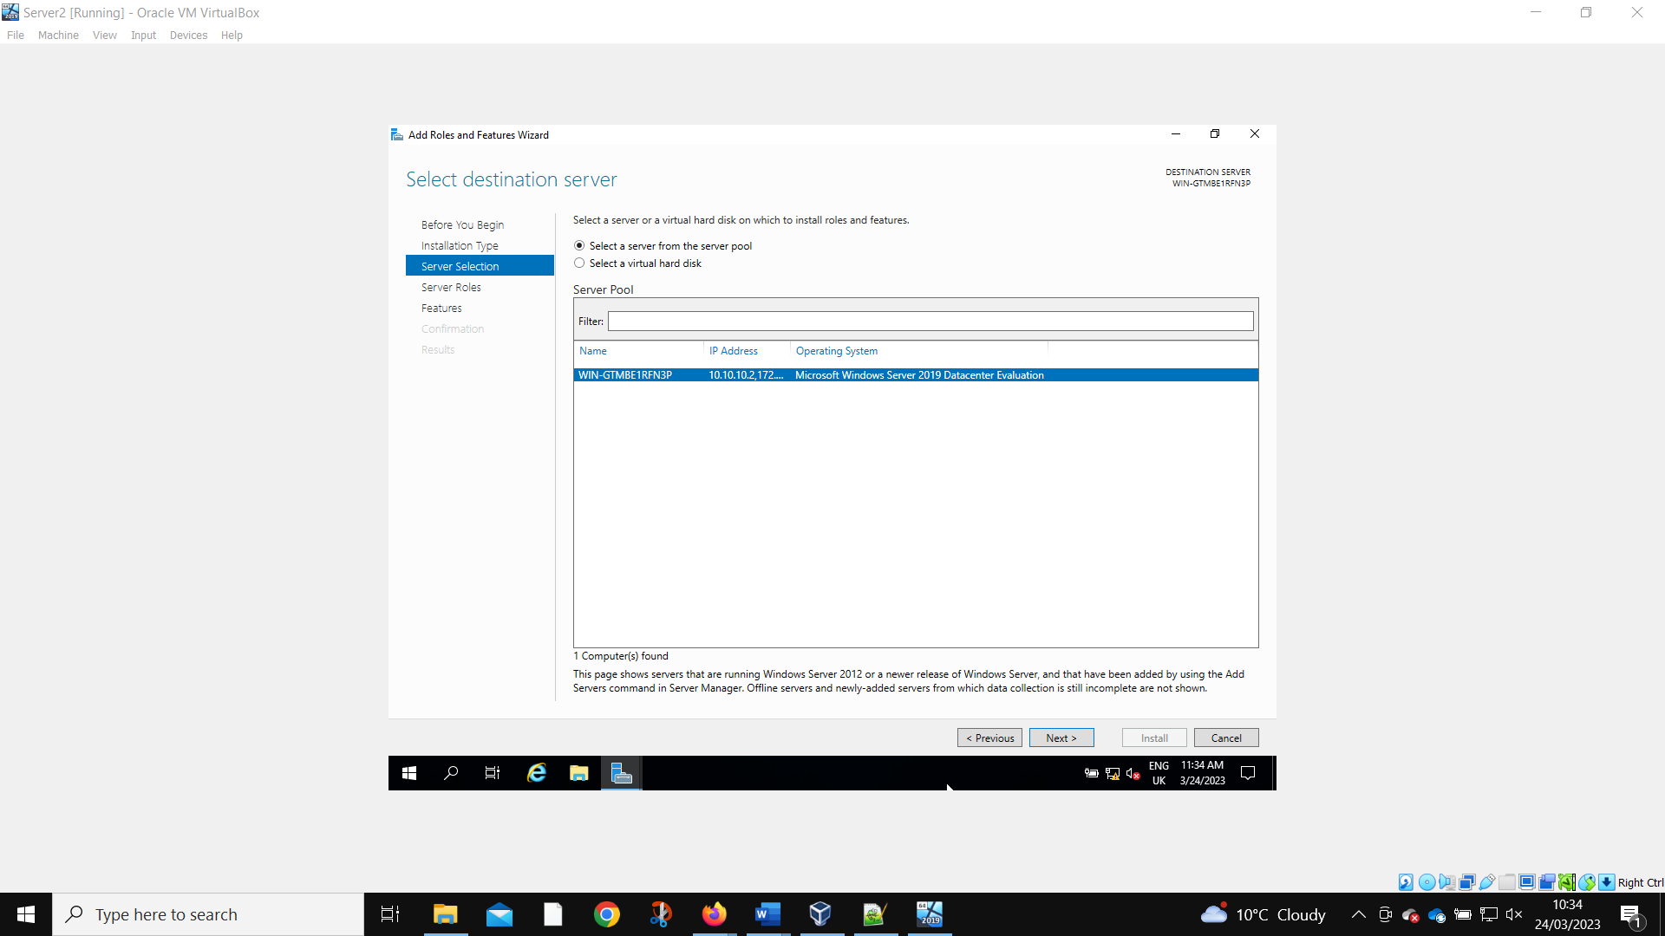
Installing the FTP server to the correct location.
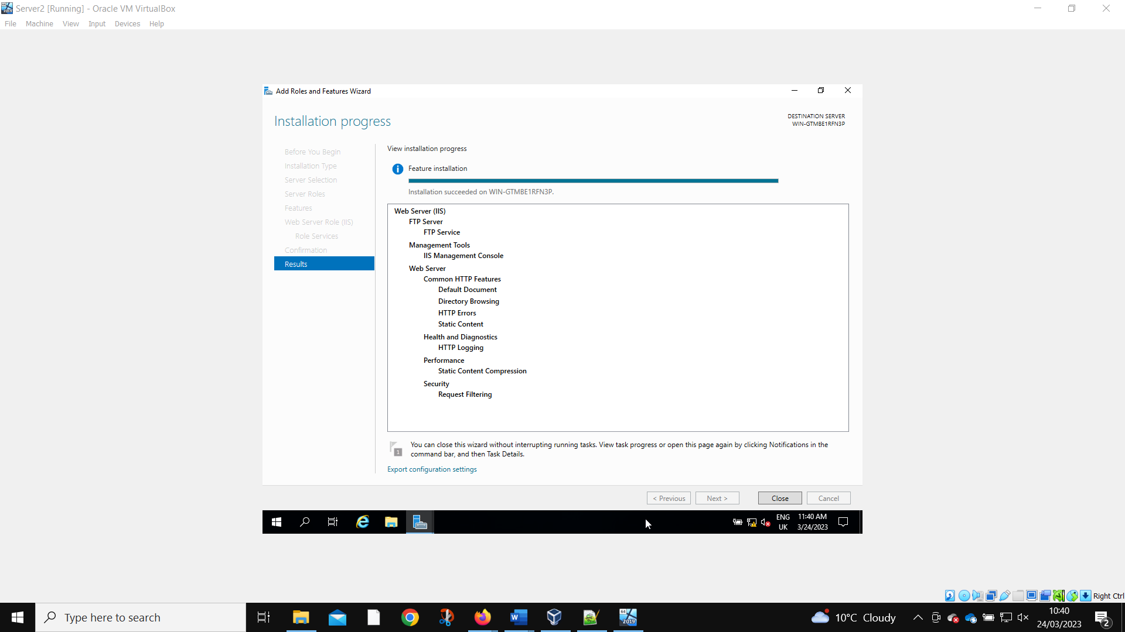
Confirmation of correct installation.
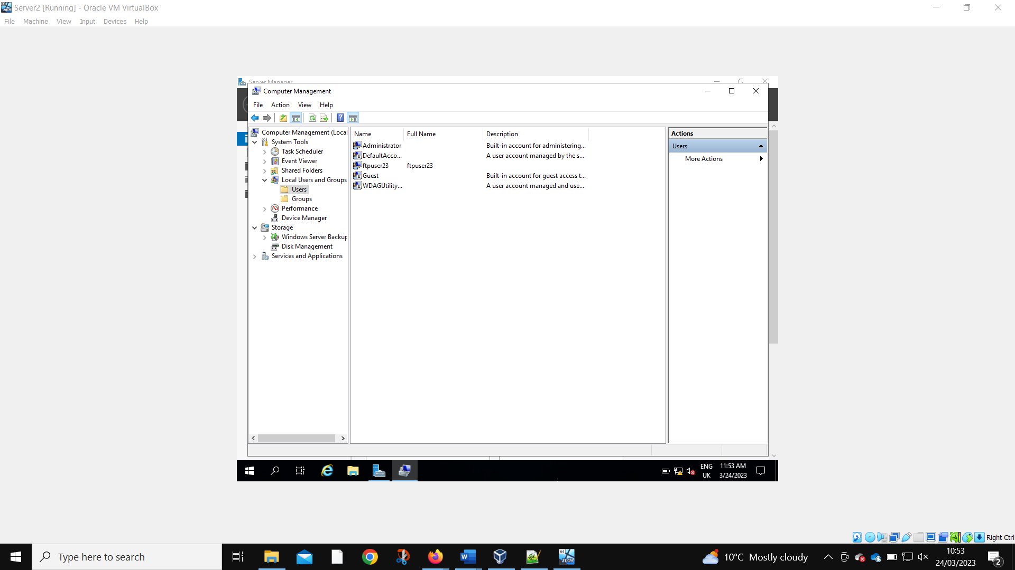
The local test account ftpuser23 is created to test the functionality of the FTP server.
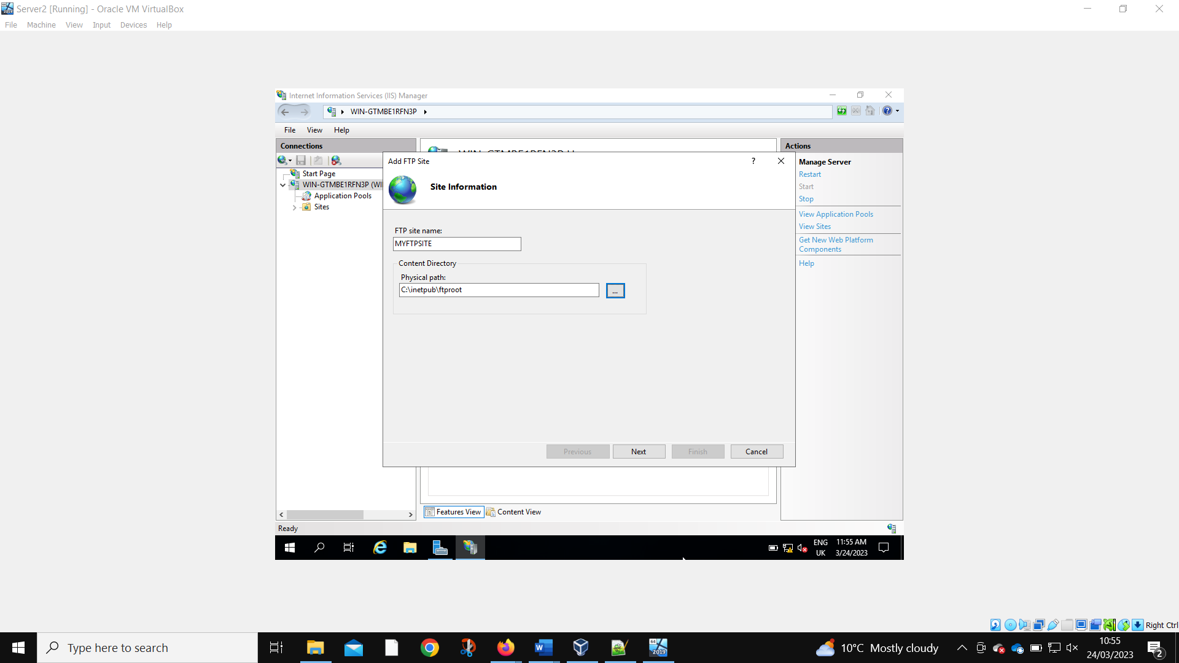
The physical path for the FTP site is set.
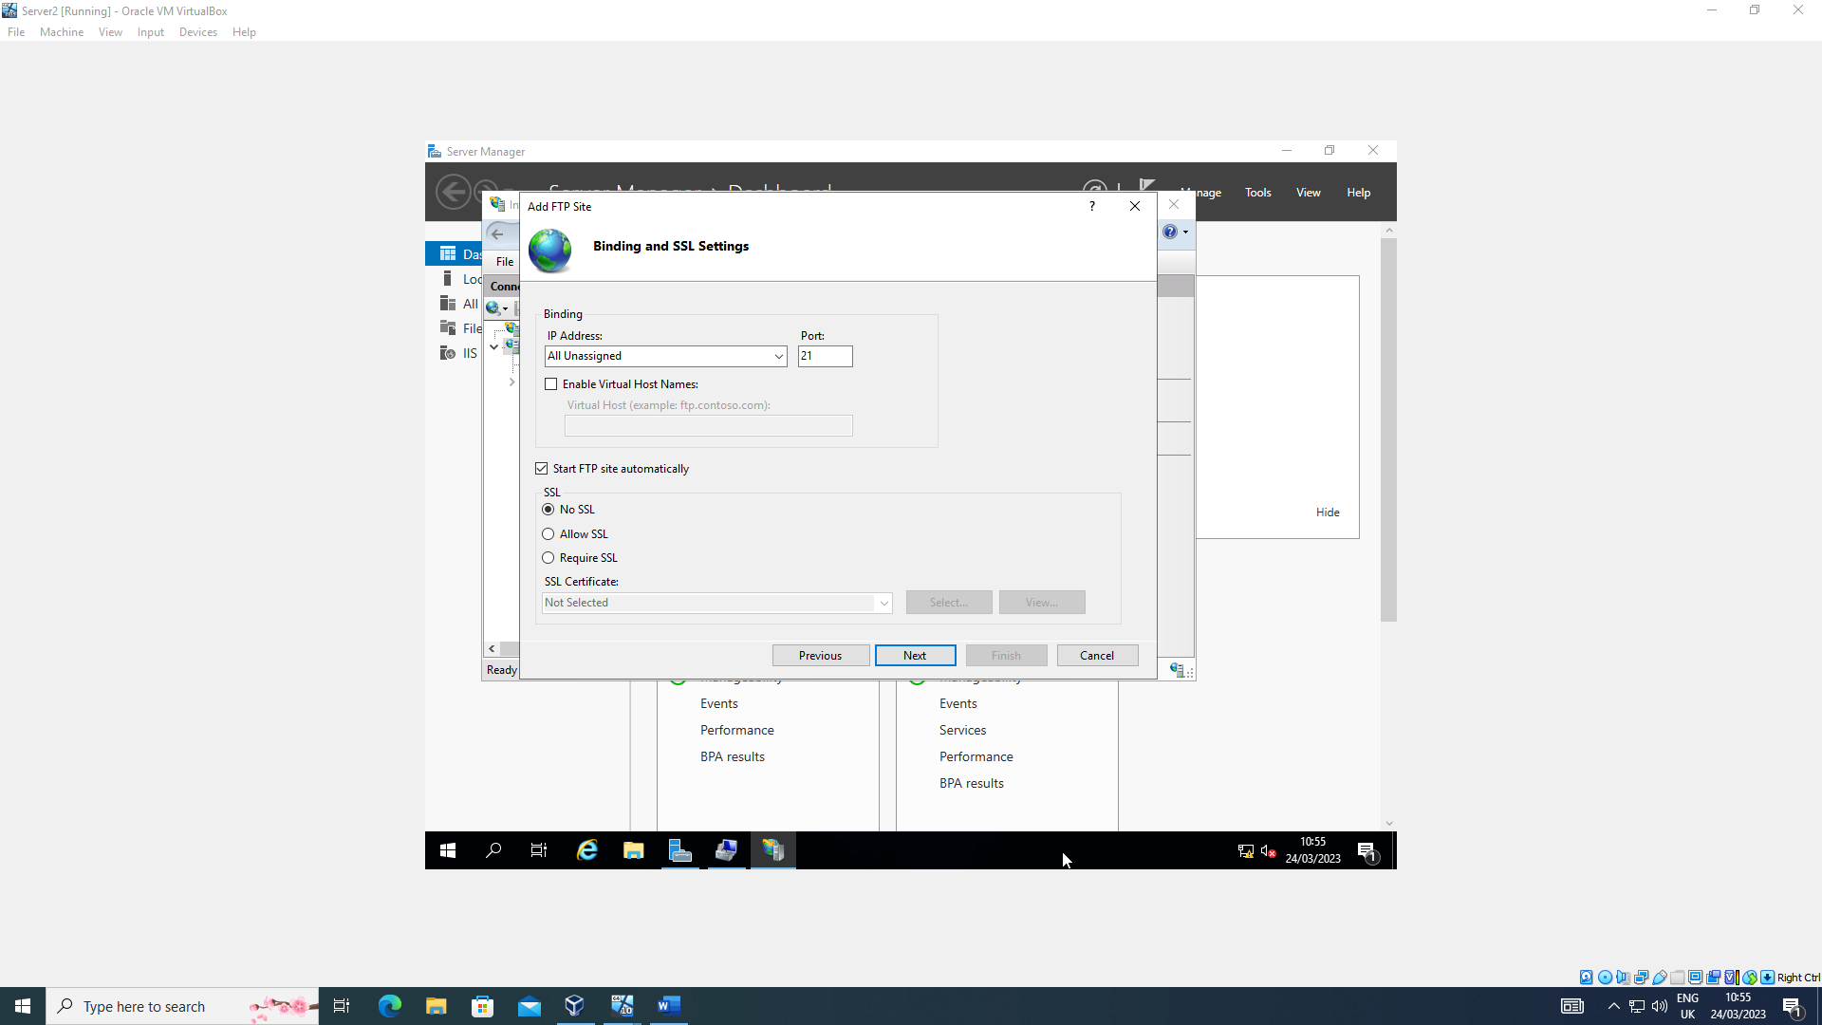
Then the port number is bound along with disabling SSL.
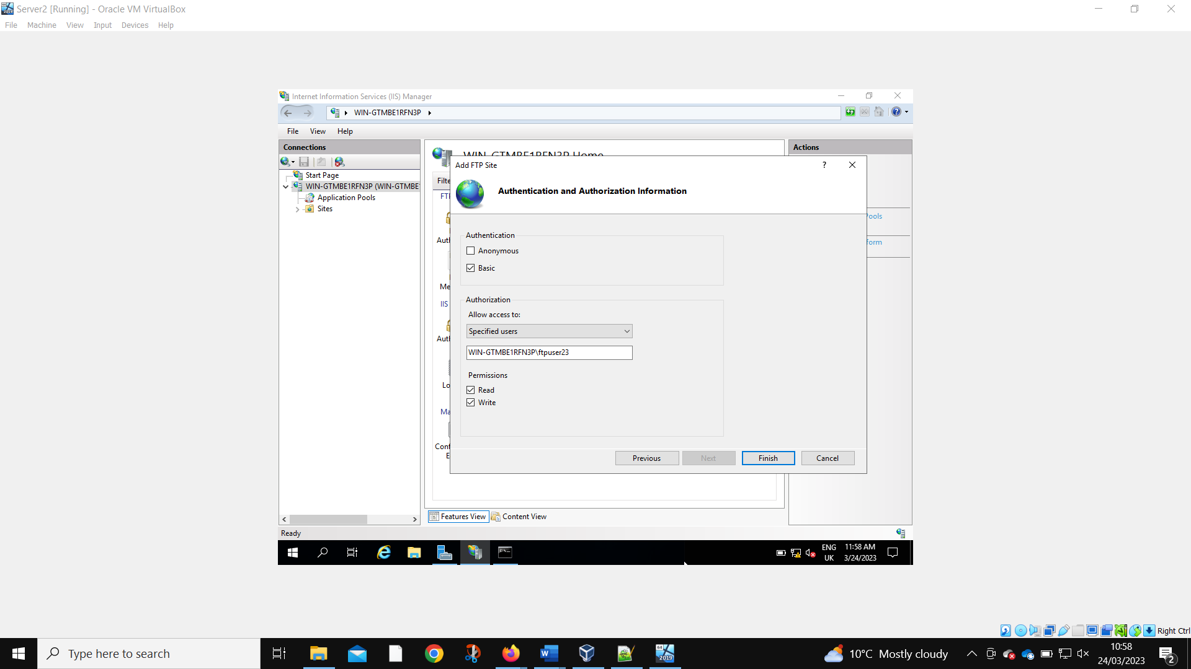
The Read Write privileges are set.
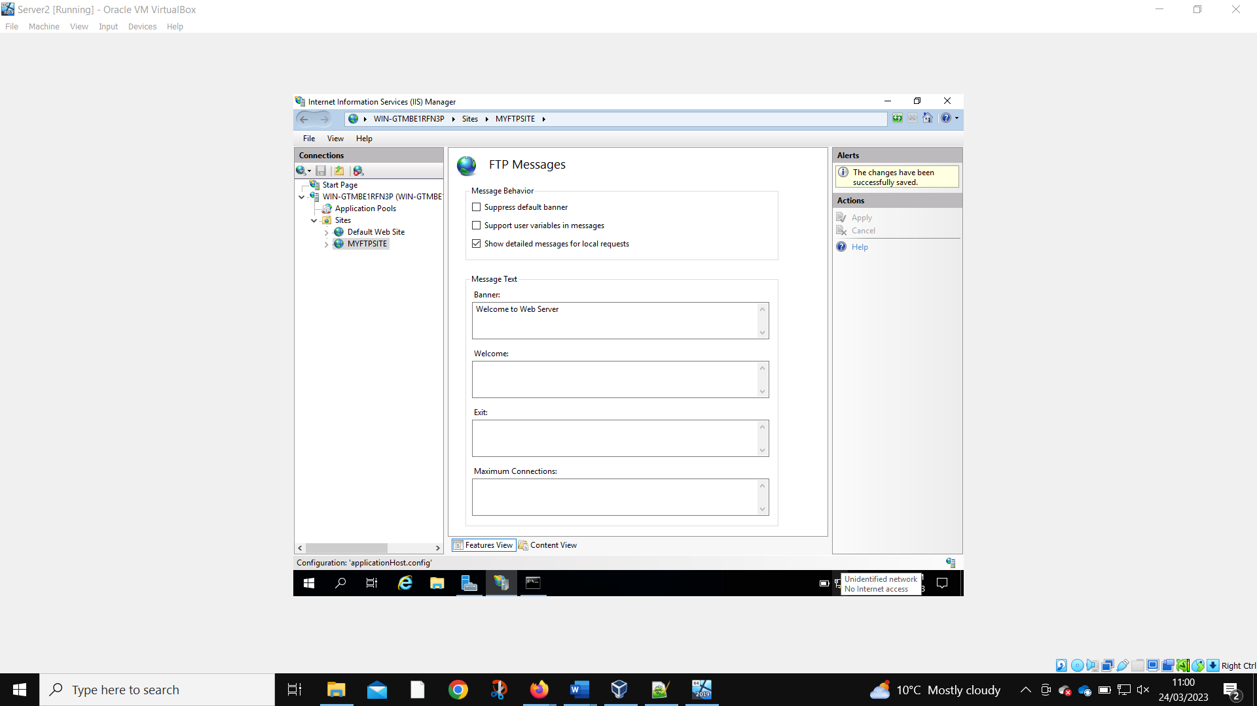
Confirmation of the FTP site being created.
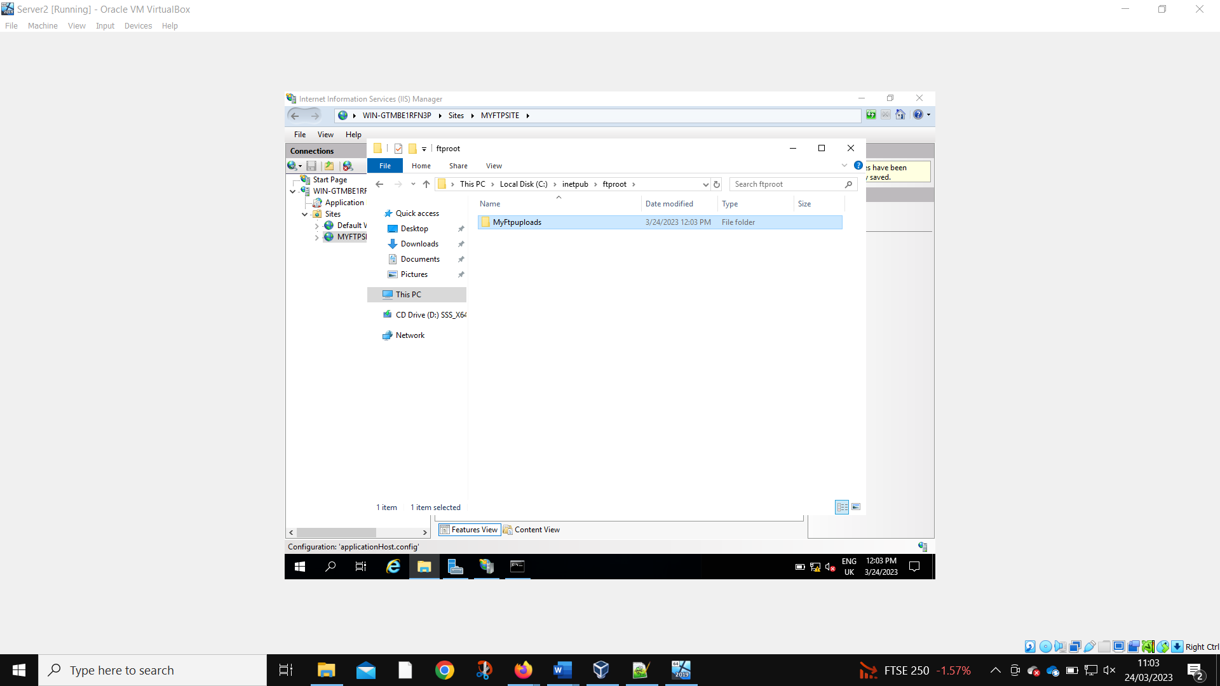
A folder is created to test sharing.
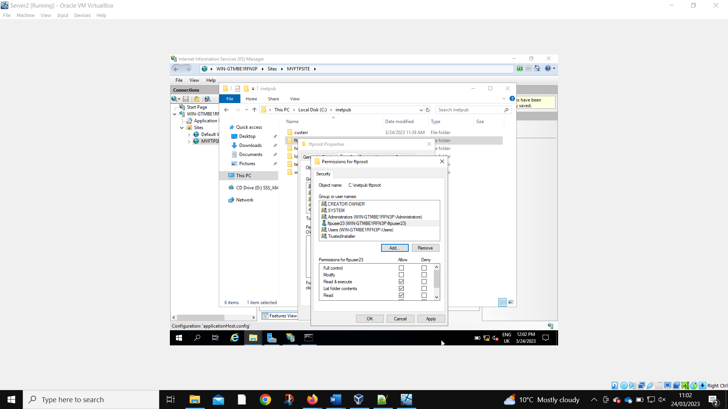
The folder permissions are being set to allow the local user to access the folder.
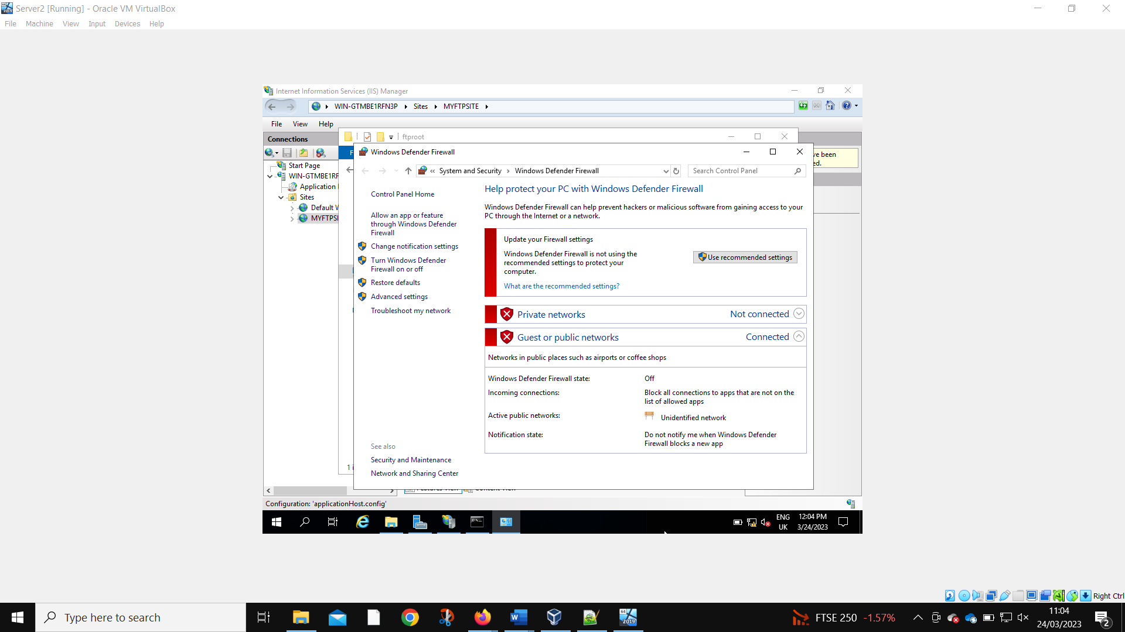
All the firewalls on Server 2 must be disabled for the FTP to work properly.
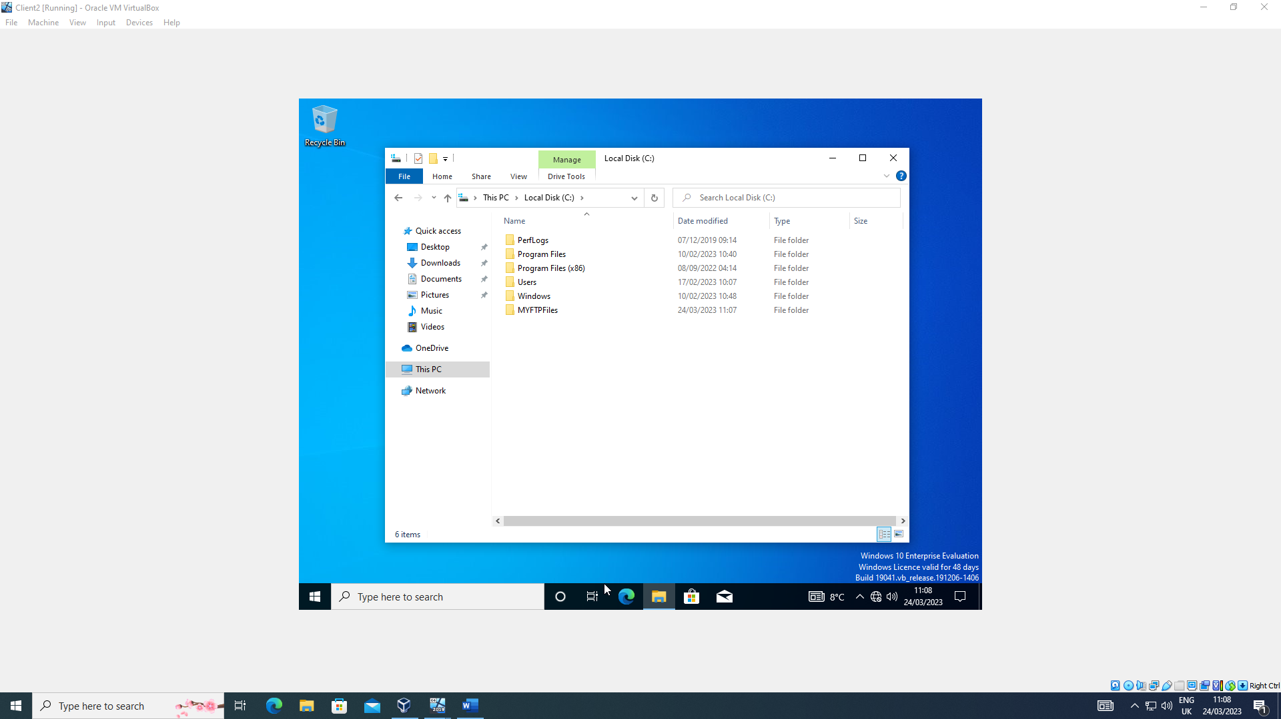
The administrator on Client 2 creates a folder to link to the FTP folder.
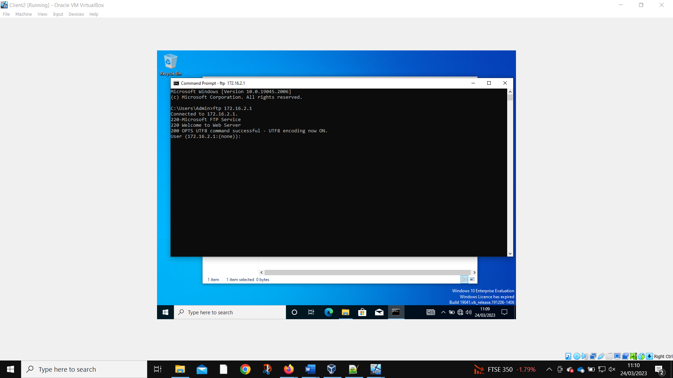
Client 2 can access the FTP server.
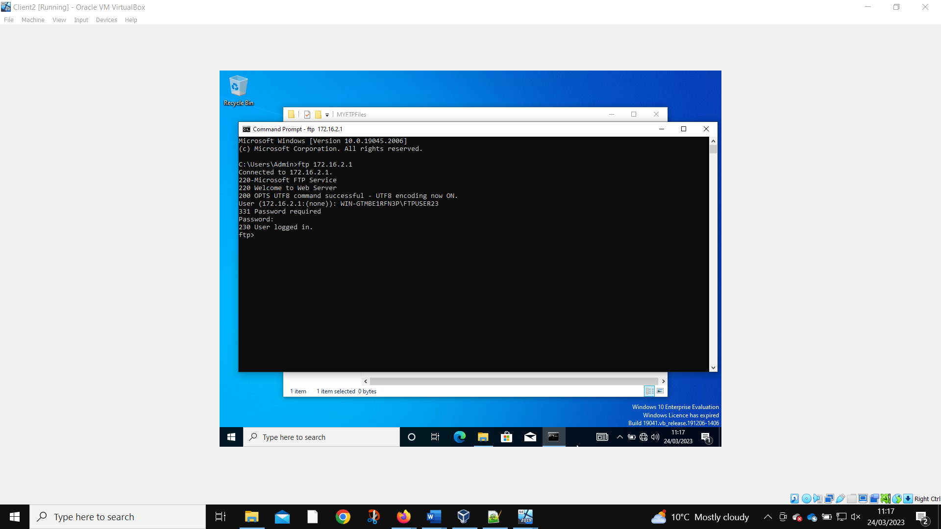
The admin can log into the local FTP account on Client 2.

2.2.3 Installing and Configuring the Routing and Remote Access Service

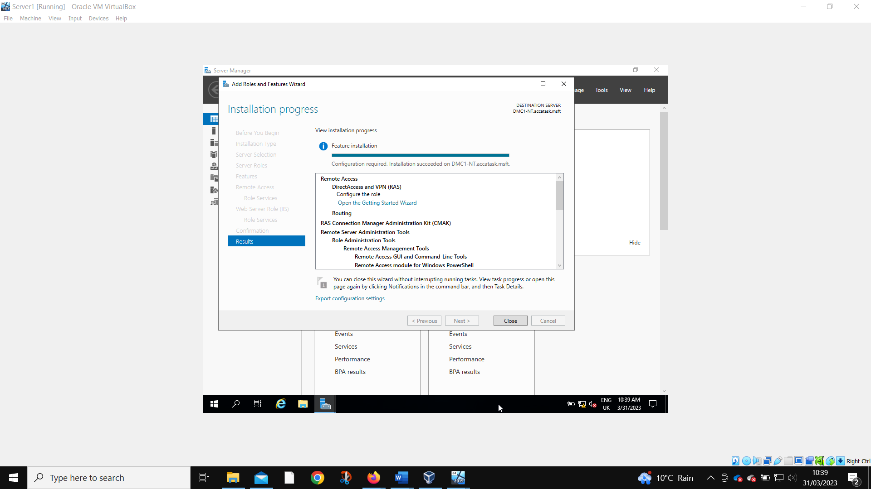
The routing and remote access is installed on Server 1.
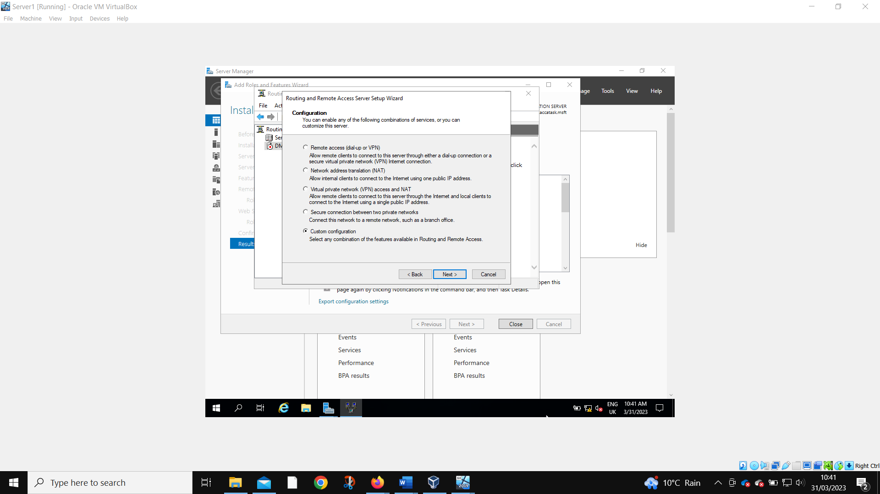
A custom configuration is needed.
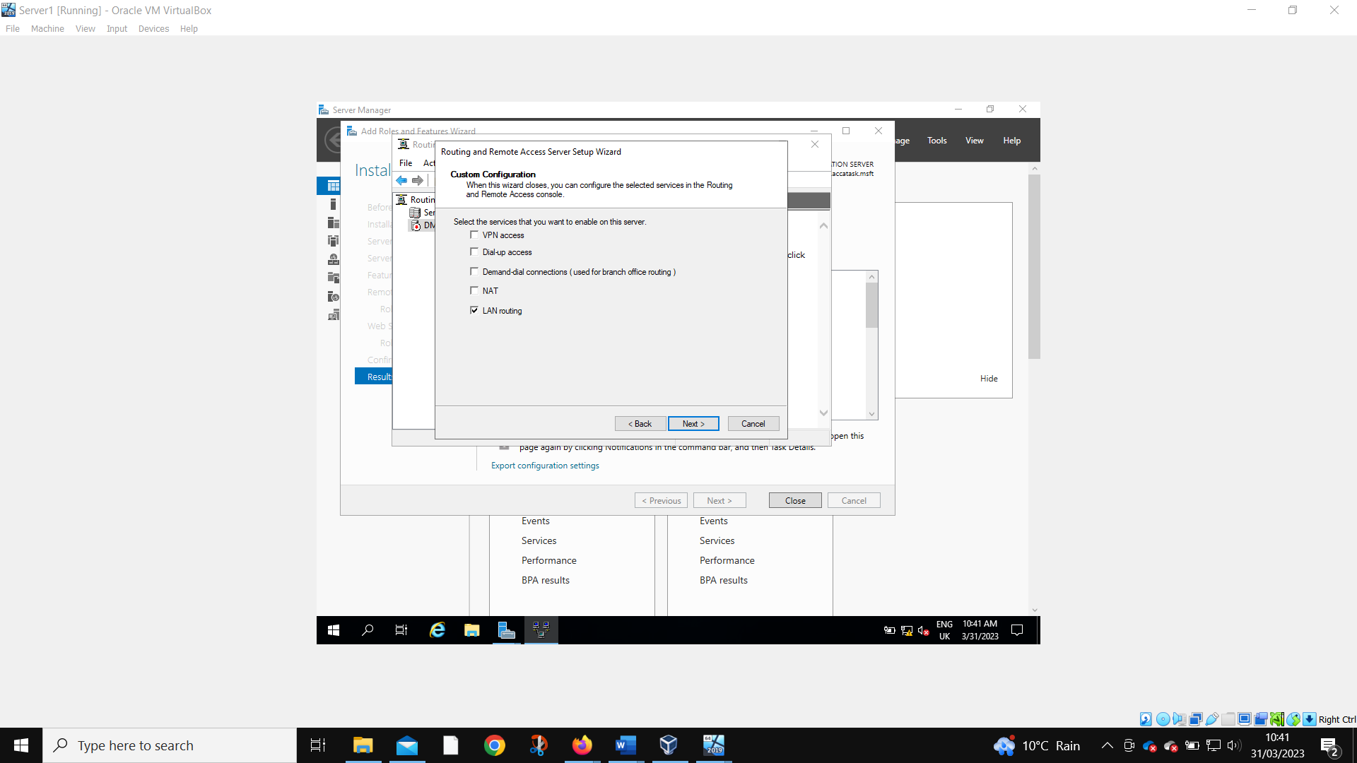
The configuration is set for LAN routing.
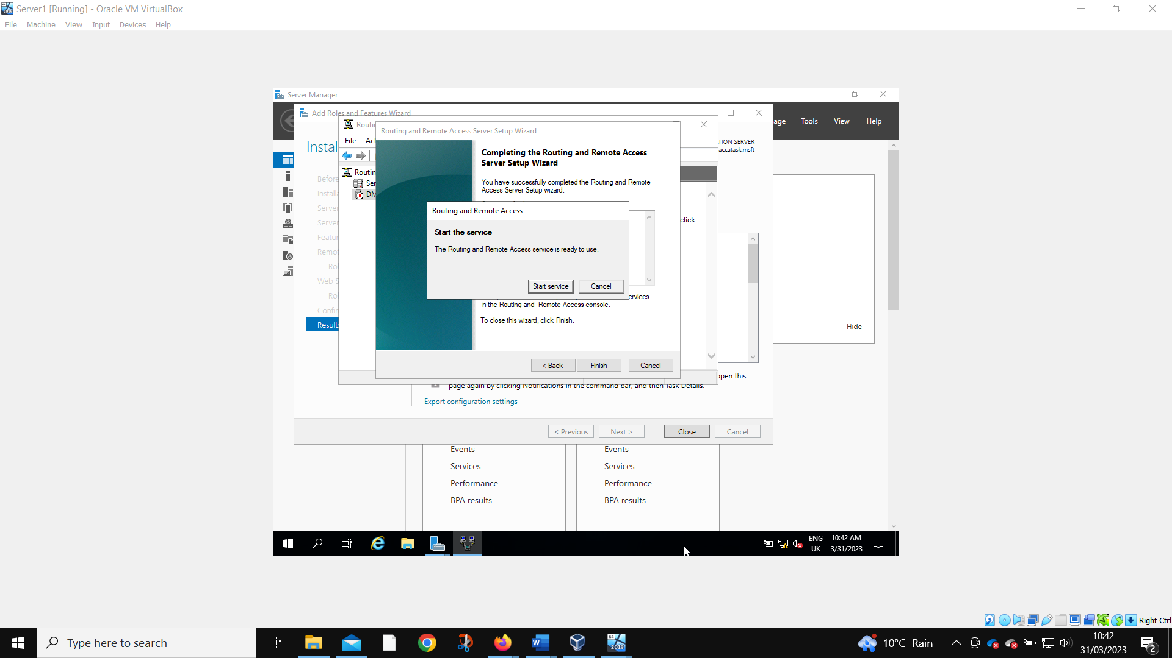
When the service has been successfully installed, it is started.
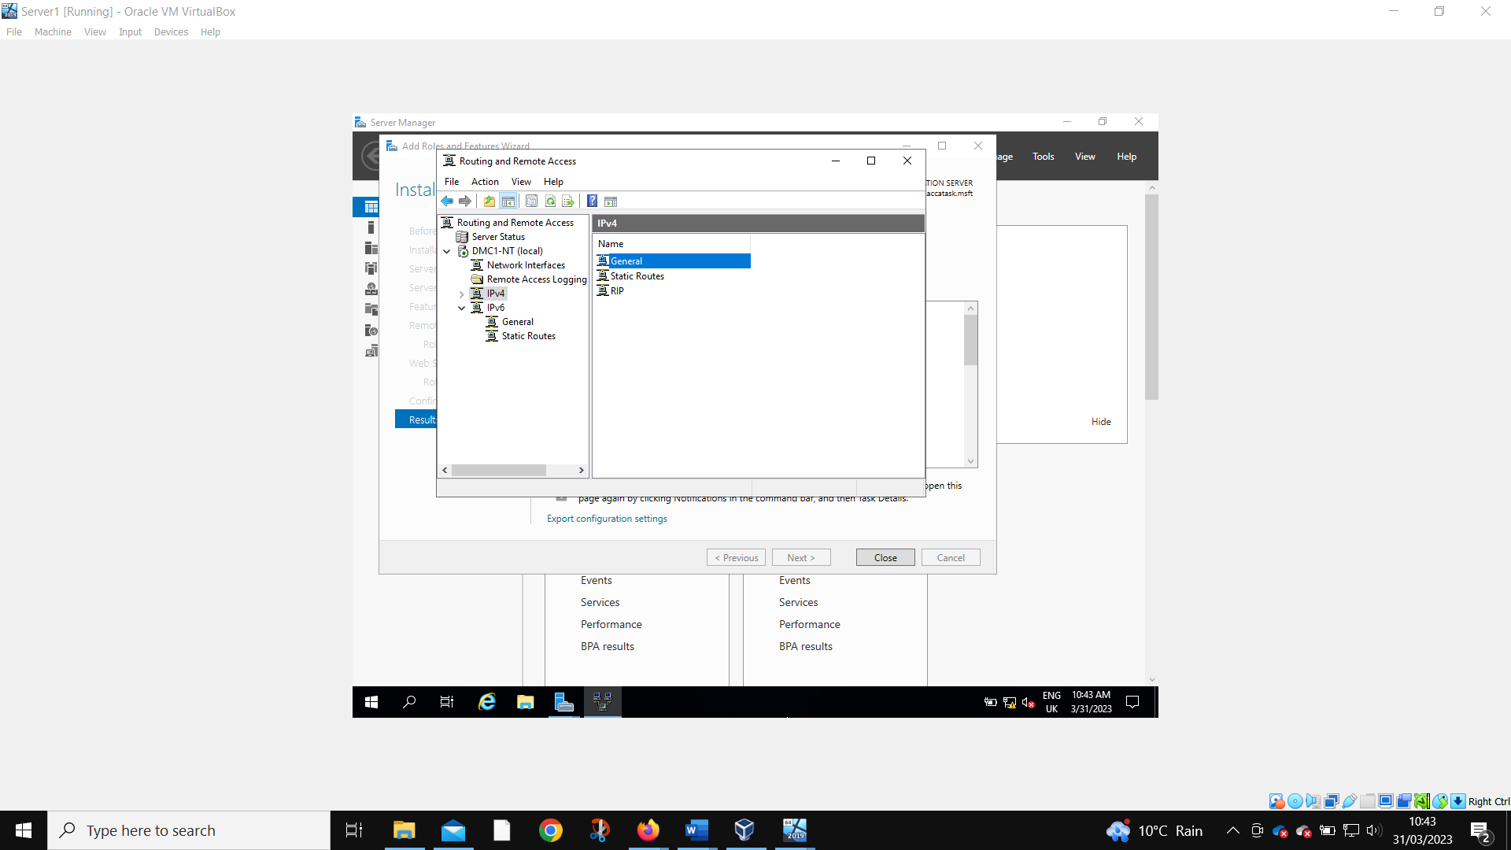
The RIP V2 is selected.
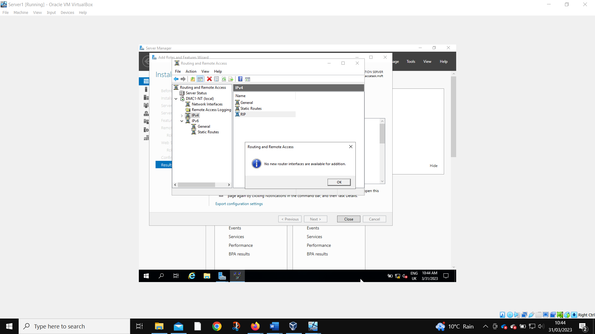
All available network interfaces – PublicNet and PrivateNet1 – are added to the routing protocol.
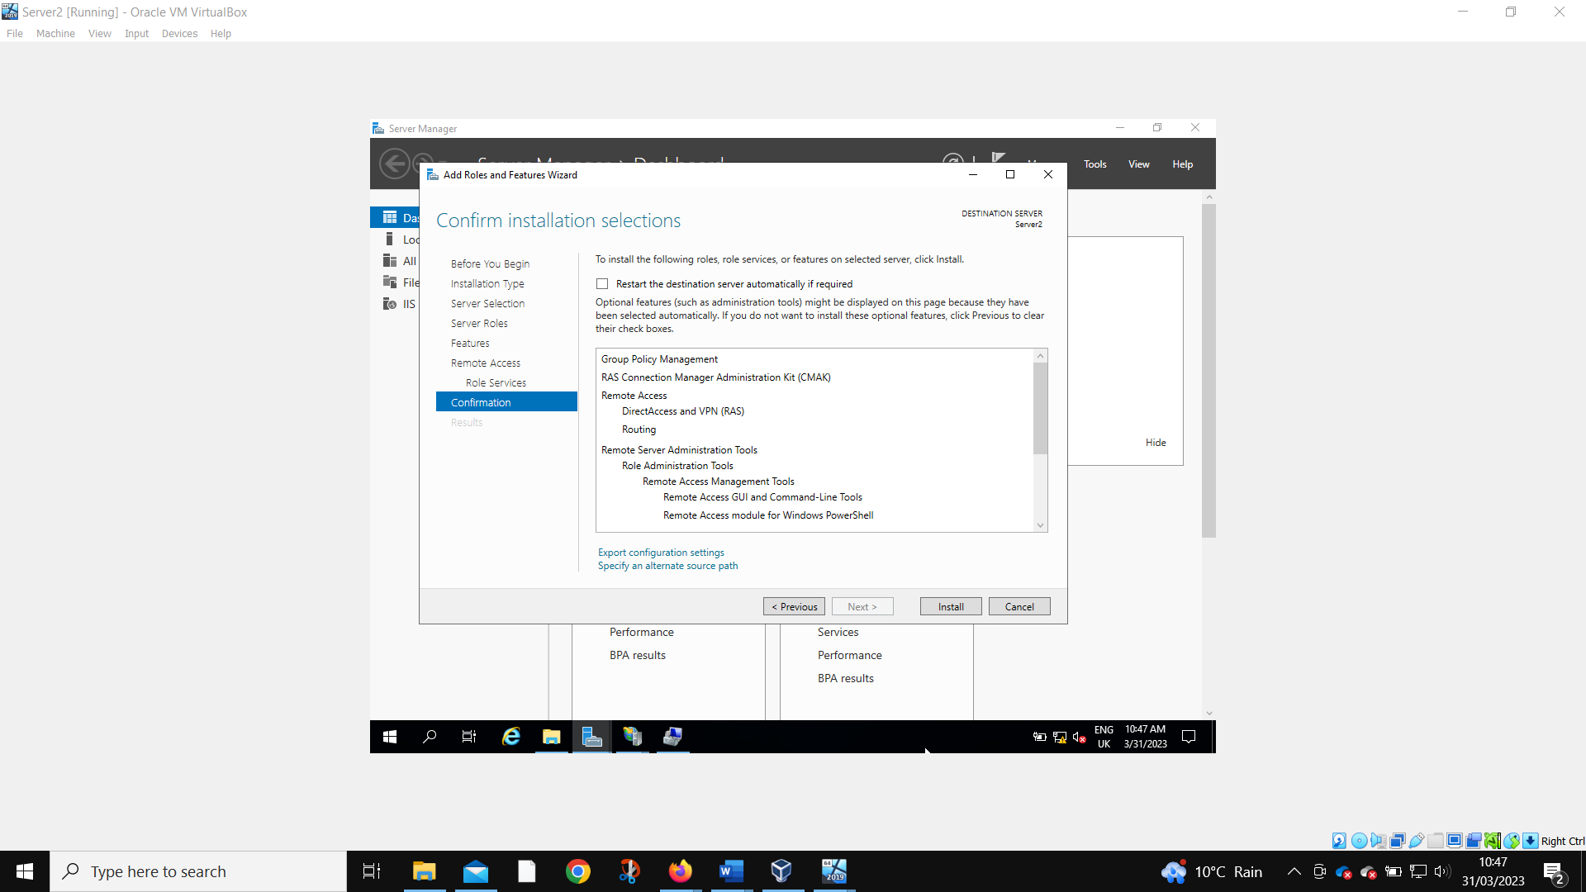
The steps are repeated on Server 2
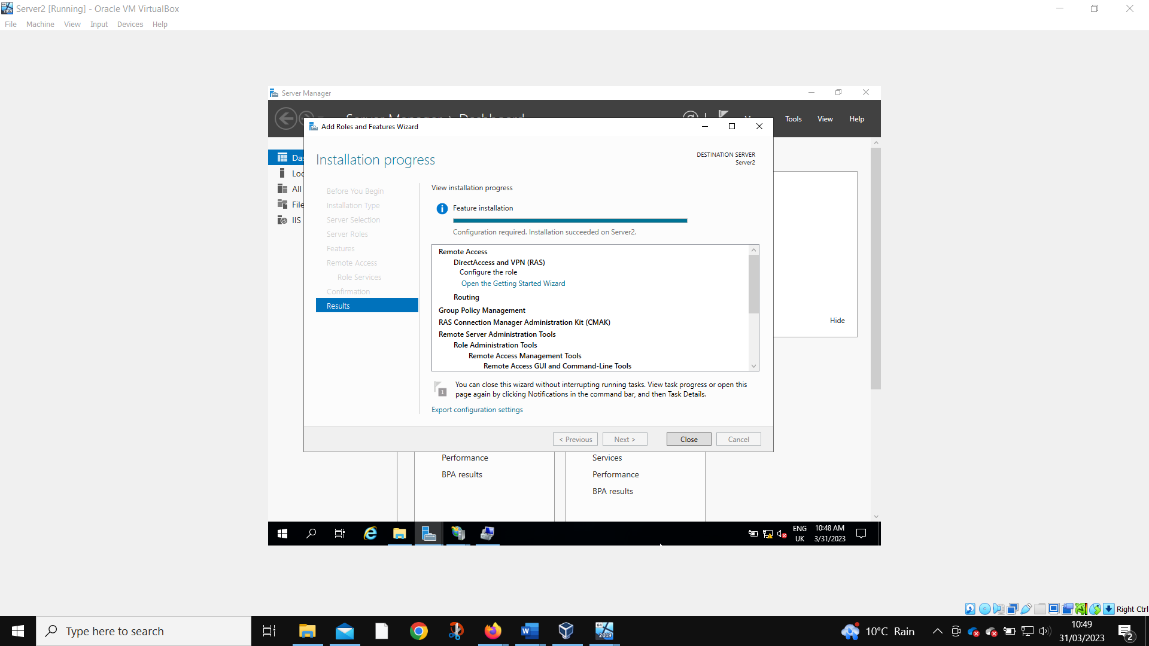
Installation confirmed.
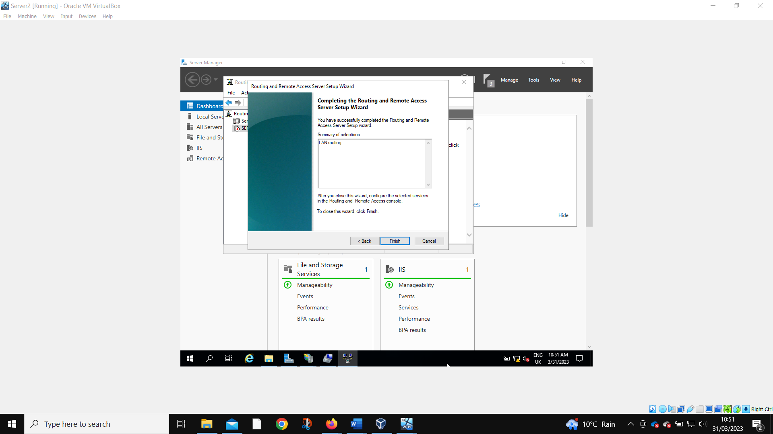
Installation successful.
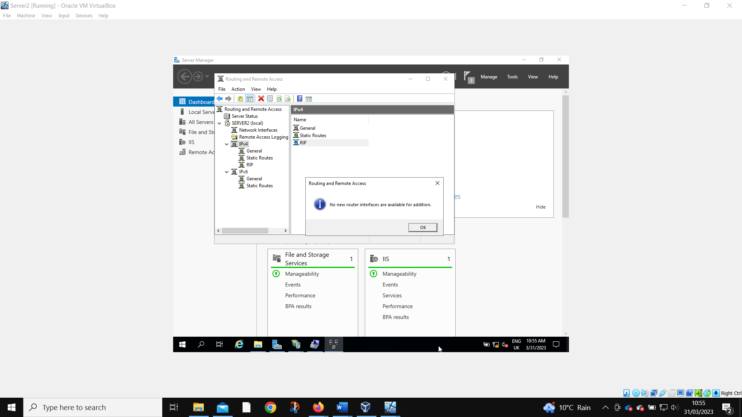
All network interfaces were added.
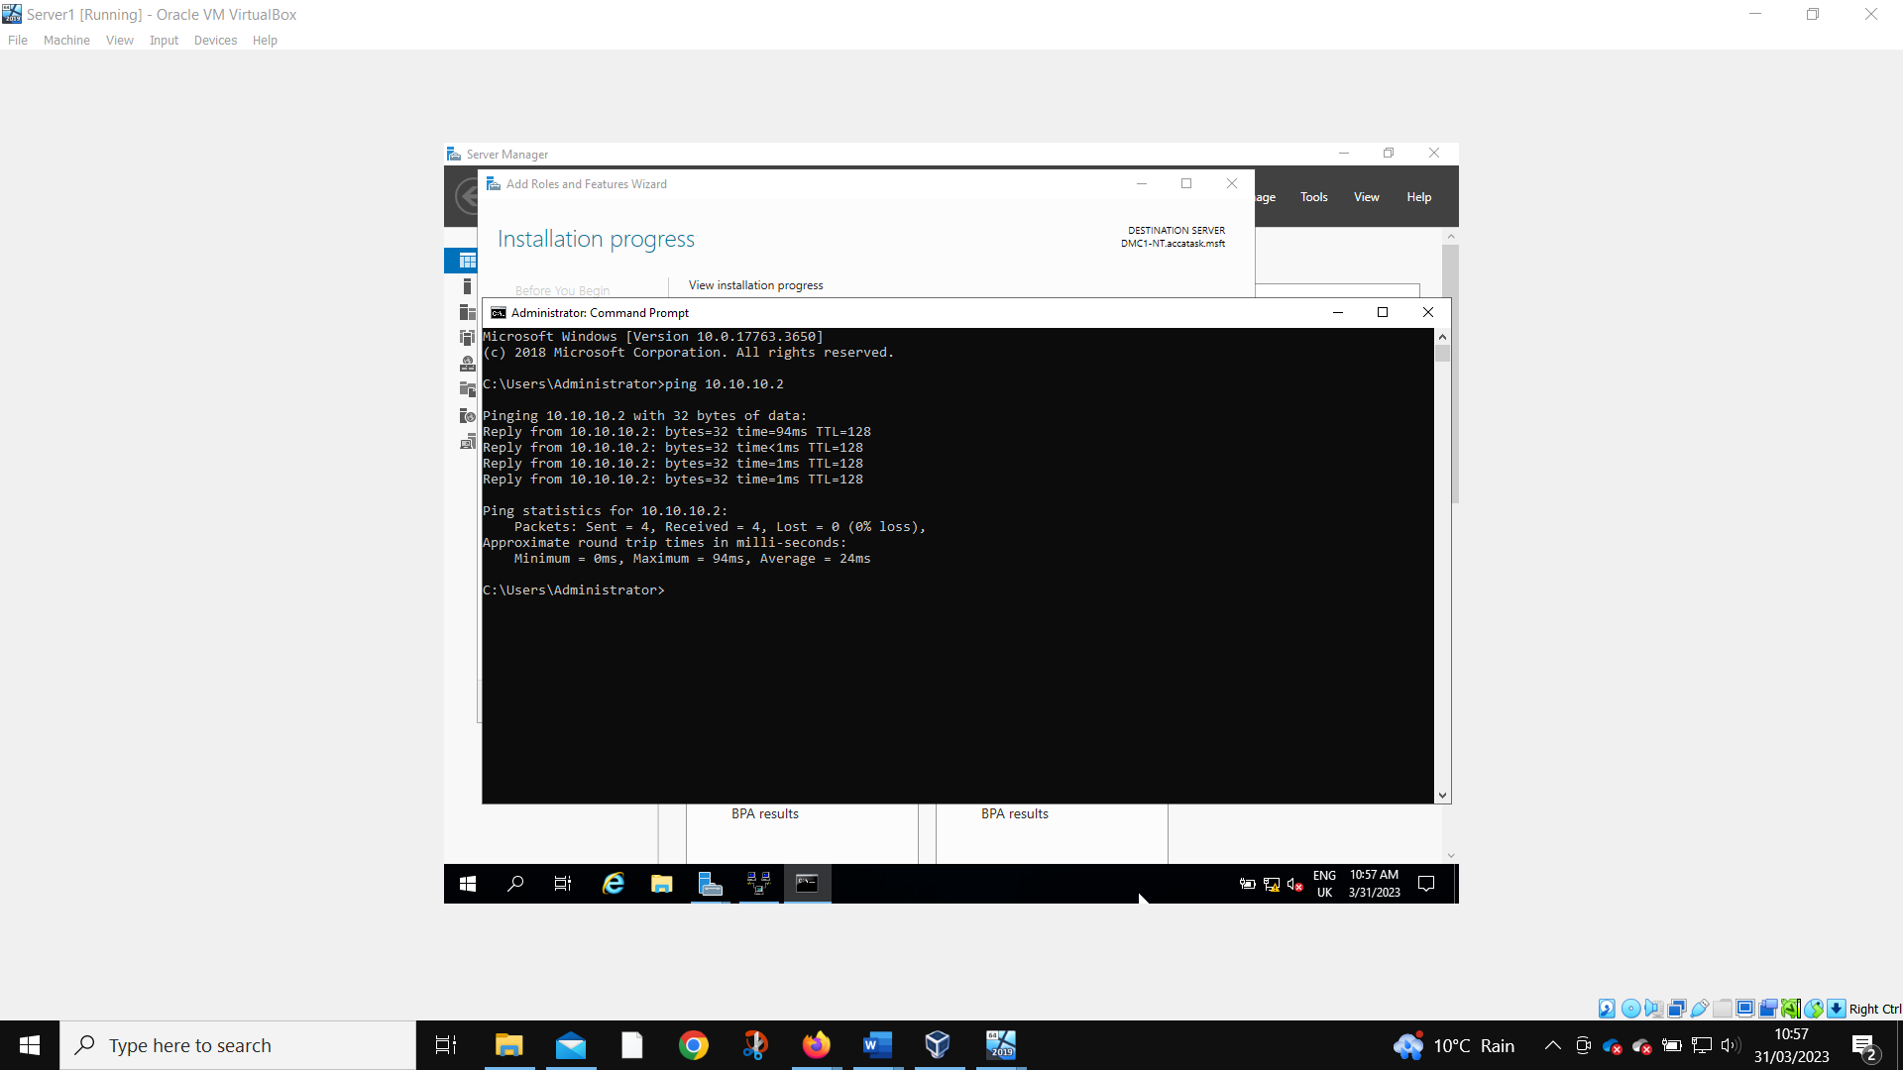
Server 1 is still able to ping the PublicNet IP of Server 2. This means that the servers are connected correctly.
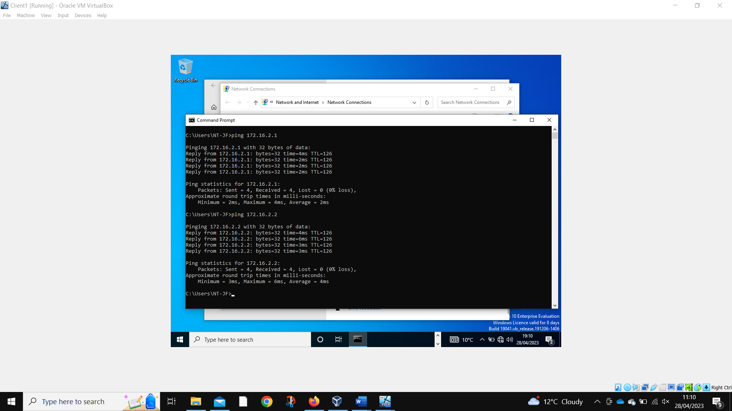
Client 1 can ping both Server 2 and Client 2.
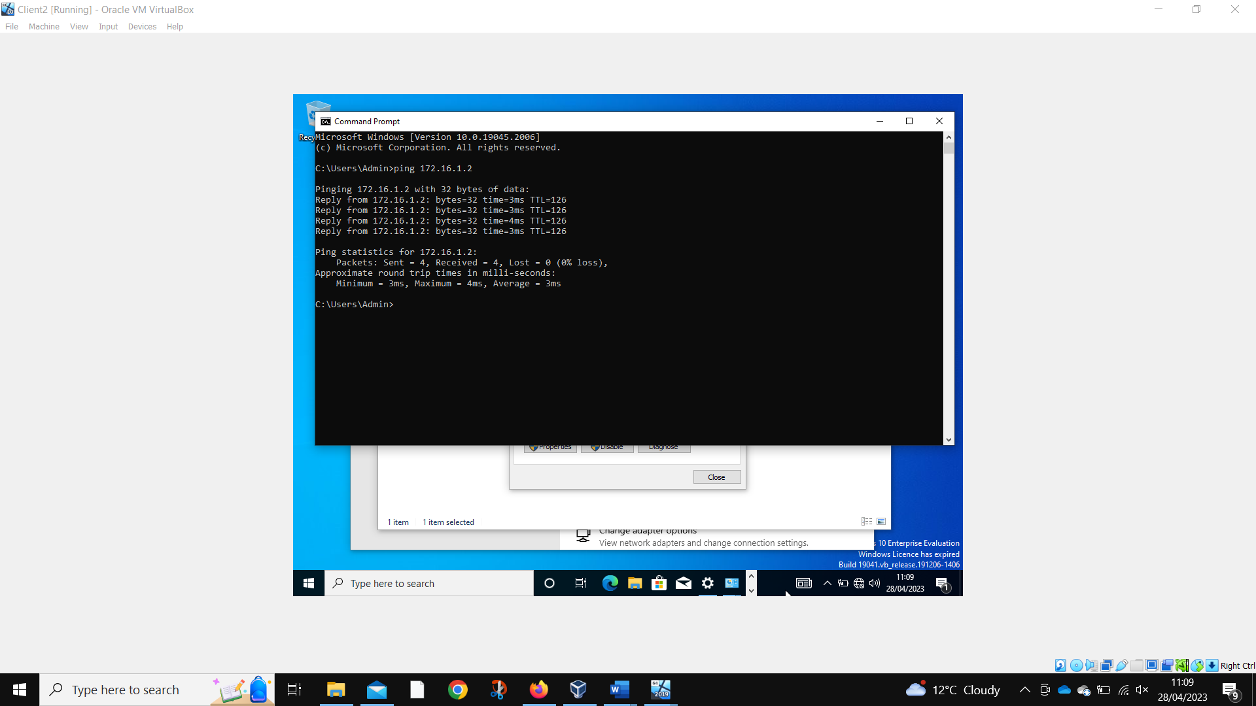
Client 2 can ping Client 1.

2.2.4 IP Packet Filtering

2.2.4.1 Stopping ‘anyone’ in PrivateNet1 from Pinging the Router Firewall Service

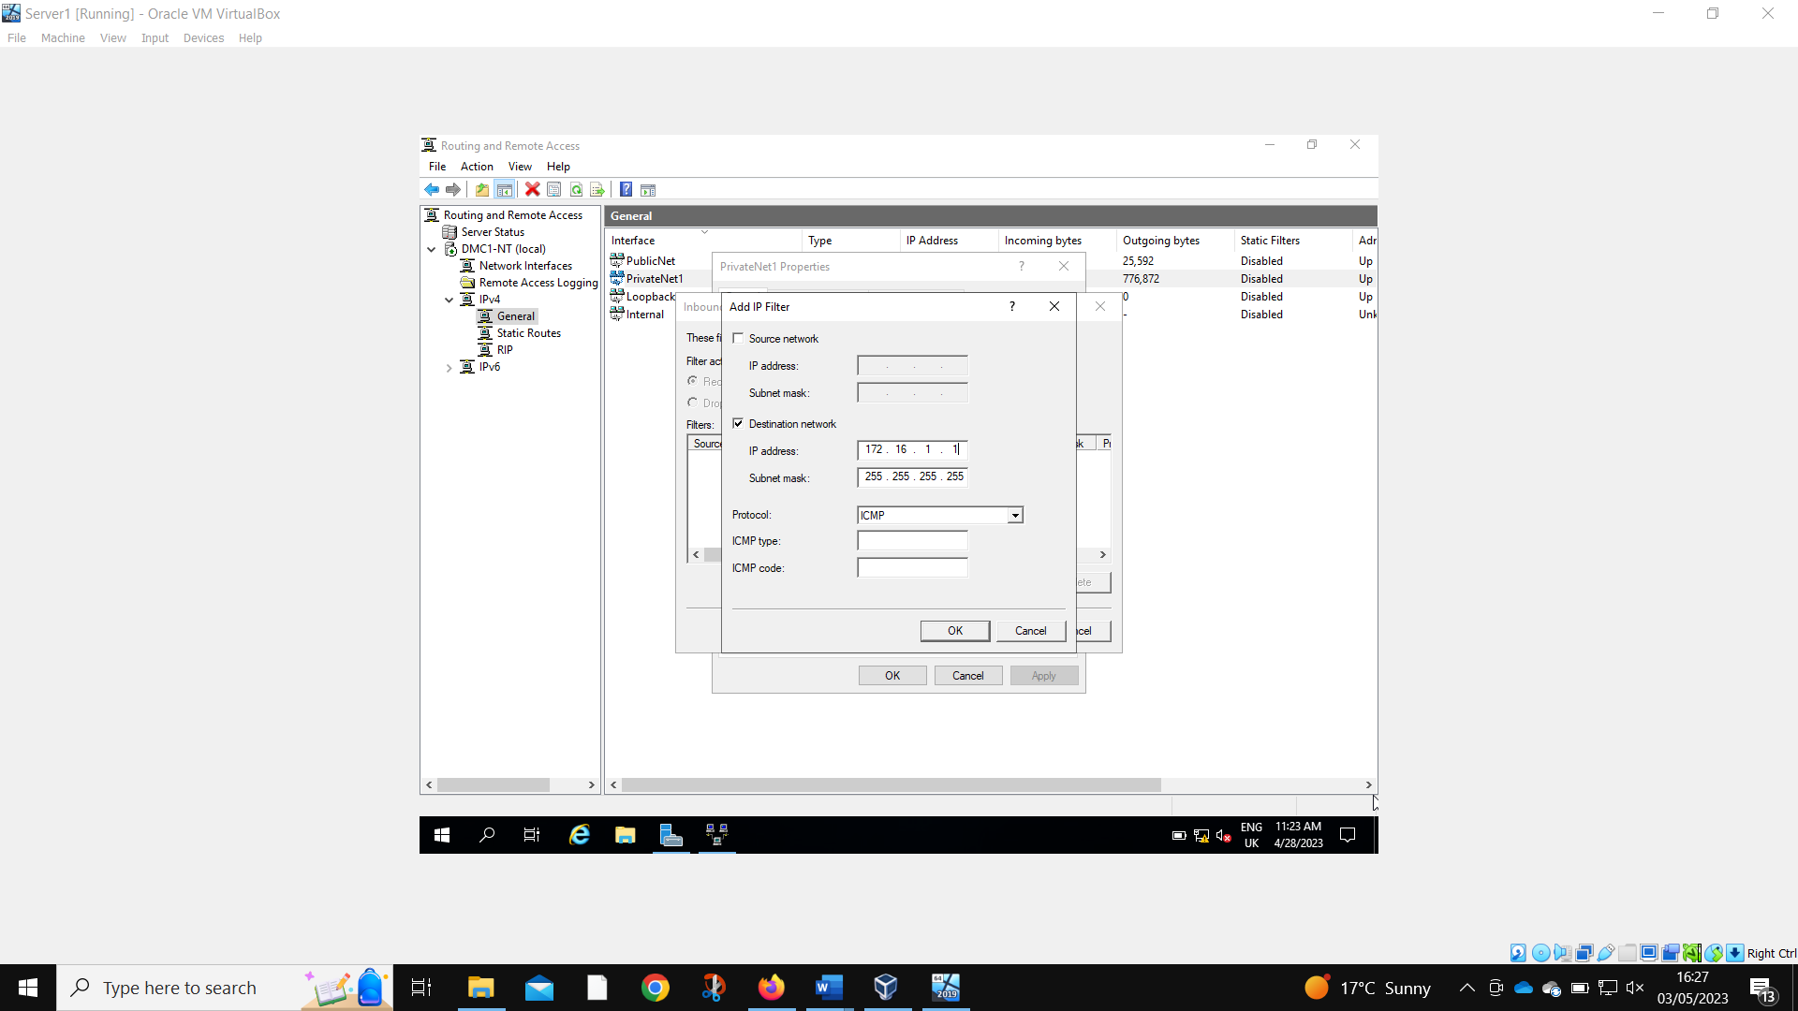
‘Everyone’ in PrivateNet 1 is prevented from pinging the router firewall.
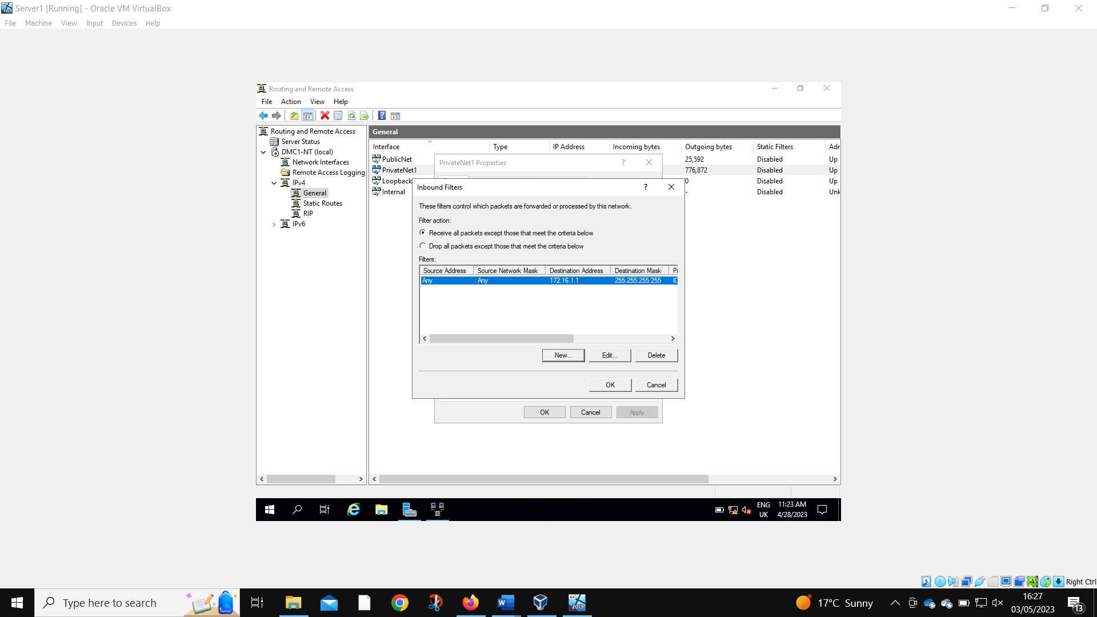
PrivateNet1 is set to receive all packets expect those that meet the criteria below. This allows other functions to continue – only pinging the server is prevented.
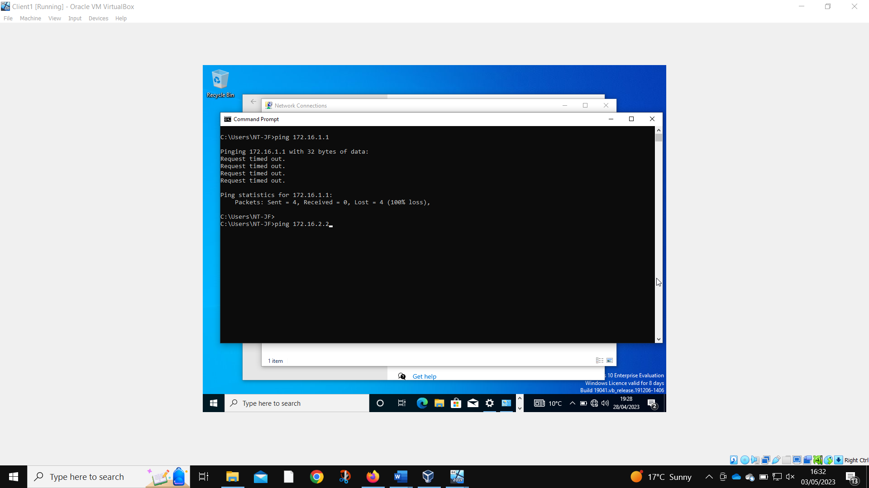
Client1 is unable to ping server.

2.2.4.2 Filter 2: Restrict Access to FTP Service running on Server2 to only hosts in PrivateNet2.

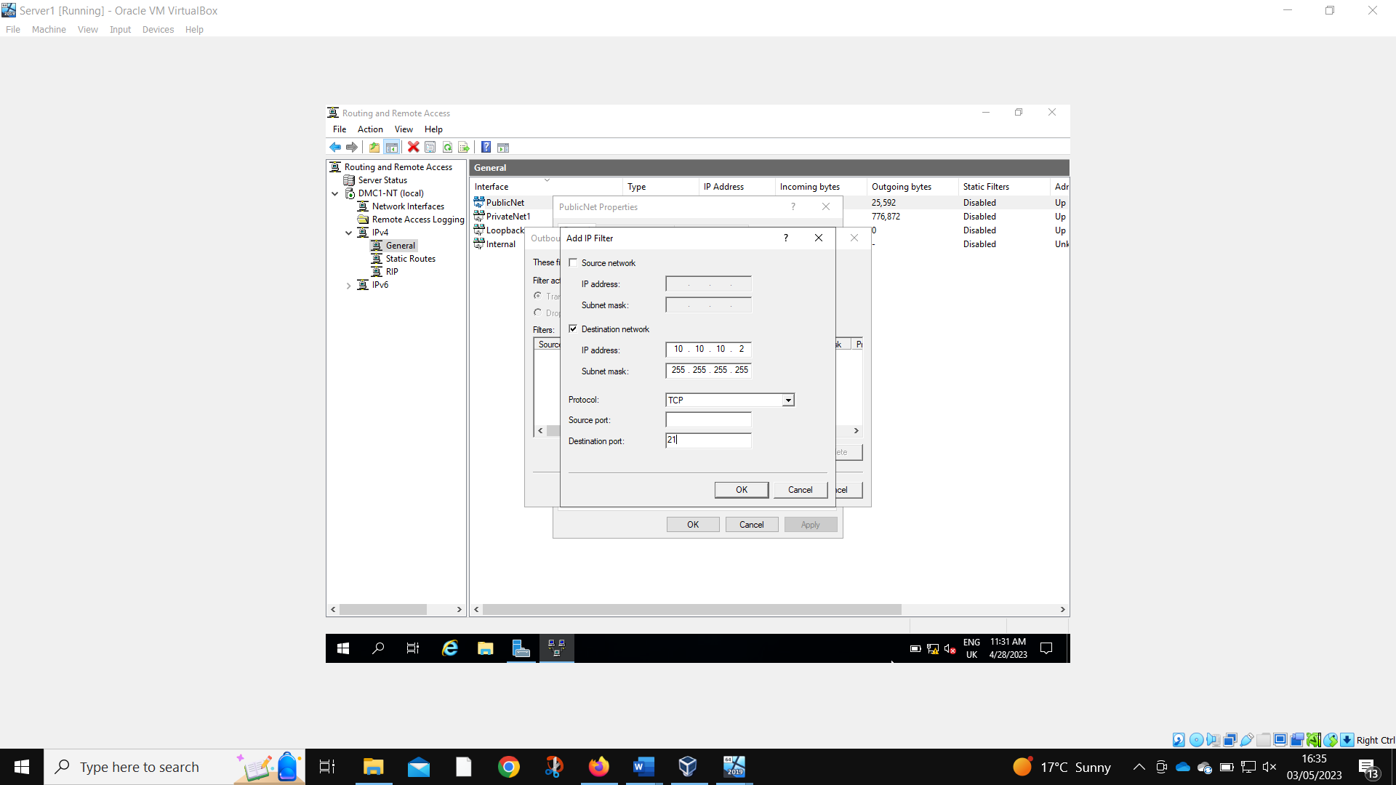
Anyone outside of PrivateNet2 is prevented from using the FTP service on Server2.
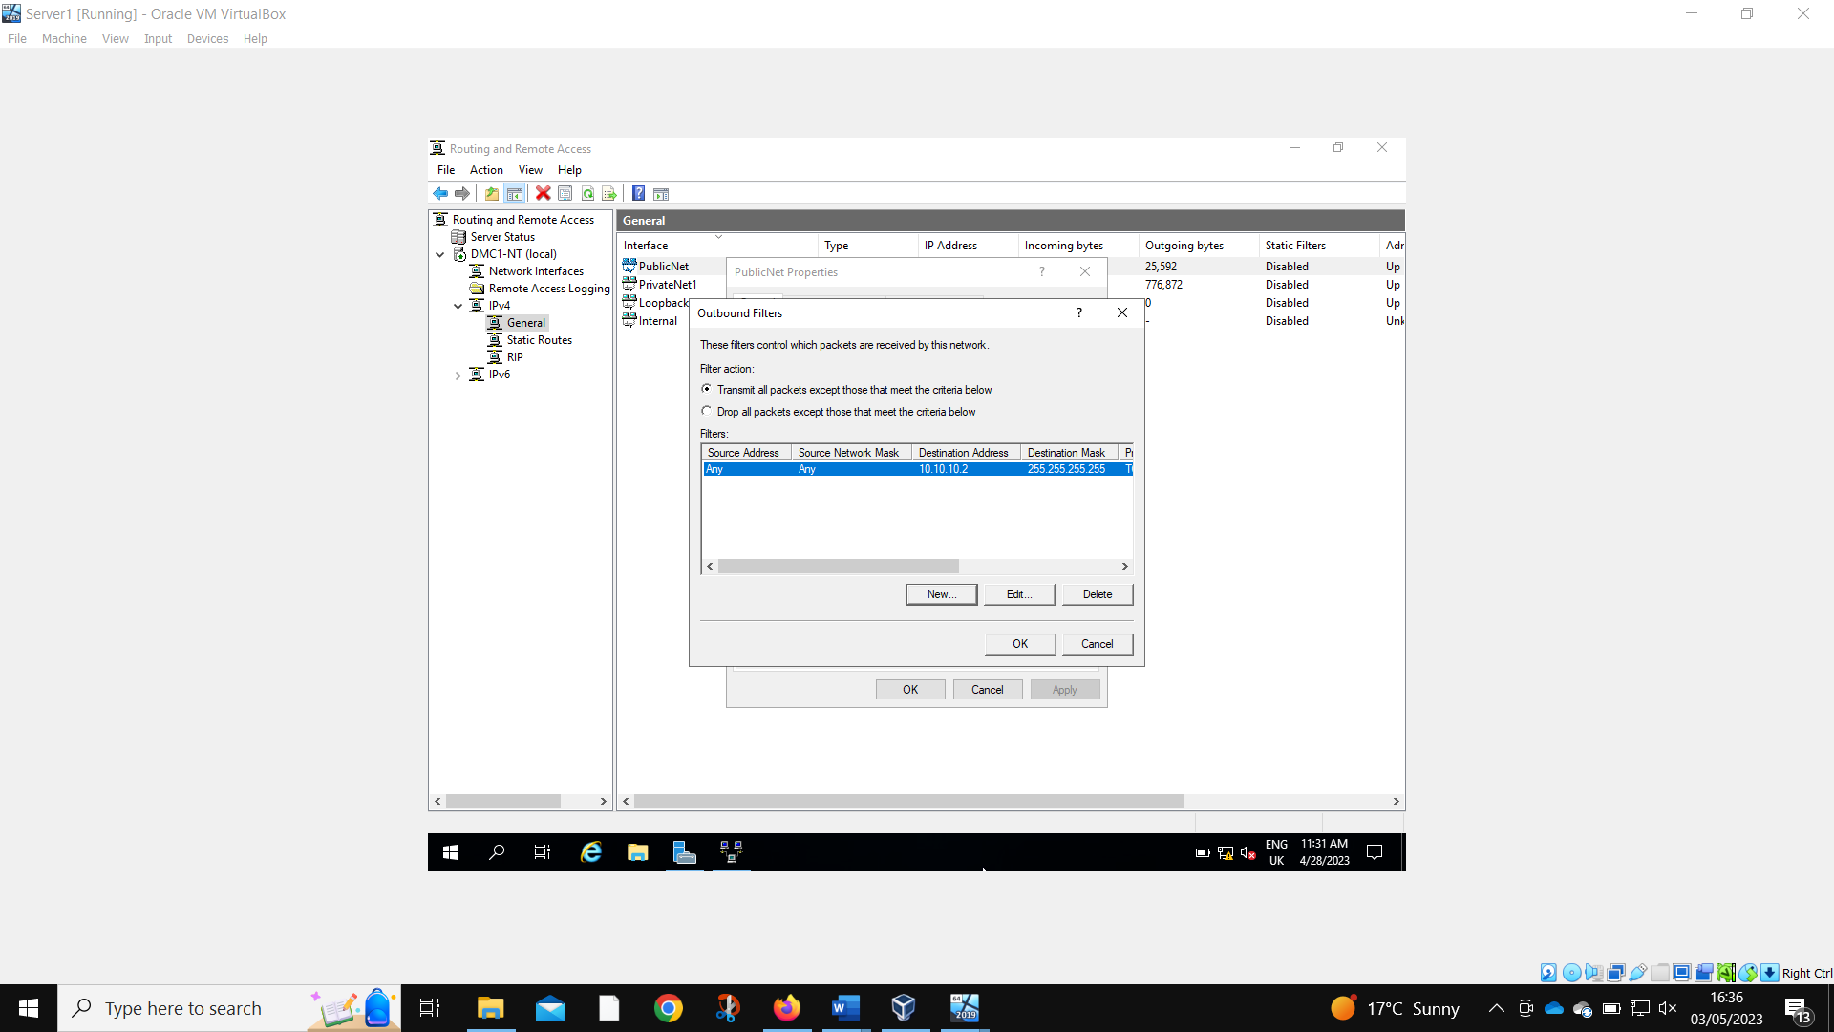
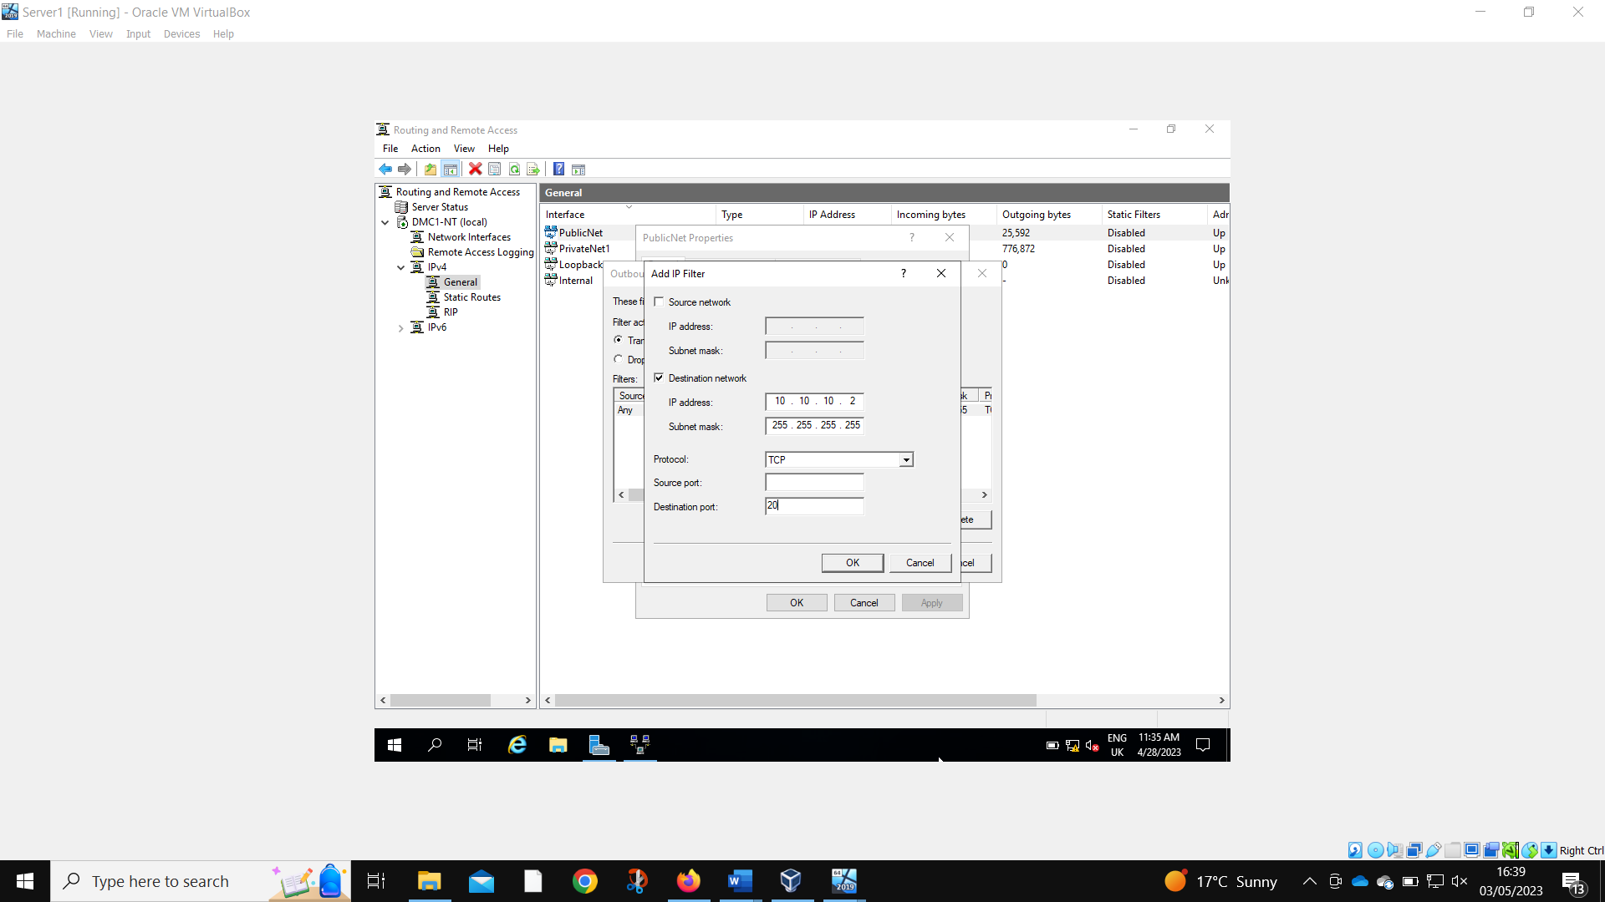
Port 20 and 21 had to be set.
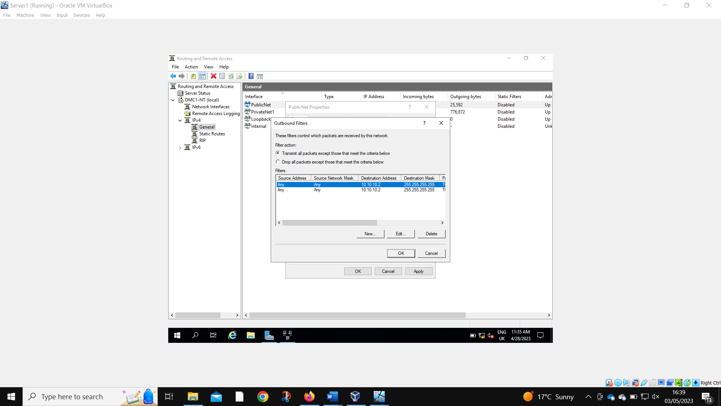
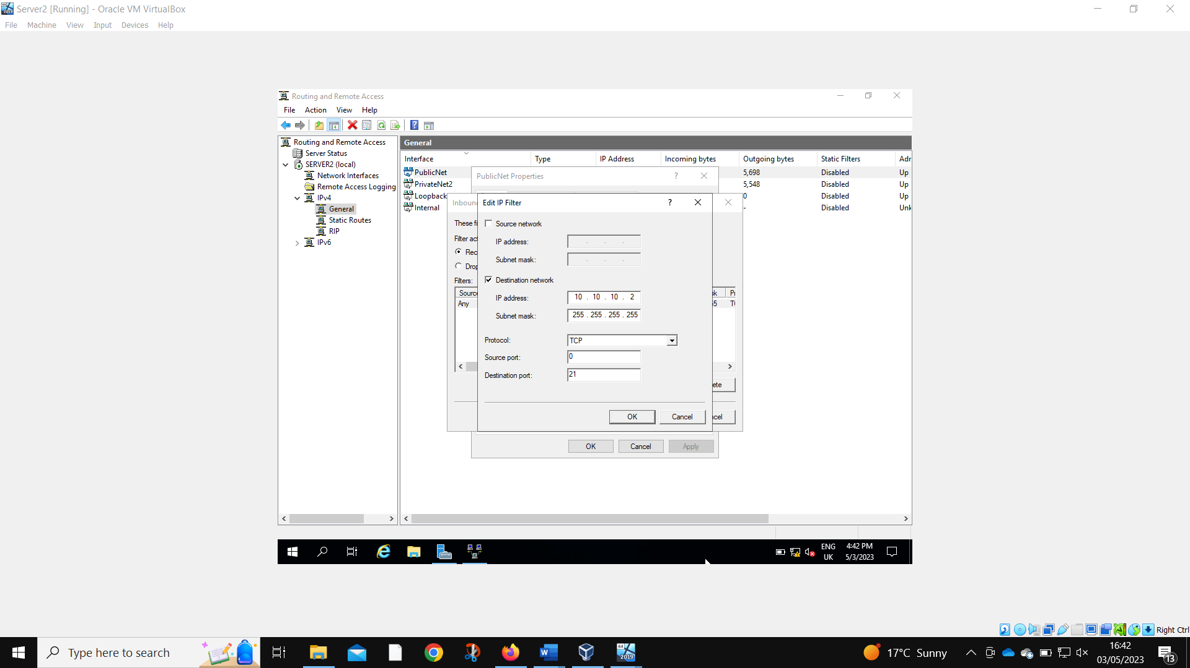
Port 21 is also blocked as an inbound on Server2.
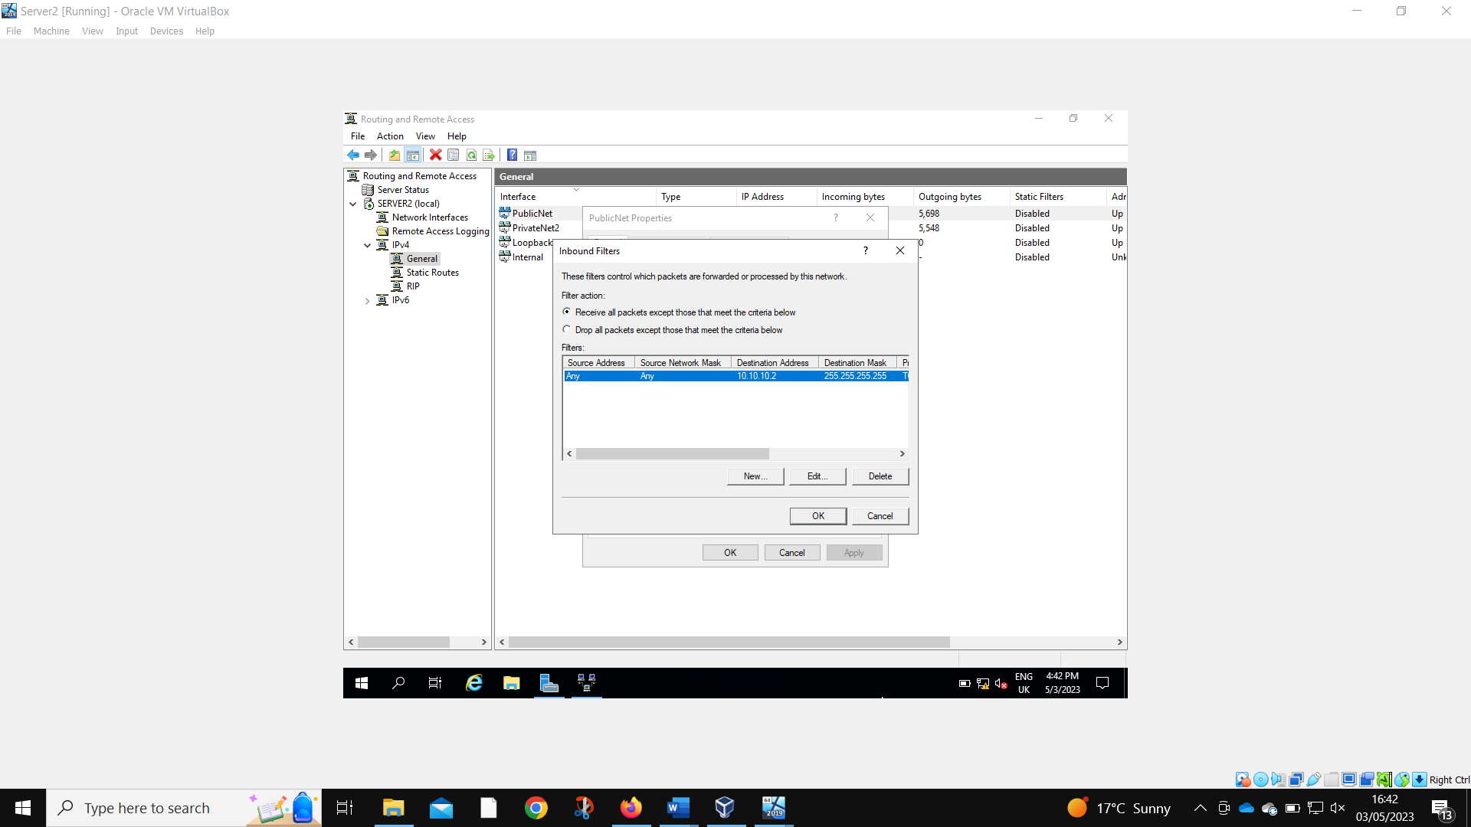
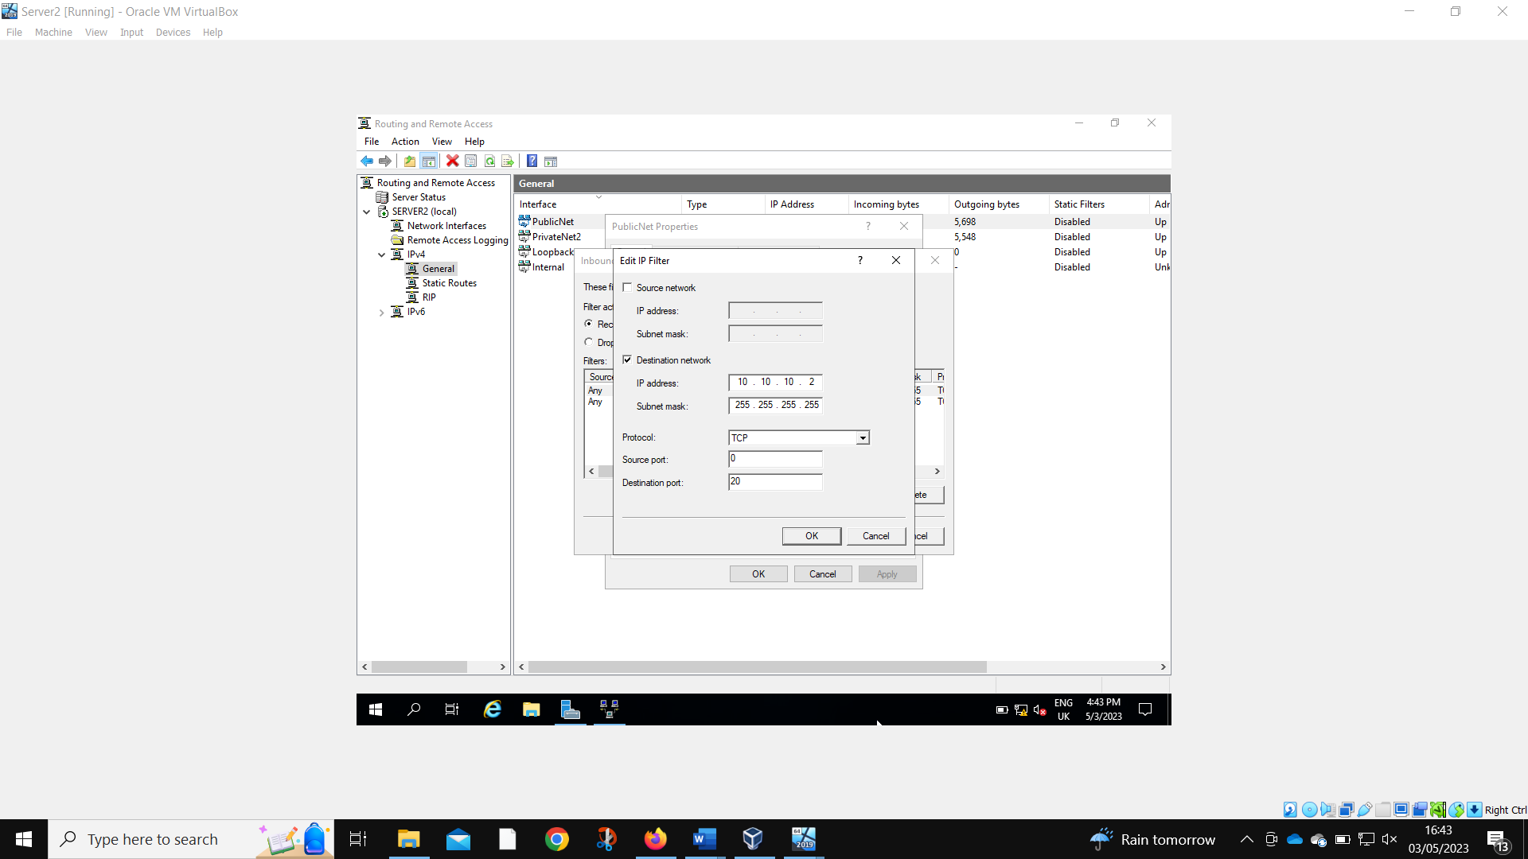
As is port 20.
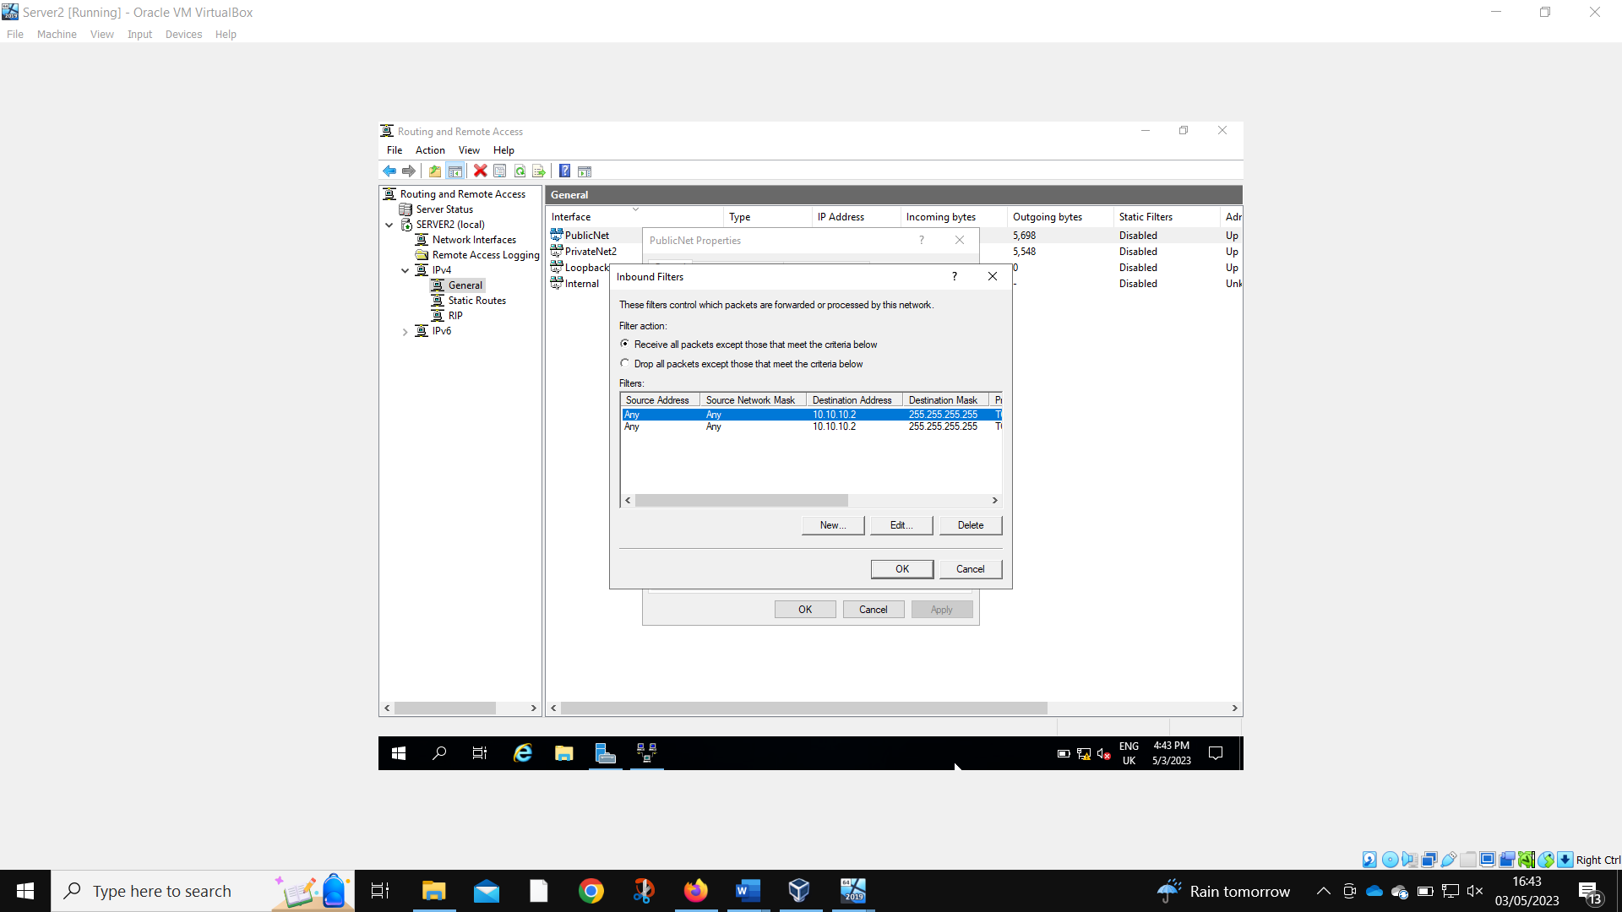
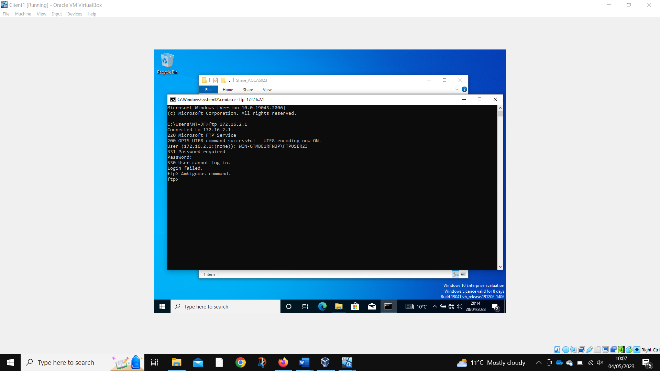
Client 1 is unable to log into the FTP service.

3. Part 2: Observational Tasks/Work

3.1 Small Office and Home Office
The term SOHO network relates to a computer network frequently used in small offices or home environments (Mitchell, 2021). Typically, these networks comprise a limited number of computing devices that are linked to facilitate the sharing of resources (Fig.3.1)
Figure 3.1. Small Office and Home Office (SOHO) Network Topology. Soho encompasses an ethernet device that directions the traffic to other devices. Adapted from CCNA tutorials (2023).

One of the fundamental and crucial measures to undertake is to ensure that all network devices, such as servers, routers, and switches, are properly secured with a strong password that include a combination of uppercase letters, lowercase letters, numerical digits, and special characters. It is recommended to regularly change passwords as a means of enhancing security. Moreover, it is necessary to perform regular data backups to protect against potential data loss. Making access restrictions to ensure that only authorized users can have access to the network as demonstrated in the work above is also critical. Furthermore, configure firewalls on all devices is also beneficial. It is necessary to periodically update the operating system and software on all connected devices.

3.2 Failover Cluster for high availability systems/services
In the case of a system breakdown, a failover cluster is a collection of more than one computer, servers, or nodes that facilitate a high availability (HA) or continuous availability (CA) environment for the various applications and services (Conrad et al., 2016). By automatically identifying and reacting to cluster faults, this sort of clustering aims to offer continuous availability for vital applications and services. When a node in a failover cluster malfunction or is rendered inaccessible, another node assumes responsibility for the workload to maintain continuous access to the applications and services. In corporate settings where high availability is essential to business operations, failover clusters are often deployed. Firstly, to use such a system, it is mandatory to know about the failover cluster's functionality as well as the applications and services it will serve. Secondly, failover cluster requires multiple physical or virtual computer systems with secured and high-speed. Thirdly, the storage infrastructure must be considered. All the computers in the failover cluster must have access to shared storage. Role Failover Cluster Manager in Windows Server OS allows administrators to create, configure and manage in Windows environments.
The variables that follow must be taken in mind while deploying this role:
- Ensure that the network and hardware satisfy the specifications for a Failover cluster.
- Configure the infrastructure for shared storage to maximise availability and resilience.
- On your chosen server(s), install the Failover Cluster Manager role.
- Using the Failover Cluster Manager tool, set up and configure the Failover cluster.
- Set up the Failover procedure and extensively test it to make sure it functions as intended.
It is essential to construct a failover cluster because it offers a highly available and solid environment for crucial applications and services; without it, the network becomes vulnerable.

4 Reflection
While using SOHO systems is highly beneficial in the multiuse, a critical approach needs to be adapted for the security and database history and/or storage. The increased price of SOHO system compared to the normal home router might be a limiting factor. However, the benefits of SOHO systems include the built-in features (such as firewalls, dual-band Wi-Fi, and wired connection) that greatly improve the use of these systems. Failover clusters are highly effective as they provide instant protection, and automatic failover if hardware fails. As the failover clusters are continuously monitored, generating a highly controlled use. Also, as failover clusters offer cluster-shared volume (CSV), the use of shared storage could improve the time management and accessibility of the shared nodes. Therefore, these approaches are highly beneficial in a business setting.

5. References

Mitchell, B. (2021) How soho routers and networks differ from Ordinary Ones, Lifewire. Lifewire. Available at: https://www.lifewire.com/soho-routers-and-networks-explained-3971344 (Accessed: May 5, 2023).

Conrad, E., Misenar, S., Feldman, S. (2016). Chapter 8 - Domain 7: Security Operations (e.g., Foundational Concepts, Investigations, Incident Management, Disaster Recovery), CISSP Study Guide (Third Edition); Pages 347-428.

Tutorials, C. (2020) Small Office Home Office Soho explained for CCNA, CCNA TUTORIALS. Available at: https://ccnatutorials.in/network-fundamentals-ccna-200-301/small-office-home-office-soho/ (Accessed: May 5, 2023).

