MARIA DIANA IUBIS(2412985)
UNIVERSITY OF WALES, TRINITY SAINT DAVID

CERTIFICATE OF HIGHER EDUCATION BUSINESS SKILLS FOR THE WORKPLACE
DIGITAL SKILLS(LCLM4002)
TASK 3 – WRITTEN REPORT
TOPIC: “WRITE A REPORT ABOUT HOW SOCIAL AND DIGITAL MEDIA CAN BE USED TO REACH A WIDER CUSTOMER BASE”

Executive summary
In this report, highlights of how social and digital media have affected organisations and in which various ways businesses are able to reach out to a number of customers at the same time have been briefly outlined. As discussed in this report the advantages and disadvantages of various social media tools on organisations are clearly highlighted. Authentic information has been included in this report in relation to the general topic of discussion.

Table of Contents
Introduction 4
The influence of social and digital media in reaching a wider customer base 4
The advantages and disadvantages of different social media tools 6
Advantages 6
Disadvantages 8
Conclusion 8
Reference List 9

Introduction
This report mainly centred on the effects of digital and social media in the operations of organisations concerning the opportunities that organisations have to extend to the customers. Besides that, the pros and cons of some of the commonly used social media tools which are used by businesses will also be evaluated in this report.

The influence of social and digital media in reaching a wider customer base
The paper shows that digital and social media deeply impact the capability of a business to build relationships with a new clientele base. It helps by making a point where firms can address global customers and immediately get their attention about their business besides increasing brand visibility. Digital and social media are also used for harnessing the power of the concept of user-generated content whereas multiple targeted operating advertising for reaching out to some particular classes of population (Dwivedi et al., 2021). Further, it has been observed that social and digital media in assisting to develop a loyal customer base as well as increasing the rate of sales for the organisation to improve their revenue.
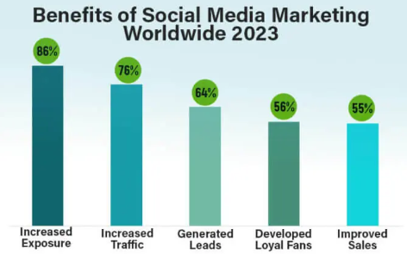
Figure 1: Benefits of social media
(Source: Educba.com, 2024)
The primary waste through which social and digital media can help companies reach a wide customer base is by increasing the visibility of the brand. The presence of multiple social media platforms enables firms to demonstrate their services or products to a huge pool of users, which automatically boosts brand awareness. It also helps in increasing brand recognition across several demographics. Along with that, it has been observed that social and digital media also help in targeted advertising. In other words, precise targeting options are available on different social media platforms (Dolega et al., 2021). It allows organisations to emphasise specific consumer segmentation based on their behaviours, interests, maximum advertising relevance and demographics.
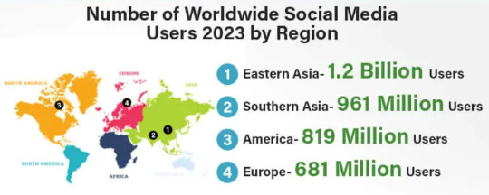
Figure 2: Global users of social media
(Source: Educba.com, 2024)
On the other hand, it has been noted that consistent content strategies, which are maintaining a proper and consistent posting schedule with appropriate and high-quality content are significant for an organisation to sustain their customer engagement procedure. It is also significant for businesses to actively respond to questions, concerns and comments to build trust among customers regarding the brand (Jomswsge.com, 2024). Social media also enables organisations to easily connect with their consumers while improving brand awareness and simultaneously influencing the attitudes of their customers.
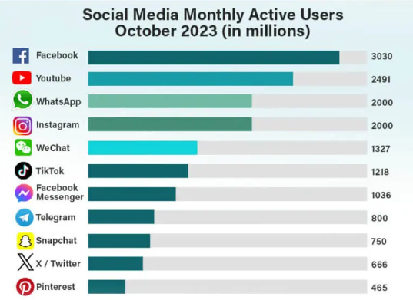
Figure 3: Monthly active users of social media
(Source: Educba.com, 2024)

The advantages and disadvantages of different social media tools

Advantages
Different social media tools help in increasing customer engagement by offering the facilities of several interactive features such as likes, and comments while also giving the option of direct messaging, which facilitates real-time communication with consumers. This eventually helps in fostering a sense of connection while building a loyal customer base. Social media tools like Hootsuite can help businesses manage multiple platforms while helping to schedule posts accordingly (Malinao, 2024). Organisations can also use influential marketing while collaborating with multiple social media influencers who can help increase the reach of the business while offering credibility in leveraging and establishing customers’ trust (Leung et al., 2022). Brandwatch is another social media tool which is helpful for organisations in terms of sentiment analysis and understanding the needs and requirements of their customers.
There are certain social media tools which help businesses encourage consumers to share their experience with the firm through reviews and posts on social media. This can help in organically generating valuable content along with social proof on behalf of the business. Social listening tools also enable companies to monitor the sentiments of their consumers by gathering feedback as well as identifying emerging market trends so as to improve their services or products. The benefit of using Buffer as a social media tool is that it can help companies with content scheduling as well as analytics so that the changing dynamics of the market trends can be easily identified (Kedi et al., 2024). Effective utilisation of different social media platforms like Twitter, Instagram, YouTube, Facebook and LinkedIn can assist companies to reach out to a diverse customer base and this entirely depends on the preferable channels used by their target audiences (Macarthy, 2021).
The advantage of using Hubspot is that it can help organisations by improving their process of social monitoring and it also offers an effective strategy through which organisations can directly interact with customers and understand the problems faced by them (Fuks, 2024). Firms can also benefit by using Canva for graphic design to attract potential customers. This is a low-cost advertising system which not only reduces the costs of organisations it also helps in maintaining the cost-effectiveness of the brand while aiding the brand in terms of competitive advantage. Creative and engaging content has the potential to go viral easily, which can rapidly expand the reach of the organisation with the help of organic sharing (Contentmarketinginstitute.com, 2021). This strategy is not only affordable but also convenient for organisations in terms of running their business smoothly.
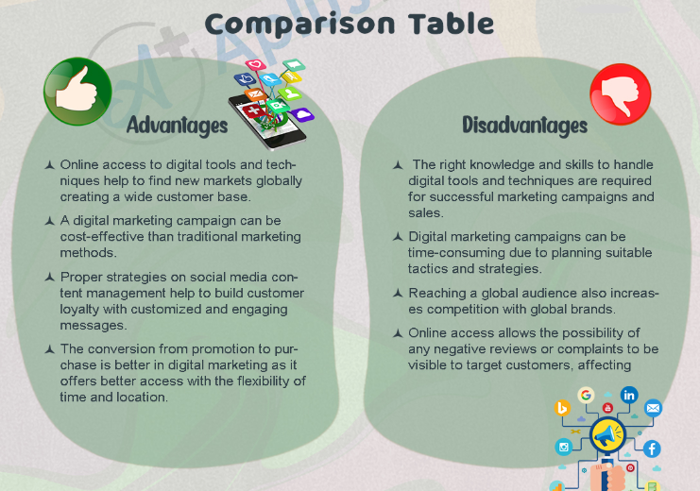
Figure 4: The advantages and disadvantages of social media tools
(Source: Aplustopper.com, 2022)

Disadvantages
It becomes difficult for organisations to keep track on a regular basis of their key performance indicators (KPIs). As a result of this, there are huge chances that the engagement level, reach and conversion rate, if not evaluated properly, can fall. In addition to that, the ineffectiveness of different social media campaigns with the help of different social media tools can also result in creating a bad image of the company among customers (Researchgate.net, 2023). The benefit of social media tools is that they can help organisations in developing their customer base, however, the drawback of social media tools is that the company have to keep track of records of the same in order to meet the target profit.
Completely relying on these social media tools and not maintaining proper records can hamper the entire business. It is also a challenging factor on the part of the organisations to increase repeat customers by completely depending on social media tools and not directly approaching the customers (Yap et al., 2021). It becomes problematic to target the right customer base, and the presence of limitations in the algorithms of social media tools generally restricts organic reach. It is a complete "platform-specific user demographics” whose navigation and proper utilisation to generate constant consent is difficult.

Conclusion
The drawbacks and benefits of using different social media tools have been mentioned along with different examples of different social media tools which has been helpful for different companies. In this report, the influence of social and digital media has been highlighted thoroughly.

Reference List
Aplustopper.com, (2022). “Advantages And Disadvantages Of Digital Marketing | What is Digital Marketing?, 8+ Digital Marketing Advantages and Disadvantages” Available at: <https://www.aplustopper.com/advantages-and-disadvantages-of-digital-marketing/> [Accessed on: 12.12.2024]
Contentmarketinginstitute.com, (2021). “50 Social Media Tool Recommendations From Top Marketers” Available at: <https://contentmarketinginstitute.com/articles/best-social-media-tools-top-marketers/> [Accessed on: 12.12.2024]
Dolega, L., Rowe, F. and Branagan, E., (2021). Going digital? The impact of social media marketing on retail website traffic, orders and sales. Journal of Retailing and Consumer Services, 60, p.102501.
Dwivedi, Y.K., Ismagilova, E., Hughes, D.L., Carlson, J., Filieri, R., Jacobson, J., Jain, V., Karjaluoto, H., Kefi, H., Krishen, A.S. and Kumar, V., (2021). Setting the future of digital and social media marketing research: Perspectives and research propositions. International journal of information management, 59, p.102168.
Educba.com, (2024). “Advantages and Disadvantages of Social Media” Available at: <https://www.educba.com/advantages-and-disadvantages-of-social-media/> [Accessed on: 12.12.2024]
Fuks, K., (2024). MARKETING ACTIVITIES OF IT COMPANIES: INFORMATION AND ORGANISATIONAL CAPABILITIES FOR DIGITAL PRODUCT DEVELOPMENT. Green, Blue and Digital Economy Journal, 1(1), pp.22-30.
Jomswsge.com, (2024). “THE INFLUENCE OF DIGITAL MARKETING AND SOCIAL MEDIA MARKETING ON CONSUMER BUYING BEHAVIOR” Available at: <https://www.jomswsge.com/pdf-189429-114019?filename=The%20influence%20of%20digital.pdf> [Accessed on: 12.12.2024]
Kedi, W.E., Ejimuda, C., Idemudia, C. and Ijomah, T.I., (2024). Machine learning software for optimising SME social media marketing campaigns. Computer Science & IT Research Journal, 5(7), pp.1634-1647.
Leung, F.F., Gu, F.F. and Palmatier, R.W., (2022). Online influencer marketing. Journal of the Academy of Marketing Science, 50(2), pp.226-251.
Macarthy, A., (2021). 500 social media marketing tips: essential advice, hints and strategy for business: Facebook, twitter, pinterest, Google+, YouTube, instagram, LinkedIn, and mor.
Malinao, D., (2024). Enhancing Customer Relationship Management in Social Media with Social CRM: A Study on Effective Social CRM Strategies and Guidelines.
Researchgate.net, (2023). “Using Social Media Marketing in the Digital Era: A Necessity or a Choice” Available at: <https://www.researchgate.net/publication/370578753_Using_Social_Media_Marketing_in_the_Digital_Era_A_Necessity_or_a_Choice> [Accessed on: 12.12.2024]
Yap, S.F., Xu, Y. and Tan, L., (2021). Coping with crisis: The paradox of technology and consumer vulnerability. International Journal of Consumer Studies, 45(6), pp.1239-1257.

