Ana Catarina Gomes Luis

INDIVIDUAL Elm pROJECT rEPORT

by

Ana Catarina Gomes Luis
University of Wales Trinity Saint David
Creative Computer Game Design
Game Design and Asset Creation 1
Team:
Aday
Catarina
Connor
Aled

Table of Content
Introduction--------------------------------------------------------------------3
Objectives and Goals for the Project --------------------------------------4
Research-----------------------------------------------------------------------.6
Prioritization-------------------------------------------------------------------7
Communication---------------------------------------------------------------8
Scope---------------------------------------------------------------------------9
Testing-------------------------------------------------------------------------9
Production Plan---------------------------------------------------------------10
Production problems and successes---------------------------------------11
Future Project Plan----------------------------------------------------------12
Conclusion--------------------------------------------------------------------12
Appendice---------------------------------------------------------------------13

Introduction
This document is a report that will describe the overall group development and individual development for the Elm game project. The project attempts to create a 15 minutes game experience, for this reason a plan needs to be laid out to help the creation of the assets and engine work, in order for the group to know each other’s tasks, what should be done, when it should be done by and including on the to do lists a risk assessment and changes of plans should be kept in update during the whole course of the production.
However, this report will be focusing on the plan for the group in the first semester, it will discuss the work that has been developed, the overall contribution of each member of the group in the tasks that needed to be developed, demonstrate the initial project plan and how it changed throughout the whole production as well as what will be needed to be done in the second semester and during the holiday break. Besides of a reflection of the overall production of the group, an individual analysis of the project production done by the group member Ana Luis, will be described in the report.

Objectives and Goals for the Project
The aim of this report as said in the introduction is to create a 15-min game experience by the end of the second year of the course, however, the goals for each semester will differ as the project goes through. For the first semester each group member was assigned with the following tasks:
Aday: Concept art for two bosses’ modelling, retopology and texture. It was also his task to produce some environment concepts.
Ana: Recreation of the concept art for some elements in the game, creation of the main character, model, retopology and texture. Creation of the concept art for two enemies including their models, retopology and texture. Adding to the creation of the characters, the creation of the concept art for the main tree, the dead trees and some environment aspects was in her tasks.
Connor: The group member was in charge of the engine programming, control design and AI programing
Aled: Creation of the concept art for some environment models and concept as well as weapons assets. Rigging the characters and construct the level design for the game.
Each team member had access to a drive where work was updated, as well as a project plan for the whole group where each task was laid out and explained, once a task was completed any member could log in and update the plan, so everyone knew what has been done and what was left to do. However, some of the members needed to be reminded to upload the plan as they followed with the project which caused in some communications problems as members lost track of the others work. As showed below:

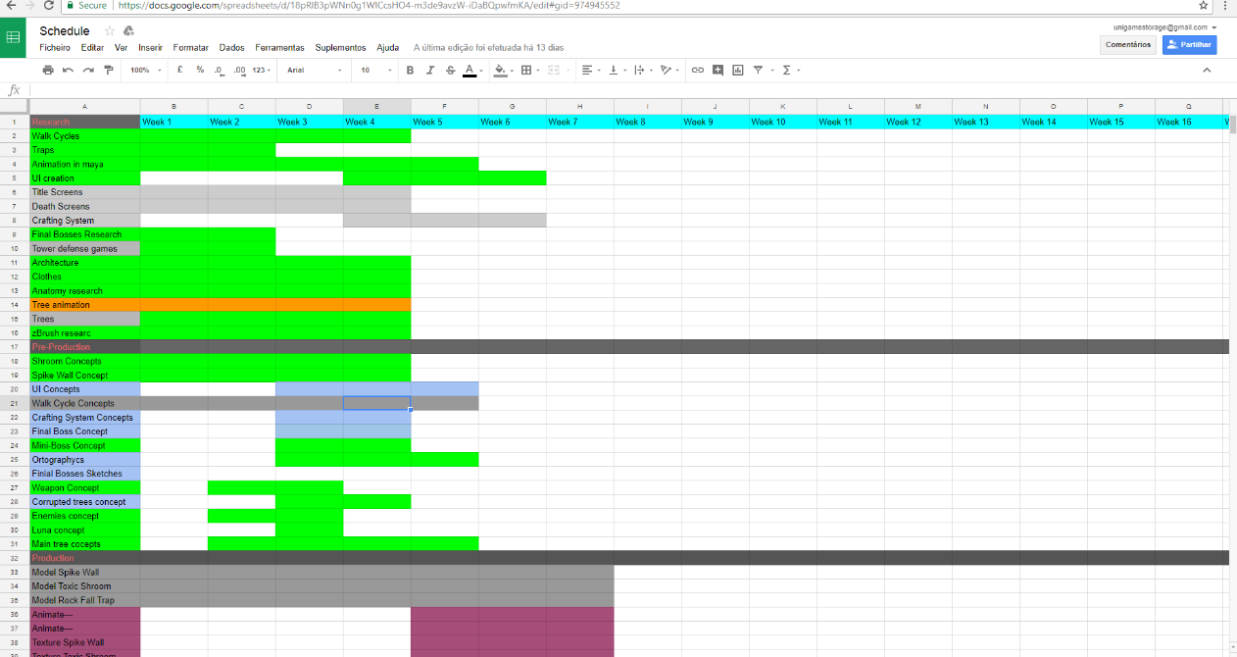

Despite the loss of track in the project plan for some of the members, in each meeting a layout of what each person had achieved that week was laid out in a word document, as well as what needed to change in the plan. As showed below:
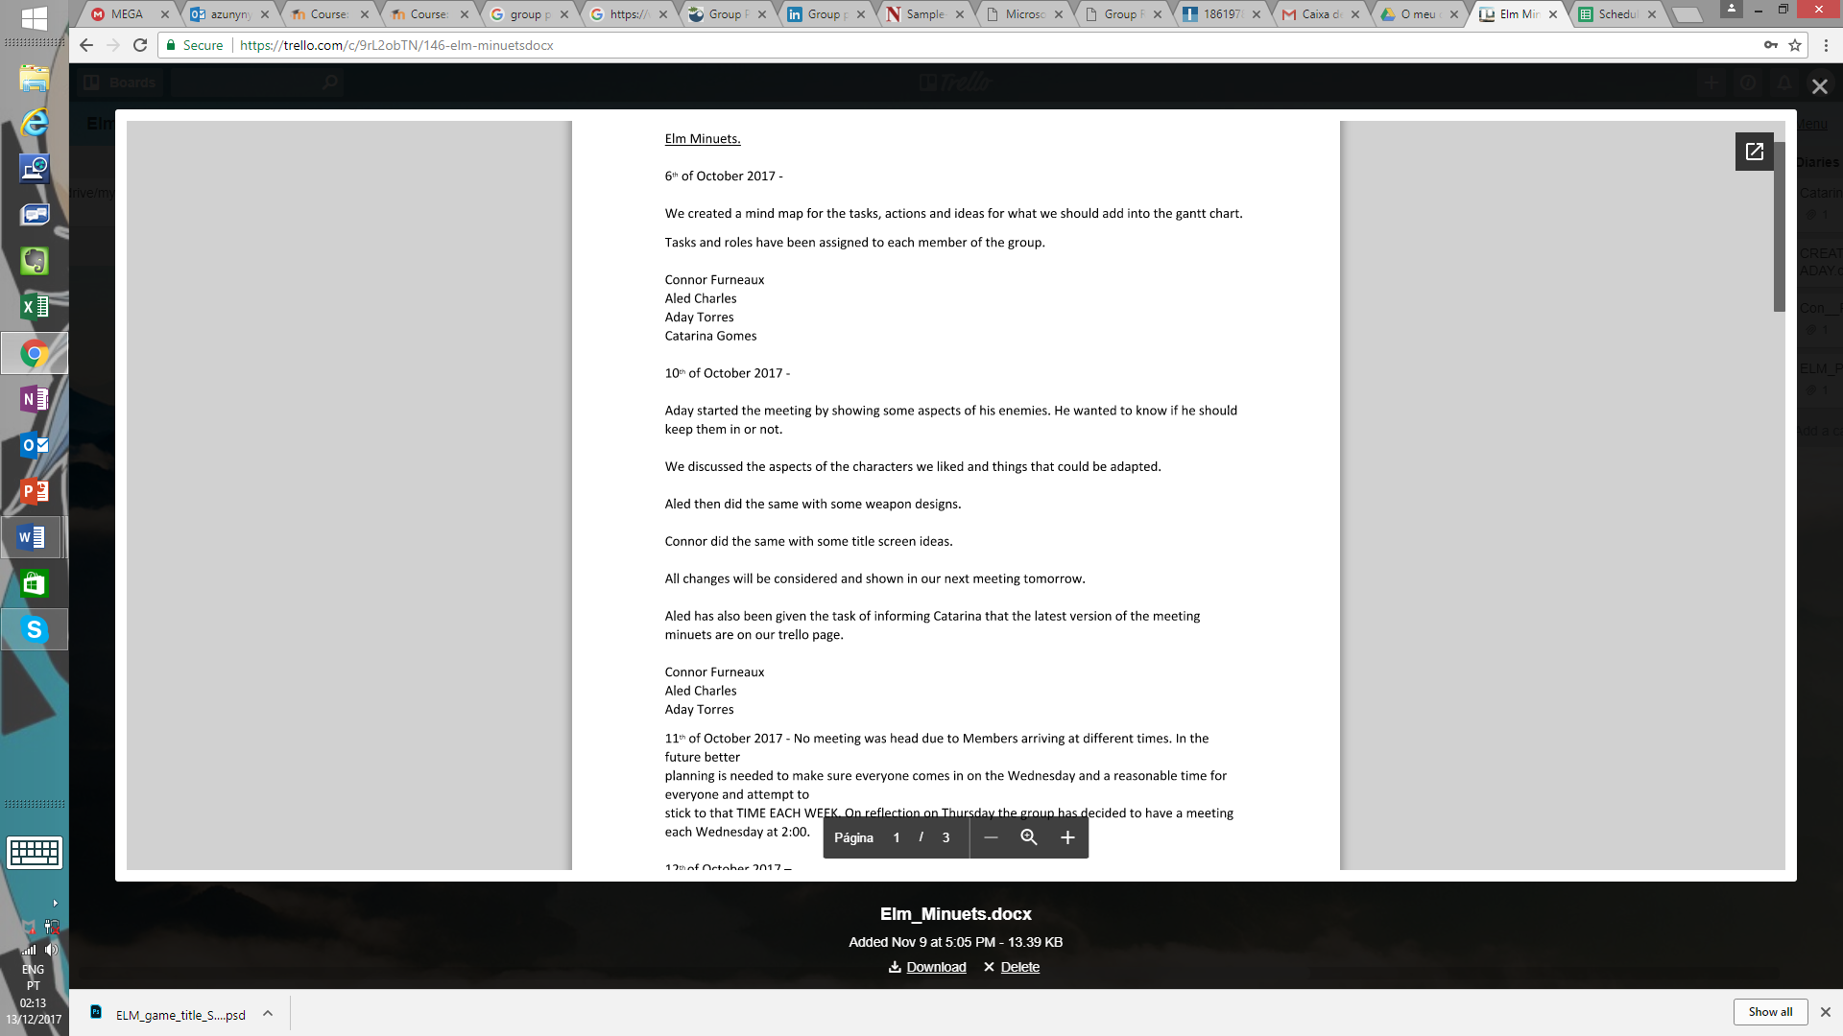

For the individual work of Ana, a initial project plan was laid out, adding to the the group plan, as well as a track of everything that was failing and what was achieved, through a game diary. However, a lot of changes needed to be done in the project plan, due to character changes and new concepts needed as well as technical issues that delayed the process of some work.
In the first semester, the goals were to create different examples of concepts and models that would give the members the opportunity of choosing what best fitted the game idea, alongside an extensive research that included similar games, architecture, concept arts, anatomy studies, zbrush tutorials and books, animation, user interface, crafting systems, fashion and clothes research. This research was split through the team members adapting to their task, however each one of them should have a range of different examples that were used for their work.

Research
The project development should meet original and unique content, however, to enable this a range of different research should be done, applying different methods and trying different concepts to the ideas. In order for the group to not be stuck with a single inspiration and end up copying, an extensive research was applied to every aspect of the game creation. With a defined art target the whole team knew what to include in their research, what type of feel the game should have and together they were able to create an overall art style that would fit each other’s concepts and models, keeping in mind each other’s best attributes and flaws. To better create a game art target, it was necessary a collaboration between the members, especially Ana and Aday in the creation of the concept for the characters as they all needed to be part of the same world and make sense in the game. That was not an easy task and caused a bit of disturbance between the members and the work, due to the fact one of the members was stuck in a different style that would not fit the rest of the assets, for this reason a combination of ideas and concepts were needed to be created in order to be able to reach a common stage where both of the group members felt comfortable developing the concepts. Alongside, this similar art targets, anatomy, animations, game mechanics, fashion, architecture and even previous concepts for the game were needed to be used as research.
Overall the project was divided into:
- Research for the concept art
- Research for the game mechanics and visual effects
- Research for the development of models in Zbrush, looking at anatomy and specific tools for detail creation
- Research for the animation
- Research for the level design using similar games as reference
Prioritization
In this semester the group has focused in the creation of the concept art for the characters as well as the models for each one of them, ending with five final characters models completed, however, only Luna’s, the main character, retopology was started, although not finished, as some technical problems with the computer were making the process slower, as well as, the retopology was getting wrong in certain areas. For this reason, and because we needed a idea of the mechanics for the character in the game a rigging was added to only the body of the character. And by next semester all the retopologies should be done, as well as the textures that weren’t achieved in this semester due to the creation of more than 2 different characters and complications with the retopology, as well as, a slower production in the concept art for one of the members and a need to redo the concept art for one of the other members. Besides the focus on the creation of the characters, it was also given personal attention from Ana to the creation of the concept art for the tree with aiming of creating the model still in this semester, however, such was not achieved because of the need to redo one of the character models and concepts alongside with concepts for some environment assets and for the main tree. This will however, be the main focus in the followed semester.
Aled, focused in the creation of environment and weapons concept, but giving prioritization to the level design and white boxing, he has also given especial attention to the creation of the game sound. Connor, prioritization was to do the engine work and animation, applying mechanics and basic playable movements in the game and the creation of traps.
Overall, the team members prioritization was split between each other accordingly with the task each one was assigned with.
Communication
The team communication was done through variable forms:
- Group chat on facebook, here people discussed their ideas, informed other members of what was discussed in a meeting if any failed to attend, the stage of work, and helped each other. It is here where most of the communication is done.
- Meetings, this was used to discuss the production that was done until the current point of the meeting, what needed to be add, discuss each other’s work, give opinions and ideas.
- Google drive/Mega/Trello page, these platforms were used for the storage of everything related to the production plan and the development of the project.

Scope
The project included the usage of the following software’s:
- Photoshop
- Zbrush
- Maya
- Unreal engine
Future software usage:
- Photoshop
- Zbrush
- Maya
- Unreal engine
- Substance painter
- Substance designer

Testing
To the test of the game development the group members asked different people from outside their class and inside their class to try the white boxing and game sound and fill in a sheet for each individual to write their opinion.
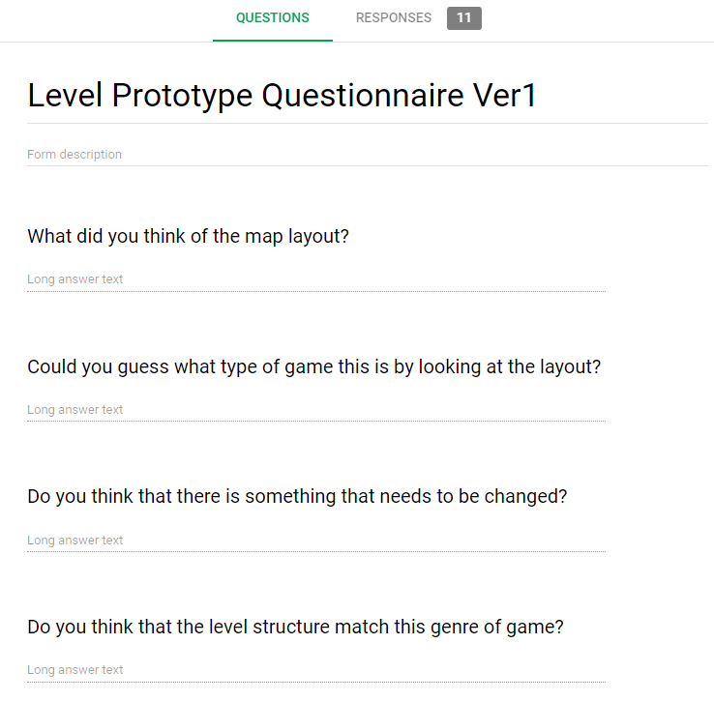

Production Plan
The production plan was designed at the begin of the semester and included everyone’s tasks on it, including research, pre-production, production and final stage. However, the roles of who was doing what in the Gantt chart was not clearly defined, which caused a bit of problems while updating it, as it could end up a bit confusing. Besides that, a lot of delays updating it difficulted the communication between the team, as the members focused more in the personal project plan and let the group plan a bit aside.

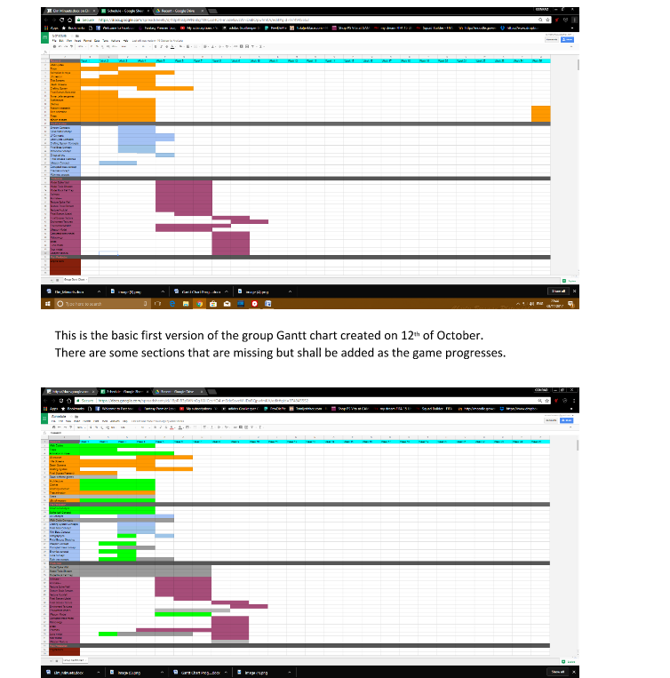

Besides the production plan being confusing, the team members failed to upload a risk assessment for the group, which turned out bad when facing problems like delays and missing members in the meetings, causing a bit of confusion between the group of what to do next.

Production Problems and Successes

Overall the project problems were spotted more in the concept art, where members had difficulty matching one another art style, resulting in delays in the production of the final concepts, others ended up with an unfinished concept art for the characters, which gave the team a blank sport on what the character would look like in the game.
Another problem was in the creation of the models and retopology, as only one of the characters had to be redone due to a need of a more interesting character view to the player in the game perspective, that lead to the need to redo the whole main character by Ana, which caused the other concepts to be delayed when one of the models were already finished. However, she managed to get the concept art finished and 3 models in zbrush finished as well as the begin of the retopology for the main character Luna. Although the goal was to finish all the retopologies of the characters and the textures, which will be delayed to the next semester. The creation of the main tree was need to be done in the upcoming semester as the models and the concept art consumed more time than the expected. A lot of problems like getting the right fit in the clothes and the colors made the concept art a longer process than expected. However, there was a need for Aled to create a rigging for Luna, so there was an example in the game world of what it would be like, he had to use a proxy as Ana failed to finish the retopology, and since Aled waited on the retopology to be finished, he needed to rush through it with the proxy which caused some problems on it. The retopology seem to be where most of the team members struggle finishing, as it takes quite a long time to get it right, as most of the time it ends up with a few mistakes that need to be fixed or a very unnatural retopology. It should be a point all the team members should focus on to improve the assets.

Future Project Plan

During the holiday break the members should have the characters topologized and painted. The main tree model should also be finished. And some planning for the exhibition and layouts should be looked over and started being thought off. By the begin of the next semester, the main tee inside should be finished, and the topology just started to give two weeks to paint all the assets and the main tree. The models and characters should be ready to be put in the engine and be worked on for the gameplay and the characters animated.

Conclusion

Overall the project met most of its target, however some were delayed due to complications and need of improvement in work phase and matching ideas. Although some of the targets were missed, there was still good points about the semester, as we have now 5 characters ready to be topologized and then put in the engine for animation after the rigging. There is a lot to improve in communication and planning as a group, and it should be things the group should define and have special attention from an early stage to avoid confusion, misunderstandings and unclear layout of tasks.

Appendices

Last Self Planning



