FEASIBILITY PLAN FOR AN INTERNATIONAL MEETING / EVENT

EVENT NAME: THE LEGENDS REIMAGINED: WALES GLOBAL CULTURALEXPO 2025
NAME:CRISTIANA ANDREEA STAICU
STUDENT ID:2026517
Slide 1: Title
Slide 2: Introduction
- The Visit Wales: Year of Legends campaign presents the full rich legacy of Wales, myths, and contemporary legends to appeal to international tourists.
- It has been built on The Legends Reimagined: Wales Global Cultural Expo 2025 will connect Welsh folklore into an immersive MICE event.
- The event aims to restore Welsh legends in addition to bringing modern-day creativity and tourism prospects.

The fusion of the traditional and the innovative can be seen in the tagline of the event, which includes Where Ancient Myths Meet Modern Creativity. It will make Wales a cultural and artistic destination in the world.
Slide 3: Event Overview and Context
- The Legends reimagined: Wales global cultural expo 2025 is a global cultural and business tourism (MICE) expo.
- The event aims to combine heritage storytelling and modern innovation to celebrate the Wales myths, legends, arts, and food.
- Cultural and heritage tourism through digital stories provides a huge opportunity to reach the youth through social media (Kasemsarn, 2025).

This shows a way of globally marketing Wales as an outstanding tourist destination in the fields of cultural, creative, and heritage tourism. It will be scheduled over four days in July 2026 at the Wales Millennium Centre, Cardiff Bay.

(Source: Visit Wales, 2023)
Slide 4: Event Nature and Purpose
- Automated technology, such as VR, MR technologies, leads to virtual tourism along with digital heritage, which relies on proper tools for development and growth (Siddiqui et al., 2022).
- Local food, beverages and craft shows will be available as culinary and craft exhibitions that bring significant direct and indirect economic effects at various levels (Gao et al., 2022).
- This will foster sustainable and authentic Welsh experiences as well as sustain the cultural and tourism development of the country.
There will be a feature of live storytelling and performances in honour of Welsh legends and myths in this event. The economic development and sustainability of tourism contribute through the attraction of foreign visitors, the MICE professionals and the cultural partners.
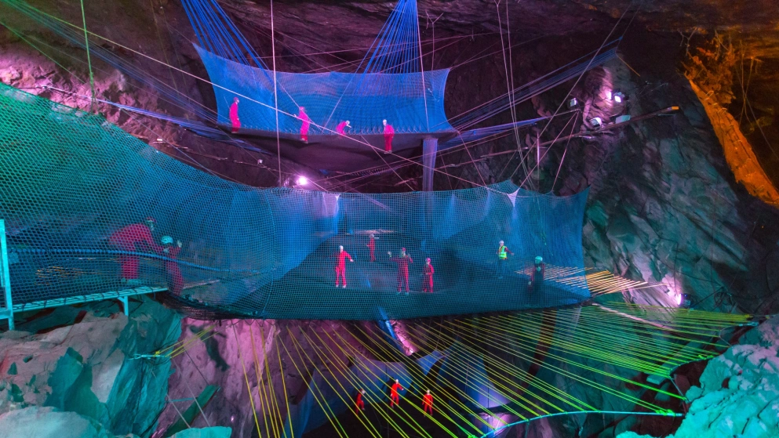
(Source: Visit Wales, 2023)
Slide 5: Market Factors: Target Market and Demand
- The tourism sector has helped 10,000 people in the region to maintain jobs, with £488 million spent by international visitors to Wales in 2024 (Gov.Wales, 2025).
- Tourists spend an average of £13.5 million in the country each day, which amounts to approx. £4.95 billion in a year, showing a high economic potential (Visit Wales, 2025).
- Moreover, the majority of travellers are now less likely to choose traditional tourism and instead opt to have meaningful, immersive and personalised visit experiences (BBC, 2025).

The market segments targeted by this event will be international travel buyers, MICE professionals and cultural tourists who want an experience of something unique and authentic. Moreover, this will also attract media representatives and influencers of major markets, including the UK, USA, Germany, and Ireland, who will be able to spread the cultural story about Wales to other regions across the world. Even though some of the travellers adopt AI as a convenience, the majority of the travellers seek to have peace, interaction, and distinct experiences that are memorable. The event can meet this demand and make Wales one of the top international cultural tourism destinations, incorporating both the use of traditional stories and modern technology.

(Source: BBC, 2025)
Slide 6: Market Factors: Competition and Marketing Strategy
- Other events, such as the Edinburgh Festival Fringe, generated £407 million in Edinburgh alone in 2022, attracting millions of people (BBC News, 2023).
- On the same note, the 2023 Glastonbury Festival attracted 200,000 people, contributing£168 million to the UK businesses (BBC News, 2025).
- Cultural heritage that includes crafts, traditions, and sights is essential to tourism and business, and digital marketing promotes it effectively (Todorova-Ekmekci, 2021).

The event will be competing with major heritage festivals in the UK and will set a position to attract more travellers, along with a better experience in comparison to other venues. Although these events are established, the new expo has an added advantage of combining the old Welsh storytelling with the current technology and providing an immersive experience that makes it a unique kind compared to the rest. In response to the market for this event, it will implement an international online campaign using a hashtag, which is: #RebornLegendary #WalesExpo. There will be strategic alliances with organisations such as VisitBritain, BBC Wales and the National Museum Wales in order to increase visibility and credibility. Furthermore, influencer relationships and the appearance of VR teaser videos will involve the audience and cause the promotion prior to an occasion.
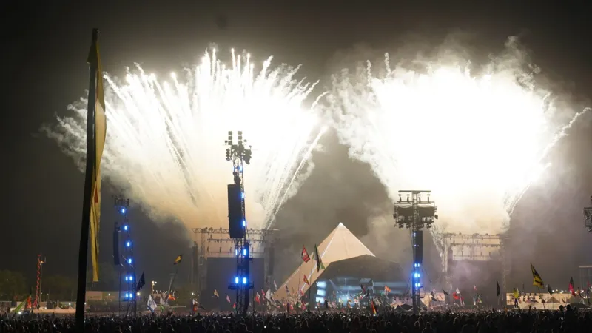
(Source: BBC News, 2025)
Slide 7: Operational Factors: Venue and Structure
- The Wales Millennium Centre has been chosen as the venue for conducting the event show as a representation of the Welsh culture and current innovation.
- Local governments will invest in the development of event venues invested by at a significant cost to promote the hospitality and tourism sector (An et al., 2021).
- The digital content overlays into the real world leads to automated technology, and location is essential to categorising the virtual events (Yung et al., 2022).

It is well accessible through the Cardiff Airport and local transport within Cardiff Bay, consequently convenient to international and local attendees. It can increase the number of people willing to visit the area. The four-day event will be designed in such a way that cultural immersion and professional activities are equalised.
Slide 8: Operational Factors: Staffing and Resources
- Experienced Staff are fundamental to tourism events, allowing the application of automated and online technologies to create an improved experience of immersion by the visitor (Parsons et al., 2023).
- Eco-friendly tourism development balances the needs of the tourist along with the host communities, as well as the environmental security and sustainable opportunities in the future (Abdellatif et al., 2024).
- The event involves a professional and diverse team, such as event managers, AR/VR, tour guides, catering personnel, and security staff, to have a smooth operation and quality experience.

Among the important resources are enhanced audio-visual and lighting facilities to facilitate performances and presentations, along with the interpretation booths, which are aimed at the international representatives. There is also other logistical support such as parking facilities, online ticketing and shuttle transport, which ensures the availability of access, convenience to the attendees and sustainability of the event.
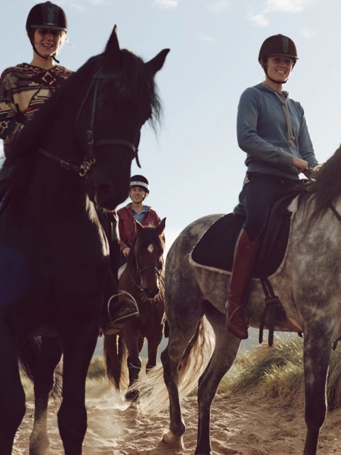
(Source: Visit Wales, 2023)
Slide 9: Funding and Revenue Generation
Category | Cost | Funding/Revenue | Cost
Venue and logistics | £120,000 | Sponsorships (Visit Wales, Welsh Govt) | 80,000
Marketing and PR | £50,000 | Ticket sales (estimated 3,000*£50) | £150,000
Performers and speakers | £40,000 | Exhibitor fees (30 x £1,000) | 30,000
Staffing and security | £30,000 | Food and beverage sales | £20,000
Technology (VR/AR) | £35,000 | Merchandise sales | £15,000
Catering and hospitality | £25,000
Miscellaneous | £10,000
Total Costs: | £310,000 |  | £295,000

This is the estimated budget that can be required for the successful event organisation.
Slide 10: Financial outcomes
- The fastest growing industries in the industry significantly require event feasibility and development.
- Ticket sales (£150,000), exhibitor fees(£30,000), food, along with beverage sales (£20,000) and merchandise (£15,000) will be used to generate revenue.
- A mix of marketing and finance was utilised to control sponsorship of events for the development (O’Toole, 2011).

The estimated price of The Legends Reimagined Expo will be £310,000, which will include the estimated cost of venue and logistics, marketing, performers, staffing, technology, catering, and other miscellaneous expenses. Further investment of £15,000 will be obtained through a government grant from Visit Wales. Corporate and Welsh Government sponsorships and £80,000 will allow the event to break even and make a profit.
Slide 11: Risk Management
- One of the most important demands of event professionals is the creation of a safe event (Liu-Lastres, 2023).
- The budget overruns will be managed through diversified sponsorships and a 10% contingency reserve.
- Outdoor recreation and events are both impacted by weather and climate change, which will impact the recreation and tourism industry due to global warming (Wilkins, 2024).

High international turnout will be addressed by conducting early digital marketing campaigns and collaborating with the airlines and travel agencies. It is going to be conducted in a hybrid format with the inclusion of both indoor activities and digital live-streaming. Technical issues, especially with AR/VR systems, will be handled through backup systems and on-site technical assistance in order to ensure that events are delivered uninterrupted.
Slide 12: Sustainable Practices
- Eco-procurement or green purchasing can be viewed as a right step that should be undertaken by the organiser of the event to diminish the negative impact on the environment (Ramely et al., 2022).
- Single-use plastic input and landfill output may be decreased with the help of water refill stations and waste sorting booths (Trisnayoni et al., 2022).
- MICE event venues should comply with the safety standards in this region and contribute to the community work along with sustainable projects based on environmental friendliness (Wee et al., 2021).

The event is going to be conscious of environmental ways, such as recycling, using renewable energy, and local food supply, to reduce environmental degradation. In particular, eco-procurement is connected with the purchasing of raw materials or event equipment on the local market.
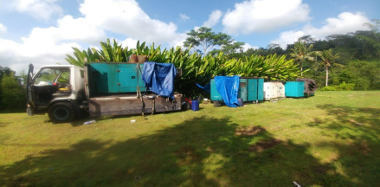
(Source: Trisnayoni et al., 2022)
Slide 13: Conclusion
- Based on the above, it can be concluded that The Legends Reimagined: Wales Global Cultural Expo 2025 has been a well-planned, innovative MICE event.
- It has highlighted the rich heritage, arts and myths of Wales, which unite classic storytelling with the latest technologies, experience, food festivals, and business contacts.
- This strategy has promoted Wales as a cultural reflection tourism destination in the international market.

It assists in sustainable tourism, economic development, and international interactions, as well as building long-term relationships. The expo emphasises the Welsh identity and makes the country a forefront in the field of creative and heritage tourism.
Slide 14: References
Abdellatif, H., Hicham, B. and Karim, B., (2024). Responsible green tourism: A new path for eco-friendly tourism development. International journal of economic perspectives, 18(2), pp.560-589.
An, J., Kim, H. and Hur, D., (2021). Keeping the competitive edge of a convention and exhibition center in MICE environment: Identification of event attributes for long-run success. Sustainability, 13(9), p.5030.
BBC (2025). The seven travel trends that will shape 2025. [online] Bbc.com. Available at: https://www.bbc.com/travel/article/20250106-the-seven-travel-trends-that-will-shape-2025 [Accessed 24 Oct. 2025].
BBC News (2023). Edinburgh festivals rebound but still ‘precarious’. BBC News. [online] 28 Jun. Available at: https://www.bbc.com/news/uk-scotland-66040062 [Accessed 24 Oct. 2025].
BBC News (2025). Profits from Glastonbury Festival double to £5.9m. Profits from Glastonbury Festival double to £5.9m. [online] 2 Jan. Available at: https://www.bbc.com/news/articles/c4gj6y0j487o [Accessed 24 Oct. 2025].
Gao, X., Gu, Z., Niu, S. and Ryu, S., (2022). Effects of international tourist flow on startup financing: investment scope and market potential perspectives. SAGE Open, 12(4), p.21582440221126455.
Gov.Wales (2025). Wales highlights tourism hot spots to boost international visitor market | GOV.WALES. [online] GOV.WALES. Available at: https://www.gov.wales/wales-highlights-tourism-hot-spots-boost-international-visitor-market [Accessed 24 Oct. 2025].
Kasemsarn, K. and Nickpour, F., (2025). Digital Storytelling in Cultural and Heritage Tourism: A Review of Social Media Integration and Youth Engagement Frameworks. Heritage, 8(6), p.200.
Liu-Lastres, B. and Cahyanto, I.P., (2023). Are we always ready? Examining event professionals approaches to risk and crisis management and resilience. Tourism management perspectives, 46, p.101073.
O’Toole, W. (2011) Events feasibility and development: from strategy to operations. Elsevier: Oxford
Parsons, D., Choi, M., Thomas, R., Glyptou, K. and Walsh, K., (2023). The policy responses of tourism agencies to emerging digital skills constraints: A critical assessment of six countries. International Journal of Tourism Research, 25(1), pp.97-108.
Ramely, A., Ab Talib, M.F., Rashid Radha, J.Z.R.R. and Mokhtar, M.F., (2022). Green event practices: Understanding the adaptation of event organisers through a systematic review. Malaysian Journal of Sustainable Environment (MySE), 9(1), pp.119-140.
Siddiqui, M.S., Syed, T.A., Nadeem, A., Nawaz, W. and Alkhodre, A., (2022). Virtual tourism and digital heritage: an analysis of VR/AR technologies and applications. International Journal of Advanced Computer Science and Applications, 13(7).
Todorova-Ekmekci, M., (2021). Presenting and promoting cultural heritage with digital media, marketing approaches and methods. Good examples.
Trisnayoni, R.A., Astawa, I.P. and Sutama, I.K., (2022). Sustainable MICE Event Practices: An Explorative Study. International Journal of Travel, Hospitality and Events, 1(1), pp.74-82.
Visit Wales (2023). Supporting you. [online] Industry. Available at: https://industry.visitwales.com/supporting-you [Accessed 24 Oct. 2025].
Visit Wales (2025). Home | Industry. [online] Visitwales.com. Available at: https://industry.visitwales.com/ [Accessed 24 Oct. 2025].
Wee, H., Mustapha, N.A. and Anas, M.S., (2021). Characteristic of green event practices in mice tourism: a systematic literature review. International Journal of Academic Research in Business and Social Sciences, 11(16), pp.271-291.
Wilkins, E.J. and Horne, L., (2024). Effects and perceptions of weather, climate, and climate change on outdoor recreation and nature-based tourism in the United States: A systematic review. PLOS Climate, 3(4), p.e0000266.
Yung, R., Le, T.H., Moyle, B. and Arcodia, C., (2022). Towards a typology of virtual events. Tourism Management, 92, p.104560.

