

Student Name: Jeet Patel
Student ID: 2532588
Module Name: Marketing Management
Module Code: LCMB7024
Lecturer’s Name: Dr Laila Maazouz
Work Count: 2452

Table of Contents
1. Introduction 2
2. Task 1: Analysis of the Macro Marketing Environment 3
2.1 Macro Marketing Environment 3
2.2 Macro Factor Analysis 1: Environmental Sustainability. 3
2.2.1 Implication on the Pioneer Organisation (Zara). 3
2.2.2 Implication on the Follower Organisation (Boohoo) 4
2.3 Macro Factor 2 Analysis: Technological Advancements. 5
2.3.1 Impact on the Pioneer Organisation (Zara) 5
2.3.2 Effect on the Follower Organisation (Boohoo) 6
3. Task 2: Pioneering and Follower Organisational Strategic Responses 6
3.1 Strategic Responses of Pioneering Organisation (Zara). 6
3.2 Strategic Responses of Follower Organisation (Boohoo). 8
4. Conclusion 10
5. References 12

1. Introduction
The strategic marketing management demands organisations to be dynamic when adapting to such dynamic external environments, so as to maintain their competitive edge. This report is a critical analysis of the impact of macro environmental factors on strategic decision-making in the UK fast-fashion retail industry, with a case study of two organisations in the industry: Zara (pioneer) and Boohoo (follower). The fact that Zara is generally credited with pioneering agile-driven fast fashion via supply chains and Boohoo as a digital native company that utilises cost leadership and online channels is well known.
The UK fast-fashion market is highly competitive and has fast product life cycles, digitalisation, and sustainability demands (Barnes and Lea-Greenwood, 2023). Although the demand for affordable fashion remains high, the industry is experiencing structural issues, such as regulatory scrutiny, environmental issues, and changes in consumer behaviour to support ethical consumption (McKinsey, 2024). Such dynamic forces generate opportunities as well as threats which are used to influence firm-level strategies.
Examination of the macro marketing environment, especially using approaches like PESTLE, is essential in determining the external forces that an organisation can do nothing with but influence the long-term strategic positioning (Kotler et al., 2023). This type of analysis helps companies to predict hazards, maximize on opportunities and adjust the marketing strategies respectively.
This report has been divided into two major tasks. Task 1 is a critical analysis of two macro-environmental influencing factors, such as environmental sustainability regulations and technological changes in the digital retail and assesses their effects on Zara and Boohoo. Task 2 attempts to analyse the strategic reactions of both companies in terms of Porter's Generic Strategies and Ansoff Growth Matrix, and how each organisation adapts to remain competitive. The report ends with some important lessons on the strategic significance of environmental scanning.

2. Task 1: Analysis of the Macro Marketing Environment

2.1 Macro Marketing Environment
The macro marketing environment includes environmental forces that affect the performance of the organisation but cannot be directly controlled by the managers (Camargo et al., 2022). The PESTLE framework is the political, economic, social, technological, legal, and environmental framework that provides a framework in which these forces are analysed and their effects are viewed, regarding strategic marketing choices (Johnson et al., 2022). In the case of the firms in the UK fast-fashion industry, macro-environmental analysis is especially important because the sector is subjected to quick change, regulatory pressure and consumer change in regard to expectations.
The contribution of the industry to world waste and carbon emissions has led to the tightening of regulations and heightened consumer activism (Niinimaki et al., 2023). At the same time, many technological innovations, especially in the field of digital retail and data analytics and supply chain innovation, have altered the way companies address their consumers and conduct business (Grewal et al., 2023; Kumar and Polonsky, 2024).
These are strategically important since they influence the cost structures, brand reputation, operational efficiency and competitive position directly. Building a competitive advantage in the long term is more probable for companies that succeed in adapting to sustainability requirements and technological inventions, and those that fail to respond may become irrelevant in the market.

2.2 Macro Factor Analysis 1: Environmental Sustainability.

2.2.1 Implication on the Pioneer Organisation (Zara).
There is a high threat of increasing regulatory demands in the UK and the wider European markets, including carbon reduction demands and longer producer responsibility. The adherence to such regulations means that large sums of money have to be invested in sustainable materials, ethical sourcing, and waste management systems, which raise the cost of operation and may have an impact on the profit margins (Niinimaki et al., 2023; Niinimäki and Karell, 2023).
Nevertheless, the idea of sustainability provides Zara with significant opportunities as well. The practices of the eco-friendly stores, recycled materials and a promise of reaching net-zero emissions have been part of the sustainability integrated into the strategic plan of the company. This goes in line with the increasing consumer desire for products that are environmentally conscious, especially among the younger consumer groups who are now more concerned with ethical consumption (McKinsey, 2024; Henninger et al., 2022).
Competitively, Zara has a progressive nature of brand equity and brand differentiation. Through the establishment of itself as a responsible fast-fashion retailer, the company is enhancing customer loyalty and reducing the reputational risks. More so, adopting sustainable practices early gives Zara an opportunity to develop industry standards and have a first-mover edge in sustainable fashion.

2.2.2 Implication on the Follower Organisation (Boohoo)
In the case of Boohoo, environmental sustainability is a greater threat than a chance. The company has experienced much criticism in terms of its environmental and ethical practices, and this has tarnished its brand image and decreased its consumer confidence (Joy et al., 2022). Such reputational issues may be translated into lower sales and less market share in an era when sustainability is shaping more and more purchasing behaviour.
Although Boohoo has a chance to rebrand through sustainable activities, it would demand significant changes to the organisation. Boohoo is less prepared and able to adjust to changes, which puts it at a higher risk of being influenced by external factors, in comparison with Zara.
With regards to competitive positioning, Boohoo has made little gains in the area of sustainability that undermine its market differentiation power. With the continued rise in the popularity of ethical brands among consumers, Boohoo runs the risk of becoming irrelevant unless it makes substantial changes in its sustainability activities.

2.3 Macro Factor 2 Analysis: Technological Advancements.

2.3.1 Impact on the Pioneer Organisation (Zara)
Zara, a pioneer in the field of fashion design and manufacturing, is impacted by the study as outlined below.
One of the significant opportunities of Zara is the technological progress, especially in the increase of efficiency and customer experience. Radio-frequency identification (RFID), data analytics, and integrated supply chain systems are among the technologies which have received a huge investment by the company. These technologies make real-time tracking of the inventory possible, accelerate the production process, and enhance demand forecasting, which enhances the responsiveness and agility of Zara (Grewal et al., 2023; Shen et al., 2024).
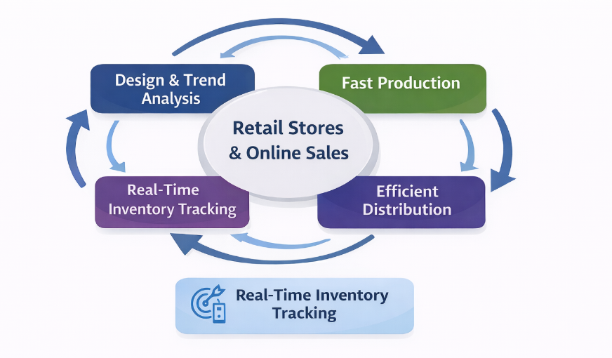
Figure 1: Zara Agile Supply Chain
Source: (Self Developed)
Nevertheless, there are also some challenges related to technological development. Technological infrastructure has to be maintained by high levels of investment, and continuous innovation by swift technological change has to be made. Regardless of these, the financial strength of Zara and its well-developed capacities can enable it to pursue technological competitive advantage.

2.3.2 Effect on the Follower Organisation (Boohoo)
Technological progress can be considered a strength and an opportunity for Boohoo. Being a digital-native retailer, Boohoo has the benefit of expanding its operations internationally using online channels, meaning that it is not restricted by physical retail infrastructure. The company uses social media marketing, collaborations with influencers, and data analytics to reach younger customers and boost sales (Statista, 2025).
Technology has helped Boohoo to have a fast pace of product development, responding promptly to the latest fashion trends. This agility helps it in its cost leadership strategy through its minimisation of inventory risks as well as its maximisation of sales efficiency.
Compared to Zara, Boohoo is more adaptable in online marketing and connectivity with customers, yet it has not provided the advanced integration of supply chains that define the activities of Zara. This restricts its capability to attain the kind of operational efficiency and responsiveness.
Competitively, technology enables Boohoo to be relevant and competitive in the online retail environment. Nonetheless, it is more prone to such problems as cybersecurity risks, dependence on a platform, and stiff competition online.

3. Task 2: Pioneering and Follower Organisational Strategic Responses

3.1 Strategic Responses of Pioneering Organisation (Zara).
Zara’s strategic moves in response to the aforementioned macro-environmental factors, namely environmental sustainability and technological advancement, can be subjected to a critical evaluation in terms of Porter’s Generic Strategies, particularly the differentiation aspect. Zara has been known for being a fashion-forward, agile, and quality-oriented brand, and it has leveraged innovation as a source of competitive advantage.
Response to Environmental Sustainability
Zara has adopted an aggressive and integrated strategy towards sustainability in which the company has incorporated environmental issues as part of its business strategy, as opposed to considering them as extrinsic factors. The company has also opened eco-friendly outlets and decided to incorporate the usage of 100 per cent sustainable materials in the long run and recycling programs in its business operations. All these are strategic shifts towards sustainable differentiation in which the company can enhance its brand value by considering environmental issues (Kotler et al., 2023).
Most importantly, the sustainability strategy adopted by Zara meets the changing consumer requirements and needs, which reduces the reputational risks involved in such operations and leads to compliance with the same. Secondly, Zara also experiences the advantage of being the first mover in the business, in which the company can enhance its brand loyalty and set the industry standards due to its operations (McKinsey, 2024). However, such projects involve high costs that can add pressure to the operations and margins of the business. However, Zara can afford such costs as compared to its competitors due to its size.
Reaction to Technological Changes.
The technological strategy followed by Zara is to increase efficiency in work as well as customer experience. The company is introduced to advanced technologies such as RFID and data analysis. These help Zara to efficiently manage inventory as well as improve the flexibility of the supply chain. This allows Zara to reduce lead times as well as be able to adapt to changing fashion trends, thereby improving competitive power (Grewal et al., 2023).
In addition, Zara’s omnichannel business model is one that combines both online and offline business. This allows customers to have a better experience when shopping online. Online marketing strategies improve customer interactions, thereby enhancing sales. This is in line with the current trend that is changing with the growing importance of digital transformation in business, with customer experience being one area that is being differentiated.
The strategic responses of Zara are defined as proactive, integrated and responsive to external trends. Having sustainability and technology as means of differentiation, the company reinforces the competitive aspect and proves to be resilient over the long term. Its effective approach is seen in the good performance in the market and adaptation to shocks in the industry (Inditex, 2024).

3.2 Strategic Responses of Follower Organisation (Boohoo).
The strategic responses of Boohoo can be examined through the Growth Matrix developed by Ansoff, since the company is much more concerned with expansion strategies to keep growing. This is based on a cost leadership orientation where its strategy is mainly marketing penetration and product development.
Response to Environmental Sustainability
The actions of Boohoo in dealing with sustainability issues have been more of a reaction and a progressive measure. The company has also unveiled other initiatives like sustainability commitments and better supply chain disclosures following criticism of the company on its environmental and ethical practices. Nonetheless, such initiatives are likely to be viewed as not sufficient, which indicates the lack of alignment between strategic intent and implementation (Joy et al., 2022).
Ansoff-wise, the efforts of Boohoo to become more sustainable can be considered a subset of product development, during which the company will launch more sustainable product lines to attract consumers who evolve in their tastes. Nonetheless, this approach has a major issue, as sustainability actions can undermine the principal value of Boohoo, which is low-cost fashion.
Most importantly, the lack of sustainability has contravened the brand's credibility as well as subjected Boohoo to regulatory and reputation risk. In contrast to Zara, Boohoo does not have the organisational resources and capabilities to carry out a large-scale change in a sustainable way. This is a reactive strategy that narrows down its competitive advantage in the long term.
Reaction to Technological Innovations.
The main aspect of Boohoo's strategy is the use of technology that helps it to be a digital-first store. The company uses social media, influencer marketing, and data analytics to reach its targeted customers and make sales. This would be consistent with market penetration since Boohoo aims at boosting its market share in the current markets by developing intensive online advertisements and competitive pricing (Statista, 2025).
Another product development activity Boohoo participates in is the quick release of new collections, depending on the fashion trends that have emerged. Its agile manufacturing strategy enables it to adapt fast to consumer demand, keeping it relevant in a highly dynamic market.
Critically, the digital capabilities of Boohoo are also a major strength that has enabled it to compete well even without physical retail infrastructure. Nonetheless, its excessive dependence on the online platform also brings its weaknesses, such as excessive competition in the online environment and reliance on third-party platforms.
Comparative Evaluation
The strategic reactions of Boohoo seem to be more short-term and reactive compared to the ones of Zara. Although Zara is approaching sustainability and technology as a part of the overall differentiation strategy, Boohoo is aiming at growth via expansion and cost-efficient strategies. The implication of this is the reduced fit between the external environmental pressures and internal capabilities.
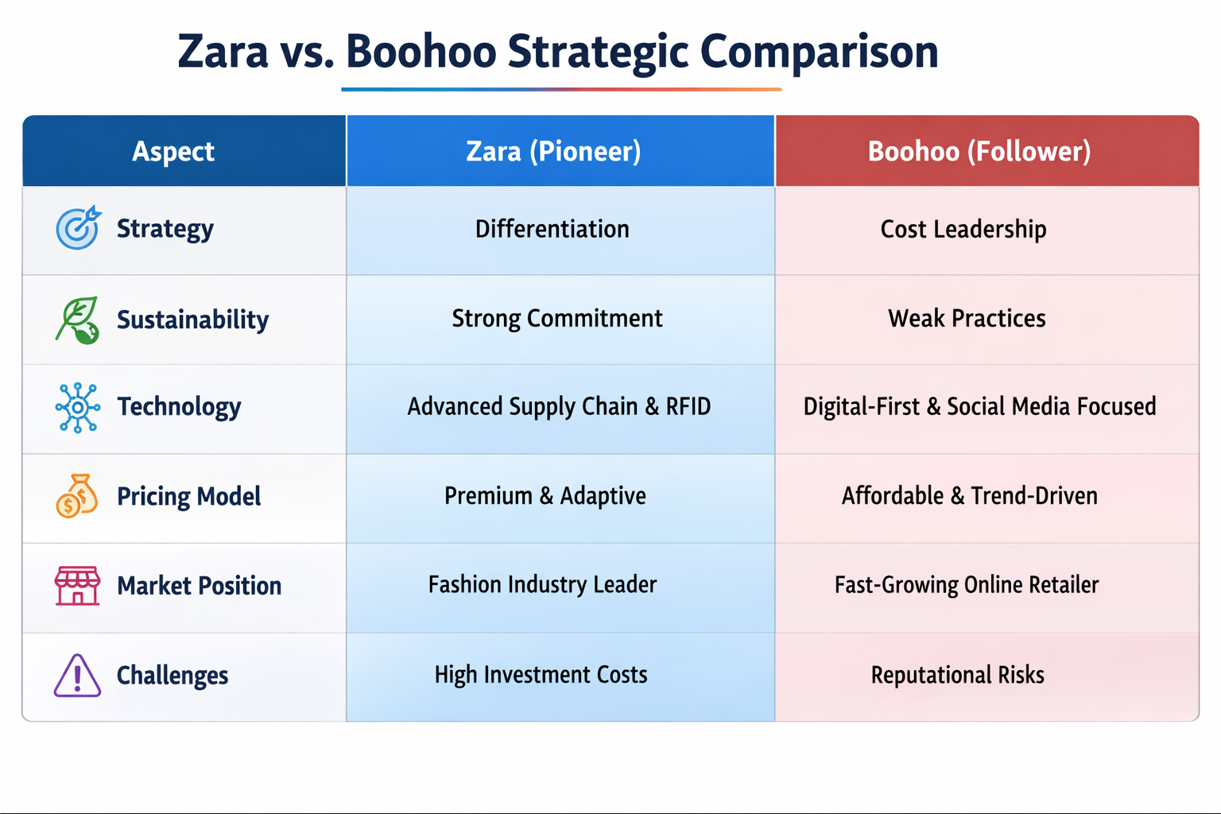
Figure 2: Zara vs. Boohoo Strategic Comparison
Source: (Self Developed)
Furthermore, the low-cost strategies do not give Boohoo the flexibility to respond to the sustainability needs, as ethical practices are known to increase the production costs of an enterprise. This is a strategic dilemma that is hard to address without altering the business model of the company.

4. Conclusion
This report also proves the importance of macro-environmental factors in strategic marketing decisions within the UK fast-fashion market. By analysing the macro-environmental factors of environmental sustainability and technological advancements, one can understand the importance of such factors in creating opportunities or threats for the business.
Zara, as a pioneering organisation, takes advantage of its capabilities in supply chain management and innovation to respond to the challenges of environmental sustainability and technological advancements. Zara’s differentiation strategy also helps the company to maintain its competitive advantage over competitors by using its sustainability strategy and technology integration strategy.
On the other hand, Boohoo, as a follower organisation, focuses more on its cost strategy and technology strategy, which can provide the company with short-term success but also increases the risks faced by the company.
By conducting a comparative analysis of the two fast-fashion retailers, one can conclude that the key to the success of the business is adapting to the challenges of the macro-environmental factors and aligning the business strategy with the macro trends in the fast-fashion market. While Zara takes advantage of the opportunities to strengthen its position in the fast-fashion market, Boohoo fails to maintain its position in the fast-changing business environment.

5. References
Barnes, L. and Lea-Greenwood, G. (2023) ‘Fast fashion in the digital era: supply chain agility and sustainability challenges’, Journal of Fashion Marketing and Management, 27(4), pp. 589–605. Available at: https://doi.org/10.1108/JFMM-03-2022-0070
Camargo, L., Pereira, S. and Scarpin, M. (2022) ‘Sustainability pressures and strategic responses in global fashion retail’, Business Strategy and the Environment, 31(6), pp. 2458–2472. Available at: https://doi.org/10.1002/bse.3033
Grewal, D., Roggeveen, A.L. and Nordfält, J. (2023) ‘The future of retailing’, Journal of Retailing, 99(1), pp. 1–6. Available at: https://doi.org/10.1016/j.jretai.2022.12.001
Henninger, C.E., Alevizou, P.J. and Oates, C.J. (2022) ‘What is sustainable fashion? Consumer perceptions and strategic implications’, Journal of Business Research, 139, pp. 343–352. Available at: https://doi.org/10.1016/j.jbusres.2021.10.018
Inditex (2024) Annual Report 2024. Available at: https://www.inditex.com/investors/annual-reports
Johnson, G., Whittington, R. and Scholes, K. (2022) Exploring Strategy. 13th edn. Harlow: Pearson. Available at: https://www.pearson.com
Joy, A. et al. (2022) ‘Fast fashion, sustainability, and ethical consumption’, Fashion Theory, 26(3), pp. 287–309. Available at: https://doi.org/10.1080/1362704X.2021.1911930
Kotler, P., Keller, K.L. and Chernev, A. (2023) Marketing Management. 16th edn. Harlow: Pearson. Available at: https://www.pearson.com
Kumar, V. and Polonsky, M. (2024) ‘Digital transformation and marketing performance in retail: an omni-channel perspective’, Journal of Retailing and Consumer Services, 75, 103540. Available at: https://doi.org/10.1016/j.jretconser.2023.103540
McKinsey & Company (2024) The State of Fashion 2024. Available at: https://www.mckinsey.com/industries/retail/our-insights/the-state-of-fashion
Niinimäki, K. and Karell, E. (2023) ‘Closing the loop: circular economy strategies in fashion’, Sustainability Science, 18(2), pp. 789–803. Available at: https://doi.org/10.1007/s11625-022-01177-8
Niinimäki, K. et al. (2023) ‘Environmental impact of fashion industry’, Nature Reviews Earth & Environment, 4(2), pp. 101–115. Available at: https://doi.org/10.1038/s43017-022-00395-9
Shen, B., Li, Q. and Dong, C. (2024) ‘The impact of technology adoption on fast fashion supply chain performance’, International Journal of Production Economics, 267, 108432. Available at: https://doi.org/10.1016/j.ijpe.2023.108432
Statista (2025) Online fashion market UK statistics. Available at: https://www.statista.com/topics/8710/online-fashion-market-in-the-united-kingdom/

