SPEAKER’S NOTES and Background information
On
CASH FLOW AND ESCAPE ROUTES
(Welshroot Vegan Burger Van)

Student: 1709285 (Mo)
Teacher: Mr. Brynach Heffernan
Date: 27/ 03/ 2019

SPEAKER’S NOTES
&
Background information

Cash Flow
We can consider our business as a self-running entity separate from its owners (us) which owes money (invested) to them and they (working in it) are employed by it. The total investment by us 3 owners is £20000 * 3 = £60000 in cash.
The Cash Flow is about the cash in the bank accounts and on the business premises, money stuck in the cheques, stocks (inventory), debtors, etc. and the time needed to convert some of them into essential cash money to pay the wages, utility bills, creditors and used for urgent purchases. It is essential to properly manage it for the survival of the business (especially a young business) through the cycle of gaps in time between cash going out and cash coming in. Normally cash coming in lags behind cash going out.(Burns, 2016).
There are two ways to manage it optimally:
1. Working capital management:
Managing stocks – e.g. keeping just adequate stock, clearing slow items with discount etc., stock control policy to maintain.
Managing suppliers – e.g. stretch payment period, check if invoiced wrongly or twice.
Debt recovery – as fast as possible.
2. Cash flow forecasting – collect details of all possible income (invested money, sales, bank interests etc.) and outgoings ( capital costs, fixed overhead costs, variable costs) and make a cash flow statement for visualising if adequate cash is being generated in the dynamics of the cash and plan accordingly about loan or if any other measures to be adopted for safety. Usually it is done over months.
Explanation of Cash flow statement:
In April, July, August, September (4 months) sales are 40% less in our permanent site in the Bay campus due to students' holidays.
We expect to serve about 18 festivals and 12 private functions a year.

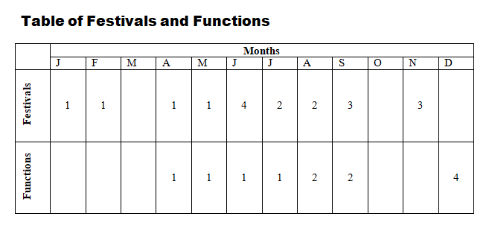
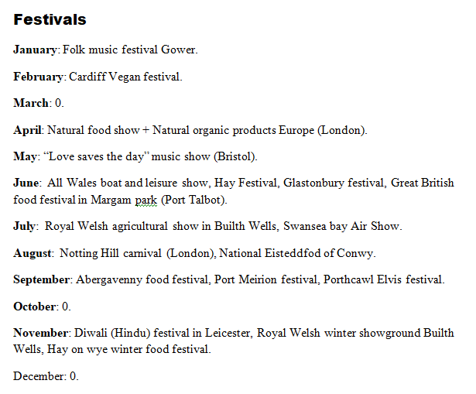

Calculations of Costs and Sales:
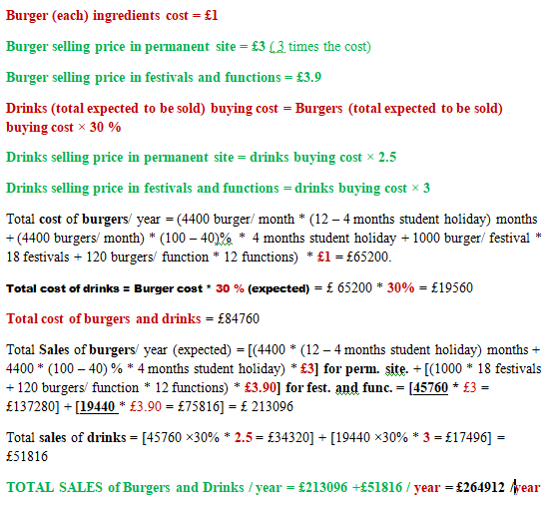

Depreciation:
Considering that the useful life of capital assets is of 10 years the depreciation rate per year would be about 24% per year which we would distribute over 12 months of each year.
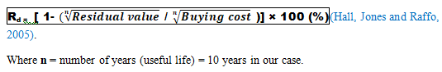

Fixed costs overheads:
To retain cash longer we would spread some payments over 12 months ( e.g. Insurance, laundry etc.) as instalments.
Wages
Working: 3 owners working permanently, extra 6 part-time employees during each festival and 2 part-time employees – during each function.
Wages are reflected in the labour and working hours needed for the proportional amount of sales and we would distribute them accordingly.
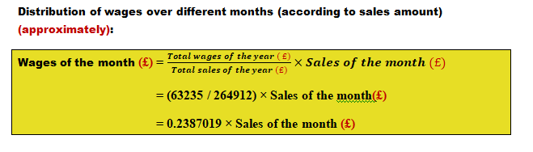
Fuel
Travelling fuel cost: for each festival - £100 and for each function - £30 (local)..
Remainder from Total fuel cost = 10000 – (18*100 + 12*30) = £7840
Then in each month’s fuel cost would be proportional to the sales of the month against the total yearly sales.
Net cash flow
NET CASHFLOW (£)/ month = Total income(£)/ month - Total outgoings(£)/ month
(Burns, 2016)
We assume we are not yet VAT registered.
According to the Cash flow forecast we do not need any loan or outside cash help to cover the day to day running of our business in any of the months in first year.
It is important to check the actual figures in real time against the forecasted figures and look for reasons of any mismatch and take necessary steps.
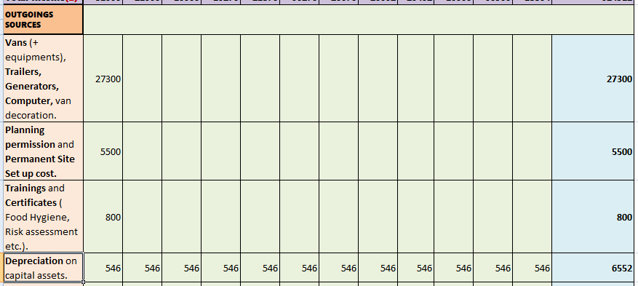
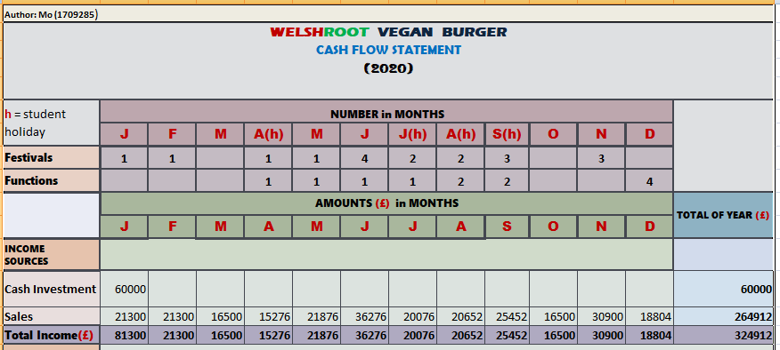

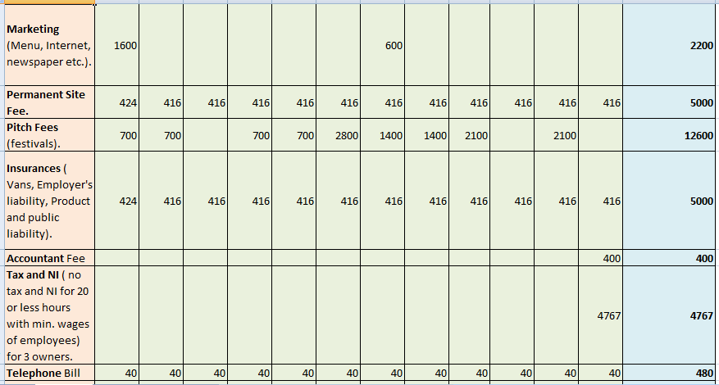

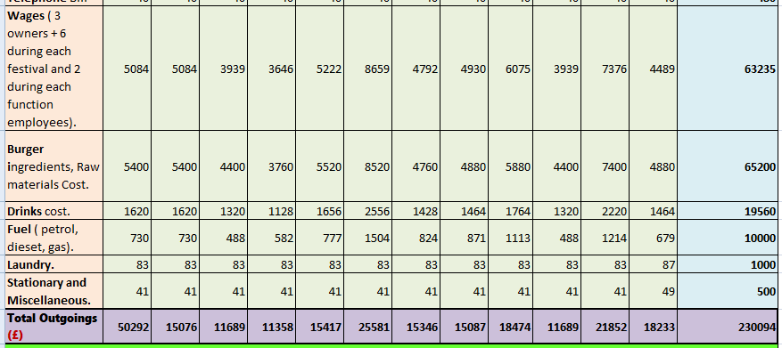

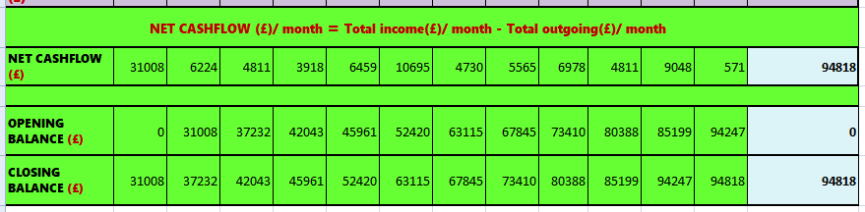

Exit Routes
It is a strategic plan to be included in the business plan to exit from ownership/ partnership to maximise profit if the business is successful and minimise the loss when the business is failing (Kenton, W., 2018).
Reasons for exiting your business can be retirement, health issues, not interested anymore, move to a different business, conflict among partners etc.
We would mix and match the following exit strategies (Ward, S., 2018) applicable for our partnership business as and when necessary.
1. Liquidation over time (Maintaining lifestyle): Streaming out money from the business as high wages and/or as profit without reinvesting it for further expansion. Then sell it after the invested capital has been returned by the profit.
We would adopt it if we see the number of existing and potential customers and possibilities of increasing sales are limited.
2. Sell your share to a partner / new active or sleeping partner:
This would be our choice in the case when any of the partners wants to exit when others do not.
3. Sell the business in the open market as a going concern: The business owners puts the business up for sale in the market for a certain or a negotiable price. They then share the money.
If strategy2 does not work we will use this one.
4. Liquidation: Close the business, upgrade it and sell it to someone or sell the remaining assets after closure.
We would use this if strategies 2, 3 do not work.
If the business grows healthily and see opportunities we would probably reinvest part or whole of the profit to expand it locally and even nation-wide.

RECOMMENDATIONS

As the cash flow is largely based on assumption/ estimation especially for the start-ups there must be consideration for significant “+“ and “ – “ tolerance. Best even, if market research is conducted, expert’s advice is taken.
There is no burger business (vegan or non-vegan) which may mean that nobody else thought about the possibility of success in this type of business in that place and that can be viability question for our business.
We should have gone to the area around our chosen Bay campus with our interviewing questions, ready vegan burgers, offer our burgers free to the students, employees of the Amazon and local residents and collect their opinions firsthand.
REFERENCES

Burns, P. (2016) Entrepreneurship and Small Business – Start-up, Growth and Maturity. 4th edn. London: PALGRAVE.
Hall, D. , Jones, R. And Raffo, C. (2005) Business Studies. 3rd edn. Ormskirk: Causeway Press Ltd.
Kenton, W. (2018) Business Exit Strategy. Available at: https://www.investopedia.com/terms/b/business-exit-strategy.asp (Accessed: 20 March 2019).
Ward, S. (2018) How to Pick an Exit Strategy for Your Small Business. Available at: https://www.thebalancesmb.com/small-business-exit-strategies-2947988 ( Accessed: 21 March 2019).

The End

