Heritage management: Conservation report-Frongoch lead mine
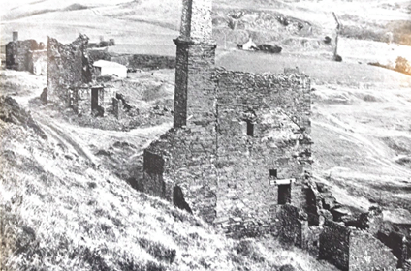

Student name: Ben Andrews
Student number: 1600787

Contents page
introduction & Historical background and context page 3
Assessment of significance Page 4
Vulnerability and risks page 5
Proposal for reuse page 6
Adoption and review page 7
Figures 1&2 page 8
Figure 3&4 Page 9
Figure 5 page 10
Figure 6 page 11
Bibliography page 12

Introduction
The Environment Agency Wales has stated that Frongoch is one of the sites where work can be under taken further to remediate the mine (Environment Agency Wales, 2002:50). The heritage and conservation work of the mine has already been partly done by Natural Resources Wales (Natural Resources Wales, 2016). The report published by Natural Resources Wales gives details of the steps that have been taken to remediate the mine over the course of several years. However, their work does not consider the heritage of the site as their focus is solely on the environmental effects of the lead mine. Nevertheless, the information provided in the report was of great significance in the purposes of writing this conservation report. This report will aim to address the significance of the historical sites at Frongoch Mine and their potential heritage as assets to the public. Moreover, given the long history of Frongoch and how it has changed over the course of time, the surrounding mines such as Weymess Mine will be taking into consideration. This report will encompass both the main site of Frongoch and the Weymess Mine (acquired by Frongoch and later used as a runoff for the Frongoch water) (Plwm, 2008). However, the first and foremost concern of this conservation plan will be to address the environmental issues associated with Frongoch, as they will pose the most significant danger to future generations.

Background and Historical Context
Despite there being some evidence of previous occupation at the Frongoch site, it was not until the 1790s that the site was fully utilised. Due to the potential (although limited) economic value of the site, it was acquired by people such as John Probert, who established smelting in Aberystwyth (Bick et al, 1996: 21). Therefore, this site and the revenue gained from working it could have been used to fund public works in Aberystwyth, given the proximity to the town. The Frongoch mine was almost under constant use for the lead and zinc it produced. Given this fact, the length and the extent of the damage done by probable pollution from this mine over the course of two centuries, the mine has been and continues to pose a large risk to the environment. As to the physical remnants of the site, the Weymess mill is still present. This, however, has been left in a state of irreparable damage, thus making a conservation report on this part of the Frongoch mines more difficult to assess due to the condition of what is arguably the best surviving architectural piece of evidence at the site. Nevertheless, the mine will still have to undergo remediation should it pose a risk to the water table, and will be discussed in this report.
T understand the complexity of the site it must first be considered how this site grew from the main site and what that specific time period it represented for the mining industry, despite Frongoch’s struggle to maintain economic viability. The previous assessment noted that the mine had a road purpose-built by one of the mine’s owners, John Taylor, for the transportation of equipment. This road was needed due to the rural location of the site an is still used today by the general public. Moreover, the road continues to provide access to the mine, despite the mine’s subsequent growth and the acquisition of the Weymess mine. The latter was worked in conjuncture with Frongoch from 1861 to 1891 (Royal Commission Wales, 2018). During that time, the site became more economical as it was able to purchase the Weymess mine. The remains of the old dressing mill of the Weymess mine remained open to the general public and the tram line still exists there. However, there is speculation regarding whether the lines running underground are still intact (Bick et al, 1996: 66) as only the outer walls of the mill remain to greet those who pass by it.

Assessment of Significance
The environmental impacts of lead and zinc on Ceredigion are made especially apparent. For instance, the amount of lead from this one source meant that the river Ystwyth failed to reduce the amount of zinc accordingly to the levels set by the European Water Framework Directive (Natural Resources Wales, 2016). The effects of zinc and lead in the river Ystwyth are magnified as the river Ystwyth meets the rivers Nant Cell, and Mawr (Natural Resources Wales, 2016: 1). This allows the zinc and lead to be carried further downstream, creating embedded environmental impacts, one of which was the river being “devoid of fish” (Natural Resources Wales, 2016:1). To this extent, the impact of human activities on the ecology of this geographical region could be far wider spread than originally thought. If the river is devoid of fish, it is possible that the natural predators of these animals will also die out and so there is a gap in the ecology. The primary concern of this report is in accordance with the Wellbeing of Future Generations Act (Welsh Government 2016), which has been put into place to remediate the lead and zinc issue. The remediation had been started by Natural Resources Wales, who over the course of several years, undertook work at the site. In 2011, the Frongoch stream was diverted from the mine to stop the river becoming more contaminated and making it more feasible to mitigate the effects of the lead pollution on the environment and the people.
Given its history, Frongoch is unique in some respects as the site does have an overwhelming amount of local history. Moreover, due to the coal trade with Bristol (Bick et al, 1998:), it is also significant on a national level too, although to what extent remains to be seen. The structural heritage that still survives from the Frongoch mine is very limited. The largest surviving structure is from the Weymess mine. In Figure 1, the aerial photo shows how few structural remains there are left of the Frongoch site. This is reinforced by Figure 2, which shows the remnants of a structure located at the site, possibly the wheel house or another structure. In terms of heritage however, this structure is of no significant importance, due to the state of the ruins and how poorly they have been preserved as there is only an outer wall and a hollow building with nothing inside. This site has little impact on preserving the heritage of mining in mid Wales; this is because of the numerous other mining sites that are found throughout the country. Therefore, this structure as it stands, holds very little value in comparison to the abundance of other better-preserved sites. Figure 3 also reflects the current state of the site. Being an image taken from another part of the building, it shows that it has been partly reclaimed by nature, with extensive vegetation growth. Due to this poor state of the current building remnants, they must be supported. Moreover, an attempt must be made to reuse them where possible as they are not only the last above ground remnants of the mine, but are also under serious threat due to the decades of non-use and vegetation growth.
The mine shafts down to 90 fathoms were repaired in 1897 (Bick et al, 1998: 66), but the deeper shafts up to 154 fathoms deep were allowed to flood. Therefore, any attempt at restoration of the mine shafts will be extremely expensive and dangerous, as the contaminated lead-zinc water will need to be cleared out. This makes the shafts significant in terms of heritage, as they are deeper than the ones that are now commercially operated primarily as a tourist destination by Big Pitt in Wales (Blaenavon World Heritage Site, 2018). The act of flooding the Frongoch mine shafts has had significant problems for the environment and the subsequent draining and restoration of the mine shafts which are now inaccessible would be likely to add to this impact. Moreover, only the remains of six shafts can still be seen (Bick et al, 1996: 66) while the rest cannot be traced despit their locations being known due to maps made by the various owners. This limits the heritage potential of the mine, which may cause a lack of interest. This difficulty is compounded by the other aspects of the mine such as the dressing crusher being in a state of disrepair so extreme that there are not enough remains to reconstruct it (Bick et al, 1996: 64). An engine was installed in 1842 by John Taylor (Bick et al, 1996: 63) but unfortunately, the engine itself was sold in 1874. Similarly, the engine house itself shows no sign of a mine shaft and only the outer walls remain at this site, which have been described by David Bick as “rubble” (Bick et al, 1996:63). This bleak outlook seems to be supported by a report published by the Environment Agency for mines in Wales, which stated that Cadw has no archaeological interest in Frongoch (Environment Agency Wales 2002: 78). The neighbouring site of Weymess though, has significant historic potential (Environment Agency Wales 2002:136).

Vulnerability and risks
Many of the environmental issues have been mitigated as a result of the work carried out by Natural Resources Wales through the steps of their remediation process. The first of these involved reducing the effects of the contaminated water by building a stream and collecting any water that may have escaped (Natural Resources Wales, 2016:1). In the second phase, waste tips were reshaped and capped to prevent the water percolation. National Resources Wales also indicated in their report, that the Dyfed Archaeological Trust have carried out a survey of the land to preserve any artefacts on the site. Therefore, any conservation work that takes place on this site must not undo or jeopardise the work that has already been done, as this would most likely cause damage and resurfacing of the pollution. The report indicates that the steps of meditation in some cases have been unsuccessful, as in the first phase of the work conducted, the lead load per year was 911 kg, but this was reduced to 343 kg (Natural Resources Wales, 2016: 2) according to the Frongoch audit, therefore, this can be considered a success. However, the Frongoch stream before the diversion, was 511 kg per year, and increased to 629 kg (Natural Resources Wales, 2016: 2). In this sense, the remediation was not successful for this part of the river that flows directly via the Frongoch mine. While the quality of water has in some parts improved to moderate, the Frongoch river has now acquired a higher concentration of lead in the water after a secondary remediation attempt. Overall, the amount of lead had reduced before any remediation work was carried out, so there is no question about whether the remediation helped it, just to what extent it was successful. From prior research, geological data indicates that the surrounding geology of the site is mainly comprised of shales and slates. These rocks are impermeable and given the contamination of the water, they provide a natural barrier. Therefore, these risks could be better mitigated by the pre-existing geology as the rock will prevent the escaped water (British Geological Survey, 1984).

Proposal for reuse
Given the current state of Frongoch, the original mining site could be remodelled and remade incorporating the original remnants of the site. This would mean that the old buildings are preserved while being maintained, and the modified land is kept as it was, simultaneously preserving the work undertaken by Natural Resources Wales. The site is useable by people again as the action taken to reduce the restoration of the mine spoil tips has been successful, with vegetation returning to the site within the space of four years (Natural Resources Wales, 2016: 2)
The prognosis for the mine remains unknown, as it would depend on the amount of public interest and the amount of funding available for remediation. For example, in Cornwall, one mine’s remediation cost up to 3.5 million pounds (Environment Agency Wales, 2002:). Frongoch is in a rural area, therefore one possible method would involve creating an anaerobic wetland treatment (Environment Agency Wales, 2002:18). This would work well given the remains of Frongoch, due to the wetland creating a good habitat for bats. The bats could roost in the remains, thus helping to boost the local bat populations. This could be implemented should the decision be made to leave the site alone in terms of heritage. In a report published by the Environment Agency for Mines in Wales, it was stated that Cadw has no archaeological interest in Frongoch (Environment Agency Wales 2002: 78). However, the neighbouring site of Weymess has significant historic potential as the buildings and mining equipment are all pre 19th century (Environment Agency Wales 2002: 136). In terms of heritage, given Frongoch’s ongoing environmental issues, the current state of the mine and the lack of feasibility for reconstruction of buildings such as the crusher, the work is not likely to go ahead. The Glogfawr mine has a similar crushing house (Bick et al, 1996: 64) while other aspects of the Frongoch mine such as the water wheels in the smithy have been listed in a 1904 sale catalogue, showing they have been sold off (Bick et al, 1996: 66). Therefore, the loss of its attributes, the degradation of the remains and the lack of significant archaeological potential suggest that renovation is not an option. Whilst they fluctuate in some reports, the water quality from the affected waters demonstrate that the remediation that has taken place to date has greatly improved the surrounding area. The measures taken were not without cost, and in time future generations of inhabitants of Ceredigion and Wales may accord a higher emphasis on the disused mining site. The mine shafts that are not known to the public but can be identified should be treated, infilled and allowed to settle.

Adoption and review
What remains at the Frongoch mine should not be needlessly neglected or torn down as it played a significant role in shaping the Mid Wales countryside. Moreover, the effectiveness of the mine bringing foreign interest into the area should be acknowledged. Considering the current state of heritage assets and the evidence provided in the figures throughout this report, all indicate that the heritage of Frongoch is very limited. Although the site may have had the potential in previous times, the sale of the site’s assets and the subsequent state of buildings mean that it would be costly and ineffective to rejuvenate the mine or the mine shafts, especially as a total of six remain. However, the effectiveness of the remediation at Frongoch is apparent from the results yielded by Natural Resources Wales. At the time of writing during the five years from the initial action taken on the mine up to the present day, the environmental mitigation has been successful in reducing the amount of lead pollution in the water. The remaining mine shafts should be remediated to make the land usable again for the public and to deal with the risk that they pose to the public in response to the ongoing support that the mine has received.

List of figures
Figure 1: Frongoch main site (mussen, 2011)
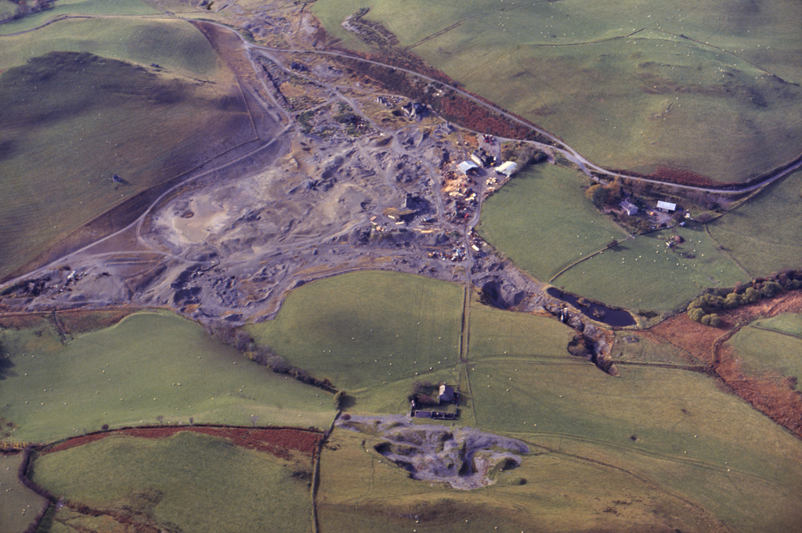
Available at: http://map.coflein.gov.uk/index.php?action=do_collection_details&numlink=61259&cache_name=cG5tcnNuYW1lLEZyb25nb2NoX3NlYXJjaHR5cGUsYWR2YW5jZWRfb3Jh [Accessed 19 May 2018].

Figure 2: Building remains at Frongoch (Lewis, 2012)
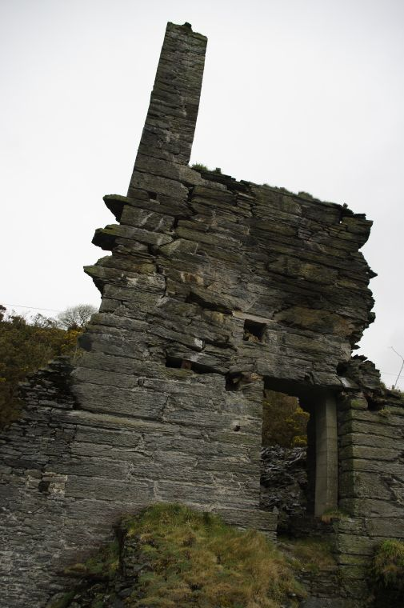
Available at: http://map.coflein.gov.uk/index.php?action=do_images&cache_name=cG5tcnNuYW1lLEZyb25nb2NoX3NlYXJjaHR5cGUsYWR2YW5jZWRfb3Jh&numlink=302#tabs-4 [Accessed 15 May 2018].

Figure 3: Building remains at Frongoch (Lewis, 2012)
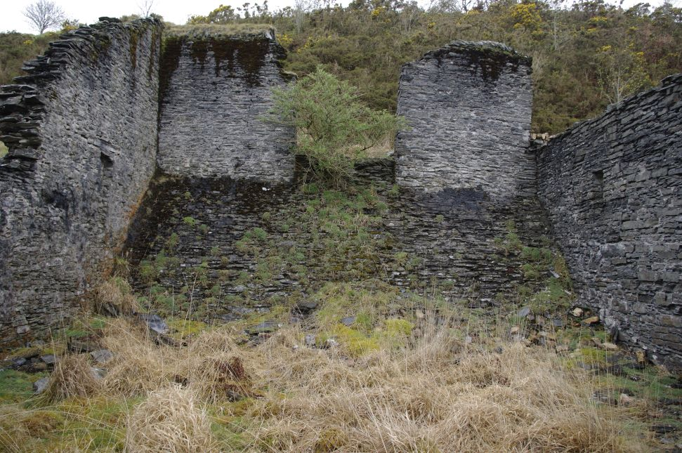
Available at: http://map.coflein.gov.uk/index.php?action=do_images&cache_name=cG5tcnNuYW1lLEZyb25nb2NoX3NlYXJjaHR5cGUsYWR2YW5jZWRfb3Jh&numlink=302#tabs-4 [Accessed 15 May 2018].

Figure 4: Frongoch power plant with the mine in the background (Lewis, 2012)
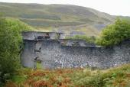
Available at: http://map.coflein.gov.uk/index.php?action=do_images&cache_name=cG5tcnNuYW1lLEZyb25nb2NoX3NlYXJjaHR5cGUsYWR2YW5jZWRfb3Jh&numlink=302#tabs-4 [Accessed 15 May 2018].

Figure 5: Weymess Mine (Plwm, 2008)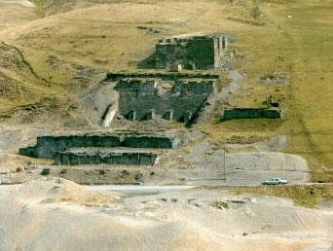

Figure 6 (R.H. Bird 1978)

Bibliography
Bick D, Parkinson, A. Briggs, C. and Fellows R. (1996). Frongoch lead and zinc mine. Keightly, U.K.: Northern mine research society
Environment Agency Wales (2002). Metal mine strategy for wales. Environment Agency Wales, pp.18-80.
Government of Wales. (2018).Well-being of Future Generations (Wales) Act 2015. [online] Available at: https://gov.wales/topics/people-and-communities/people/future-generations-act/?lang=en [Accessed 14 May 2018].
Royal Commission Wales . (2018). Coflein Mapping. [online] Available at: http://map.coflein.gov.uk/index.php?action=do_details&cache_name=cG5tcnNuYW1lLEZyb25nb2NoX3NlYXJjaHR5cGUsYWR2YW5jZWRfb3Jh&numlink=33907#tabs-4 [Accessed 16 May 2018].
British Geological Survey. (1984). Record details |Aberystwyth.| BGS maps portal | OpenGeoscience | Our data | British Geological Survey (BGS). [online] Bgs.ac.uk. Available at: http://www.bgs.ac.uk/data/maps/maps.cfc?method=viewRecord&mapId=9611 [Accessed 18 May 2018].
National Resources Wales (2016). ABANDONED MINE CASE STUDY: FRONGOCH LEAD & ZINC MINE. [online] Natural Resources wales, pp.1-2. Available at: https://naturalresources.wales/media/679803/frongoch-mine-case-study_2016_06.pdf [Accessed 18 May 2018].
Plwm.org.uk. (2009). Frongoch Mine (Main Site) | Plwm. [online] Available at: http://www.plwm.org.uk/index.php?q=events/332 [Accessed 16 May 2018].
Wilson, J. Bastow. “The Cost of Heavy-Metal Tolerance: An Example.” Evolution, vol. 42, no. 2, 1988, pp. 408–413. JSTOR,

