ECEY4001/C Human Development: Part 1 Structure (Infographic)

Physical/Physiological needs:
What does this mean?
These are the most basic biological requirements necessary for human survival. They are factors that most closely influence behavior (McLeod, 2024). Without these needs being met, physiological functions are impaired or suboptimal. They include shelter, warmth, sleep, food, air and drink (Kenrick et al., 2010).
Why is it important?
Physiological or physical needs are critical for human survival. These needs are important because they may not be postponed for long. They are prioritized when compared to other needs at higher levels of the pyramid of needs. Unless these are met to the required extent, the individual will not be motivated to pursue higher needs. Meeting physical needs such as food is essential for a growing child for whom failure so to do can have several detrimental effects (Gallegos et al., 2021). Adequate, well-balanced nutrition enhances muscle development, supports optimal growth, and helps the child both to achieve and to maintain healthy weight (Saavedra & Prentice, 2022).

Safety and Security:
What does this mean?
These needs are at the second level of Maslow’s hierarchy. These are related to the need for control and order. Some of the components frequently included within this level are financial and job security, health, and safety from injury and accidents.
Why is it important?
For children, a safe and secure environment is critical for optimal growth and development. A safe and secure environment allows the child to express their feelings and thoughts freely. The child who feels secure understands that their needs and requests will be met. When the child does not feel sufficiently secure, they may respond to a situation in a manner that is inappropriate or non-compliant.
Being able to feel secure is essential for the child’s emotional well-being. The child is less likely to feel stressed and anxious. The child is likely to form healthy emotional attachments. Such children are better able to cope with challenges in life.
In the context of early childhood education, practitioners can help children to feel safe and secure by working to establish and maintain otherwise authentic and candid relationships with the child. Practitioners should make time for frequent check-in conversations with learners and their families.
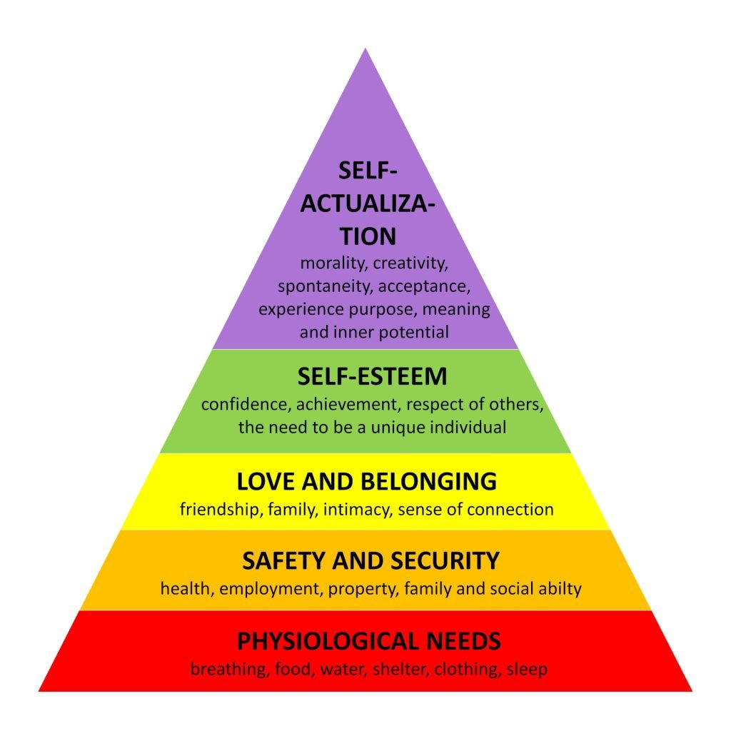
Maslow’s hierarchy of needs(https://www.simplypsychology.org/maslow.html).

Love and acceptance/belonging:
What does this mean?
This refers to the need to feel as part of a group. This includes the need to love, belonging and acceptance. In order to satisfy this need, individuals may seek friendships and seek to belong to social groups.
Why is it important?
A sense of belonging is essential for the development and maintenance of interpersonal relationships. In the classroom environment, adequate support can help the child to feel connected with others, and feel valued and needed (Rejaan et al., 2021). Strong relationships with caregivers and teachers can help the child feel supported and understood both of which are protective for adjustment and development in later life (Rejaan et al., 2021; King et al., 2018). A sense of belonging helps the child to develop internal working models of interactions and relationships with others (Rejaan et al., 2021).
In the classroom environment, creating a sense of belonging requires the practitioner to model effective interactions for learners. The practitioner should help weave social practices. The learners may be asked to choose partners and react in socially acceptable ways while interacting with peers. Children should be encouraged to share items with others. Group projects can help learners to develop and enjoy friendships (Senior & Howard, 2014).

Self Esteem:
What does this mean?
Esteem needs refer to the individual’s need to feel respected by others. Individuals may seek to feel a certain sense of power. The individual may need to feel to be held in high esteem by both herself and by other persons. The individual also need to feel a sense of self-confidence, competence and self-respect. Self-esteem is related to the need to be appreciated by others and to be recognized (Muris et al., 2023).
Why is it important?
Positive self-esteem is essential for optimal child development. Positive self esteem is linked to higher resilience (Liu et al., 2021). A child with high self-esteem will likely feel proud and undeterred even when they make a mistake. Such children tend to have greater sense of control over events and activities in their lives. Positive sense of self-control encourages the child to act independently (Cerino, 2021). The child is likelier to take responsibility for own actions and is generally more comfortable and secure in their relationships and roles. Such individuals are also likelier to be more self-assertive and make independent decisions even when faced with peer pressure. For children with low self-esteem, there is risk of being easily frustrated. The child may lose interest in learning and may find it difficult to make and keep friends. They may be more easily bullied and may become withdrawn. They may also develop self-defeating tendencies when faced with challenges.

Self-Actualization:
What does this mean?
Self-actualization is the need for growth. It is considered the highest level of needs (Del Castillo, 2021). It is one’s desire to become what one is truly capable of becoming. It is concerned with growth. In its pursuit, individuals will exploit and seek to fully use their talents and capabilities. It allows one to enjoy moments of transcendence and peak experience
Why is it important?
Self-actualization is associated with a greater sense of self-fulfillment. The individual will know what he or can do and where he or she fits. The individual is likelier to be more self-driven and focused on making progress (Trivedi & Mehta, 2019).

Reference List
- Cerino, A. (2021). The importance of recognising and promoting independence in young children: The role of the environment and the Danish forest school approach. Education 3-13, 51(4), 685–694. https://doi.org/10.1080/03004279.2021.2000468
- Del Castillo F. A. (2021). Self-actualization towards positive well-being: combating despair during the COVID-19 pandemic. Journal of public health (Oxford, England), 43(4), e757–e758. https://doi.org/10.1093/pubmed/fdab148
- Gallegos, D., Eivers, A., Sondergeld, P., & Pattinson, C. (2021). Food Insecurity and Child Development: A State-of-the-Art Review. International journal of environmental research and public health, 18(17), 8990. https://doi.org/10.3390/ijerph18178990
- Kenrick, D. T., Griskevicius, V., Neuberg, S. L., & Schaller, M. (2010). Renovating the Pyramid of Needs: Contemporary Extensions Built Upon Ancient Foundations. Perspectives on psychological science : a journal of the Association for Psychological Science, 5(3), 292–314. https://doi.org/10.1177/1745691610369469
- Liu, Q., Jiang, M., Li, S., & Yang, Y. (2021). Social support, resilience, and self-esteem protect against common mental health problems in early adolescence: A nonrecursive analysis from a two-year longitudinal study. Medicine, 100(4), e24334. https://doi.org/10.1097/MD.0000000000024334
- McLeod, S. (2024, August). Maslow’s Hierarchy of Needs. ResearchGate. https://www.researchgate.net/publication/383241976_Maslow
- Muris, P., & Otgaar, H. (2023). Self-Esteem and Self-Compassion: A Narrative Review and Meta-Analysis on Their Links to Psychological Problems and Well-Being. Psychology research and behavior management, 16, 2961–2975. https://doi.org/10.2147/PRBM.S402455
- Saavedra, J. M., & Prentice, A. M. (2023). Nutrition in school-age children: a rationale for revisiting priorities. Nutrition reviews, 81(7), 823–843. https://doi.org/10.1093/nutrit/nuac089
- Senior, C., & Howard, C. (2014). Learning in friendship groups: developing students' conceptual understanding through social interaction. Frontiers inPpsychology, 5, 1031. https://doi.org/10.3389/fpsyg.2014.01031
- ‌Trivedi, A., & Mehta, A. (2019). Maslow’s Hierarchy of Needs -Theory of Human Motivation. International Journal of Research in All Subjects in Multi Languages, 7(6), 38–41. https://www.raijmr.com/ijrsml/wp-content/uploads/2020/01/IJRSML_2019_vol07_issue_06_Eng_09.pdf

Human Development: Part 2 Structure
The Concept of Holistic Child Development
Introduction
What is going to be discussed?
In this segment, the concept of holistic child development is discussed. As an approach to child care, holistic child development seeks to nurture children’s emotional, mental, social and physical wellbeing. In the context of early childhood education, holistic development is achieved by creating an otherwise safe and comfortable environment that allows the child to both learn and grow. Holistic child development requires educators to work to develop the child as a ‘whole’ and focus beyond just academic achievement (Granger, 2019).
Physical Development
Early childhood is a critical period for the child’s physical development. During this time, the child develops ability to use and to control their bodies through changes in the brain, senses and muscles. The child is exploring the world around him or her and can be supported to become more capable of handling complex physical movements. Optimal physical development is essential for a number of reasons. First, optimal physical development encourages motor development and maximal child independence (Bukvić et al., 2021). Proper muscle development is essential for achievement of key physical developmental milestones such as walking, feeding oneself among others (Sutapa et al., 2021). Secondly, physical development helps to improve the child’s mental and physical wellbeing. Play and related forms of physical activity during this period are essential for maintaining healthy weight. Children who are more physically active are less likelier to develop lifestyle diseases such as diabetes and obesity and tend to experience lower levels of stress. Lastly, optimal physical development is critical for the child’s cognitive development. By allowing children to more fully explore their environment, play and other forms of physical activity allows children to develop better ability to think, reason, and solve problems.
For early childhood education practitioners, learner’s physical development may be supported by incorporating several types of age-appropriate physical activity into the learning process. For infants and toddlers, for instance, this may take the form of practicing tummy time. The infant or toddler may be encouraged to reach out for toys and other objects placed nearby. Flipping the pages of a book when reading with the child and singing songs that require body movement can similarly promote physical development. For children ages 3-5, potentially age-appropriate physical activities may include an obstacle course, dancing to music, ball games and rope jumping.

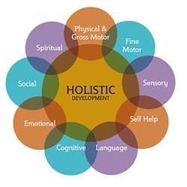
Elements of holistic child development. (https://omc-group.com.au/wp-content/uploads/2016/03/holistic-developmentpic.htm)
Social and Emotional Development
Emotional and social growth are key to holistic child development. Social and emotional development allow the child to develop connections with other persons within their environments (Thummler et al., 2022). Emotional and social development will allow the child to develop better relationships with others and to interact more effectively. The child learns to take turns, to help his or her friends, to play and cooperate with others. As the child develops emotional awareness, they are better able to recognize and to understand their feelings and the feelings and actions of other persons. Emotional and social development is also key for better self-regulation when the child is able to express their thoughts and feelings in otherwise socially acceptable ways (Calhoun et al., 2020). Optimal social and emotional development is essential for development of meaningful relationships and better self-confidence, reduced emotional distress and increased resilience (Cohen et al., 2015; Housman et al., 2017).
In the context of early childhood education, practitioners may help children to develop emotionally and socially. Practitioners should provide children with sufficient opportunities for playful group activities. This allows the child to learn from their peers through mutual cooperation and sharing thereby enhancing social skills. Practitioners will teach the child to rake turns and to share through daily routines including play. By working with the child to identify and talk about emotions, the practitioner may help the child to understand own and other person’s feelings. By offering reassurance and comfort, the educator can help the child to understand that strong feelings such as frustration and anger are normal and can be worked through. The child is taught mechanisms for managing emotions.
It is essential for practitioners to make their expectations behavior known. These expectations should be developmentally appropriate. By modelling positive behaviors such as patience and gentleness, the educator helps the child to learn to treat others in a similar manner.
Intellectual and Cognitive Development
Besides physical and social development, the ability to think and reason appropriately is key to holistic child development. Cognitive and intellectual development involves advancements in problem-solving skills and even memory.
Practitioners may select age-appropriate activities and exercises to promote intellectual development. For toddlers, imaginative play may be useful for symbolic thinking and counterfactual reasoning (Weisberg, 2015). Practitioners may integrate songs and movement into the classroom. Songs can act as didactic and pedagogical tools that enhance learning and develop cognitive skills (Gluschankof, 2007; Supartini & Weismann, 2020). For children ages 3-6, the use of maze exercises and puzzles can enhance memory and spatial learning. Maze exercises help the child to develop planning, decision-making, perceptual organization, and visual-motor coordination (Venkatesan & Lokesh, 2020). Similarly, puzzles aid cognitive development including problem-solving and spatial abilities (Doherty et al., 2021).
Child cognitive development can also be enhanced by real-life problems which encourage higher-order thinking. Questions and case scenarios should be framed such as to encourage the child to apply knowledge, values, and skills in reasoning (Sulaiman et al., 2017).

Reference list-
- Bukvić, Z., Ćirović, D., & Nikolić, D. (2021). The importance of physical activity for the development of motor skills of younger school age children. Medicinski Podmladak, 72(2), 34–39. https://doi.org/10.5937/mp72-31878
- Calhoun, B., Williams, J., Greenberg, M., Domitrovich, C., Russell, M. A., & Fishbein, D. H. (2020). Social Emotional Learning Program Boosts Early Social and Behavioral Skills in Low-Income Urban Children. Frontiers in Psychology, 11. https://doi.org/10.3389/fpsyg.2020.561196
- Cohen, J., Onunaku, N., Clothier, S., & Poppe, J. (2005). Helping young children succeed: Strategies to promote early childhood social and emotional development. Washington, DC: National Conference of State Legislatures.
- Gluschankof, C. (2007). Research and practice in early childhood music education: Do they run parallel and have no chance to meet? The case of preschool singing repertoire. In Proceedings of European Network for Music Educators and Researchers of Young Children, 27–31.
- Granger, E. (2019). Ensuring a holistic and quality education for every ensuring a holistic and quality education for every child: A phenomenological inquiry of principals’ child: a phenomenological inquiry of principals’ transformational leadership transformational leadership. Https://scholarworks.sfasu.edu/cgi/viewcontent.cgi?article=1300&context=etds
- Housman, D.K. (2017). The importance of emotional competence and self-regulation from birth: a case for the evidence-based emotional cognitive social early learning approach. ICEP 11, 13. https://doi.org/10.1186/s40723-017-0038-6
- Sulaiman, T., Muniyan, V., Madhvan, D., Hasan, R., & Rahim, S. S. A. (2017). Implementation of higher order thinking skills in teaching of science: A case study in Malaysia. International Research Journal of Education and Sciences, 1(1), 2550–2158.
- Supartini, T., & Weismann, I. T. J. (2020). Development of learning methods through songs and movements to improve children’s cognitive and psychomotor aspects. European Journal of Educational Research, 9(4), 1615–1633.
- Sutapa, P., Pratama, K. W., Rosly, M. M., Ali, S. K. S., & Karakauki, M. (2021). Improving Motor Skills in Early Childhood through Goal-Oriented Play Activity. Children (Basel, Switzerland), 8(11), 994. https://doi.org/10.3390/children8110994
- Thummler, R., Engel, E. M., & Bartz, J. (2022). Strengthening Emotional Development and Emotion Regulation in Childhood-As a Key Task in Early Childhood Education. International journal of environmental research and public health, 19(7), 3978. https://doi.org/10.3390/ijerph19073978
- Venkatesan, S., & Lokesh, L. (2020). Studying the effects of Porteus Maze Test in children with learning disabilities. International Journal of Asia Pacific School Psychology, 1(2), 117–125.

as self-esteem. A sufficient and well-balanced diet is essential for cognitive and physical development. By providing the child a balanced intake of essential nutrients, brain development and functions including memory and concentration is enhanced.
Poor nutrition during early childhood increases risk of wasting and stunting. These children may never attain full linear growth potential (De Sanctis et al., 2021). The children
Human Development: Part 3 Structure
Maslow’s significance in understanding child development
Introduction
What is going to be discussed?
This segment discusses how Maslow’s theory furthers understanding and enhancement of child development. For early child education practitioners, a mastery of the concepts of Maslow’s theory and hierarchy of needs can help to better inform learning and enhance the classroom experience.
1.Understanding the importance of basic needs
It is important for practitioners to understand children's basic needs because these needs are necessary if the child is to be able to work towards achieving higher needs such may also never attain their full cognitive capacity. Adequate nutrition that includes micronutrients helps to strengthen the immune response (Gombart et al., 2020). Undernutrition may impair immunity, increasing risk of infections and even death.
Consistent with Maslow’s hierarchy of needs, another basic need for the child would be rest. Sufficient rest and sleep is necessary for optimal brain development in children. During sleep, there is consolidation of memories and processing of learning which may help to further the child’s cognitive development. Sleep and rest are similarly linked to improved concentration, focus, and problem-solving skills (Paller et al., 2020). Additionally, sufficient rest may reduce irritability and anxiety while helping the child to better manage their emotions. Sleep and rest also enhance physical growth and development and may improve immune functioning.

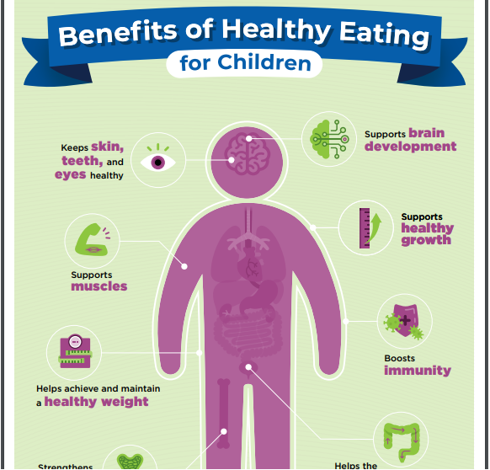
Role of proper nutrition in children (https://www.cdc.gov/nutrition/php/resources/healthy-eating-benefits-for-children.html).
To optimize nutrition, stakeholders have implemented several strategies. In the childcare and school environment, this goal may be achieved by selecting menus that are nutritionally adequate. These menus should be consistent with established dietary guidelines. The foods provided to children should be in adequate quantities. The meal patterns should balance energy and nutrients to meet the child’s need according to the age and activity level. Involvement of parents in the planning of the meals is essential in order to help ensure that certain preferences and special needs unique to the child are taken into consideration. Fruits and vegetables as well as whole grains provides nutrient-dense foods ensuring the child obtains most essential nutrients. High-fat diets and diets high in sodium and processed sugars should be limited (Gowrishankar et al., 2020; Vos et al., 2017). In the school and childcare setting, providing age-appropriate utensils and furniture that are essential to encourage the child to enjoy their meals.
As demonstrated in the foregoing discussion, rest is an important component of child development. To ensure sufficient rest for the child, practitioners may encourage consistent sleep routines. Relaxing bedtime routines such as reading can help to enhance sleep and rest. Another strategy that may enhance sleep is creating an appropriate sleep environment. This includes a dim-lit room with minimal noise both factors being able to enhance comfort and rest. Children should similarly be provided time to play and pursue non-academic interests and hobbies.
2.Creating a safe and stable environment
Creating a safe and secure classroom environment is important for optimal development and learning. A safe and secure learning and home environment provides the child the requisite confidence and reassurance that encourages exploration and learning (Hardie et al., 2022). A safe childcare or learning setting helps foster the child’s emotional wellbeing. This may, in turn, help the child to develop without undue anxiety
Being able to feel secure is essential for the child’s cognitive development. Where the child feels secure, they are better able to explore their environment which helps to foster learning (Lacoe, 2016). Similarly, practitioners who work to create safe childcare and learning settings can also help to enhance the child’s emotional attachments. Such children are better able to cope with challenges in life.
Cognizant of the need for creating safe and secure learning and care environment, early Years practitioners are able to implement steps to achieve this goal. In the classroom environment, educators may achieve this by celebrating and embracing diversity. Learners should receive equitable and supportive spaces. Educators need to incorporate diverse perspectives in curriculum delivery. This not only enriches the child’s understanding of the world but also promotes empathy and mutual respect potentially creating safe environments for other learners (Grosse et al., 2021). It is similarly critical for learners to work to ensure physical safety for learners. The practitioner needs to conduct safety audits in the class regularly, work to identify and minimize safety risks. Learners and children should be protected from verbal and physical abuse by others within their environment including fellow learners (Pons et al., 2014). By encouraging constructive conflict resolution techniques such as peer mediation can promote understanding and sympathy. Negotiation and problem-solving skills help learners to feel safer and secure and are likely to help reduce interpersonal violence.
3. Building Self-Esteem and Confidence
The concepts of human developmental needs as outlined by Maslow highlight the need for practitioners to work to enhance self-esteem, confidence, and independence for the learner. From Maslow’s theory, practitioners are aware that enhanced self-esteem can help to developed increased resilience. As the child develops higher self-esteem, they are better able to withstand challenges that they experience both within and outside the classroom (Cerino et al., 2021). By helping the child to become more confident in their abilities, the practitioner may help the child to develop more sense of control over daily events and activities. An increased sense of self-esteem and self-confidence can also enhance independence (Liu et al., 2021). For the confident child with healthy levels of self-esteem, taking responsibility for own actions it normal. Such children are better able to take up new and more challenging roles. For self-confident young persons, the ability to confidently consider and select between different choices allows one to be more independent and self-assertive. This protects the child from undue and negative peer influences. On the contrary, low self-esteem is linked to several adverse developmental outcomes (McClure et al., 2011). For children with low self-esteem, it is not uncommon to be more easily frustrated. This can cause the child to fear taking up more challenging tasks and to lose interest in learning. These children may also experience difficulties establishing relationships with peers.
Conclusion
Maslow is significant to Early Years practice because he provides a framework for practitioners to work with appropriate stakeholders to help mee children’s key development needs. Maslow’s theory and hierarchy of human needs provides a framework for stakeholders to provide more holistically work to meet children developmental needs. Practitioners should work to create safe and stable environments for children to enhance learning. Children should be provided sufficient and well-balance diets to optimize growth an development.

Reference list-
- McClure, A. C., Tanski, S. E., Kingsbury, J., Gerrard, M., & Sargent, J. D. (2010). Characteristics associated with low self-esteem among US adolescents. Academic pediatrics, 10(4), 238–44.e2. https://doi.org/10.1016/j.acap.2010.03.007
- Pons, F., de Rosnay, M., Bender, P. K., Doudin, P. A., Harris, P. L., & Giménez-Dasí, M. (2014). The impact of abuse and learning difficulties on emotion understanding in late childhood and early adolescence. The Journal of Genetic Psychology, 175(3-4), 301–317. https://doi.org/10.1080/00221325.2014.903224
- Cerino, A. (2021). The importance of recognising and promoting independence in young children: The role of the environment and the Danish forest school approach. Education 3-13, 51(4), 685–694. https://doi.org/10.1080/03004279.2021.2000468
- Grosse, G., Streubel, B., Gunzenhauser, C., & Saalbach, H. (2021). Let's Talk About Emotions: the Development of Children's Emotion Vocabulary from 4 to 11 Years of Age. Affective science, 2(2), 150–162. https://doi.org/10.1007/s42761-021-00040-2
- Paller, K. A., Creery, J. D., & Schechtman, E. (2021). Memory and Sleep: How Sleep Cognition Can Change the Waking Mind for the Better. Annual review of psychology, 72, 123–150. https://doi.org/10.1146/annurev-psych-010419-050815
- Gowrishankar, M., Blair, B., & Rieder, M. J. (2020). Dietary intake of sodium by children: Why it matters. Paediatrics & child health, 25(1), 47–61. https://doi.org/10.1093/pch/pxz153
- Vos, M. B., Kaar, J. L., Welsh, J. A., Van Horn, L. V., Feig, D. I., Anderson, C. A. M., Patel, M. J., Cruz Munos, J., Krebs, N. F., Xanthakos, S. A., Johnson, R. K., & American Heart Association Nutrition Committee of the Council on Lifestyle and Cardiometabolic Health; Council on Clinical Cardiology; Council on Cardiovascular Disease in the Young; Council on Cardiovascular and Stroke Nursing; Council on Epidemiology and Prevention; Council on Functional Genomics and Translational Biology; and Council on Hypertension (2017). Added Sugars and Cardiovascular Disease Risk in Children: A Scientific Statement From the American Heart Association. Circulation, 135(19), e1017–e1034. https://doi.org/10.1161/CIR.0000000000000439
- Bosmans, G., Van Vlierberghe, L., Bakermans-Kranenburg, M. J., Kobak, R., Hermans, D., & van IJzendoorn, M. H. (2022). A Learning Theory Approach to Attachment Theory: Exploring Clinical Applications. Clinical child and family psychology review, 25(3), 591–612. https://doi.org/10.1007/s10567-021-00377-x
- Lacoe, J. (2016). Too Scared to Learn? The Academic Consequences of Feeling Unsafe in the Classroom. Urban Education, 55(10), 004208591667405. https://doi.org/10.1177/0042085916674059
- Gombart, A. F., Pierre, A., & Maggini, S. (2020). A Review of Micronutrients and the Immune System-Working in Harmony to Reduce the Risk of Infection. Nutrients, 12(1), 236. https://doi.org/10.3390/nu12010236
- De Sanctis, V., Soliman, A., Alaaraj, N., Ahmed, S., Alyafei, F., & Hamed, N. (2021). Early and Long-term Consequences of Nutritional Stunting: From Childhood to Adulthood. Acta bio-medica : Atenei Parmensis, 92(1), e2021168. https://doi.org/10.23750/abm.v92i1.11346

