
The Trinity Hotel****
Takeaway Menu

STARTERS |  |  |  |  | MAINS
Bruschetta with cherry tomatoes, olive and basil (v) |  | 10 |  |  | Angus Beef Burger with chips  (angus beef , grilled onion, tomato an lettuce in a homemade bun ) |  | 18
Chicken fingers with chips |  | 8 |  |  | Signature Chicken Burger with chips  (boneless chicken breast , onion ,tomato, cheddar cheese in a homemade roll ) |  | 16
Tuna tartare with avocado, lime and pink pepper |  | 12 |  |  | V-Burger with green salad (v)  (vegan brioche , vegetable joint, roasted peppers and chili sauce ) |  | 15
Humus with bread sticks and baby carrots (v) |  | 8 |  |  | House of Trinity salad with creamy Caesar sauce  (kale, spring onion, black beans , croutons , cucumber )  Chicken Katsu  Grilled Salmon |  | 10  14  16
Dill pickle beef skewers with wild rice |  | 12.5
COFFE / TEA |  |  |  |  | WINES (75cl)
Caffe Americano |  | s 2.7 / m 3.5 |  |  | Casa Marin Sauvignon Blanc  (the winner of The Best Sauvignon Blanc in the world , white wine , mixed fruits cocktail with citrus notes ) |  | 18
Caffe Late |  | s 3 / m 3.7 |  |  | Avalon Lodi Cabernet Sauvignon 2018  (intense red wine with cherry flavour and spices aromas ) |  | 16
Espresso |  | s 2.5 / m 2.7 |  |  | Rombauer Vineyard Chardonnay  (white wine with butter , vanilla and oaky notes ) |  | 18
Cappuccino |  | s 3 / m 3.7 |  |  | SOFT DRINKS (0.33l)
Caffe Mocha |  | s 2.7 /m 3.5 |  |  | Aloe Vera Juice |  | 5
Chai Latte |  | s 3.5 / m 3.7 |  |  | Pepsi/Coke/Diet Coke |  | 4
Flat White |  | s 3/ m 3.5 |  |  | Fanta/Mirinda/7UP |  | 3
Jasmin Tea |  | 3 |  |  | Natural Orange Juice |  | 4
Early Grey |  | 4 |  |  | Still/Sparking Water |  | 3
Detox Tea |  | 4
 |  |  |  |  | Combo
*Pair Avalon Lodi Cabernet Chardonnay (75cl) with Angus Beef Burger and Chips
*Pair Casa Marin Sauvignon Blanc (75cl) with Tuna tartar with avocado, lime and pink pepper

Address  The Trinity Hotel  72 Kings Street  South Wales  Swansea  SE7 7DS  Tel:01781445669 | Delivery&Collection  Monday to Saturday  10AM to 10PM |  | Online Orders  Just Eats/ Deliveroo |  |  | Cash and card payment accepted  (v)-Vegetarian  If you have any enquires regarding calories , please ask a member of our staff

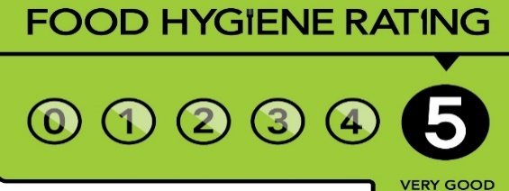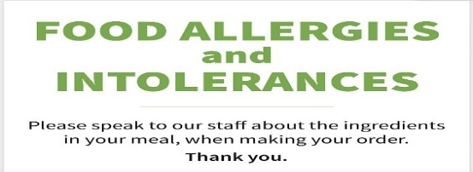

Reference

- Bhojwani. (2007). Food service management : Principles and practice. Rajat Publications.
- Ferreira, & Muller, R. (2013). Innovating the wine tourism product : food-and-wine pairing in Stellenbosch wine routes. African Journal for Physical Health Education, Recreation, and Dance, 19(sup-3), 72–85.
- Furmston. (2001). Principles of commercial law (2nd ed.). Cavendish.
- Journal of nutrition in recipe & menu development. (1994). Haworth Press.
- Metcalfe, Sampson, H. A., & Simon, R. A. (2008). Food allergy : adverse reactions to foods and food additives (4th ed.). Blackwell Pub.
- Smith. (2015). Another person’s poison : a history of food allergy. Columbia University Press. https://doi.org/10.7312/smit16484
- Wurgaft. (2008). Economy, Gastronomy, and the Guilt of the Fancy Meal. Gastronomica, 8(2), 55–59. https://doi.org/10.1525/gfc.2008.8.2.55

Student name : Maria-Francesca Scurtu
Student no : 2117746
Module : Food and Beverage Operation
Lecturer name : Steve Jones

