Programme: | MSc Public Health and Social Care in Practice
Module: | Population Health and Digital Health Promotion
Module code: | LCHS7009
Lecturer: | Dr Ping Wu
Assignment Title: | Component 1: 2 Blogs
Student Name: | Bilkis Begum
Student ID: | 2432744

Blog 1: “Pocket Mindfulness: How Calm Is Changing Digital Mental Health”

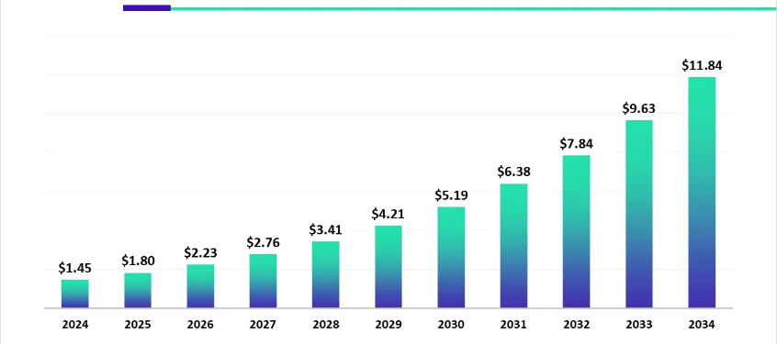
The Undressed Crisis: Mental Health in the Digital Era
- According to Olawade et al. (2024) The worldwide market for AI in mental health is estimated at US$ 1.45 billion in 2024, increasing to US$ 1.8 billion in 2025, and is anticipated to reach over US$ 11.84 billion by 2034.
- AI in mental health is rapidly expanding, with approximately 1 in 8 young adults and 1 in 10 adults using AI chatbots for mental health advice, primarily driven by 24/7 access, low cost, and reduced stigma (World Health Organization, 2025).
(Towards Healthcare, 2025)
- The global median of governmental health expenditure designated for mental health is under 2% (Kieling, 2024).

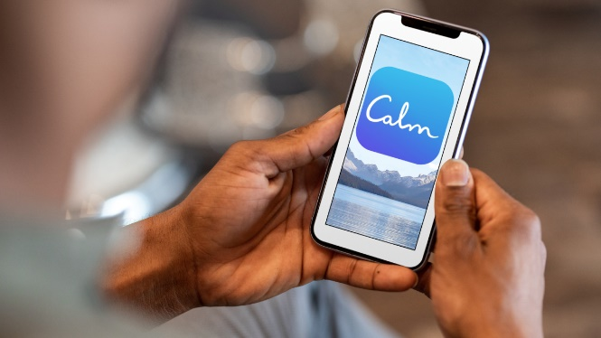
Digital Mindfulness: The Overview of Calm
Calm is a mindfulness application designed for both novices and meditation aficionados. It may assist individuals in attaining inner tranquillity and managing life's pressures. Calm is an acclaimed mindfulness application accessible on iOS, Android, and desktop platforms. Established in 2012, it has surpassed 100 million downloads and garnered over 1.5 million 5-star ratings (Ritchie et al., 2023). It is often regarded as an excellent foundation for novices because of its organised lessons and soothing narration, facilitating the establishment of a constant practice.
(Balagam, 2021)
See:
A Breakdown of the Calm App: Tested and Reviewed by 6 Editors

Empirical Evidence of Influence: Findings from Research
Research by Cruz-Gonzalez et al. (2025) indicates that Calm decreased mind-wandering and enhanced concentration by 14%. Calm indicates that research suggests use the app for a minimum of three weeks may assist with emotional management. A research indicated that participants' aggression and susceptibility to negative feedback decreased by 57% (Gavrilova and Zawadzki, 2023). The ability to measure the mental health benefits of Calm is one of its most significant strengths.

The Procedure of Digital Healing
Research indicates that mindfulness applications may mitigate symptoms related to mental health disorders (Balagam, 2021). These applications especially address three domains: attention control, defusion, and persistent negative cognition. App-based treatments are effective due of their accessibility and convenience. Calm offers evidence-based treatments at all hours, in contrast to traditional therapy, which often entails waiting lists and geographical limitations (Olawade et al., 2024).

Advantages and Limitations
Benefits:
- Easy to scale and widely accessible
- Encourages active user participation
- Based on evidence-informed information
- Supports efficient use of resources
- Allows personalised user experiences
Key Limitations:
- Short duration of interventions
- High dropout rates among users
- Potential conflicts of interest
- Limited diversity in reach or representation

Addressing the Shortfalls: A Path Forward
- Consider mindfulness apps as a supplementary resource to professional mental health therapy, especially for severe symptoms (Ritchie et al., 2023).
- Advanced algorithms can correlate users' symptoms, preferences, and response patterns with appropriate therapy.
- Augmented social support may aid users in sustaining interest and provide peer help to those facing demotivation.
- Collaboration with healthcare professionals may enhance the oversight of clients necessitating advanced care and ensure appropriate use (Cruz-Gonzalez et al., 2025).

References
Balagam, I. (2021). Is the Calm App Right for You? Here’s What Our Experts Say. [online] Healthline. Available at: https://www.healthline.com/health/mental-health/calm-app-reviews.
Cruz-Gonzalez, P., He, A.W.-J., Lam, E.P., Ng, I.M.C., Li, M.W., Hou, R., Chan, J.N.-M., Sahni, Y., Vinas Guasch, N., Miller, T., Lau, B.W.-M. and Sánchez Vidaña, D.I. (2025). Artificial intelligence in mental health care: a systematic review of diagnosis, monitoring, and intervention applications. Psychological Medicine, [online] 55. doi: https://doi.org/10.1017/s0033291724003295.
Gavrilova, L. and Zawadzki, M.J. (2023). Examining How Headspace Impacts Mindfulness Mechanisms Over an 8-Week App-Based Mindfulness Intervention. Mindfulness, 14(9), pp.2236–2249. doi: https://doi.org/10.1007/s12671-023-02214-4.
Kieling, C., Buchweitz, C., Caye, A., Silvani, J., Ameis, S.H., Brunoni, A.R., Cost, K.T., Courtney, D.B., Georgiades, K., Merikangas, K.R., Henderson, J.L., Polanczyk, G.V., Rohde, L.A., Salum, G.A. and Szatmari, P. (2024). Worldwide Prevalence and Disability From Mental Disorders Across Childhood and Adolescence: Evidence From the Global Burden of Disease Study. JAMA Psychiatry, [online] 81(4), pp.347–356. doi: https://doi.org/10.1001/jamapsychiatry.2023.5051.
Olawade, D.B., Wada, O.Z., Odetayo, A., David-Olawade, A.C., Asaolu, F. and Eberhardt, J. (2024). Enhancing Mental Health with Artificial Intelligence: Current Trends and Future Prospects. Journal of medicine, surgery, and public health, [online] 3(3). doi: https://doi.org/10.1016/j.glmedi.2024.100099.
Ritchie, H., Roser, M., Dattani, S. and Rodes-Guirao, L. (2023). Mental health. [online] Our World in Data. Available at: https://ourworldindata.org/mental-health.
Towards Healthcare (2025). AI in Mental Health Market Skyrockets 24.15% CAGR by 2034. [online] Towardshealthcare.com. Available at: https://www.towardshealthcare.com/insights/ai-in-mental-health-market-sizing.
World Health Organization (2025). Over a billion people living with mental health conditions – services require urgent scale-up. [online] Who.int. Available at: https://www.who.int/news/item/02-09-2025-over-a-billion-people-living-with-mental-health-conditions-services-require-urgent-scale-up.

Blog 2: “Creating an AI-Powered CBT Platform for Everyday Mental Wellbeing”

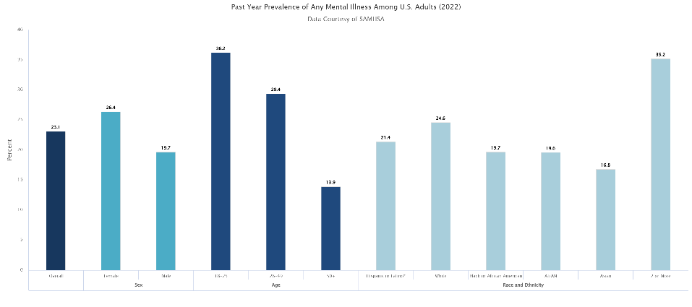
Continuing Issue: Mental Health Care Deficits
According to World Health Organisation (2025),Over 1 billion people, or approximately 13%–15% of the global population, live with a mental health disorder, with anxiety and depression being the most common. In 2022, about 59.3 million individuals aged 18 and older in the United States had AMI . This figure constituted 23.1% of the total adult population in the United States (National Institute of Mental Health, 2024). The prevalence of AMI was greater in females (26.4%) compared to males (19.7%).
(National Institute of Mental Health, 2024)

Introducing MindfulAI Companion: A Novel Approach
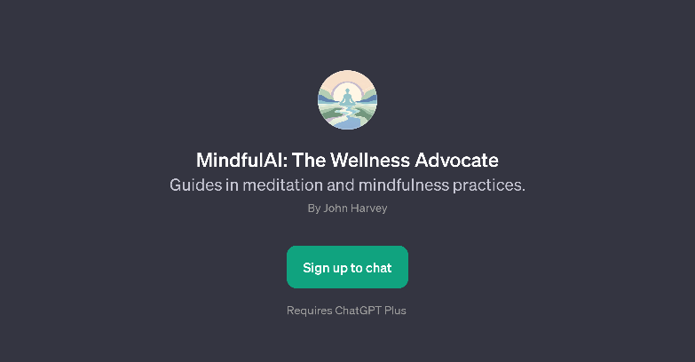
To rectify such shortcomings, propose the creation of MindfulAI Companion, an AI-driven digital platform that amalgamates cognitive behavioural therapy with advanced machine learning, real-time monitoring, and customised treatments (Torous et al., 2025).
Key Design Features and Architecture
MindfulAI Companion uses cutting-edge technology and proven therapies:
AI-Driven Personalisation: Using advanced machine learning techniques, the program customises medication to user behaviour and symptoms. Artificial intelligence improves therapy scheduling, material selection, and delivery, and studies show that personalised therapies have more effect (Koh et al., 2021).
Instant Biometric Integration: Unlike self-reported apps, MindfulAI Companion monitors mental health physiologically using wearable devices and smartphone sensors.
ACBT Module System: Interactive modules offer evidence-based cognitive-behavioral treatment based on user progress and interaction.
Digitised Therapy Assistant: An AI-driven conversational agent provides 24/7 therapeutic conversations, psychoeducational information, and intervention suggestions using natural language processing (Kieling et al., 2024).

Daily Mental Health Challenges Made Smarter with MindfulAI Companion
Urgent Crisis Assistance
The platform employs sophisticated crisis detection algorithms that examine user inputs, behavioural patterns, and physiological data for signs of suicidal intent or substantial deterioration.
Tailored Therapeutic Strategies
Investigations on the effectiveness of digital cognitive behavioural therapy inform the platform's customised treatment protocols that adapt based on user response patterns (The Lancet Digital Health, 2022).
Confronting Healthcare Inequities
MindfulAI Companion provides evidence-based support to those on critical professional care waiting lists. Studies demonstrate that mobile apps used during waiting periods for psychiatric appointments significantly reduce symptoms of depression and anxiety (Martinengo et al., 2021).

Advantages
- CBT, mindfulness, and behavioural activation may have a stronger effect on mental health than single therapies (Torous et al., 2025).
- Unlike standalone apps, MindfulAI Companion integrates professional supervision and escalation processes to ensure care continuity.
- Traditional mental health services struggle to scale, but the platform can serve an endless number of consumers with customised experiences.

Challenges
- Privacy and data protection concerns: AI personalisation requires large amounts of data collection, which can create privacy risks.
- Over-reliance on technology: Users might depend too much on apps instead of developing independent coping skills.
- Need for clinical validation: For serious mental health conditions, the platform requires long-term and costly research to prove effectiveness (Martinengo et al., 2021).

Addressing the Gaps: Implementation Approaches
- Data protection and privacy framework
- Bias reduction and equity assurance
- Professional integration and training
- Clinical validation procedures
- Improvements in accessibility
- Ethical oversight framework

References
Kieling, C., Buchweitz, C., Caye, A., Silvani, J., Ameis, S.H., Brunoni, A.R., Cost, K.T., Courtney, D.B., Georgiades, K., Merikangas, K.R., Henderson, J.L., Polanczyk, G.V., Rohde, L.A., Salum, G.A. and Szatmari, P. (2024). Worldwide Prevalence and Disability From Mental Disorders Across Childhood and Adolescence: Evidence From the Global Burden of Disease Study. JAMA Psychiatry, [online] 81(4), pp.347–356. doi: https://doi.org/10.1001/jamapsychiatry.2023.5051.
Koh, A., Swanepoel, D.W., Ling, A., Ho, B.L., Tan, S.Y. and Lim, J. (2021). Digital health promotion: promise and peril. Health Promotion International, 36(Supplement_1), pp.i70-i80.
Martinengo, L., Stona, A.-C., Griva, K., Dazzan, P., Pariante, C.M., von Wangenheim, F. and Car, J. (2021). Self-guided Cognitive Behavioral Therapy Apps for Depression: Systematic Assessment of Features, Functionality, and Congruence With Evidence. Journal of Medical Internet Research, 23(7), p.e27619. doi: https://doi.org/10.2196/27619.
National Institute of Mental Health (2024). Mental Illness. [online] National Institute of Mental Health. Available at: https://www.nimh.nih.gov/health/statistics/mental-illness.
The Lancet Digital Health (2022). Mental health in the digital age. The Lancet Digital Health, 4(11). doi: https://doi.org/10.1016/s2589-7500(22)00191-1.
Torous, J., Linardon, J., Goldberg, S.B., Sun, S., Bell, I., Nicholas, J., Hassan, L., Hua, Y., Milton, A. and Firth, J. (2025). The evolving field of digital mental health: current evidence and implementation issues for smartphone apps, generative artificial intelligence, and virtual reality. World Psychiatry, [online] 24(2), pp.156–174. doi: https://doi.org/10.1002/wps.21299.
World Health Organization (2025). Over a billion people living with mental health conditions – services require urgent scale-up. [online] Who.int. Available at: https://www.who.int/news/item/02-09-2025-over-a-billion-people-living-with-mental-health-conditions-services-require-urgent-scale-up.

