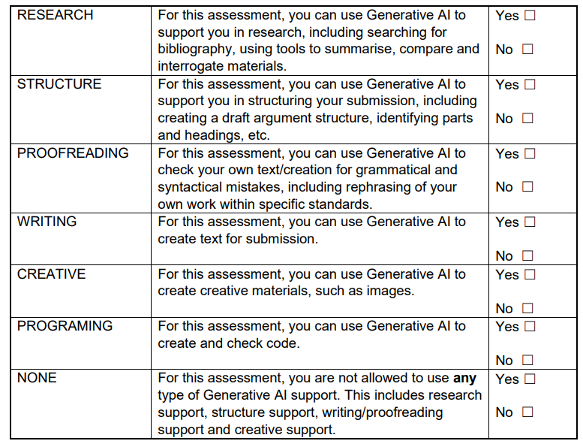
I confirm that I have not used any AI tools in the research and creation of this assignment. I confirm that I have not presented any AI generated materials as my own work. I confirm I have copies of my drafts, notes, and other resources I used, which I may be asked to provide in evidence.

Before our first lesson, my feelings towards this module were fearful. I didn’t have any interest in using my acting skills and knowledge in education. I will try my best to open my mind to this module, what it could teach me and what I could take from it even if I have no desire to continue with it.
I’m trying to take one step at a time, and to not focus on negative feelings, so I’m throwing myself into the workshops that I will be facilitating. The first lesson was great for getting my workshop bearings and I found myself enjoying it. Immediately, I found things that resonated with me, aspects that I found engaging and entertaining and I wanted to take those into our first workshop.
I felt Tom and Nicole and I worked well together and had strong ideas. I was quite nervous when “performing” the workshop. It feels very vulnerable to be playing myself. I think this will be something I take away as if I have the mind-set of playing a “character” maybe it won’t seem as scary. Looking at the technicality of our first workshop, for our first try, I think we did well. I think we handled the room well and supported our classmates, who were kind enough to play children during the exercise. One thing that I want to remember as my personal “golden rule” is that there is no right or wrong when children are taking part in this workshop. It’s a different experience where they can create something random and wonderful but in an appropriate, safe and controlled space for everyone, including us as facilitators. Children can be very creative with answers, and though some answers may not be the best, it’s important not to shut them down. The website, Twisty Tails Nurseries, gives information for parents in this context, however, it also applies to facilitators like us.
Acknowledge your child’s feelings, offer alternatives, and demonstrate empathy while staying firm in your decision. Encourage problem-solving skills: Instead of simply saying ‘no,’ encourage your child to find alternatives or solutions to their desires. (Headoffice, 2023).
One of my worries going into the assessment is that I accidently shut down a child’s creativity or upset them by saying the wrong thing. Offering alternatives but still taking their idea or answer into account might result in a better atmosphere and make the child feel heard.
I found this method of working very effective. With guidance from Ali, we would be put in to groups to start planning on the Monday then have two days to develop and rehearse the plan ready for Thursday’s class where we would get constructive feedback from Ali/the class. I enjoyed this as I could use feedback from the last session to show improvements in my knowledge/skills.
My second group was with Deryn and Liv, and again, I think we worked well together. I enjoyed our slightly risky decision to make everything play themed, as in playing a character. We used a few drama conventions giving us a blank canvas to start with. Our goal was to get the children (classmates) to create their own world with items they had to find during a scavenger hunt. A lot this was adaptation which is something I now know is a huge skill in facilitating. I think I maybe took charge a little too much during the workshop, because it felt like there were moments when the conventions were going slower than we hoped or it took more encouragement from me to keep it up. For example, I tried my best during hot-seating to create questions for Deryn because it did slow down a little.
Developing adapting skills was important for me in this task. Something was said during this practice workshop that threw me off. I think I handled it well during the workshop and allowed myself to process the uncomfortable feeling afterwards. I didn’t enjoy this in the moment but think it was a good learning curve and feel I can be better prepared for assessment day. I also think treating the assessment as a performance would be beneficial for me because I think that’s my strong suit. I wanted to know more about adaptation and found an article, What to Do When the Unexpected Happens During a Live Performance from the site, BACKSTAGE.
Always remember to move forward with full reinvestment back into the performance. After a brief acknowledgment of what has transpired, perhaps you improvise a line or two to transition from the event back into the world of the performance and recommit to the intentions, objectives, and relationships of the character you’re portraying. If the performer can put it behind them, the audience can too. (Barron J, Brown D.W, 2017).
Looking at this with a performance perspective helps me understand that adapting as a facilitator is just improvising when something unexpected happens. This makes me feel more comfortable and confident going into this as I have a more “performance” mindset.
After the workshop we understood that there was maybe too much freedom and not enough structure to keep control and keep it going. This was useful though because I can use this feedback to create the next workshop and create something fun with freedom but not so much that as facilitators, we’re drowning in it.
I found the “The Mantle Of The Expert” work challenging. I understand the key feature is presenting the children as experts in their imaginary world, but found some of the language used in the text difficult to understand. The videos helped me understand the technique much better allowing me to see how it can transform children into prison guards.
Working with Tom, Liv and Chris I could really see how far we’d come after the feedback and knowledge picked up from earlier workshops. I felt more confident going into the planning process. The outcome of the workshop was a massive positive, we had great feedback, and everyone found the creativity very engaging/entertaining. I think this is the way to go for the assessment, to give children creative freedom and a sense of achievement.
I was very nervous to meet the children for the first time, and just being in the space of a primary school. I find the environment extremely uncomfortable and hard to centre myself. I was hoping this would be an experience that would make me feel more encouraged for the assessment. We played games with the children this time, rather than create a full workshop which did take the edge off for me. Overall, the children responded well to the games but it was hard to gain their attention, especially during “Zip Zap Boing”, as some knew this game it was hard to get their attention back. Some children didn’t want to participate in the games. We tried our best to keep the energy up but it seemed to fail a few times. I’m not sure what we could have tried during that time.
The workshop process was hard for me, as the first experience in the school did not make me feel any less anxious which made it difficult to engage with the planning. I am disappointed in myself because I feel I let my group down during the final stage of the module. I try not to get effected by nerves, especially in group work but this time I struggled. I still put ideas in motion and put myself forward in discussions because I want to be involved in the process. After we found a solid plan and went through it a few times it helped my confidence and I tried to hold onto it as long as I could in hopes that it would improve my work.
Assessment day went very well in my opinion. (Find plan in Appendix 1). I think we created a good environment for everyone. I think my energy was up in a very good way. I had a little trouble adapting to situations and did panic a little, but my issues with this environment, I think I did as well as I could when unexpected things happened and the children needed re-direction. I was very surprised with my feelings afterwards as I genuinely enjoyed the experience in the end and felt a massive sense of achievement. It was very interesting to witness children getting into the spirit of things and throwing themselves in the exercises.
This is something I found surprising as I really thought that they would need more encouragement to participate, however they really took to it. During the video Dorothy Heathcote: Three Looms Waiting. BBC Omnibus (Dir. Ronald Smedley, 1971), she’s working with a group of boys who at first seemed uninterested but she came into the room with a massive sense of authority yet calming and fun presence, and because of this the children were more inclined to listen and to take part. It also helps when the facilitator throws themselves into the role making the children less likely to feel silly or uncomfortable, because the leader is also taking part.
It was an amazing experience talking to the children as they all had great attitudes to the games and drama of it all. They all responded very well to the workshop which made me feel we had done a good job of making it a fun experience that they wanted to participate in.
Appendix
Appendix 1:
Script for Workshop.pdf

Reference List:
Twisty Tails Nurseries (2023) The Struggle of Parents: Overcoming the Fear of Saying ‘NO’ to their Children. Available at: Overcoming the Fear of Saying 'NO' to your Children | Twisty Tails (Accessed: 29th March 2025).
Barron J, Brown D.W. (2017) What to Do When the Unexpected Happens During a Live Performance. Available at What to Do When the Unexpected Happens During a Live Performance (Accessed: 4th April 2025)
Heathcote D. (2012) Dorothy Heathcote: Three Looms Waiting. BBC Omnibus (Dir. Ronald Smedley, 1971) [video]. Available at: Dorothy Heathcote: Three Looms Waiting. BBC Omnibus (Dir. Ronald Smedley, 1971) (Accessed: 23rd April 2025).

