

PROGRAMME: BA (HONS) LEADERSHIP AND MANAGEMENT SKILLS FOR THE WORKPLACE
MODULE: UNDERSTANDING AND ENGAGING STAKEHOLDERS
MODULE CODE: LCLM5001
ASSIGNMENT TITLE: UNDERSTANDING THE IMPORTANCE OF STAKEHOLDER ENGAGEMENT IN SUCCESSFUL COMMENCEMENT AND COMPLETION OF PROJECT
STUDENT NAME: AMINAT JIMOH
STUDENT ID: 2442741

EXECUTIVE SUMMARY
This report presented a stakeholder management plan for implementing ConnectPlus Platform in Tesco which is an AI-driven customer loyalty and engagement initiative. It outlined the project objectives and by applying power-interest matrix, salience model and others, identification of internal and external stakeholders have been identified. Some major stakeholders related to this project of Tesco are senior management, The Project manager, IT and Software development team, customers, regulatory authorities, investors and others. This project has been largely helpful for identifying the role of stakeholder in analysts' involvement with Tesco’s success. A detailed communication plan is provided which is largely effective in mentioning the ways stakeholder communication could be established for the success of Tesco related to launching its ConnectPlus Platform.
This paper emphasised the sustainability, collaboration of stakeholders, and improvements that are being carried out by Tesco strategically. The RACI matrix helped to ensure effective governance, whereas the SWAN, OWAN, and 4C models helped to identify the capabilities of the firm internally and externally and the strategy for customers. Sustainability of stakeholders improves the reputation and performance of Tesco. This report analyses sustainable stakeholder engagement of the artificial intelligence-driven Tesco AI-based platform on ConnectPlus platform. It examines the identification of stakeholders, engagement processes, modalities, ethics, issues and business impacts. The results indicate that the relevant engagement benefits the stakeholders and offers them towards a superior collaboration, consumer loyalty, compliance with regulations, and operational efficiency, which underlines successful project execution and long-term competitive strength.
Table of Contents
1. Introduction 4
1.1 Company Background 4
1.2 Overview of the ConnectPlus Platform 4
1.3 Business Need for the Project 4
1.4 Scope and Purpose of the Report 4
2. Smart Objectives 5
3. Identification and Categorisation of Key Stakeholders 6
3.1 Project Overview 6
3.2 Internal and External Stakeholders 6
3.3 Stakeholder Mapping (Power-Interest Matrix) 7
3.4 Salience Model 8
3.5 Stakeholder Analysis Table 9
4. Roles, Responsibilities, Benefits and Challenges of Stakeholders 10
4.1 Importance of Stakeholder Engagement throughout the Project Lifecycle 10
4.2 Stakeholder Engagement Matrix 12
4.3 Conflict Management Strategies 13
5. Critical Explanation of the process to engage these key stakeholders 13
5.1 Stakeholder Engagement Process 13
5.2 Stakeholder Typology 14
5.3 Communication Plan 15
5.4 RACI Matrix 16
5.5 SWAN & OWAN Analysis 18
5.6 4C Model 19
6. Evaluation of the Impact of Sustainable Stakeholder engagement in Business Performance 20
6.1 Benefits 20
6.2 Challenges 22
6.3 Ethical Considerations 22
6.4 Impact on Tesco's Performance 23
6.5 KPIs 23
7. Recommendations and Conclusion 26
7.1 Recommendations 26
7.2 Conclusion 27
References 28

1. Introduction

1.1 Company Background
In this project the chosen company is Tesco which is a British multinational retailer in the largest supermarket chain of the UK (Tesco, 2026). Tesco offers diverse products such as everyday groceries, homeware, health, beauty and many others within both the online and offline business channels. The total revenue earnings of Tesco is accounted as 98.531 billion USD in 2026 which was an increment of 10.6% from 2025 (Macrotrends, 2026). These high revenue earnings increased due to effective customer loyalty in this company anchored by the famous clubcard program, reward provision to customers and others. Thus, Tesco is suitable for launching a digital customer loyalty and engagement platform called “ConnectPlus”.

1.2 Overview of the ConnectPlus Platform
ConnectPlus aims to offer a digital system for generating customer loyalty and engagement platforms in Tesco. This platform will help to involve AI-powered personalized recommendations through giving mobile rewards, advanced customer analytics that can strengthen data-driven decision-making and customer retention. This brand differentiation rollout plan will take six months.

1.3 Business Need for the Project
This new project will address the growing need for increasing customer loyalty, personalised shopping experience and customer data integration for strategic decision-making. For evidence support, it is seen that almost 51% of the customers of Tesco seek positive brand interaction in a positive way followed by personalized recommendation generation (Comtech, 2024). Thus, based on this growing demand, by integration of AI and digital engagement features, ConnectPlus will accelerate effective customer retention for business growth within both the domestic and international markets.

1.4 Scope and Purpose of the Report
This report will evaluate the implementation of the ConnectPlus platform by examining the project management approaches. For this purpose, stakeholder engagement, their roles and responsibilities, engagement of stakeholders and others will be evaluated for the successful implementation of the ConnectPlus Platform.

2. Smart Objectives
Objectives | Specific | Measurable | Achievable | Relevant | Time-bound
Successful launching of the ConnectPlus Platform | Improvement in the customer loyalty by integrating AI-driven personalised recommendations | Increment of the customer retention by 15% | Using digital infrastructure, skilled employees followed by project resources | Supports customer retention strategies | 6 months
Implementation of mobile-based engagement features and customer analytics | Improvement in the customer analytics | Increment of the mobile application engagement by 20% | Deployment of platform using staff training and stakeholder support | Increase data-driven decision-making and create competitive advantage by enhancing customer experience | 6 months
Table 1: SMART Objectives
(Source: Self-Developed)

3. Identification and Categorisation of Key Stakeholders

3.1 Project Overview
This ConnectPlus implementation project involves an AI-driven customer loyalty and engagement platform for Tesco. This project is mainly aimed to give the provision of personalised product recommendations, mobile-based rewards and customer analytics to increase the customer experience. This project is scheduled to be completed within six months. Thus, in the following section, both the internal and external stakeholder identification will be made by assessing their power and interest as well.

3.2 Internal and External Stakeholders
Stakeholder Type | Name | Roles and Responsibilities
Internal Stakeholders | Senior management | Provision of making strategic decision and approves project milestones
Internal Stakeholders | The Project manager | Planning and coordination to control overall project activities
Internal Stakeholders | IT and Software development team | Development and integration of tests and trials for the deployment of new platform
Internal Stakeholders | Customer service team | Clear customer queries during and after the new project implementation
Internal Stakeholders | Operational and marketing Staff | Customer engagement strategy development, regular employee training and monitoring of project activities of implementing ConnectPlus
External Stakeholders | Customers | End users of platform ConnectPlus
External Stakeholders | Technology vendors | Supply of AI solutions, software and technical support
External Stakeholders | Cloud service providers and AI solution partners | Delivery of secure and scalable infrastructure for implementing the ConnectPlus  AI solution partners will integrate customer analytics, personalised recommendation algorithms and others
External Stakeholders | Regulatory authorities | Providing and monitoring legal and data protection compliance
External Stakeholders | Investors | Providing fund for project initiation and monitor overall financial performance
Table 2: Identification of Internal and External Stakeholders of Tesco for Launching ConnectPlus
(Source: Self-Developed)

3.3 Stakeholder Mapping (Power-Interest Matrix)
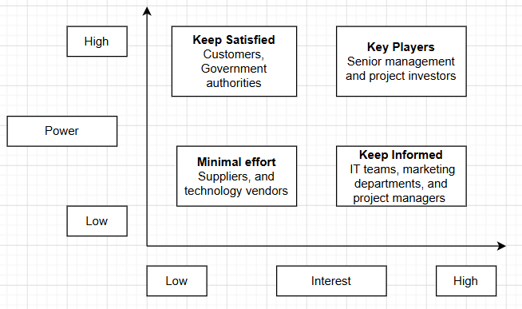
Figure 1: Power-interest Matrix of Stakeholders
(Source: Self-developed)
The power-interest matrix helps to classify the stakeholders based on their level of power and influence (Interreg, 2024). From figure 1, it has been seen that the senior management team and project investors are considered as key players who have high power and high interest in this project. These stakeholders require close collaboration and regular inclusion in the decision-making process. Further, customers and the government authorities have high power in this project and they should be kept satisfied through effective communication and compliance management. However, IT teams, project managers and operational staff have high interest, however, and their power is low on the overall project implementation who should be kept informed properly. Lastly, suppliers and technology vendors have low power and low interest in this project who are managed through minimal effort by frequent communication only.

3.4 Salience Model
The Salience Model refers to the framework which is used for assessing the importance of stakeholders in terms of three primary attributes such as power, legitimacy and urgency (Umbrex, 2025). Based on these attributes, three types of stakeholder are there such as latent, expectant and definitive. However, project investors and senior management teams can be classified as definitive stakeholders as they possess all these three attributes. Definitive stakeholders involve highest priority and demand immediate and gained highest attention from the project (Rebelsguidetopm, 2026). Thus, senior executives help to provide financial resources, informed decision-making and others secure successful delivery of projects which makes them definitive stakeholders. Further, regulatory agencies follow the dominant segment of being expectant stakeholders which have power and legitimacy. Their role is to ensure consumer projection regulation and cybersecurity issues, unless reputational damage and financial penalties are faced which creates an important power of these stakeholders. On the other hand, customers are considered as dependent stakeholder and technology vendors followed by cloud service providers are discretionary stakeholders. Dependent stakeholders involve legitimacy and urgency whereas discretionary involve legitimacy only in the salience model (Shafique and Gabriel, 2022). Customers have legitimate expectations and urgent service requirements and have limited organisational power. However, their feedback is essential for platform improvement. Technology vendors and cloud service providers accelerate successful implementation, however, they possess limited decision-making authority.

3.5 Stakeholder Analysis Table
Stakeholders | Power | Interest | Key Expectations | Engagement strategies
Senior Management | High | High | Business growth and having high return on investment | Providing monthly progress reports through performance dashboard management
Project managers | High | High | Achieving project objectives using adequate resources | Daily communication and risk management meetings
IT and software development team | Medium | High | Clear project requirements and timely technical decision-making | Regular status update and meetings
Customer service team | Medium | High | User-friendly platform integration to communicate with customers | Effective performance monitoring through training session
Operational and marketing staff | Medium | High | Effective marketing campaign | Cross-functional meetings through regular communication
Customers | Low | High | Expect personalised recommendations, secure transactions and seamless digital experience | Loyalty incentive generation, mobile notifications and customer surveys
Technology vendors | Medium | Medium | Timely payment provision with long-term business partnership development | Vendor review meetings followed by performance evaluation
Cloud providers and AI solution partners | Medium | High | Successful platform integration through reliable collaboration | Service monitoring and performance review
Regulatory authorities | High | Medium | Securing regulatory reporting and legal compliance | Compliance audits and regulatory reporting
Investors | High | High | Getting effective financial returns from successful project outcome | Provision of quarterly financial reports
Table 3: Stakeholder Analysis Table
(Source: Self-Developed)

4. Roles, Responsibilities, Benefits and Challenges of Stakeholders

4.1 Importance of Stakeholder Engagement throughout the Project Lifecycle
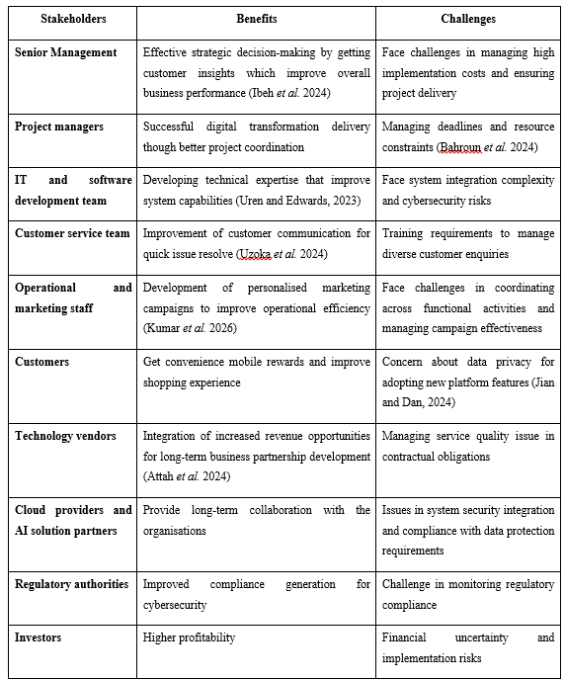
Table 4: Benefits and Challenges of Stakeholder Engagement
(Source: Self-Developed)

4.2 Stakeholder Engagement Matrix
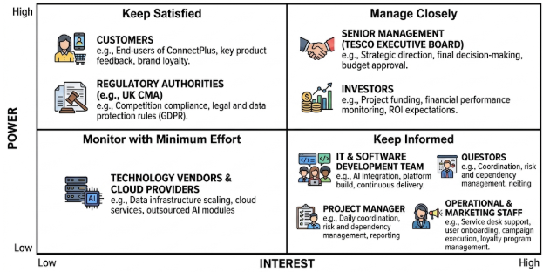
Figure 2: Stakeholder’s Matrix
(Source: Self-developed)
The stakeholder matrix is largely helpful as it ensures greater classification of stakeholders as per their level of power as well as interest (Rodgers, 2024). This framework is also helpful for enabling Tesco to leverage appropriate engagement strategies mostly during the implementation of the ConnectPlus customer loyalty platform. This matrix also indicates that Senior Management as well as Investors are considered as influential stakeholders, while Customers and Regulatory Authorities have high power due to their influence on legal compliance. Other significant stakeholders like the Project Manager, IT and Software Development Team, Operational and Marketing Staff, as well as Customer Service Team have higher interest as they are directly associated with project execution. Lastly, Technology Vendors as well as Cloud Service Providers have relatively low power and interest as they take part in monitoring to enable smooth technical support.

4.3 Conflict Management Strategies
Conflicts among stakeholders are inevitable at business organizations due to the presence of differences in project priorities, resource allocation, project timelines, as well as expectations (Bongo and Sy, 2023). As a result, Tesco needs to effectively adopt collaborative conflict management through suitably encouraging open communication, regular stakeholder meetings, as well as transparent decision-making for resolving issues. It is also important for Tesco to enable Continuous feedback mechanisms that could act as trust-building activities for effectively contributing in robustifying stakeholder relationships, decreasing resistance to change, along with assisting on time project delivery.

5. Critical Explanation of the process to engage these key stakeholders

5.1 Stakeholder Engagement Process
Stakeholder engagement can be considered as a systematic process related to identifying stakeholders, analysing their interests, planning engagement activities, implementing communication strategies (Bongo and Sy, 2023). On a similar note, as per ConnectPlus platform of Tesco, stakeholder engagement might be requiring to initiate with the process of stakeholder identification as well as prioritisation by applying tools or framework such as Power-Interest Matrix. As a result, it could be said that it is highly important for Tesco in enabling adoption of consistent feedback mechanisms leading to ensuring continuous and effective stakeholder participation. In addition, regular stakeholder consultation could be effective in promoting trust, transparency, as well as robust stakeholder relationships (Wadesango, 2023). Therefore, Tesco needs to effectively adopt an iterative engagement process consisting of the process related to consultation, collaboration, monitoring, as well as evaluation for ensuring successful platform deployment.

5.2 Stakeholder Typology
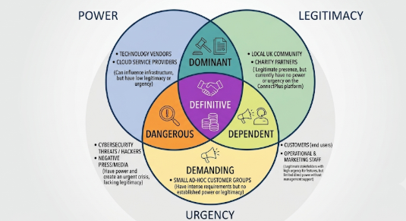
Figure 3: Stakeholder Typology
(Source: Self-developed)
Stakeholder typology could be helpful for suitably classifying stakeholders as per their power, legitimacy, urgency, influence, as well level of interest within a project. The stakeholders possessing these three characteristics such as interest, power, and legitimacy could be identified as principal stakeholders (Kapiriri and Razavi, 2021). Such kinds of stakeholders are also required to be closely overseen by the management as the reason is that they could affect the direction of the project, a lawful or legitimate basis, along with expecting a prompt reaction. In regards to the ConnectPlus, top management and investors are the principle kind of stakeholders as they have both power and legitimacy. On the contrary, dominant stakeholders have the tendency to possess or having both power and legitimacy, such as cloud service providers and technology partners. These stakeholders could have effectively enabled them to have a greater influence on strategic decisions of Tesco. On the contrary, there are also dangerous stakeholders who possess power as well as urgency even without legitimacy that belong to groups like cybercriminals responsible for spreading negative publicity that leads to project risks. Thus, this above given model could help Tesco to prioritise stakeholder engagement efforts as well as allocating resources in an effective way through aligning with stakeholder influence as well as project importance.

5.3 Communication Plan
Stakeholder | Information Shared | Communication Method | Frequency | Responsible Person
Senior Management | Project progress, risks, milestones | Reports and meetings | Monthly | Project Manager
Investors | Financial performance and ROI updates | Financial reports | Quarterly | Finance Manager
Project Team | Task updates and project issues | Team meetings and emails | Weekly | Project Manager
IT Team | Technical requirements and testing updates | Workshops and meetings | Weekly | Technical Lead
Customers | Platform features and rewards updates | Mobile notifications and surveys | Monthly | Marketing Team
Technology Vendors | Project requirements and service updates | Email and review meetings | Monthly | Procurement Manager
Regulatory Authorities | Compliance and data protection reports | Formal reports | Quarterly | Compliance Officer
Table 5: Communication plan
(Source: Self-developed)
The communication plan helps to ensure that each stakeholder is informed with relevant details, in the right way as well as at suitable times. Ensuring ongoing dialogue has been vital as it makes things clearer or transparent between stakeholders and leads to better cooperation. As a result, this could help to take timely decisions and manage stakeholder expectations to sustain their engagement in launching Tesco's ConnectPlus platform.

5.4 RACI Matrix
Project Activity | Project Manager | Sustainability Manager | Procurement Manager | Store Operations Manager | IT Team | Marketing Team | Executive Board
Defining project objectives | R | C | C | I | I | I | A
Conduct ing stakeholder analysis | R | C | C | C | I | I | A
Developing sustainability strategy | C | R/A | C | I | I | C | I
Reviewing supplier sustainability standards | I | C | R/A | I | I | I | C
Supplier engagement and selection | I | C | R/A | I | I | I | C
Developing implementation plan | R/A | C | C | C | C | I | I
Upgrading digital monitoring systems | C | I | I | I | R/A | I | C
Staff training and awareness | R | C | I | A | I | C | I
Launching sustainability communication campaign | I | C | I | I | I | R/A | C
Monitoring project performance | R | C | C | C | C | I | A
Evaluating KPIs and reporting | R | C | C | C | C | I | A
Projecting closure and lessons learned | R | C | C | C | I | I | A

Table 6: RACI Matrix
(Source: Self-developed)
Interpretation
Table 7's RACI matrix demonstrates a clear allocation of roles and responsibilities throughout Tesco's sustainability and supply chain improvement project, ensuring accountability and effective coordination among key stakeholders. The Project Manager is responsible for planning, monitoring, and coordinating project activities, while the Executive Board remains accountable for strategic decisions and project approval. Functional managers, including the Sustainability Manager, Procurement Manager, Store Operations Manager, IT Team, and Marketing Team, contribute specialised expertise within their respective areas. This structured responsibility framework reduces role ambiguity, improves communication, enhances collaboration across departments, and supports the timely achievement of Tesco's sustainability and operational objectives.

5.5 SWAN & OWAN Analysis
SWAN Analysis (Internal Dynamics)
- Strengths (S): Leads the UK grocery market with a 28.5% market share. Highly profitable retail media networks and data monetisation are propelled by the Clubcard ecosystem through dunnhumby (Londonstockexchange, 2026).
- Weaknesses (W): Low profitability (profit margins) in respect of revenue (£3.15bn operating profit and £73.7bn revenue); bad Central European units (Czechia, Hungary, Slovakia) weaken group returns (Financial Times, 2026).
- Goals (A): Achieving a 30% market share in the UK and shifting to high-margins/capital-light sources of revenue (e.g., Tesco Marketplace platform) (Pratley, 2026).
- Nuances (N): Tesco Bank was sold to Barclays, which moved Tesco as a direct financial provider to a white-labeled corporate partner (Figure 4).
OWAN Analysis (External Dynamics)
- Opportunities (O): Hyper-growth in a fast delivery through Tesco Whoosh (sales have increased by 51 to £400m) and customizing ad placements to suppliers.
- Concerns (W): Continued pressure on operations costs and rigid compliance with regulations on volumes of healthy food (HFSS regulations).
- Competition (C): Systemic pricing conflicts with German discounters Aldi and Lidl, and highly competitive loyalty wildest tricks on the part of Sainsbury.
- Niches (N): Long-margin premium high growth Tesco Finest brand (sales growth 15) and leading B2B wholesale control via Booker Group division (Figure 4).
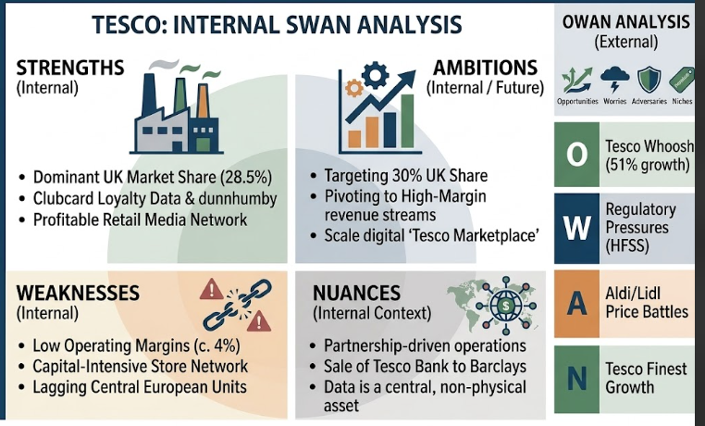
Figure 4: SWAN and OWAN analysis
(Source: Self-developed)

5.6 4C Model
- Customer: Tesco has been focusing on customer needs based on Clubcard, personalised promotions and a wide range of products keep shopping complaints and loyalty business sustainable (Khoirunnisa, Wiyani, and Susilo, 2022).
- Cost: Tesco offers value and as part of Tesco value, they have managed to include lower prices, reward schemes and Tesco own brand products so that they are able to provide the customers with lower overall shopping price (Figure 5).
- Convenience: Tesco offers a smooth shopping experience with supermarkets, Express stores; online grocery services and click-and-collects which are easily accessible to customers (Figure 5).
- Communication: Tesco enhances customer relations along with loyalty by personalised digital marketing, Clubcard as well as social media interaction to foster long-term interactions (Figure 5).
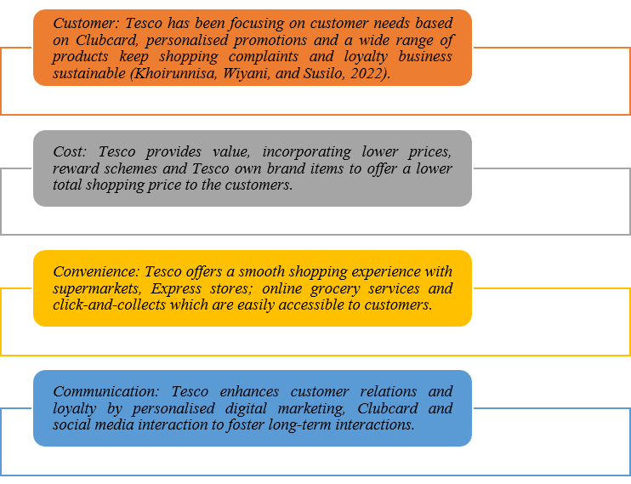
Figure 5: 4C analysis
(Source: Self-developed)

6. Evaluation of the Impact of Sustainable Stakeholder engagement in Business Performance

6.1 Benefits
Enhancing Customer Trust and Loyalty
Sustainable stakeholder engagement is now a powerful contributor to the long term business performance of Tesco in that stakeholder relationships have been enhanced with the customers, employees, suppliers, investors and local communities. In the presence of constant communication and teamwork, Tesco determines the expectations of the stakeholders and in its strategic decision making, it takes them into consideration, enhancing its financial and non-financial results. Good engagement increases trust and transparency, allowing the organisation to be proactive in regards to the changing market and sustainability issues (Rathobei et al., 2024).
Sustainable stakeholder engagement would also enable customers to be more satisfied and loyal as they would know that the products were sourced in a responsible way, with better quality and their respective plans in terms of environmental and social responsibility. Good customer relationship assists Tesco in attaining repeat purchase in addition to boosting its competitive position in UK juice market. Employees also enjoy inclusive workplace programmes, training and wellbeing programmes which have seen them become more motivated, more productive and have increased retention whilst cutting down on the costs of recruiting, training and running the operations.
Enhancing the Supply Chain Resilience and Co-operation
Getting suppliers involved assists Tesco to build resilient and ethical supply chain since it encourages responsible sourcing, environmental conformity as well as long-term relations. Close cooperation with suppliers decreases the operational risks, enhances product availability and promotes sustainably produced products and packaging. These initiatives generate both shared value and operational efficiency and resilience in business throughout the supply chain (Esposito et al., 2024).
Enhancing Investor Confidence and Corporate Reputation
Environmental, social and governance (ESG) concern has confidence building in the minds of the investors by showing a strong resolve to these principles in Tesco. The show of sustainable stakeholder involvement boosts the corporate image, increases transparency and minimises perceived business risks, becoming more appealing to responsible investors. At the same time, social practices, which are connected with the work with local communities, relations with charities, food donation programmes and environmental activities contribute to the enhancement of the social licence to operate of the Tesco and formation of the brand image.
Innovation and Sustainable Value Creation Support
Research also reveals that stakeholder engagement positively affects organisational learning, ability to innovate and sustainable value creation, through sharing of knowledge and collectively solving problems. Such abilities facilitate the idea of continuous improvement and allow businesses to create the innovation of solutions that may increase competitiveness and profitability in the long-term (Alshukri et al., 2024). Thus, sustainable stakeholder engagement offers Tesco strategic advantages based on enhancing operational performance, the enhancement of stakeholder trust, sustainability growth and establishing sustainable value to the organisation and society.

6.2 Challenges
Though it is beneficial in terms of strategy, sustainable stakeholder engagement poses a number of challenges to Tesco when implementing the ConnectPlus platform. When dealing with various stakeholder expectations in various international market localities, this may cause conflicting priorities towards the objectives of the project, the decision to invest or not, and customer demands. In addition, resistance to organisational change among employees will impede the adoption of the platform, and decrease productivity. The challenge of data privacy as well as cybersecurity is a problem as personalisation on AI needs to collect and process significant amount of customer data. Saha et al. (2024) pointed out that the balancing of any stakeholder-related interests and securing the long-term organisational value should be strengthened through the continuous communication, transparency and appropriate governance. Along with that, it is recommended that the company needs to arrange a number of external technology partners, this adds more complexity to the project and this risk may affect the implementation of a project, which may affect project timelines and services quality.

6.3 Ethical Considerations
The stakeholder interaction in this case should be ethical in ensuring that there would be trust and long-term acceptance of the platform with the name of the new brand, the ConnectPlus. Tesco will be required to comply with the UK General Data Protection Regulation (UK GDPR) such as seeking the consent of the customers in collecting or analysing any personal data in order to make AI-based recommendations. Being open regarding how the customer information is used and kept is also considered significant in order to alleviate the privacy issues and retain the customers not only unconcerned but also undistressed. Moreover, AI algorithms must also be followed to prevent biases or discrimination in recommendations, which may adversely impact certain groups of customers. Ethical stakeholder relationships are based on fairness, accountability and trust in each other where organisations gain greater stakeholder devotion and organisational reputation is safeguarded (Ugah et al. 2025). The idea of sustainable digital transformation and responsible innovation is thus afforded by ethical governance.

6.4 Impact on Tesco's Performance
The proper stakeholder engagement directly boosts the organisational performance of Tesco because it improves the execution of project, customer loyalty and strategic decision making. Close coordination among senior management, project teams, technology partners as well as customers, will enable the implementation of the connectplus and minimize delays of projects, as well as operation risks. Relationship marketing contributes to value generation among stakeholders, particularly by establishing long-term relationships in organisational levels rather than emphasising on the short-term transactions (Agustiana and Pratama, 2025). Therefore, sustainable stakeholder involvement empowers Tesco to enhance the competitive edge, efficiency and profitability of its operations and contributes to its effective globalization of the ConnectPlus platform.

6.5 KPIs
In order to measure the success of the stakeholder engagement during the project single ConnectPlus Tesco should pay attention to the measurable Key Performance Indicators (KPIs). They are customer retention rate, increasing the number of active users of Clubcard along with ConnectPlus, customer satisfaction (CSAT), Net Promoter Score (NPS), stakeholder customer satisfaction survey result, rate of employee training completion, project milestones as well as regulatory compliance incidents. The monitoring of financial indicators like the use of personalised promotions in generating revenues and the return on investment (ROI) should also be monitored.
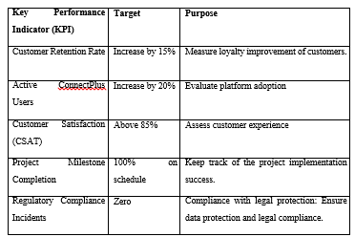
Table 7: KPI table
(Source: Self-developed)

Stakeholder Engagement Plan
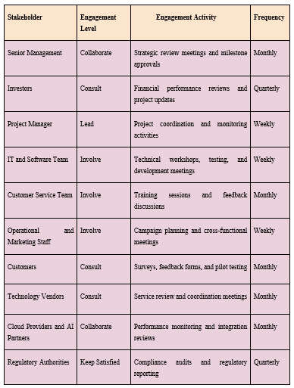
Table 8: Engagement plan
(Source: Self-developed)
Table 6 shows that given key stakeholders of the project and how much influence the stakeholder would have on or by the ConnectPlus project, the approaches range from consultation to collaboration. This identified approach could help Tesco to motivate the commitment of the stakeholder at all stages, ensure better communication among stakeholders as well as also lay the path for the successful completion of the project.
Importance of the engagement plan
The importance of stakeholder engagement for interdisciplinary workingStakeholder engagement is critical for meaningful interdisciplinary work, enabling teamwork, fostering trust and enabling decisions made between different practitioners, users of services and organizations. Ensuring the full involvement of relevant stakeholders allows them to define roles; facilitate communication between parties; promote their professional role; improve the quality of care delivered and to be able to work with partners more seamlessly (Albagami et al., 2024). Collaborative ways of working prevent the dominance of power imbalances, ensure clearer roles, overcome barriers to working together as is inherent in practice across different teams/ disciplines (Bemme and Kirmayer, 2020) and establish mutual respect and sharing of information in pursuit of collaborative and consistent outcomes between organisations (Biringer et al., 2021).

7. Recommendations and Conclusion

7.1 Recommendations
Recommendation 1: Enhance a constant connection with stakeholders
To ensure a consistent two-way communication Tesco should conduct periodic stakeholder meetings, use digital dashboards, surveys on customer feedback and provide progress reports. Constant communication enhances transparency, stakeholders’ expectations, developing trust, and early detection of project risk thus gaining greater commitment of stakeholders in the implementation of the Connectplus (Tumpa and Naeni, 2025).
Recommendation 2: Improve the capability of employees using change management and training
Tesco needs to train employees in the implementation of AI technologies, data protection, and practices of customer engagement widely in the context of the connect plus. The good change management programmes will minimize resistance to change, enhance staff confidence, maintain uniform service delivery both in local and overseas markets.
Recommendation 3: Enhance moral governance and information security
Tesco ought to conduct periodic reviews of AI algorithms and keep to the letter of the UK GDPR and data protection laws as well as engage in transparent interactions with the customers by demonstrating the ways AI is used. Ethical governance will enhance customers' trust, reduce regulatory risk and contribute to long-term sustainability of the platform of ConnectPlus (Ahmad, 2025).

7.2 Conclusion
This report took into consideration the importance of good stakeholder involvement in order to achieve successful integration of the Tesco ConnectPlus platform. Stakeholders identified along with analysed were both internal and external as per the popular stakeholder management models, including the Power-Interest Matrix and Salience Model. The roles of the stakeholders, engaging the strategies, communications planning, and conflict managing and responsibility distribution using the relevant project management tools were also discussed in the report. The results show that good stakeholder engagement increases collaboration, trust, project performance, and customer satisfaction and minimizes implementation risks as well as promoting compliance with the regulations. Overall, sustainable stakeholder engagement is among most critical aspects of success that can assist Tesco in the successful implementation of the connectplus. It also help in acquiring customer loyalty, improving the effectiveness of its operations and guaranteeing the sustainable competitive advantage in the international retail and online shopping context.

References
Agustiana, U.Z. and Pratama, G., (2025). Cooperative principles and economic sustainability in the digital era: Evidence from Indonesian cooperatives. Journal Magister Ilmu Ekonomi Universtas Palangka Raya: GROWTH, 11(2), pp.60-69. Available at: https://e-journal.upr.ac.id/index.php/jgr/article/download/24655/8083 (Accessed: 12 July 2026)
Ahmad, S., (2025). Strengthening Consumer Protection Through Enhanced Risk Governance in Financial Services. Available at: https://www.preprints.org/frontend/manuscript/ae0e22f71dd95b695b4f02937008767b/download_pub (Accessed: 10 July 2026)
Alassane Bandé, Ika, L.A. and Salmata Ouédraogo (2024). Beneficiary participation is an imperative, not an option, but does it really work in international development projects? International Journal of Project Management, pp.102561–102561. Available at: Beneficiary participation is an imperative, not an option, but does it really work in international development projects? - ScienceDirect
Albagami, R.M., Alghamdi, A.A., Alsharif, A.A., et al. (2024). Understanding and barriers of professional identity formation among current students and recent graduates in nursing and midwifery in low resource settings in two universities: A qualitative study. BMC Nursing, 23, 146. https://doi.org/10.1186/s12912-024-01795-2
Alshukri, T., Ojekemi, O.S., Öz, T. and Alzubi, A. (2024) 'The interplay of corporate social responsibility, innovation capability, organizational learning, and sustainable value creation: Does stakeholder engagement matter?', Sustainability, 16(13), article 5511. Available at: https://doi.org/10.3390/su16135511 (Accessed: 28 April 2026).
Attah, R.U., Garba, B.M.P., Gil-Ozoudeh, I. and Iwuanyanwu, O., (2024). Evaluating strategic technology partnerships: Providing conceptual insights into their role in corporate strategy and technological innovation. Int J Front Sci Technol Res, 7(2), pp.77-89. Available at: https://www.researchgate.net/profile/Ifechukwu-Gil-Ozoudeh/publication/386278181_Evaluating_strategic_technology_partnerships_Providing_conceptual_insights_into_their_role_in_corporate_strategy_and_technological_innovation/links/674d8c8a359dcb4d9d4b6e4b/Evaluating-strategic-technology-partnerships-Providing-conceptual-insights-into-their-role-in-corporate-strategy-and-technological-innovation.pdf (Accessed: 12 July 2026)
Bahroun, Z., As’ad, R., Tanash, M. and Athamneh, R., (2024). The multi-skilled resource-constrained project scheduling problem: A systematic review and an exploration of future landscapes. Management Systems in Production Engineering, 32(1), pp.108-132. Available at: https://reference-global.com/download/article/10.2478/mspe-2024-0012.pdf (Accessed: 12 July 2026)
Bemme, D. and Kirmayer, L.J. (2020). Global Mental Health: Interdisciplinary challenges for professional identity, power and communication. Transcultural Psychiatry, 57(6), pp.759–776. https://doi.org/10.1177/1363461520961630.
Biringer, E., Davidson, B., Sundfør, B., et al. (2021). Interprofessional collaboration and professional identity in mental health services. (Please note: several Biringer et al. papers were published in 2021. The screenshot alone is insufficient to determine which specific paper was cited.)
Bongo, M.F. and Sy, C.L., (2024). Can diverse and conflicting interests of multiple stakeholders be balanced?. Annals of Operations Research, 339(3), pp.1813-1837. Available at: Can diverse and conflicting interests of multiple stakeholders be balanced? | Annals of Operations Research | Springer Nature Link
Cmotech, (2024). Study shows personalisation key to consumer loyalty in UK. Available at: https://cmotech.uk/story/study-shows-personalisation-key-to-consumer-loyalty-in-uk (Accessed: 12 July 2026)
Esposito, B., Sica, D., Supino, S. and Malandrino, O. (2024) 'Measuring the impact of circular economy performance on financial performance: The moderating role of stakeholder engagement', Business Strategy and the Environment, 33(6), pp. 5109–5126. Available at: https://doi.org/10.1002/bse.3744 (Accessed: 28 April 2026).
Financial Times (2026) Tesco explores sale of European business. 8 July. Available at: https://www.ft.com/content/0f3ba8c7-eb96-4c18-a274-b8f8609b8f0c (Accessed: 26 April 2026).
Ibeh, C.V., Asuzu, O.F., Olorunsogo, T., Elufioye, O.A., Nduubuisi, N.L. and Daraojimba, A.I., (2024). Business analytics and decision science: A review of techniques in strategic business decision making. World Journal of Advanced Research and Reviews, 21(2), pp.1761-1769. Available at: https://www.academia.edu/download/120419621/WJARR-2024-0247.pdf (Accessed: 14 July 2026)
Interreg, (2024). Enhancing Stakeholder Engagement through Power. Available at: https://www.interreg-central.eu/news/enhancing-stakeholder-engagement-through-the-power-interest-matrix/
Jian, C. and Dan, D., (2024). The Emerging Challenges of Customer Relationship Management with Customer Data Platforms (CDP): Constraints and Perspectives. American Journal of Management Science and Engineering, 9(3), pp.56-63. Available at: https://www.academia.edu/download/118302610/j.ajmse.20240903.11.pdf (Accessed: 12 July 2026)
Kapiriri, L. and Razavi, D.S. (2021). Salient stakeholders: Using the salience stakeholder model to assess stakeholders’ influence in healthcare priority setting. Health Policy OPEN, 2(1), p.100048.Available at: https://www.sciencedirect.com/science/article/pii/S2590229621000198
Khoirunnisa, S.R., Wiyani, W. and Susilo, E.A. (2022) 'Relationship between customer, cost, convenience, and communication on consumer buying decisions', Jurnal Penelitian, 9(2), pp. 106–117. Available at: https://eprints.unmer.ac.id/4017/2/3.%20Relationship%20between%20customer%2C%20cost%2C%20convenient....pdf (Accessed: 28 April 2026).
Kumar, V., Kotler, P. and Kumar, A., (2026). Transformative marketing strategies in the era of new-age technologies: Principles, plan, purpose, and practice. Journal of the Academy of Marketing Science, 54(1), pp.1-27. Available at: https://link.springer.com/article/10.1007/s11747-025-01120-6 (Accessed: 12 July 2026)
London Stock Exchange [LSE] (2026) Preliminary Results 2025/26. Available at: https://www.londonstockexchange.com/news-article/TSCO/preliminary-results-2025-26/17549062 (Accessed: 26 April 2026).
Macrotrends, (2026). Tesco Revenue 2012-2026 | TSCDY. Available at: https://www.macrotrends.net/stocks/charts/TSCDY/tesco/revenue (Accessed: 12 July 2026)
Pratley, N. (2026) Tesco’s overseas empire is in retreat – but shareholders have no complaints. The Guardian, 9 July. Available at: https://www.theguardian.com/business/nils-pratley-on-finance/2026/jul/09/tesco-supermarket-empire-uk-ireland (Accessed: 28 April 2026).
Rathobei, K.E., Ranängen, H. and Lindman, Å. (2024) 'Stakeholder integration in sustainable business models to enhance value delivery for a broader range of stakeholders', Business Strategy and the Environment, 33(4), pp. 3687–3706. Available at: https://doi.org/10.1002/bse.3651 (Accessed: 12 July 2026)
Rebelsguidetopm, (2026). The Stakeholder Salience Model and How to Use It. Available at: https://rebelsguidetopm.com/stakeholder-salience/ (Accessed: 12 July 2026)
Rodgers, A. (2024). Using a Stakeholder Matrix: 3 Practical Examples. Available at: https://simplystakeholders.com/stakeholder-matrix/ (Accessed: 14 July 2026)
Saha, K., Yarnall, M. and Paladini, S., (2024). Sustainable practices in the animal health industry: A stakeholder‐based view. Business Strategy and the Environment, 33(4), pp.3356-3382. Available at: https://onlinelibrary.wiley.com/doi/pdf/10.1002/bse.3633 (Accessed: 14 July 2026)
Shafique, K. and Gabriel, C.A., (2022). Vulnerable stakeholders’ engagement: Advancing stakeholder theory with new attribute and salience framework. Sustainability, 14(18), p.11765. Available at: https://www.mdpi.com/2071-1050/14/18/11765 (Accessed: 14 July 2026)
Tesco, (2026). Tesco - Supermarkets | Online Groceries, Clubcard & Recipes. Available at: https://www.tesco.com/?srsltid=AfmBOorQnvuOAe_hCoRwuttQQntXpjApCINhYldx-yQ7gZ5GOP70AYbw (Accessed: 14 July 2026)
Tumpa, R.J. and Naeni, L., (2025). Improving decision-making and stakeholder engagement at project governance using digital technology for sustainable infrastructure projects. Smart and Sustainable Built Environment, 14(4), pp.1292-1329. Available at: https://www.emerald.com/sasbe/article-pdf/14/4/1292/9813157/sasbe-10-2024-0451.pdf (Accessed: 11 July 2026)
Ugah, E.P.T.A., Ndubuisi, O.G. and FNisafetyE, F.I.S.P.O.N., (2025). Fundamentals of Business Ethics and Corporate Social Responsibility in Modern Organizational Practices. Available at: https://www.seahipublications.org/wp-content/uploads/2025/04/IJIDPS-J-12-2025.pdf (Accessed: 13 July 2026)
Umbrex, (2025). Mitchell-Agle-Wood Stakeholder Salience Model Guide. Available at: https://umbrex.com/resources/frameworks/organization-frameworks/stakeholder-salience-model-mitchell-agle-wood/ (Accessed: 14 July 2026)
Uren, V. and Edwards, J.S., (2023). Technology readiness and the organizational journey towards AI adoption: An empirical study. International Journal of Information Management, 68, p.102588. Available at: https://www.sciencedirect.com/science/article/pii/S0268401222001220 (Accessed: 13 July 2026)
Uzoka, A., Cadet, E. and Ojukwu, P.U., (2024). Leveraging AI-Powered chatbots to enhance customer service efficiency and future opportunities in automated support. Computer Science & IT Research Journal, 5(10), pp.2485-2510. Available at: https://www.k12insight.com/app/uploads/2025/11/Leveraging_AI-Powered_chatbots_to_enhance_customer.pdf (Accessed: 12 July 2026)
Wadesango, O.V. (2023). Proactive Approaches To Stakeholder Engagement. Journal of accounting, finance and auditing studies, 9(3). Available at: https://www.um.edu.mt/library/oar/bitstream/123456789/113756/1/JAFAS9%283%29A10.pdf

Appendix 1: Importance of Stakeholder Engagement
Stakeholders | Benefits | Challenges
Senior Management | Effective strategic decision-making by getting customer insights which improve overall business performance (Ibeh et al. 2024) | Face challenges in managing high implementation costs and ensuring project delivery
Project managers | Successful digital transformation delivery though better project coordination | Managing deadlines and resource constraints (Bahroun et al. 2024)
IT and software development team | Developing technical expertise that improve system capabilities (Uren and Edwards, 2023) | Face system integration complexity and cybersecurity risks
Customer service team | Improvement of customer communication for quick issue resolve (Uzoka et al. 2024) | Training requirements to manage diverse customer enquiries
Operational and marketing staff | Development of personalised marketing campaigns to improve operational efficiency (Kumar et al. 2026) | Face challenges in coordinating across functional activities and managing campaign effectiveness
Customers | Get convenience mobile rewards and improve shopping experience | Concern about data privacy for adopting new platform features (Jian and Dan, 2024)
Technology vendors | Integration of increased revenue opportunities for long-term business partnership development (Attah et al. 2024) | Managing service quality issue in contractual obligations
Cloud providers and AI solution partners | Provide long-term collaboration with the organisations | Issues in system security integration and compliance with data protection requirements
Regulatory authorities | Improved compliance generation for cybersecurity | Challenge in monitoring regulatory compliance
Investors | Higher profitability | Financial uncertainty and implementation risks

