E-Portfolio

Learning in the Digital Era

Katherine Monk

2220232

Contents:
Page 1: Title.
Page 2: Contents page.
Page 3: Written summary of the article ‘How adverse childhood experiences shape our brains’ by Gary Donohoe, 2022.
Page 4: PowerPoint video link explaining the skills essential for working within childhood psychology.
Page 5: Academic poster.
Page 6: 150-word reflection on my contribution to the poster and working within a team.
Page 7: Evidence of communication within a group.
Page 8: Evidence of communication within a group.
Page 9: Evidence of communication within a group.
Page 10: Evidence of communication within a group.
Page 11: References
Page 12: References
Page 13: References

Task One
‘How adverse childhood experiences shape our brains’
Donohoe, (2022) states that exposure to adversities in early years increases the probability of having psychological difficulties in adulthood. Cognitive Behavioural Therapy (CBT) is a form of therapy that specialises in talking through problems. Exposure to adversities within the early years can alter the way that a person processes information, the use of CBT explores that and helps participants understand that reality has changed. Donohoe states that because of a dampening within the frontal lobe the amygdala within the limbic system has been altered due to early adversity and stress, this would further explain why someone feels threatened in calm situations.
Donohoe states that people who suffered physical neglect have a higher chance of psychological difficulties arising within adulthood within a social setting. This test was carried out using a Childhood Trauma Questionnaire (CTQ) which tested against the adversities physical abuse, emotional neglect, emotional abuse, and sexual abuse. Whilst the inclusion of these adversities is important, they are broad subjects and it is left up to interpretation of what they could mean, Donohoe could have also included other specific adversities such as exposure to domestic violence, losing a parent, or living with someone who abuses drugs or alcohol as these adversities are more specific.
Research now uses brain imaging which looks at interactions between neurotransmitters whereas previously psychologists used MRI’s which used radio waves to produce images of the brain. Using brain imaging, psychologists can more accurately state which neurotransmitters are being used and why. The use of brain imaging within this study showed that exposure to physical neglect reduced levels of cognition.
The biggest downfall of this study is that Donohoe could not come up with a fundamental answer to the original hypotheses because the participants were under the age of eighteen at time of publication so no further relevant study could be completed and therefore questions arose concerning the validity of the CTQ.
Reference:
Donohoe, G. (2022, August 15). How adverse childhood experiences shape our brains. BPS. https://www.bps.org.uk/psychologist/how-adverse-childhood-experiences-shape-our-brains.

Task Two
Skills essential for working within childhood psychology.pptx

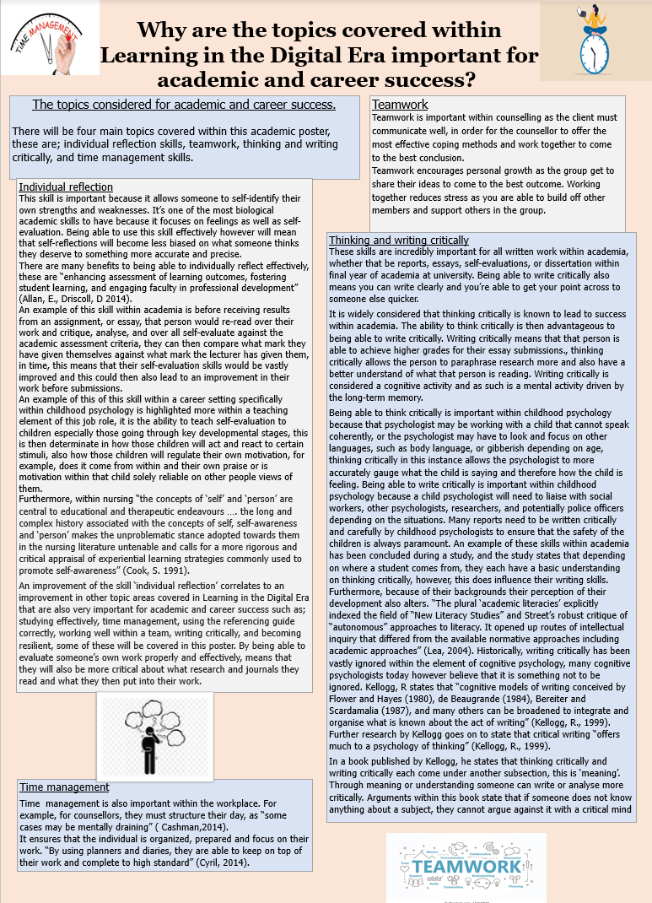
Task Three – Part one
Task Three – Part two
My contribution to the academic poster was the subsections ‘thinking and writing critically’ and ‘individual reflection skills’. I also designed the layout of the academic poster. I worked alongside Charlotte on this group project, and she contributed ‘teamwork’ and ‘time management’, she also added colour and pictures to the poster.
I found this project to be fun, I enjoyed researching and reading a variety of journals and books. Working with Charlotte was good, but I do think that she could have contributed more to her half of the project, however she did send complete her work before I did and send me her work early on.
From completing this task, I feel more comfortable going into my next group activity, I feel that I contributed good work overall, I designed the overall layout of the poster, which is something I haven’t done before, but enjoyed learning a new skill.

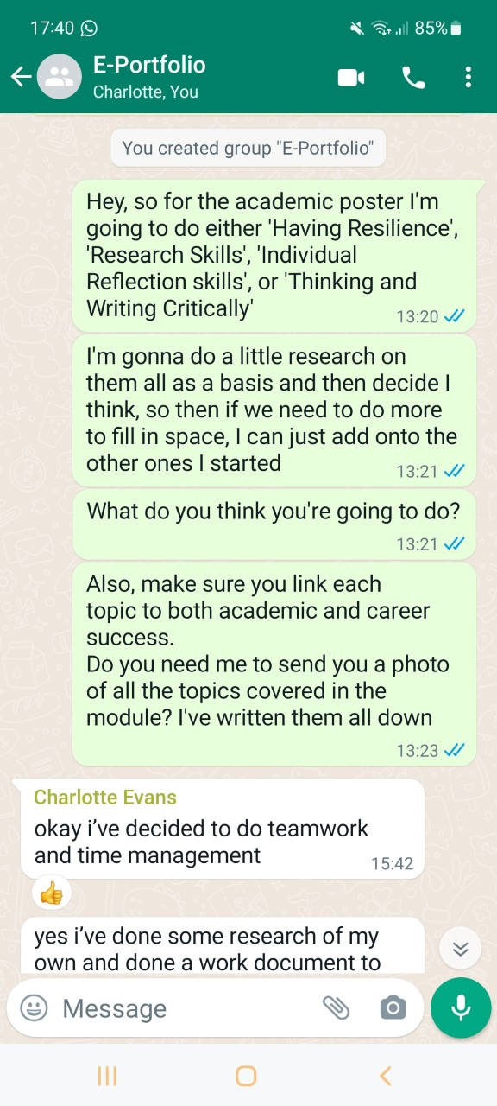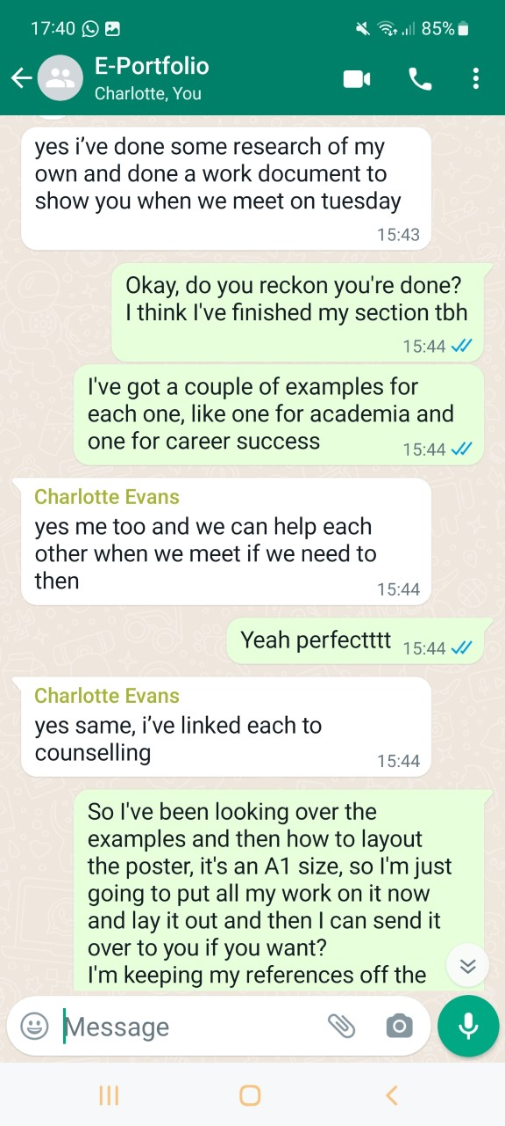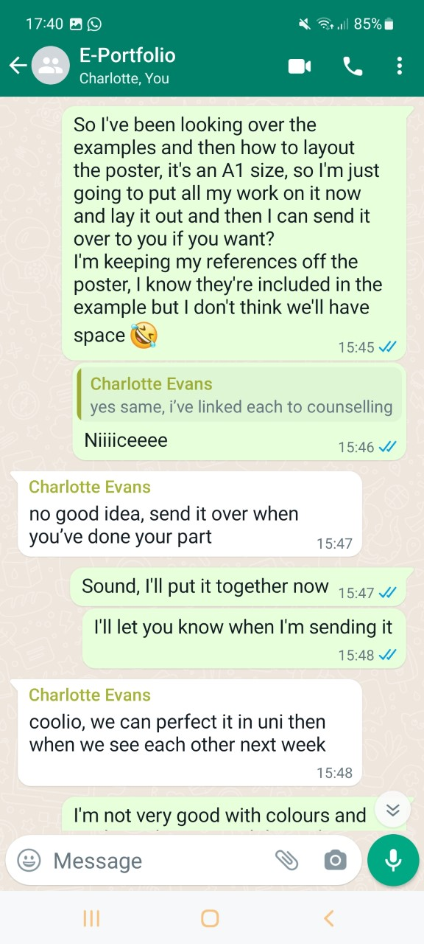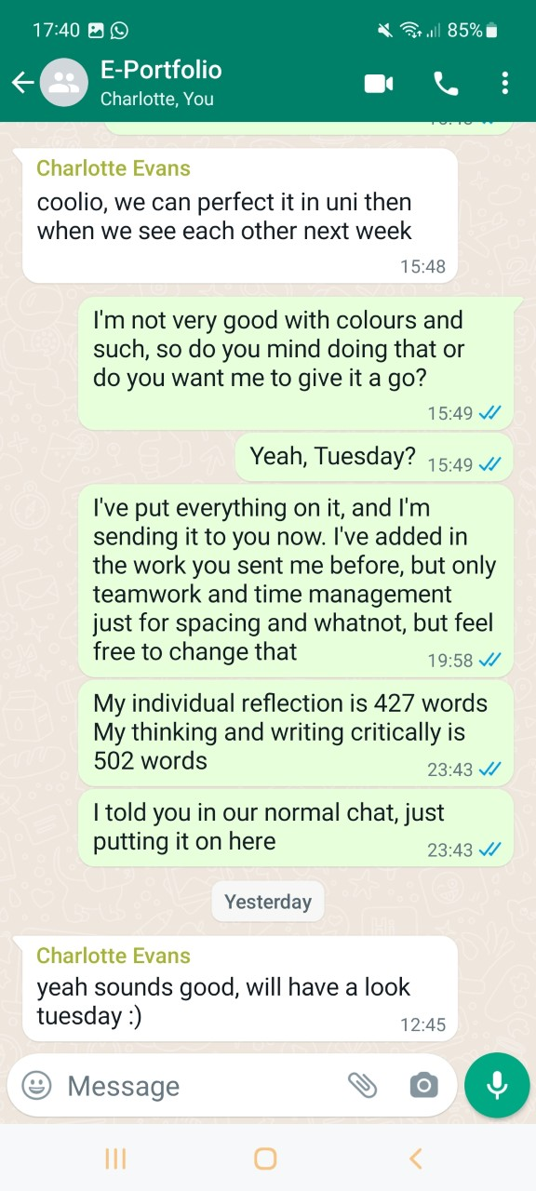
Task Three – Part three
References
Alamargot, D., & Chanquoy, L. (2001). Through the models of writing: with commentaries by Ronald T. Kellogg & John R. Hayes (Vol. 9). Springer Science & Business Media.
Alamargot, D., & Chanquoy, L. (2001). Through the models of writing: with commentaries by Ronald T. Kellogg & John R. Hayes (Vol. 9). Springer Science & Business Media.
Allan, E. G., & Driscoll, D. L. (2014). The three-fold benefit of reflective writing: Improving program assessment, student learning, and faculty professional development. Assessing Writing, 21, 37-55.
Allan, E. G., & Driscoll, D. L. (2014). The three-fold benefit of reflective writing: Improving program assessment, student learning, and faculty professional development. Assessing Writing, 21, 37-55.
Banyard, P., & Flanagan, C. (2011). Ethical Issues in Psychology (1st ed.). Routledge. https://doi.org/10.4324/9780203180983.
Be Well Talks: Fear of Recurrence | Wellspring Chinguacousy. (n.d.). https://wellspring.ca/chinguacousy/programs/all-programs/speaker-series-fear-of-recurrence/
Burgess, R. G. (Ed.). (2005). The ethics of educational research (Vol. 8). Routledge.
Canpolat, M., Sekvan, K. U. Z. U., Yildirim, B., & Canpolat, S. (2015). Active listening strategies of academically successful university students. Eurasian Journal of Educational Research, 15(60), 163-180.
Carayannis, E. G., Barth, T. D., & Campbell, D. F. (2012). The Quintuple Helix innovation model: global warming as a challenge and driver for innovation. Journal of innovation and entrepreneurship, 1(1), 1-12.
Cashman, A (2014, June 4). Prisonization and time management.
Cherry, K. (2018, April 8). The Major Psychology Subject Behind How Children Develop. Verywell Mind. https://www.verywellmind.com/what-is-child-psychology-2795067.
Cook, S. H. (1999). The self in self‐awareness. Journal of Advanced Nursing, 29(6), 1292-1299.
Cook, S. H. (1999). The self in self‐awareness. Journal of Advanced Nursing, 29(6), 1292-1299.
Cyril (2014, October 10). Time management and academic achievement of higher educated students. https://files.eric.ed.gov/fulltext/EJ1097402.pdf
Donohoe, G. (2022, August 15). How adverse childhood experiences shape our brains. BPS. https://www.bps.org.uk/psychologist/how-adverse-childhood-experiences-shape-our-brains.
Enago academy. (2021, November). Effective time management tips for researchers.
Haselton, M. G., Nettle, D., & Andrews, P. W. (2015). The evolution of cognitive bias. The handbook of evolutionary psychology, 724-746.
Hering, B. B. (2021, March 25). 5 Science-Based Time-Management Tips. FlexJobs Job Search Tips and Blog. https://www.flexjobs.com/blog/post/science-based-time-management-hacks/
https://www.ccpa-accp.ca/fr/prioritization-and-timemanagement/#:~:text=Time%20management%20also%20translates%20to,prepare%20for%20the%20next%20client.
https://www.enago.com/academy/time-management-tips-for-researchers/
Kellogg, R. T. (1999). The psychology of writing. Oxford University Press.
Kellogg, R. T. (1999). The psychology of writing. Oxford University Press.
Kellogg, R. T. (2008). Training writing skills: A cognitive developmental perspective. Journal of writing research, 1(1), 1-26.
Kellogg, R. T. (2008). Training writing skills: A cognitive developmental perspective. Journal of writing research, 1(1), 1-26.
Lillis, T. “Academic literacies”: sustaining a critical space on writing in academia. (2019). Journal of Learning Development in Higher Education, 15. https://doi.org/10.47408/jldhe.v0i15.565.
Lillis, T. “Academic literacies”: sustaining a critical space on writing in academia. (2019). Journal of Learning Development in Higher Education, 15. https://doi.org/10.47408/jldhe.v0i15.565.
Mallon, S., & Elliott, I. (2021). What is ‘sensitive’ about sensitive research? The sensitive researchers’ perspective. International Journal of Social Research Methodology, 24(5), 523-535.
McCosker, H., Barnard, A., & Gerber, R. (2001, February). Undertaking sensitive research: Issues and strategies for meeting the safety needs of all participants. In Forum Qualitative Sozialforschung/Forum: Qualitative Social Research (Vol. 2, No. 1).
Miller, K. (2019, June 19). CBT Explained: An Overview and Summary of CBT (Incl. History). PositivePsychology.com. https://positivepsychology.com/cbt/
Resnik, D. (2015, December 1). Research Ethics Timeline (1932-Present). Cloudfront.net. https://d1wqtxts1xzle7.cloudfront.net/48189085/Ref-Research_Ethics_Timeline-libre.pdf?1471664131=&response-content-disposition=inline%3B+filename%3DResearch_Ethics_Timeline_1932_Present.pdf&Expires=1672533010&Signature=TjL3ztIDd9jyluLMQNTZMqsNsGsR8CyJj0H1oosy50XqYbqa6RhjSQx5qDy6wBMS1dvTyMDienD8odjo4PkJ4oENASLqTKtrhZFNbUl7e1U-a2mFTxAcOY2p7zD~8czWxHNPbGfjyJpQzZc~djbSKMvUdUX2osOYbdqxGBMsSIiGRGiynql28om5b4nltmJYagqZQpYzaERs~0DUUtyc3T4mtXnmcIlg5oGK0D5slqf6X4piXNYVmre0LPkl80yedHXa7H8GdW~-6IXzAWlj7C7bjUFcBGlShxSYyIdQL-iW4jGqfmBlxJ4U7kmErQvkxiOUWzCvkA6uTIDGFuFwBQ__&Key-Pair-Id=APKAJLOHF5GGSLRBV4ZA
Sacco, R. G. (2013). Re-envisaging the eight developmental stages of Erik Erikson: the Fibonacci life-chart method (FLCM). Journal of Educational and Developmental Psychology, 3(1), 140-146.
Shaw, S. M. (2000). If our research is relevant, why is nobody listening?. Journal of Leisure Research, 32(1), 147-151.
Smith, D. (2003, January). The first code. Https://Www.apa.org, 63. https://www.apa.org/monitor/jan03/firstcode
Symonds, M. R., Gemmell, N. J., Braisher, T. L., Gorringe, K. L., & Elgar, M. A. (2006). Gender differences in publication output: towards an unbiased metric of research performance. PloS one, 1(1), e127.
Tahira, M., & Haider, G. (2019). THE ROLE OF CRITICAL THINKING IN ACADEMIC WRITING: AN INVESTIGATION OF EFL STUDENTS’PERCEPTIONS AND WRITING EXPERIENCES. International Online Journal of Primary Education, 8(1), 1-30.
Tahira, M., & Haider, G. (2019). THE ROLE OF CRITICAL THINKING IN ACADEMIC WRITING: AN INVESTIGATION OF EFL STUDENTS’PERCEPTIONS AND WRITING EXPERIENCES. International Online Journal of Primary Education, 8(1), 1-30.
Team is everything! (n.d.). SCiA Group. https://jobs.sciagroup.co.uk/people
Wann, D. L., & Grieve, F. G. (2005). Biased evaluations of in-group and out-group spectator behavior at sporting events: The importance of team identification and threats to social identity. The journal of social psychology, 145(5), 531-546.
Watson, J. B., & Rayner, R. (1920). Conditioned emotional reactions. Journal of experimental psychology, 3(1), 1.

