An investigation examining whether play therapy reduces social anxiety and improves social skills in young children.

Summary of proposal- indicates the topic, hypothesis (if appropriate) and brief details of your methodology (continue on separate sheet if necessary) (1000 words- as a guide).

Topic area

Diagnostic And Statistical Manual Of Mental Disorder (DSM-5) (2013, p. 202) implies that Social Anxiety Disorder (Social Phobia) marks fear or anxiety about one or more social situations in which the individual is exposed to possible scrutiny by others. For example, social interactions such as having a conversation, meeting unfamiliar people, being observed, eating or drinking and performing in front of others such as giving a speech.

Furthermore, in children the fear or anxiety must occur in peer settings and not just during interactions with adults. When exposed to such social situations, the individual fears that he or she will be negatively evaluated. The individual is concerned that he or she will be judged as anxious, weak, crazy, stupid, boring, intimidating, dirty, or unlikable (DSM-5, 2013, p. 202). The individual fears that he or she will act or appear in a certain way or show anxiety symptoms, such as blushing, trembling, sweating, stumbling over one's words, or staring, that will be negatively evaluated by others. Some individuals fear offending others or being rejected as a result. Fear of offending others for example, by a gaze or by showing anxiety symptoms may be the predominant fear in individuals from cultures with strong collectivistic orientations. (DSM-5, 2013, p. 203)

(DSM-5, 2013, p. 204) suggests that the median age at onset of social anxiety disorder in the United States is 13 years, and 75% of individuals have an age at onset between 8 and 15 years. However, approximately 8 million people in the UK suffer from social anxiety disorder. In addition to this, social anxiety among children and adolescents does have a huge disadvantage as it does frequently damage their social skills, family life, academic performance and peer relationships. Moreover, (Kessler et al. 2005) conveys that social anxiety disorder is the third most common mental health disorder after depression and substance abuse, with lifetime prevalence rates of around 12%. It is common in young people.

Linking to play therapy it varies from systemic normal play in which a professional such as a therapist improves as well as enhances their personal social issues. Play therapy builds on the natural way that children learn about themselves and their relationships in the world around them suggested by (Axline,1947, Carmichael, 2006 and Landreth, 2002). The treatment of play therapy has many advantages. For example, it allows young children to communicate with other individuals, improve and develop social skills, learn to express their feelings as well as adjust their behaviour. Furthermore, play therapy allows a secure psychological gap from their issues as well as grants different expressions of emotions suitable to their full development.

(Terpstra E and Tamura R, 2008) implies that children learn many social skills through playing with their peers. Skills such as understanding social roles, participation, communication, appropriate reaction to the situation, verbal interactions, cooperation, altruism, waiting for one's turn, arguing, and even crying and making noise (Uren N, Stagnitti K 2009). Additionally, the play is regarded as a key aspect in all areas of development including social skills (Whitted S, 2011).

Aim of your study

My aim for this research proposal is to investigate the impact of play therapy with young children who have social anxiety as well as increasing social skills.

What theory and research will you be including?

There are a few existing theories and research that suggests that play therapy is a successful treatment for young children with social anxiety. For example, (Ahmadvand M, 2011) addressed the effect of group games on social skills and intelligence of preschool children. The results showed that playing has caused an increase in the social skills and intelligence of the involved subjects . Another example is (FathAli Pouri, 2013) who also investigated a theory that conveys the effect of play therapy on reducing anxiety and social phobia of female elementary school students. The results indicated that play therapy reduces anxiety and social phobia of the subjects.

In line with other theories, (Ghasemin Siyah Kal Roudi, 2015) concentrated on the effectiveness of play therapy on self esteem and social skills of a female elementary school students. The results showed that play therapy increases self esteem and social skills of these subjects, which overall shows that treatment of play therapy does have many advantages.

Rationale of the study

There are a few reasons why social anxiety was picked for this research proposal. According to (DSM-5, 2013) in general, higher rates of social anxiety disorder are found in females than in males in the general population (with odds ratios ranging from 1.5 to 2.2), and the gender difference in prevalence is more pronounced in adolescents and young adults, which implies that social anxiety disorder is very common and can effect even young children. As a result of having social anxiety it could really destroy an individual’s social skills such as lack of interaction with others, having difficulties building social relationships, lack of communication which could be considered from a young age, low self esteem as well as trouble being assertive.

Furthermore, as believed by (ReAttach Therapy International Foundation, 2018) carried out a study on reducing social anxiety within young adults. However, this study was not very broad as it only focused on young adults with social anxiety, which suggests there has been limited amount of research with young children that have the same disorder. Therefore, one of the key rationale for this study is to look at and investigate whether social anxiety works for young children.

Hypothesis

My hypothesis for this research proposal is that the treatment of play therapy could reduce social anxiety within young children and increase social skills. It is predicted that play therapy will help reduce social anxiety and increase social skills within young children.

Proposed Methodology (1000 words- as a guide)

Design (unrelated/related, IVs and DVs, criterion and predi

The design for this proposal research is quantitative field experiment data, which is a nomothetic approach. The independent variable is play therapy on the other hand the dependent variable is the scores on the social anxiety scale. As well as this, this is a related design as all individuals will be engaged pre and post the investigation.

Participate

My target and statistical population consist of gender neutral preschool children, thirty participants will take part in this research, and all are formally diagnosed. The researcher works in a primary school setting so it was easier to access and recruit these participants. However, the thirty participants in this study will be split into two groups. Group A will be involved in the research and investigation while Group B will be in a control group. The age of five years old was chosen at random, followed by the age range of three to six years old. The topic covered 15 individuals in the control group and 15 will be involved (case group). The type of sampling that will be used for this research proposal is stratified sampling (STS).

Supporting (Neil J. Salkind, 2010) stratified sampling is when the population is divided into non overlapping groups, or strata, along a relevant dimension such as gender, ethnicity, political affiliation, and so on. The researcher then collects a random sample of population members from within each stratum. Furthermore, this method ensures that all relevant observational strata are included in the sample.

Materials

The type of play therapy intervention that will be carried out through this research is creative visualisation, and it will last a total of ten weeks as one session will be held each week. Following that, a questionnaire will be given to measure levels of social anxiety.

A questionnaire was picked as the material for the proposal as it is quicker and easier to get an ending result, also it can be accessed through online and mobile tools, it is very reliable and dependable and it can cover every aspect of a topic. The type of questionnaire that will be carried out is based on scales. The researcher will use the subject of happiness scale, the scale includes four questions overall and they are measured on a like good scale. As well as this, the scale has also been used by Mathew Parackal and Sherly M. Parackal. See appendix D for an example of the subject happiness scale. The citing of play therapy would be talked about in the procedure section.

Proposed Procedure

A randomised control trial was utilised. Group A successfully completed the questionnaire and the ten weeks of play therapy, the name of the games is listed in appendix A. However, group B were in a separated environment as a control group and did not participate in the testing as they were on a waiting list. The participants would be measured on the questionnaire for diagnosis before and after the intervention. The study will be conducted by Group A having ten sessions of play therapy which lasted for 45 minutes while Group B was exposed to no intervening variable. Each session games were selected in such a way that would match with the children’s age as well as their developmental characteristics. Three to four games were considered for each session, and after two sessions, one of the games was removed and replaced with a new one. The games that were to be played in that session were announced to the children at the beginning of each session.

Due to the therapist's familiarity with the working environment as well as children, she initially attempted to prepare the children by playing a game that maximised the children's level of physical activity. According to Yazdanipour (2010) the therapist practically taught the children how to play each game prior to it is implementation. For example, information about one of the sessions (the second session) is provided. This session's games included balloon and paper games, a chair game, a napkin game, and acting out a birthday party role.

The therapist's primary approach in playing all of these games was to perform practical and group games to improve subjects' social skills in terms of social anxiety, group participation as well as group following reduction. Taking into account the weakness of children in collective relationships skills and group participation, the therapist selected plays for intervention which were in line with these features. As well as this, the main aspect of plays used in this research was their functionality. It allows the child to review the problem by playing instead of talking and find a suitable solution for it.

As a result, in these plays, children practise skills like compatibility, communication, cooperation and participation, group formation and adherence to it’s rules, flexibility, and problem solving. The ending product of this research proposal indicates the effectiveness of play therapy on reduction of social anxiety and increasing social skill in the case group in the post test stage which shows in appendix B.

Research findings by Yazdanipour (2010) indicated that play therapy can be effective in reducing social anxiety. Considering the strong effect of intervention, it can be concluded that play significantly reduced social anxiety of the children. Data analysis indicates post test social anxiety scores in the case group reduced compared to pre test scores and social skill scores of post tests increased compared to scores of pre test. This suggests that the intervention of play therapy has been effective in reducing social anxiety and increasing social skills. However, results showed two subscales or social skills (feeling perception and partner search) had no significant difference. But results on three other sub scales of social skill including group following participation in group and nonverbal skill showed significant differences.

Results

To test the hypothesis a quantitive design has been used and therefore to further test that hypothesis an appropriate statistical analysis will be utilised.

Ethical Considerations (500 words - as a guide)

There are different principles involving ethics considerations. For example, risks. As stated by The British Psychological Society (2021) risk can be defined as the potential physical or psychological harm, discomfort or stress to human participants that a research project may generate. This is an important consideration in psychological research, where there is a wide range of potential risks. For example, linking to the research proposal the potential risks could be to the participant’s self esteem, personal social status, privacy, personal values and beliefs, and personal relationships, as well as the adverse effects of the disclosure of illegal, sexual or deviant behaviour, declares by The British Psychological Society (2021).

Giving Advice

In some kind of investigation, the giving of advice is ethical if this forms an intrinsic part of the research, is agreed with the participant and has been subject to ethics review in advance. In such a case, associating with the research proposal the investigator has a responsibility to discuss this with the participant if the investigator believes that by not doing so the participant’s future wellbeing may be endangered implies The British Psychological Society (2021).

Valid Consent

According to The British Psychological Society (2021) the researcher should ensure that every person from whom data are gathered for the purposes of research consents freely and voluntarily to participation, having been given sufficient information to enable them to make an informed choice. They should be free during the data gathering phase to withdraw or modify their consent and to ask for the destruction of all or part of the data that they have contributed within agreed and consented limits suggested by The British Psychological Society (2021).

Moreover, linking to the research proposal which includes participants between the ages of three to six year old children, as well as parents, head teachers and year tutors, the participants themselves should also be given consent. As the participants are young and some cannot give consent by physical words, this procedure is very important as they could use a thumbs up, a nod or a smiling face if it is possible. Additionally, a consent form also needs to be carried out for a successful research. An example of a consent form is shown in appendix C.

Confidentiality

Linking to confidentiality The British Psychological Society (2021) conveys that participants in psychological research have a right to expect that information they provide will be treated confidentially and, if published, will not be identifiable as theirs. In the event that confidentiality and or anonymity cannot be guaranteed, the participant must be warned of this in advance of agreeing to participate.

Associating with the research proposal it is vital to make sure all documents and information are protected due to data protection as well as privacy. This could be done by making sure not to include any names or surnames as well as keeping all information in a password protected computer or a safe. This suggests that confidentiality has been carried out correctly. However, if this procedure is performed incorrectly there could be a huge risk linking to confidentiality. For example, having the participants names on a sheet of paper without locking it up breaks the data protection rule and that could easily cause problems with the child and parents.

Debriefing

The British Psychological Society (2021) shows that when the research data gathering is completed, especially where any deception or withholding of information has taken place, it is important to provide an appropriate debriefing for participants. For example, relating to the research proposal information will be given to participants after data collections to inform them of the outcome of their participation as well as that the debrief form needs to be worded so it suits young children between three to six year olds.

References

American Psychiatric Association. (2013) Diagnostic and Statistical Manual of Mental Disorders DSM-5 (5th Edition). Washington. DC.

Association For Play Therapy (2021) Play Therapy Makes a Difference. Available at:
https://www.a4pt.org/page/PTMakesADifference/www.google.com (Accessed: 12 February 2021)

British Psychologist Society (BPS). (2021) BPS Codes Of Human Research Ethics. Leicester:UK.

Fatemeh, M and Fariba, Y. (2010) Effect of play therapy on reduction of social anxiety and increasing social skills in preschool children. Available at:
https://www.ijeprjournal.org/article.asp?issn=2395-2296;year=2017;volume=3;issue=2;spage=128;epage=132;aulast=Mollamohammadi#ref15
(Accessed: 26 July 2017)

Neil J. Salkind (2010) Stratified Sampling. Available at: https://methods.sagepub.com/reference/encyc-of-research-design/n445.xml
(Accessed: 27 December 2012)
Appendix

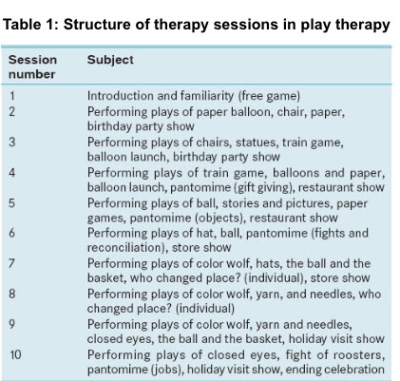

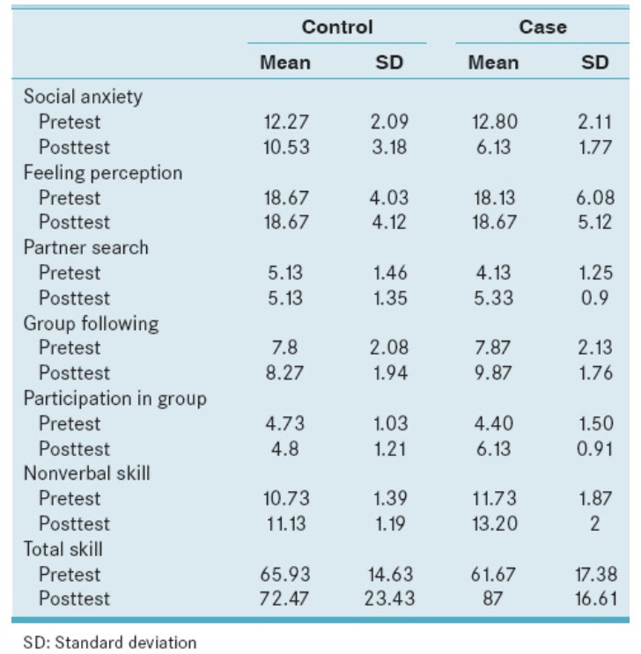
B

C)

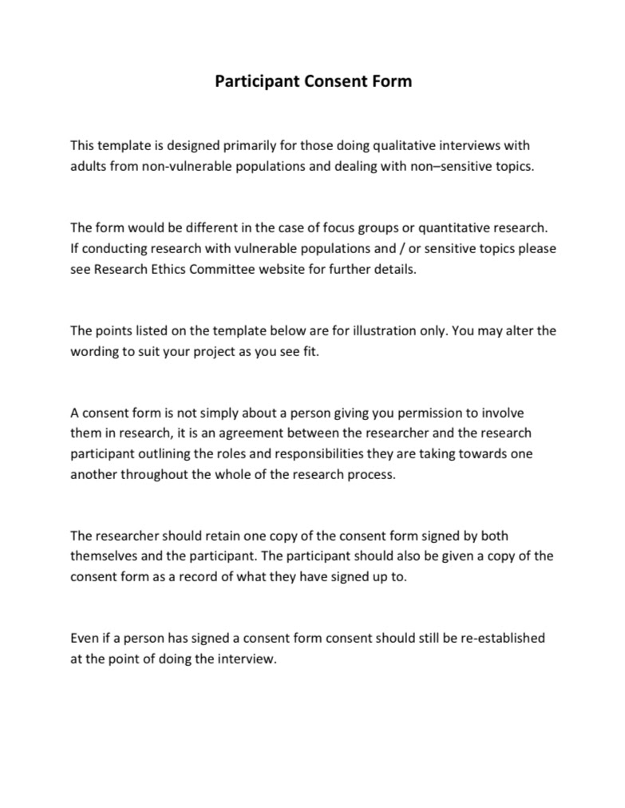

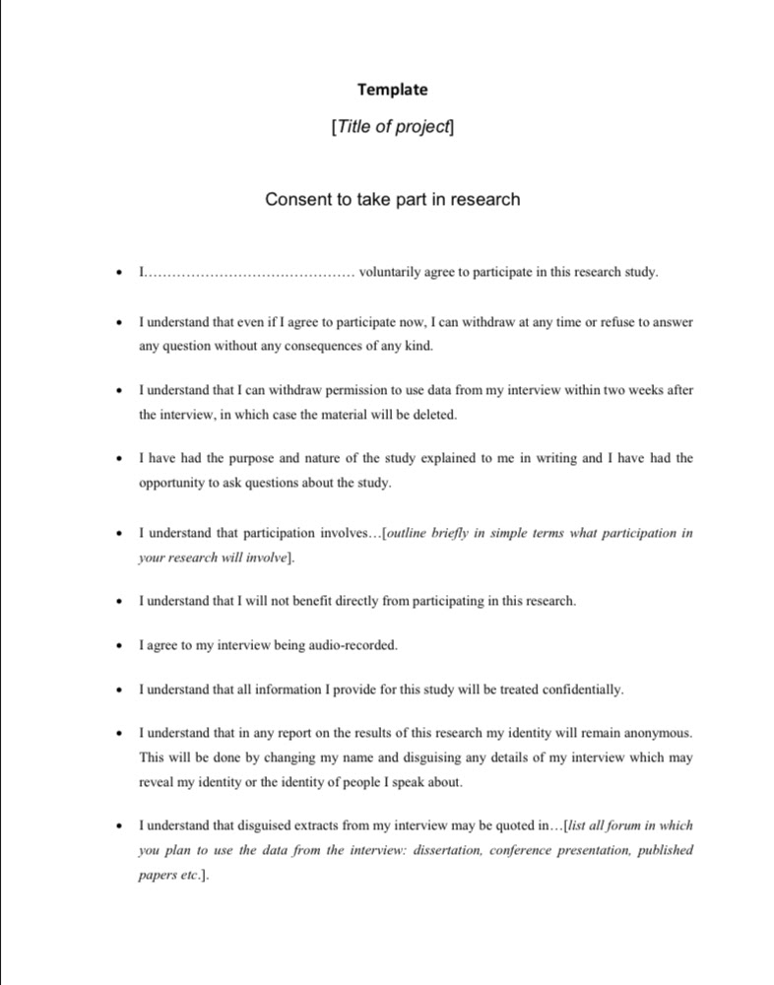

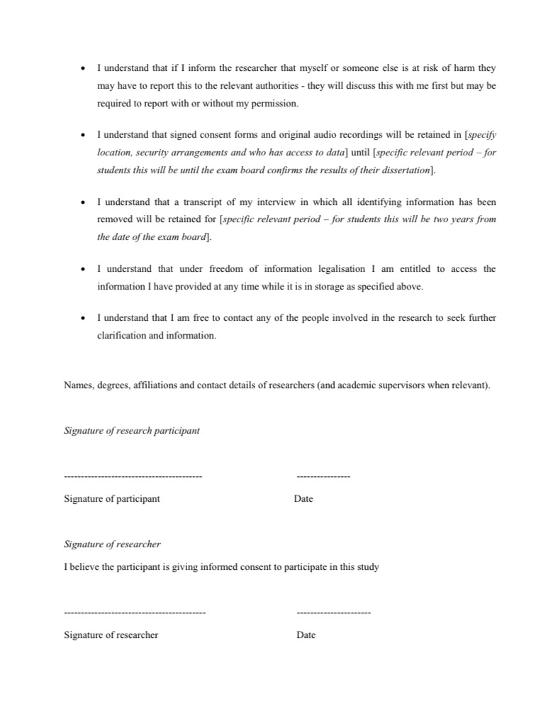
D)


