- Formula Ford
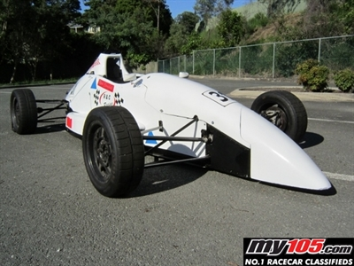  Suspension assignment  Vehicle systems | Callum Evans (1702660)  HND/BSc Engineering

Contents
1.Introduction……………………………………………Page
2.Equipment……………………………………………Page 4
3.WinGeo3 Instructions……………………………Page 5
4.Methodology 1………………………………………Page 7
5.First analysis…………………………………………..Page 8
6.Methodology 2………………………………………Page 9
7.Second analysis……………………………………Page 10
8.Equations……………………………………………Page 12
9.Roll centres …………………………………………Page 14
10.Conclusion………………………………………. Page 16
11.Recommendations for further study…Page 17
12.References …………………………………………Page 18

List of Figures

Figure 1. Picture showing the digital inclinometer used in our investigation
Figure 2. Picture showing the setup of the 2 DTI gauges to measure tow
Figure 3. Picture to show Engineering square being used to mark the edge of the hub onto the paper
Figure 4. Screenshot showing the location of the Formula Ford.GME data file
Figure 5. Screenshot showing the result after opening Formula Ford. GME file in WinGeo3
Figure 6. Screenshot showing the tables created in WonGeo3
Figure 7. Table showing 3-dimesional results obtained in the first workshop session
Figure 8. Table showing calculated tie-rod inclination compared to WinGeo generated figure
Figure 9. Graph to show Toe span VS Ride height
Figure 10. Graph to show camber VS ride height
Figure 11. Screenshot showing roll centres/ locus obtained from WinGeo3
Figure 12. Screenshot showing roll centres/ locus obtained from WinGeo3
Figure 13. Screenshot showing roll centres/ locus obtained from WinGeo3
Figure 14. Screenshot of Microsoft Excel document used to create all tables and graphs

- Introduction

The aim of this investigation is to measure the static ride height of a 1996 Formula Ford single seater race car. The suspension system at the front right-hand side corner of the car Is measured in relation to its co-ordinates. Accurate measurements must be taken using the appropriate tooling and then inputted into WinGeo3. This can then be used to simulate suspension behaviour and find the suspension frequency. Results obtained from the measurements taken from the Formula ford car will then be compared to an accurate software model that has been created with accurate measurements. Tables and graphs will be created to compare the accuracy of the measured suspension co-ordinates against the computer generated WinGeo3 file.

- Equipment
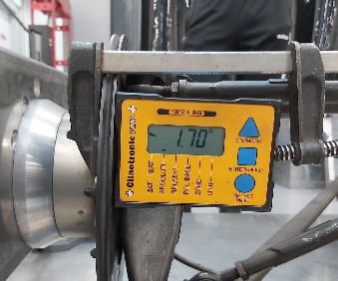
Digital inclinometer
Figure 1
This is used to accurately measure the incline of slopes in Degrees. During the second workshop session, it was used to measure the change in the angle off the steering push rod. (See Figure 1)
Digital height gauge
The height gauge is used to measure the vertical distance from the bench/ground to a chosen point. It is important to zero the height gauge first by setting the scriber end down onto a flat surface and pressing the zero button. During the first workshop this was used to measure the height of Track rod ends and the connection points of the wishbones. In the second workshop session its only use is to measure the wheel height after adjusting the damper length.
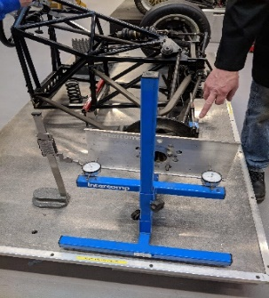
DTI gauge
Figure 2
This is used to very accurately measure the differences in toe. It was only used in the second Worksop session to measure the differences in the toe angle every time the ride height was adjusted. Figure 2 shows how we set up the DTI gauges.
Steel Rule
The rule is used to draw long lines. With the uses of flat squares placed at either end that have been squared off the side of the workbench, one can insure a long square line.
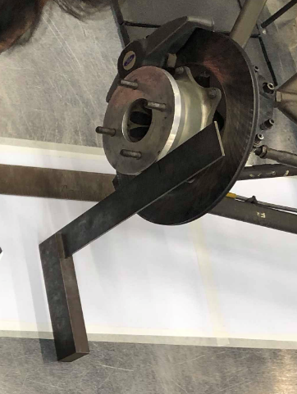
Engineers square
Figure 3
This is used to transfer edges on the suspension system down to the bench where an accurate measurement can be taken (see Figure 3). A flat square can also be used to make sure the engineers square is parallel to the edges of the bench.
Flat Square
Most used in this investigation to crate long squared off lines across the workbench from the straight edges of the bench. Then they can also be used to square up the steel rule and other pieces of equipment allowing one to make very accurate X, Y and Z axis lines.
Vernier Calliper
This is the most important tool for the investigation and can take some practice to read accuracy from it. In the investigation. It’s mostly used for measuring the diameter of track rod end bolts, diameters of hubs and the thread that was used to adjust the ride height of the Formula Ford Car.

WinGeo3
WinGeo3 is a software that creates simulations of car behaviour depending on its suspension characteristics. One can input measured figures into the software and simulations can be run where variables such as ride height can be changed to quickly see how this effects the car. Graphs can then be produced to compare date easily.

- WinGeo Instructions

After opening the WinGeo3 application, navigate to the top left of the screen and click on file, then open. The window shown below should open. Click the Formula Ford Data.GME
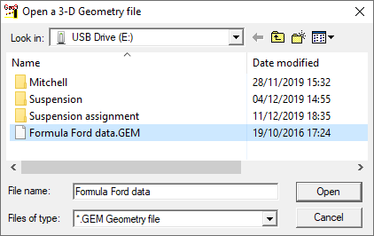

Figure 4
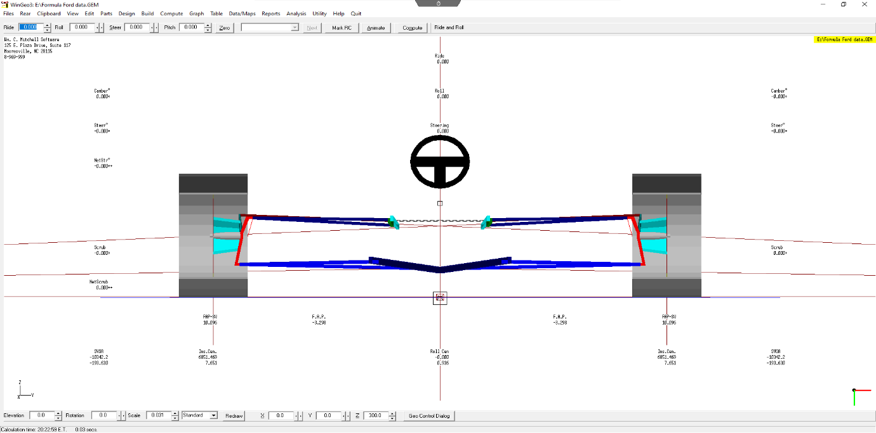
You should then see this which is your Formula Ford car that you worked on in the workshop session
Figure 5

From here you can crate tables by navigating to the ‘Table’ tab at the top of the screen. This is where you will in put your ride height values from 20 to -25mm
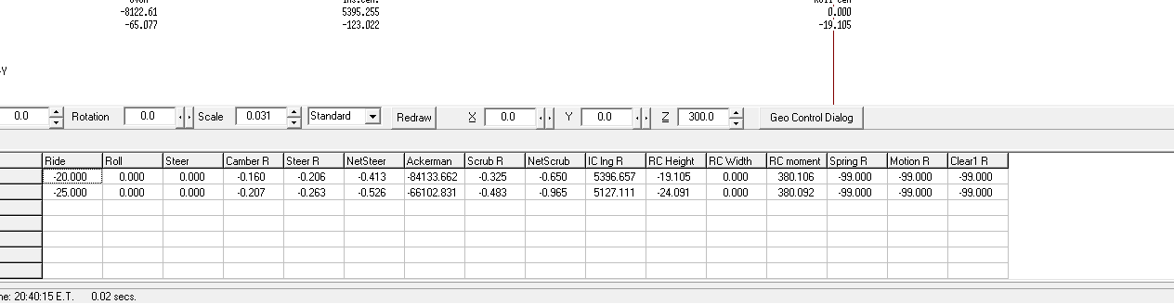

Figure 6
Figure 6 above shows what the tables look like, they show up at the bottom of the screen and can be saved as a separate document to then be put into an excel document to create graphs

- Methodology 1

  - First workshop session
The aim of this workshop session was to measure the X, Y and Z co ordinated for the inner and outer tie rods of the Formula ford car.
- The centreline of the chassis will need to be marked. This will now be the y-axis
- The steering must be put to as close to central as possible. To do this have someone hold the steering wheel steady while someone else measures the steering rack on both sides using a Vernier.
- Once the steering is dead central the steering must be locked in place.
- The wheel hub diameter must be measured then divided by 2
- Mark the edge of the wheel hub down to a secure piece of paper placed on the stand. To do this use an engineer’s square
- Then using the radius of the wheel hub measure in from your point and make another mark with a sharp pencil.
- Use a large flat square and the edge off the flat bench and line it up with the previous mark made.
- Use another square and a steel rule to draw the x-axis
- Use an engineer’s square and position it next to the bolt of the tie rod and measure from here to the surface of the engineer’s square with a Vernier
- Measuring the radius of the tie rod bolt and add it to the pervious measurement
- Transfer the overall length on to the bench/paper by going off from the square
- The distance between the centre of the bolt and the x axis is your x co-ordinate
- Using a rule measure the distance from the y-axis to the centre point of the bolt to find your y co-ordinate
- Using an engineering block that you will have to measure the height of. You will find your z co-ordinate by placing a height gauge on top of the engineering block and measuring the height of the midpoint of the bolt.
- Therefore, the height of engineering block + height measured = z co-ordinate
- This method will have to be repeated on the inner tie rods to measure their relationships to the x, y and z axis
- You can now use there found measurements to find out the steering tie rod inclination
- This information can now be in putted into WinGeo3

- First Analysis

  - 1st Session Analysis
The results from the first session are not accurate. There is a lot of human error due to the in experience of the people taking the measurements. With a lot of people working around a tight space it is easy to accidently move the measuring equipment slightly causing unreliable results. The table the car sits on could get knocked slightly which can upset the measuring equipment such as the inclinometer. Damaged equipment from overuse can also affect accurate results.

Tie Rod Joint Co-ordinates
 | x | y | z
Steering tie rod on hub | -70.901 | 740.501 | 309.53
Steering tie rod inboard | -154.501 | 184.5 | 310.45

Figure 7
Tie Rod Inclination
WinGeo3 (Degrees) | Collected (Degrees)
0.094 | 0.009
Figure 8

Figure 7 shows the collected data from the first workshop session we had. After inputting the figures into WinGeo3, the software calculated the tie rod inclination to be 0.094 degrees. The actual value after putting the inclinometer directly onto the tie-rod of the Formula Ford car was 0.009 degrees. However, when using the inclinometer, it was possible that the bench wasn’t exactly level therefore the tool would not have been zeroed properly.

- Methodology 2

  - Second workshop session

The aim of this workshop session was to measure the sprung and un-sprung mass of the Formula Ford car. Other measurements taken were, wheel height, bump steer toe and camber.
- Begin by replacing the right side in board damper with an adjustable piece of threaded bar.
- Attach a flat plate to the wheel studs and insure it’s a flat surface.
- Place the DTI gauge stand against the flat plate, ensure the gauges are compressed to give out a negative reading
- Fix the inclinometer perpendicular to the brake disk and zero it.
- Find a surface on the piece of flat plate attached to the hub that is parallel to the bed. This is where the height gauge will measure from each time.
- Make sure all equipment is set to zero.
- Take a note in a table of all your starting measurements off all your pieces of equipment
- The measurements you should have will include, DTI A and DTI B, Adjustable Damper Length, Camber and wheel height.
- As someone adjusts the threaded bar 2 whole revolutions each measurement should now be taken
- Repeat the process of turning the adjustable damper 10 times until all data is collected.
- Measure the weight of the unsprang mass by removing all the bots that connect the wishbones, push rod and steering rod to the chassis. Leave the wheel connected and turn it wheel down and place onto a scale. This will be your true unsprang mass.
- Open the FormulaFord.GME file into WinGeo3
- To create a table within WinGeo3 click on ‘Table’ at the top of the screen.
- Then on the drop-down list click on ‘show table’ and a table will appear
- Change your ride height value to 25 and press enter
- Change this value in increments of 5 all the way to -25

- Second Analysis
Figure 9
(Figure 9) Graph to show Toe vs ride Height
The information on the graph show very similar data as expected and they both cross at the origin. However, if everything was perfect then both lines would follow the same trend. Any differences in trends would be down to human error and other factors including the condition of the Formula Fords chassis. For example, any wear in the bolts or the ball joints will affect the measurements.

Figure 10
(Figure 10) Graph to Show camber vs ride Height
The information shown on the graph shows large differences between the trends of the 2 lines. Both lines intersect the origin at the same time but they both curve in different direction. The Car Data line increases at a much faster rate after going through the origin compared to the WinGeo3 line. These differences can be caused from the same reasons as in figure 6. Human error, poor equipment and a deteriorated old vehicle like the Formula Ford can all effect the data.

- Equations

$$\frac{Wheel Height}{Damper Height }=Suspension Leverage$$

$$\frac{57.24}{26.4}=2.17$$

$$\frac{Spring Rate}{2.2}X 9.81 ÷0.0254=Spring Rate in Newtown Meters$$
$$\frac{387}{2.2}X 9.81÷0.0254=67939.69 nm$$

$$\frac{Spring Rate}{Suspention Leverage }=Wheel Rate in Newtown Meters$$
$$\frac{67939.69}{2.17^2}=14427.93$$

Mus = Unsprung mass = 26kg
Ms = Weight of car = 425kg

$$\frac{ms+63}{Each Wheel }-mus=mass each corner-mus$$

$$\frac{425+62}{4}-26=96.75kg$$

$$\frac{1}{2π}\sqrt{\frac{Wheel Rate }{Each corner-Mus }=car frequency }$$

$$\frac{1}{2π}\sqrt{\frac{14472.93}{96.75}}=1.95Hz$$

$$\frac{1}{2π}\sqrt{\frac{Wheel Rate+256000}{unsprung mass }=Wheel Frequency}$$

$$\frac{1}{2π}\sqrt{\frac{14472.93+256000}{26}=16.23Hz}$$

- Roll centres
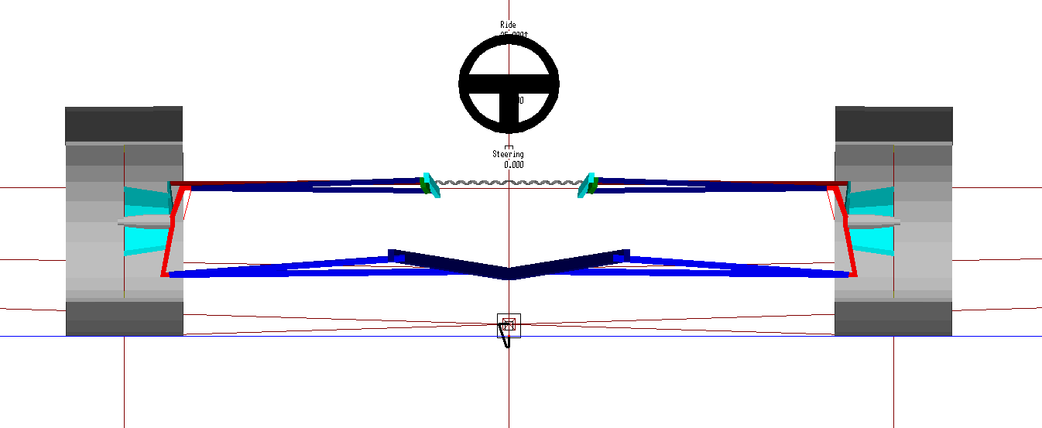
Figure 11
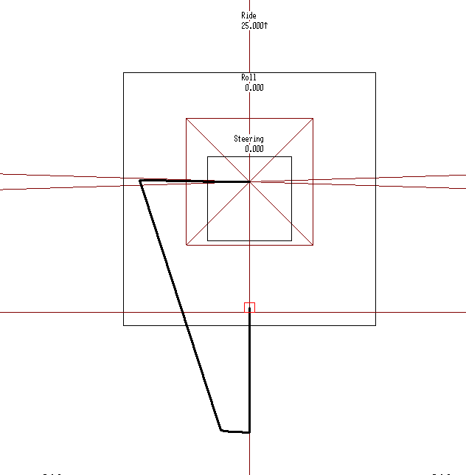

Figure 12

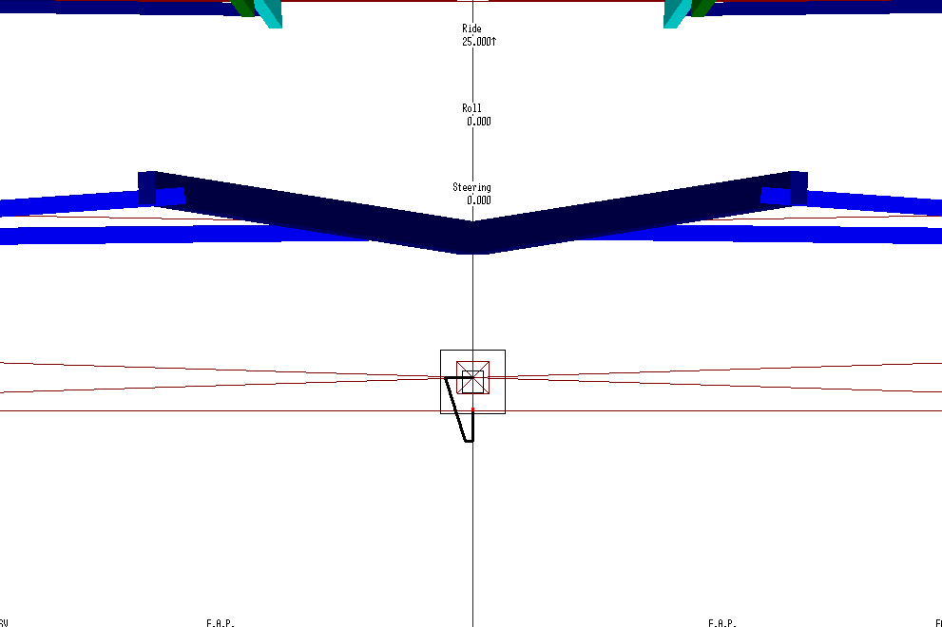
Figure 13

The roll centre is created by uploading the Formula Ford.GME file to WinGeo3. Raise the ride height value to -25 to simulate 25mm of bump. In 0.1-degree increments add 3 degreed making sure to press enter after every value that is inputted. Then input 25mm of rebound and reduce the roll (pressing enter each time) until zero roll and ride height is reached. A locus of the roll centre position will then be produced. This will then show how effective the suspension design is at controlling this parameter.

- Conclusion
During this investigation the main points that were found included, the measured results have not been the same as the WinGeo3 generated data. Calculations such as the Tie-Rod Inclination, camber and toe have proved that there was clearly a problem with either the measurements processes, the equipment or the fact that the Formula Ford car is old and has worn bushes and bolts etc.
Figure 6 shows the inaccuracy of the results because the 2 lines should be following similar trend lines. However, deviation and fluctuation can be seen.
From the calculations the car frequency is less that 2hz which means it is a safe environment to drive in and won’t be hazardous to your health, as anything above 5hz can damage the human organs.
It has been shown in the calculations section that the wheel rate can be found by using the spring rate divided by the suspension leverage.
The investigation has shown how important it is to be accurate when measuring and calculating a suspension system. Any slight error in zeroing or data recording can make a huge difference to results. Also, its apparent that significant temperature change in the worksop can also make a slight difference in results

- Recommendations for Further Study

In future investigations it would be interesting to introduce another single seater race car and compare data. It would be interesting to see how calculations such as Wheel and car frequency with the different total weight and un-sprung mass of the cars.
Changing variables such as the wheel weights and using different materials such as carbon fibre to make the wishbones and steering rods, then see how this would affect the results such as camber and toe would also be interesting.
For further study it would also be beneficial to do some background research on the Formula Ford’s suspension system and other characteristics to get a better understanding of the vehicle

- References

1.Formula Ford Colin . (2001). 1997 Van Dieman Formula Ford . Available: http://www.my105.com/ListingDetails/id/14049. Last accessed 1/12/2019.

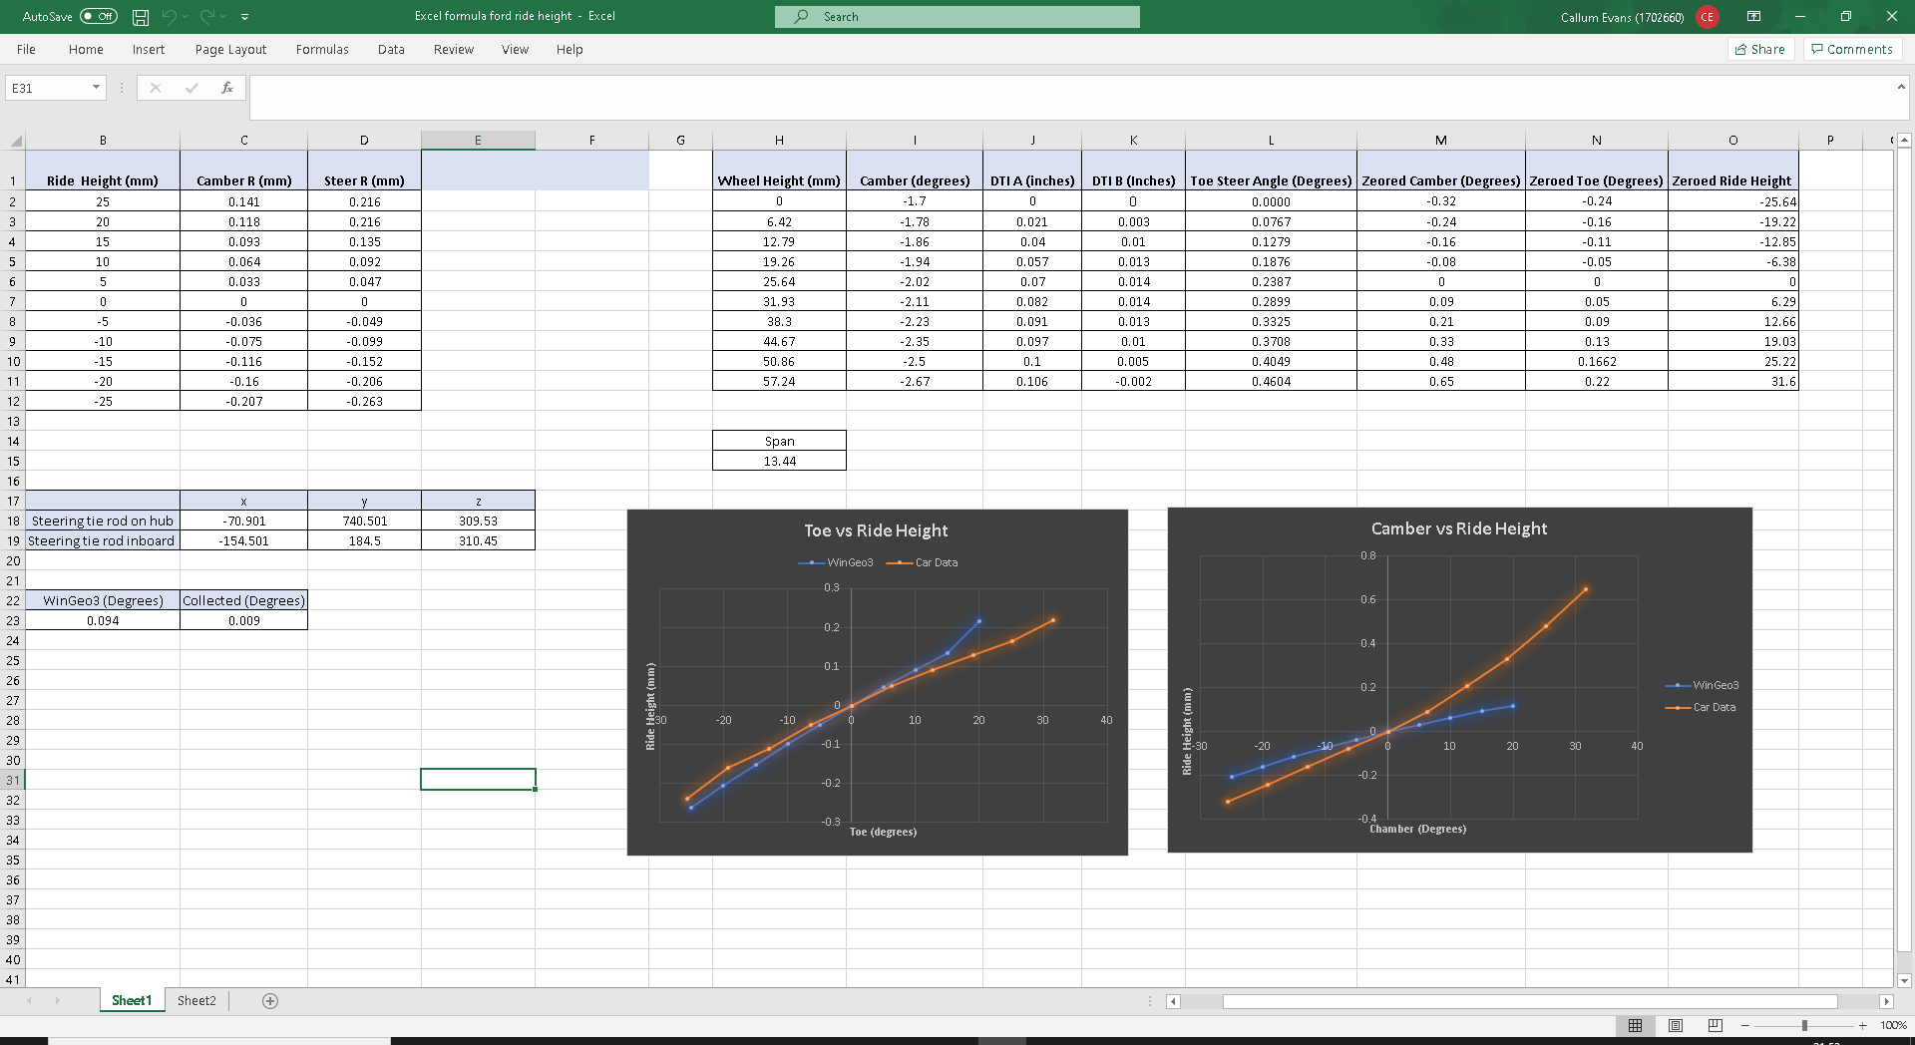
- Appendix
Figure 14

