Name: Colimis Andrei Alexandru
Student number: 2323371
Module Code: ACMA4009 APPLIED ANALYTICS

- Write down the base units for the following:
a) Temperature
b) Luminous Intensity
c) Volume
d) Displacement
e) Time

Answers:
- Kelvin (K)
- Candela (cd)
- Cubic meter (m³ )
- Meter (m)
- Second (s)

- Given that Pressure is defined as;

$$Pressure=Force/Area$$

Write down the base units of Pressure.

Answer:
Pressure is defined as Force/Area. The base unit for Force is Newton, which is equivalent to kg⋅m/s². The base unit for Area is square meter (m²). Therefore, the base unit for Pressure is N/m², which can also be written as kg/(m⋅s²).

- A body of mass 2kg rests in limiting equilibrium on a rough inclined plane, which is at an angle of 45⁰ to the horizontal.

a) Draw a free your answer booklet showing the frictional force, normal reaction and the body diagram in component of weight that acts down the slope.

b) Calculate the maximum magnitude of frictional force.

c) State which of the other forces are equal and give a reason why you can state this without calculation.

d) Calculate the magnitude of the normal reaction to the surface.

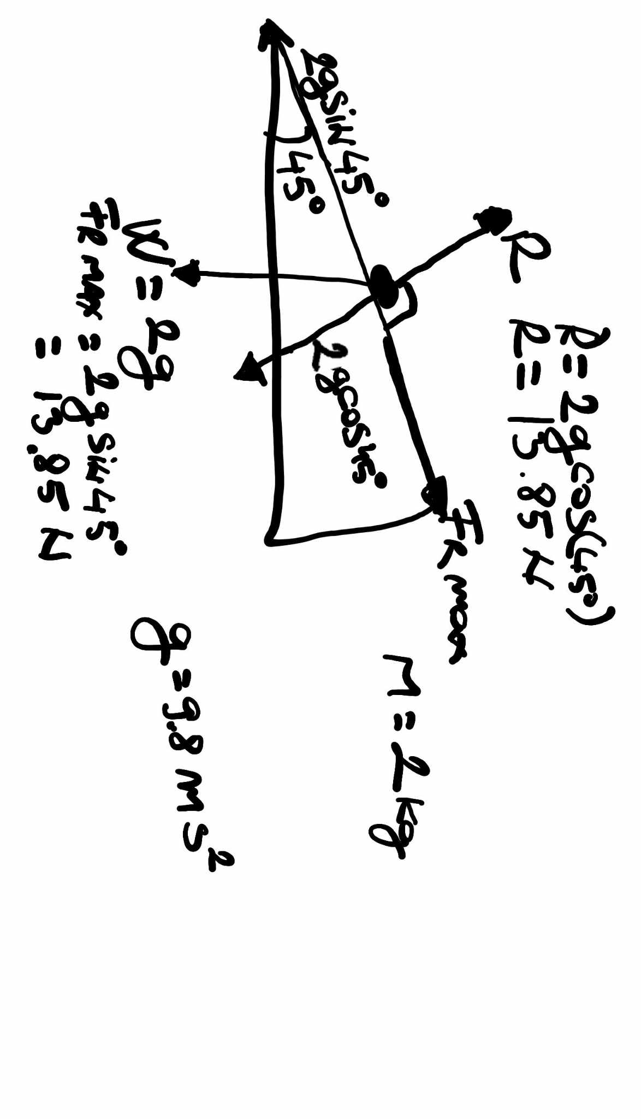
Answers:

In limiting equilibrium on an inclined plane, the following forces are equal:
-The component of the weight force acting parallel to the inclined plane
-The maximum frictional force
Reason:
Limiting equilibrium means the object is on the verge of sliding.
For this to happen, the forces acting parallel to the inclined plane must be balanced.
The component of the weight force acting parallel to the plane pulls the object downwards.
The maximum frictional force opposes this motion.
Since the object is not sliding, these two forces must be equal in magnitude.

4. Solve the following by factorising:

i) $x^{2}-5x+6=0$
ii) $x^{2}+7x+6=0$
iii)$x^{2}+10x=-25$
iv) $x^{2}-2x-15=0$
v) $2x^{2}+3x+1=0$

Answers:

a)
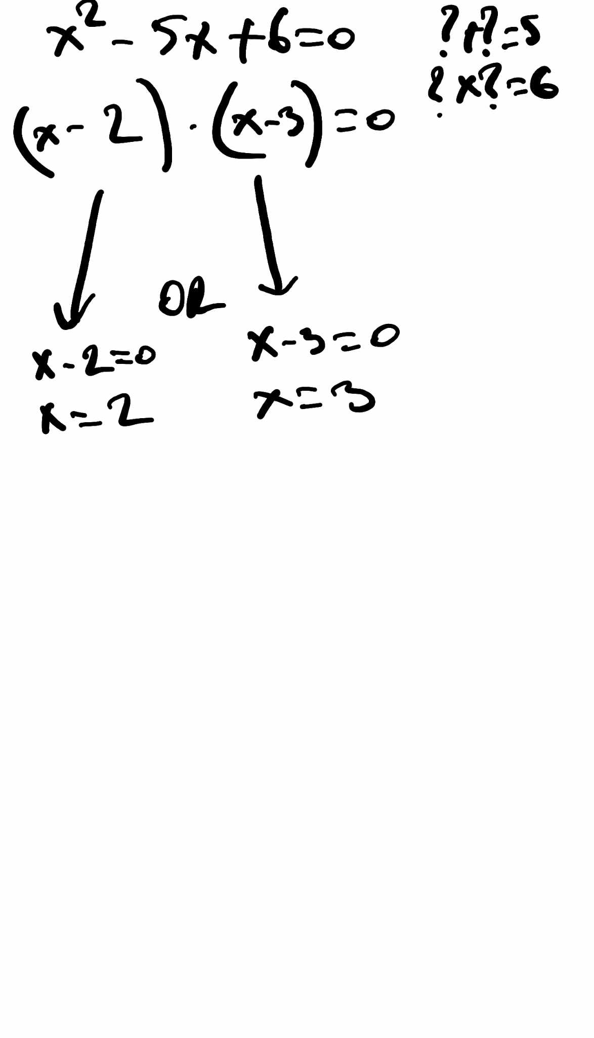

b)
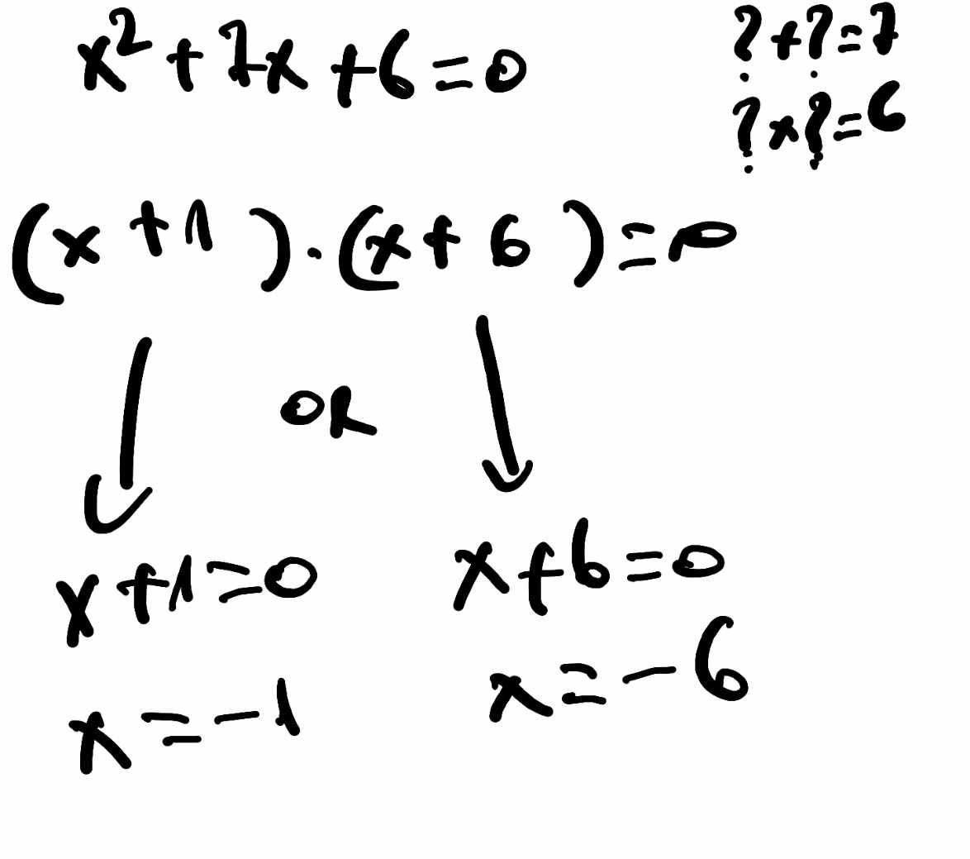

c)
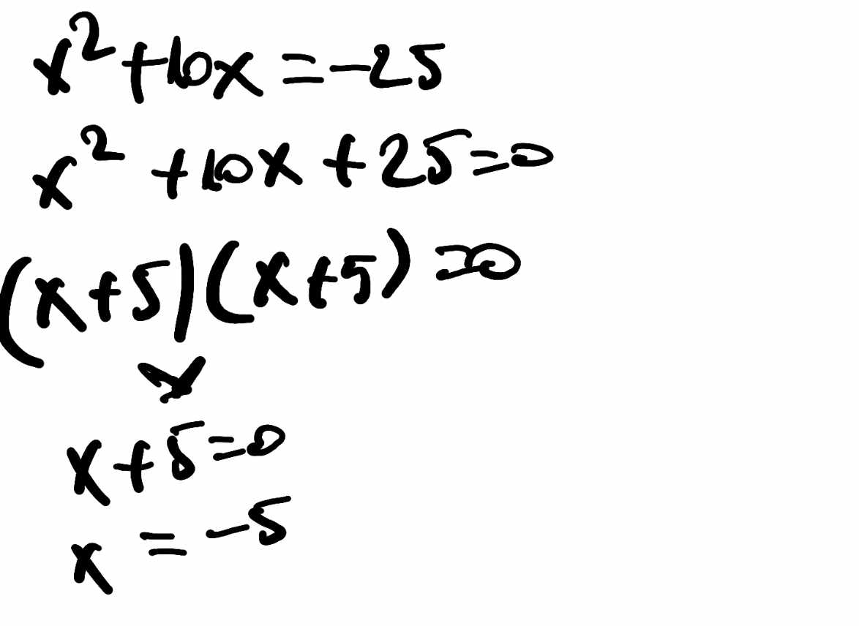
d)
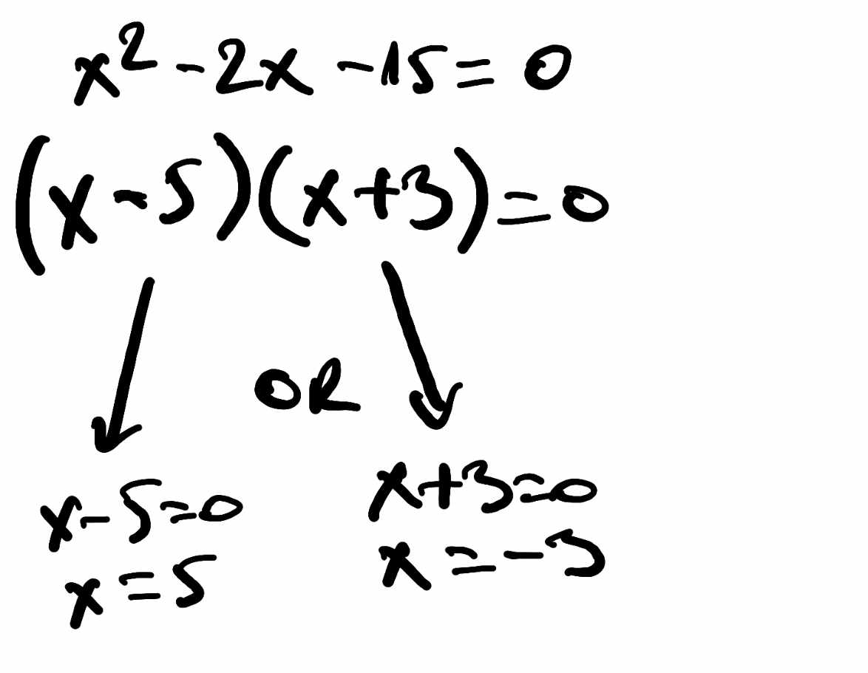

e)

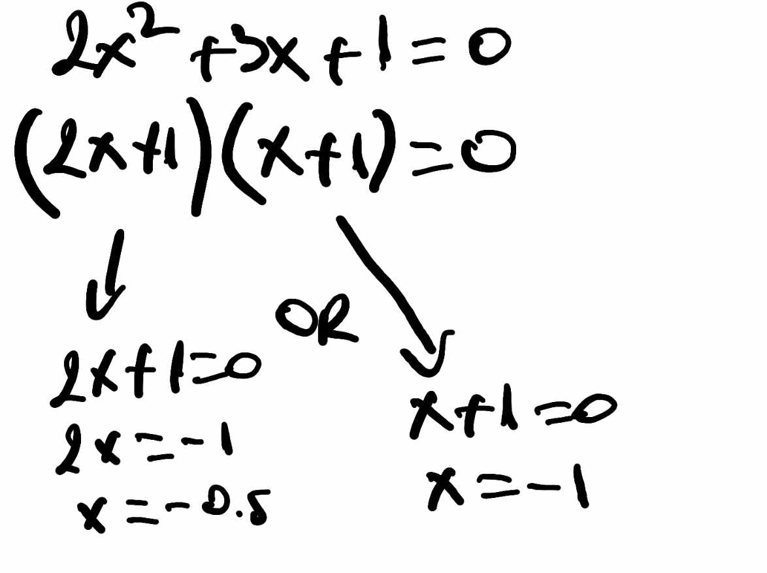
5. Solve the following (to 2d.p’s) by using the quadratic formula:

- $x^{2}-4x-1=0$

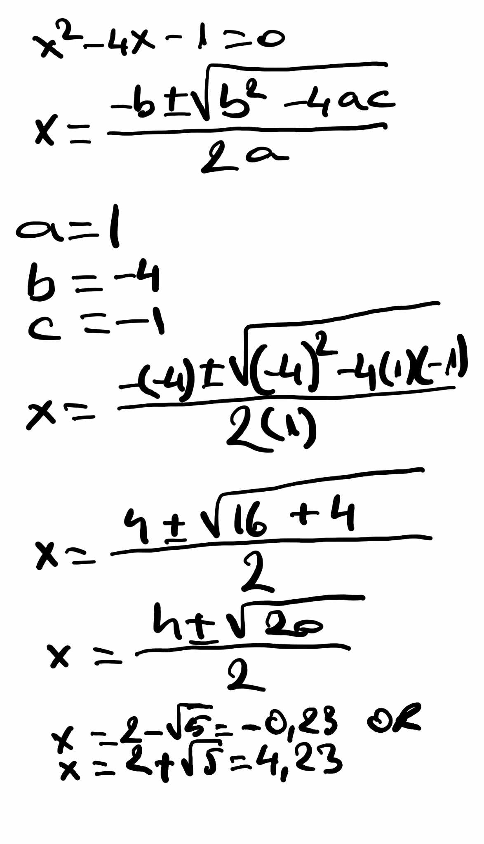
b) $2x^{2}+3x-1=0$
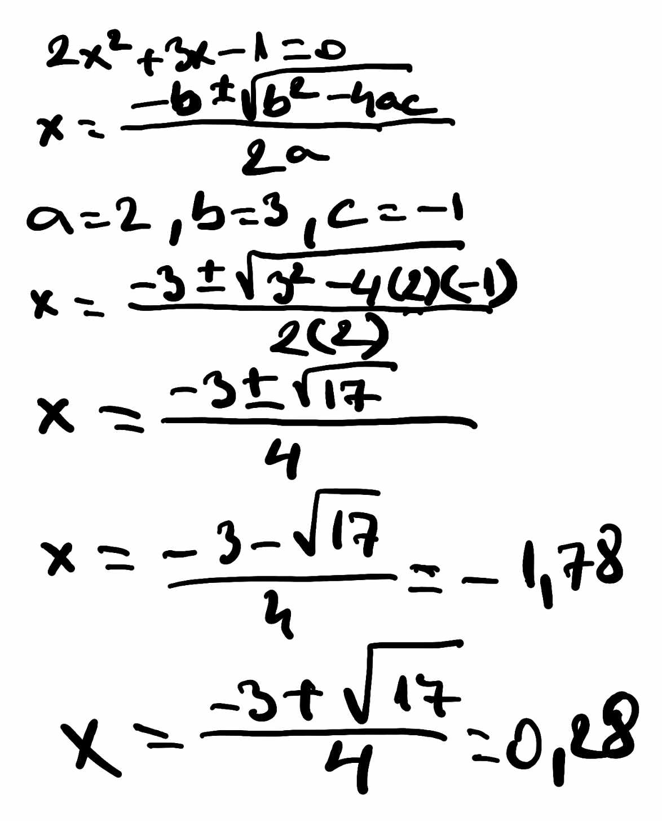

6 Solve the following equations

- $\frac{3(x-1)}{2}=.\frac{x+2}{4}$

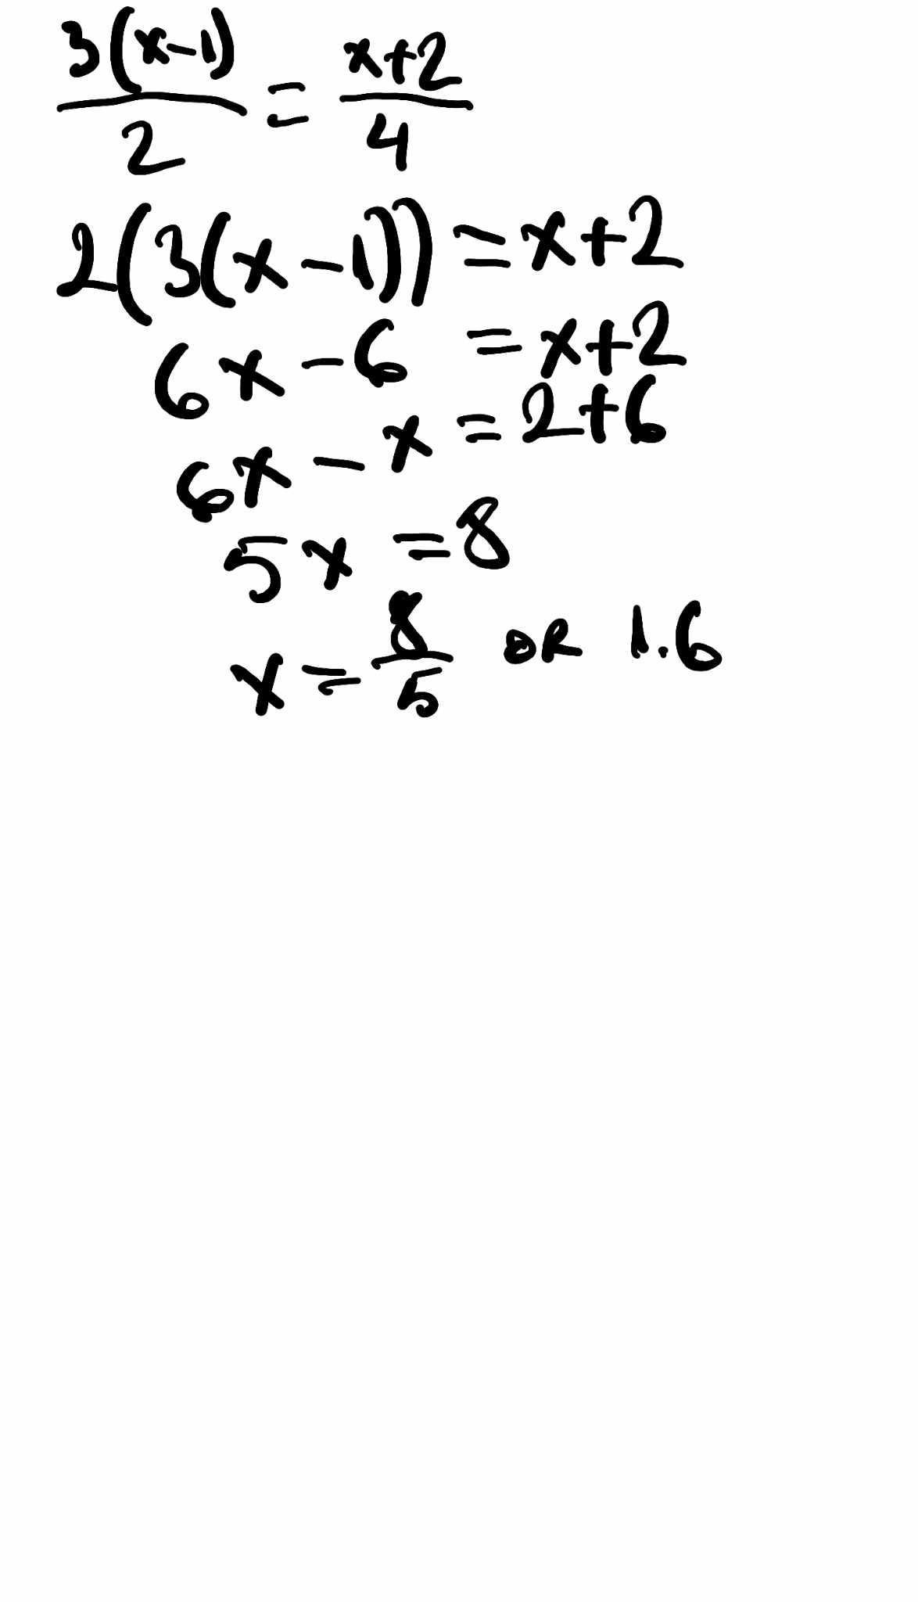

b) 2x + 5y = 7
3x + 2y = 5

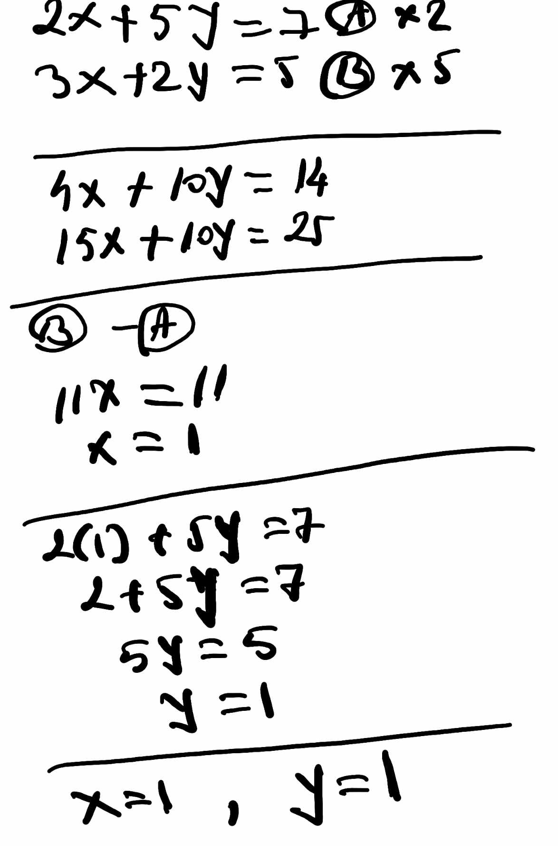

7. For the following electrical circuit :

Find:

a) The total resistance of the circuit
b) Current I₂ in the branched circuit.
c) The power supplied by the cell
 

