8/3/2020
Jennifer Clark
1909864
A Case Study Based on Blaenavon.

BMSP4005
Jessica Shore

This assignment will be split into two parts.
Part A will focus on the town of Blaenavon, the history of the town and the possibilities of regenerating and improving certain sectors to encourage tourists to the area. Interest will be paid into what makes Blaenavon historically unique, the past, present and future developments within the town. Mention will be given to what Stakeholders are, and who they are in support of Blaenavon.
Part B will pay focus on regeneration ideas for Blaenavon; potential future developments which could increase revenue within the town, improve the community for the local residents. Evidence supporting this appraisal will be referenced within Part B.

Introduction/ Part A
The town of Blaenavon lies in a rural part of the Valleys in South East Wales. Blaenavon was granted National Heritage status in the year 2000, by UNESCO (Blaenavon 2020, 2020).
The main history of the town dates back to the 1770’s when Blaenavon became hosts to its own Ironworks which then led on to the opening of the coal mines, quarries, a railway which was used to transport goods across the UK. The town quickly became a prominent landmark in the 19th Century during the industrial revolution, with the whole community involved in these industries in one way or another. Mining communities were built within the town to accommodate all of its workers to maximise production in the town (UNESCO, 2020).
With Blaenavon itself, there are several historically important landmarks:
- The Ironworks- In 1789 Sidney Gilchrist Thomas revolutionised the steel industry by using steam to power the blast furnaces which were at the Ironworks to remove Phosphorus from Iron Ore. This was a major break through in the iron and steel industry during this period and this led to the expansion in production in Blaenavon.
- The Big Pit and National Coal Museum- Once fully operation, the Big Pit coal mine which operated 300 feet underground and opened in 1860, ceasing production in 1980. This historical landmark now operates as a prize-winning history tour and mining experience, allowing visitors to descend 300 feet below into the mines. Also on site visitors can take a tour around the National Coal Museum. Exhibiting genuine mining artifacts and simulation recordings of the miners throughout their working day (Atlas Obscura, 2020).
During the Industrial Revolution, Blaenavon’s population grew due to the high employment demand at Big Pit, Ironworks and other businesses. The town expanded during its peak in 1947 to 12,500 residents. Based on figures published in the 2014 Blaenavon Statistics and Census, it is believed that the population has fallen below half and was recorded as 6055 residents (PSSU Research Team, 2014).
The historical sites in Blaenavon reside on the outskirts of the town, this in turn has an impact on the economy and business potential within the town. With the mining community spirit still strong within the town, the residents are used to a certain way of life. As the years have gone on, the town itself has become run down and businesses collapsing due to loss of income and lack of investments. At the towns lowest they saw an estimated 75% of its buildings boarded up. The historical developments in Blaenavon are funded and maintained by its National Heritage Site status. The town has received a massive £8.7million in National Lottery Funding to restore the town to its former glory by restoring and renovating store shop fronts, restoring the towns chapel- Bethlehem Chapel so this can be used by the local community, creating a sense of togetherness and re-establishing residents’ faiths. In the centre of the town tourists and residents can visit the Blaenavon World Heritage Centre, this can be found in what was the former local school, St Peter’s school. The centre provides the community with access to a library, café, tourist information centre and up to date conference room facilities (Trustees of the National Heritage Memorial Fund (a), 2019).
Residents have since been visited by the National Lottery Funding committee to see how they feel the funding and development in Blaenavon has gone. One fairly new resident of the town Professor John Hunt who is an active member of the Bethlehem Chapel is quoted as saying “Playing The National Lottery is not just about filling a little tick on a piece of paper in the hope you might win something. You’re doing great stuff. You’re helping communities grow.” ( Trustees of the National Heritage Memorial Fund (b), 2019).
Playing an active part in the community Martha Meridith, a young resident of Blaenavon expresses the importance of family and the sense of community which is present within the town and she is a member of the towns HWB project- project funded by the National Lottery. This project is based on exploring the history and diversity of the town ( Trustees of the National Heritage Memorial Fund (c), 2019).
In 1895 the town opened the Blaenavon Workmen’s Hall. This became an integral part of the community and still is today. The large auditorium building was funded and maintained by the workers of the town; this created a sense of togetherness as it did not belong to anyone person in particular. Within the building, the workers and their families had access to a library and reading rooms, a games room where they could play snooker and billiards. A ‘picture dome’ or cinema provided everyone with entertainment and recreation. The workers wives would gather there during the day and once the working men had finished their shift in the mines, they would meet at the workmen’s hall to socialise and unwind. This sense of community is still strong within Blaenavon, ex miners who still reside in the town gather together along with their families and other residents (Blaenavon Workmen's Hall (a), 2020).
Another vital aspect to towns and businesses are Stakeholders. A stakeholder is defined by (Cambridge University Press, 2020) “a person such as an employee, customer, or citizen who is involved with an organization, society, etc. and therefore has responsibilities towards it and an interest in its success”. Managing a site such as Blaenavon with vast historical relevance, takes time, investments and innovation. A collaboration was formed within Blaenavon called Blaenavon World Heritage Site Partnership. These are individual organisations or individuals that have invested in the town in one form or another. Alongside the World Heritage Site Partnership, Blaenavon also has stakeholders. Collectively the Blaenavon stakeholders established the ‘Commons Forum’ thus enabling efficient and effective contact between themselves and the wider community. The Stakeholder map would look typically look like the (diagram A) pictured below:
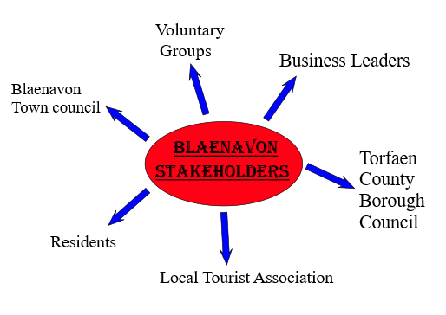Diagram A.
The Stakeholders would gather and communicate on a regular basis to discuss each other’s ideas and thoughts about the town. Input is also welcomed from the wider community, the more input into the forum, the better the chances of people wanting to visit, live, work and make investments into the town (UNESCO- World Heritage Convention (a), 2020).
According to (UNESCO- World Heritage Convention (b), 2020) there are 24 Scheduled Ancient Monuments and 82 structures or building which are listed as being of historical interest or Special Architectural in Blaenavon. The main buildings and or monuments are owned by the public that reside in Blaenavon. This, alongside the other historical attractions such as the Big Pit and the Ironworks, makes Blaenavon rather unique. Through local and national advertising and investments, promoting these attractions and artifacts could have the potential to attract more visitors to the town as well as to the outskirts where the main attractions sit. This would enable Blaenavon to once thrive again.

Part B
The term Regeneration is defined as “to improve a place or system, especially by making it more active or successful” (Cambridge University Press (b), 2020). Once a town becomes less appealing to visitors and residents, investments made into the town can become less and the population could gradually start decreasing, with custom and residents relocating elsewhere. Regeneration projects can boost and rejuvenate a town which can make it more appealing to investors and the general public, bringing back revenue and custom, in theory boosting the community from within too, having happy residents and business owners will have a positive impact on individuals that are visiting the area. Therefore, encouraging income into the town.
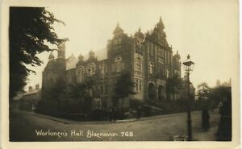 Workmen’s Hall, Blaenavon- 1920 (yorkshirebidding, 2020)
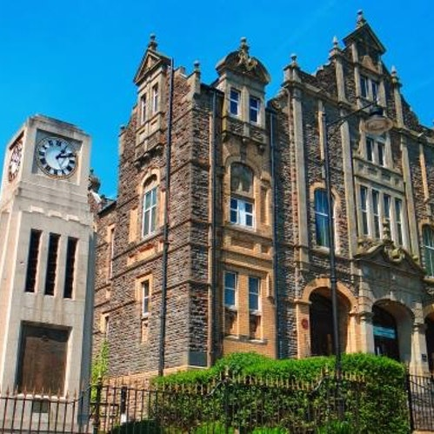

Workmen’s Hall, Blaenavon- 2020
(ENTS24 LTD, 2020)

As shown in the pictures above, the Workmen’s Hall has been maintained and restored to a high standard. This building is still an integral part of the community. The Workmen’s Hall have a dedicated Facebook page, which keeps the public up to date with social events and any other news. On the 11th July 2020, this statement was published:


Blaenavon Workmens Hall
11 July ·
Hello followers.
An update from Blaenavon Workmen’s Hall in the light of the Minister’s announcement yesterday with regard to cinemas.
We have been successful in gaining funding to cover a substantial amount of work to make our beloved building safe and and upgrade some of the areas that badly need some TLC.
This work will take some months, and the Board of the Hall has decided to keep the building closed to negate any health and safety risk to the public as it is carried out.
This will certainly take us to the later months of this year, and potentially into 2021.
There is a Board meeting on Tuesday to further discuss this and the information that we have received via TCBC.
We will keep you updated as soon as we can, and continue to provide updates as the work commences.
Our beautiful building deserves only the best, and it’s well overdue 😊

(Blaenavon Workmen's Hall, 2020)

With this injection of funding into the Workmen’s Hall, this is a great opportunity to generate publicity for Blaenavon and its residents. One regeneration idea for the town could be to celebrate the reopening and renovations on the Workmen’s Hall, is a miner’s and their families Reunion festival weekend. A chance for Blaenavon to come alive again, bring people together and strengthen the sense of community within. The historical landmarks which reside at Blaenavon are something which need celebrating and remembering how it used to be. The sacrifices which were made by the miners and their families. This could be an event in which all resident’s young an old could get involved with. The local youth group could run a cake and traditional welsh food stall. The local school could involve the younger generation by incorporating Blaenavon’s past into their history sessions and could present a history enactment in the town but also at the Big Pit. Back in the day when the Big Pit was fully operational, not only did men of all ages work in the mines, but there was also a substantial amount of children some as young as 5, not in education but working in the mines in the dark, the were keepers of mine doors to maintain the oxygen flow below ground, this was a dangerous job for children they would spend up to 12 hours on their own in dark tunnels and unfortunately many suffered injuries. The use of child labour was banned under the Coal Mines Regulation Act on 4th August 1842 (National Museum Wales, 2020). This would be a fantastic opportunity for children of all ages to delve into what some of the resident’s youth was like in comparison to theirs today. Accommodation could be made available and it would be something that residents and former workers could organise for ex miners who no longer live in Blaenavon but would like to stay for the whole reunion. These could be discounted rooms in local bed and breakfasts with possibly the discount being donated to the maintenance of the town’s historical attractions. This could encourage spending within the town. Events could be organised inside the Bethlehem Chapel and the Workmen’s Hall such as a miner’s bingo session, with mining words used instead of the convention ‘line’ ‘house’ ‘bingo’. A dance evening featuring different Era’s throughout the mining period could be held in the auditorium inside the Workmen’s Hall, attendees could be encouraged to dress in periodic clothing and partake in traditional dances for example the Foxtrot, the Waltz, Swing Dancing and so forth. Being actively productive, Blaenavon Partnership and Stakeholders could use the time while the Workmen’s Hall is undergoing renovations to organise and advertise locally and nationally. A small admission fee could help cover the costs of advertising. With the main income being made within the town itself.
Another idea which could aid in the regeneration of Blaenavon and attract visitors into the town itself is by linking the historical attractions which begin on the outskirts of the town, to one another via some sort of tram or park and ride. This would take quite a large investment, but one which could be greatly beneficial to the town and its historical relevance. The Big Pit is located overlooking the town, high upon the hill. There is sufficient amount of parking for people visiting the Big Pit, History Museum and Ironworks. A guided tour around Blaenavon would interest all ages and depending on the specific experience requested, costs would be covered by booking fees. Private tours of the mines and experience days could bring in revenue for the Big Pit. Special event days and guest speakers (ex-miners, ex residents) could share their own experiences. The Big Pit employs residents of or around Blaenavon and some of these employees were actual miners before it ceased production in 1980. As depicted in the picture below, this is a map of Blaenavon and the surrounding area. A dedicated route in and around Blaenavon could be formed. Residents and youths of Blaenavon could be employed and the passion and town spirit could once again be reignited. The World Heritage Site attracts nearly half a million visitors to the area per year, if the visitors could be attracted from the Heritage Site overlooking the town, down into the town, businesses within Blaenavon could once again thrive. Almost a fifth of employed residents in Blaenavon are in manufacturing. According to (Torfaen public service board, 2017) in the ‘What is not so good about Blaenavon’ section of their publication they have outlined some of the following issues regarding the social, economic, environmental and cultural well-being factors:
- Relatively isolated compared to other Torfaen settlements
- Dependent on adjacent settlements for range and supply of many goods and services
- A fifth of residents are income deprived
- Anti-social behaviour significantly higher
- Higher levels of residents with no access to a car or van
As shown in the picture below, the area of Blaenavon is quite vast and without adequate transport links, parts of the town can be isolated and forgotten about, residents without transport are at quite a disadvantage. A transport link through the town, engineered for the locals and visitors and manufactured by employing locals would hugely benefit the town. Applications for funding and support could be made via the appropriate channels such as Welsh Government Grant Scheme, National Lottery Funding and through local fundraising and support generated via social media.
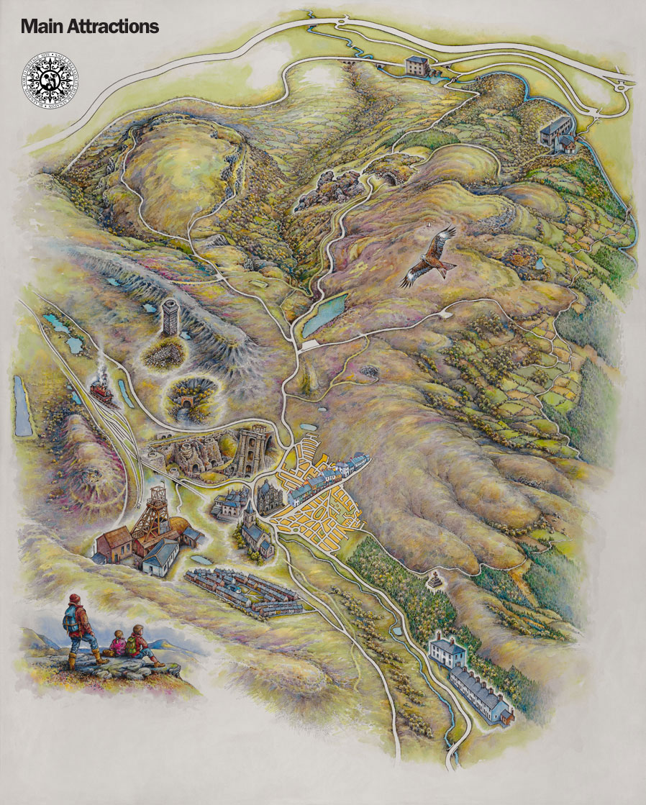
(World Heritage Site, 2020)
In conclusion to this case study of Blaenavon, the importance of the historical relevance has been highlighted throughout. Blaenavon, a World Heritage Site plays homage to the public who made the town what it is. A community brought together through hard work and sacrifice. The town booming and at its peak being during the Industrial Revolution. A period in time which saw productivity and community spirit at its highest. A town today, which has come together in support, to maintain and restore the historical structures and by doing so, keeping the memories alive through the preservation of genuine artifacts and storytelling through the generation. Although Blaenavon is thought to be economically disadvantaged in comparison to elsewhere in the Torfaen area, there are many regeneration possibilities some of which have been outlined in this report. Economic and Welfare issues have been identified by official channels with the purpose of acknowledging improvements are needed and in which areas. With the correct planning and organisation, Blaenavon has the potential to thrive again once more. The mines may remain inactive, but the memories will live on through every person who indulges and takes the 300-foot plunge below. Taking a guided tour by actual miners, who send you back in time through their depiction of times gone past. The Workmen’s Hall renovation and the injection of the National Lottery Funding to the area will all have a positive impact on the towns alongside its residents and visitors.

References
Trustees of the National Heritage Memorial Fund (b). (2019, September). 25 years: voices from Blaenavon. Retrieved from Heritage Fund: https://www.heritagefund.org.uk/news/25-years-voices-blaenavon [Accessed 03/08/2020]
Trustees of the National Heritage Memorial Fund (c). (2019, September). 25 years: voices from Blaenavon. Retrieved from Heritage Fund: https://www.heritagefund.org.uk/news/25-years-voices-blaenavon [Accessed 03/08/2020]
Atlas Obscura. (2020). Big Pit National Coal Museum. Retrieved from Atlas Obscura: https://www.atlasobscura.com/places/big-pit-national-coal-museum [Accessed 03/-8/2020]
Blaenavon 2020. (2020, August). Blaenavon World Heritage Site. Retrieved from Visit Blaenavon: https://www.visitblaenavon.co.uk/en/VisitBlaenavon/Visit-Blaenavon.aspx [Accessed 04/08/2020]
Blaenavon Workmen's Hall (a). (2020, August). History. Retrieved from Blaenavon Workmen's Hall: https://blaenavonworkmenshall.uk/ [Accessed 04/08/2020]
Blaenavon Workmen's Hall. (2020, July). Blaenavon Workmen's Hall. Retrieved from Facebook: https://www.facebook.com/BWMHDC/ [Accessed 04/08/2020]
Cambridge University Press (b). (2020, August). Definition of Regeneration. Retrieved from Cambridge Dictionary: https://dictionary.cambridge.org/dictionary/english/regenerate [Accessed 03/08/2020]
Cambridge University Press. (2020, August). Dictionary . Retrieved from Cambridge Dictionary: https://dictionary.cambridge.org/dictionary/english/stakeholder [Accessed 03/08/2020]
ENTS24 LTD. (2020). Blaenavon Workmen's Hall events. Retrieved from ENTS24: https://www.ents24.com/blaenavon-events/blaenavon-workmens-hall [Accessed 04/08/2020]
National Museum Wales. (2020). Children in Mines. Retrieved from National Museum Wales: https://museum.wales/articles/2011-04-11/Children-in-Mines/ [Accessed 04/08/2020]
PSSU Research Team. (2014, December ). Torfaen Local Service Board. Retrieved from Blaenavon Town: https://www.torfaen.gov.uk/cy/Related-Documents/Research-and-Citizen-Engagement/Statistics-and-Census-Information/Blaenavon-Town.pdf [Accessed 04/08/2020]
Torfaen public service board. (2017, March). Blaenavon Well-Being Inforgraphics . Retrieved from Torfaen public service board: http://www.torfaenpublicservicesboard.co.uk/en/Documents/Assessment-of-Well-being/Part-2-Well-being-of-Blaenavon-and-its-communities.pdf [Accessed 04/08/2020]
Trustees of the National Heritage Memorial Fund (a). (2019, Septemeber). 25 years: restoring the prosperity and pride of Blaenavon. Retrieved from Heritage Fund: https://www.heritagefund.org.uk/news/25-years-restoring-prosperity-and-pride-blaenavon [Accessed 03/08/2020]
UNESCO. (2020, August). Blaenavon Industrial Landscape. Retrieved from United Nations Educational, Scientific and Cultural Organization : https://whc.unesco.org/en/list/984/ [Accessed 03/08/2020]
UNESCO- World Heritage Convention (a). (2020). Protection and management requirements. Retrieved from World Heritage Convention: https://whc.unesco.org/en/list/984/ [Accessed 03/08/2020]
UNESCO- World Heritage Convention (b). (2020, August). World Heritage Convention. Retrieved from United Nations Educational, Scientific and Cultural Organisation: https://whc.unesco.org/en/list/984/ [Accessed 03/08/2020]
World Heritage Site. (2020). Explore Blaenavon. Retrieved from Visit Blaenavon: https://www.visitblaenavon.co.uk/en/Maps/main-attractions.html [Accessed 03/08/2020]
yorkshirebidding. (2020, August). Blaenavon. Workmen's Hall # 768 by Viner & Co. Retrieved from Ebay: https://www.ebay.co.uk/itm/Blaenavon-Workmens-Hall-768-by-Viner-Co-/392532919280 [Accessed 04/08/2020]

