Women through crisis: The relationship between
female artists, ‘Mother’ nature and our future climate.
By Esme Littlechild

Student number: 2103253
Module: Independent project – ADAA6000
Supervisor: Dr Estefani Bouza Arnoso
Submission date: 2nd January 2025
Word count:
Submitted in partial fulfilments of the requirement for the degree of BA (Hons) Documentary photography, University of Wales Trinity Saint David, Swansea.

Contents

Illustrations………………………………………………………………. Pg. 2

Abstract…………………………………………………………………... Pg. 3

Introduction………………………………………………………………. Pg. 4

Chapter 1- The Ecofeminist movement………………………………. Pg. 5

Chapter 2- Interconnected………………………………………………Pg. 9

Chapter 3- Community…………………………………………………. Pg. 24

Conclusion………………………………………………………………...Pg. 28

Appendix…………………………………………………………………. Pg. 31

References………………………………………………………………...Pg. 26

Bibliography…………………………………………………………….... Pg. 34

List of illustrations

Figure 1. NASA (2023). Global land- ocean temperature index. Available at: https://climate.nasa.gov/vital-signs/global-temperature/?intent=121. Accessed: (3rd November 2024).

Fig. 2. Mendieta, A. (1976) Untitled (from the Silueta Series), Mexico. The Estate of Ana Mendieta Collection, Courtesy Galerie Lelong, New York and Paris and Alison Jacques Gallery, London. Available at: https://www.galerielelong.com/news/ana-mendieta80. Accessed: (3rd November 2024).

Figure 3. Körner, S and Bellin-Harder, F. (2007). The 7000 Eichen of Joseph Beuys – experiences after twenty-five years. Journal of Landscape Architecture. https://www-tandfonline-com.ezproxy.uwtsd.ac.uk/doi/pdf/10.1080/18626033.2009.9723418. Accessed: (16th November 2024).

Figure 4. Ackroyd, H and Harvey, D. (2021). Beuys’ Acorns. Tate Modern, London. 4th May- 14th November 2021. Available at: https://www.ackroydandharvey.com/beuys-acorns-tate-modern/. Accessed: (13th December 2024).

Figure 5. Black, S and Ginsburg, A (2017-2018). 7000 Marks, Ohio. Available at: https://www.sarablack.org/7000-marks/. Accessed: (16th November 2024).

Figure 6. Littlechild, E (2023) Wildflowers. Comma exhibition, Swansea college of art. 25th-30th April 2023.

Figure 7. Littlechild, E (2024) Wildflowers. Comma exhibition, Swansea college of art.

Abstract

This autoethnographically essay analyses the impact that the climate crisis has conveyed on the relationship between women and nature depicted through female visual artists, further addressing how we can repurpose our connection to nature and create climate action. Urgency in our next steps in preserving our environment determine our futures stability, visual art successfully portrays this emergency through multiple forms discussing the impacts on humanity, especially women. Through analysis and research of ecofeminism, the Anthropocene and the health of the planet today the essay creates a tool of navigation to be used to evoke societal change.

Climate change is fundamentally the defining crisis of our lifetime, in a world of hyper connectivity and technological dependency we are increasingly disconnecting and disregarding our relationship with nature as a society. While this is a universal issue, women are most impacted as ‘an estimated 4 out of 5 people displaced by the impacts of climate change are women and girls’ (United Nations, 2022). As a female visual artist, it is imperative in today’s climate to readdress women’s relationship with ‘Mother nature’ through the medium of art, as it can formulate ways to repurpose and reappraise how we interact with the environment moving forward. Our current sociopolitical climate reflects the demand for action, with the impeding ‘Project 2025’ implemented by President Elect Donald Trump and reinforced by the millions of American Republicans who voted for him, claiming control over women's autonomy through the overturning of abortion rights in the Roe v. Wade legal ruling. Also, the boosting of oil and gas companies for economic profit, significantly reversing climate aims and oppressing women systemically. Evidently, there is a need for drastic change which this autoethnographical essay will seek to discuss through visual art the relationship between women and nature depicted by female artists, and what is needed to be done in the future to navigate and reinforce climate action.
Defining this firstly in chapter one, which will discuss the evolution of the ecofeminist movement, examining the connection between women and nature through their shared experiences of oppression. Supported by ecofeminists such as Françoise d'Eaubonne, Vandana Shiva and Donna Haraway. Additionally, justified through research and the proposed Anthropocene, this being the believed age in which human activity has significant impact on the earth. Secondly, chapter two goes onto explore the work of Ana Mendieta, Jospeh Beuys, Heather Ackroyd & Dan Harvey, Johann Don-Daniel and Sara Black & Amber Ginsberg in relation to the interconnected relationship becoming disconnected through climate change and the efforts in preservation and conservation to change this. Importantly noting the comparison of the different forms of visual art and their situ in how they argue a better methodology in evoking societal change. Finally, I will then analyse my own practice through the body of work wildflowers which synthesises the previous artists findings through the concept of community.

Chapter 1- The Ecofeminist movement
The Ecofeminist movement started in the 1970s combining feminism with environmentalism, with the intent of equitability and sustainability for the future. Over the last five decades it has played a pivotal role in the advocacy against climate change through, women’s pursuit and relationship with ecology. Starting with French writer and radical feminist Françoise d'Eaubonne, who coined the term ‘Ecofeminism’ in 1972. She addressed the parallels between the patriarchal oppression of women and nature and its fate in environmental health. Furthermore, criticism is evident as these ideologies represent traditional views of essentialism through gender, as discussed in my interview with artist Rowan Lear. Lear supports ecofeminist Val Plumwood in her definition of dualism is formed by ‘domination and subordination’ (Plumwood, 2002, p.31). Lear explains this as: ‘You fall into binaries of men is culture, women is nature. And it is not helpful to do that, it is helpful to show that it is culturally constructed’ (Lear, 2024). Exemplified in the second wave of feminism with the protesting for gender equality such as the equal pay act in 1970 and the sex discrimination act in 1975. Putting laws into place to ensure equality within the ideological state apparatus. Therefore, d’Eaubonne’s writing spoke of the era and the greater struggle within women’s oppression, as knowledge of climate damage was not as significant then. Showing the focus was more on patriarchal and capitalist oppression on women.
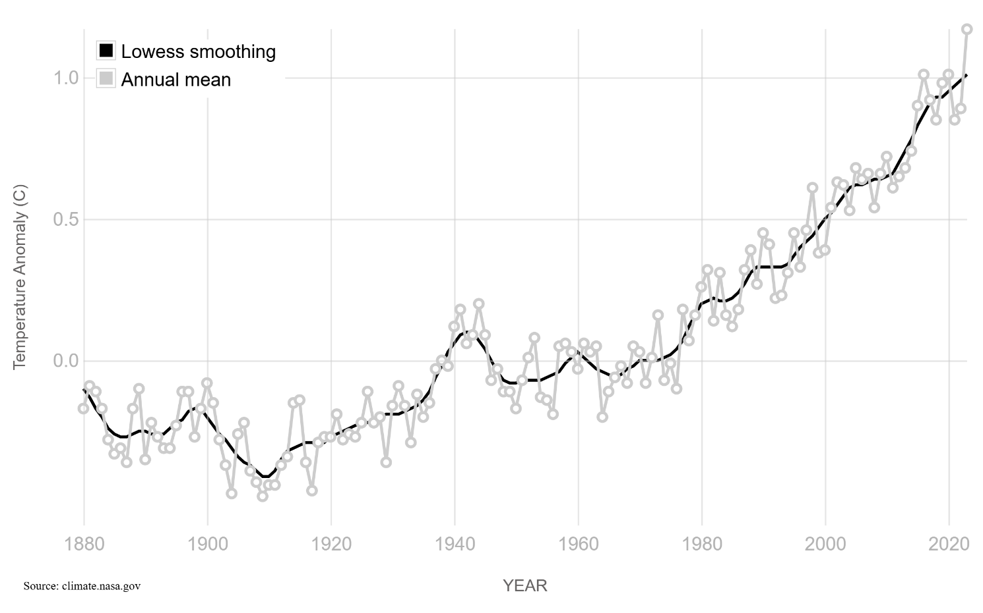
Figure 1- NASA (2023), Global land- ocean temperature index.
During the 1980s scientist and researcher Paul J. Crutzen and Eugene F. Stoermer coined the term ‘Anthropocene’, which Crutzen defined that ‘human activities are exerting increasing impacts on the environment on all scales, in many ways outcompeting natural processes’ (Crutzen, 2006, p.13). Depicted through the unprecedented levels of anthropogenic warming, meaning the rise in earth’s temperature caused by human activities. Figure 1 portrays the global land- ocean temperature index from 1880 to 2020, where apart from the anomaly in the 1940s, the 1980s depicts the rapid and still increasing rise in temperature. Reasons for this lies in the burning of fossil fuels and deforestation amongst many other contributors. Globally, deforestation peaked in the 1980s with the growth in population, land was being turned into housing and agricultures expansion meant over ‘80% of new agricultural land came from intact and disturbed forests’ (Gibbs et al, 2010, pg.16736). Ecofeminist Vandana Shiva relates this research back to the movement by saying ‘“The earth is rapidly dying: her forests are dying, her soils are dying, her water is dying, and her air is dying’ (Shiva, 1989, P xii). While dualism is still present with the use of personification when gendering nature as ‘her,’ there is more focus around the environmental oppression as ‘dying’ is an emotive analogy that creates urgency around change and reflection of our actions.
Contemporary analysis of ecofeminism today expands on this where it is more reflective of the climate crisis urgency and the need for change. Cultural critic and ecofeminist Donna Haraway tells us that: ‘Our task is to make trouble, to stir up potent response to devastating events, as well as to settle troubled waters and rebuild quiet places’ (Haraway, 2016, p.1). The importance in ‘our’ is a decision to not dwell on the ‘cultural constructions’ of men but leave the past and collectively move into the future to repurpose our connection with the environment. However, women are the ones settling ‘troubled waters’ especially in visual art, with exhibitions such as RE/SISTERS: A Lens on Gender and Ecology in 2024 which took place in the Barbican art gallery, London. Over fifty international female artists such as Ana Mendieta, Laura Aguilar, Pamela Singh, Otobong Nkanga and Carolina Caycedo created multimedia work around the systematic links of resisting capitalism, the relationship between gender and equality and the power structures that threaten this. Emphasising this idea of women being the bigger advocates for climate change especially within visual art. While this is not to diminish men’s efforts in the climate crisis but to advocate Haraway’s words, where to create change as a community and fix the gender divide there needs to be equal participation. As parallels, fixing patriarchy could help fix the environmental crisis. Visual art has the power to do this as well as transform research into visual representation, altering and integrating different perspectives and offering new alternatives to statistics. Methodologies both qualitative and quantitative can be complex to digest and require a high level of understanding, however when portrayed through visual art it is more approachable and interpretable, creating narrative where often data cannot. Furthermore, the research can be transpired into different forms of representation through the broad subjectivity of visual art, therefore it can be used to promote climate action through its ability to connect with individuals more intimately.

Importance of this essay is imperative through research influence on visual art. After March 2024 where the Sub-commission on Quaternary Stratigraphy (SQS) voted against the proposal given by the research and scientific Anthropocene working group (AWG), in the declaring of the Anthropocene. Acknowledging however, that currently eight out of the twenty-four international members in the AWG are women (AWG, 2024). Subsequently, this is an improvement from a decade ago where of the twenty-nine scientific members of AWG there was only one woman (Raworth, 2019). While this is an advancement, it is not sufficient enough as women statistically are most impacted, they should be the most represented in their research. Visual art has the power to influence perceptions, opinions and societal values which is why in the next chapters I will be using female visual artists to represent current female AWG members. Specifically, Naomi Oreskes, Jaja Syvitski (previously known as James), Barbara Fiałkiewicz-kozieł and Francine McCarthy informing their research through visual conceptual depictions.
Geologist, science historian and author Naomi Oreskes, through her book Merchants of Doubt, illudes back to ecofeminist perspectives around patriarchy by saying:
For the past 150 years, industrial civilisation has been dining on the energy stored in fossil fuels, and the bill has yet come due. Yet we have sat around the dinner table denying that it is our bill and doubting the creditability of the man who delivered it (Oreskes, 2010, p.226).

Furthermore, it signals back to men as instigators which is evident within her own research institution the AWG. Evaluating on ecofeminism and its evolution in meaning through time shows how female artists can utilise this theory and put it into practice to create conceptual change. As well as this understanding its capabilities in connecting culture and nature to inform relationship and practice. While recognising that ecofeminism as a movement is extensive in avenues, it shows the importance of women and natures interconnections to repurpose our climates future. Additionally, research acts as a valuable tool within this as it shows to the extent that we are harming our planet. Furthermore, ecofeminism insists that through interconnection, reappraising of the environment can be done through navigation of hegemonic masculinity and climate dominations.

Chapter 2- Interconnected.
Ecofeminism insists the importance of the relationship between women and nature in their synonymous and intimate connection. This is evident through women’s physical collaboration with the land as well as the act of preservation and conservation through ethics and care. Similarities between women and nature can be biological with reproduction, menstruation and pregnancy following a similar life cycle, as well as societally constructed with women stereotyped as nurturers and caregivers. An iconography in environmental art, Ana Mendieta (1948-1985) explores a deeper bond between the female body and the natural world in various locations, through her over two hundred earth body works as part of her Silueta series between 1973-1980. As she describes the interaction as a return to the ‘maternal source’ (Tate, 2018). Implying the previous essentialist view at the time as ‘mother nature’ is symbiotic. Expressing the intangible bond that reciprocates equally the needs of one another. Mendieta explores the connection through performance, photography, earth and body art as well as sculpture making it a tangible interaction. Analyse of her practice is seen in diverse representation of the female body, her earth body works explore her physical body’s belonging with different terrains such as mud, sand, grass and rocks. Political theorist, Jane Bennet echoes Mendieta’s experience of attachment and intimacy when submerged into nature as ‘my ‘own’ body is material and yet this vital materiality is not fully or exclusively human’ (Bennett, 2010, p.112-113). Suggesting her materiality in visual art is her body’s activation to nature which produces a performance. Imperative to note is Mendieta’s exile from Cuba as a child within this, as she finds comfort within the land, Figure 2 being in Mexico implies this as the beach, language and culture resemble Cuba, however her physical absence suggests she still feels a sense of unbelonging.
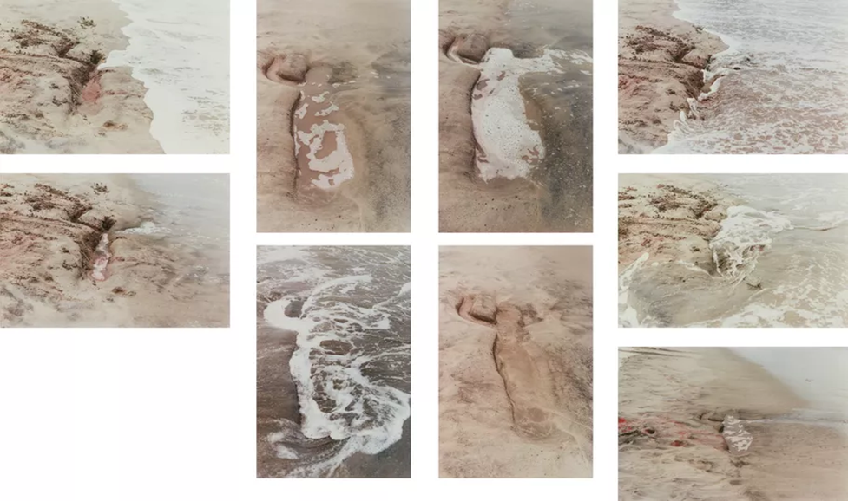
Figure 2. Ana Mendieta (1976). Untitled, from the Silueta Series.
Understanding this deep-rooted relationship makes the analysis of her absence and presence relate to the Anthropocene through her body becoming a trace within nature. Susan Best comments on Mendieta’s series through signifying a ‘feminist space (of) dwelling’, where the ‘female body (is) at once present in outline and yet absent in actuality’ (Best,2007, p.81-82). Figure 2 demonstrates this firstly through ‘absence in actuality’ as her silhouette becomes a representation of women, where the outline is still present it symbolises a feminization of nature and a depiction of nature’s effects on women. Moreover, observers of her work today can depict the metaphorical connotations of climate change in the rise in sea levels, as seen in Mendieta’s silhouette through the documentation, the tide removes her trace. Embodying the impact of women in today’s climate crisis. Member of the AWG, oceanographer Jaja Syvitski discusses this through vulnerable areas at risk of flooding and that this ‘may increase by 50% under projected 21st century eustatic sea level rise’. This is due to ‘human-induced accelerated sedimentary compaction from water, oil and gas mining’ (Syvitski et al, 2009, pg.2). Referring to Ecofeminist Vandana Shiva, who as previously in the essay mentioned ‘her waters are dying’, Savitsky suggests through Mendieta’s work that it is our own anti-environmental behaviour that is causing a fragmented relationship and harm towards the planet. Figure 2 implies this as nature is restoring itself by washing away the trace of the human body. This suggests that to repurpose our relationship with nature we need to stop using harmful, extractive, and polluting methods against the environment, and intern our traces on earth will be more permanent than destructive. Furthermore, it symbolises the paradox within the Anthropocene in humans temporary time on earth, contrasting to the extensive impact that has been left. Acknowledging, that climate change was not politically prevalent in the 1970s, it is important to note as Mendieta was ahead of her time and was aware of how anthropogenic behaviours could impact her relationship with nature, which is shown through how she portrays natures reclaiming of her silhouette.
Preserving her trace through documenting the removal of her silhouette through photography allows the body of work to live on in a new form, it never truly disappears. Instead, it is captured in an ephemeral and temporal moment that we can witness but never enter as described by Sontag ‘A photograph is both a pseudo-presence and a token of absence’ (Sontag,1973, p.12). Its longevity lives on to influence generations to come, a key aspiration in visual art to create change which this body of work has done. For example, my traces on earth through my carbon footprint, choice in sustainable process and material within my practice, echo her message to reflect on our interconnected relationship to heal earths current disconnect. However, the subjectivity of Mendieta and her trace cannot be experienced, archived, or recorded in its true form. Photography dematerialises the images’ purpose in this way, as nature is frozen in time, preventing its natural course suggesting our traces on earth are permanent. Feeding back into ecofeminist concepts of oppression, capitalism profits off the materialisation of art by institutionalising her work into a gallery space, where it is reconstructed through curation, altering the meaning and influence of the work from intimate to publicised. Overall, while it is important to preserve and document the body of work, when referring to my interview with Rowan Lear she mentions she has less interest in:
Particularly photographic work which illustrates climate change, you show us what it looks like, well what is that going to do? Just reproduce the same world. So, what can you do different to change it? (Lear, 2024).

Implying that when Mendieta’s body of work is viewed in the relation to climate change and its effects on women’s relationship with nature, photography as a medium is restrictive on its influence. Signifying that a more interactive and immersive form of visual art would evoke a higher level of effect on the viewer, in aims of preserving our environment.

Implementing this reformation of ecological art in context to the gallery space, is successfully done by environmental activist Joseph Beuys, expanding arts meaning away from its traditional forms such as introducing participatory art. Whilst he is a male artist, that is not to say that he is not a part of influencing change within female artists practices, which I will go on to later discuss. Arguably, Beuys offers a new perspective to ecofeminism especially in this era of the 1980s views of men, as he was a pioneer in influencing community response to environmental destruction. Rejecting the idea that ‘Climate change is a man-made problem and must have a feminist solution’ (Robinson, 2021). Displayed within 7000 Oaks (1982-1987), Beuys suggests this through his use of city forestation, where he used nature to replenish a damaged urban landscape, as the Second World War devastated the city Kassel, in Germany. Impacting, both the community and climate as seen in figure 1, through the drastic temporary increase in ocean and land temperature in the 1940s as a direct result of the weapons of war.
Moreover, his aims to reconnect the community through planting 7000 oak trees to restore the city was seen as a radical act that demanded sociopolitical environmental change. Comparing it to Mendieta’s work it supports the belief that environmental art does not conform to a gallery space as it loses its impact. Beuys expands on the individual portrayal of Mendieta’s relationship to nature into to a community project, to immerse the public into climate action and reclaim agency over their urban environment. Expanding on this, Beuys represented each tree alongside a basalt stone, only being removed from outside the Fridericianum museum as each tree was planted, juxtaposing the analogy of nature’s evolving relationship to stone within industrial landscapes. Creating new locations for its presence to impact, where the scale of the stones reflected to the community a constant reminder of their need to partake in revitalising their city as well as preserving it. Members of the AWG, Syvitski and Fiałkiewicz-Kozieł suggest the importance of Beuys reforestation today as ‘Abnormally long strings of drought years have led to tree mortality and forest turnover through widespread wildfires’ (Syvitski et al, 2024, p.17). Portraying the importance to regenerate and replace what we have destroyed. Relating to ecofeminism, Beuys expands the responsibility to the community to reinforce and heal the interconnected relationship between women and nature. Therefore, Beuys expressed that ‘humanity now needed a reemphasis on the feminine strengths of sensitivity, receptivity, warmth, creativity, spirituality, and openness to the future’ (Adams, 1992, p. 31). Evoking the interpretation that to combat climate change and readdress our relationship we need to adapt a feminized approach, acknowledging that men such as himself can embody this. 7000 oaks for example, conveys these notions of fertility, regeneration, nurturing, caring and cultivating new life. Beuys choosing the planting of oak trees reiterates this need to close the gender divide moving forwards, as shown in the oaks monoecious feature of having both male and female flowers located on them.
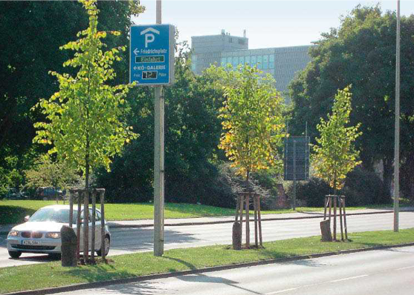

Figure 3. Körner and Bellin-Harder (2007), Joseh Beuys, 7000 oaks.

Moreover, Figure 3 presents the oaks after Beuys death (1986), as conservation was left to the community, where landscape architectures Stefan Körner and Florian Bellin-Harder reevaluated the maintenance of this project twenty-five years later. Addressing figure 3 they evaluated that the ‘trees have difficulty surviving there, and need to be frequently replaced’, where ‘seventy replacement or newly planted trees are required each year’ (Körner and Bellin-Harder, 2009, p.11). Implying, that although the community are restoring the oaks, it is through our poor maintenance and anthropogenic behaviours that they are dying in first place. Urbanisation has reclaimed and contaminated the trees over time as portrayed in figure 3, the oaks are situated directly in a position with prominent levels of exhaust pollution. Ironically, we question their lack of survival and expect a different outcome with replanting, illuding to the idea that our community needs to be educated and understand the ways to preserve and maintain our relationship with nature. Furthermore, 7000 Oaks reflected Beuys’s social sculpture theory, which expanded the definition of art. Elaborating that everyone is an artist, introduced here through the inclusivity to interact and maintain the health of the oaks.
Disappointingly, when analysing the oaks in 2009 ‘signs of neglect and attempts to remedy them are clearly apparent’ (Körner and Bellin-Harder, 2009, p.11). Proposing that Beuys hopes for social change is not prevalent, where there is a dominant issue in our society’s values and norms in our negligence towards nature. Equally, it is important to justify here that women are also responsible for the lack of maintenance, reinstating through Beuys work that ecofeminism’s parallel gender constructs are not universal. Evidence previously suggests however, that Beuys shows a lack of educating and informing the community in how to preserve the trees which could have prevented the environmental neglect.

Evolving the project further, multi-disciplinary artists Heather Ackroyd & Dan Harvey started a body of work called Beuys’ Acorns in 2007. Travelling to Kassel they collected hundreds of acorns from Beuys oak trees and nurtured them into saplings where they continue to sustain and convey Beuys message, being that the ‘most powerful activity; is planting trees’ (Beuys and Kuoni, 1993, p.160). Climate urgency in current contemporary society advocates this message as ‘up to 15 billion trees are now being cut down every year across the world’ (WWF, 2023). Exhibiting the saplings around Europe, replanting them and educating children in schools shows both the power of conservation and a more successful advancement on what Beuys was pushing to achieve. Interestingly, it argues the concept of maintenance as at the same time in Kessel, landscape architectures Körner and Bellin-Harder previous findings portrays a restricted view of ethics and care. Ackroyd & Harvey expand on this, through the idea of repurposing the material and cultivating new life from Beuys’s dying trees through its produce, metaphorically it embodies this idea of mother nature in action.
Female artist Ackroyd shows the influence of both Mendieta and Beuys as she declares that: ‘I often say, I've never cut the umbilical cord with these trees. It's working with living material’ (Jacobs, 2021). Referring to Mendieta’s description of the relationship as a return to the ‘maternal source,’ however through the role of regeneration and preservation of trees and healing the climate. Suggestively, this illudes to the context of ecofeminism, as women having a more interconnected relationship with nature expands beyond Beuys’s climate action, focusing on the longevity of 7000 oaks, implying more successful influence and climate impact in the hands of women. Pursuing this idea can however be critiqued through the representation of Beuys’ Acorns in different forms and locations.
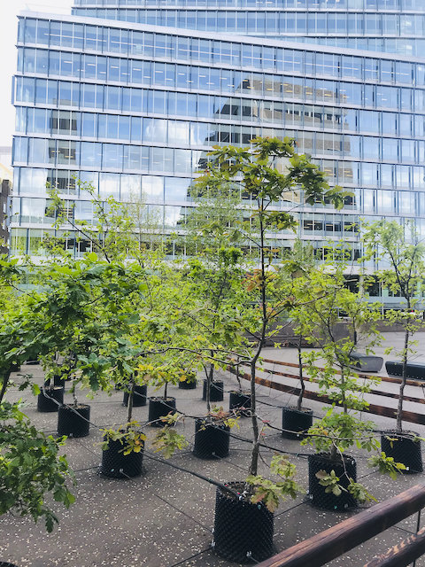

Figure 4. Ackroyd & Harvey (2021), Beuys Acorns. Tate Modern, London.
Firstly, in 2021 to commemorate one hundred years since the birth of Joseph Beuys, Ackroyd and Harvey exhibited the body of work in Tate modern, London. Figure 4 shows the composition of the one hundred oak saplings which amplify the previously argued prospect of environmental arts belonging in gallery spaces. Exemplified clearly in Beuy’s Acorns defying of the external boundaries of the gallery walls, as they were situated on the terrace outside the building. Influenced by Beuys and his aims in city forestation, Ackroyd and Harvey imitate this structurally through the linear placement of the trees as seen in both figure 3 and 4, in the controversial juxtaposition of the trees to the industrial landscape. Unnaturally, figure 4 portrays an anthropogenic and dystopian display on humans’ ability to control and manipulate the situ and structures of nature into conforming to fit linearly into the urbanised area. Further reflecting on the previous outcome of Beuys work 7000 oaks, in the effects of pollution on the tree’s health, there seems to be a repetition of the same mistakes.
Proving this and relating it back to the ecofeminist perspective on the parallel patriarchal experience in pollutions impacts on women as well as nature. Agnes Agyepong, CEO of global black maternal health portrays this in relation to London, saying: ‘Pregnant women exposed to air pollution are more likely to have children who are born prematurely, underweight or stillborn’ (London City Hall, 2023). Synthesising the disproportionate health effects of climate change on women thus fragmenting their relationship with the environment. Mendieta and Ackroyd convey this further through their maternal connection with nature, Ackroyds previous defiance in not cutting ‘the umbilical cord with these trees’ generates an analogy to Agyepong’s findings around motherhood and direct link to trees undergoing the same result as the foetus from pollution. Implying, that this method of environmental art in urbanised cities cannot be effective in tackling climate change as pollutants out scale the trees efforts to purify the air and benefit us. Until we reduce our anthropogenic behaviours, we are in fact damaging the trees health through this form of visual art, which is the opposite intent. While we cannot be aware currently of the impact this has had on the trees, their temporary location suggests that the health of the trees will be less impacted than 7000 oaks for example. Also, London is improving its level of air pollution with clear air zones and policies decreasing the concentration of pollution by ‘65 percent in central London’ (London.gov, 2024). Evoking that there is hope to successfully reintroduce this body of work in future to restore the health of women’s relationship with nature. Justifying the errors in this body of work is imperative to show Ackroyd and Harvey’s transition into educating the next generation, contrasting the two, presents the evolution of a singular body of work in its everlasting effect.
During the summer of 2024, Beuy’s Acorns relocated its influence on Whitefriars Church of England Primary Academy in Norfolk, where they aimed to inspire children through Joseph Beuys original work and have them adopt the trees from Beuys Acorns. Female artist Johann Don-Daniel led the project, further advocating women’s advances in evolving 7000 oaks into creating climate change. Successfully the impact of reestablishing natures relationship with children through climate change education is seen by the WWF, School for Nature scheme. Implementing the need for schools to establish interaction with nature into their curriculum, thus supporting and deepening our relationship, where education needs to provide consistent activities sharing natures experiences and opportunities to create climate action (Mckinlay et al, 2022). Additionally, reconnecting this back to women who are three times more likely to suffer from mental health then men (Mental health Foundation, 2022). Nature is proven to improve mental health within the younger generation where environmental interaction ‘substantially promotes attention restoration, moderates the impacts of stress, improves behaviours and symptoms of ADHD’ (McCormick, 2017). Suggesting that women’s psychological relationship with nature is healed through their interconnected properties and can be restored through early integration with educational environmental activities. Furthermore, these trees have not been planted yet, so the effect is not yet clear, however the children have created several forms of visual art themselves responding to the sounds of the trees. Moreover, it shows that Beuys social sculpture theory is evident decades later with prominent social change through education which leaves a promising future for the environment. Arguably, while educating the younger generation is beneficial, we are in a climate crisis and we do not have time to wait, implying that educating older generations is just as necessary.

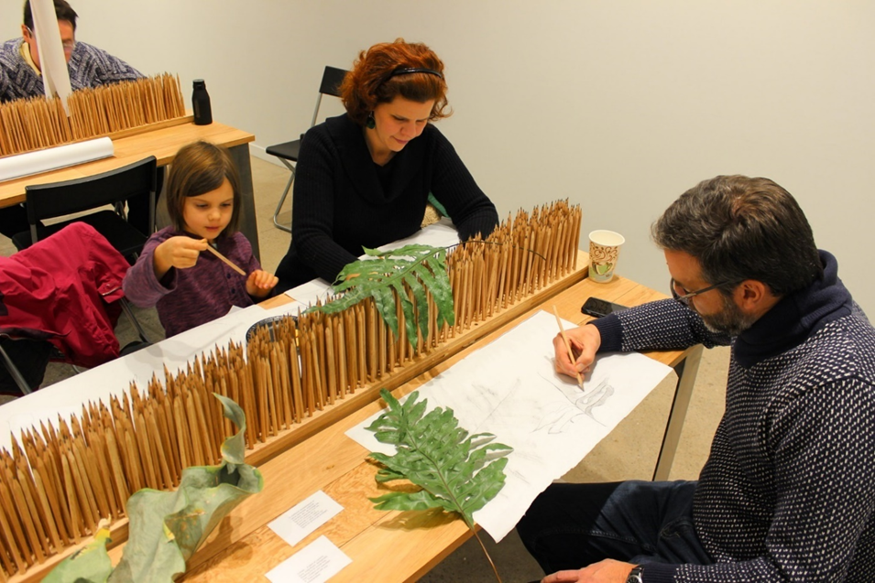
Sara Black and Amber Ginsberg’s body of work 7000 Marks in 2016, readdresses these concepts and suggests new ways to repurpose the material also done in Beuys Acorns, and use it as a tool to educate communities of all ages. Addressing this in the current climate is key as in 2021, Office of National Statistics stated that 75% of adults are worried about the impact of climate change, with women being more worried and making more lifestyle changes than men. As well as 16–24 being the largest age group with 22% reporting not feeling anxious at all and stating this was due to lack of knowledge on climate change or believing there were bigger priorities (Office for National Statistics, 2021). Suggesting that although everyone needs to be educated on climate change the younger generation do particularly need this reinforced. Also to reiterate ecofeminism’s aims of men becoming equal in efforts to repurpose the environment to revitalise and remove the anxiety around women’s relationship with nature. Compared to Beuys work where oak trees were not maintained and ‘replaced’ when neglected, Black and Ginsberg along with Ackroyd & Harvey offer a sustainable approach of regenerating and reusing the oak to recontextualise that our relationship with nature is never too late to save and make an impact with. Exploring this in 2016 as Black and Ginsberg felled oak trees contaminated with Sudden Oak Death and repurposed them into 7000 pencils to use in workshops to educate the community. Inspiring environmental and social change in this way as when individuals use the pencil they will learn about sudden oak death. While the disease is not caused by climate change the pathogens survive and grow with warmer temperatures and environmental disturbances increase the spread. Professor of Earth Science, Francine McCarthy and member of AWG expands on this further through her teaching of the impact of the Anthropocene on the planet at Brock University, Ontario. Demonstrated in her own research at the geological site Crawford Lake, where every year the crystals formed in summer sink to the lakebed creating layered intervals of geologic time. As our summers get warmer through climate change these layers become more defined. McCarthy refers to as this representative of ‘tree rings’ (TEDx Talks, 2024). Earths elements are synonymous in this way as the same anthropogenic exposure is absorbed by the trees. Moreover, Black and Ginsberg use the same principle of educating these issues but through visual art workshops using the 7000 pencils.
Figure 5. Black and Ginsburg (2017-2018). 7000 Marks, Ohio.
Previously the evidence of Mendieta, Beuys, Ackroyd and Harvey all suggest the defiance of environmental art not situating well to gallery spaces. Alternatively, located in SPACES Gallery in Cleveland, 7000 Marks suggest that when used within community perspectives to educate, the galley space evokes climate action efficiently. Figure 5 shows this through the multigenerational aspect of the participants as well as the workshop generating more visual art through activities such as asking them to look to geologic pasts to imagine future worlds. Jane Bennet summarises this influential use of the pencils as ‘the curious ability of inanimate things to animate, to act, to produce effects dramatic and subtle’ (Bennet,2010, P.6).
Concluding on this chapter it is clear that climate change has directly disconnected women and natures interconnected relationship through natures reclaiming of Mendieta’s trace. Furthermore, while men are involved in climate action it is evident through Beuys’s 7000 Oaks that women due to their intimate relationship, seek to perverse the longevity of the work by repurposing the original concepts in order to educate the community and create change. Additionally, the analysis of the works relation to the gallery space through its form and composition in its ability to relay the urgency to evoke action from the viewers suggests participatory and educational workshops are the most beneficial. While photography is restrictive in its temporal documentation and removes environmental meaning from Mendieta’s performance. Installation art such as city forestation shown in Beuys and Ackroyd & Harvey’s projects suggests that until we come together as a community to clear the levels of pollution in our urbanised cities, reforestation in these areas is creating more harm to the trees. Illuding to the suggestion that by remodifying the project into repurposing the materials to educate society is healing the disconnect that Mendieta found within her body of work.
Chapter 3- Community
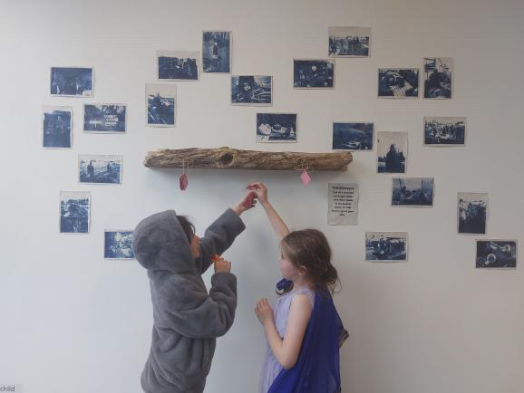
Analysis of all previous artists have influenced how I approach the climate crisis today, while I understand that it is impossible to solve the climate crisis myself through my practice, I believe the answer is in creating a community. Rowan Lear supported this in the interview stating to create change is ‘to recognise that you are part of something bigger, and therefore you have a responsibility to put your body on the line when you need to’ (Lear, 2024). Expanding on this, my project Wildflower in 2023, documented a female gardening group named ‘Women’s shed’ located in Swansea, which implemented through photography, sculpture and immersive interaction the portrayal of womanhood and its formation around nature.
Figure. 5 Esme Littlechild (2023), Wildflowers. Comma exhibition, Swansea college of art. 25th-30th April 2023.
Defining my relationship with nature as a female visual artist is imperative in the climate crisis we are in currently, where through documenting community groups I have restored a deep connection to the impact that being in nature can have on women. Reemphasising this in my choice of sustainable materials allows me within my practice to physically connect to the environment and what it has to offer, compared to the anthropogenic structure of city life. However, as seen in figure 5 the log is sourced from the beach, relating this to Mendieta’s body of work poses an ethical question on my position. While in her work nature washes away her trace, I interfere with natures natural cycle reflecting humans’ interference with ‘mother’ nature. Additionally, I critiqued Mendieta in her use of photography and gallery confinements in which my work shows an alternative approach to convey this more successfully. Using cyanotypes is a more sustainable method than ink printing, as well as this it contextually feeds into the relationship between natures need for light to survive and the images use of light to produce the image.
Immersing myself into the community group of women from different ages, backgrounds, and relationships to nature I became educated in how to garden as well as forming friendships. Referring to Black and Ginsberg it resonates the importance of generational education on the way to maintain the planets health. Figure 5 shows this as through my exhibition the younger generation are learning to build a healthy relationship to gardening. Further seen in this body of work I produced beetroot dyed, seed paper anthrotypes of the flowers grown at ‘Women’s shed’ which can either be taken away to plant or planted within the planter made of scrap wood within the exhibition. Once the exhibition is finished the flowers feed back to the community boosting the ecosystem in different locations, expanding on the efforts of Ackroyd & Harvey’s replanting in children adopting the oak saplings.
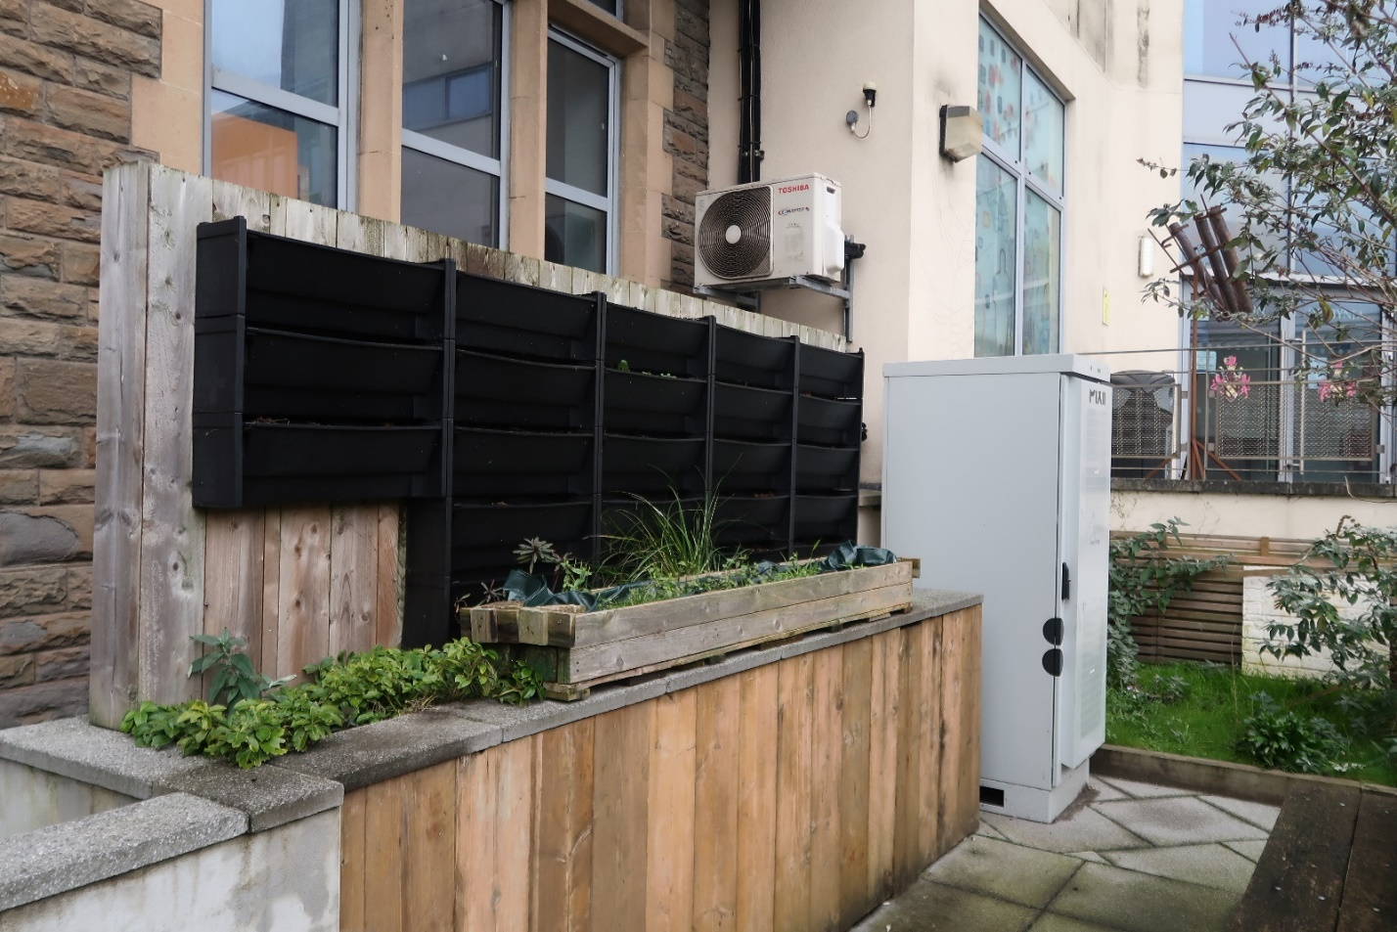
However, the longevity of the flowers in today’s climate is unknown with all previously analysed female members of the AWG being co signatories in stating that ‘the planet is now hotter, more contaminated and biologically more degraded.’ Suggesting the impact on ‘exerting pressure on political institutions, legal frameworks and economic relations, all of which are meant to protect human communities and give them meaning’ (Zalasiewicz et al, 2024). Signifying that these patriarchal institutions related to ecofeminism in the oppression of women and nature have not been successful as they were ‘meant to protect human communities’ such as ‘Women’s Shed,’ where funding and government support is hard to come by. Noting also that AWG form their own community here allowing them to progress their research together in globally understanding of the disconnected relationship with nature in the Anthropocene.
Figure 7. Esme Littlechild (2024), Wildflowers. Comma exhibition, Swansea college of art.
Expanding on the planter’s condition today a year later, figure 7 reflects Beuys’s city forestation through landscape architecture influenced by Brutalism, where urban landscapes are modified to remind you of the natural world. Located outside the university, the green area is an attempt to bridge the gap between ‘political institutions’ and nature especially within the visual arts. Dissecting the word ‘landscape’ itself suggests a controlled and tangible claiming of nature, situating my planter here reacts to a community who live in a city trying to escape urbanisation through gardening however, the planter symbolises that they cannot escape. As seen in figure 7 with the generator and extractor fan placed directly next to the flowers. Impacting my connection to nature as it is inevitable that my practice in ecology will be restricted by societies preference to anthropogenically modify areas created for nature to thrive.

In conclusion, the intention of this essay was to readdress the global environmental crisis through the ecofeminist concept of women’s interconnected relationship to nature in hopes of creating climate action in our community. By analysing this through female artists, their connection to nature has been explored in a magnitude of ways within their practice that create a guide to further our understanding of the impacts on women. Extensive research on the Anthropocene and our current climate has supported visual art providing additional information about the severity of harm within the environment., as well as supporting female researchers in gender dominance. Findings from this essay have suggested that we need to act now,
Firstly, Mendieta

. In order to discuss the relationship between female take different forms weather through their body, educating or empowerment in community groups. Sum up what each person has done an compare them
Suggestion to what is needed in the future through analysing joseph Boyce work the replanting and restoring is only effective if we maintain it, even more through black Gringsby if we educate from it.

Climate crisis is becoming more of an issue so the importance for the need of artists to make this point, not getting better its getting worse.

However, when using Beuys to influence the female artists it reinforces the patriarchal system of women following men. Suggesting that as a female artists I am subjected to the societal beliefs of men myself
Appendix
6th December 2024
Esme Littlechild in conversation with ecologist themed artist, writer and researcher Rowan Lear:
Esme: My dissertation is based on the impact of the Anthropocene on women in visual art. How do you feel this reflects and impacts you and your practice?
Rowan: There is so much happening, and we can see, particularly in the United States the laws that are going to but already increasingly likely restricting women's autonomy. And there is parallel with what is happening with trans rights, both her and in the US. There is a connection between responses to the Anthropocene and ways that the government are dealing with it very badly, and the re extraction of the return to this kind of primitive accumulation, which means reorganising and reinstating of patriarchy. And that is not a happy thing to consider, reading Margaret Attwood she traces a roadmap of how this might come to pass again. So, I think it is very apocalyptic in a way especially if you’re a woman.
Esme: Such as the handmaid's tale, what is it about this reading and the concepts that informs your work exactly?
Rowan: Margaret always says, everything I have put in my books is possible, everything, every technology exists, every political move has already happened before in another place, another time. I am aware of that when I think about the space for women at the same time there is a lot of work been happening for a long time but maybe picking up pace now. To me, it is to prioritize to privilege to recentre women's work, I guess because I am kind of working in the agricultural space, but there's a lot of extremely good, powerful peasant movements, which are largely run by women, led by women. There are revolutionary movements like Rojava in northeast Syria, where they have this philosophy of genealogy, in which women's rights are protected. The Zapatistas also enshrine, the women's law. So, there is also counter examples to what looks very, very bad in some places.
Esme: Understanding this do you believe in ecofeminist perspectives, or do you think there needs to be more diversity. As your practice does not fit into the often-critiqued essentialism view of ecofeminism, such as queer representation which I know you support through un/nature queer reading group.
Rowan: Ecofeminism has many different forms, so I would not want to call it all one thing, I think there's strands of eco feminism which stray into essentialization or centralizing, so they essentialize the relationship women with nature. I think if you are a good materialist feminist, you look at the material conditions of the world and how they have come to be and you understand why, for example, women are the largest food producers in the world. That is not because women are naturally better, there is no such thing as natural. This is why there is an importance on this reading group un/nature. It is because there is a set on social, cultural, historical, economic conditions have led to women being in that position. That does not mean they are not the people who should be doing it, but it just needs to denaturalise that. And the best examples of ecofeminism do, do that. You fall into binaries of men is culture, women is nature. And it is not helpful to do that, it is helpful to show that and show that it is culturally constructed.
Esme: It is important to understand these cultural constructions especially when we look at the fact that statistically women are most impacted by climate change, yet we are the ones doing the most to fix it. Signifying that women are structurally tied into this relationship with nature and take a lot more care and push for change.
Rowan: Women, racialised women, queer people, disabled people, that has always been the way. It is almost like a revolution.
Esme: And when looking to the future what do you think will be needed in visual art to move past this? And what can be done to repurpose our relationship with the climate?
Rowan: There is a lot of answers to this question. Here is the first thing I say is that in a lot of movements, such as the art workers for Palestine movement, we specifically talk about artists as art workers. So, artists recall that they are doing work, and therefore should be fairly paid and is a form of labour that is part of a capitalist system, whether you like it or not. Understanding your position as a worker also means you understand your solidarity with other workers. There is something about visual artists to recognise that you are part of something bigger, and therefore you have a responsibility to put your body on the line when you need to. Maybe that means going to a protest, maybe that means your practice is critically engaged with what is happening. No one thinks this should be the case, but less interest in the type of work, particularly photographic work which illustrates climate change, you show us what it looks like, well what is that going to do? Just reproduce the same world. So, actually what can you do different to change it? And that does not mean I think people should give up on art. But I have been thinking about, how do we expand on this category of art.
Esme: You speak about photography here and the ability and power it holds as a medium and the need for it to adapt in order to create a prominent sense of change especially within the climate crisis. What could photographers do, and how does documentation as a process effect this?
Rowan: I mean understanding that you are in the world when you make these images, that your image is result of a set of negotiations and collaboration, not an independent of the world. And then to be very attuned to what your pictures are doing, who are you sharing them with? There are so many rules for photographers, but documenting and archiving is really important. There is a place for photography that breaks this gaze, like the colonial gaze that offers new ways to see things. And how people do not necessarily think about what when into the making of that image, the performative and also the material conditions of production. Also another thing to note is, the same companies who make components for cameras and drone cameras are also the same factories that are making weapons. So the way that the visual technology industry and the war industry have always been connected, and that is an interesting thing to draw attention to. As understanding our relationship between particular ways of seeing and how that relates to other ways of understanding how you map territories.

Reference list:
Books:
- Bennett, J. (2010). Vibrant Matter: A Political Ecology of Things. Durham: Duke University Press.
- Best, S. (2007). ‘The Serial Spaces of Ana Mendieta,’ Art History, Vol. 30, No.1.
- Beuys, J. and Kuoni, C. (1993). Energy plan for the Western man: Joseph Beuys in America. New York: Four Walls Eight Windows.
- Eckart Ehlers and Krafft, T. (2006). Earth system science in the Anthropocene. Berlin: Springer, pp.13–18.
- Haraway, D. (2016). Staying with the Trouble: Making Kin in the Chthulucene. Durham: Duke University Press.
- Oreskes, N. and Conway, E.M. (2010). Merchants of doubt: How a handful of scientists obscured the truth on issues from tobacco smoke to global warming. London: Bloomsbury.
- Plumwood, V. (2002). Feminism and the Mastery of Nature. Routledge.
- Shiva, V. (1989). Staying Alive: Women, Ecology and Development. London: Zed press.
- Sontag, S. (1973). On Photography. New York, Rosetta Books.

Articles:
- Gibbs, H.K., Ruesch, A.S., Achard, F., Clayton, M.K., Holmgren, P., Ramankutty, N. and Foley, J.A. (2010). Tropical forests were the primary sources of new agricultural land in the 1980s and 1990s. Proceedings of the National Academy of Sciences, 107(38), pp.16732–16737.Available at:https://pmc.ncbi.nlm.nih.gov/articles/PMC2944736/pdf/pnas.200910275.pdf . Accessed: (5th December 2024).

- Körner, S. and Bellin-Harder, F. (2009). The 7000 Eichen of Joseph Beuys – experiences after twenty-five years. Journal of Landscape Architecture, 4(2), pp.6–19. Available at: https://www.tandfonline.com/doi/epdf/10.1080/18626033.2009.9723418?needAccess=true. Accessed: (8th December 2024).

- McCormick, R. (2017). Does Access to Green Space Impact the Mental Well-being of Children: A Systematic Review. Journal of Pediatric Nursing, 37, 3–7. Available at: https://doi.org/10.1016/j.pedn.2017.08.027. Accessed: (13th December 2024).

- Summerhayes, C.P., Zalasiewicz, J., Head, M.J., Syvitski, J., Barnosky, A.D., Cearreta, A., Fiałkiewicz-Kozieł, B., Grinevald, J., Leinfelder, R., McCarthy, F.M.G., McNeill, J.R., Saito, Y., Wagreich, M., Waters, C.N., Williams, M. and Zinke, J. (2024). The future extent of the Anthropocene epoch: A synthesis. Global and Planetary Change. Available at: file:///C:/Users/Student/Downloads/future_extent_Anthropocene_GPC_publ.pdf. Accessed: (7th December 2024).

- Syvitski, J.P.M., Kettner, A.J., Overeem, I., Hutton, E.W.H., Hannon, M.T., Brakenridge, G.R., Day, J., Vörösmarty, C., Saito, Y., Giosan, L. and Nicholls, R.J. (2009). Sinking deltas due to human activities. Nature Geoscience, 2(10), pp.681–686. Available at: file:///C:/Users/Student/Downloads/SyvitskiDeltas_Paper.pdf. Accessed: (5th December 2024).

- Zalasiewicz, J., Adeney Thomas, J., Waters, C.N., Turner, S. and Head, M.J. (2024). The meaning of the Anthropocene: why it matters even without a formal geological definition. Nature, 632(8027), pp.980–984.Availabel at: https://doi.org/10.1038/d41586-024-02712-y. Accessed (8th December 2024).

Journals:
- Adams, D. (1992). Joseph Beuys: Pioneer of a Radical Ecology. Art Journal, 51(2), p.26. Available at: https://www.jstor.org/stable/pdf/777391.pdf. Accessed: (7th December 2024).

Interviews:
- Lear, R. (2024). In conversation with curator, Rowan Lear.

Websites:
- Boyd, E. (2021). The role of women in managing climate change. [online] GOV.UK. Available at: https://www.gov.uk/government/speeches/the-role-of-women-in-managing-climate-change. Accessed: (13th December 2024).

- Jacobs, B. (2021). Why planting a tree is a radical act. [online] www.bbc.com. Available at: https://www.bbc.com/culture/article/20210618-joseph-beuys-the-original-eco-activist. Accessed: (28th November 2024).

- London City Hall. (2023). New report shows shocking difference in air quality breathed by London’s communities, with Black and diaspora communities worst affected. [online] Available at: https://www.london.gov.uk/%20New%20report%20shows%20shocking%20difference%20in%20air%20quality%20breathed%20by%20London%E2%80%99s%20communities%2C%20with%20Black%20and%20diaspora%20communities%20worst%20affected. Accessed: (12th December 2024).

-Mental Health Foundation (2022). Men and women: Statistics. [online] Mental Health Foundation. Available at: https://www.mentalhealth.org.uk/explore-mental-health/statistics/men-women-statistics. Accessed: (19th November 2024).

- Nations, U. (2022). Why women are key to climate action. [online] United Nations. Available at: https://www.un.org/en/climatechange/science/climate-issues/women. Accessed: (7th December 2024).

- Office for National Statistics (2021). Three-quarters of Adults in Great Britain Worry about Climate Change - Office for National Statistics. [online] www.ons.gov.uk. Available at: https://www.ons.gov.uk/peoplepopulationandcommunity/wellbeing/articles/threequartersofadultsingreatbritainworryaboutclimatechange/2021-11-05. Accessed (13th December 2024).

- Tate (2018). Ana Mendieta: ‘Pain of Cuba / body I am’ | Tate Modern. [online] Tate. Available at: https://www.tate.org.uk/whats-on/tate-modern/ana-mendieta-pain-cuba-body-i-am. Accessed: (5th December 2024).

- TEDx Talks (2024). Humans permanently altered our planet. It’s time to act | Francine McCarthy | TEDxManhattanBeach. [online] YouTube. Available at: https://www.youtube.com/watch?v=Y1YhXFAxWkA. Accessed: (15th December 2024).

- WWF (2023). The Effects of Deforestation. [online] WWF. Available at: https://www.wwf.org.uk/learn/effects-of/deforestation. Accessed: (16th November 2024).
- www.london.gov.uk. (2024). New report reveals dramatic improvements in London’s air quality since 2016 | London City Hall. [online] Available at: https://www.london.gov.uk/new-report-reveals-dramatic-improvements-londons-air-quality-2016. Accessed: (8th December 2024).

Reports:
- Newsletter of the Anthropocene Working Group. (2024). Available at: https://quaternary.stratigraphy.org/files/working-groups/AWG-2023-Newsletter_final_CWST_16-March.pdf. Accessed: (26th November 2024).

- Walton, H., Dajnak, D., Beevers, S., Williams, M., Watkiss, P. and Hunt, A. (2015). Understanding the Health Impacts of Air Pollution in London for: Transport for London and the Greater London Authority. [online] Available at: https://www.london.gov.uk/sites/default/files/hiainlondon_kingsreport_14072015_final.pdf. Accessed: (4th December 2024).

- Mckinlay, M., Howkins, C., Foster, M., Welch, S., Allan, V., Albon, R., Hackland, J. and Collier, M. (2022). SCHOOLS FOR NATURE. [online] Available at: https://www.wwf.org.uk/sites/default/files/2024-09/Schools-for-Nature-Report-2024.pdf. Accessed: (9th December 2024).

Bibliography

Books:
-Barr, S. (2016). Environment and Society. Routledge.
-Barry, J. (2007). Environment and social theory. Milton Park, Abingdon, Oxon; New York: Routledge.
-Mendieta, A., Rosenthal, S., Heathfield, A., Bryan-Wilson, J. and Hayward Gallery (2013). 1948-1985: Traces. London: Hayward Gallery.
-Mies, M. and Shiva, V. (2014). Ecofeminism. London: Zed Books Ltd.
-Viso, O.M., Mendieta, A., Hirshhorn Museum and Sculpture Garden and Museum, W. (2004). Ana Mendieta: earth body: sculpture and performance, 1972-1985. Washington, D.C.: Hirshhorn Museum and Sculpture Garden, Smithsonian Institution; Ostfildern-Ruit.
- Warren, K.J. (1997). Ecofeminism: Women, Culture, Nature. Bloomington: Indiana Univ. Press.
Articles:
- Chandra Mondal, G. and Majumder, P. (2019). Ecofeminism: Encouraging Interconnectedness with Our Environment in Modern Society. American Journal of Educational Research, 7(7), pp.482–484. Available at: https://doi.org/10.12691/education-7-7-7. Accessed: (4th December 2024).
-
Journals:
- Montagnino, F.M. (2018). Joseph Beuys’ Rediscovery of Man–Nature Relationship: A Pioneering Experience of Open Social Innovation. Journal of Open Innovation: Technology, Market, and Complexity, 4(4), p.50. Available at: file:///C:/Users/Student/Downloads/Joseph_Beuys_Rediscovery_of_Man-Nature_Relationsh.pdf. Accessed (5th December 2024).

Websites:
- Admin (2024). Beuys’ Acorns inspires a school in King’s Lynn - GroundWork. [online] GroundWork -. Available at: https://www.groundworkgallery.com/beuys-acorns-inspires-a-school-in-kings-lynn/. Accessed: (17th December 2024).

- Der Feldweg (2017). Joseph Beuys 7000 Oaks | Documentation [video]. YouTube. Available at: https://www.youtube.com/watch?v=HE87qEUtApI&t=993s. Accessed: (13th November 2024).

Podcasts:
- Hassel, K. (2021). Raquel Cecilia Mendieta on Ana Mendieta [podcast]. 7th September 2021. Available at: https://open.spotify.com/episode/3wrIZPDbrR9nqdxnI1ey9B. Accessed: (15th November 2024).
Interviews:
- Lear, R. (2024). In conversation with curator, Rowan Lear.

Reports:
- The Heritage Foundation (2023). Mandate for Leadership: The Conservative Promise. [online] Available at: https://static.project2025.org/2025_MandateForLeadership_FULL.pdf. Accessed: (13th November 2024).
- UK Parliament (2023). The UK’s contribution to tackling global deforestation - Environmental Audit Committee. [online] Parliament.uk. Available at: https://publications.parliament.uk/pa/cm5804/cmselect/cmenvaud/405/report.html. Accessed: (23rd November 2024).

