

Module: Human Resource Management

Module Code: LCMB7000

Assignment Title: Assessment 1 (Human Resource Management)

Student Name: Miraj Ahmmed

Student ID: 2123801

Contents
Introduction 3
Defining the concept of labour market 4
Impact of COVID 19 on labour market 4
Effect of BREXIT on the labour market of United Kingdom 9
Innovative measures to attract and retain the new entrants from the labour market 10
Other measures to incentivise the retention of the existing workforce of Primark 12
Conclusions 14
References 15

Introduction
Human resource management is the combination of recruiting, selecting, deploying, managing and developing the employees within the organisation so that the activities of the organisation can be performed in effective manner. The human resource is considered as the lifeline of an organisation. The report aims to analyse the labour market of United Kingdom in Post COVID and post BREXIT situation. The HR analysis has also been conducted Primark which is a renowned fashion retailer associated with international market. Primark was founded in 1969 in United Kingdom and it has 78000 employees who are associated in various grocery outlets of the organisation. The impact of COVID 19 and BREXIT has also seen to the human resource of Primark. The innovative measures for the newly recruited employees as well as existed stuffs.

Defining the concept of labour market
Labour market refers to the supply and demand of labour where the employees supply the labour and the employers provide the demand to the market. The labour market is also called as job market as the job of the people are affected based on the rules and regulations of labour market (Sapsford, 2013). The supply and demand of labour in domestic and international market affects the job opportunity of the people and the employment and unemployment rates are changes as per the demand of labour within the market. The supply and demand of labour has also influence on the work hour and compensation of the employees.
The globalisation and technological improvement have direct impacts on the labour market at the international arena. The new technologies have opened the chance of the people to participate various kinds of jobs. Hence, the skill development shaped on modern technologies has great impact on the job of the people (Sapsford, 2013). The labour market has been impacted in the significant manner by the COVID 19 pandemic. The unemployment has been increased, employment reduced, job vacancies contracted, overall earnings dropped and various events have been incurred to the worldwide labour market. For example, the BREXIT issue has also impacted on the UK labour market as the rate of immigration has been reduced and tax free business activities have been hampered.

Impact of COVID 19 on labour market
Employment and unemployment in both pre-pandemic and post pandemic level:
The scenario of the employment in the COVID 19 pandemic situation have been analysed through the following chart. The employment is compared between the pre pandemic and post pandemic level in the worldwide labour market so that the ultimate impact of COVID 19 on the labour market can be assessed. They are discussed as follows:
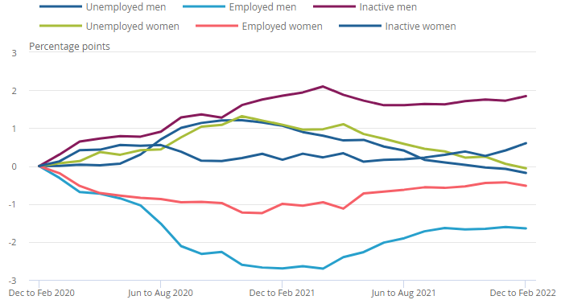
Source: (ONS- Labour force survey, 2022)
Both employment and economic activities have been reduced in COVID 19 pandemic and it has increased the level of unemployment to the economy. From the second quarter of 2020, the employment of both men and women were reduced in alarming rate. The reduction of employment was in ceiling point at the fourth quarter of 2021. It has been identified that the reduction of employment is higher to the case of men than that of women (OECD, 2021). But, it is a positive thing that the employment and unemployment rate are overturning to pre-pandemic level at the first quarter of 2022. The impact of unemployment has been adjusted through the effective steps of government in the global economy and different kinds of cautionary steps are already undertaken. The overturn of unemployment to pre pandemic level denotes the growth in labour market that can arise the job opportunity and individual earnings.

Level of part time and full time employees in COVID 19 pandemic:
The participation of part time employee and full time employees to different kinds of jobs are also analysed in the point view of labour market of United Kingdom. The analysis of the levels of part time and full time employees by the effect of COVID are explained below:
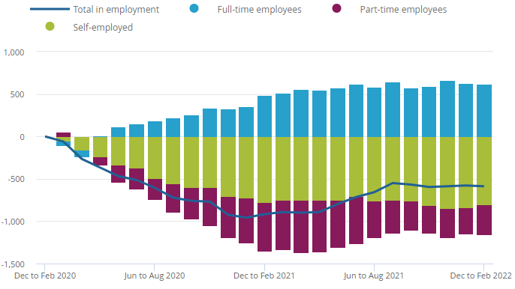
Source: (ONS- Labour force survey, 2022)
Based on the above bar chart, the part time employees were above self-employee and full times employees. But the COVID 19 pandemic has changed this structure and the part time employees have been dropped in alarming rate. But, the rate of part time employees and full time employees have been offset in the pandemic situation (LARSEN et al., 2021). The full time employees have been increased in the significant rate at the last quarter of 2021. As per focusing on the total employment, it has been found hat the total employment is being increasing from 2022 as the economic activities have been enhanced in the recent time.

Levels of economic inactivity:
Economic inactivity is the situation when the production and selling of the goods and services have been stagnant to the economy. Such kind of situation has been created to the economy of the world by COVID 19. The levels of inactivity in the COVID situation are presented as follows:
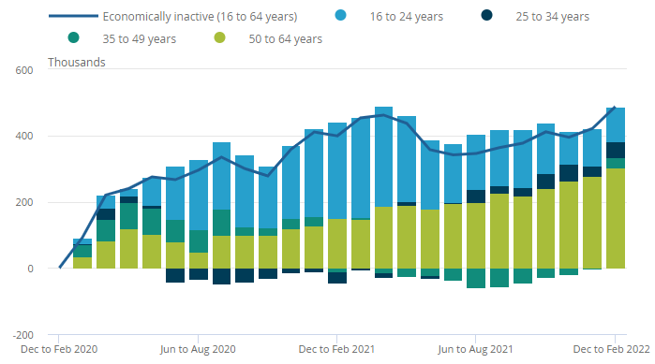
Source: (ONS- Labour force survey, 2022)
As per starting the COVID 19 pandemic, the economic activities were also enhanced in compared to last three months. In the COVID situation, the production activities were hampered, SME sector was affected the most and different service provided organisation were freeze as the lockdown was declared by the government. For maintaining various health obligations, the economic inactivity was enhanced in that situation (VORLEY, 2021). The economic inactivity led to contract the job opportunity for the people and the participation of the people to different jobs were limited in the pandemic situation.

Impact of COVID 19 on labour market participation:
The trend analysis between the pre pandemic and post pandemic about the labour market participation has been analysed in this phase of the report. The scenario of labour market participation in pandemic situation are analysed below:
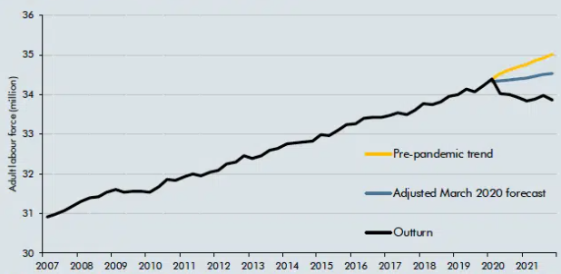
Source: (ONS-OBR, 2022)
The outbreak of COVID 19 pandemic shifted the working trend of the people. By this way, the people were starting to work from home. The work life balance of the people was re-evaluated in the pandemic situation. For this reason, the working trends of the employees in the labour market was adjusted from March, 2020 (VORLEY, 2021). After that the working trend of the employees in the labour market was overturned and total rate of working of employees was reduced in significant manner.

Effect of BREXIT on the labour market of United Kingdom
The withdrawal of United Kingdom from European Union is called BREXIT. It was executed from 31st January 2020 and provided different economic adjustment. The labour market of United Kingdom has been affect most by BREXIT and the employment opportunity and earnings of the people have been contracted by this way. The effect of BREXIT on the labour market of United Kingdom are explained as follows:
Shortage of stuffs is now acute in UK: By the impact of BREXIT, the shortage of stuffs has been faced by various organisations in the United Kingdom. There are some jobs where, the middle skilled EU national can be suited. But the BREXIT issue has increased the cost per employee of the organisation and total number of employees have been reduced. For example, about 90000 employees from the hospitality sector of UK left by the impact of BEEXIT. Primark is also facing the problems by BREXIT issue as the organisation fails to recruit value added employees (CLARKE, 2017). The shortage of stuffs in the labour market is compelling the organisation to recruit the stiffs with high salary and benefits. It has been forecasted that about 1.7million job vacancies is not existing at United Kingdom.
Struggling to keep supply chain: Different kinds of retailers in the market of United Kingdom is facing the problem to limited suppliers by the impact of BREXIT. The management of Primark is also facing the limited supply chain at the retail market as BREXIT has limited the free entry with other European countries. As a result, the wages of employees have been increased in the high extent (MAGNANI, 2022). For example, the drivers are paid £950 for per shift at the post BREXIT situation. According to Financial Times (2020) about 25000 drivers go back to their country by the impact of BREXIT and it has increased the complexity to keep the supply chain in proper ways.
Reducing economic activities: On the basis of the report of Financial Times (2020), the national income of the people at United Kingdom has been reduced by 0.6% and 1.3% by the direct impact of BREXIT. The tax free entry of different business has been contracted and the SME sector of the United Kingdom has been faces loss in some context. Many kinds of EU businessman have been backed to home. The contraction of the scope of business has reduced the economic activities (CLARKE, 2017). Thus, the chance of employment of the people in labour market of United Kingdom has been reduced in the alarming rate.

Innovative measures to attract and retain the new entrants from the labour market
As a human resource manager of Primark, different types of innovative measures that can attract and retain the new entrant to the labour market are discussed in this sector of the report. They are analysed as follows:
Offering consistent message: At the inception point, the consistent message from Primark can be sent to the potential employees. The uniqueness of the organisation is mentioned to the message to the employees so that the attraction of the employees can be created. The value driving vision of the company can be mentioned to the consistent message of the organisation (Fargus, 2010). Thus, the best suited employees can be captured by Primark from the labour market. Hence, the consistent message can present the values of the organisation towards the employees and appropriate person can be recruited to the organisation.
Defining the culture of organisation: The corporate culture should be communicated with the new entrants to the workforce of the organisation. By defining the corporate culture, the new employee can perceive the value that Primark holds and interact in appropriate manner. The communication with the new employee about the organisational culture can make them adapted with the new work environment (Stack, 2013). It is effective to provide the cultural orientation to the new entrants from the labour market to fit for the job within Primark. Thus, the new employees can be attracted and retained for a long time to the workplace of the organisation.
Offering competitive benefits: The competitive benefits can be offered to the newly recruited employees. By this way, the new employees will be motivated to work in Primark and their commitment will also be increased. Hence, the competitive benefits can be offered based on the ability of the employees (OKYERE et al., 2013). The offering of competitive benefits is also required to enhance the attraction of the stuffs to the workplace and capture the highest performance from them.
Encouragement and feedback: The encouragement and feedback can be provided to the newly recruited employees within Primark. Hence, the regular encouragement to the employees to ensure their spontaneous participation in the organisational functions. On the other hand, the feedback on the employee performance can point out their fault and motivate them to perform well in the workplace (Stack, 2013). The regular feedback from top management can also engage the employees with the management and they can be retained to the organisation.
Maintaining growth options: To attract and retain the new entrants from labour market the growth options need to be undertaken for the employees. For instance, the financial and non-financial support, promotion, acknowledgement and various growth options can be offered them to enhance their attraction for the workplace. Moreover, the employees can be rewarded as per the organisational desired performance (OKYERE et al., 2013). Thus, the level of motivation of the newly recruited stuffs of Primark can be increased and they can be retained to the company for long time.

Other measures to incentivise the retention of the existing workforce of Primark
The design of proper incentive plan for the employees can enable the organisations to retain the best employees for a long time. Different measures to incentivise the retention of the existing workforce of Primark are explained below:
Paying above the average salaries: The existing employees of Primark can be offered some extra salaries than that of the average salary structure of the company. As per paying the employees above the average salary their satisfaction level to the workplace of Primark can be enhanced (Stack, 2013). Thus, the best existed employees can be satisfaction and their retention can be ensured by the HR managers of Primark.
Appreciation and respect: The HR managers can appreciate and show the respect to the existing employees. The proper appreciation of the employee performance can recognise them to the workplace and the commitment can also be increased in significant manner. The top management can show affection and respect to engage them with the organisation (Fargus, 2010). The appreciation of the best performance can also motivate the stuffs to perform their job duties properly.
Empowerment: The management of Primark can empower the existing employees to boost their satisfaction. For example, the top management of the company can allow the employees to the decision making activities (Stack, 2013). Thus, the employees can directly involve in the organisational decision making and their authority to the workplace can be increased. By empowering the employees can satisfy them and retain them for long time.
Providing flexibility: The flexibility in work condition, working hour, job roles and many kinds of factors can be provided to the exited employees. The flexible work environment can ensure the inclusive work environment and the growth of the employees can be ensured to the organisation (SALE, 2021). The flexibility to the employees can also increase their participation in the organisational activities that is effective for grabbing the superior values from market. In either case, the flexibility to the employees can retain them long time to the organisation.
Incentive plan for best performers: The financial and non-financial incentive plan can be undertaken by Primark for retaining the existed employees. Different types of incentive plans of the company motivate the employees to the workplace (SALE, 2021). For example, the rewards, compensation, allowances and various kinds of incentive plan can be executed effectively by Primark to retain the existed employees to the workplace.

Conclusions
By analysing the impact of COVID 19 pandemic and BREXIT on the labour market of United Kingdom, it has been found that the labour market is affected in the high extent. The nature of employment to the labour market of the United Kingdom based on pandemic and the vacancy level to the organisation are discussed. The level of effect of BREXIT to the UK labour market are discussed and different examples are analysed. As a HR managers of Primark, the incentivise plan to attract the new entrants to the labour market and retain them are also analysed evaluated. Finally, the required strategic approaches to retain the existed employees within Primark are discussed to this report.

References
Sapsford, D., 2013. Labour Market Economics. Hoboken: Taylor and Francis.
Fargus, P., 2010. Measuring and improving employee motivation. London: Financial Times Prentice Hall.
SALE, J., 2021. MAPPING MOTIVATION. [S.l.]: ROUTLEDGE.
Stack, L., 2013. Managing employee performance. [Highlands Ranch, CO]: Productivity Pro.
OKYERE-KWAKYE EUGENE. ODURO ADDO SIMON. (2013). EMPLOYEE RETENTION: a critical factor for organisational performance. [Place of publication not identified], LAP LAMBERT ACADEMIC PUBL.
MAGNANI, M. (2022). Making the global economy work for everyone: lessons of sustainability from the tech revolution and the pandemic.
VORLEY, T. (2021). Productivity and the pandemic: challenges and insights from Covid-19.
OECD. (2021). OECD Employment Outlook 2021 Navigating the COVID-19 Crisis and Recovery.
LARSEN, C., KIPPER, J., SCHMID, A., & PANZARU, C. (2021). Transformations of regional and local labour markets across Europe in pandemic and post-pandemic times: challenges for regional and local observatories.
CLARKE, S. (2017). Work in Brexit Britain: reshaping the nation's labour market.

