Learning In The Digital Era
Component 1: E-portfolio

Submitted by:
REHAN MAJID
Student number:
2526568

Date: 3RD March 2026

Table of contents
Contents
E-portfolio link 2
Screenshot of e-portfolio cover page/ welcome page 3
Task 1 3
Screenshot of ‘Essential Skills’ 4
Screenshot of ‘Reflection’ 4
Task 2 4
Screenshot of mind map 5
Link to mind map 5
Screenshot of the academic poster 5
Link to the academic poster 6
Task 3 6
Screenshot of automatic referencing tool 7
Task 4 7
Screenshot of each page of e-portfolio 8

E-portfolio link

https://sites.google.com/view/rehaneportfilo/home/automatic-referencing

Screenshot of e-portfolio cover page/ welcome page



Task 1

Screenshot of ‘Essential Skills’

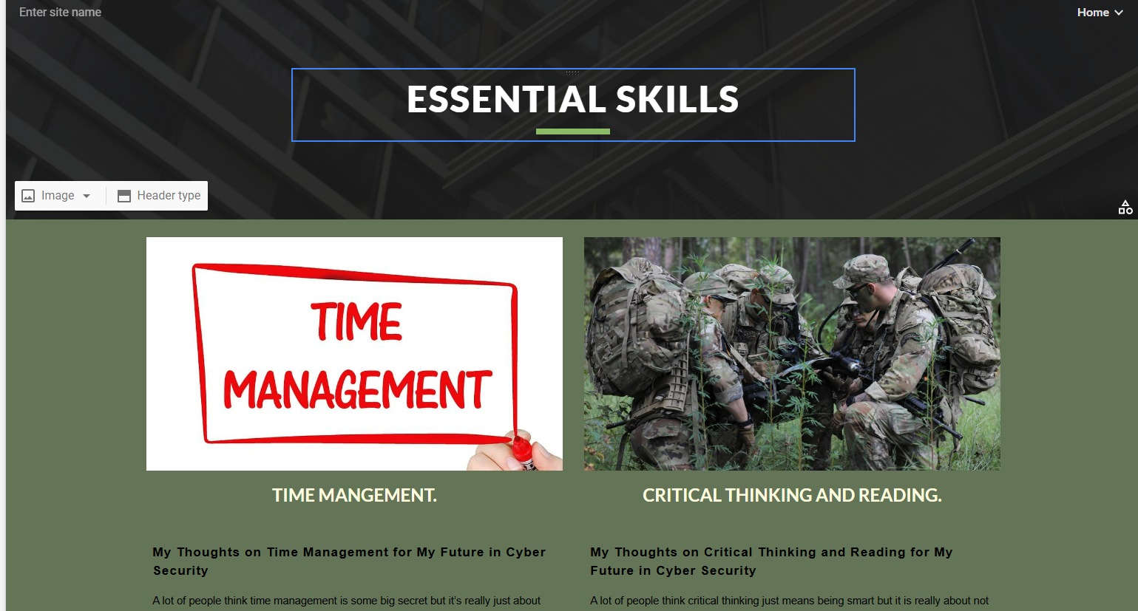

Screenshot of ‘Reflection’
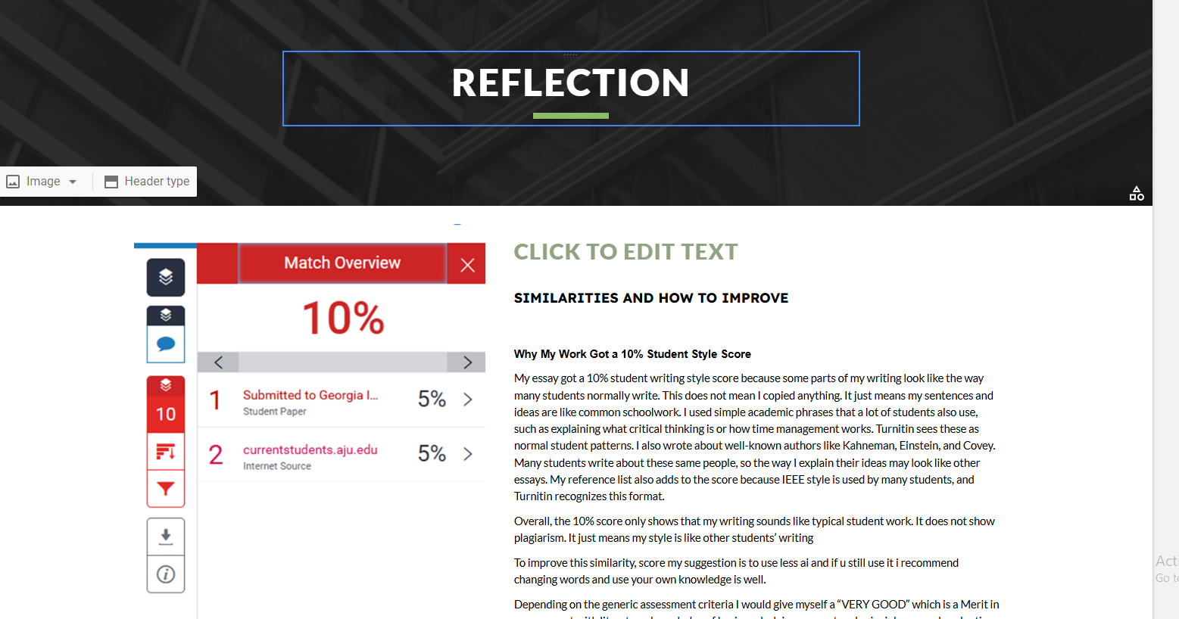

Task 2

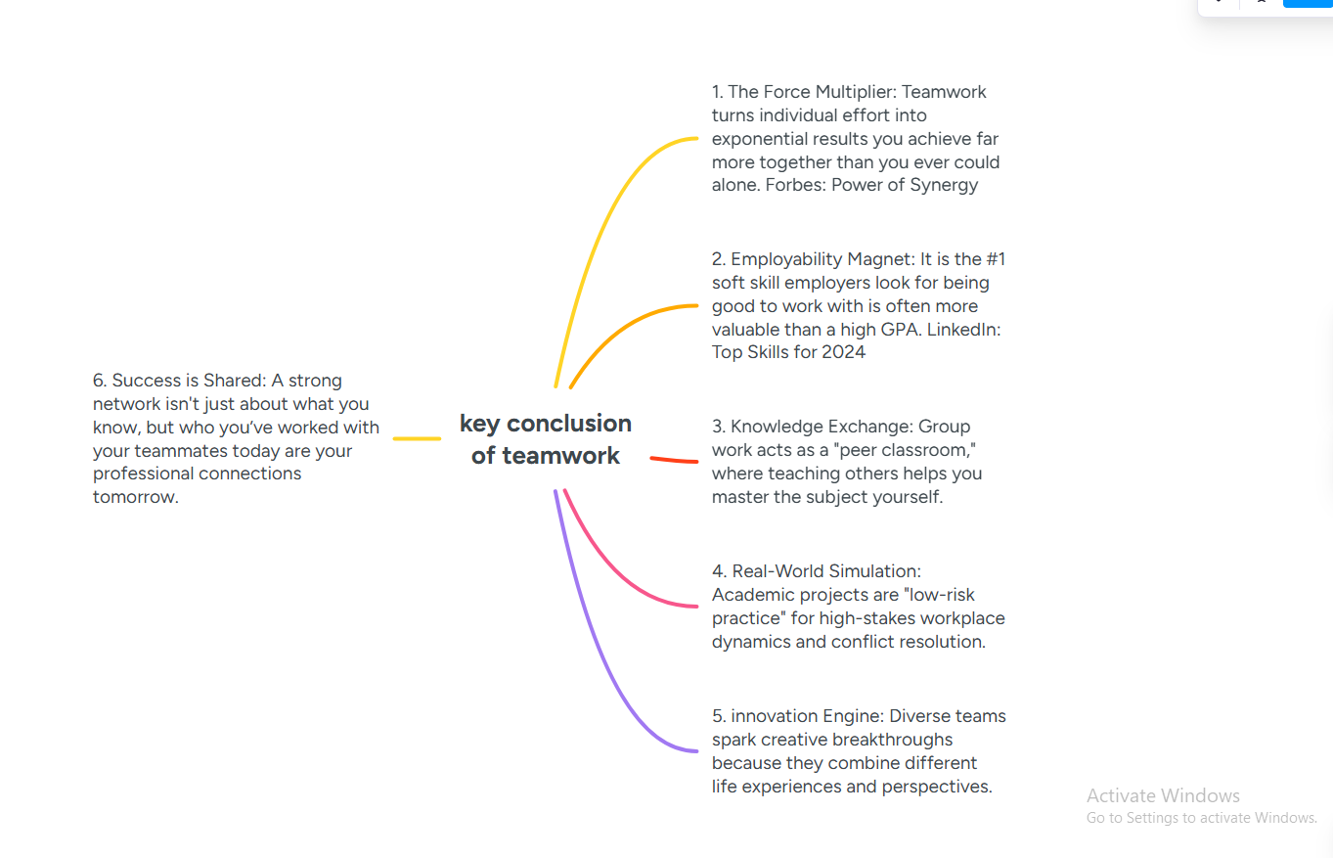
Screenshot of mind map

Link to mind m

https://mm.tt/map/3942747294?t=BEIRdspAVD

Screenshot of the academic poster
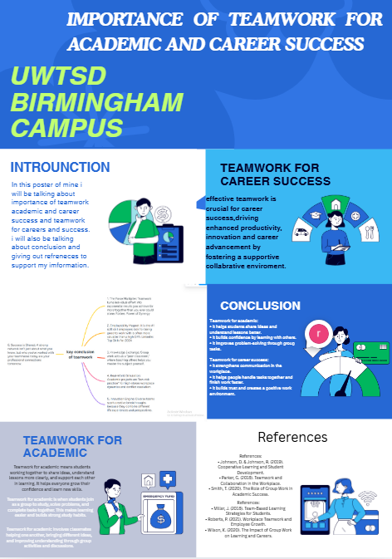

Link to the academic poster

https://www.canva.com/design/DAHBf2L-uOc/frnJd6yDBpt_RopJpBibpQ/edit?utm_content=DAHBf2L-uOc&utm_campaign=designshare&utm_medium=link2&utm_source=sharebutton

Task 3

Screenshot of automatic referencing tool
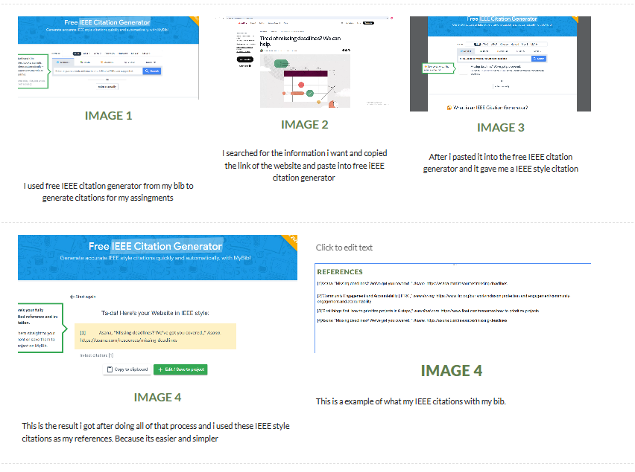

Task 4


