Student Name: - Rubina Akbur

Student Number: - 2118370

Course Title: - Academic and Employability Skills

Assignment Title: Reflective Report

Module Code: BMSW4001_BIRM-

Lecturer: - Jonathan Wyatt

Contents Page
Introduction……………………………………………………………3
Reflective Writing …………………………………………………….3
Model of relflection…………………………………………………….4
Reflect Task 1 – Academic Report ………………………………….5
Reflect Task 2 – Group Presentation ………………………………..7
Personal Development Plan …………………………………………..9
Conclusion……………………………………………………………….9
References………………………………………………………………10

Introduction
During my Academic and Employability skills lesson, I had the opportunity to complete a variety of assignments and activities that reflected on my learning and comprehension of the course. In this reflective writing, I will focus on my academic report as well as my experiences working as a group to create a job opportunity with other students.
This report will be discussing a reflection on experiences that were encountered while writing the academic report and while carrying out a group presentation. While learning, we used a popular model of reflection known as the Gibbs Reflective Cycle which has been proved that when it is understood it will work effectively. Gibbs (2013) states that two important features of studying successfully are not about skills but about understanding.
Reflective Writing
Reflective writing is when writing is formed including certain criteria’s or thoughts like, feelings, perceptions, and a reaction lead to a particular event or circumstances. This gives you the opportunity to capture an experience or an action that you took deliberate control of and expected a result. Reflection is somewhere around the technique of learning and representing the learning (Moon, 1999).
There are different approaches to reflecting are that.you will need to think about what had been done and then scrutanise the event or task by logically thinking from a different outlook. However, you also need to contemplate on what happened as well as the pros and cons.
Finally, cautiously justifying what needs to be done differently in coming times and why?

Model of reflection
The model of reflection that was chosen was the Gibbs reflective cycle. Reflection provides the writer or a reader the chance to think about his/hers individual experiences, examination to shape ones thinking and to accept new ideas.
During 1998, Gibbs who was an American sociologist and psychologist published his Reflective Cycle book in 1998. It supports people in circumstances that have arisen regularly mainly when they do not go to plan.
The Gibbs reflective cycle which is a 6-stage experience: description, feelings, evaluation, analysis, conclusion and an action plan. Description is when you need to think about circumstances event or an activity in depth. Then you have feelings where you need to consider what ones thoughts were during the event or activity. After that you have an evaluation where one questions them if what they experience was good or bad. Next, analyse what you have learnt. Then you have conclusion where you think about what could you have done better. Finally, action plan is based on your conclusion and one needs to think about how they can develop in the future.
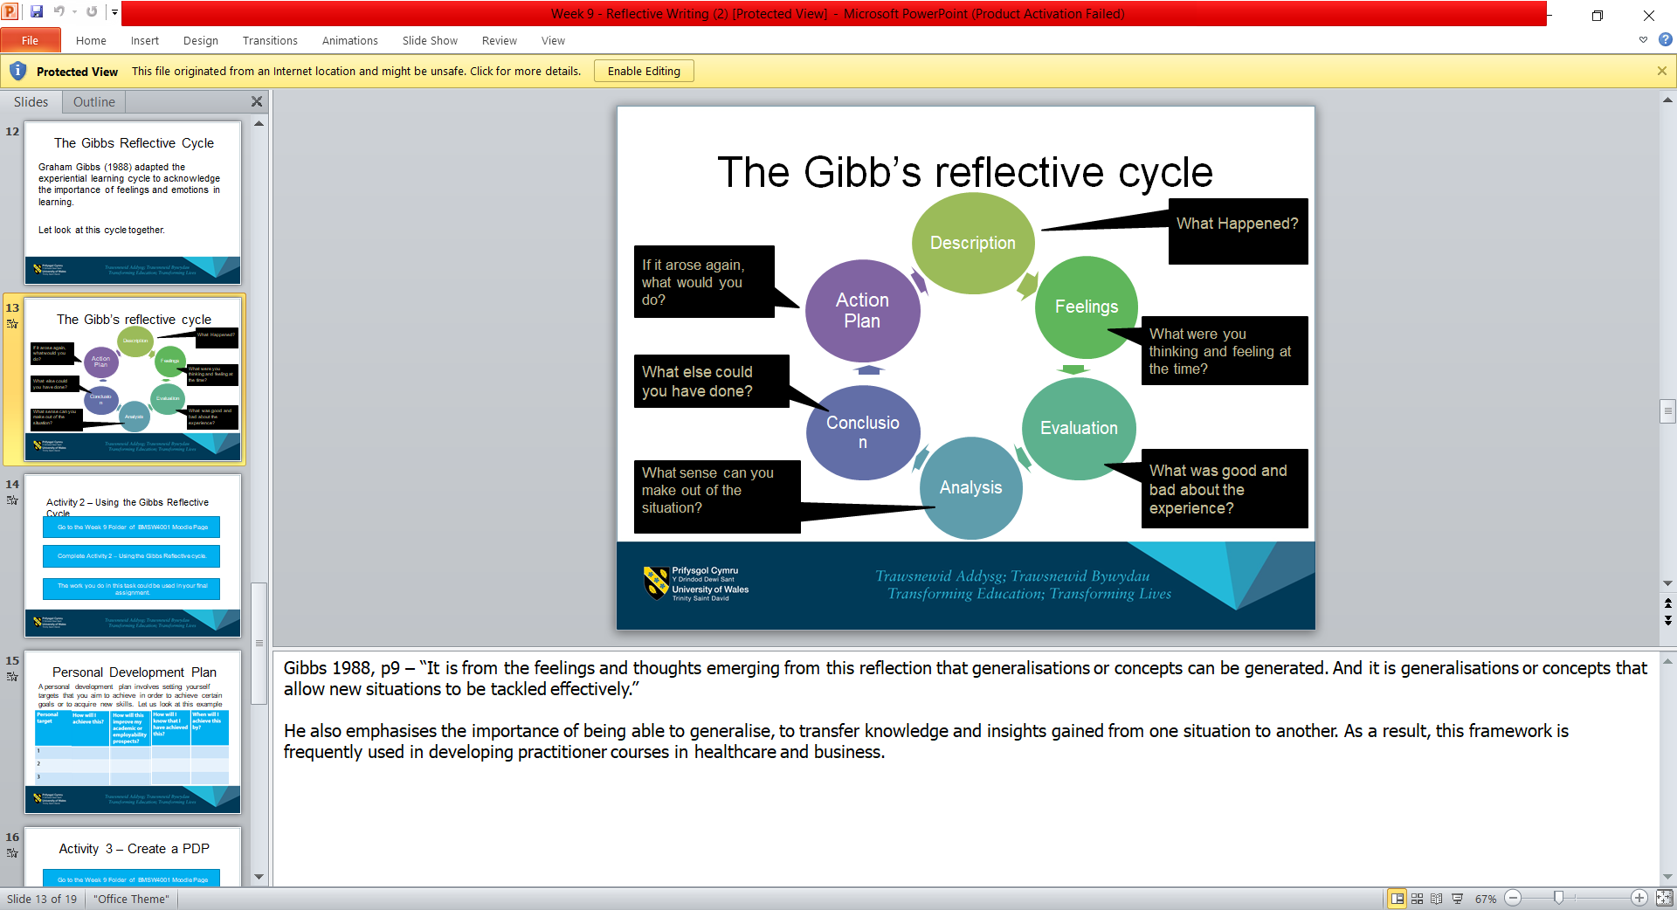
(Gibbs1998)

Reflect Task 1 – Academic Report
Description
During this module we were taught how research strategies and software skills to enables us to utalise effective communication tools. While at doing this model we were hoping to gain confidence in our studies to enhance our skills for better learning. Having been taught academic skills gave us a better approach to learning. Study skills that were taught were a variety of skills which fought the process of learning to organise and gaining new information and also allow us to articulate our work once we edited it to make improvement.
However the top skills that I needed to learn were time management so that I can organise my time to use it more effectively. This benefited me with less stress and hopefully more opportunities. Also, learning how to note take to ensure the notes help me understand the topic, idea or hypothesis.
Finally, it was also demonstrated how to use the CRAAP test so that we could evaluate the information that was needed.
Feelings
Throughout the first academic term I was feeling overwhelmed as it had been a while since I studied and times had changed. The learning styles had changed and the way information needed to be recorded was different to what I was used it. However, what scared me the most was the citation as this was totally new to me and I knew it would take up most of my time. My main level of thought was I don’t think I will maintain a work life balance.
Evaluation
The pros while doing the academic report was finding the correct citation that matched what I wanted to record and to ensure that it was making sense. It took me ages to find the information as I was not use to this style of learning. I then continued to have no motivation and started to procrastinate. People have a habit of procrastinating; we are just not built to be active or productive all the time (Blinkist, 2021). Once I found the right sources I began to enjoy my report writing and started to manage my time better but was disappointed in myself of how much time I wasted avoiding my work. This gave me the acknowledgment that I need to find my sources first and then my report writing will be easier to put together.

Analysis
In my personal development plan my target ensure that time is managed well through different activities, organisation so that if you get it it right you can work effectively and meet targets required. Wilson R, et al (2021) states that through academic development and through advance study habits student enhance their study habits.
A higher quality of research will define better work, if we do not do the research it affect the learning in class. Students should be motivated to research to gain a understanding as this will support them to be more active during class (Buijs, M. and Admiraal, W. 2013).
Conclusion
To ensure that I do better next time I will use the plan out your time sheet and the study plan which was shared with us during the lesson so that I can identify and make time for my work so that I do not procrastinate and most importantly stress out when the deadlines are coming nearer.
Action Plan
If I had to do the report again I will ensure that I find my sources beforehand, so that it enables me to plan and prepare my time, follow assignment brief and record the correct information that needs to be provided. I need to guarantee that the steps needed are met so that I can achieve my goals.

Reflect Task 2 – Group Presentation
Description
During the lesson we were allocated our groups where we needed to work together as a team, chose a specific role so that we could find a job advertisement that we had an interest in line with our course. A job advertisement needed to be created where the key information was required. As a group we chose to do a PowerPoint so that we could identify the key areas. However, key areas that we needed to identify in the advertisement were employers name, job title, and description of role, details of qualification, skills required and an application deadline.
The skills that I gained while creating a PowerPoint alongside others were to be able to insert pictures that generated the same information that was written. Also the ability to put together a PowerPoint that was clear to understand also targeted an audience that took interest.
Feelings
I was very excited at first because I was working with girls who were as enthusiastic as I was and were willing ti put in the effort to achieve results. Because there was a lady online who we had never met but was part of the team, it felt a
little awkward because I wasn't sure what to expect and wanted to make sure the interactionas measurable. My initial thought was whether the lady online would be informative and share information with people she didn't know because she was very quiet and agreed to everything.
Evaluation
The unequivocal part of the presentation was having the ability to share work equally with others, they had the same objective as me which enhanced our learning because we learnt from each other. We collaborated skills needed and then broke the work into parts and steps so that we were able to work together.
The negative effects I had been when certain people in my group took over and felt the need to make it mainly about their interests. This made it difficult to maintain the enthusiasm and excitement as I was beginning to feel like an outsider because at times I was told that it should be another way when really there was no right or wrong answer.

Analysis
The detailed examination was that there was a lack of fluency and the job advertisement lacked in organisation. It has been said by Claypool (2015) that fluency and also discussion have a direct impact on the frame of mind and that it usually affects attitudes by making it more positive.
Conclusion
A clear group discussion would have been better for us to generate our ideas and to ensure that all voices were heard equally and clearly. Particular people took over and that should have not happened and there should have been a better working system and effective communication. It has been said that if you have clear communication then you will require a clearer understanding (Aizpún, 2009).
Action Plan
All things considered if I had the opportunity to do this again I will ensure that my ideas are accountable and understood as I would continue to do the same for others. Also, I will not let others take over as everyone should have the opportunity to share goals that we all need to collaborate. Only those share their experiences and facts can be in a position to evaluate (Aizpún, 2009).

Personal Development Plan
Personal Target | How will I achieve this? | How will this improve my academic or employability prospects? | How will I know that I have achieved this? | When will I achieve this by?
1.Speak slowly | Take deep breathes before I start | It will help me speak and think clearly so that the audience understand me. | From future analysis. | Hopefully by the end of the term as this term is new and has been a learning curve.
2.Being clear about what I need to present | Ensure I practice in front of family and friends. | It will give me the ability to gain confidence and be better each time I have to present. | As soon as possible we need to make eye contact daily when speaking to others. | Before I gain another presentation.
3.Having eye contact with the audience when speaking | Practice in front of family and friends or maybe even at work. | It will give me the ability to gain confidence and be better each time I need to present. | The next time I stand in front of people I will hopefully feel confident and clear about the task. | As soon as I can as we need to make eye contact daily when speaking to others.

Conclusion
Finally, as a result I found this module very informative, as I did not feel that I would learn so many new skills. The teacher who taught us gave us a clear reflection on what our expectations were and how we needed to present our work as well as ourselves. At the beginning my biggest worry was if I would be able to manage my time so that I gave my university work a priority. Time management is so crucial when you are a student and if this is managed well then you will most definite will be able to research as well as meet your deadlines.
Next term I will ensure that I do less procrastination and put my free time to good use. However and most importantly I will ensure that I have a work-life balance so that it limits stress and prioritise my health and well-being

References
Aizpún, M. (2009) ‘Why Is Communication Important in Dermatology?’, Actas dermo-sifiliográficas (English ed.), 100(3), pp. 164–165.
Blinkist (2021) The Procrastination Cure (Blinkist Summary). Carpenteria, CA: linkedin.com.
Buijs, M. and Admiraal, W. (2013) ‘Homework assignments to enhance student engagement in secondary education’, European journal of psychology of education, 28(3), pp. 767–779.
Claypool, H.M., Mackie, D.M. and Garcia-Marques, T. (2015) ‘Fluency and Attitudes’, Social and personality psychology compass. Claypool, HM, Mackie, DM, and Garcia-Marques, T (2015), Fluency and Attitudes. Social and Personality Psychology Compass, 9, 370-382. doi: 10.1111/spc3.12179., 9(7), pp. 370–382.
Gibbs, G. (1998) Learning By Doing : A guide to teaching and learning methods, Oxford: Further Education Unit, Oxford Polytechnic
GIBBS, G., 2013. Teaching intelligence - Self-reflective improvement: News. Times Higher Education, (2103), pp. 20.
Moon, J.A. (1999) Reflection in learning & professional development : theory & practice. Abingdon: Routledge.
Wilson, R., Joiner, K. and Abbasi, A. (2021) ‘Improving students’ performance with time management skills’, Journal of university teaching & learning practice, 18(4), pp. 230–250. doi:10.53761/1.18.4.16.

